वार्षिक प्रतिवेदन प्रारूप वर्ष 2020 – 21

**अध्ययनशाला का नाम:** इलेक्ट्रॉनिक्स अध्ययनशाला, देवी अहिल्या विश्वविद्यालय, इंदौर

**स्थापना वर्ष:** 1990

**विभागाध्यक्ष का नाम**: डॉ. अभय कुमार

**फ़ोन नंबर**: +91-731-2463754, +91-9424008159

**ई–मेल**: [dr.abhaykumar@gmail.com](mailto:dr.abhaykumar@gmail.com)

|  |  |  |  |
| --- | --- | --- | --- |
| स. क्र. | संचालित पाठ्यक्रम का नाम | पाठ्यक्रम प्रारंभ वर्ष | स्वीकृत सीट |
| 1 | Ph.D | -- | -- |
| 2 | M Tech Embedded Systems | 2002 | 18 |
| 3 | M Sc Electronics & Communication | 1993 | 40 |
| 4 | Integrated M.Tech in Electronics Spl: Embedded Systems (AICTE Approved) | 2020 | 30 |
| 5 | B.Sc (Electronics, Computer Science, Mathematics) | 2020 | 30 |
| 6 | B.Sc (Electronics, Physics, Mathematics) | 2020 | 30 |

**अकादमिक वर्ष (2020-21) मे अध्ययनशाला मे विद्यार्थियों की संख्या**

|  |  |  |  |
| --- | --- | --- | --- |
| पाठ्यक्रम | पाठ्यक्रम संख्या | कुल विद्यार्थियों की संख्या | उत्तीर्ण विद्यार्थियों की संख्या |
| स्नातक | 03 | 70 | Newly launched Programme in 2020 |
| स्नातकोत्तर | 02 | 34 | 18 |
| पी. एच. डी. |  | 03 | 01 |

**अकादमिक वर्ष (2020-21) मे अध्ययनशाला मे प्रवेशित विद्यार्थियों की संख्या 30 जून 2021 तक**

|  |  |  |  |  |  |  |  |  |  |  |  |  |  |
| --- | --- | --- | --- | --- | --- | --- | --- | --- | --- | --- | --- | --- | --- |
| पाठ्यक्रम का नाम | वर्ष | सामान्य वर्ग | | अजा | | अजजा | | अपिव | | एनआरआई | | कुल संख्या | |
| छात्र | छात्रा | छात्र | छात्रा | छात्र | छात्रा | छात्र | छात्रा | छात्र | छात्रा | छात्र | छात्रा |
| M Sc E&C | 2020-21 | 0 | 3 | 0 | 0 | 0 | 0 | 3 | 0 | 0 | 0 | 3 | 3 |
| M Tech ES 2 Yrs | 2020-21 | 5 | 1 | 0 | 0 | 0 | 0 | 2 | 2 | 0 | 0 | 7 | 3 |
| Integrated M Tech 5 Yrs | 2020-21 | 4 | 3 | 1 | 1 | 0 | 0 | 5 | 2 | 0 | 0 | 10 | 6 |
| B.Sc ECM | 2020-21 | 7 | 10 | 1 | 1 | 1 | 0 | 5 | 5 | 0 | 0 | 14 | 16 |
| B.Sc EPM | 2020-21 | 9 | 4 | 2 | 1 | 0 | 0 | 6 | 2 | 0 | 0 | 17 | 7 |

व**र्ष (2020-21) में अध्ययनशाला मे शिक्षकों की संख्या 30 जून 2021 की स्थिति में**

|  |  |  |  |  |  |  |  |  |  |  |  |  |
| --- | --- | --- | --- | --- | --- | --- | --- | --- | --- | --- | --- | --- |
| शिक्षक | सामान्य वर्ग | | अजा | | अजजा | | अपिव | | एनआरआई | | कुल संख्या | |
| पु. | म. | पु. | म. | पु. | म. | पु. | म. | पु. | म. | पु. | म. |
| सहायक प्राध्यापक | 0 | 1 | 0 | 0 | 0 | 1 | 0 | 1 | 0 | 0 | 0 | 3 |
| एसोसिएट प्रोफेसर | 0 | 0 | 0 | 0 | 0 | 0 | 0 | 0 | 0 | 0 | 0 | 0 |
| आचार्य | 2 | 0 | 0 | 0 | 0 | 0 | 0 | 0 | 0 | 0 | 2 | 0 |
| संविदा शिक्षक | 0 | 0 | 0 | 0 | 0 | 0 | 1 | 0 | 0 | 0 | 1 | 0 |
| अतिथि शिक्षक | 3 | 1 | 0 | 0 | 0 | 0 | 0 | 1 | 0 | 0 | 3 | 2 |
| कुल | 5 | 2 | 0 | 0 | 0 | 1 | 1 | 2 | 0 | 0 | 6 | 5 |

**अध्ययनशाला द्वारा प्रकाशन एवं अकादमिक गतिविधियां वर्ष (2020-21) 30 जून 2021 की स्थिति में**

|  |  |
| --- | --- |
| **प्रकाशन/ अकादमिक गतिविधियां** | **संख्या** |
| जर्नल मे प्रकाशित शोध पत्र (इम्पेक्ट फैक्टर) | 09 (Average Impact factor> 1): Appendix – A |
| पुस्तकों मे लेख | 01: Appendix – A |
| पुस्तक लेखन | Nil |
| पुस्तक संपादन | Nil |
| मोनोग्राफ | Nil |
| पेटेंट्स /Copyrights | * A Copyright on “PERFORMANCE ANALYSIS OF WEB SERVICES USING M-LEARNING ANDROID APPLICATION” granted to Ms. Kirti Panwar Bhati and Mr. Aditya Soni from Copyright Office, Government of India in 2021. |
| कांफ्रेंस/ सेमिनार लेख प्रस्तुतीकरण | 05: Appendix – A |
| कांफ्रेंस/ सेमिनार का आयोजन | Nil |
| वर्कशॉप मे उपस्तिथि | 27 (Please refer Appendix – B for details) |
| वर्कशॉप का आयोजन |  |
| अतिथि व्याख्यान प्रस्तुति | * Ms. Kirti Panwar Bhati delivered expert Lecture on ‘Introduction to MQTT protocol and Live Demo’, organized by IET, DAVV in AICTE ATAL FDP on 17 Oct, 2020 |
| अतिथि व्याख्यान आयोजन | Nil |
| कांफ्रेंस मे अध्यक्षता | Nil |
| अन्य कोई विवरण | * Dr. Manju K. Chattopadhyay served as reviewer for Springer Journal of Supercomputing, Elsevier Journal of King Saud University- Computer and Information Sciences, Journal of The Electrochemical Society (JES), TELKOMNIKA Telecommunication Computing Electronics and Control, HardwareX, Bulletin of Electrical Engineering and Informatics. |

**PhD Awarded**

PhD is awarded to Mr. Shitesh Tiwari on 30 June, 2021 under the supervision of Dr. Sumant Katiyal and co-supervision of Dr. Parag Parandkar on title “Low Power Low Noise VCO Design in Nanometer Paradigm and its Performance Evaluation”.

**Visvesvaraya PhD Scheme (MeitY) Activities**

Two PhD scholars under the scheme are pursuing research work and both of them have several SCI/SCOPUS publications to their credit.

**अध्ययनशाला के शिक्षकों एवं विद्यार्थियों द्वारा वर्ष (2020-21) मे प्राप्त पुरस्कार / फैलोशिप एवं अन्य महत्वपूर्ण संस्थाओ से प्राप्त पदक 30 जून 2021 की स्थिति में**

|  |  |  |
| --- | --- | --- |
| स. क्र. | अवार्ड/ पुरस्कार/ फैलोशिप / महत्वपूर्ण संस्थाओ से प्राप्त पदक | शिक्षक/ विद्यार्थी का नाम |
| 1. | Certificate of Appreciation for ‘Fostering the ecosystem bridging Government, Academia and Industry’ by AICTE and Texas Instrumentation. | 1. Dr. Abhay Kumar 2. Dr. Manju K. Chattopadhyay |
| 2. | Best Paper Award for paper titled “Analysis of Security Breaches and Security Mechanism in Analyzing and Visualizing Automobile Data” in International Conference ICIAETM 2021 organized by Prestige Inst. of Engg, Management & Research, Indore during 09-10 April, 2021. | Ms. Kirti Panwar Bhati  & Ms. Surbhi Jain |
| 3. | AICTE Scholarship for GATE Qualified MTech Students  Rs. 12,400 per month | 1. Rohit Borkar 2. Amit Sharma 3. Ankit Kumar Soni 4. Ayush Sharma 5. Nisha Yadav 6. Pratik Kumar |

**वर्ष 2020-21 मे अध्ययनशाला में प्रारम्भ किये गए नए पाठ्यक्रम की जानकारी 30 जून 2021 की स्थिति में**:

Department has launched Three Undergraduate Programmes in 2020 – 21 session

1. AICTE approved Integrated M. Tech in Electronics Spl: Embedded Systems (5 Years) with intake of 30
2. BSc (Electronics, Computer Science, Mathematics), Intake: 30
3. BSc (Electronics, Physics, Mathematics), Intake:30

**विभाग द्वारा की गई प्लेसमेंट गतिविधियों का संक्षिप्त विवरण:**

Following students of M Tech Batch: 2020-21 are selected for one year project work –cum-placement as per details given below:

|  |  |  |  |  |  |
| --- | --- | --- | --- | --- | --- |
| **S. No.** | **Roll No.** | **Name of Students** | **Programme** | **Organization** | **Approximate Stipend per month** |
| 1 | 20MTES01 | AMIT SHARMA | M.Tech ES | CG POWER, BHOPAL | 12400* |
| 2 | 20MTES07 | PRATIK KUMAR | M.Tech ES |  |
| 3 | 20MTES08 | SINGH MEENAKUMARI | M.Tech ES | SINGULARITY AIX,  AHMEDABAD | 7000 |
| 4 | 20MTES02 | ANKIT KUMAR SONI | M.Tech ES | CSIR-CEERI, PILANI | 12400* |
| 5 | 20MTES03 | AYUSH SHARMA | M.Tech ES | 12400* |
| 6 | 20MTES04 | NAVEEN KUMAR  MEHROTRA | M.Tech ES |  |
| 7 | 20MTES05 | NISHA YADAV | M.Tech ES | 12400* |
| 8 | 20MTES06 | PRABHANSHU BANGAR | M.Tech ES |  |
| 9 | 20MTES09 | SHASHIKALA SINGH | M.Tech ES |  |
| 10 | 20MTES11 | VARDAN TARE | M.Tech ES |  |
| 11 | 19ECN01 | ADITI | M.Tech ES |  |
| 12 | 19ECN03 | HIMANSHU | M.Sc ECN | CUTTING EDGE MEDICAL  DEVICE PVT. LTD., INDORE |  |
| 13 | 19ECN06 | SUMIT S. RATHORE |  |
| 14 | 19ECN05 | SHUBHAM MISHRA |  |
| 15 | 19ECN04 | RATNESH MAGGAR | M.Sc ECN | KRAT PVT. LTD., INDORE |  |

*AICTE Stipend

**वर्ष 2020-21 मे अन्य महत्वपूर्ण गतिविधियों का विवरण 30 जून 2021 की स्थिति में**

1. School of Electronics has organized a debate competition on the topic "Are women really safe in Cyber World" on 25 Jan, 2021. This program was an activity under the Awareness Drive "सम्मान " by M.P. Police for Women Safety. Guddi is the Mascot for the drive.

|  |  |
| --- | --- |
| C:\Users\SOEX\Downloads\IMG-20210125-WA0030.jpg | C:\Users\SOEX\Downloads\IMG-20210125-WA0045.jpg |

1. Technical meet up is organized on topic “Design Thinking on Embedded Systems (from raw chip to functional setup” on 20th Feb, 2021 by Algotronix community- a student’s community of School of Electronics consisting of final year students and alumni of Department.

|  |  |
| --- | --- |
| C:\Users\SOEX\Downloads\IMG-20210220-WA0000.jpg | C:\Users\SOEX\Downloads\IMG-20210220-WA0004.jpg |

1. Another Workshop was organized on topic “Interfacing of Sensors with Raspberry Pi” on 05 May, 2021 by Algotronix community.

**Activities Undertaken during Covid-19 Lockdown**

**1. Academic Activities**

1. **Use of Online Courses & Study Material**: All the programmes being run in the department has a provision of inclusion of learning offered by MHRD initiative such as **MOOC Courses** launched on Swayam, NPTEL platforms. Department also provides inclusion of results of those courses in the student’s gradesheet.
2. **Online Classroom:** Classes are conducted in Online mode through Zoom, Google Classroom App etc. Snippets of online classes activities are provided below:
3. **Conduct of Online Comprehensive Viva Voce**

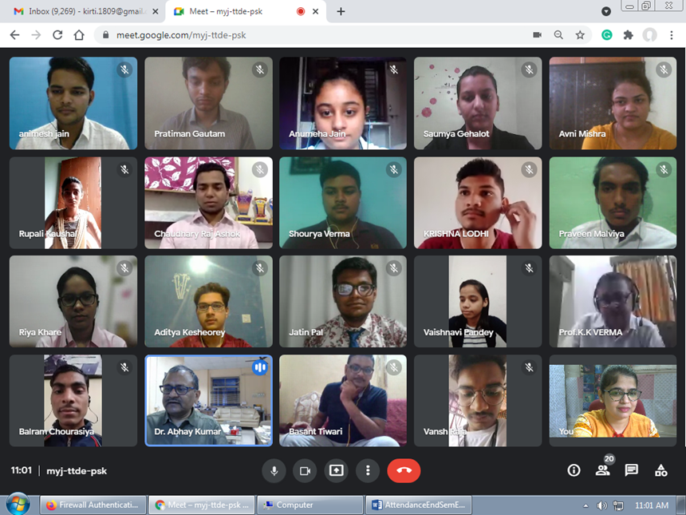

1. **Conduction of online End Semester Examination**

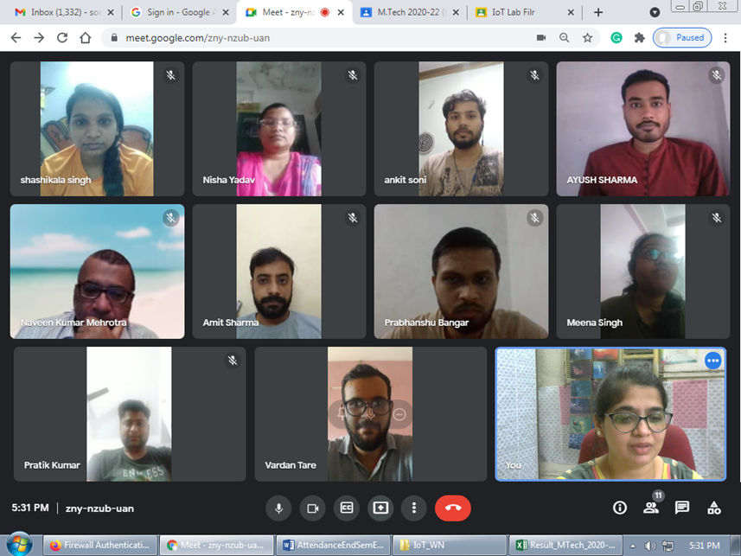

1. **Conduction of online Laboratory Viva Voce**

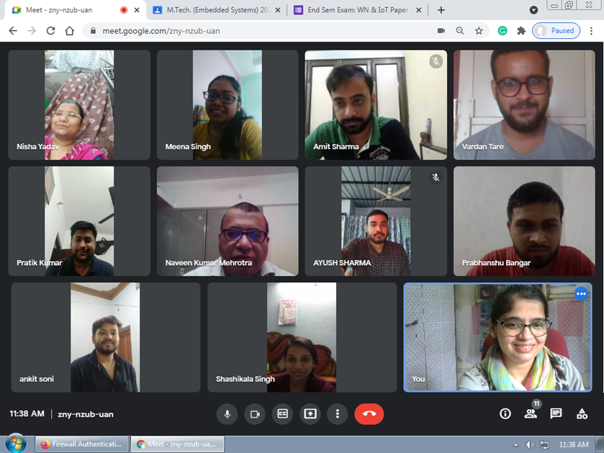

**Appendix – A**

**List of Publications**

1. **Journal Publications**

### V. Tiwari, PP Bansod and A Kumar, “CT image reconstruction from sparse projections using adaptive total generalised variation with soft thresholding”, International Journal of Biomedical Engineering & Technology (InderScience), June, 2021.                                            [SCOPUS Indexed]

### H Pal and A Kumar, “Stability Analysis of Multiscale Bubble Entropy and Power Metric based Seizure Detection Technique with MLA”, IETE Journal of Research, May 2021.   [SCI Indexed]

### Das, S. C., Das, S., Ghodke, N., Katiyal, S., & Majumdar, A. (2021). Development of gravitational acceleration measurement set up based on laser beams. Asian Journal For Convergence In Technology (AJCT) ISSN -2350-1146, 7(1), 110-114. https://doi.org/10.33130/AJCT.2021v07i01.023

### Nikki Ahuja, Priyesh Kanungo, Sumant Katiyal, Profit Model for admission control and resource scheduling for optimum utilization of resources in Cloud Computing Environment, JIMS 8i – Int. J. of Inf. Comm. & Computing Technology, 448-454(2020)

1. Nikki Ahuja, Priyesh Kanungo, **Sumant Katiyal**, Significance of Admission Control Mechanism in Cloud Computing Environment, International Journal of Distributed and Cloud Computing, Vol 8, No 1&2, 1-8 (2020)
2. K. T. Upadhyay, **Manju K. Chattopadhyay**, Sensor applications based on AlGaN/GaN heterostructures, Elsevier’s Materials Science and Engineering: B, Vol. 263, 2021, 114849,

<https://doi.org/10.1016/j.mseb.2020.114849>, [Scopus Indexed, IF: 4.051 (2020)]

1. K. T. Upadhyay, **Manju K. Chattopadhyay**, A new analytical model for sensing response of AlGaN/GaN based pH sensor, Springer Journal of Computational Electronics, 20, 1400–1410 (2021) <https://doi.org/10.1007/s10825-021-01687-7> [Scopus Indexed, IF: 1.807 (2020)]
2. T. Upadhyay, **Manju K. Chattopadhyay**, A composition dependent unified analytical model for quaternary InAlGaN/GaN HEMTs for pH sensing, Springer Journal of Electronic Materials, 50, 3392–3405 (2021). <https://doi.org/10.1007/s11664-021-08836-5>,

[Scopus Indexed), IF: 1.938 (2020)]

1. N. Gupta, A. P. Shah, R. S. Kumar, **T. Gupta**, S. Khan and S. K. Vishvakarma, "On-Chip Adaptive VDD Scaled Architecture of Reliable SRAM Cell With Improved Soft Error Tolerance," in *IEEE Transactions on Device and Materials Reliability*, vol. 20, no. 4, pp. 694-705, Dec. 2020, doi: 10.1109/TDMR.2020.3019135. [SCI Indexed]
2. **Articles in Book (Book Chapter)**
3. Soni, H., Bhati, K., Katre , N., & Meshram, P. (2021). IoT Doordarshi: Smart Weather Monitoring System using Sense Hat for improving the Quality of Crops. In Smart Agriculture Automation using Advanced Technologies. SPRINGER TRANSACTIONS ON COMPUTER SYSTEMS AND NETWORKS.
4. **Conference Papers/Proceedings**
5. R. Karothia, Manju K. Chattopadhyay, Vigorous deep learning models for identifying tomato leaf disease, 2nd International Conference on Data Science and Applications (ICDSA 2021) [Soft Computing Research Society](https://www.scrs.in/) and  [Jadavpur University, Kolkata, India](http://www.jaduniv.edu.in/), April 10-11, 2021
6. R. R. Chowdhary, Manju K. Chattopadhyay, Orchestration of Automated Guided Mobile Robots for Transportation Task in a Warehouse like Environment, IEEE International Conference on Emerging Trends in Industry 4.0 (ETI 4.0), OP Jindal University, Raigarh, Chhattisgarh, India, 19 - 21, May 2021.
7. R. Karothia, Manju K. Chattopadhyay, Convolutional Neural Networks Based Vigorous Deep Learning Model, IEEE-EDS Delhi Chapter supported MICRO-2020: 7th International Conference on Microelectronics, Circuits and Systems, Organized by Delhi Technological University, Delhi, India, 25-26 July 2020.
8. Manju K. Chattopadhyay, K. Y. Upadhyay, Unified Analytical Model for Charge Density and Plasmonic waves in the Quaternary AlInGaN/AlN/GaN Heterostructures, Delhi Chapter supported MICRO-2020: 7th International Conference on Microelectronics, Circuits and Systems, Organized by Delhi Technological University, Delhi, India, 25-26 July 2020.
9. Jain , S., & Bhati, K., Analysis of Security Breaches and Security Mechanism in Analyzing and Visualizing Automobile Data. International Conference on Innovative Applications of Emerging Technologies and Management (p. 87). Indu Publication, New Delhi, 2021.

**Appendix – B**

**Participation in Workshop/Expert Lecture/Seminars**

**Dr. Manju K. Chattopadhyay**

1. Participated in AICTE Training And Learning (ATAL) Academy Online *FDP on "Quantum Computing"* from 05 Oct 2020 to 09 Oct 2020 at Centre for Development of Advanced Computing (C-DAC), Mohali.
2. Participated in TI MOOC on *Embedded System Design using MSP430 MCU*.
3. Participated in AICTE Training And Learning (ATAL) Academy Online Elementary FDP on "Serverless *IoT for societal products*" from 24 May 2021 to 28 May 2021 at Indian Institute of Information Technology Kottayam.
4. Participated in Online Summer School-cum-FDP on ‘*Advances in Signal Processing and Machine Learning*’ Jointly organized by MHRD-Institution Innovation Council, DDUC Chapter, Department of Electronic Science, University of Delhi & National Academy of Sciences India (NASI) – Delhi Chapter Supported By IEEE Electron Device Society (EDS), Delhi Chapter 20-26 July 2020.
5. Attended Students Humanitarian Technology Conference (SHTC) 2021, IEEE Kerala Section, 1-2 May 2021.
6. Participated in ‘The Guinness World Record Event –Most users to take an online computer programming lesson in 24 hours’ on 24-25 April 2021.
7. Participated in National Supercomputing Mission’s ‘Workshop on ARM based HPC’ organized by C-DAC and the NSM Nodal centres for training in HPC and AI, 02-03 March 2021.
8. Attended National webinar on NEP 2020: Issues addressed and Impact, Organized by Devi Ahilya University, Indore, 20 August 2020
9. Attended "International Workshop on Mobile THz Systems 2020 (IWMTS2020)", 02 Jul 2020
10. Attended IEEE International Conference on Flexible and Printable Sensors and Systems (FLEPS 2020), 1-19 August 2020.
11. Attended National Seminar on Computer Vision & Image Processing (NaSCoVIP 2020)organized by IEEE Gujarat Section, 09-11 Oct 2020
12. Participated in the 4th meet up on "*Design Thinking on Embedded Systems -from raw chip to functional setup*’ by Algotronix group of the department, 20 Feb 2021

**Ms. Pratibha M. Umale**

1. Five day online ATAL FDP on Internet of Things, organized by IHRD College of Engineering, Kallooppara, from 14th to 18th September, 2020.
2. Five day online ATAL FDP on ADVANCES IN CLEAN ENERGY CONVERSION TECHNOLOGIES & MATERIALS FOR ENERGY STORAGE APPLICATIONS. The FDP is scheduled from 21-25 September 2020.

**Ms. Kirti Panwar Bhati**

1. Participated in Webinar on “Essentials of Setting AI/DL Lab ” organized by Bennett Univ, Noida on 17 July, 2020
2. One Week Online Short Term Training Programme Sponsored by AICTE on “Big Data and Hadoop”

during 20th -25th July, 2020 organized by IPS Academy, Indore

1. Participated in National Webinar on “Introduction to Automotive Embedded Systems” organized by SKITM, Indore on 08 Aug, 2020
2. Participated in Workshop on “3D Printing” organized by DDUKK, DAVV, Indore from 3-5 Sep, 2020
3. Participated in ATAL FDP on "Data Sciences" from 2020-9-7 to 2020-9-11 at University of Hyderabad.
4. Participated in Webinar on “Introduction to Block Chain” KC College on Engg. & Management, Thane on 19 Sep, 2020
5. Participated in Training Programme on Digital tools for Writing, Authoring & Reviewing Manuscripts jointly organized by Electronics & ICT Academies, MNIT Jaipur, NIT Patna & IIT Guwahati during 21st September and 2nd October 2020
6. Participated in Training Programme on “Cyber Security” jointly organized by Electronics and ICT Academies, NIT Patna, and MNIT Jaipur held from 05th - 11st October, 2020
7. Participated in ATAL FDP on "Data Sciences" from 2020-10-20 to 2020-10-24 at Ramakrishna Mission Vivekananda Educational and Research Institute.
8. Participated in ATAL FDP on "Artificial Intelligence" from 2021-1-4 to 2021-1-8 at Dr. Ambedkar Institute of Technology
9. Participated in ATAL FDP on "Electric Vehicles from 2021-2-1 to 2021-2-5 at Manipal University Jaipur
10. Participated in the 4th meet up on "Design Thinking on Embedded Systems -from raw chip to functional setup’ by Algotronix group of the department, 20 Feb 2021

**Dr. Rameez R. Chowdhary**

1. Online Faculty Development Programme on “Social Robotics” organized by IIITDM, Jabalpur, June 2021.