 | Synthesis, Catalysis, Theoretical / Computational, and Spectro-Analytical Characterization Studies Laboratory
location | School of Chemical Sciences, Takshashila Campus, Indore
Faculty member(s) | Dr. Ashok Kumar, Dr.A.V. Bajaj, Dr. Sheela Joshi, Dr. Pratibha Sharma, Dr. Savita Khare
Contact Details | - Dr. Ashok Kumar, Mobile No. 9425962688;  e-mail: drashoksharma2001@yahoo.com  - Dr.A.V. Bajaj, Mobile No.9425363818  email: dravbajaj@gmail.com  - Dr. Sheela Joshi, Mobile No. 9826085169  email: spjoshi@radiffmail.com  - Dr. Pratibha Sharma, Mobile No. 9425187226  e-mail: drpratibhasharma@yahoo.com  - Dr. Savita Khare, Mobile No.9407164882  kharesavita@rediffmail.com
keywords | Synthesis , Catalysis – Homogeneous, Heterogeneous, Nanocatalysis, Organocatalysis, Structural Characterization & Interpretation ( NMR, IR, , UV, Mass, elemental, XRD, SEM etc.) Chromatogarphic resolution /purification ( Column, TLC, GC,HPLC),Potentiostat
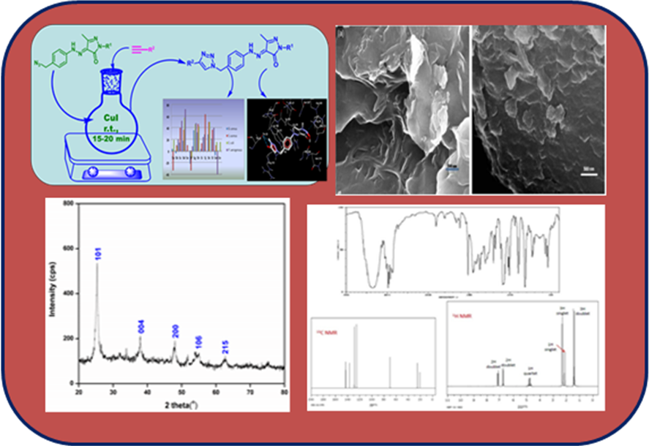
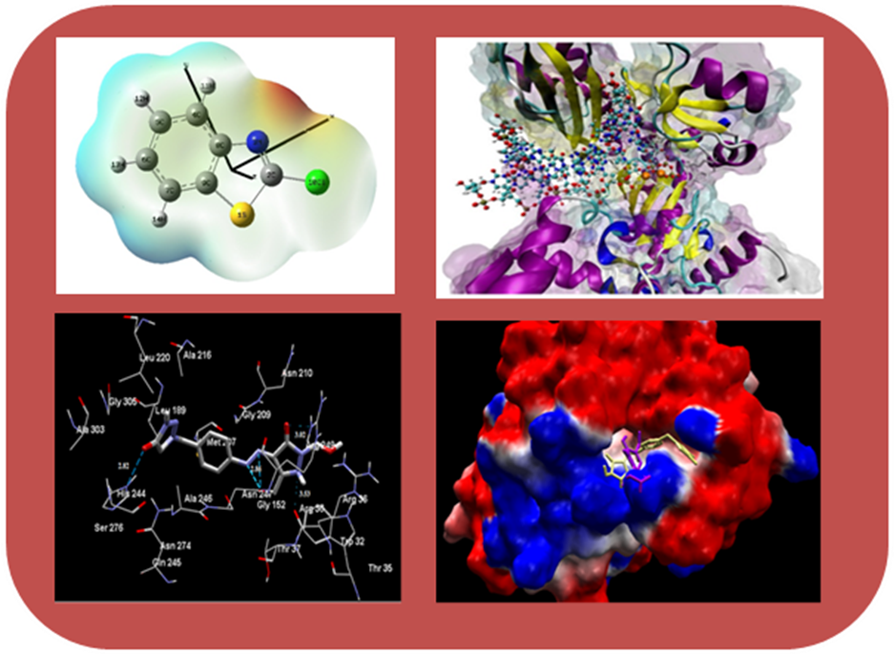
Facilities & Expertise | This group of researchers have expertise in the synthesis , spectroanalytical characterization of a variety of organic compounds, heterocyclic compounds, and different nanocatalytic systems derived from metals /carbon based /organocatalytic/ mesoporous materials together with theoretical/computational studies to ascertain the mechanistic pathway vis-a-vis evaluation of medicinal potential through molecular modelling studies. Research labs are equipped with modern equipments and software (Gaussian 09) for computational studies.  Research domain and expertise of faculty members are as follows:  Dr. Ashok Kumar  Synthesis, Physico - Analytical Studies, Spectroscopic Studies, Electrochemistry, Computational studies  Dr.A.V. Bajaj  Bioorganic/Bioinorganic Chemistry  Dr. Sheela Joshi  Synthesis & Medicinal Chemistry – SAR/QSAR, Spectroscopic Studies  Dr. Pratibha Sharma  Synthesis – Carbocycles / Heterocycles, Catalysis / Organocatalysis /Nanocatalysis, Spectroscopic Studies, Theoretical l Studies, Biological Evaluation Including QSAR/ Docking, electrochemical studies  Dr. Savita Khare  Catalysis-Homogeneous /Heterogeneous, Spectroscopic Studies  Following instruments/Accessories are available in the department laboratory:  (i) All accessories required for the synthesis  (ii) Rotatory Evaporator  (iii) Gas Chromatograph,  (Iv) HPLC  (v) UV-Visible spectrophotometer,  (vi) Fourier Transform Infra Red Spectrometer (Perkin Elmer FTIR- ATR),  (vii) Potentiostat (BAS Electrchemical System)  (viii) Muffle Furnance  (xi) Deep Freezers  (x) Autoclave, Ovens, Distillation assembly  (xi) Vaccuum Filtration pump

