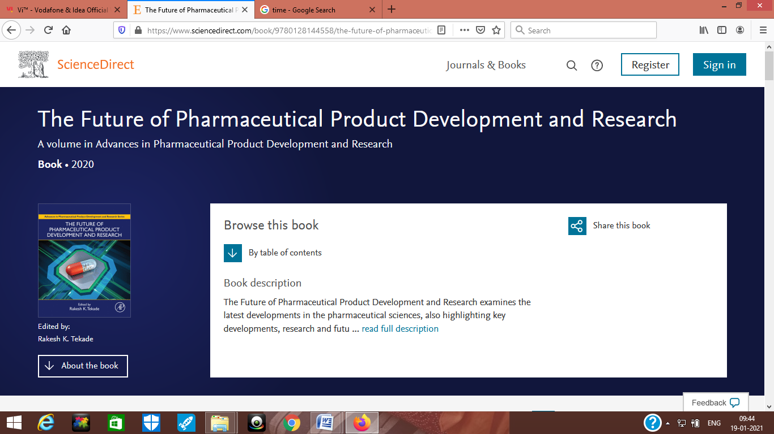

**Book Chapters-2020**

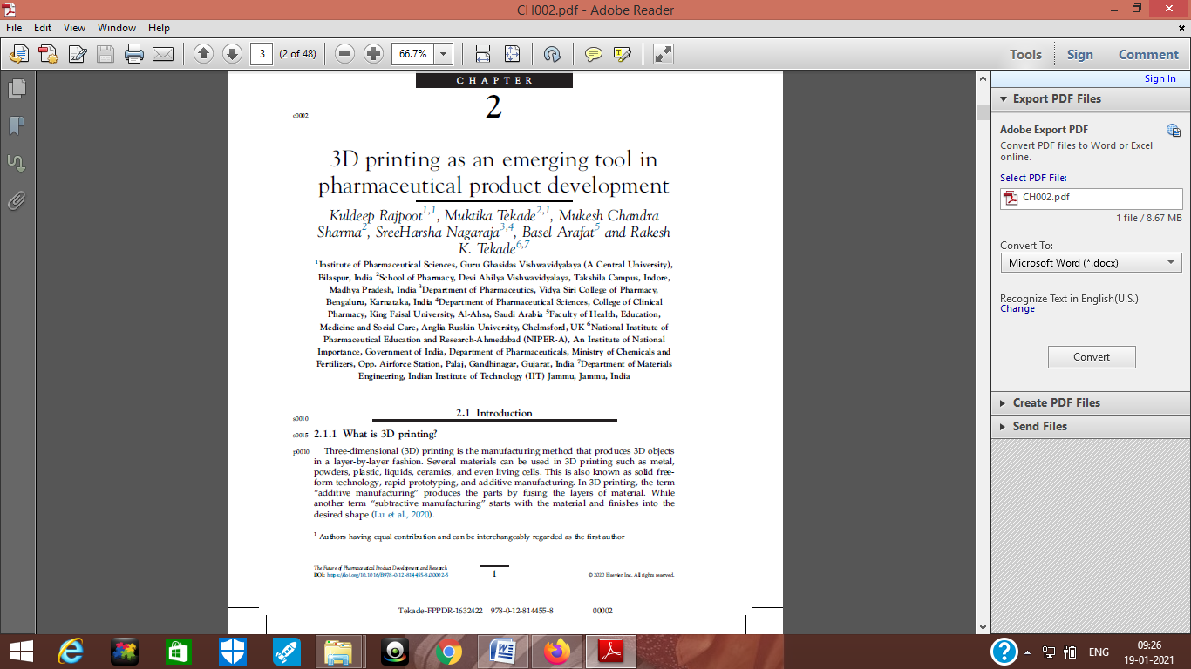

K Rajpoot, M Tekade, **MC Sharma**, N Sreeharsha, B Arafat, RK Tekade, 3D printing as an emerging tool in pharmaceutical product development. The Future of Pharmaceutical Product Development and Research, 2020,27-71, Publisher Academic Press (Elsevier; **ISBN 978-0-12-814455-8**)

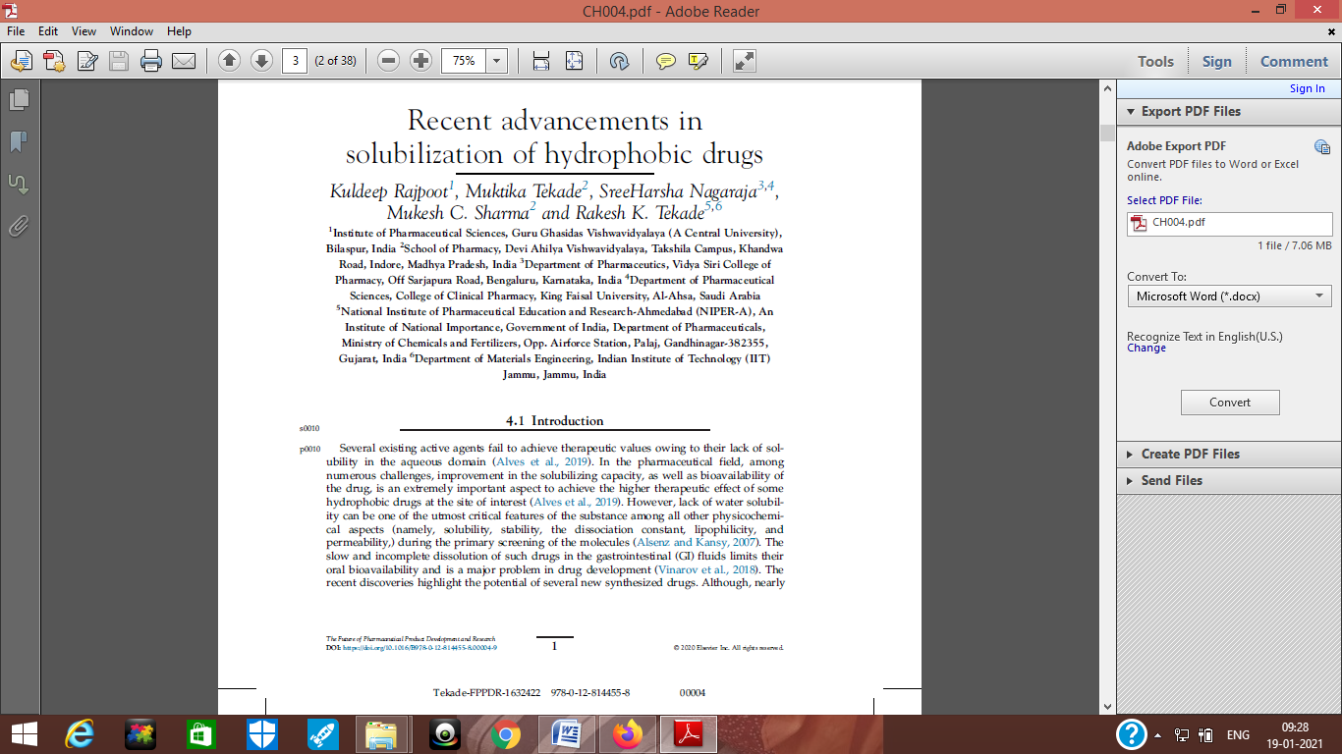

K Rajpoot, M Tekade, N Sreeharsha, **MC Sharma**, RK Tekade, Recent advancements in solubilization of hydrophobic drugs ,The Future of Pharmaceutical Product Development and Research, 2020,109-144 Publisher Academic Press (Elsevier; **ISBN 978-0-12-814455-8**)

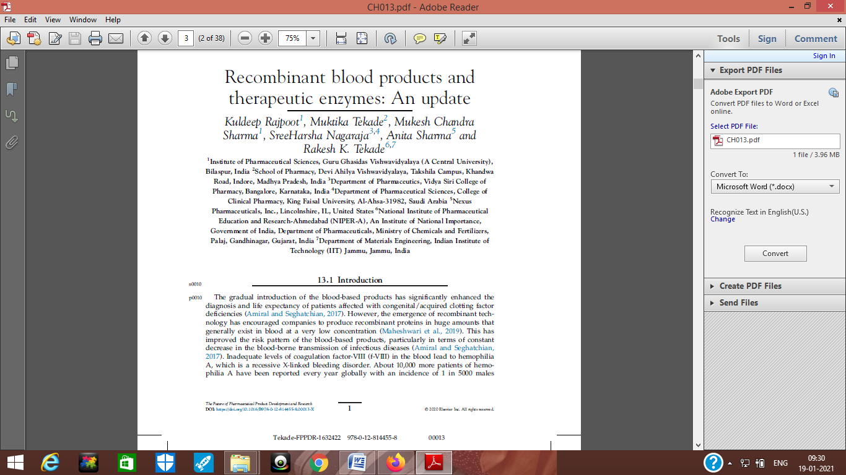

K Rajpoot, M Tekade, **MC Sharma**, N Sreeharsha, A Sharma, RK Tekade, Recombinant blood products and therapeutic enzymes: An update The Future of Pharmaceutical Product Development and Research 2020, 447-482 , Publisher Academic Press (Elsevier; **ISBN 978-0-12-814455-8**)

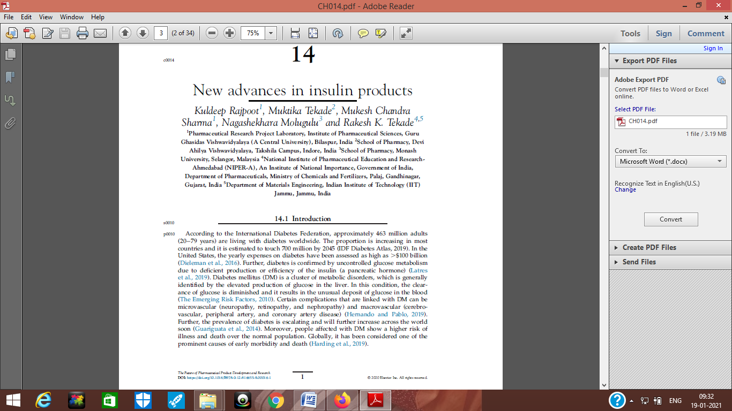

K Rajpoot, M Tekade, **MC Sharma**, N Molugulu, RK Tekade; New advances in insulin products” The Future of Pharmaceutical Product Development and Research 2020, 483-514 , Publisher Academic Press (Elsevier; **ISBN 978-0-12-814455-8**)

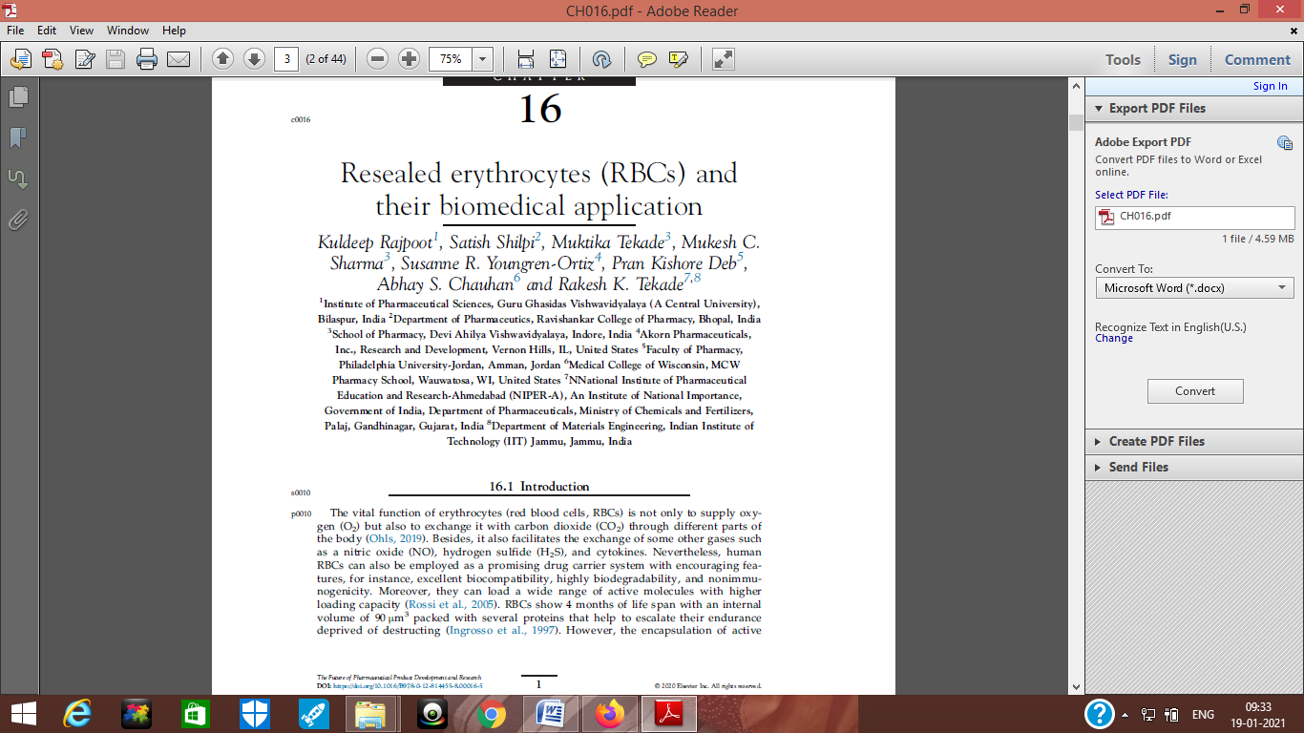

K Rajpoot, S Shilpi, M Tekade, **MC Sharma**, SR Youngren-Ortiz, PK Deb, Chauhan AS , R K Tekade ; Resealed erythrocytes (RBCs) and their biomedical application” The Future of Pharmaceutical Product Development and Research 2020, 539-580, Publisher Academic Press (Elsevier; ISBN 978-0-12-814455-8)