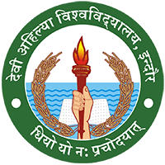

DEVI AHILYA VISHWAVIDYALAYA, INDORE

7.1.1
Gender Equity

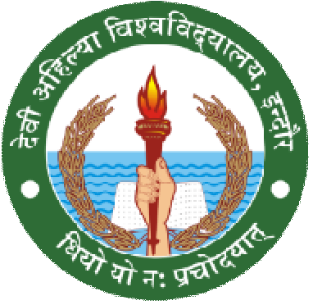
REPORT 01

DEVI AHILYA VISHWAVIDYALAYA, INDORE DEPARTMENT OF LIFELONG LEARNING
SESSION 2020-2021

Special Guest Lecture

CYBER SECURITY FOR WOMEN
Dr. Bharti Joshi
Head

Date | Time | Platform | No. of. participants | Coordinator
23RD JAN, 2021 | 1pm | Offline | 20 | Dr.Bharti Joshi

The special guest lecture is conducted on Cyber security for women under the guidance of Ashish Shukla (Ass. SI , Mahavir Singh parihar & Vikrant Tiwari from Cyber security cell , Indore Police, Indore Head of the department Dr.Bharti joshi with the faculties Bunty Pal, Vijesh Mane& Anita Pal they welcome the guest and give vote of thanks The main motive to conduct the guest lecture is women’s protection for self & others .The participants must aware of activities that fall under the ambit of cybercrime to ensure they do not participants in such acts .And learn what they should do against them and protect themselves from such critical situation.

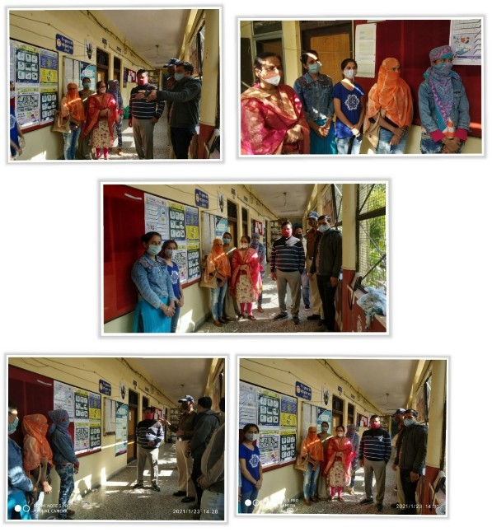

CYBER CRIME
Cybercrime is criminal activity that either targets or uses a Computer, A computer network or a networked device most, but not all, cybercrime is committed by cybercriminals or hackers who want to make money, Cybercrime is carried out by individual or organization.
Key Message-Aware from social networking
-Use a full-service internet security suite
-Keep your software update -Strengthen your home network
-Talk to your children about the internet.
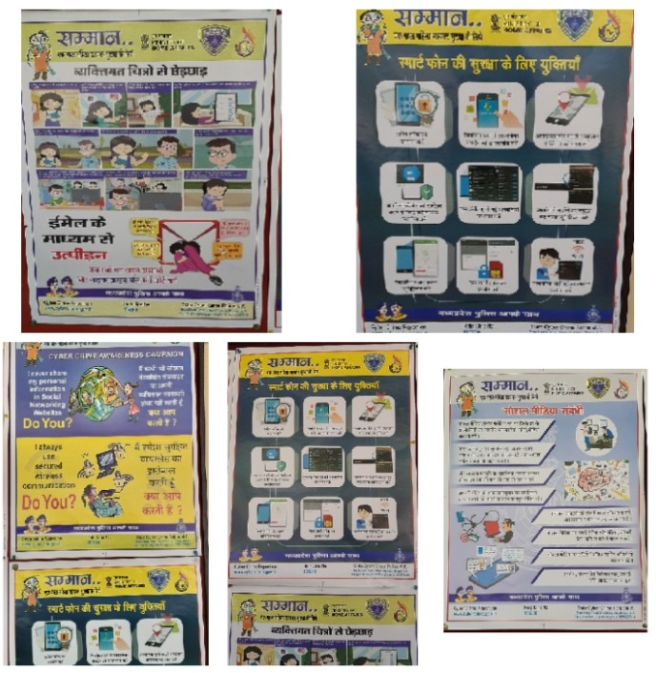

Specific example-Due to online activities cybercrime increases so protect yourself -Personal information is stolen and used maintain privacy-High password for online harassment-keep up to data on major security breaches.

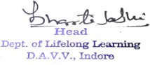
Summary of the special guest lecture-There are 20 participants who join the lecture (offline mode)- All are fully active and take initiative -All having perfect discussion with each other.

REPORT 02

DEVI AHILYA VISHWAVIDYALAYA, INDORE DEPARTMENT OF LIFELONG LEARNING
SESSION 2020-2021

POSTER MAKING COMPETITION

Mahila Samman Beti Bachao

Dr. Bharti Joshi
Head

Date | Time | Platform | No. of. participants | Instructor
26 Jan, 2021 | 10 to 5 pm | Online | 20 | Mrs. Anita pal

OBJECTIVE FOR COMPETITION
The students expressed their whole views and thoughts about female honour & save our daughter and by writing slogans and quotes. This activity kept the students engaged and it was organized to explore and encourage creativity in students and offer them a platform to showcase their skills.

Objective of the competition-
-To improve the social, economic, health and nutrition status of women.
-To create awareness regarding different women and child development
-Ensuring education and participation of the girl child
-To safeguard the constitution rights of women and children.

KEY MESSAGE
-To boost the ongoing movements ‘Beti Bachao &Mahila samman by poster making
-Discover best creative ability
-Awareness amongst the citizens
-Give inspiration to women’s make themselves strong

Judge was Dr.Hement koshik, Head of Institute of Design, Awantika University, Ujjain, and M.P.

PRIZE HOLDER’S
FIRST PRIZE –KUNAL ASTE, B.Voc. 3rdsem.
SECOND PRIZE –RUCHI SIRTURE –Diploma in Interior Designing 1stSEM. All the posters which was made by the students are presented as online exhibition On you tube channel Link- https://youtu.be/EAwL1RvXwkg
The Honour of the participants is done by Mrs. Anita Pal & Head of the Department Dr.Bharti Joshi.

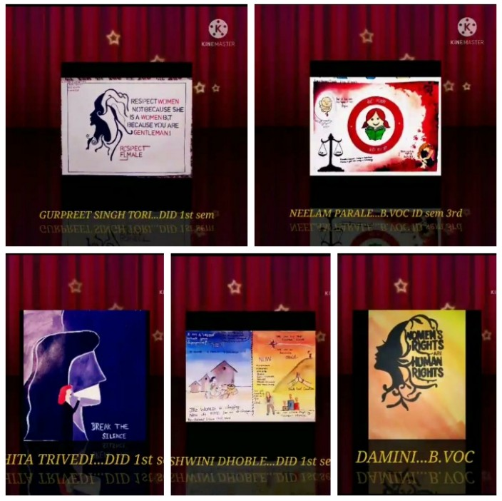

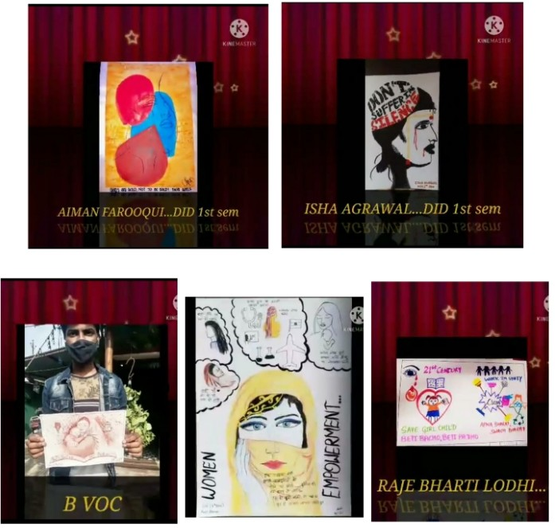

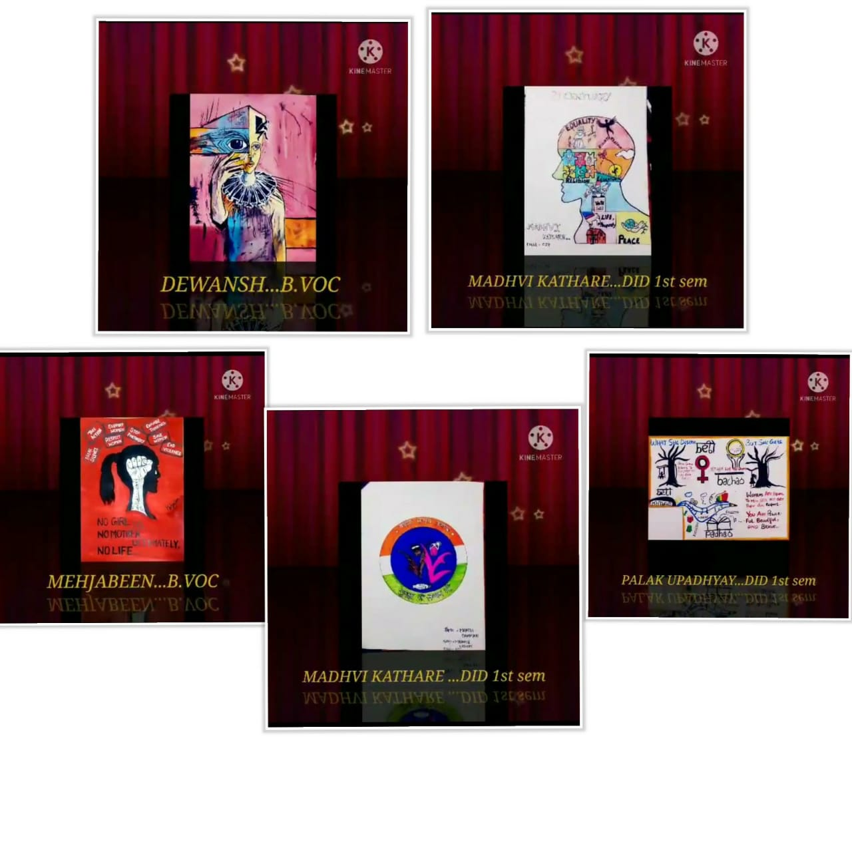
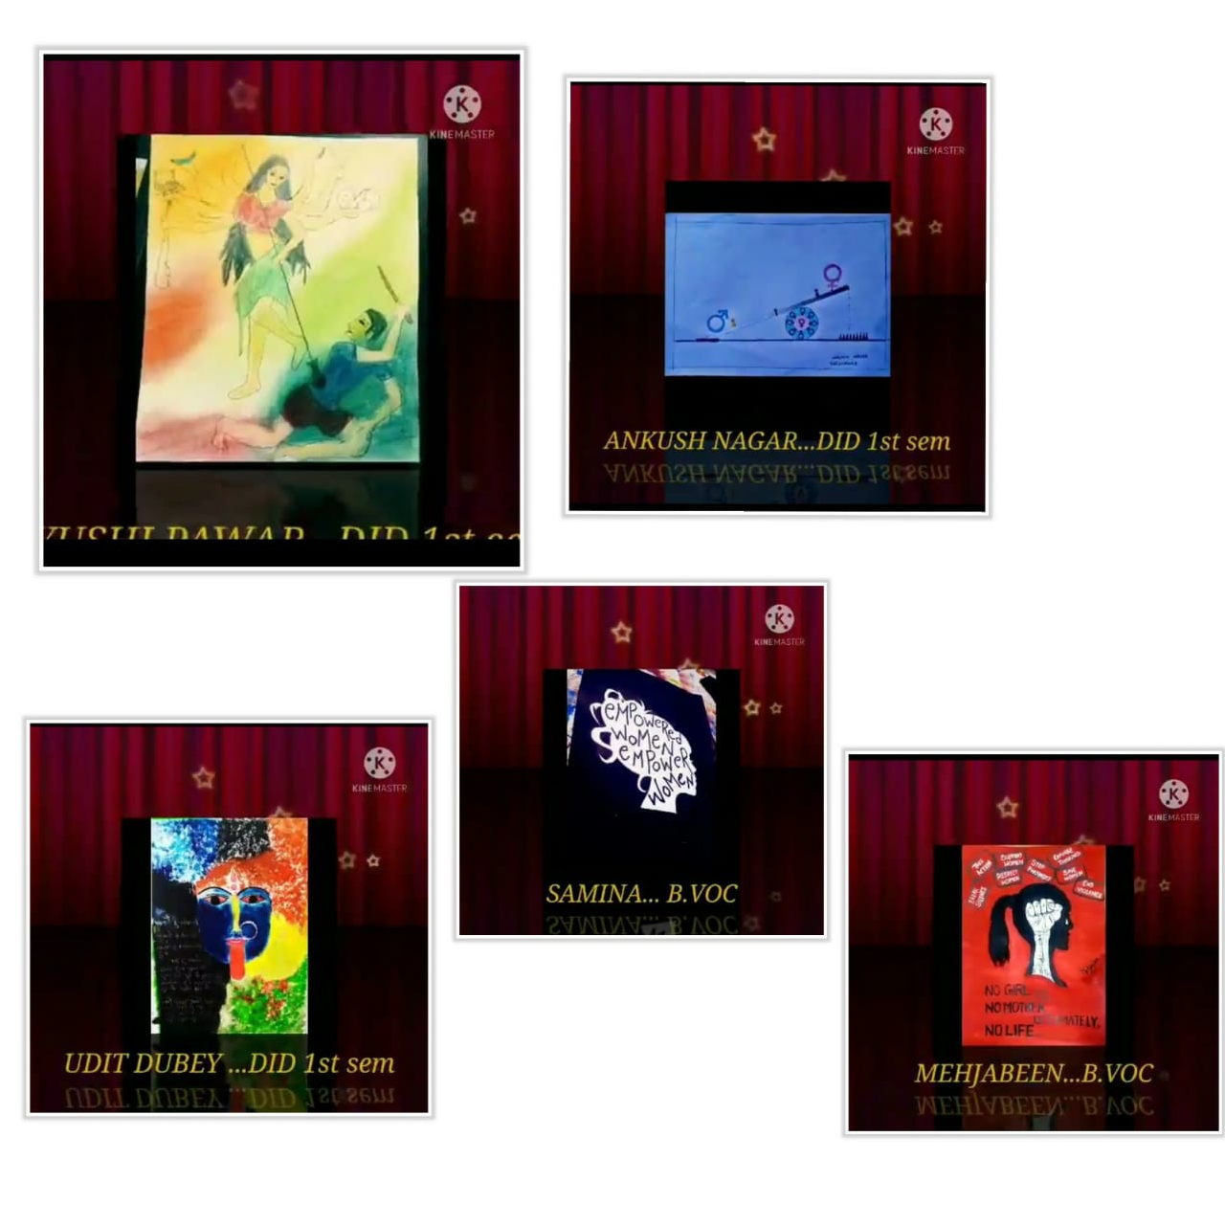

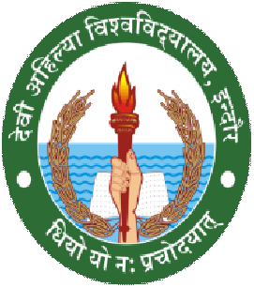
REPORT -03

DEVI AHILYA VISHWAVIDYALAYA, INDORE
DEPARTMENT OF LIFE LONGLEARNING

SESSION -2020-2021

Dr. Bharti Joshi
Head

POSTER MAKING COMPETITION

WOMENS EMPOWERMENT IN CURRENT SCENARIO

DATE | TIME | PLATFORM | NO.OF.PARTICIPAN TS | Convener
8 MARCH 2021 | 05:30 to  6:30 | dolllcompetition @gmail.com | 14 ( Department level) | Mona Dharamsey

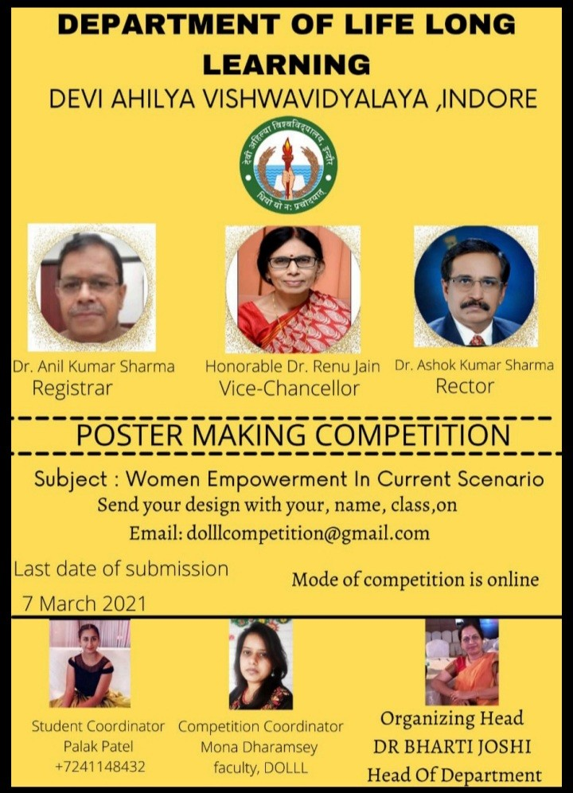

INSTRUCTIONS ARE:
- Drawing /painting must be on white sheet of A3 size
- The theme should be main focus of the poster
- Last day of submission 7 March 2021
- Scoring will be done on the basis of neat and clear work with creative ideas of poster making.
REGISTRATION IS DONE ON:
Google form: https://suveyheart.com/form/60377bdf18ae2311880e6c3b
DESIGN WITH PDF IS SEND ON EMAIL: dolllcompetition@gmail.com
Women Empowerment is the process of empowering women. This can be defined to promoting WOMEN’S sense of self-worth,their ability to determine their own choices,and their right to influence social change for themselves and others…..

PRESENTING POSTERS BY COMPETITORS
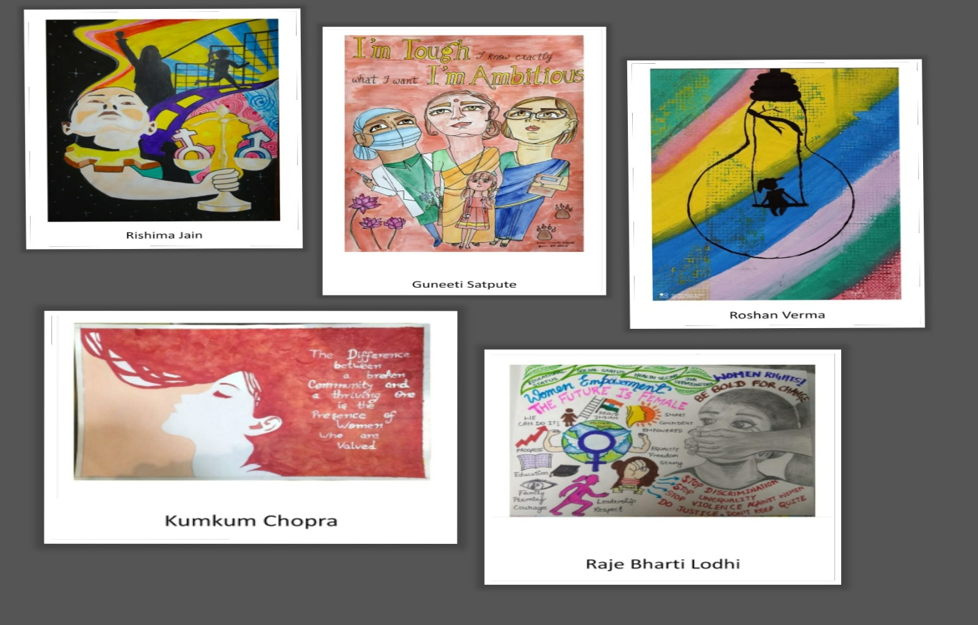

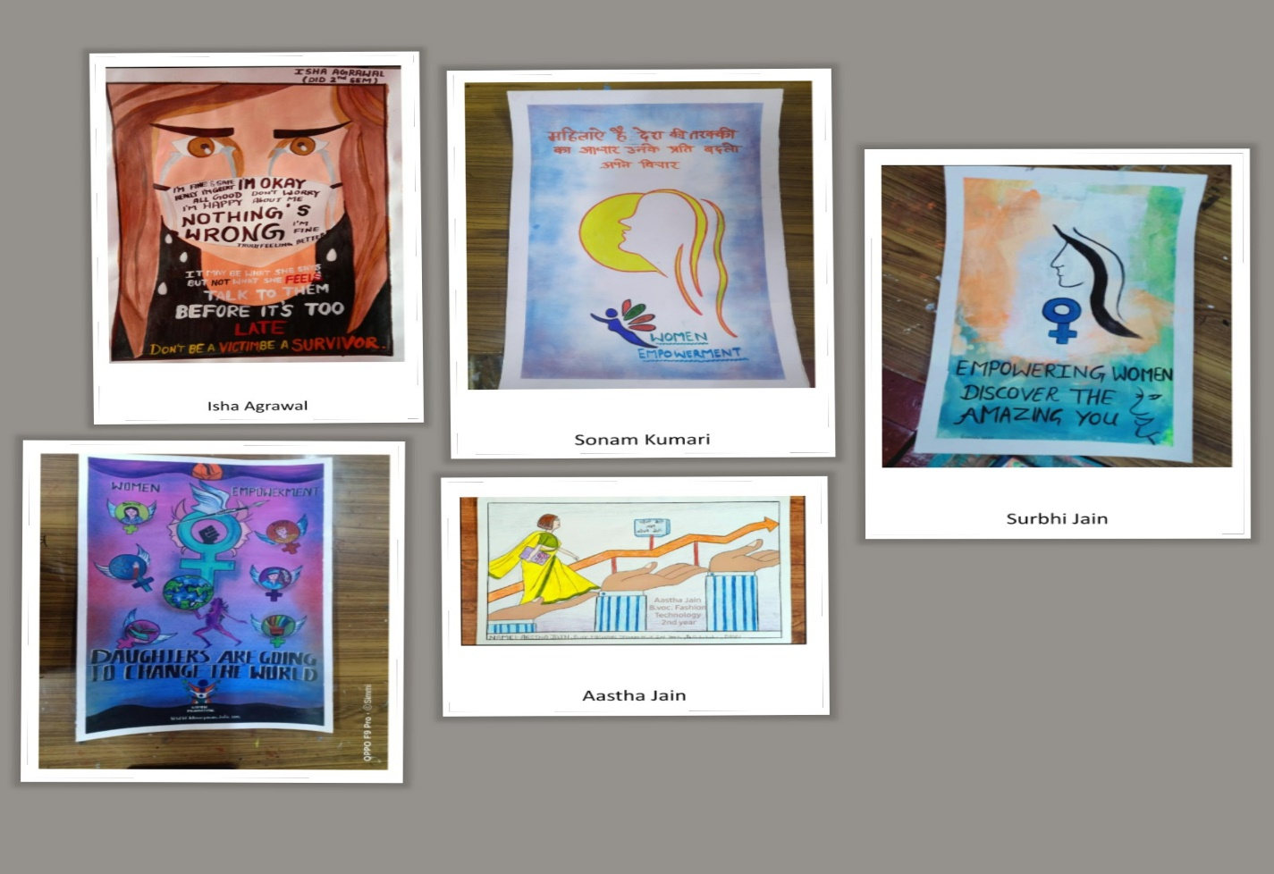

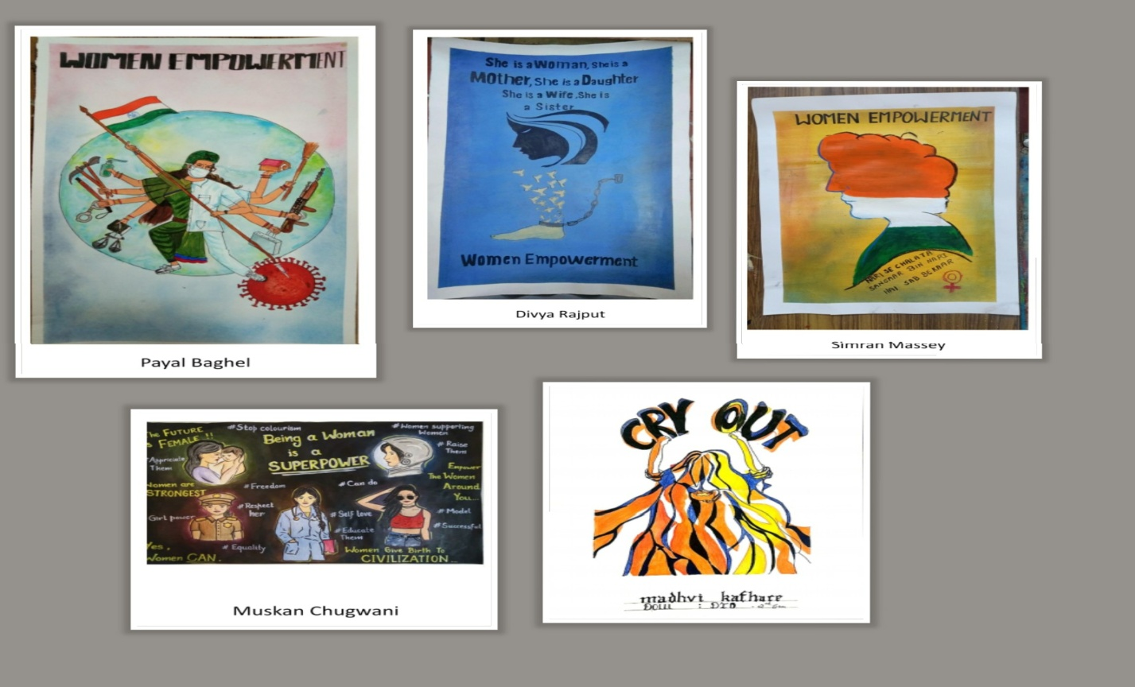

Date: 07/03/2021

Institute of Engineering and Technology
DAVV
International Women’s Day
8th March 2021
This International Women’s Day, National Service Scheme (NSS), IET DAVV organized an interactive webinar on “Redefining Women Empowerment.” Our guest speaker Dr. Sameera Nayeem, Divisional Coordinator of the MP Rajya Anand Sansathan, was introduced by Dr. Pragya Shukla. She then engaged in conversation with students and faculty members that enriched everyone. The program commenced with Ganesh Vandana and was followed by a speech by Dr Sanjiv Tokekar, Director IET. A student-curated video on Women empowerment was played for the audience.

The congregation learned about the reason behind Women’s Day Celebration, women’s education, and its benefits to society. Close to the end of the webinar, students and faculty shared individual opinions, thoughts, and ideas. A concluding speech by Dr. Bhawana Nigam marked the end of the program.

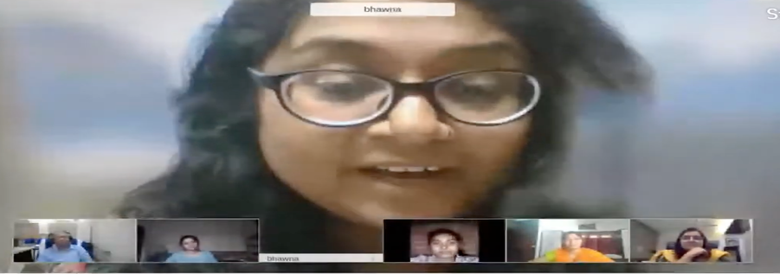
Figure 1: Institute of Engineering and Technology

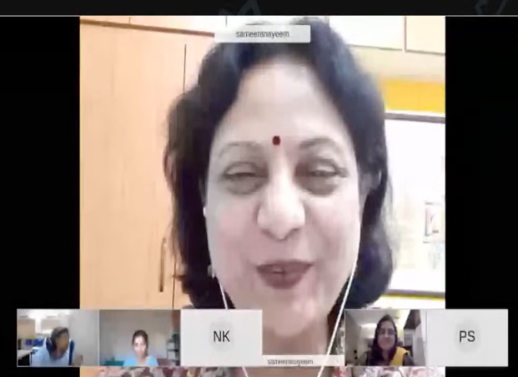
Figure 2: Institute of Engineering and Technology

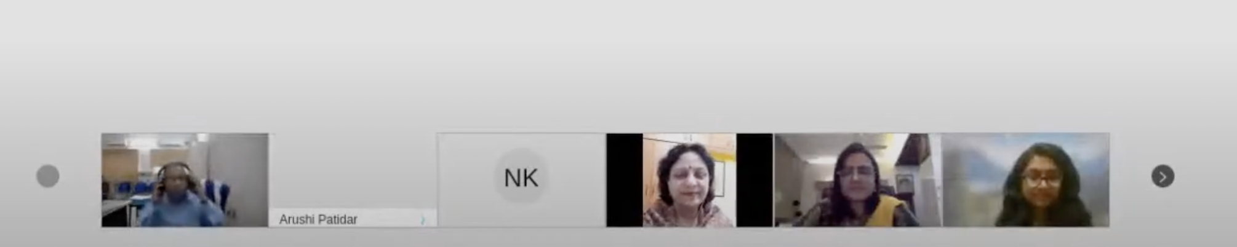
Figure 3: Institute of Engineering and Technology

Girls Common Room

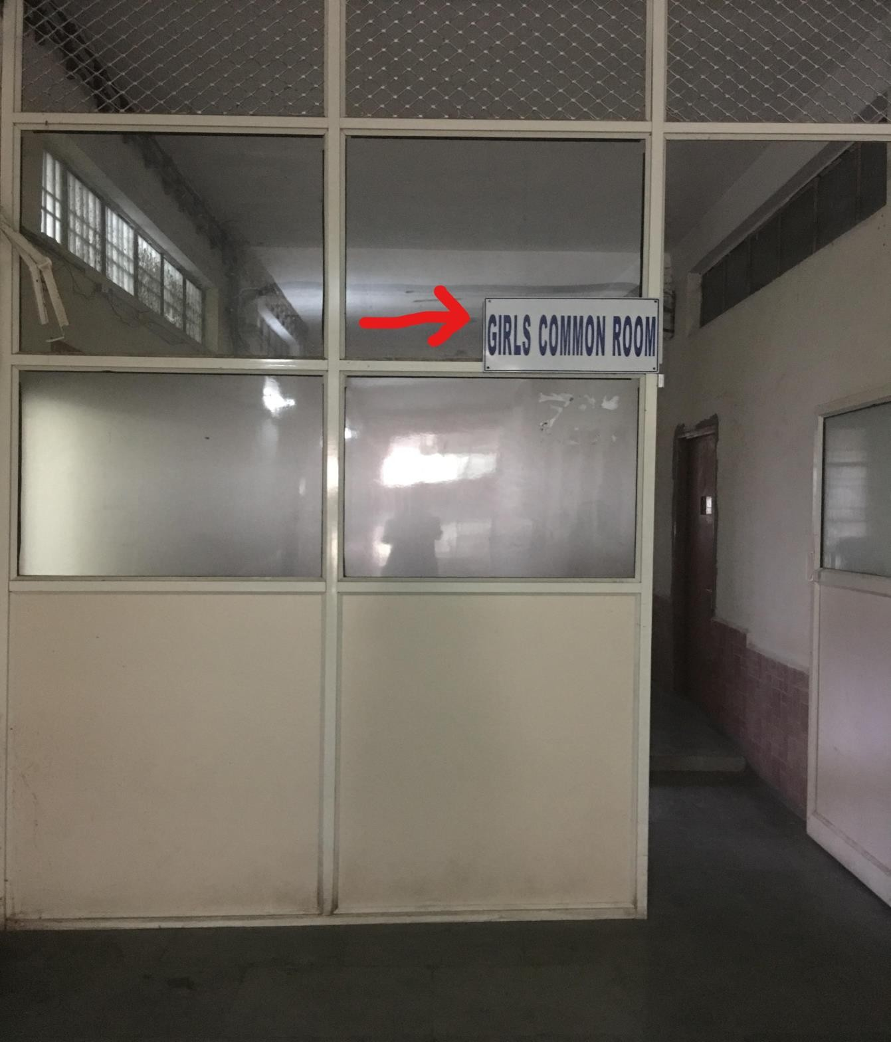
Figure 4: International Institute of Professional Studies

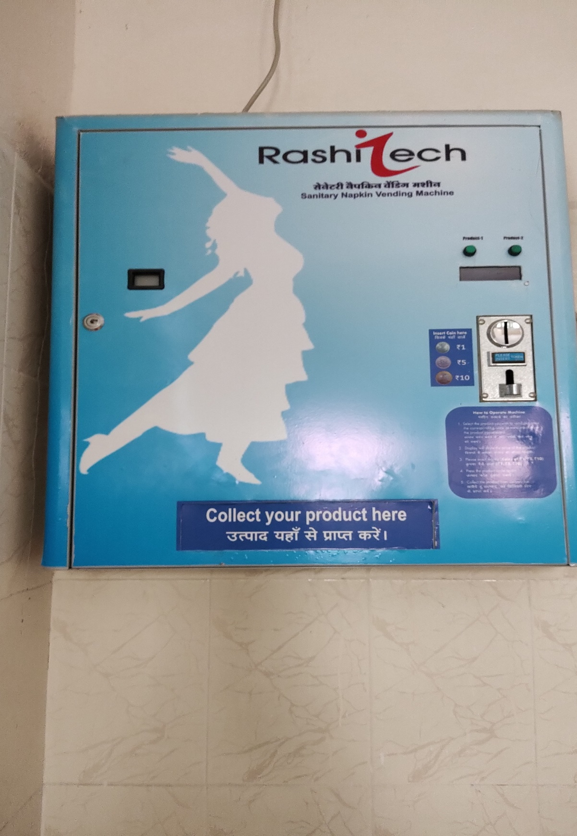
Figure 5: School of Economics

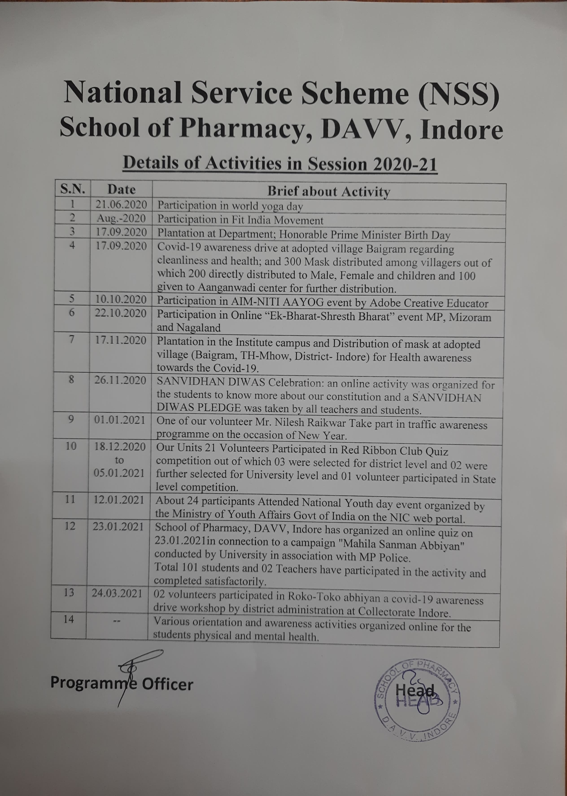
Figure 6: School of Pharmacy

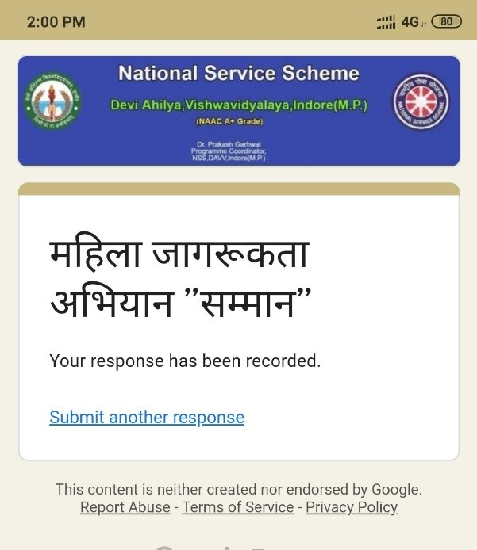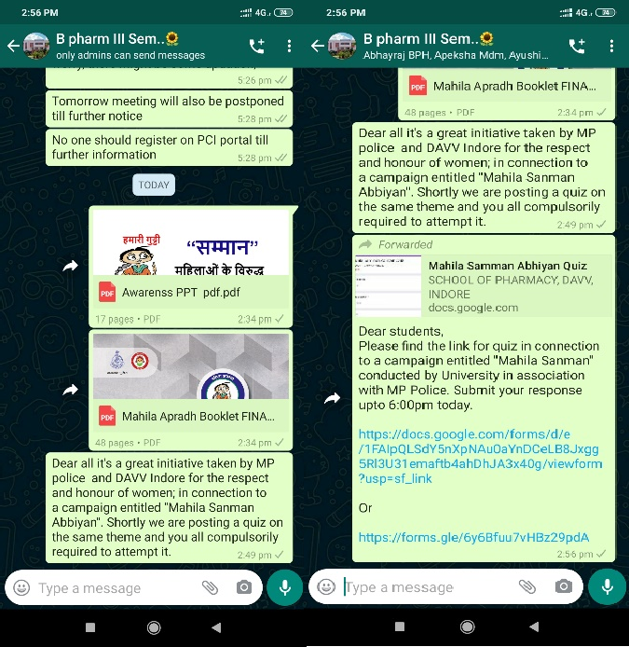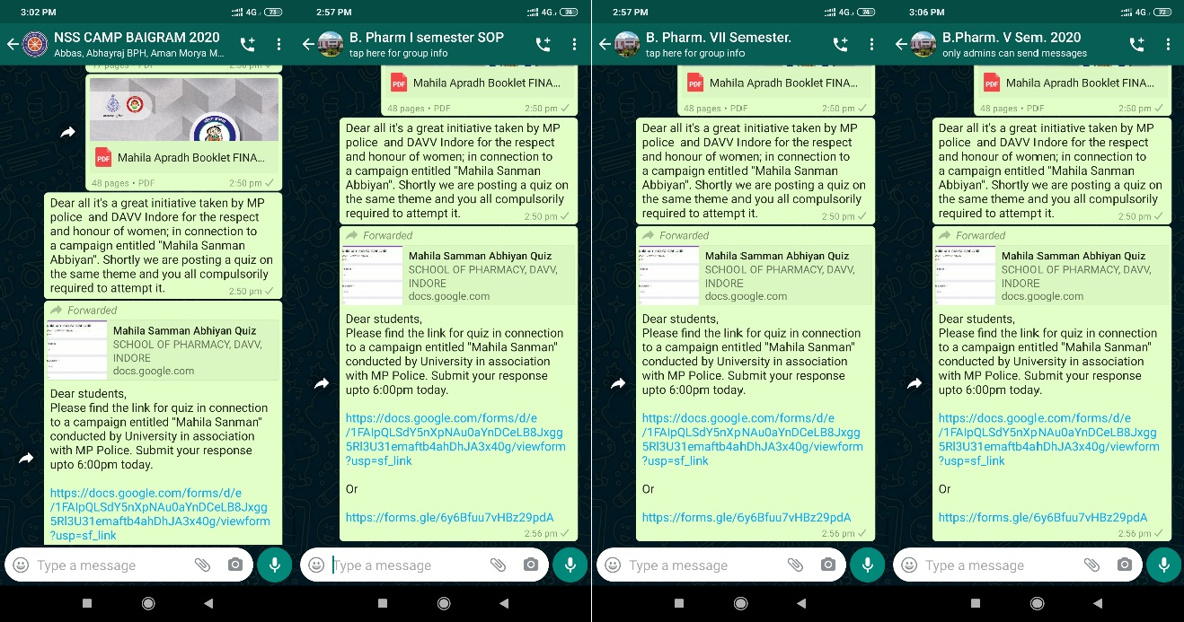
Figure 7: School of Pharmacy
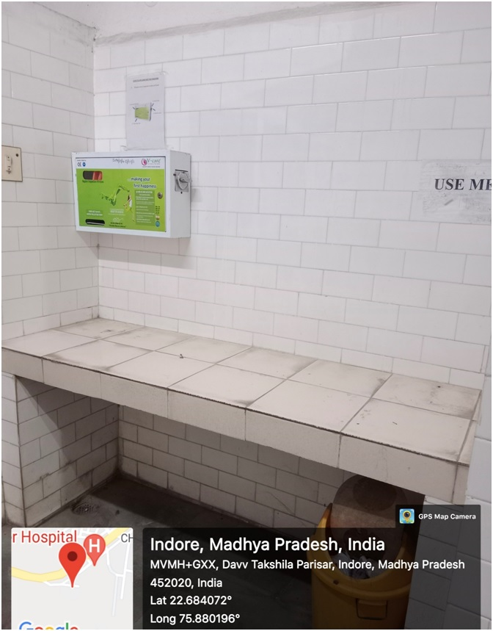
Figure 8: School of Pharmacy

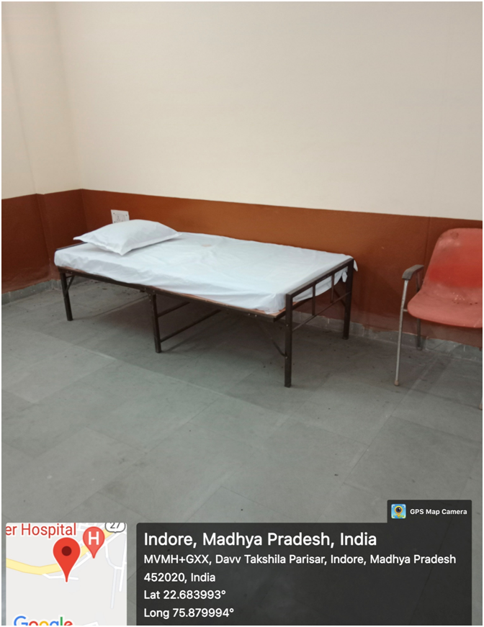

Figure 9: School of Pharmacy

