**Brief Report**

In remembrance of Indian Mathematics genius Srinivasa Ramanujan, the Applied Sciences Department, Institute of Engineering & Technology, Devi Ahilya Vishwavidyalaya organized an online popular Lecture by an eminent expert **Prof. Rajeeva Laxman Karandikar** on the topic **"Role of Statistics in the era of Big Data and Analytics”** on 6 Jan. 2021 at 4:00 pm on Webex.

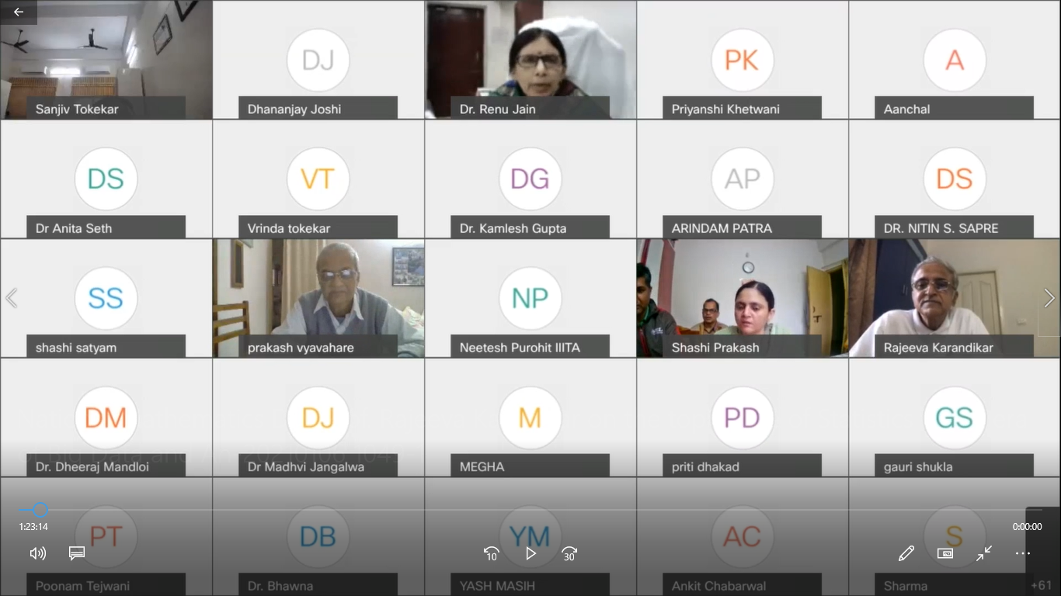 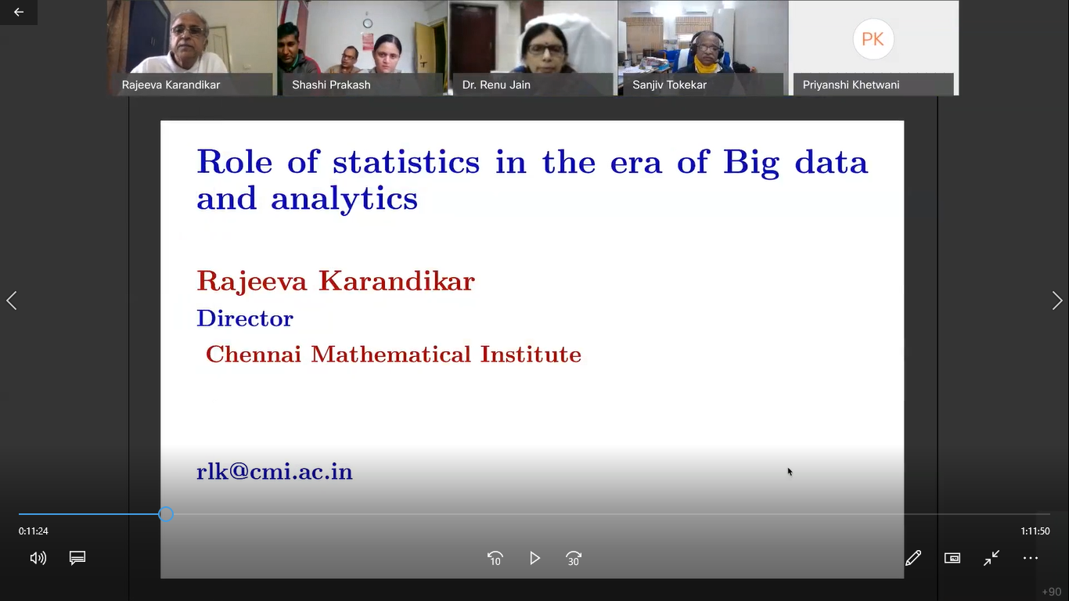

Prof. Rajeeva Laxman Karandikar is a well-known Mathematician, Statistician and a Psephologist. He is a winner of many awards including the most prestigious **Shanti Swarup Bhatnagar award** (1999).

The theme of his lecture was that a statistical model is an important part of the data interpretation exercise. A model gives us the right frame of reference to interpret the data. Ignoring well studied and well documented statistical ideas can lead to erroneous conclusions. Knowing how data is collected helps in determining if the proposed analysis is ignoring a variable important for drawing conclusions. It is important to have domain knowledge and build good models. Also, interaction with the experts in the domain and incorporating their views is a must in the model. He took interesting examples to explain this.

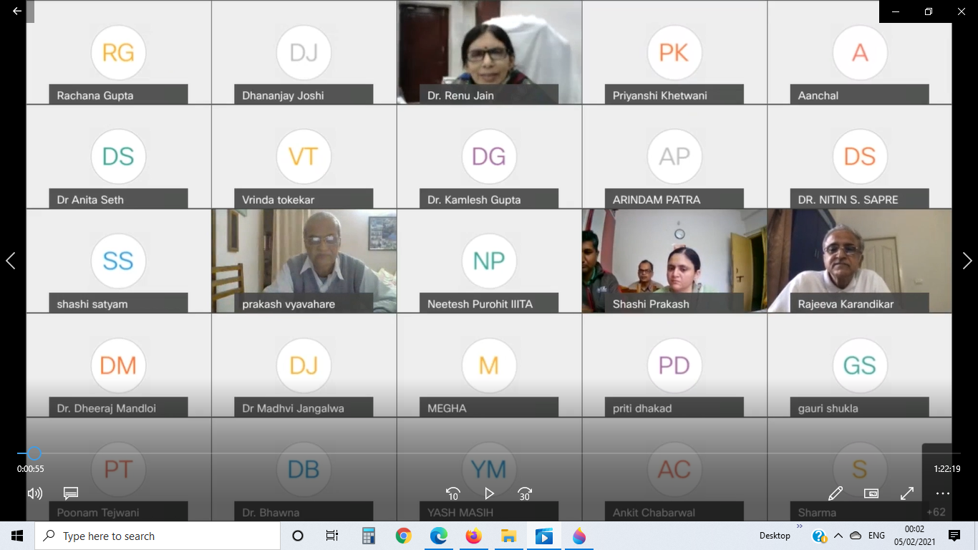 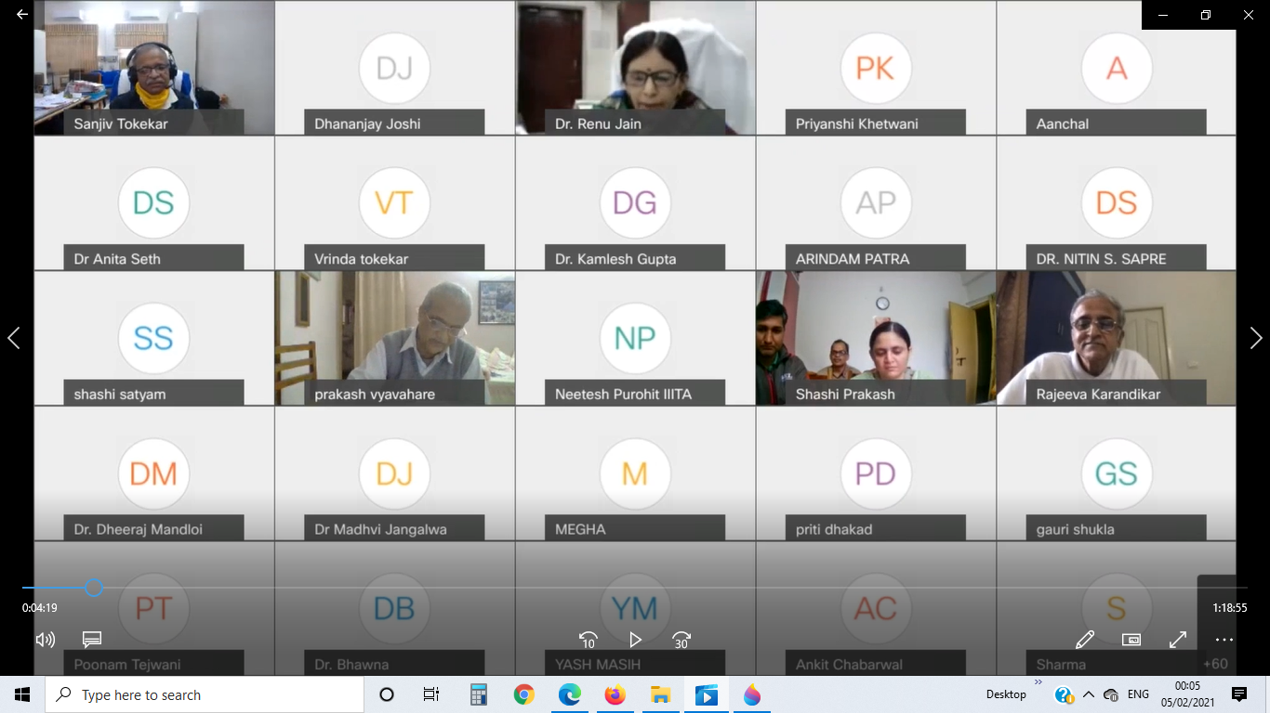 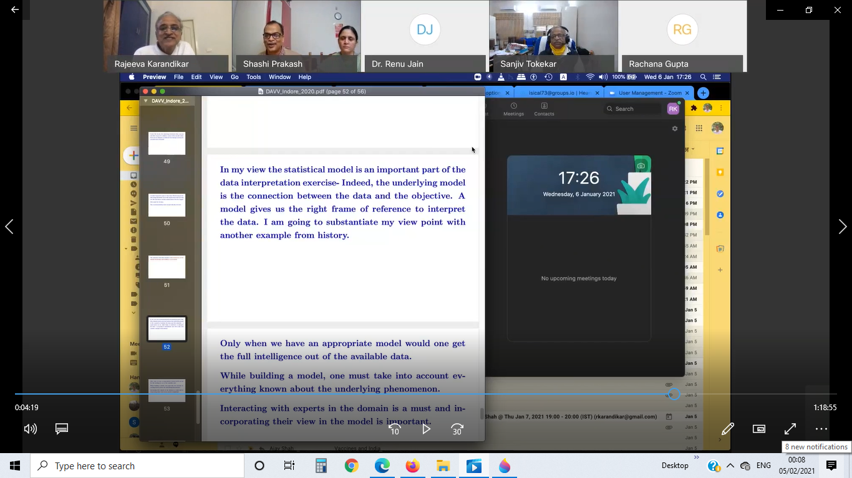

The session was chaired by Honarable Vice-Chancellor Dr. Renu Jain. Other than the Director of the Institute Dr. Sanjiv Tokekar and the Head of Department Applied Sciences Dr. Shashi Prakash, more than 90 faculty members of the Institute, UTD Departments and other colleges, special guests, dignitaries and students also joined the program.

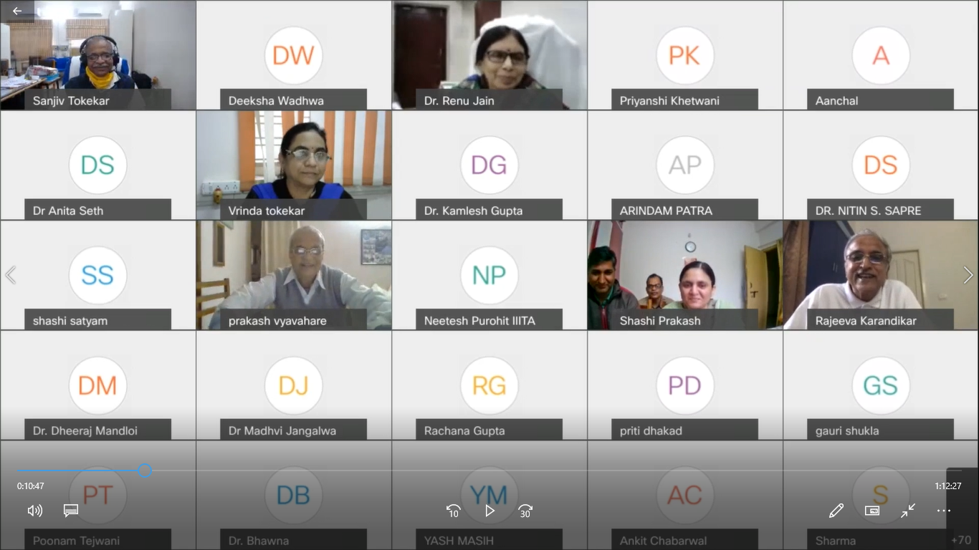 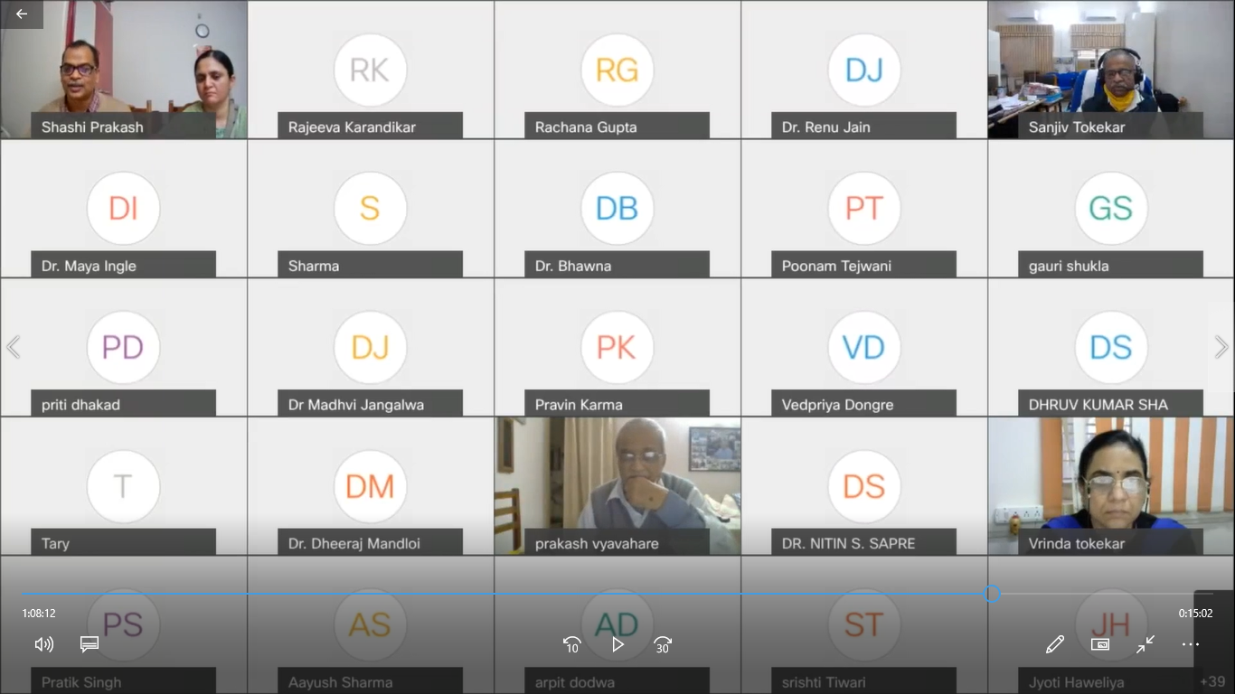

Also on the occasion of Mathematics day on 22nd Dec 2020, an online poster presentation on **‘Life and contributions of Srinivasa Ramanujan’** and online quiz of general interest/awareness based on the subject of Mathematics was organized by the department of Applied Sciences. Winners names were announced before the expert lecture.

The organizing team included Dr. Sufia Aziz, Dr. Rohit Pathak, Dr. Rachana Gupta and Dr. Chandrashekhar Chauhan of Applied Sciences Department.