Guru Poornima Mahotsav
Guru Poornima Mahotsav was celebrated on 10/7/2017. On this occasion Plantation was done in the nearby garden.
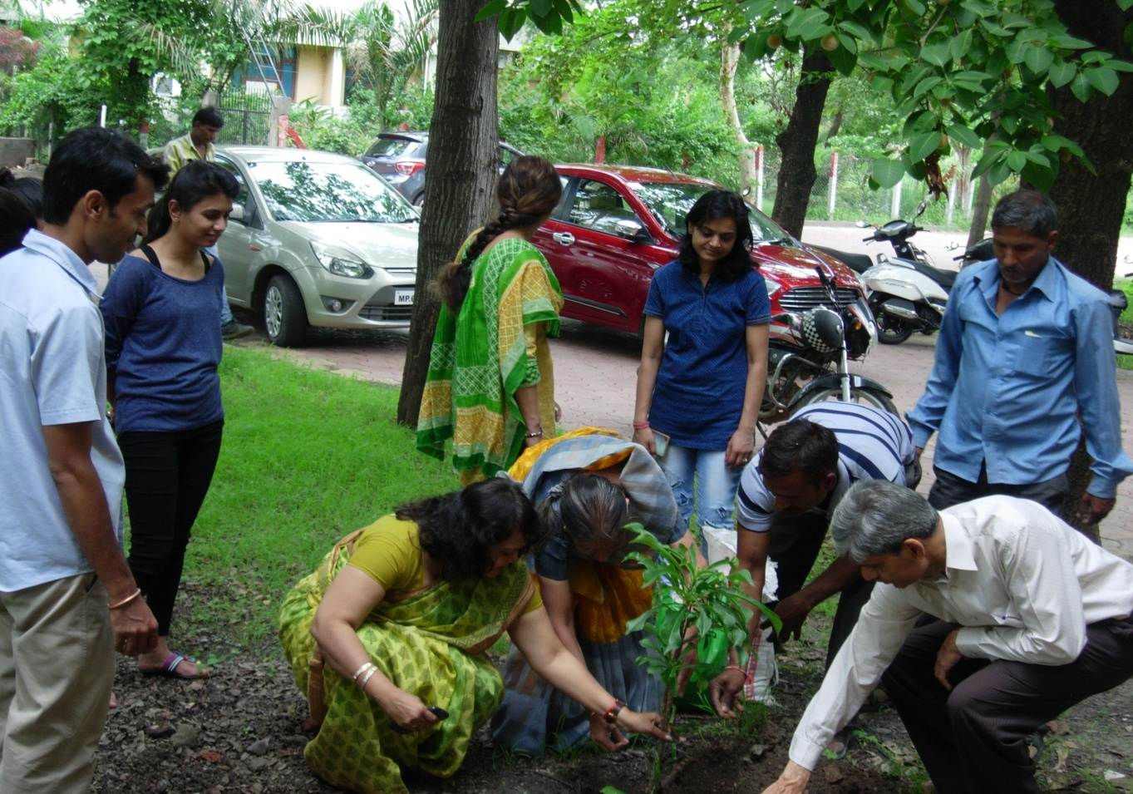

Teachers Day Celebration
Teachers’ day was celebrated on 5/9/2017. Students organized a brief cultural program in the honor of teachers.
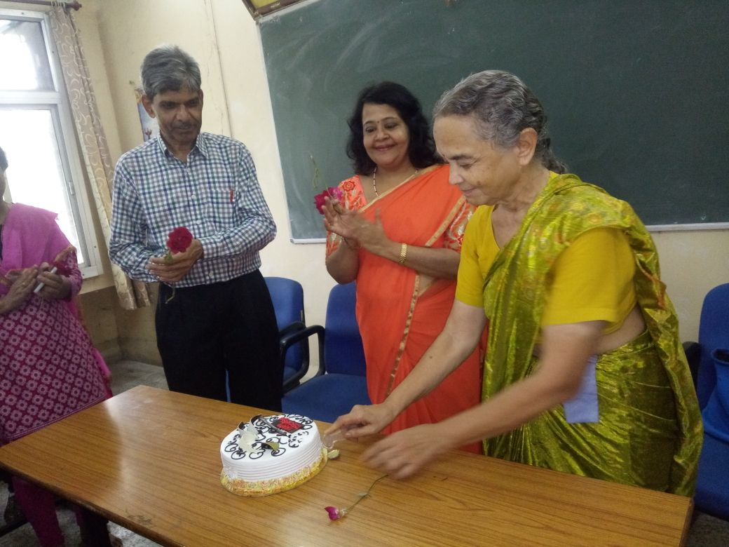

Students’ Election Activities
Students’ Election was held in Devi Ahilya Vishwavidyalaya between 23-30 Oct 2017.
Class Representatives of M.Sc. I and III semesters were nominated.
Sem I – S. Priyanka Sem III – Arshiya Khan

Students’ Participation in GIAN
Global Institute of Academic Network (GIAN) was organized by IIT, Indore.
Thirty two students participated in GIAN Program titled “How Next Generation Sequencing (NGS) is Untying the Knots in Viral Pathogenesis” held at IIT, Indore
from 23rd – 30th Oct 2017.

Dr. Meeta Jain attended World Environment Congress
Dr. Meeta Jain attended World Environment Congress (3rd World Research Journals Congress) held at Banglore on 10-12 Jan 2018, chaired one session and obtained Best Presentation Award titled “Salt stress induced effects on biochemical parameters in etiolated maize leaf segments during greening”

Health cards for Students of the department
Health cards for Students of the department were prepared at Health Center, DAV, Indore on 22.3.2018.

Three day Workshop on “Practical Experiences of Meditation”
Three day Workshop on “Practical Experiences of Meditation” in collaboration with Heartfulness Institute was held on 19, 20 and 21 April 2018 at 4.00 PM in School of Biochemistry, DAVV, Indore. The distinguished trainers were;

- Dr. P. W. Dandekar, Senior Faculty in Electronics, Heartfulness Practitionar.
- Dr. Nitin Sharma, Cardio Anaesthetist at Choithram Hospital, Indore.
- Mr. Rajesh Raverkar.

