**Minutes of the Meeting_September 2021**

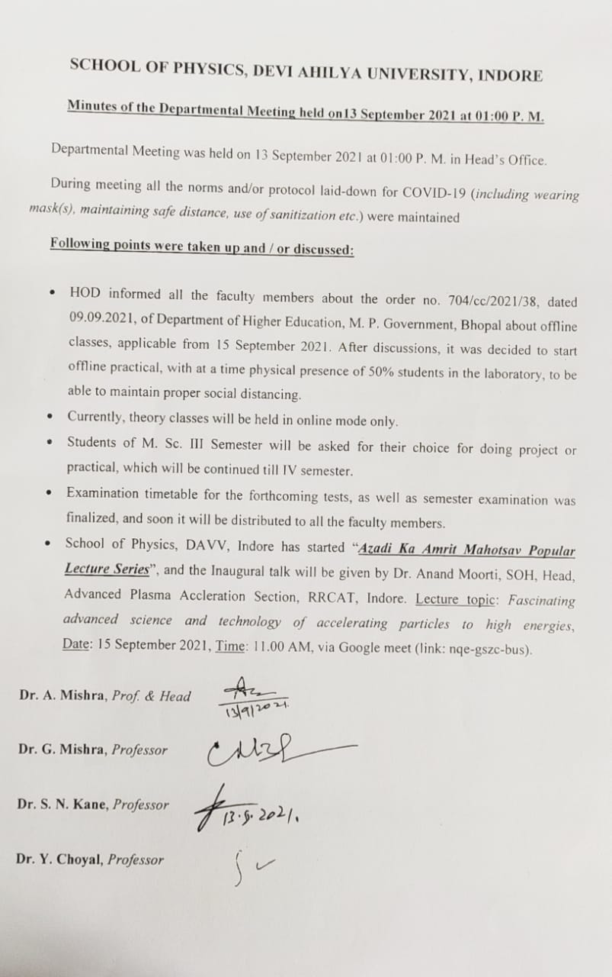

**Online Organized Guest Lecture**

1. **Guest Lecture organized by School of Physics on 15 Sep 2021 (75th Azadi ka Amrit Mahotsav)_coordinator Prof. (Dr.) G. Mishra**

**Invited Speaker**: **Dr. Anand Moorti**, SOH, Head, Advanced Plasma Acceleration Section, RRCAT, Indore.

**Title of the talk**: *Fascinating advanced science and technology of accelerating particles to high energies.*

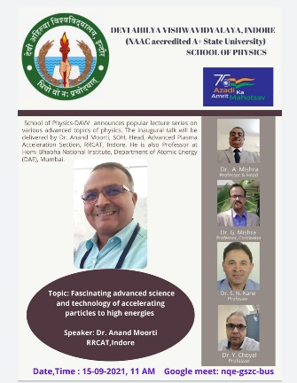

1. **Guest Lecture organized by School of Physics on 18 Sep 2021 (75th Azadi ka Amrit Mahotsav)_coordinator Prof. (Dr.) Y. Choyal**

**Invited Speakers**:

1**. Dr. Kailash Sati**, Scientists F (Associate Director) Center for High Energy Science and Systems (CHESS) Hyderabad DRDO, Ministry of Defense.

**Title of the talk**: Defense Applications of Lasers.

1. **Dr. Sandeep Maity,** Chief Scientist (Sensor and Analytics) GE/ Baker Hughes, 70+ patents

**Title of the talk**: Photonics: Industrial 4.0 perspective and outlook.

1. **Shri Anant Deshpande**, Director and owner, Trokut solutions Pvt Ltd, Mumbai

**Title of the talk:** Industrial laser market scenario in India.

1. **Dr. Mukesh Javeria**, Sr. Scientist and Assist. Professor (AcSIR), National Physical Laboratory, New Delhi.

**Title of the talk:** Careers in Physics.

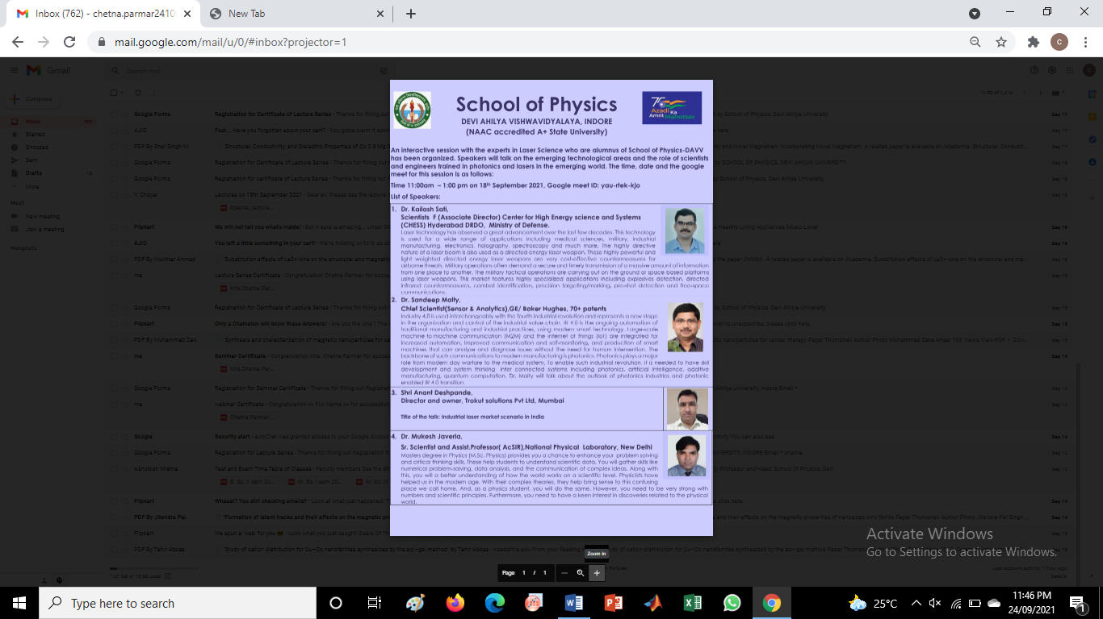

1. **Guest Lecture organized by School of Physics on 09 Oct 2021 (75th Azadi ka Amrit Mahotsav)_coordinator Prof. (Dr.) S. N. Kane**

**Invited Speakers**:

1. **Shri Shesh Nath Singh,** SOH, Head, Accelerator Magnet Technology Division (AMTD) Raja Ramanna Centre for Advanced Technology (RRCAT), Indore

**Title of the talk**: Power Power Everywhere

**2. Dr. Kailash Ruwali, SOG**, Accelerator Magnet Technology Division (AMTD) Raja Ramanna Centre for Advanced Technology (RRCAT), Indore

**Title of the talk**: Magnets for Accelerators.

