Ldwy vkWQ lks'ky lkbZal

**nsoh vfgY;k fo'ofo|ky;]bUnkSj**

**twu 2015 dk okf"kZd izfrosnu**

1- v/;;u'kkyk dk uke - Ldwy vkWQ lks'ky lkbZal

2- स्थापना वर्ष - 1989

3 foHkkxk/;{k dk uke - izks- dUgS;k vkgwtk

4 कोर्स कोऑर्डिनेटर - डॉ ज्योति शर्मा

4. फ़ोन नंबर - 0731-2362150, 0731-2362140

5. ई मेल - [soss.davv@gmail.com](mailto:soss.davv@gmail.com)

|  |  |  |  |
| --- | --- | --- | --- |
| स क्र | संचालित पाठ्यक्रम का नाम | पाठ्यक्रम प्रारम्भ वर्ष | स्वीकृत सीट |
| a | स्नातक (BSW) | 2007 | 60 |
| b | स्नातकोत्तर(MSW) | 2004 | 60 |
| c | एम्. फिल |  |  |
| 1 | समाजशास्त्र | 1989 | 20 |
| 2 | समाज कार्य | 1989 | 20 |
| 3 | राजनीतिविज्ञान | 1989 | 20 |
| 4 | इतिहास | 1989 | 20 |
| 5 | गृह विज्ञान | 1989 | 20 |
| 6 | भूगोल | 1989 | 20 |
| 7 | मनोविज्ञान | 1989 | 20 |
| d | पी. एच. डी. | 1989 |  |
| 1 | समाजशास्त्र |  |  |
| 2 | समाज कार्य |  |  |
| 3 | राजनीतिविज्ञान |  |  |
| 4 | इतिहास |  |  |
| 5 | गृह विज्ञान |  |  |
| 6 | भूगोल |  |  |
| 7 | मनोविज्ञान |  |  |
| 8 | मिलिट्री साइंस |  |  |

अकादमिक वर्ष (2016-17) में विभाग/ संस्थान / अध्ययनशाला में विद्यार्थियो की संख्या

|  |  |  |  |
| --- | --- | --- | --- |
| पाठ्यक्रम | पाठ्यक्रम संख्या | कुल विद्यार्थीओ की संख्या | उत्तीर्ण विद्यार्थिओं की संख्या |
| स्नातक (BSW) | 1 | Nil | 11 |
| स्नातकोत्तर | 1 |  | 39 |
| (MSW II) |  | 17 |  |
| (MSW IV) |  | 27 |  |
| एम्. फिल | 7 |  |  |
| समाजशास्त्र |  | 05 | 16 |
| समाज कार्य |  | 08 | 18 |
| राजनीतिविज्ञान |  | 10 | 20 |
| इतिहास |  | 09 | 13 |
| गृह विज्ञान |  | 06 | 10 |
| भूगोल |  | - | 13 |
| पी. एच डी | 8 |  |  |
| सर्टिफिकेट कोर्स |  |  |  |
| डिप्लोमा |  |  |  |
| पी जी डिप्लोमा गाइडेंस एन्ड काउंसलिंग |  | 11 | - |
| अन्य कोई पाठ्यक्रम |  |  |  |

अकादमिक वर्ष (2016-17) में विभाग/ संस्थान / अध्ययनशाला में प्रवेशित विद्यार्थियो की संख्या 30 जून 2017 तक:

|  |  |  |  |  |  |  |  |  |  |  |  |  |  |
| --- | --- | --- | --- | --- | --- | --- | --- | --- | --- | --- | --- | --- | --- |
| पाठ्यक्रम | सेमे /वर्ष | सामान्य वर्ग | | अजा | | अजजा | | अपिव | | एन आर आई | | कुल संख्या | |
|  |  | छात्र | छात्रा | छात्र | छात्रा | छात्र | छात्रा | छात्र | छात्रा | छात्र | छात्रा | छात्र | छात्रा |
| MSW | 2016-18 | 01 | 05 | 01 | 01 | 03 | 02 | 01 | 03 | - | - | 06 | 11 |
| P. G. Diploma Guidance & Counseling | 2016-17 | 3 | 8 | - | - | - | - | - | - | - | - | 3 | 8 |

वर्ष (2016-17 ) में विभाग / संस्थान / अध्ययनशाला में शिक्षकों की संख्या ३० जून, २०१७ की स्थिति में :

|  |  |  |  |  |  |  |  |  |  |  |  |  |
| --- | --- | --- | --- | --- | --- | --- | --- | --- | --- | --- | --- | --- |
| शिक्षक | सामान्य वर्ग | | अजा | | अजजा | | अपिव | | एन आर आई | | कुल संख्या | |
|  | पु | म | पु | म | पु | म | पु | म | पु | म | पु | म |
| व्याख्याता / सहायक प्राध्यापक | - | - | - | - | - | - | - | - | - | - | - | - |
| रीडर / एसोसिएट प्रोफेसर | - | - | - | - | - | - | - | - | - | - | - | - |
| आचार्य | - | - | - | - | - | - | - | - | - | - | - | - |
| संविदा शिक्षक | - | - | - | - | - | - | - | - | - | - | - | - |
| अतिथि शिक्षक | 1 | 5 | - | - | - | - | - | 1 | - | - | - | - |
| कुल | 1 | 5 | - | - | - | - | - | 1 | - | - | - | - |

विभाग/ संस्थान / अध्ययनशाला द्वारा प्रकाशन एवं अकादमिक गतिविधियाँ वर्ष (2016-17) 30 जून की स्थिति में:

foHkkxk/;{k izks- dUgS;k vkgwtk

**Contribution of Dr. Kanhaiya Ahuja (2016-17)**

1. “***Development of Infrastructure and its impact on Economic Growth in M.P***.”, Journal of Madhya Pradesh Economic Association, ISSN- 2277-1123, Vol.XXVII, No.1, February 2017.
2. ***“Factors Affecting Demand for Health Insurance in Indore District”***, published in Unnayan, International Bulletin of Management and Economics, ISSN: 2349-6622, Volume VI, January 2017.
3. ***“Trends of Foreign Direct Investment in India”***“Unnayan” International Bulletin of Management and Economics, ISSN No.2349-7165, Vol. V, July 2016.
4. “***India Then and Now-A Conceptual Representation of the Past Present and The Probable Future”*** International Journal of Latest Engineering and Management Research (IJLEMR) ISSN: 2455-4847, Volume 02 - Issue 04, April 2017, PP. 69-70
5. Delivered a lectures on “ ***Sampling Techniques in Research***” in UGC SAP-DRS-I Level workshop on “ *Research Methodology and Quantitative Techniques in Physical Education and Sports”* organized by “ School of Physical Education”, DAVV, Indore on 06 March 2017.
6. Delivered a lecture as chief guest on “***Challenges of doing business in India*** “in the inaugural function of two day National Seminar on “*Issues, Opportunities and Challenges of Business in Fast Changing Scenario of Indian Economy*” organized by School of Studies in Economics, Jiwaji University, Gwalior on 19 March 2017.
7. Delivered a special lecture on “***Human Rights: Indian Perspectives***” in a National Workshop on “*Human Rights and Social Welfare*” organized by Shri Jain Diwakar Mahavidyalaya, Indore on 10 December 2016.
8. Presented a paper on “***Development of Infrastructure and its impact on Economic Growth***” in a two day XXVII Annual conference of Madhya Pradesh Economic Association, organized by School of Economics, DAVV, Indore on 17-18 February 2017.
9. Presented a paper on “***International Trade and Growth Dynamics in India***” in a two day International Seminar on *Globalization and Indian Economy: Issues and Challenges”*, organized under UGC-SAP DRS Phase-III, by School of Economics, DAVV, Indore on 17-18 February 2017.
10. Presented a paper on “***Trade Dynamics of India With BRICS***” in a two day International Seminar on *Globalization and Indian Economy: Issues and Challenges”*, organized by School of Economics, DAVV, Indore on 17-18 February 2017.
11. Delivered a keynote address on “***Strategies for Women Empowerment in India***” in a national seminar on “*Women Empowerment*” organized by “Development *Foundation* “Indore at IMS, DAVV, Indore on 5 March 2017.
12. Delivered a lectures on “***Research Techniques***” in a six day National Workshop (20-26 March 2017) on “Research *Methodology”* organized by “B.S. Govt College, Depalpur”, Indore on 24 March 2017.
13. Delivered a keynote lecture on “***Indian Economy since Independent***” during A workshop on “*Economic Issues in present Perspective*”, organized by “New GDC Govt. Girls College, Kila Maidan, Indore on 18 April 2017.
14. Delivered two lectures on “ ***Testing of Hypothesis and interpretation of Results***” in a three day orientation programme ( 21-22 December 2016) on “ *Research Methodology and Statistical Analysis in Social Sciences*”, organized by “ *National Institute of Public Cooperation and Child Development (Western Regional Centre), Indore*” on 23 December 2016.
15. Delivered a keynote address on “ ***Impact of Demonetization on Indian Economy***” in a national workshop on “*Impact of Demonetization and GST on Indian Economy*” organized by J.N.S. Government College, Shujalpur on 20 December 2016.
16. Delivered a keynote address on “***Development of Social Sector in India***” in a valedictory session of a two day national seminar (24-25 September 2016) on “Economic *Development through Social Sector*”, organized by Govt. P.G. College, Khargone, (M.P.) on 25 September 2016.
17. Delivered two lectures on “***Sampling Techniques in Social Science Research*** “ and ***“Inferential Statistics and Testing of Hypothesis*** “ in a ten day Research Methodology Workshop sponsored by ICSSR, New Delhi, organized by Department of Economics, Guru Ghasidas Vishwaviyalaya ( A Central University) , Bilaspur on 9 March 2017.
18. Delivered two lectures on “***Testing of Hypothesis*** “ and ***“Measurement of Correlation in***  **Quantitative Analysis**“ in a ten day Research Methodology Training Programme for Ph.D. scholars in Social Sciences (13-22 June 2017) sponsored by ICSSR, New Delhi, organized by M.P. Institute of Social Science Research (MPICSSR), Ujjain on 14 June 2017.
19. Delivered two lectures on “***Testing of Hypothesis*** “and ***“Measurement Issues in Quantitative Analysis*** “in a Workshop on “Research Methodology and Data Analysis” from November 21 to 25, 2016 sponsored by Rajya Shiksha Kendra, Government of Madhya Pradesh, organized by M.P. Institute of Social Science Research (MPICSSR), Ujjain on 22 November 2016.
20. Delivered a keynote address on “***Sustainable Development in India***” in a seminar on “*Challenges of Sustainable Development with special reference to women empowerment*”, organized by “Development *Foundation* “Indore at Holkar Gyan Mandalapam, Khel Prasaal Parishar, Indore on 13 May 2017.
21. Delivered two lectures on “***Composite Index in Research*** “ and ***“Quantitative Techniques in Research***“ in a ten day Research Methodology Programme for Ph.D. scholars in Social Sciences (20-29 March 2017) sponsored by ICSSR, New Delhi, organized by Department of Economics, Indira Gandhi National Tribal University ( A Central University), Amarkantak (M.P.) on 20 March 2017.
22. Delivered two lectures on “***Descriptive Statistics****,* “ and ***“Inferential Statistics and Testing of Hypothesis*** “ in a ten day Research Methodology Training Course for Ph.D. Scholars in Social Science, sponsored by ICSSR, New Delhi, organized by Department of Economics, A.P.S. University, Rewa, on 31 August 2016.
23. Delivered a Lecture as “Session Chair” on ***“Global Competitiveness and Indian Economy***” in the Technical Session during Eleventh International Conference (February 4-5, 2017), organized by “*Prestige Institute of Management and Research”, Indore* on the theme **"***Developing Skills and Competencies for Global Competitiveness***"** on 4 February 2017.
24. Delivered two lectures on “**Sampling Techniques in Research”** and “**Inferential Statistics and Testing of Hypothesis”** **in** a “UGC Short Term Course in Research Methodology*”* organized by “UGC-Human Resource Development Centre”, DAVV at Saint Paul College, Indore, on 4 May 2017.
25. Delivered two lectures on “**Indian Economy: A Journey Since Independence” and “Balance of Payments and Policy Implications”** in a “UGC Refresher Programme*”* organized by “UGC-Human Resource Development Centre”, DAVV at BSS, Bhopal on 19 May 2017.
26. Delivered two lectures on “**Sampling Methods in Research” and** “**Testing of Hypothesis”** in a “UGC Orientation Programme” organized by “UGC-Human Resource Development Centre”, DAVV at Saint Paul College, Indore, on 30-31 May 2017 respectively.

कोर्स कोऑर्डिनेटर - डॉ ज्योति शर्मा 2016-2017

1. **(i) Published Papers in Journals**

|  |  |  |  |
| --- | --- | --- | --- |
| **S.No.** | **Paper Title with Page No.** | **Journal Name** | **ISSN**  **No.** |
| 1 | A study of impact of Emotional Intelligence on Team Work  ( 40-45) | Indo Global Journal of Applied Management Science  Vol 4, Issue 1, Mar 2016  Impact factor 1.235 | ISSN-2320-7892 |
| 2 | Impact of Communication and Feedback on employee participation  ( 46-50) | Indo Global Journal of Commerce and Economics  Vol 3, Issue 1, April 2016  Impact factor 1.098 | ISSN-2329-9796 |
| 3 | An Association between Academician’s Job Satisfaction and selected Demographic Characteristics  ( 213-222) | International Journal of Research in IT & Management Volume 6, Issue 3 (March, 2016) (IMPACT FACTOR – 5.96) <http://www.euroasiapub.org> | (ISSN 2231-4334) |
| 4 | An Empirical Analysis of Job Satisfaction and Effective Time Utilization in Higher Education  (234-361 ) | International Journal of Research in Economics and Social Sciences Volume 6, Issue 2 (February, 2016) (IMPACT FACTOR – 5.545) | (ISSN 2249-7382) |
| 5 | Influence of Academician’s Satisfaction towards Organization Policy on Time Utilization Efficiency in Higher Education  ( 234-264) | International Journal of Research in Economics and Social Sciences Volume 6, Issue 1 (January, 2016) (IMPACT FACTOR – 5.545) | (ISSN 2249-7382) |
| 6 | Women Entrepreneurship- Factors leading to Success of Women led Enterprise | Research Journal of Management Sciences  Vol.5(9),46-50,Sep (2016) | (E-ISSN 2319-1171) |

**(B) Ongoing and Completed Projects**

|  |  |  |  |  |
| --- | --- | --- | --- | --- |
| **S. No.** | **Title** | **Agency** | **Period** | **Grant Mobilized** |
| 1 | “A Study of Vocational Training on Women Empowerment of women :With Special reference to Low Income segment women of Indore | U.G.C.,  New Delhi. | 18 Months  Received on 2013  Ongoing | 358600/- |

**(C) Research Guidance**

|  |  |  |  |
| --- | --- | --- | --- |
| **Degree** | **Number Enrolled** | **Thesis Submitted** | **Degree awarded** |
| M.Phil | 3 | 3 (March 2016)  2 (March 2017) | Thesis Submitted |
| Ph. D | 6 | 01 | 6 |

**(D)Chapters published in Books**

|  |  |  |  |  |
| --- | --- | --- | --- | --- |
| **S.No.** | **Book** | **Chapter** | **Author/s** | **Publisher/ISBN** |
| 1 | Dynamism of Global ERA & Changing Management Practises | A Systematic Literature Review to Study Influence of Socio-Economic factors on Women Entrepreneurship | Dr. Anshu Bhati  Ms. Utkarsha Soni  Dr. Jyoti Sharma  2016 | Excellent Publications, Indore  ISBN-978-93-84935-99-3 |
| 2 | Make in India  Management’s Role & Perspectives | Impact of Entrepreneurship on Women’s Economic Empowerment in Rural Region of Indore | Dr. Jyoti Sharma  Ms. Utkarsha Soni  Feb 2017 | Shree Parasmani Publications,Indore  ISBN-978-93-8416-4997 |
| 3 | Transformation in Business Governance | A Study of relationship between Self Esteem and Managerial Effectiveness | Dr. Jyoti Sharma  Feb 2017 | Shroff Publications  Navi Mumbai  ISBN-978-93-5213-495-3 |

**Paper presented in Conferences, Seminars, Workshops, Symposia**

|  |  |  |  |  |  |
| --- | --- | --- | --- | --- | --- |
| **S. No.** | **Title of the paper presented** | **Title of Conference/ Seminar etc.** | **Date(s) of the event** | **Organized by** | **International/**  **National/**  **State** |
| 1 | A systematic Literature to study Influence of Socio-Economic Factors on Women Entrepreneurship | II National Conference on Dynamism of Global Era & Changing Management Practices | 12 May  2016 | Acropolis Institute of Management Studies & Research | National |
| 2 | To study the impact of Emotional Quotient among students (With reference to Post Graduate students of Social Work in Indore) | Transformation in Business Governance | ISBN-978-93-5213-495-3  Feb 2017 | Vishist School of Management,  Indore | International Conference |

**Invited Lectures and Chairmanships at national or International**

**conference/ seminar/ workshops etc.**

|  |  |  |  |  |
| --- | --- | --- | --- | --- |
| **S. No.** | **Title of The Lecture/Academic Session** | **Title Of Conference/ Seminar Etc.** | **Date(s) Of The Event** | **Organized By** |
| 1 | Session Chair in International Conference | Innovative Business Practices for Creating Vision in Global Era | 29 Dec 2015 | Acropolis Faculty of Management and Research,Indore |
| 2 | Invited as Guest Speaker by World Vision India- Indore Urban Development Program, Indore | GO-NG0-CSR  NGO Meet | 14 April 2016 | World Vision India- Indore Urban Development Program, Indore |

**Workshops conducted**

|  |  |  |  |  |
| --- | --- | --- | --- | --- |
| **S. No.** | **Role** | **Title of the Invited Lectures / Keynote Addresses’ / Workshops** | **Date(s) Of The Event** | **Organized By** |
| 1 | Resource Person | Skill development | 02 Jul 2016 | Shri Govindram Seksaria Institute of Technology & science (Mgmt Department) |

समाज विज्ञान अध्ययन शाला की महत्वपूर्ण गतिविधियाँ (2016-17)

**1. Teacher’s Day**

**Date:** 06 Sept 2016

**Topic:** Teachers day celebration

**Venue:** Department of social science

**Time:** 1:00 pm

Department of social science organized a programme for celebrating the teacher’s day on the 6th September. All the teachers and staff members of school of social science were invited. Some teachers of commerce department were also invited.

Prof. Kanhaiya Ahuja Head School of Social Science facilitate the activity and Dr. Jyoti Sharma, Dr. Varsha Patel, Mrs. Sarika Dixit helps in organising the activity. Mr. Arvind Parihar, Ms. Akanksha Tripathi, Mrs. Vasudha Jahangir and other faculty members and JRF students were present in the activity.

Students welcomed everyone and honoured them. Anchoring was done by Mr. Pankaj Salvi and Ms Gayatri Choudhary. First of all lamp lightening ceremony in front of goddess Saraswati was done by the head of the department Prof. Kanhaiya Ahuja sir and Dr. Jyoti Sharma. Kulgeet was played after the ceremony. Then a speech by Prof. Kanhaiya Ahuja sir and Dr. jyoti Sharma was given which made the day explicable. Followed by the speech games like musical chair race, color conflict games were conducted for the teachers by the students. After games a documentary on school of social science was presented by student. Followed by the documentary Ms Veethika Acharya gave a speech on the role of teacher in the life of student and some activities were also performed by the Students. Cake cutting ceremony was done by Prof. Kanhaiya Ahuja sir.

**शिक्षक दिवस**

**दिनांक:** 06 सितम्बर 2016

**विषय :** शिक्षकदिवस

**स्थान:** समाजविज्ञानअध्ययन शाला

**समय:** 1:00 PM

सामाजिकविज्ञान के स्कूलने 6 सितंबर को शिक्षकदिवस के लिए एक कार्यक्रम का आयोजन किया सभी शिक्षकों और स्टाफ के सदस्यों को आमंत्रित किया गयाथा Aवाणिज्यविभाग के कुछशिक्षकों को भीआमंत्रित किया गयाथा !

एमएसडब्ल्यूके सभीछात्रउपस्थितथे A शिक्षकजोइस कार्यक्रम में उपस्थितथेA

डॉकन्हैयाआहूजा,(HOD) डॉज्योतिशर्मा, (Course Coordinator) श्डॉवर्षापटेल, श्रीमतीसारिकादीक्षित, श्रीअरविंदपरिहार, आकांक्षात्रिपाठी, श्रीमतीवसुधाजहांगीर, जे.आर.एफछात्रksछात्रोंनेसभी का स्वागत किया और सभी को सम्मानित किया गयाA संचालन श्री पंकज साल्वी और गायत्री चौधरी द्वारा किया गया था। पहले देवी सरस्वती के सामने दीप पृजवलन समारोह श्री कन्हैया आहूजk जी और श्रीमती ज्योति शर्मा द्वारा किया गया था !

समारोह की शुरूआत कुलगीत से की गयी।इसके बाद डॉकन्हैयाआहूजा और श्रीमती डॉ ज्योति शर्मा द्वारा एक भाषण दिया गया था। कई पृकार के खेल छात्रों द्वारा शिक्षकों के लिए आयोजित किये गये। खेल के बाद सामाज विज्ञान अध्ययन शाला पर एक वृत्तचित्र छात्रो द्वारा प्रस्तुत किया गया था। वृत्तचित्र के बाद वीथिका आचार्य छात्रा नेजीवन में शिक्षक की भूमिका पर एक भाषण दिया था। आकाश रक्षक द्वारा एक नृत्यप्रदर्शन दिया गया और नीतीश कुमार शर्मा द्वारा एक गायन प्रदर्शन दिया गया । सभी शिक्षकों को उपहार के साथ सम्मानित किया गया।अंत मे धन्यवाद गायत्री द्वारादिया गयाथा।

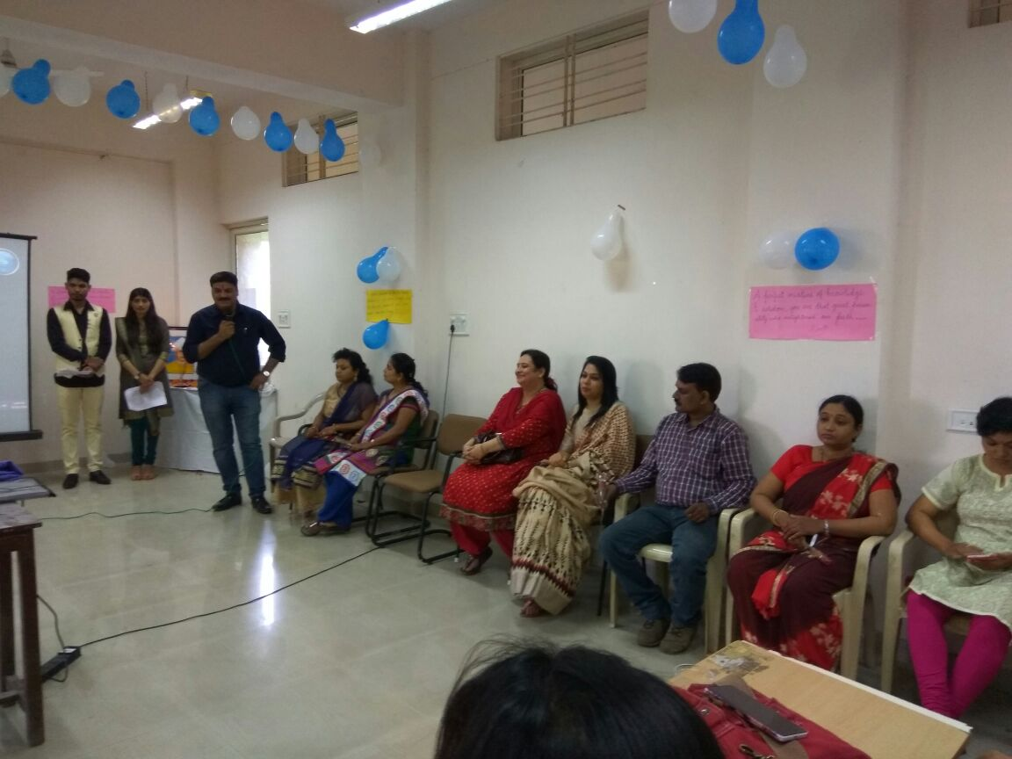

**2. Social work Profession and Report Writing**

**Date**- 4/oct/2016

**Venue**- School of Social Science, DAVV

**Resource person**- Mr. Ashutosh Joseph

**Topic**- Social professional work and Report writing

**Time**- 11:30 AM.

For upgrading the knowledge of professional social work professor Dr. Kanhaiya Ahuja sir has organised the guest lecture which was co-ordinated by Dr. Jyoti Sharma Mam. The whole incharge was taken by Mrs. Sarika Dixit. In this lecture Mrs. Varsha Patel, Ms. Akansha Tripathi, and Mr. Arvind Parihar also co-operated.

All the students of M.S.W. were present in the lecture. The program was introduced by Ankita Joshi and welcome of the guest done by Vaibhav Bamniya and at last vote of thanks to the guest given by Ankita Joshi.

In this lecture Mr. Ashutosh Joseph discussed the Professional social work and its qualities, along with this he discussed about Report writing and its importance.

**अतिथि व्याख्यान पर एक रिपोर्ट**

**तारीख:** 4 / अक्टूबर / 2016

**स्थान :** सामाज विज्ञान अध्ययन शाला

**वक्ता:** श्री आशुतोष जोसेफ

**विषय** :सामाजिक पेशेवर काम और रिपोर्ट लेखन

**समय :** 11:30 AM।

पेशेवर सामाजिक कार्य gsrq प्रोफेसर डॉ कन्हैया आहूजा जी के द्वारा ज्ञान के उन्नयन के लिए अतिथि व्याख्यान आयोजन किया गया जिसका समन्वय डॉ ज्योति शर्मा द्वारा किया गया । कार्यकृम का आयोजन श्रीमती सारिका दीक्षित के निर्देशन मे किया गया। इस व्याख्यान ने श्रीमती वर्षा पटेल, सुश्री आकांक्षा त्रिपाठी और श्री अरविंद परिहार जी ने भी सहयोग पृदान कियी।

  एम. एस .डब्ल्यू के सभी छात्र व्याख्यान में उपस्थित थे। कार्यक्रम अंकिता जोशी और अतिथि स्वागत वैभव बामनीया द्वारा किया ग़या और अंत मे अतिथि को अंकिता जोशी द्वारा धन्यवाद दिया गया A इस व्याख्यान में श्री आशुतोष जोसेफ, ने पेशेवर सामाजिक कार्य और उसके गुणों पर चर्चा की इस के साथ लेखन और इसके महत्व की रिपोर्ट के बारे में जानकारी दी।

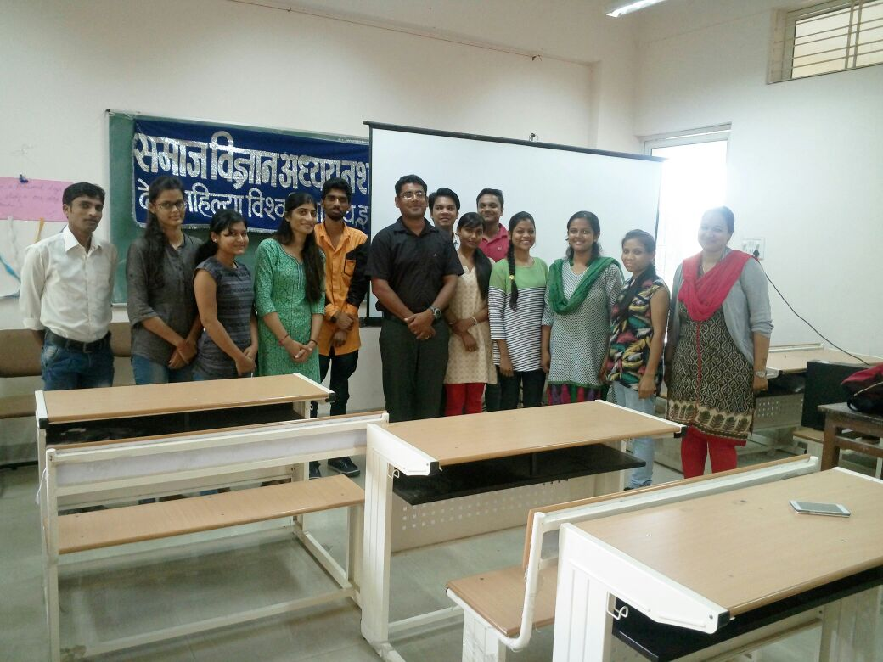

**3. Guest Lecture on Mental and Behavioural Fitness**

Date- 24/11/2016

Topic- Special lecture on Mental and Behavioural Fitness

Venue- School of Social Science, DAVV

Resource person- Mr. Aanand Goud, Director of SOUL (Society for Universal Love) NGO.

Time- 2 pm

For awareness of Mental health and behavioural fitness, DR. Kanhaiya Ahuja has organized a guest lecture which is coordinated by Dr. Jyoti Sharma and the whole in-charge was taken by Dr. Sarika Dixit. In this program Dr. Varsha Patel, Ms. Akanksha Tripathi also co-operated.

All the students of MSW 1st and 3rd Semester and students of Guidance and counselling were present during the lecture. The program was anchored by Ms. Ayushi Datta and guests were welcomed by Ms. Nikita Agarwal and Mr. Pankaj Salvi and at last vote of thanks was given by Dr. Jyoti Sharma.

In this Seminar, Mr. Aanand Goud discussed about spreading awareness on mental health issues, its early detection, psycho-social counselling related to it, importance of Mental Health, Mental hygiene practices, emotional stability etc.

तारीख- 24/11/2016

संगोष्ठी का विषय - मानसिक और व्यवहारिक स्वास्थ्य

स्थान - समाज विज्ञान अध्ययनशाला, डी. ए. वी. वी.

मुख्य वक्ता - श्री आनंद गौड़

समय- 2 PM

यह कार्यक्रम मानसिक और व्यवहारिक स्वास्थ्य के बारे में जागरूकता के लिए किया गया जो डॉ.कन्हैया आहूजा द्वारा संगठित किया गया, डॉ ज्योति शर्मा द्वारा समन्वित किया गया तथा जिसका पूरा प्रभार डॉ सारिका दीक्षित द्वारा लिया गया. इस कार्यक्रम का डॉ वर्षा पटेल औरसुश्री आकांक्षा त्रिपाठी ने सहसञ्चालन किया।

एमएसडब्ल्यू 1 और 3 सेमेस्टर और मार्गदर्शन और परामर्श के सभी छात्र एवं छात्राये इस संगोष्ठी के दौरान उपस्थित थे। कार्यक्रम की मेज़बानी सुश्री आयुषी दत्ता ने की. मुख्य वक्ता का स्वागत सुश्री निकिता अग्रवाल और श्री पंकज सालवी ने पुष्प गुच्छ प्रदान कर के किया. अंत में डॉ ज्योति शर्मा द्वारा मेहमानों का धन्यवाद ज्ञापन किया गया।

इस संगोष्ठी में मुख्य वक्ता श्री आनंद गौड़ ने मानसिक स्वास्थ्य के मुद्दों पर जागरूकता फैलाने, मानसिक स्वास्थ्य से संबंधित मनोवैज्ञानिक और सामाजिक परामर्श, मानसिक स्वास्थ्य के महत्व, मानसिक स्वच्छता और भावनात्मक स्थिरता आदि पर विचार-विमर्श किया गया।

**4. Report on Constitution Day Program**

**Date- 26/11/2016**

**Venue- School of Social Science, DAVV**

**Topic- Constitution Day Program**

**Time- 1.30 PM**

**Department of Social Science organized a program for celebrating the Constitution Day, on 26th November 2016. The whole incharge was taken by Ms. Akanksha Tripathi.**

**The anchoring was done by Niteesh Kumar, Preamble was read by Pankaj Salvi and Fundamental Duties were read by Ankita Shah. Speech was delivered by Gayatri Chaudhary, Sangeeta Gurung and Veethika Acharya. Vote of thanks was given by Vaishali Chauhan.**

**All the students of MSW were present in the program. Teachers who attended the program are Dr. Jyoti Sharma, Dr. Varsha Patel, Dr. Sarika Dixit and Ms Akanksha Tripathi.**

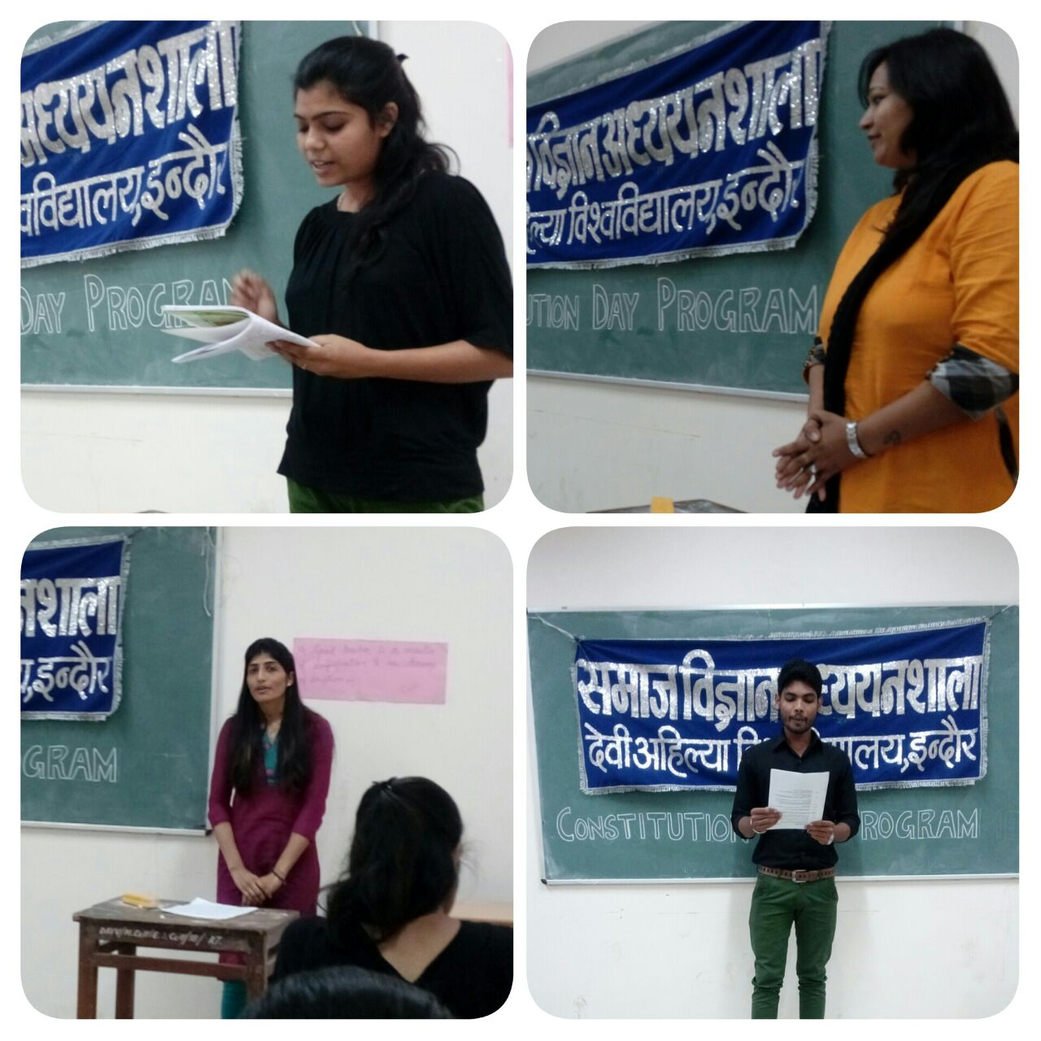

**.Students delivering speech on Constitution Day Program**.

संविधान दिवस कार्यक्रम पर रिपोर्ट

**तारीख 26/11/2016**

**स्थान -सामाजिक विज्ञान अध्ययनशाला, डी. ए. वी. वी.**

**विषय- संविधान दिवस कार्यक्रम**

**समय- 1.30 PM**

सामाजिक विज्ञान **अध्ययनशाला** **ने 26 नवंबर 2016** को संविधान दिवस मनाने के लिए एक कार्यक्रम का आयोजन किया जिसका पूरा प्रभार सुश्री आकांक्षा त्रिपाठी द्वारा लिया गया।

कार्यक्रम का संचालन नितीश कुमार द्वारा किया गया, संविधान की प्रस्तावना पंकज सालवी द्वारा पढ़ी गयी और मौलिक कर्तव्यों का वाचन अंकिता शाह द्वारा किया गया। भाषण गायत्री चौधरी, संगीता गुरुंग और वीथिका आचार्य द्वारा दिया गया था। धन्यवाद ज्ञापन वैशाली चौहान द्वारा दिया गया।

एमएसडब्ल्यू के सभी छात्र- छात्राएं कार्यक्रम में उपस्थित थे।शिक्षक जिन्होंने इस कार्यक्रम में भाग लिया वे है डॉ ज्योति शर्मा, डॉ वर्षा पटेल डॉ सारिका दीक्षित एवं और आकांक्षा त्रिपाठी ।

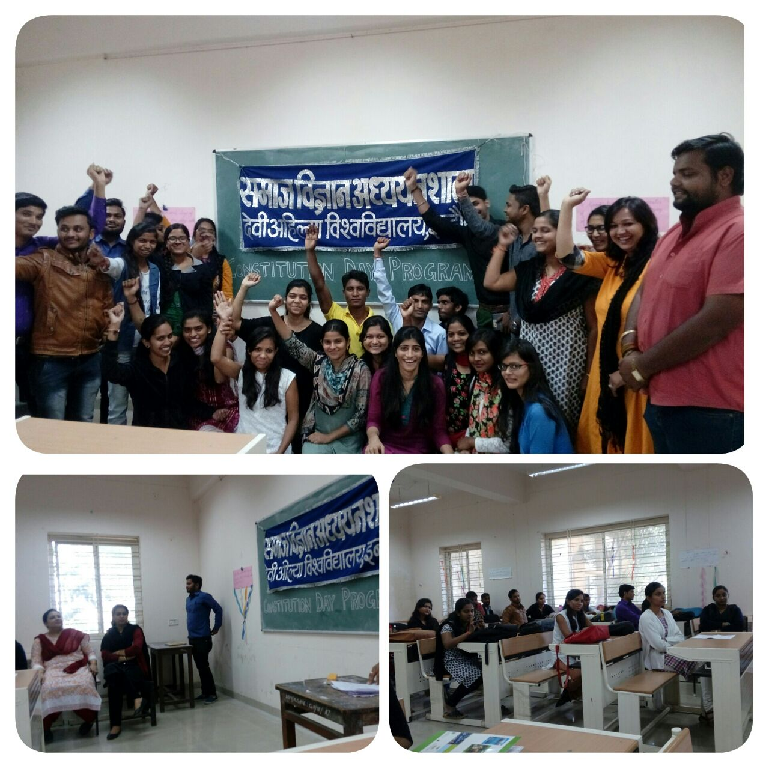

जून 2017( 14 जून - 4 जुलाई) में प्रस्तावित गतिविधि:

Refresher Course in Research Methodology

विभाग द्वारा की गयी प्लेसमेंट गतिविधियों का संक्षिप्त विवरण:

|  |  |  |  |  |
| --- | --- | --- | --- | --- |
| **क्र स** | **विषय** | **विद्यार्थी का नाम** | **कंपनी का नाम** | **वेतन (CTC) RS** |
|  | MSW | अविरल जैन | Jubilant Agri Concumers pvt. Ltd | 3.25 LPA |
|  | MSW | अंकित वर्मा | Basix Municipal wate ventures pvt . Ltd | 1.5 LPA |
|  | MSW | दीपक नागर | Gajara difrancial geare limited | N.A |
|  | MSW | रामजस साहू | Reliance Powerplant coal mines , Sigrauli | 4.5 LPA |
|  | MSW | हिमांशी भावसार | CETI, Indore | 1.2 LPA |
|  | MSW | पुनीत टेलर | Adivasi Chetna Shikshan Seva samiti Jhabua, M.P | 1.44 LPA |