**twu 2019 dk okf"kZd izfrosnu**

**1- v/;;u'kkyk dk uke &Ldwy vkWQ lks'ky lkbZalsl**

**2- LFkkiuk o’kZ &1989**

**3- foHkkxk/;{k dk uke &izks- js[kk vkpk;Z**

**4- Qksu ua- &0731&2362150] 2362140**

**5- bZ- esy -soss.davv@gmail.com**

**6- fo|kfFkZ;ks dh la[;k &d{kkokj %**

|  |  |  |  |
| --- | --- | --- | --- |
| **Ø-** | **lapkfyr ikBîØe dk uke** | **ikBîØe çkjEHk o"kZ** | **Loh—r lhV** |
| **A** | **स्नातक B.S.W. (Bachelor of Social Work)** | **2007** | **60** |
|  | **स्नातक B.A. (Bachelor of Arts)**  **History, Political Science, Sociology/ Psychology** | **2019** | **60+60** |
| **B** | **स्नातकोत्तर** |  |  |
|  | 1. Master of Social Work (MSW) | 2004 | 60 |
|  | 2. M.A.(Sociology) | 2018 | 50 |
|  | 3. M.A. (Clinical Psychology) | 2018 | 50 |
|  | 4. M.A.(Political Science) | 2018 | 50 |
|  | 5. M.B.A. (Rural Development) | 2018 | 50 |
|  | 6. M.B.A. (Public Administration & Policy) | 2018 | 50 |
| **C** | ,e-fQy-M. Phil.  Sociology/ Social Work /Political Science/ History/ Home Science/ Geography/ Psychology/ | 1989 | 20 in each |
| **D** | पी. एच.डी. (Ph.D. Course Work)  Sociology/ Social Work /Political Science/ History/ Home Science/ Geography/ Psychology/ Military Science | 1989 |  |
| **E** | Certificate/Diploma/PG Diploma |  |  |
| **1** | |  | | --- | | P.G. Diploma in Labor Law and Personnel Management | | 2005 | 30 |
| **2** | PG Diploma Human Rights | 2005 | 30 |

**अकादमिक वर्ष (2019-20) में विभाग/ संस्थान / अध्ययनशाला में विद्यार्थियो की संख्या**

|  |  |  |  |
| --- | --- | --- | --- |
| **पाठ्यक्रम** | **पाठ्यक्रम संख्या** | **कुल विद्यार्थिओं की संख्या** | **उत्तीर्ण विद्यार्थिओं की संख्या (III)** |
| Bachelor of Social Work II Sem | 1 | 2 | 2 |
| Bachelor of Social Work IV Sem | 1 | 8 | 8 |
| BA Sociology II | 1 | 57 | 57 |
| BA Psychology II | 1 | 25 | 24 |
| MSW II | 1 | 18 | 18 |
| MSW IV | 1 | 9 | 9 |
| M.A.(Sociology)-II | 1 | 12 | 12 |
| M.A.(Sociology)-IV | 1 | 3 | 3 |
| M.A. (Clinical Psychology)-II | 1 | 41 | 41 |
| M.A. (Clinical Psychology)-IV | 1 | 14 | 14 |
| M.A.(Political Science)-II | 1 | 15 | 15 |
| M.A.(Political Science)-IV | 1 | 7 | 7 |
| M.B.A. (Rural Development)-II | 1 | 12 | 12 |
| M.B.A. (Rural Development)-IV | 1 | 7 | 7 |
| M.B.A.  (Public Administration & Policy)-II | 1 | 33 | 33 |
| M.B.A.  (Public Administration & Policy)-IV | 1 | 10 | 10 |
| PG Diploma Human Rights | 1 | 1 | 1 |
| PGDip. Labour Law &PM | 1 | 6 | 6 |
| **,e-fQy-**M.Phil. | 4 |  |  |
| M.Phil.Sociology-II Sem | 1 | 4 | Exam Postponed due to Covid |
| M.Phil.Political Science-II Sem | 1 | 5 |
| M.Phil.History-II Sem | 1 | 1 |
| M.Phil.Geography-II Sem | 1 | 4 |
| **पी. एच.डी. (Ph.D. Course Work)**  **Sociology/ Social Work /Political Science/ History/ Home Science/ Geography/ Psychology/ Military Science/** Journalism & Mass Communication | 8 |  |  |
| Total |  | 294 | 280 |

Note : Due to Covid 19 Final Exam Postponed.

**अकादमिक वर्ष (2019—20) में विभाग/ संस्थान / अध्ययनशाला में प्रवेशित विद्यार्थियो की संख्या 30 जून 2019 तक**

|  |  |  |  |  |  |  |  |  |  |  |  |  |  |
| --- | --- | --- | --- | --- | --- | --- | --- | --- | --- | --- | --- | --- | --- |
| पाठ्यक्रम | सेमे /वर्ष | सामान्यवर्ग | | अजा | | अजजा | | अपिव | | एनआरआई | | कुलसंख्या | |
|  |  | छात्र | छात्रा | छात्र | छात्रा | छात्र | छात्रा | छात्र | छात्रा | छात्र | छात्रा | छात्र | छात्रा |
| BA Sociology | 2019-20 | 9 | 19 | 6 | 3 | 1 | 4 | 10 | 7 | 0 | 0 | 26 | 33 |
| BA Psychology | 2019-20 | 3 | 18 | 0 | 0 | 1 | 1 | 6 | 0 | 0 | 0 | 10 | 19 |
| स्नातक BSW  (Bachelor of Social Work) | 2019-20 | 4 | 1 | 0 | 0 | 0 | 0 | 2 | 1 | 0 | 0 | 6 | 2 |
| स्नातकोत्तर(MSW)  Master of Social Work | 2019-20 | 3 | 3 | 2 | 0 | 2 | 0 | 3 | 5 | 0 | 0 | 10 | 8 |
| M.A.(Sociology) | 2019-20 | 2 | 5 | 1 | 0 | 1 | 0 | 3 | 1 | 0 | 0 | 7 | 6 |
| M.A. (Clinical Psychology) | 2019-20 | 5 | 28 | 0 | 4 | 0 | 1 | 0 | 3 | 0 | 0 | 5 | 36 |
| M.A.(Political Science) | 2019-20 | 5 | 4 | 3 | 1 | 0 | 0 | 9 | 1 | 0 | 0 | 17 | 6 |
| M.B.A.  (Rural Development) | 2019-20 | 6 | 3 | 0 | 1 | 0 | 0 | 2 | 0 | 0 | 0 | 8 | 4 |
| M.B.A.  (Public Admin & Policy) | 2019-20 | 15 | 11 | 1 | 1 | 0 | 1 | 3 | 3 | 0 | 0 | 19 | 16 |
| P. G. Diploma  Labour Laws | 2019-20 | 2 | 2 | 0 | 1 | 0 | 0 | 0 | 1 | 0 | 0 | 2 | 4 |
| Diploma Human Rights | 2019-20 | 0 | 0 | 1 | 0 | 0 | 0 | 0 | 0 | 0 | 0 | 1 | 0 |
| **,e-fQy-**M.Phil. | 2019-20 | 0 | 0 | 0 | 0 | 0 | 0 | 0 | 0 | 0 | 0 | 0 | 0 |
| Sociology | 2019-20 | 0 | 0 | 0 | 0 | 0 | 0 | 0 | 0 | 0 | 0 | 0 | 0 |
| Political Science | 2019-20 | 0 | 0 | 0 | 0 | 0 | 0 | 0 | 0 | 0 | 0 | 0 | 0 |
| History | 2019-20 | 0 | 0 | 0 | 0 | 0 | 0 | 0 | 0 | 0 | 0 | 0 | 0 |
| Geography | 2019-20 | 0 | 0 | 0 | 0 | 0 | 0 | 0 | 0 | 0 | 0 | 0 | 0 |
| Total |  | 54 | 94 | 14 | 8 | 5 | 7 | 38 | 22 | 0 | 0 | 110 | 134 |

**foHkkx@laLFkku @v/;;u”kkyk }kjk izdk”ku ,oa vdknfed xfrfof/k;kWa o’kZ ¼2018&19½ 30 twu 2019 dh fLFkfr esa&**

|  |  |
| --- | --- |
| **izdk”ku@ vdknfed xfrfof/k;kWa** | **la[;k** |
| **tuZy esa izdkf”kr “kks/k i=** | **3*+7** |
| **iqLrd ys[ku** | **0** |
| **dkaQzsal@lsfeukj ys[k izLrqrhdj.k** | **2*+10** |
| **dkaQzsal@lsfeukj dk vk;kstu** | **4** |
| **odZ”kki esa mifLFkfr** | **9** |
| **odZ”kki dk vk;kstu** | **2** |
| **vfrfFk O;k[;ku izLrqfr** | **16*+4** |
| **vfrfFk O;k[;ku vk;kstu** | **19** |
| **dkaQzsal esa v/;{krk** | **0** |
| **QSdYVh MoyiesaV izksxzke** | **1** |
| **सांस्कृतिक कार्यक्रम** | **1** |
| **सिम्पोजियम** | **1** |
| **परियोजना** | **1** |
| **खेलकूद गतिविधि** |  |
| अन्य | **5** |

*Prof. Rekha Acharya, Professor School of Economics, Head SOSS, DAVV, Indore

**Contribution by Prof. Rekha Acharya, Head School of Social Sciences, DAVV, Indore:**

**Prof. Rekha Acharya Head, Dean School of Social Sciences, Devi Ahilya University, Indore**

**Paper Published:**

1. Challenges for Goods & Service Tax during Pandemic”, International Journal of Advance Science & Technology, Vol. 29 no. 11s (April, 2020, Scopus index,)

2. मध्य प्रदेश में ग्रामीण जनजातीय समुदाय में रोजगार के स्वरुप पर सरकारी योजनाओं के प्रभाव का मूल्यांकन” A UGC-CARE list – Group I – PARISHODH Journal – ISSN no. 2347-6648. Volume IX, ISSue III March 2020,

3. **Budget Arthshastri Ki Nazar Main, (Spinners World 2020)**

**Paper Presented**

1. “Impact of Social Security Schemes on Multidimensional Poverty: A study from rural tribes of Madhya Pradesh” a two day ICSSR sponsored National Seminar on Social Development of Vulnerable Groups: Issues Challenges in Contemporary India (Dates: 28-29 November, 2019). Organized by M. P. Institute of Social Science Research, Ujjain.

2. Analysis of Social and Economic Protection in India – A parity between Center & State Policies – with special reference to Indian Old age Programmes” as Invited Speakers on 5th Feb.2020 in a National Seminar on Policies and Programmes of Social Security in India: Challenges, Opportunities and Possibilities” , organized by MPISSR, Ujjain on 5 & 6 February, 2020 sponsored by ICSSR, New Delhi

**Guest Speaker:**

1. Coordinator- One Day Meet on Academia, Society and Industry interface.(School of Economics, DAVV, Indore) 20.09.19
2. Key Note Speaker in Workshop Topic-Mahatma Gandhi Chintan evam Drashti (SABVGACC, Indore) 20.09.2019
3. Guest Lecture- Thirteenth PIMR International Conference on "Business and Entrepreneurial for Global Prosperity and Happiness", Prestige Institute of Management & Research, Indore, 09.10.19
4. Expert Speaker- Topic – Academic Planning & Excellence, 7 Day Integrated Faculty Development Programme on ‘Emerging issues and practices in Higher education’ Organised by The Bhopal School of Social Sciences, Bhopal (27 December to 2nd January 2020
5. Guest Lecture in “ CSR funds for Social Development” in a capacity Building Workshop on role of CSR in Women & Child Development for Govt., Civil Society organizations & Co-operate representatives, organized by National Institute of Public Cooperation & Child Development, Regional Center, Indore on January8-10, 2020.
6. Subject Expert-Workshop on Research Methodology (Ministry of Human Resource Development Centre BRAUSS, MHOW) 27 January, 2020

Fundamental of Research Methodology for Social Sciences)

Concept and Process of Research Design)

1. Main Speaker -Topic -(Analysis of social and economic protection in India- A parity between Centre and State policies- With Special reference to Indian Older population) National Seminar- Policies and Programmes of Social Security in India, Challenges, opportunities and Possibilities. (M.P. Samajik Vigyan Shodh Sansthan) 05.-06 /02./2020
2. Two Guest lecturers in “Ten days Training Course on Research Methodology in Social Sciences for Research Scholars” during 10 to 19 February, 2020 organized by MPISSR, Ujjain & sponsored by Indian Council of Social Science Research, New Delhi,

1. Action Research Projects in Social Sciences 2. “Analysis & Presentation of Data’

1. Invited Lecture on Research Methodology at Shaskiye Snatkottar Mahvidyalaya, Khargone (M.P.) 02.03.2020
2. Co Chairperson in National Seminar on Indian economy: Issues and Challenges& (MPEA on Gandhian Economics agricultural Development in Madhya Pradesh 04-05 March 2019), Organised by School of Economics, DAVV, Indore
3. Guest Lecture on Current Challenges of Indian Economy, Webinar on Issues and Challenges of Online Teaching in India (Jain Diwakar College, DAVV, Indore) 23.05.2020
4. Key Note Speaker (How to Be Vocal For Local and Global: Issues & Challenges) In National Webinar on the Present Scenario of Economy due To Covid-19 (Department Of Economics (Jhunjhunwala P.G. College, Aridabad Ayodhya) 10.06.2020
5. Guest Speaker – Topic ‘Impact of Covid 19 Crises on MSME and Cottage Industry: Challenges & Opportunities’ in National Webinar on State Of Indian Economy in the Time of Covid-19 Crisis: Challenges and Remedies (Government Mahavir College Petlawad District, Jabua, M.P.) 15.06.2020
6. Expert Lecture in National Webinar on the Socio-Economic and Psychological Impact of Pandemic Covid-19 on Our Society, Organised by Government Nirbhay Singh Patel Science College, Indore (M.P. ) 24.06.2020
7. Guest Speaker in One Day National Webinar On topic ‘MSME Funding: A Tool For Women Empowerment’ (K. G. Mittal College Of Arts & Commerce) 02.07.2020
8. Guest Speaker- Arth ke Sanchay, Sanrakshan, upbhog aur vitran ki swasth vidha

In Webinar Arth Sangoshthi (Govardhan Math Puri, Odisha) 6 July, 2020

**Achievements:**

1. Secretary Gandhi Chair, Establishment of Chair in School of Social Sciences, DAVV, Indore
2. Certificate of Honor, International Women's Day 2020)
3. Inaugurated - Atal Tinkaring Laboratory in Kendriya Vidhyalaya, Indore 27.02.2020
4. NSS Unit in SOSS, DAVV, Indore
5. Nominated by M. P. Government as a Representative for Samajik Shodh Sansthan, Ujjain
6. Counseling Cell **Sahiyog** established in School of Social Sciences, Devi Ahilya University, Indore
7. Co-Ordinator Tarang Vaarta – Bharat Bane Bharat Abhiyan, 29 July 2020

**Contribution of visiting faculty:**

**1. Dr. Sarika Dixit,**

**Project ICSSR IMPRESS An Analytical Study on Menstrual Health & Hygiene amongst Tribal Women**

1. Invited Lecture 2 March 2020 ‘**Field work Practicum in Social Work’**

2. Paper presented in **International Conference on Women Empowerment & Sustainable Development** - Role of Social Norms and Culture in Gender Violence, 6-7 March 2020

3. Faculty Orientation Programme (MHRD), Ramanujam College, New Delhi, 04 June -1 July 2020

4. Faculty Development Programme SPM 2 , Emerging Trends of Pedagogy in Language , Literature and Social Sciences ,College for Women in association with Ramanujam College, Indore 13 July -19 July 2020

5. Workshop on MOOCS (MHRD), DAAV, Indore, 11-16 May 2020

**2. Satyam Samraat Acharya**

1) Guest Speaker in Government Sanskrit College, Indore, Vishwa Hindi Diwas, 14 Sept. 2019

2) Chief Guest Debate Competition & Annual Function Govt. College MHOW 4 November 2019

3) Committee Member of Alumnae in Govt. College MHOW, 20 Sept. 2019

4) Invited as a Artist Jasne-rekhta, Delhi Hindi Caligrapher, 23 December 2019

5) As a Panelist Hidustan -Pakistan Guft- Gu , Pakistani Channel Raygani 14 August 2020

**3. Ayushi Mishra**

1. Workshop on Criminology (Criminal Psychology) Organized by Man mantra- Psychological & Training services, May 2020

2. Workshop on Carrier Coach Organized by counselor Council of India, June 2020-09-3. Training on Addressing Sexual harassment at Workplace: Prevention & Redressal in Context of COVID 19 Organized by UN Women, UNFPA, WHO & OSC , Ministry of Women & Child Development, June 2020

3. Saksham – A Series of Webinar on Self Empowerment, Organised by Self Align, An Affiliated Training Center of Albert Ellis Institute, New York , June 2020

**Contribution of Research Scholars**

**1. Harshita Vijayvargiya**

**Paper Published**

1. Identification Of Unorganised Workers: A Step Prior To Social Security" (BSSS Journal of Social Work, E-ISSN No.:2582-4864 ISSN No. : 0975-251x (Print) Volume XII, Issue, I, June 2020

2. Midlife Crisis among Women: With Special Reference to Rajgarh, M.P. [Woman Empowerment & Sustainable Development (IC-WESD-2020) First Edition 2020 ISBN –“978-93-89522-28-0”], March 2020

3. Impact of Stress on the Socio-Economic Life of Female Employees (With Special Reference to Pithampur) BSSS Journal of Social Work: ISSN No. : 0975-251x (Print) Volume XI, Issue. I, November 2019

**Paper Presented in Conference/Seminar**

1.’‘Indian Labour a Driving Force for Economic Development’ Organised by MP Economic Association, School of Economics, 5 March 2020

2. Mid-Life Crisis among Women (With Special Reference to Rajgarh, M.P.),

**International Conference on Women Empowerment & Sustainable Development**, Organized by School of Mass Communication & Journalism, DAVV, Indore, Dated: 6-7 March 2020

**2. Ashutosh Pandey**

**Paper Published**

धर्म आधारित लैंगिक विभेद के प्राचीनतम ऐतिहासिक एवं पारंपरिक परिप्रेक्ष्य , Published in दृष्टिकोण , UGC Care Lisr Group I Listed ISSN 0975-119X , Volume 12, Issue 2 March-April 2020

**3. Sujeet Kumar Chauhan**

**Paper Published**

1. An Analytical Study of Factors Affecting Eco-Tourism in the Rewa City (M.P.) Interdisciplinary Journal of History Issn-0976-075x (Impact Factor 5.6), June 2020

2. Panna Pathar Main Paristhik Paryatan Evam Paryavaran Sanrakshan Vikas Evam Sambhavnaye (Nibandhmala Issn 2277-2359 (Impact Factor 6.1), May 2020

**4. Kavita Tomar:**

**Paper Presented In Conference/Seminar**

1. A Geographical Study: Narora Atomic Power House (National Seminar on Environmental Sustainability & Conservation: Issues and Challenges) BLP Government College MHOW, dated 14-15 Nov 2019
2. Orientation Programme Organised by NIPCCD on Research Methodology & Statistical Analysis, Dated 26-28 August 2019

**5. Ajay Kumar Yadav**

**Paper Published:**

1. Bundelkhand Krashi Jalvayu M.P. Me Bhoomi Upyog Pratirup: Ek Kaalik Evam Sthaniya Adhhyan (Parishodh Journal, Impact Factor- 6.3) UGC care List Group IVolume IX, Issue III, March 2020

**Paper Presented In Conference/Seminar**

1. Harit Bharat Abhiyan: Ek Kadam Paryavaran Evam Vanya Jeev Sanrakshan Ki Aur (National Seminar on Bio-Diversity, Wildlife Conservation and Management (Janbhagidari Samiti Govt. Home Science P.G. College Hoshangabad M.P.) April 2020
2. Climate Change and Its Impact on Agriculture in Bundelkhand Agro Climate Region (National Seminar on Environmental Sustainability & Conservation: Issues and Challenges) BLP Government College MHOW, Nov 2019

**6. Gyanendra Yadav**

**Paper Presented In Conference/Seminar**

1. Use of Hypothesis in Historical Research Webinar on Hypothesis organised by (GASS & Indore School of Social Work) May 2020
2. **Girja Shankar Patel**

**Paper Presented:**

1. Sharki Sthpatya Kala: Ek Prantiya Sthapatya Kala Charmotkarsh (Bhugol Swadesh Charcha , Multidisciplinary & Multilingual ) ISSN: 2581-4788 Impact Factor - 6.003, Vol. 16 Special Issue 01 Jan. 2020
2. Madhyakal Main Shahrikaran Ki Avdharna Evam Uske Mool Tatv- Ek Etihaasik Adhyyan (Bhugol Swadesh Charcha, Multidisciplinary & Multilingual) ISSN :2581-4788 Impact Factor - 6.003), Volume 15, Issue 02, October 2019
3. **Akash Chaurasia**

**Paper Published:**

1. An Analytical Study of Availability of Water Resources And Its Management In Dhar District (Annual Interdisciplinary Journal Of History) ISSN No.0976-75 X Impact Factor- 5.60 Vol. 6 Issue 11, June 2020

List of Guest Lectures during 2019-20

|  |  |  |  |  |
| --- | --- | --- | --- | --- |
| **S. No** | **Date** | **Activity Name** | **Resource Person** | **No of Participants** |
|  | 26/08/2019 to 31/08/2019 | Deeksharambh  ( Orientation programme) | Hon’ble V.C Renu Jain ma’am  S.P Maneesha Pathak Soni ma’am  HOD Rekha Acharya ma’am.  Mr Akhilesh Sengar , Mr Rajeev Mujumdar (Unichem Laboratories Ltd ,Indore, Madhya Pradesh,& Dr Vinay Joshi. | All Students of SOSS |
|  | 08/08/2019 | Development of Life Skills | स्वानन्द किरकिरे (पार्श्वगायक प्रख्यात)2. डॉ. विकास दवे (वरिष्ठ संपादक, देवपुत्र पत्रिका | 50 |
|  | 05/08/2019 | Teachers Day Celebration | By All Students of SOSS | 150 |
|  | 21/09/2019 | IAS बनने की ख्वाहिश | डॉ. मनोज कुमार शर्मा (IPS, एडिशनल कमिश्नर ऑफ पुलिस, पश्चिमी मुंबई)  मनीषा पाठक सोनी (ASP, इंदौर) | 70 |
|  | 10.10.2019 | World Mental Health Day”  (Suicide prevention) | **1. Awareness Campaign**  **Using Slogan**  *‘Be kind to your mind’*  **2. A Street Play**  3. T**alk Station** | 60 |
|  | 23.12.2019 | Strategies for Guidance & Counseling | Dr. Ram Gulam Razdan  Mr. Manish Khatri Add. S.P  Dr. Krishna Mishra, Psychiatrist | 40 |
|  | 18 May 2020 | Misconceptions and Current Trends in Practicing Counseling Psychology and Psychotherapy. | Neha Yeole, Psychologist Australian Psychological Association. | 38 Participants |
|  | 19 May 2020 | Importance of Yoga in Physical and Mental Health | Deepti Gami  (Yoga Therapist) | 35 |
|  | 23 May 2020 | Addiction Disorders”. | Dr. Pawan Rathi  Clinical Psychologist Arvindo medical College, Indore | 56 |
|  | 25 May 2020 | Importance of Life Philosophy in Counseling Practice | Parvrajika Tathagathaprana, Sanyasini in Shree Sharda Math, Indore | 46 |
|  | 28 may 2020 | Problems due to reverse Migration in Post Covid | Ms. Bharti Thakur,  Founder NARMADA Khargone | 64 |
|  | 30 May 2020 | Depression and Dementia | Dr. Raman Shrama, MBBS, MRC Psych and MSC from U.K. | 45 |
|  | 1 June 2020 | Impact of COVID on Indian Economy | Dr. Bakshi Amit K. Sinha”,  Assistant Professor Centre for Economic Policy and Public Finance, ADRI, Patna. | 70 |
|  | 3 June 2020 | Schizophrenia | Mrs. Tanuja Bharadwaj  Clinical psychologist | 40 |
|  | 5 June 2020 | Phenomenology in Psychiatry | Dr. Rahul Mathur MBBS, MD in Psychiatry. | 50 |
|  | 20 June2020 | “ Adolescent Sexuality, Sex and Spirituality” | Dr.J.S. Tuteja, Paediatrician of Indore and former Head of National Advisory Action Plan Mission | 70 |
|  | 22 June 2020 | History of Pandemic | Prof. J. C. Upadhyay | 65 |
|  | 25 June 2020 | Gandhi Peace and Pandemic | Prof. Ambikesh Kumar Tripathi, Mahatma Gandhi Central University, Bihar | 100 |

**Symposium**

|  |  |  |  |  |
| --- | --- | --- | --- | --- |
| S. No. | Date | Activity Name | Resource Person | No of Participants |
|  | 16.12.2019 | Symposium on Behavioral and Social Changes in an Age of Rapid Transition | 1. Dr. Rodney Clarken, Professor Emeritus, Wayne State University, U.S.,  2. Padma Shree Dr. Janak Palta  3. Prof. D.K. Verma, Professor & Head, Division of SC, ST & OBC Development, BRAUSS, Mahow. | 45 |

**Workshop**

|  |  |  |  |  |
| --- | --- | --- | --- | --- |
| **S. No** | **Date** | **Activity Name** | **Resource Person** | **No of Participants** |
| **1.** | 17.12.2019 | Workshop on Experimental Psychology | Dr. Rodney Clarken, Professor Emeritus, Wayne State University, U.S. | 30 |
| **2.** | 24.02.2020-28.02.2020 | Workshop Rational Emotive and Cognitive Behavior Therapy | Ms. Gauri Row Kavi  Dr. Ashok Sharma | 62 |

**Seminar:**

|  |  |  |  |  |
| --- | --- | --- | --- | --- |
| **S. No** | **Date** | **Activity Name** | **Resource Person** | **No of Participants** |
| **1** | 20/08/2019 | National Seminar on  अपराध दर में वृद्धि- एक भारतीय नागरिक की भूमिका | ADGP वरुण कपूर  मनोविश्लेषक डॉ माया वोहरा  श्रुति बजाज  रिटायर्ड कर्नल निखिल धीमान | 73 |
| **2** | 8 JUNE, 2020 | International WebinarOn“**Anxiety Disorders”**  *In Collaboration With*  **Eduscan (U.A.E)** | Dr. Alka Kalra,  International Psychologist And Founder Of Eduscan | 100 |
| **3** | 27-28 June 2020 | Two days Webinaar  “Post- Covid Scenario On Indian Society”  <https://www.facebook.com/soss.davvindore> | 1. **Dr. NMP Verma**, Department of Economic, Babasaheb Bhimrao Ambedkar University, ***“Economic Challenges ‘’***. 2. **Dr. Jilly John**,HOD, Dept. Of Social Work, Central University of Kerala, ***“Social Issues and Challenges ‘’*** 3. **Dr. Rekha Arya**, Clinical and Rehabilitation Psychologist ***“Challenges faced by the Indian Youth*** . | 742 |
|  |  | Day Two | 1. **Dr. Shiv Narayan Yadav**Ex. Vice Chancellor, Awadesh Pratap Singh University,Rewa***‘’ Administrative Challenges*** 2. **Dr. Shobha Managoli**, Clinical Psychologist ***“The Psychological Challenges ‘’*** faced during COVID 19. 3. **Dr. Manju Singh** , Professor of Economics , Malviya National Institute of Technology , Jaipur , ***Rural India Post COVID 19 Scenario*** |  |

**Faculty Development Programme**

|  |  |  |  |  |
| --- | --- | --- | --- | --- |
| **S. No.** | **Activity** | **Date** | **Organization** | **No. of Participants** |
| 1 | FDP on Awareness Generation on E Learning Program | 21 October 2020 | NIPCCD & School of Social Sciences, DAVV, Indore | 30 |

**Cultural Activity:**

|  |  |  |  |  |
| --- | --- | --- | --- | --- |
| **S. No.** | **Activity** | **Date** | **Organized by** | **No. of Participants** |
| 1 | Garba Program | 05 October 2019 | School of Social Sciences, DAVV, Indore | 300 |

**Annual Sports Activity SPORTEK**

|  |  |  |  |  |
| --- | --- | --- | --- | --- |
| **S. No** | **Date** | **Activity Name** | **Activities Details** | **Participants** |
| 1 | 6-7.02.2020 | SPORTEK | Sports Activities | All SOSS Students |

**List of Awards By Students of School of Social Sciences: (2019-2020)**

|  |  |  |  |  |  |
| --- | --- | --- | --- | --- | --- |
| [S.No](http://s.no/) | Name | Event | Date | Organized By | Position |
|  | Garvita Jain | Debate Competition | Sept. 2019 | St. Paul Institute Of Professional Studies | 1 |
|  | Vidhyansh Pandey | Elocution  (Inter Collegiate) Competition | Sept. 2019 | St. Paul Institute Of Professional Studies | 3 |
|  | Vidhyansh Pandey | Debate Competition | Sept. 2019 | St. Paul Institute Of Professional Studies | 2 |
|  | Gautam Das | Debate Competition | July. 2019 | Yuva Manch Kukshi | 4 |
|  | Gautam Das | India's International Movement To The United Nations (Best Delegate In The Committee Of Lok Sabha) | October 2019 | India's International Movement To The Unite Nations | Best Delegate |
|  | Gautam Das | Rank In Academics | Nov. 2019 | Columbia Convent School, Indore | 1 |
|  | Aman Kumar Singh | Disc Throw( Athletics) | July 2019 | Krida Bhartiya Khel Mela | 1 |
|  | Aman Kumar Singh | Wushu | August 2019 | 6th Students Olympic National Games, Utrakhand 2 | 1 |
|  | Aman Kumar Singh | National Adventure Program | August 2019 | National Adventure Institute (Panchmari) | A |
|  | Aman Kumar Singh | Shot Put Athletics | August 2019 | United Nation Games 2019 | 1 |
|  | Aman Kumar Singh | Scout And Guide | January 2020 | Kendriya Vidyalaya Sangathan | Rajya Puruskar |
|  | Abhishek Panwar | Essay Competition | Sept 2019 | School Of Social Sciences, Davv | 3 |
|  | Akanksha Soni | Short Story Writing Competition | March 2019 | The Great Indian Book Tour | 2 |
|  | Arti Kulkarni | District Competition | February 2019 | Dada Nirbhay Singh Patel | 3 |
|  | Arti Kulkarni | Inter College Elocution Competition | March 2019 | Jain Diwakar College, Indore | 1 |
|  | Arti Kulkarni | Debate Competition | April 2019 | Bissau, Rajasthan | 2 |
|  | Arti Kulkarni | Debate Competition (Kalidas) | November 2019 | Inter University | 1 |
|  | Arti Kulkarni | Best Speaker | August 2019 | Youth Parliament | Best Speaker |
|  | Ritik Shukla | Inter unit Drill Competition | Sept 2019 | NCC Unit | 1 |
|  | Ritik Shukla | Republic Day Parade | Jan 2020 | Nehru Stadium | Gold Medal |

**SPORTEK Winners:**

|  |  |  |  |  |
| --- | --- | --- | --- | --- |
| S. No. | Name | Competition Name | Department Name | Position |
|  | Runit Abraham | Chess Competition | SOSS, DAVV, Indore | 1 |
|  | Ritik Shukla | Race 100/ 400 Metre Boys | SOSS, DAVV, Indore | 1 |
|  | Pratiksha Mishra | Race 100/ 400 Metre Girls | SOSS, DAVV, Indore | 1 |
|  | Mahesh Patel | Badminton Single Boys | SOSS, DAVV, Indore | 1 |
|  | Pratiksha Mishra | Badminton Single Girls | SOSS, DAVV, Indore | 1 |
|  | Ajay Kumar Yadav  +  Yogendra Yadav | Badminton Doubles Boys | SOSS, DAVV, Indore | 1 |
|  | Pratiksha Mishra  +  Sharmila Kushwaha | Badminton Doubles Girls | SOSS, DAVV, Indore | 1 |
|  | Ajay Kumar Yadav  +  Pratiksha Mishra | Badminton Mixed | SOSS, DAVV, Indore | 1 |
|  | 1. Dewansh Dwivedi 2. Amitesh Singh 3. Pankaj Yadav 4. Anurag Gupta 5. Sharmila Kushwaha 6. Shreya Patel 7. Nirmal Rawat 8. Ayush Pathak 9. Rishabh Malviya 10. Gaurang Sharma | Basket Ball | SOSS, DAVV, Indore | Winner Team |
|  | Topesh Patle | Lemon Race Boys | SOSS, DAVV, Indore | 1 |
|  | Shailly Jain | Lemon race Girls | SOSS, DAVV, Indore | 1 |
|  | 1. Dewansh Dwivedi 2. Amitesh Singh 3. Pankaj Yadav 4. Mahesh Patel 5. Sharmila Kushwaha 6. Anjali Aamga 7. Nirmal Rawat 8. Sanjay Singh Parmar 9. Anurag Gupta 10. Divas | Vollyball | SOSS, DAVV, Indore | Winner Team |
|  | Gargee Londhe | Sack Race Girls | SOSS, DAVV, Indore | 1 |
|  | Aman Kumar Singh | Sack Race Boys | SOSS, DAVV, Indore | 1 |
|  | 1. Sanjay Singh Parmar **(Captain)** 2. Ayush Jha **(Vice - Captain)** 3. Amitesh Singh 4. Rishabh Jain 5. Diwas Ghintal 6. Rishabh Malviya 7. Nirmal Rawat 8. Adarsh Namdev 9. Rajnikant 10. Gaurang Sharma 11. Anjali Aamga 12. Shreya Patel 13. Pankaj Yadav 14. Garima Raje | Cricket | SOSS, DAVV, Indore | Winner team |

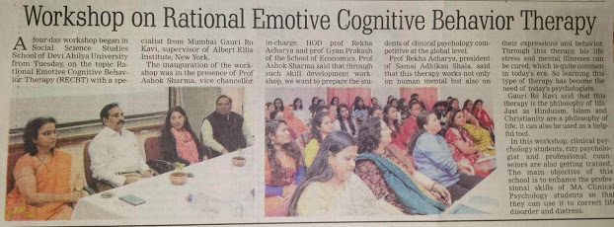

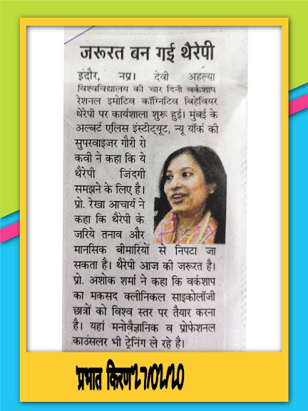

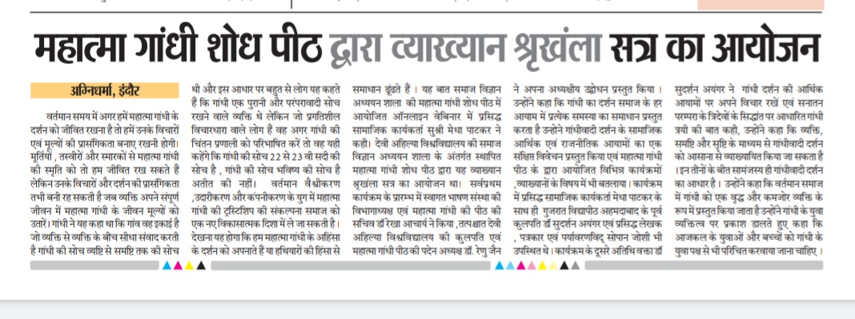

**DEEKSHARMBH-2019**

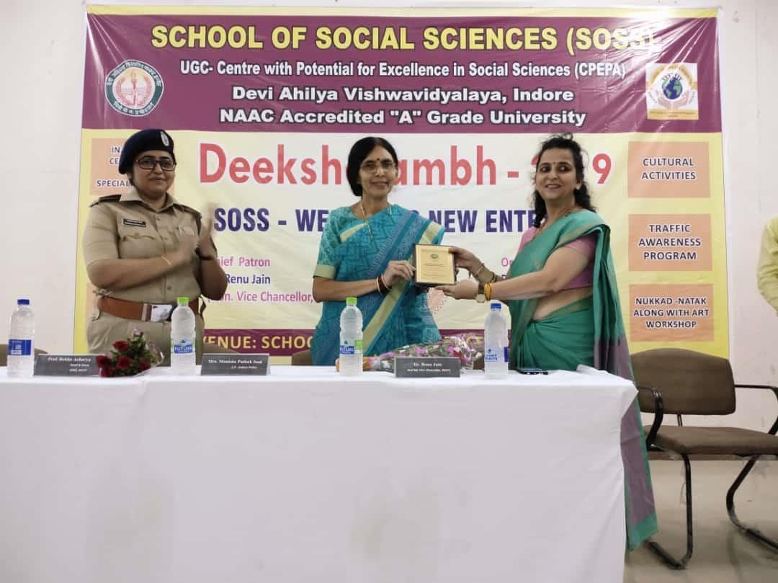

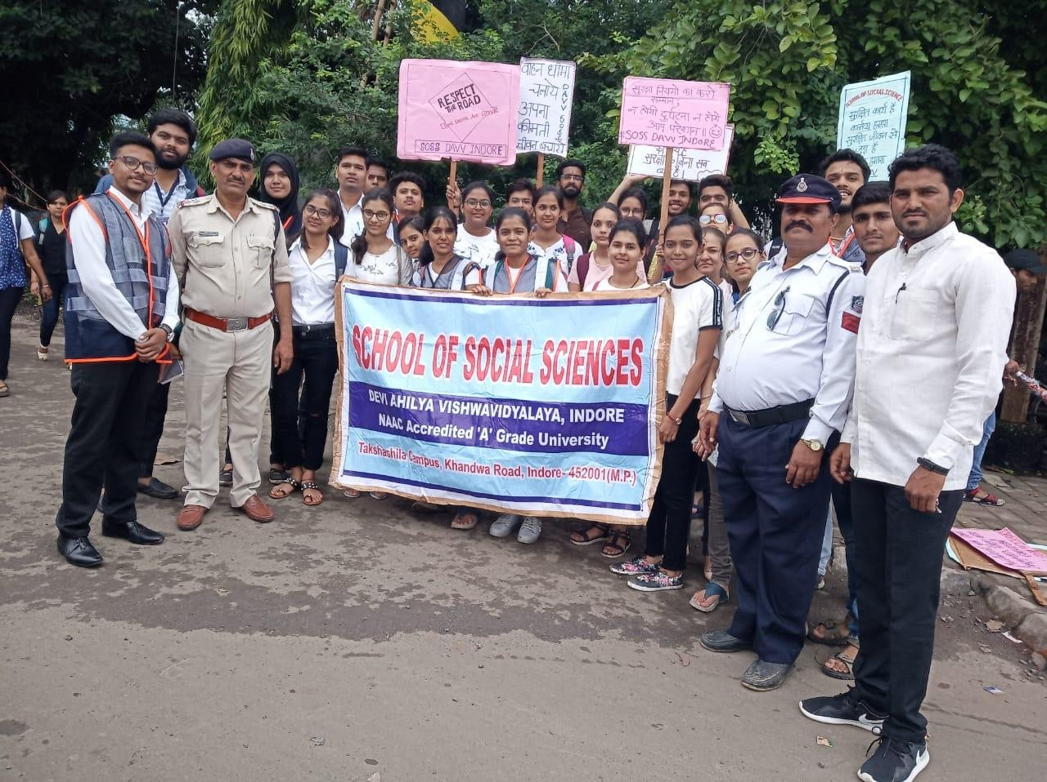

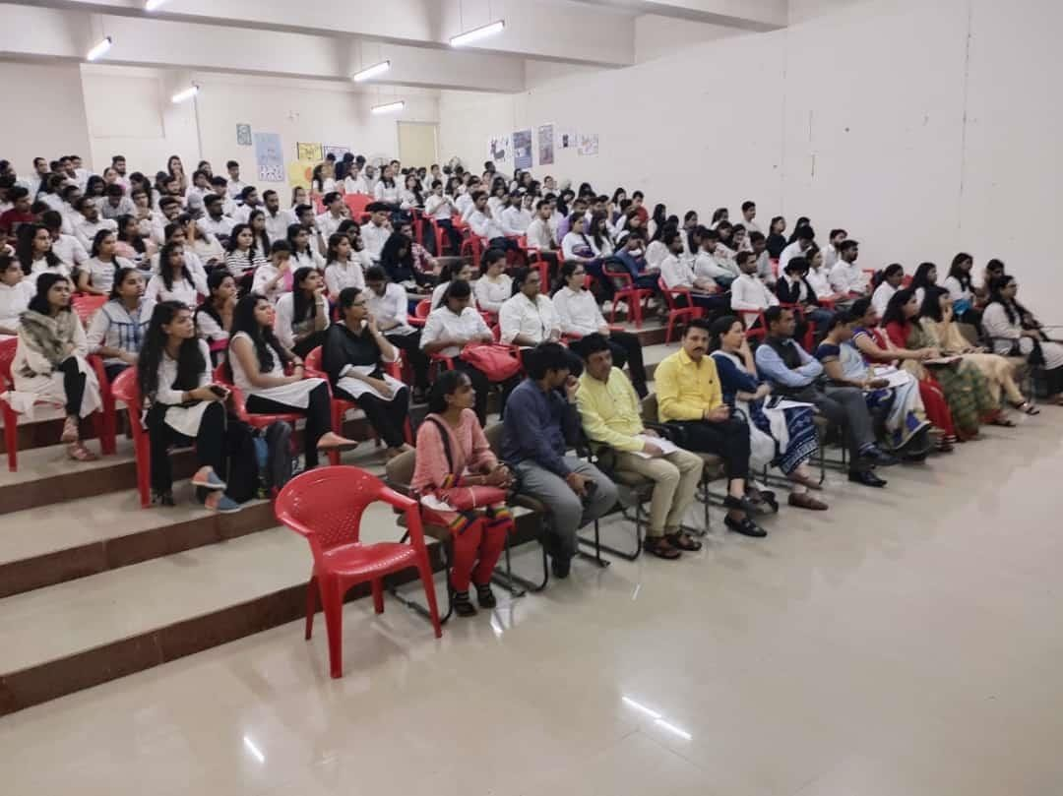

**2. विषय: '' डेवलेपमेन्ट ऑफ लाईफ स्किल्स दिनांक: 08/08/2019**

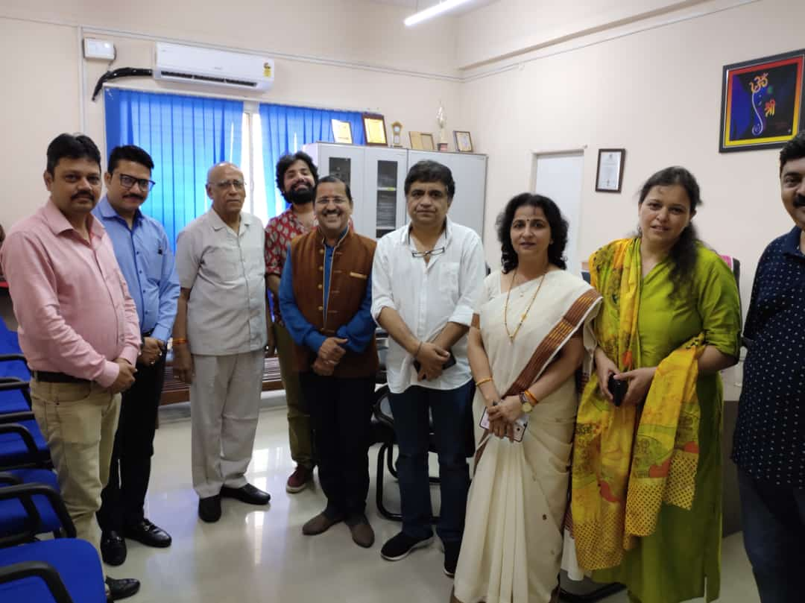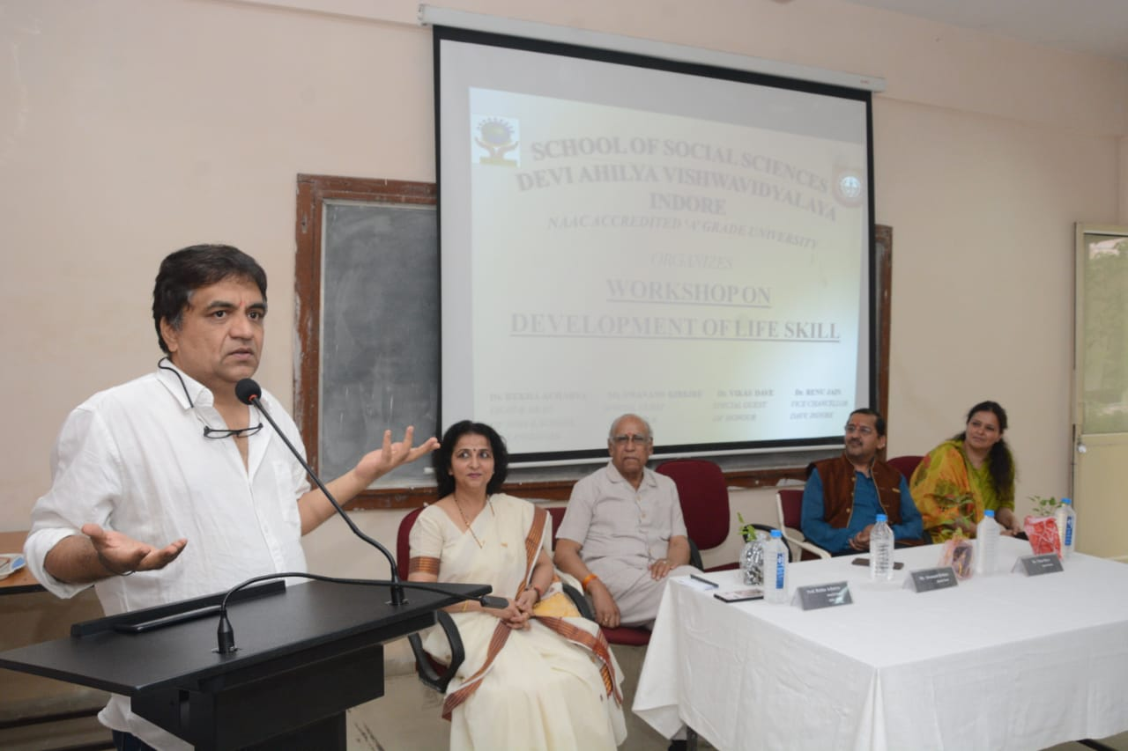

3. **“अपराध दर में वृद्धि- एक भारतीय नागरिक की भूमिका”** पर एक दिवसीय संगोष्ठी

**20/08/2019**

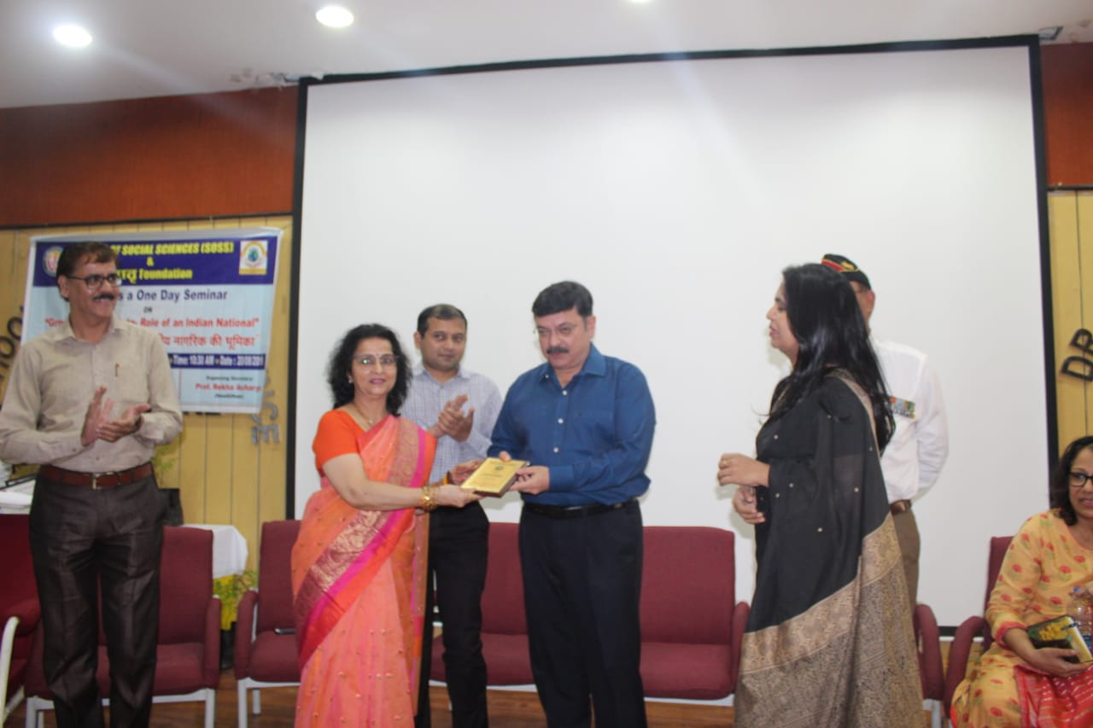

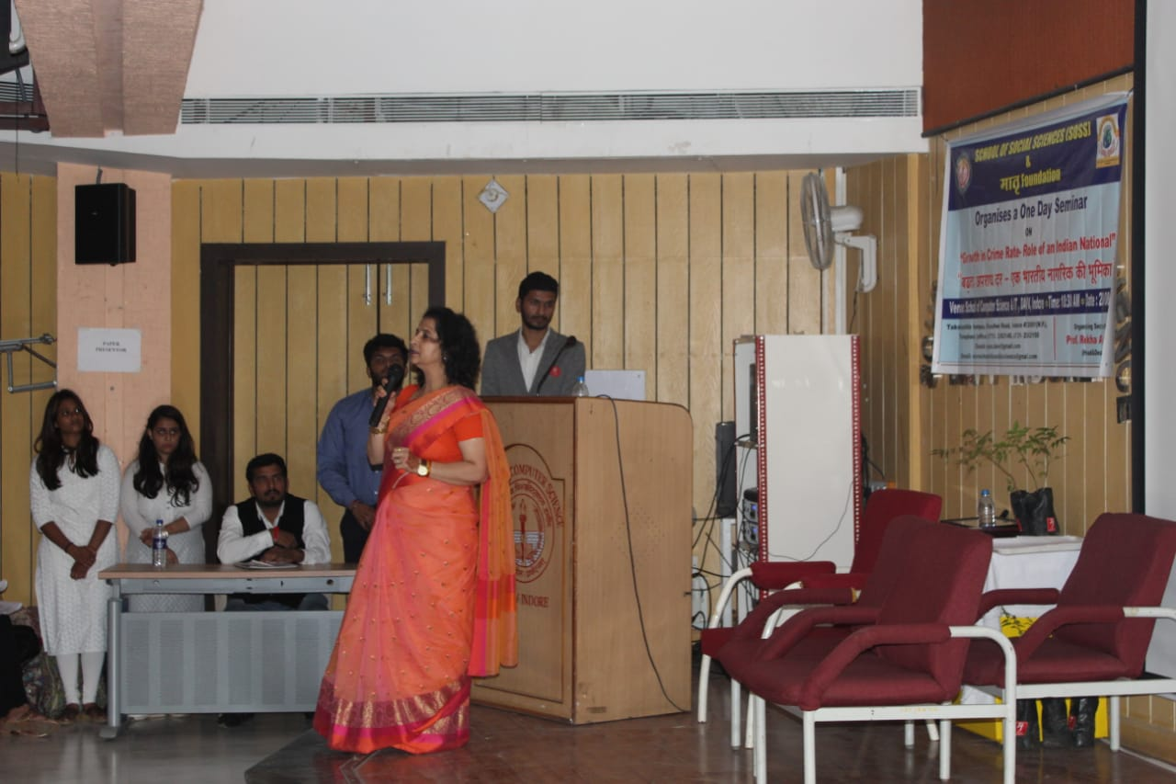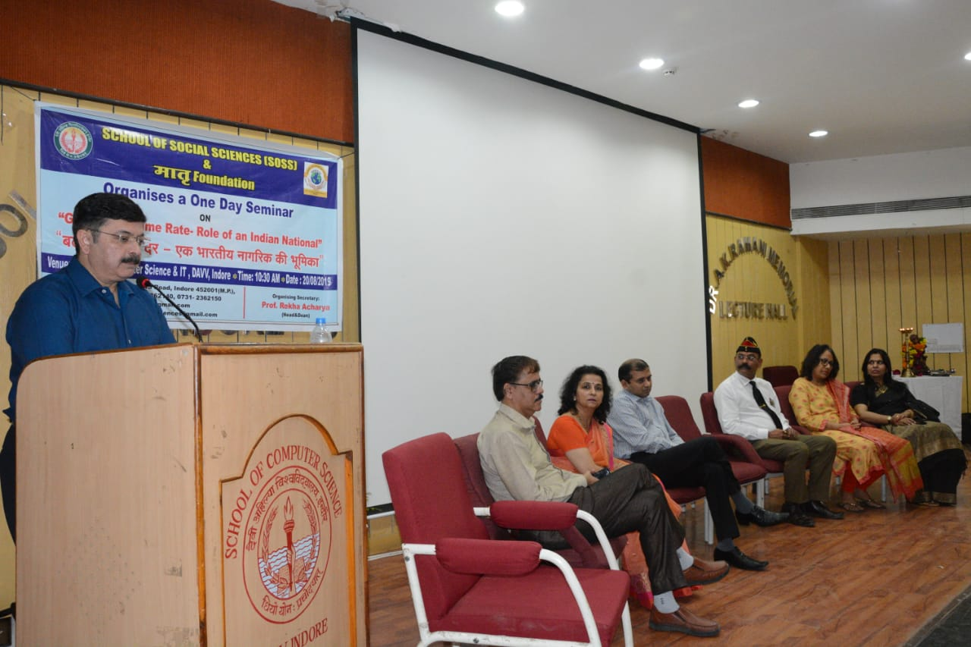

**3. विषय:** **'' IAS बनने की ख्वाहिश?'' दिनांक:** 21/09/2019

**वक्ता:** 1**.** **डॉ. मनोज कुमार शर्मा (IPS, एडिशनल कमिश्नर ऑफ पुलिस, पश्चिमी मुंबई)**

**2. मनीषा पाठक सोनी (ASP, इंदौर)**

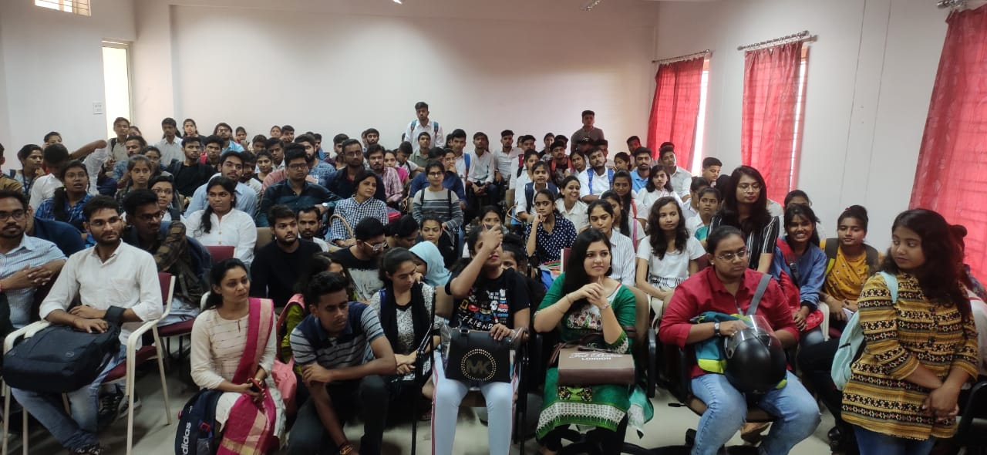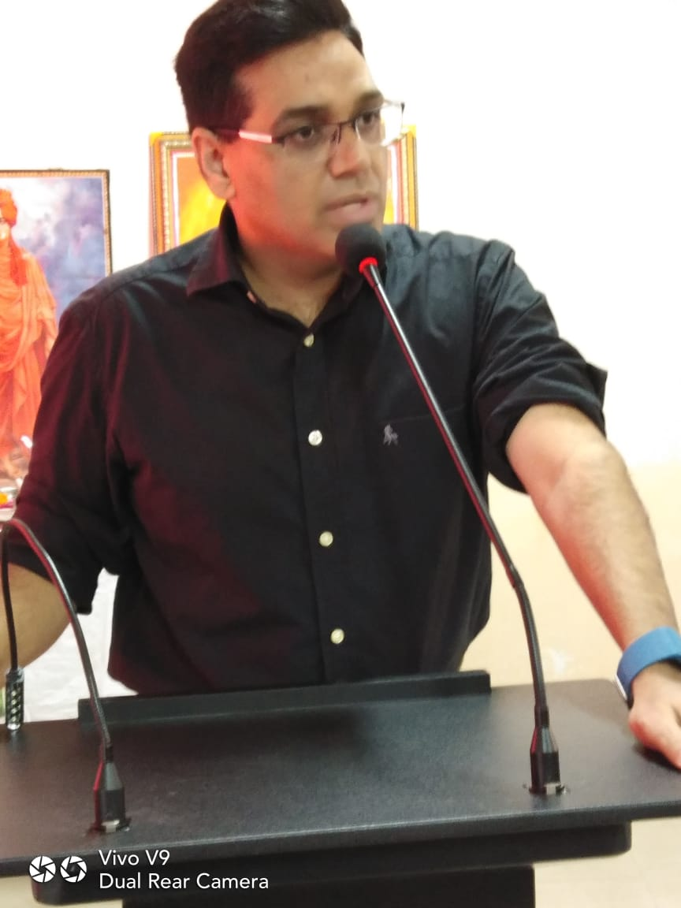

“**WORLD MENTAL HEALTH DAY”**

**DATE: OCT 10, 2019**

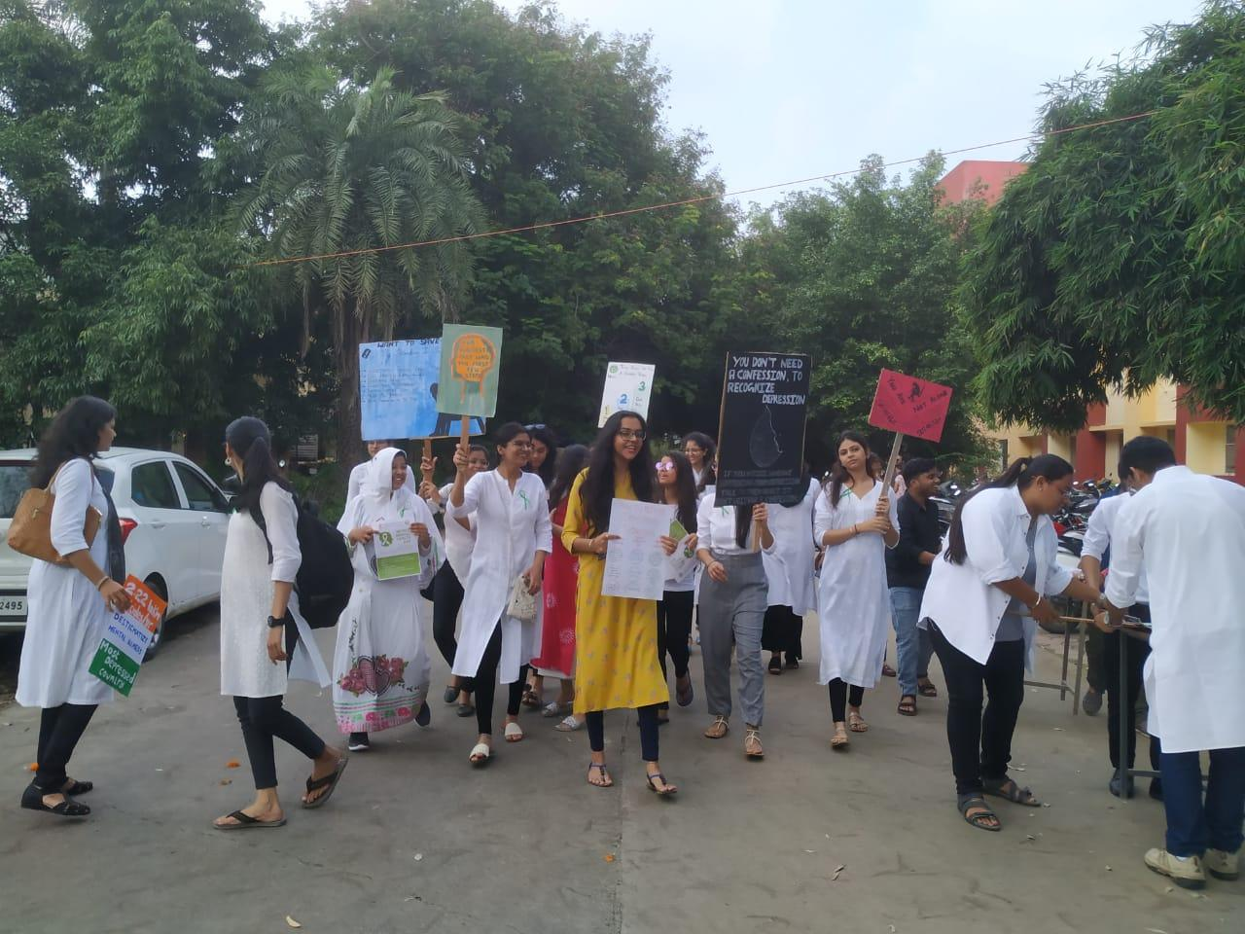

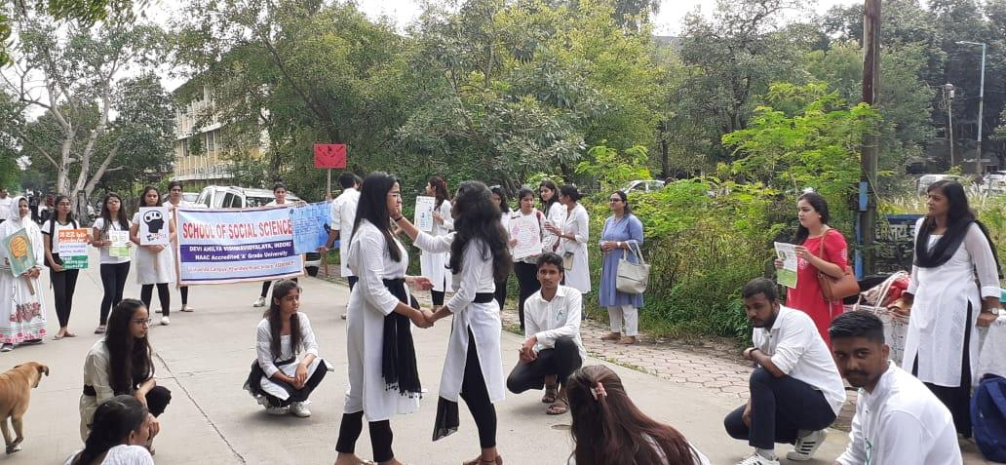

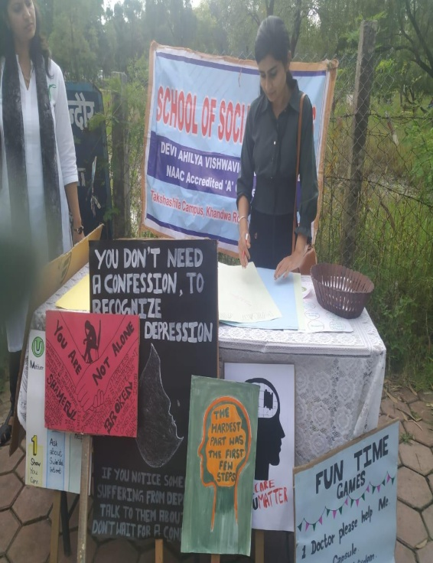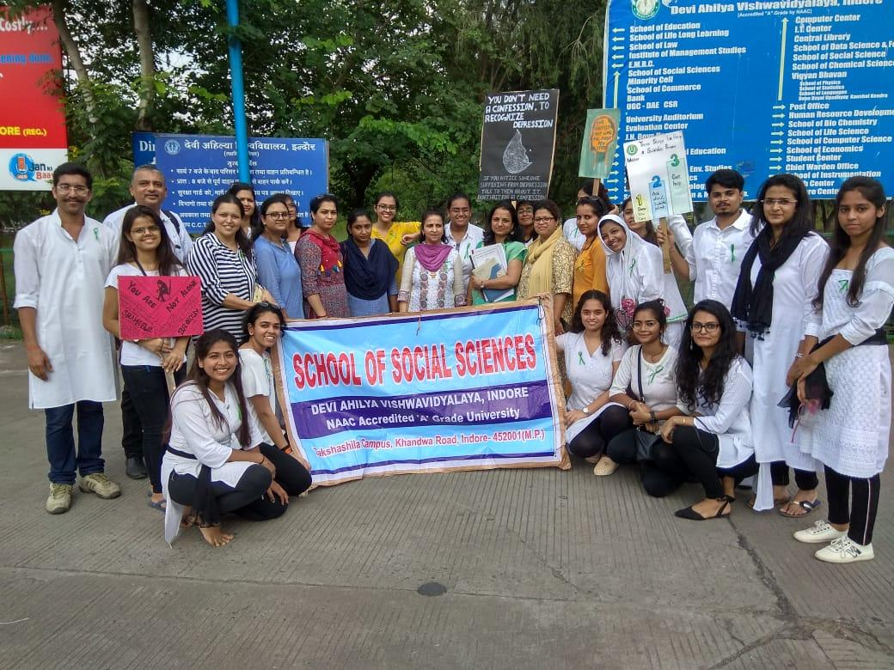

**Symposium on** “**Behavioural and Social Changes in an Age of Rapid Transition”**

**DATE: DEC 16, 2019**

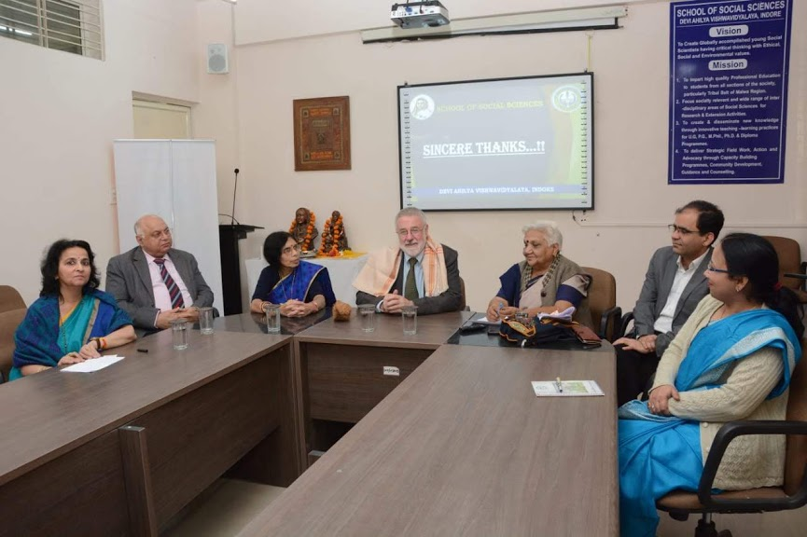

**Workshop on RESOURCE PERSON: DR. RODNEY CLARKEN**

**DATE: 17th Dec 2019**

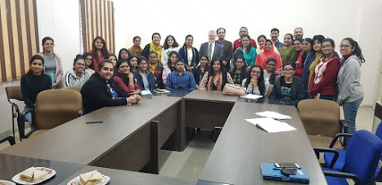

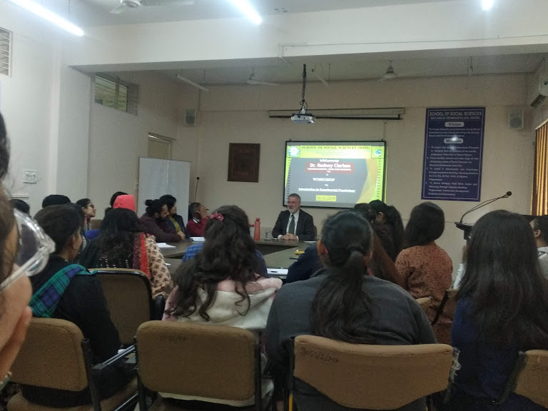

“**TRAINING PROGRAM ON STRATEGIES FOR GUIDANCE & COUNSELLING”**

**DATE: DEC 23, 2019**

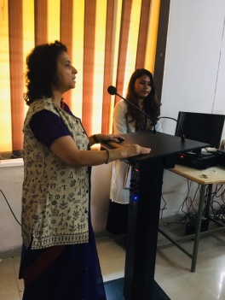

**RATIONAL EMOTIVE AND COGNITIVE BEHVIOUR THERAPY WORKSHOP**

**24th FEB. 20 to 28th FEB. 2020**

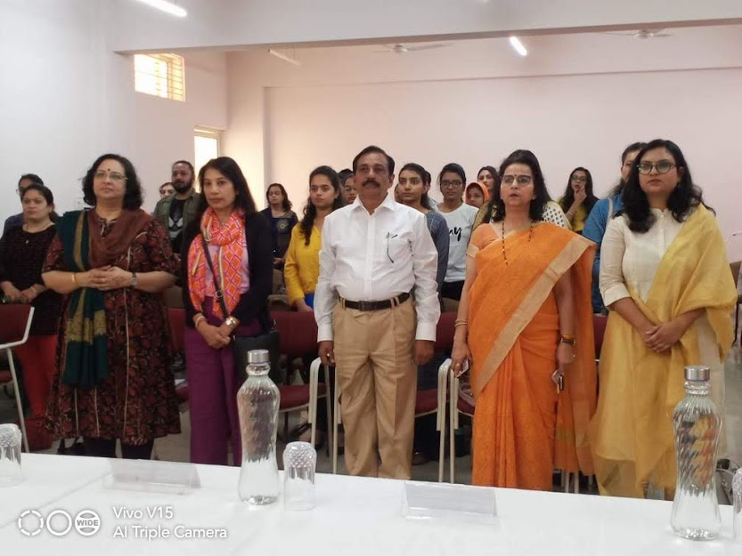

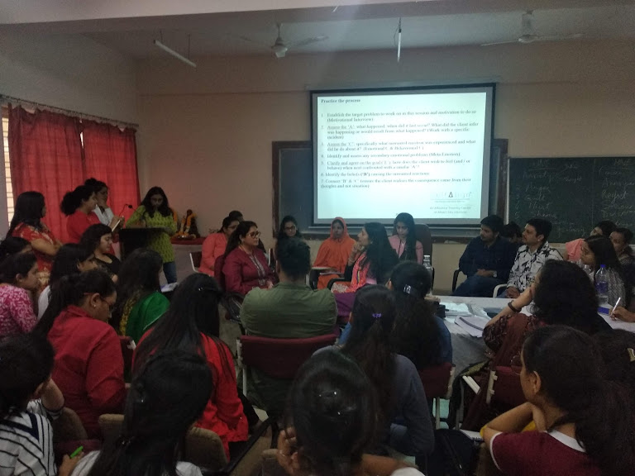

“**GUEST LECTURE SERIES”**

**DATE: May 18, 2020 – July 7, 2020**

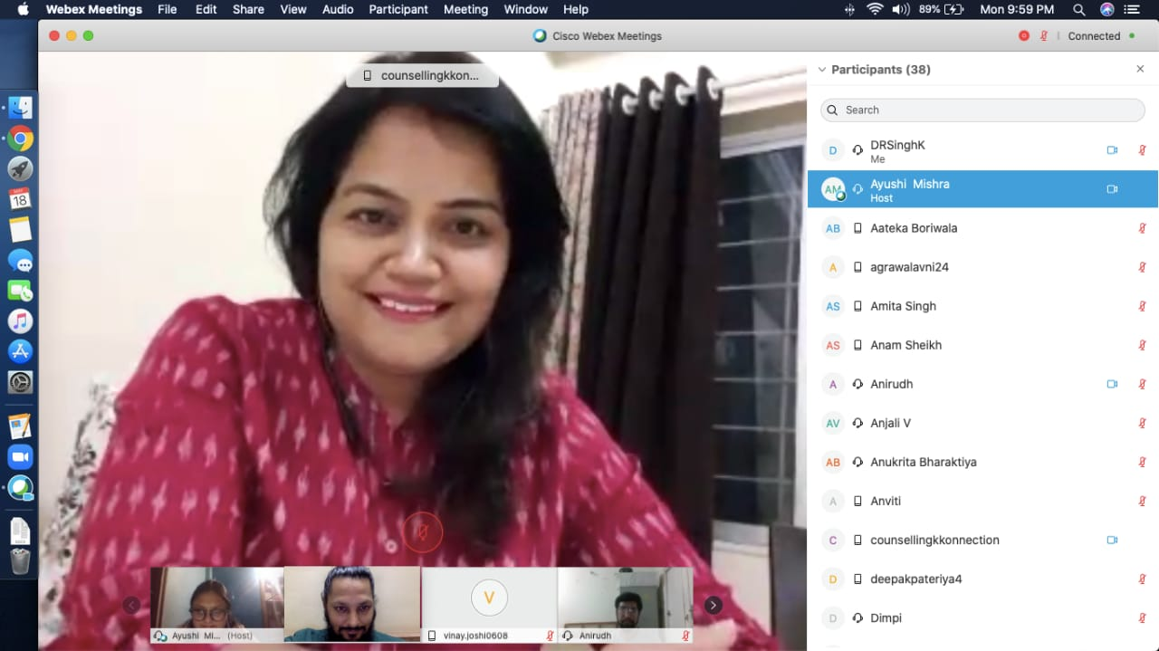

**May 19th 2020**

**“Importance of Yoga in Physical and Mental Health”**

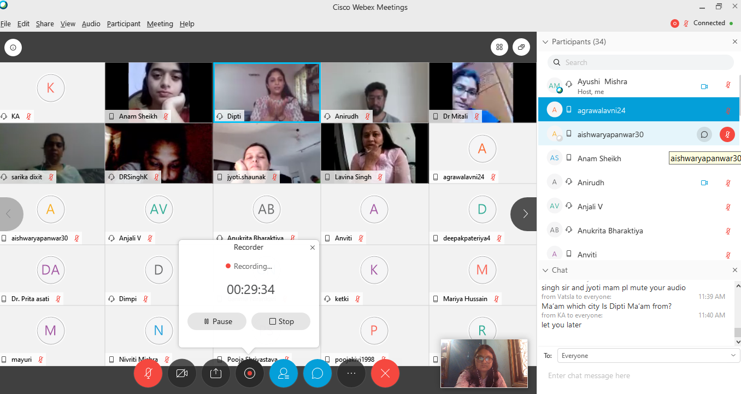

**May 23rd 2020**

**“****Addiction Disorders”**.

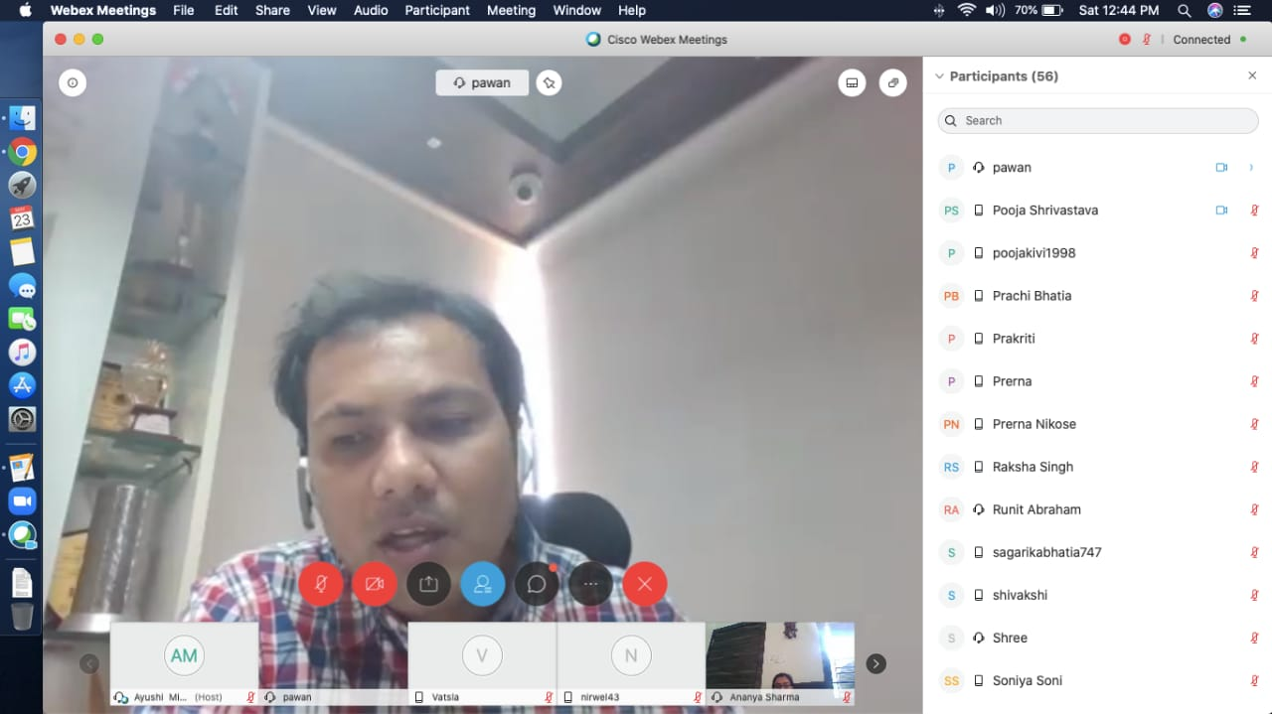

**May 25th 2020**

**“Importance of Life Philosophy in Counselling Practice”**

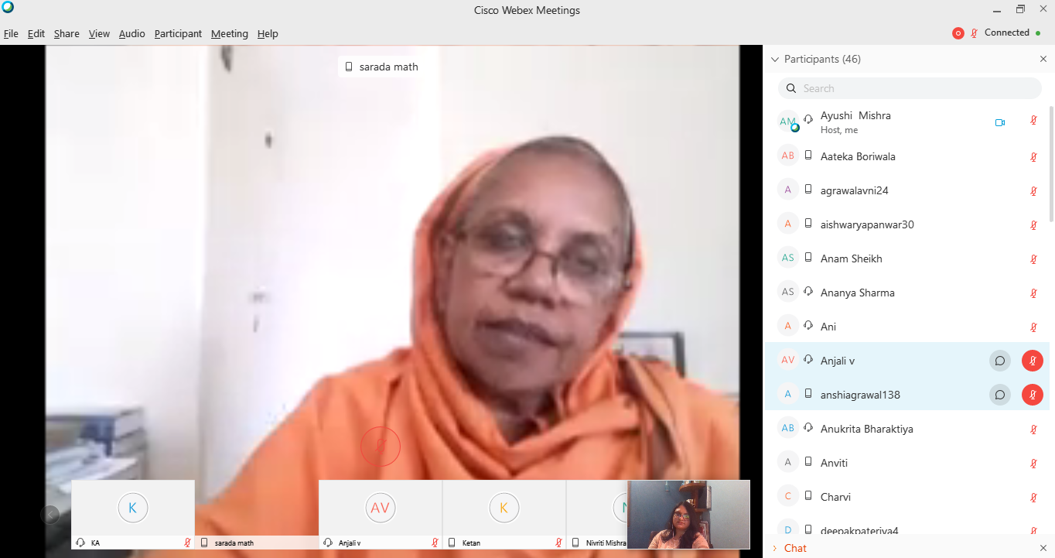

**May 28th 2020**

**“Problems due to reverse Migration in Post Covid”**

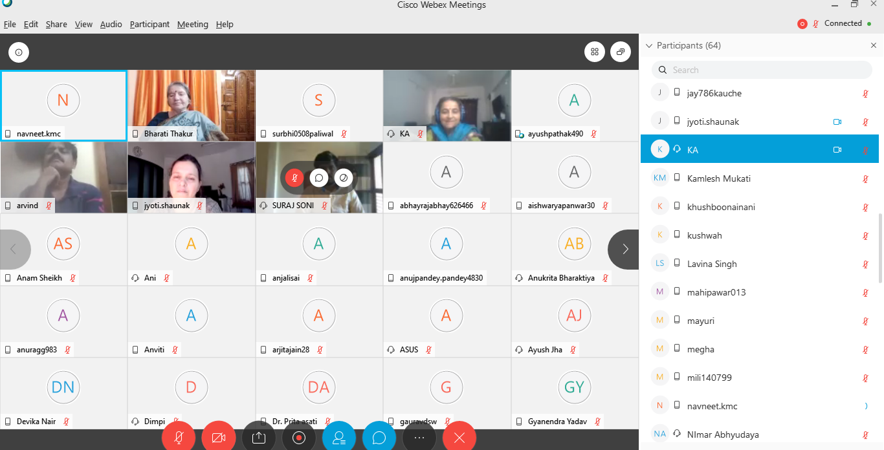

**May 30th 2020**

**“****Depression and Dementia”**

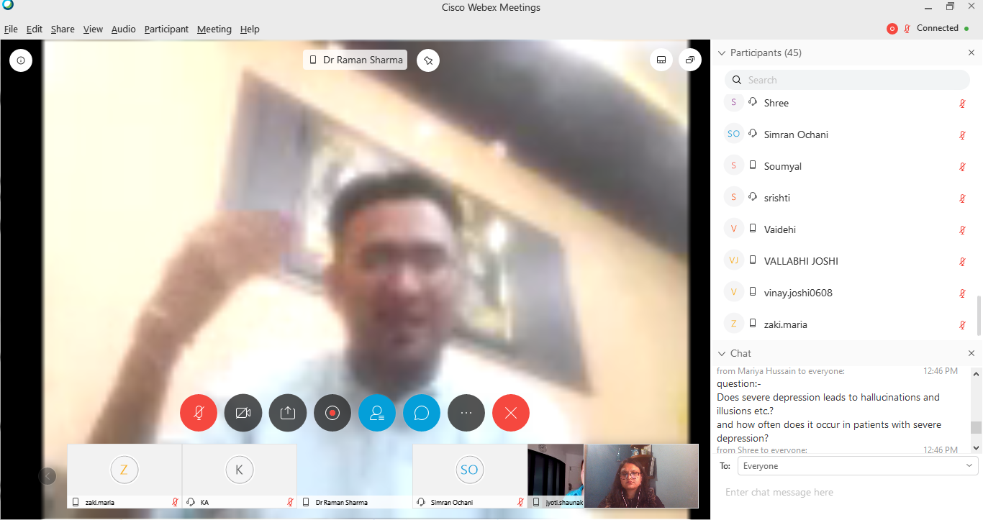

**June 1st 2020**

**“Impact of COVID- 19 on Indian Economy: A preliminary Analysis”**

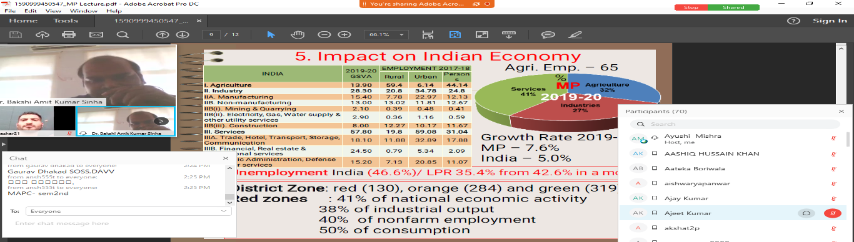

**June 3st 2020**

**“Schizophrenia”**

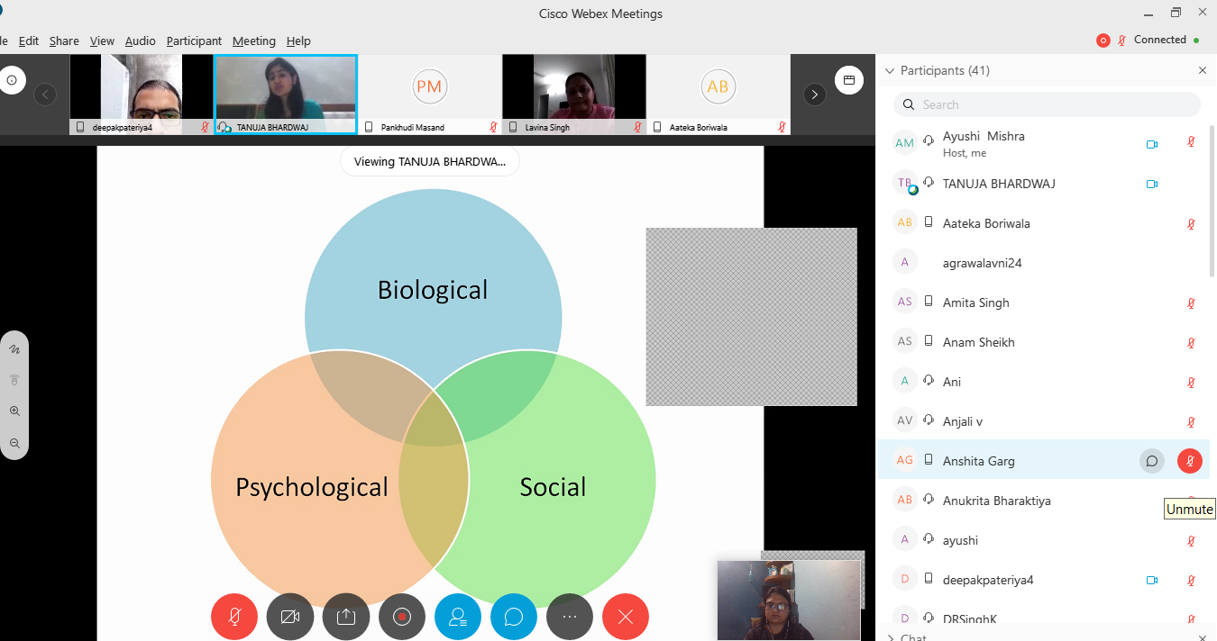

**June 5st 2020**

**“Phenomenology in Psychiatry”**

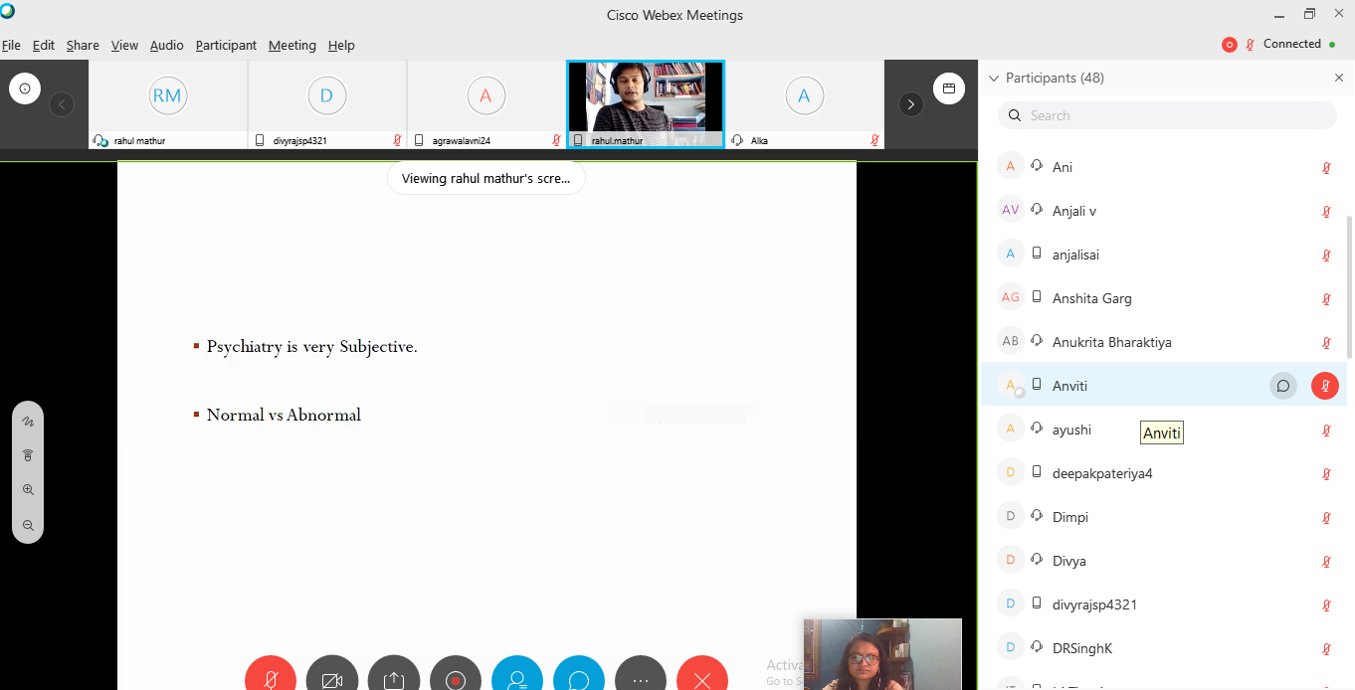

**Guest Lecture -10**

**Adolescent Sexuality, Sex and Spirituality”**

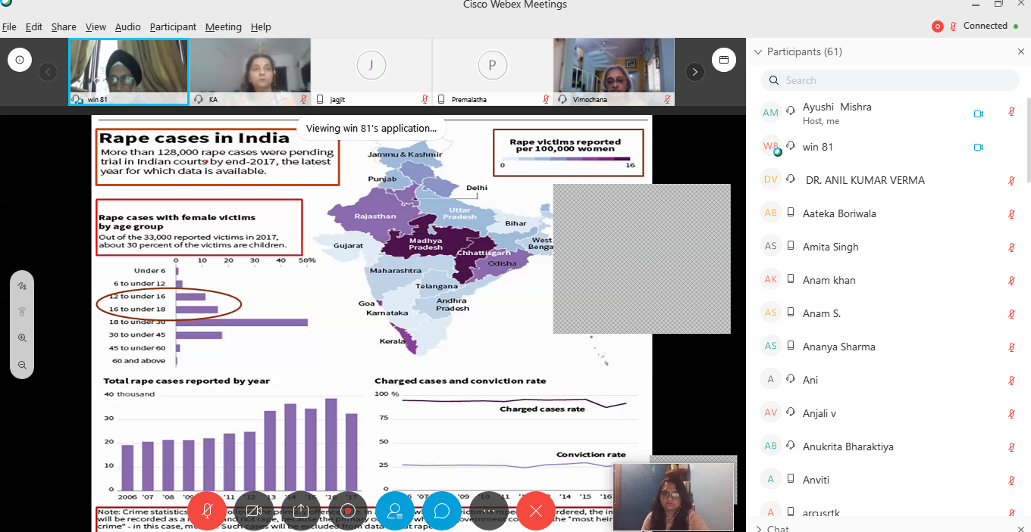

International Webinar on Anxiety Disorders

In Collaboration with

**EDUSCAN (U.A.E) DATE: JUNE 8, 2020**

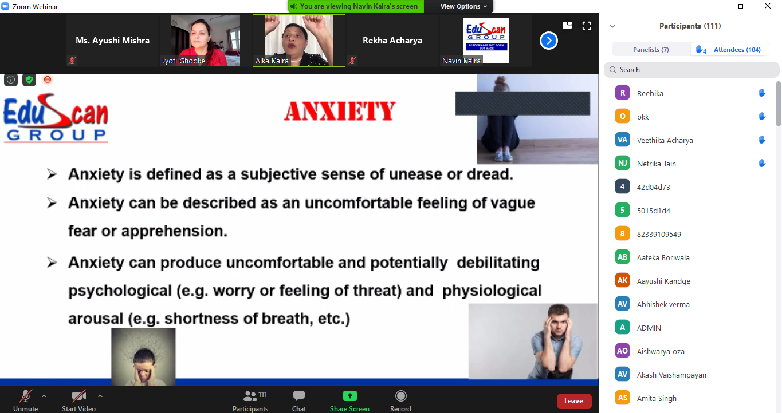

**Guest Lecture- July 7, 2020**

**“Role of Non-Profit Organization in Self and Social Development”**

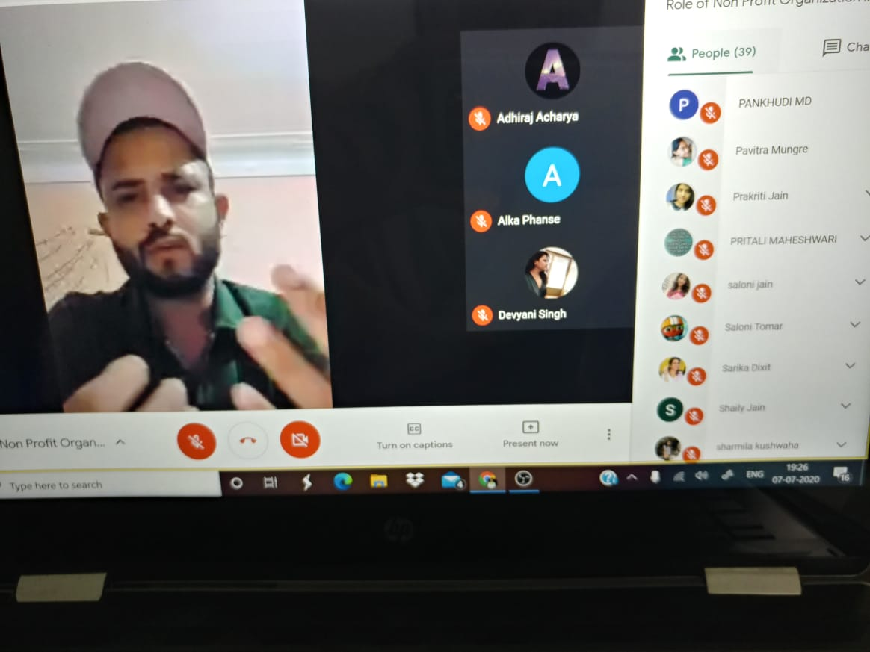

**महात्मा गांधी पीठ**

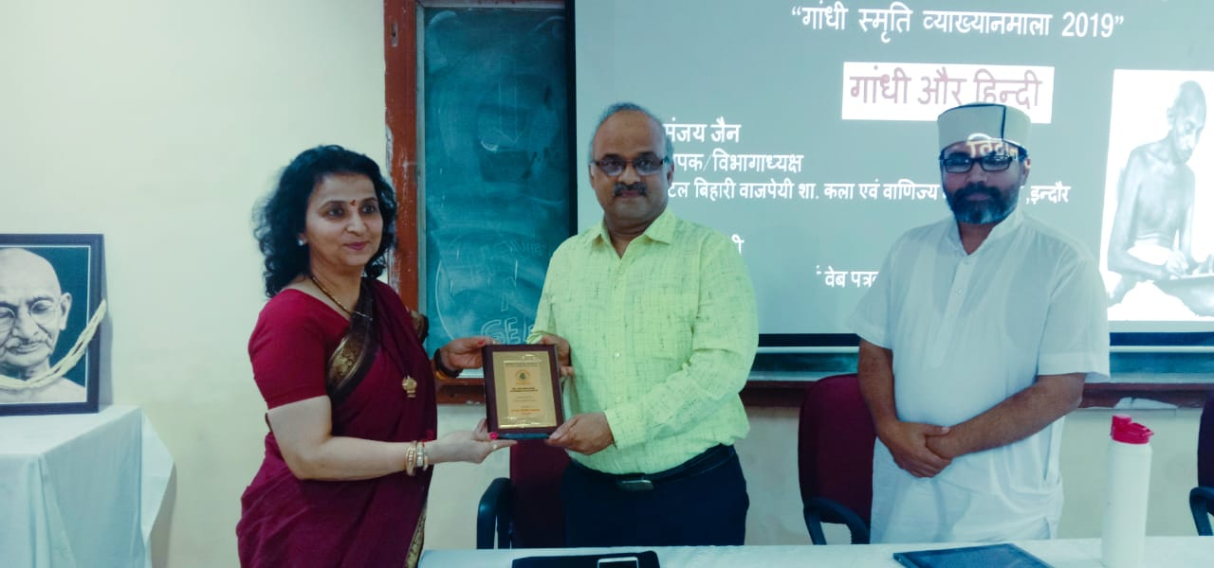

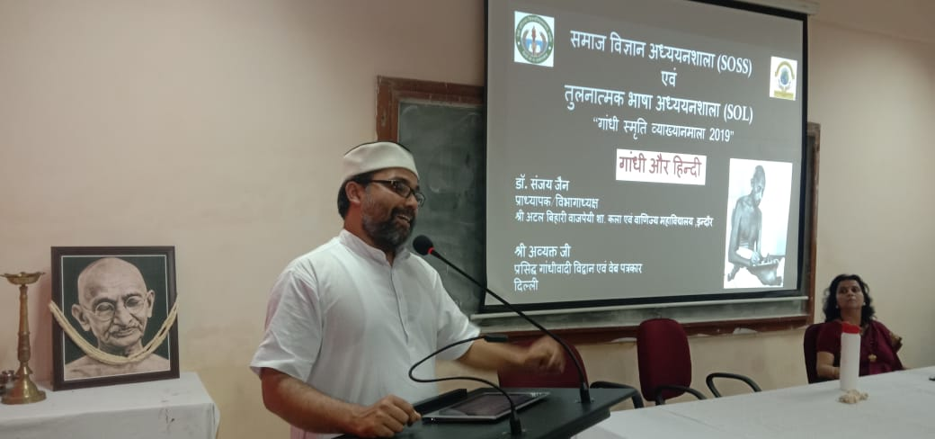

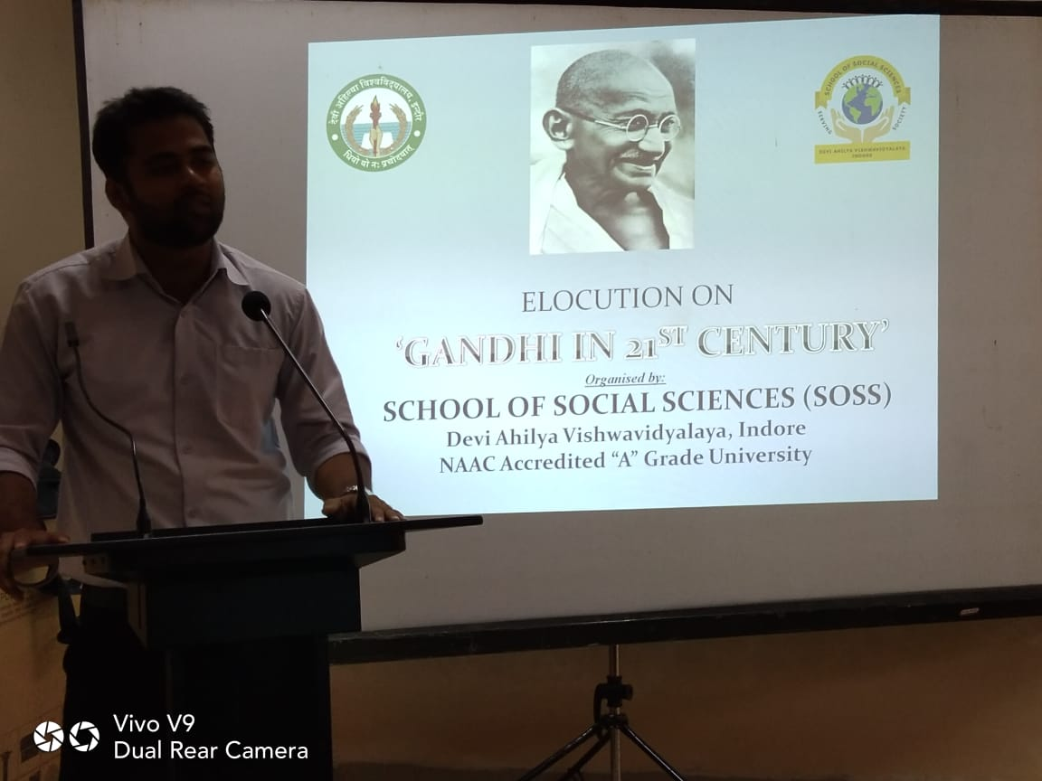

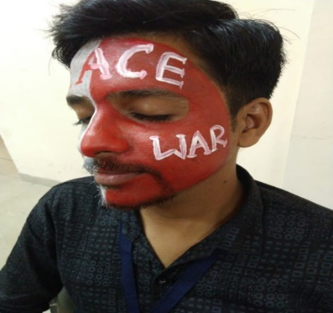

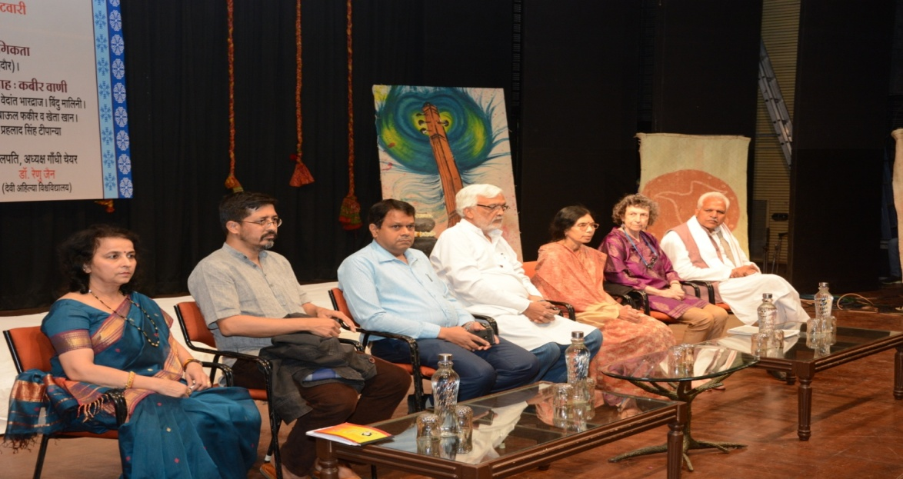

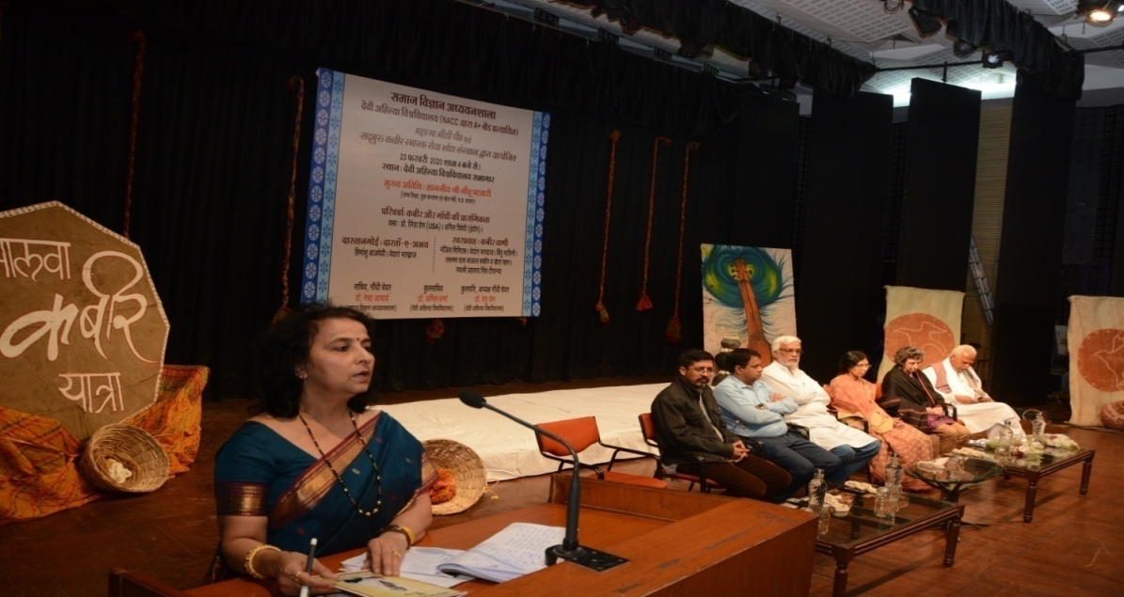

**SPORTEK**

**06th -07th March, 2020**

