

DEVI AHILYA VISHWAVIDYALAYA, INDORE

7.1.2
Alternate Sources of Energy and Energy Conservation Measures

School of Energy and Environmental Studies, DAVV Indore M.P.
7.1.7 Initiatives taken by the institution to make the campus eco-friendly (at least five)
. School organized different activities for environment protection. i.e. plantation , shram dan for an hour per week
- Energy Conservation opportunities:
(i)Energy Efficient Building Design

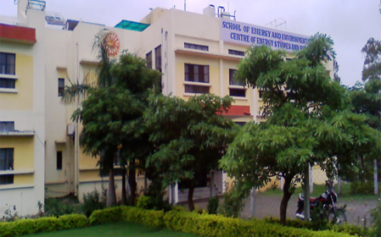
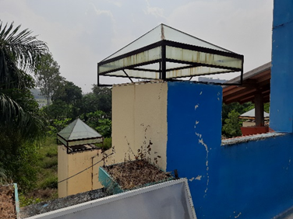
Energy Efficient Building Cooling ducts

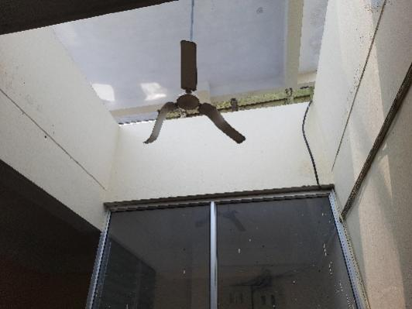
Passive cooling tower
Features
- East –west long orientation: Minimum cooling load in summer and maximum heat gain in winter
- Hollow walls: Reduction in cooling and heating load in summer and winter
- South wall windows for maximum solar heat gain in winters
- North wall window designs for proper lighting.
- Exact overhang sizes to cut direct radiation gain into the building
- Light colours on outside walls for minimum heat gain
- Light shaft for lighting
- Reflection from overhangs top white tiles to roof inside the building
- Passive cooling tower to cool /reduce Air conditioning load whole building in Summer

(ii)Energy efficient lighting, Air conditioners and other gadgets
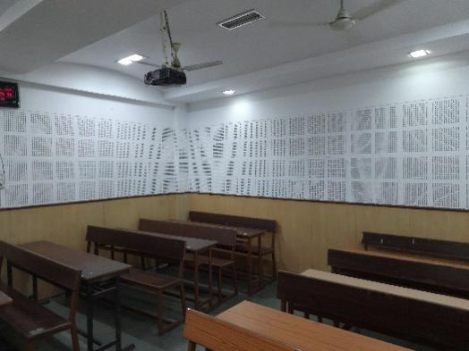
Energy efficient lighting

The following Energy efficient lighting and Air conditioners are installed for use and demonstration.
- LED lights for inside and outdoor lighting,
- Metal Halide fixtures,
- Induction lighting systems
- Energy efficient Five Star and three star Air conditioners are installed in the building.

(iii)Renewable Energy Systems
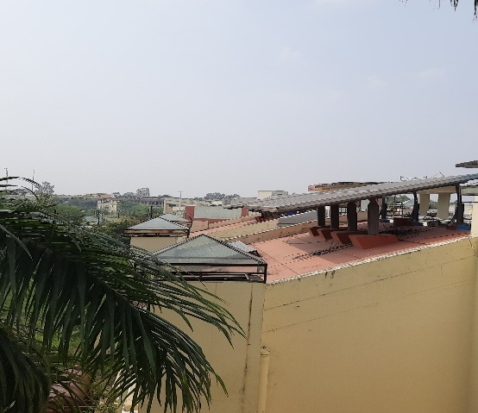
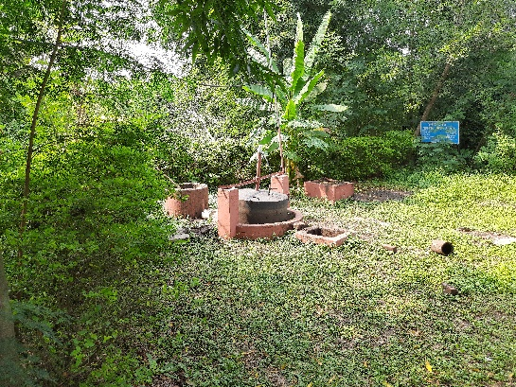
Solar PV Plant Bio gas plant

- 5 kW_{p} Photovoltaic power plant to meet the maximum demand of the department
- 2 cu meter biogas plant for departmental kitchen and for demonstration

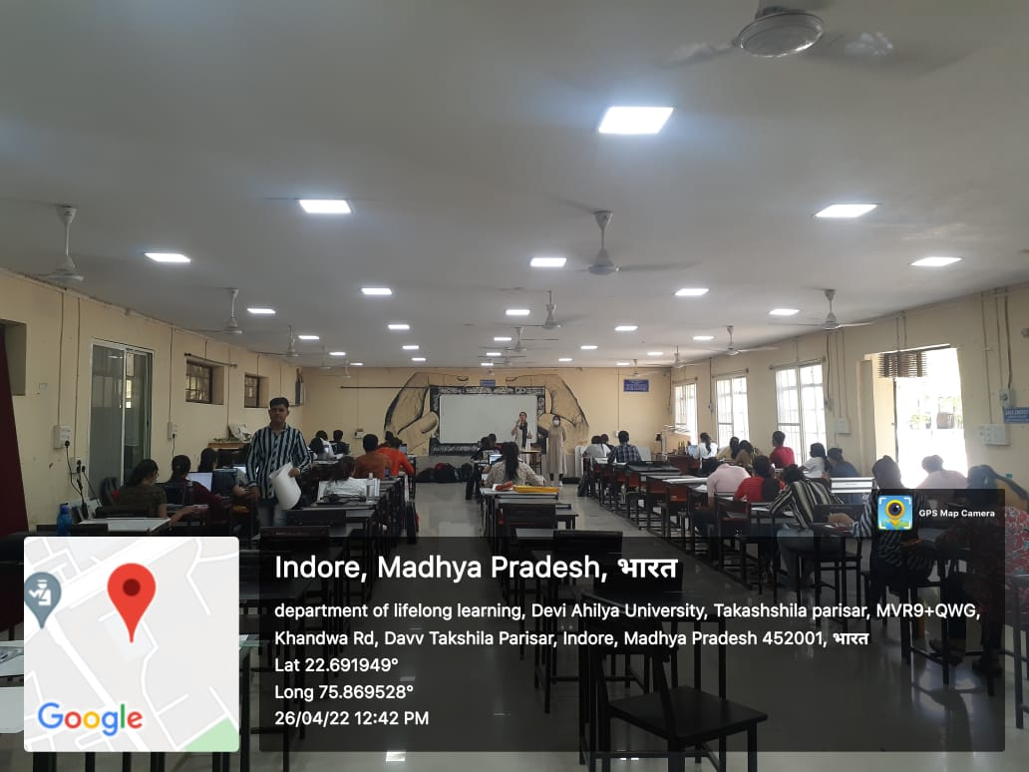
Figure 1- Department of Lifelong Energy (LED)
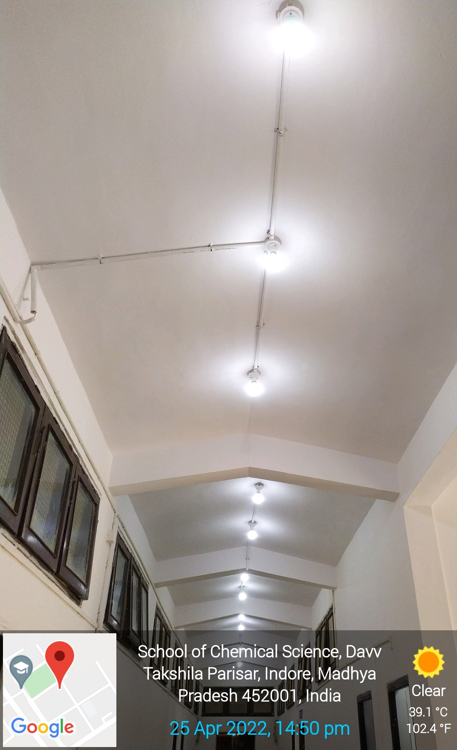
Figure 2: School of Chemical Science (LED)
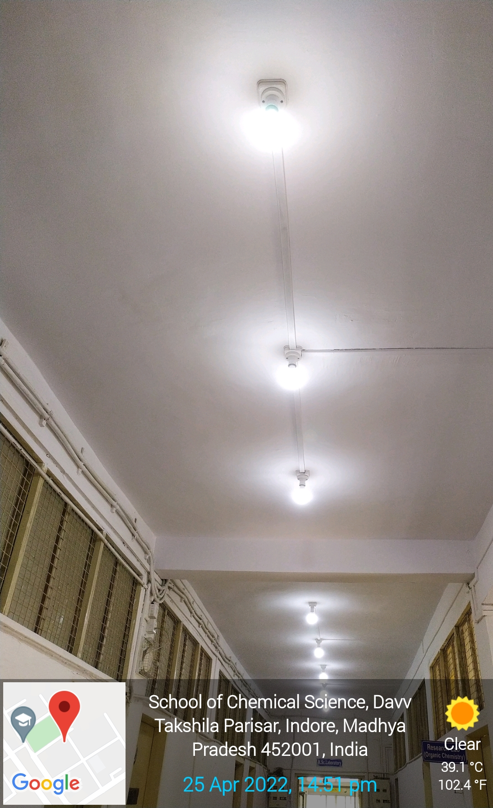
Figure 3: School of Chemical Sciences(LED)
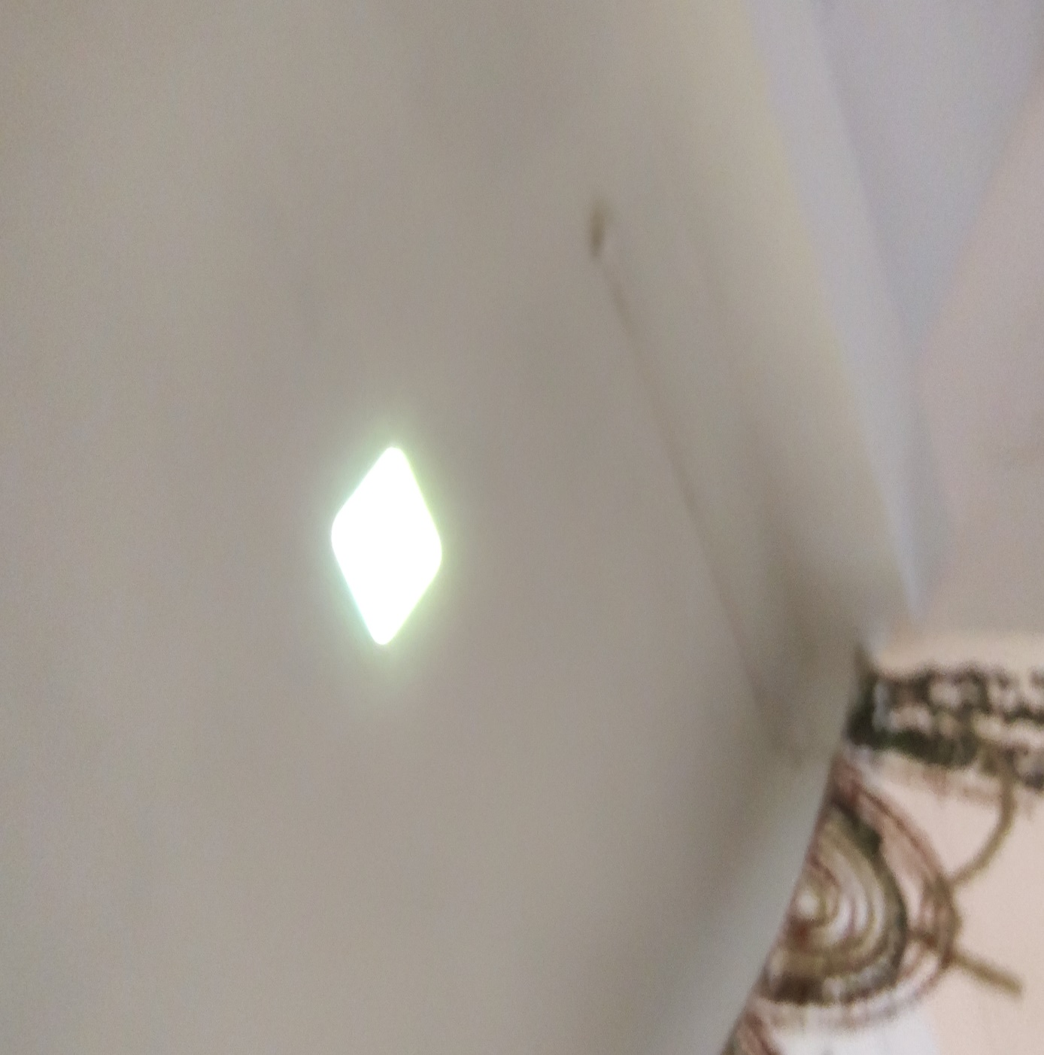
Figure 4: School of Economics (LED)
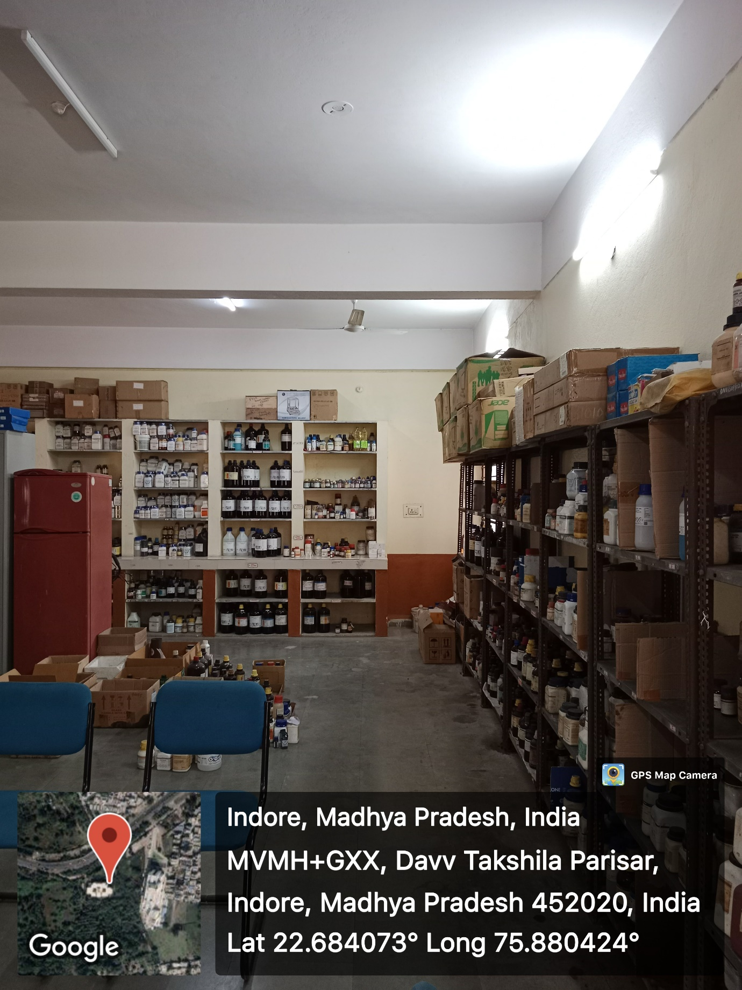
Figure 5: School of Pharmacy (LED)

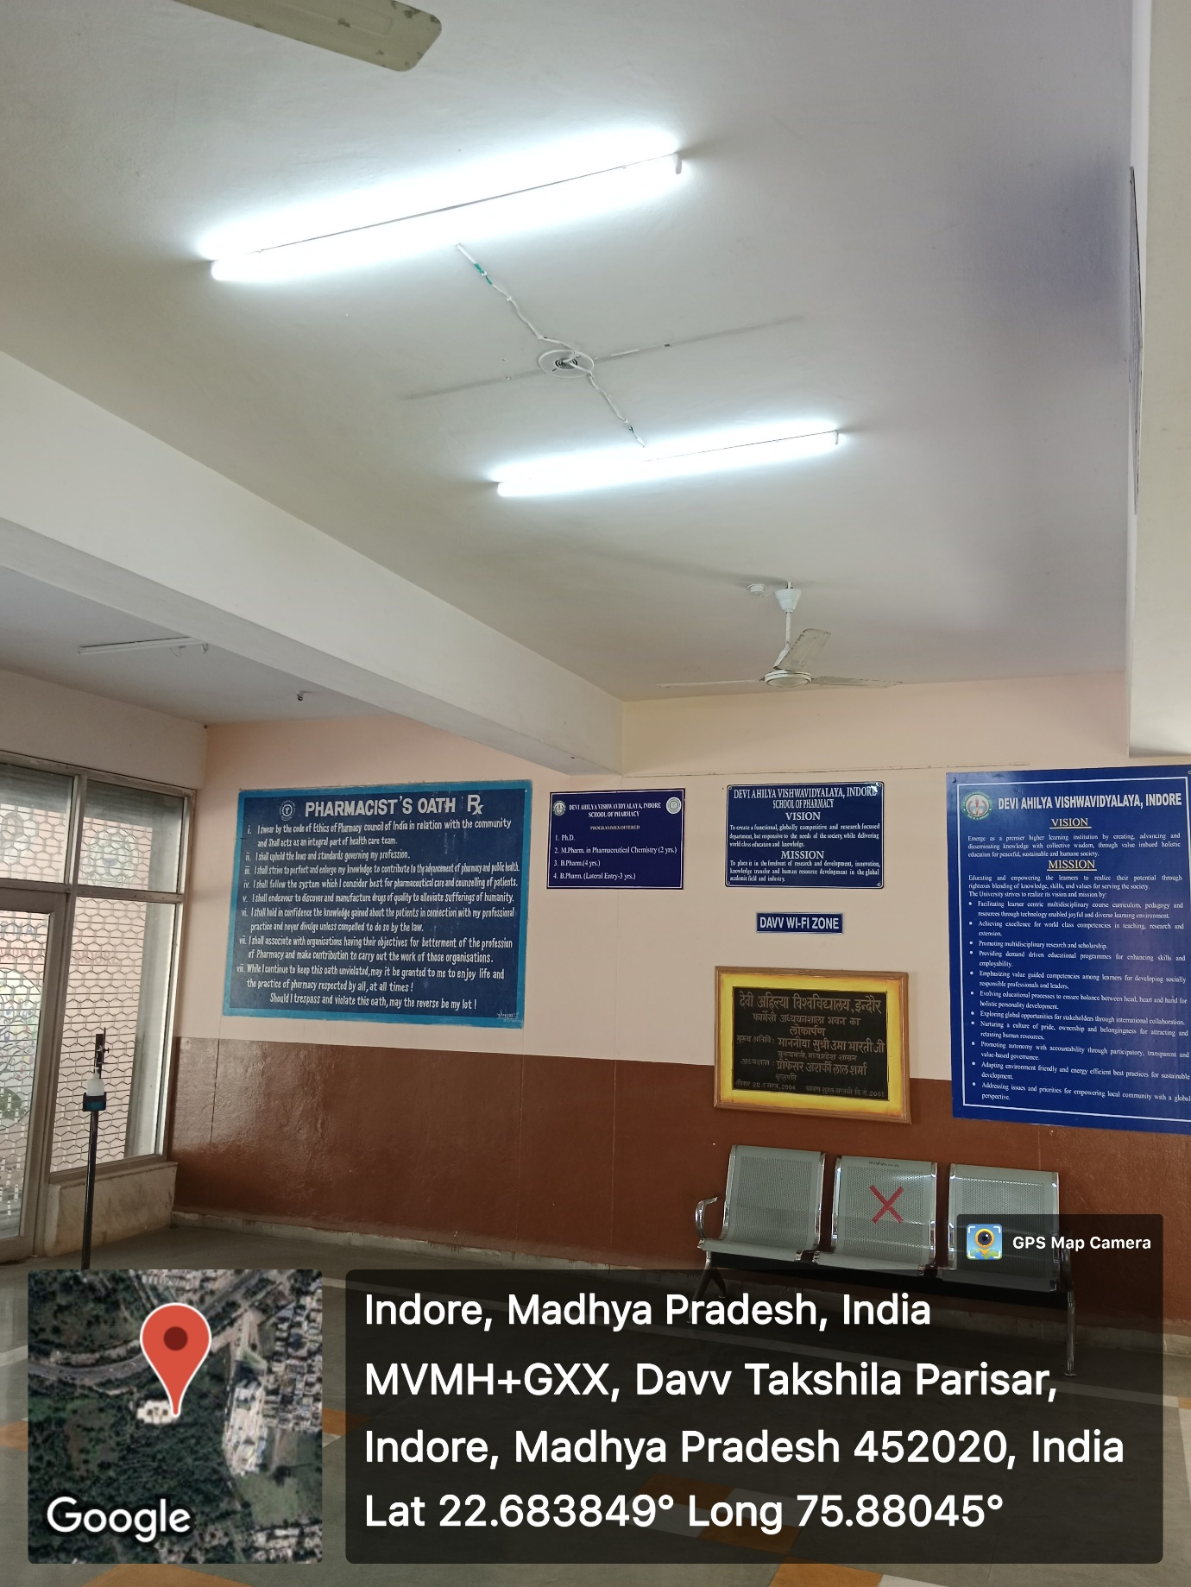
Figure 6: School of Pharmacy (LED)

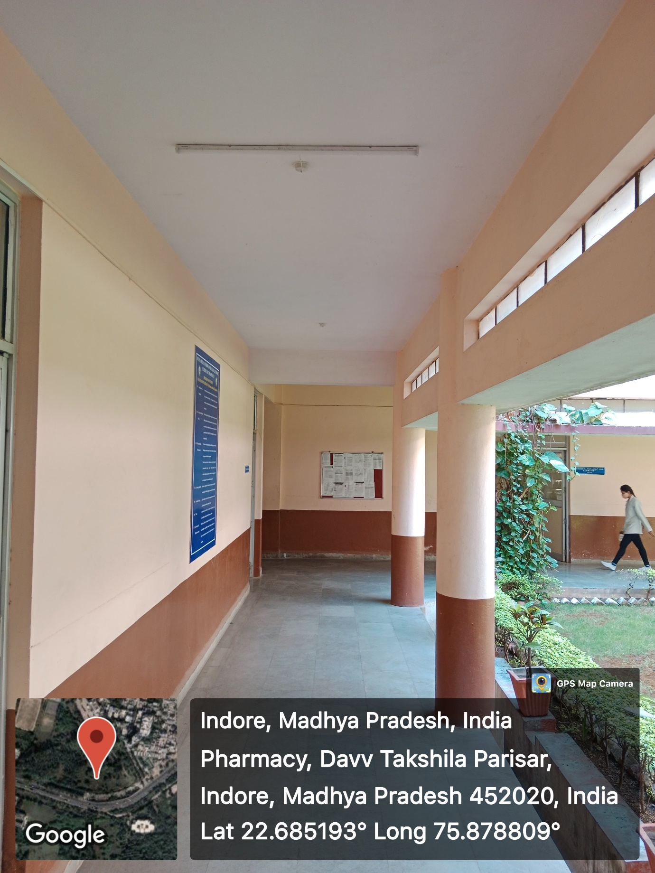
Figure 7: School of Pharmacy
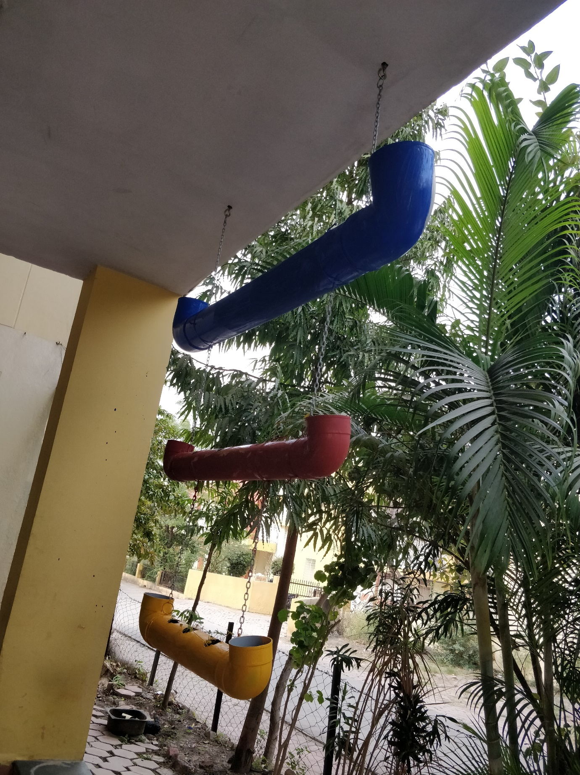
Figure 8: School of Journalism

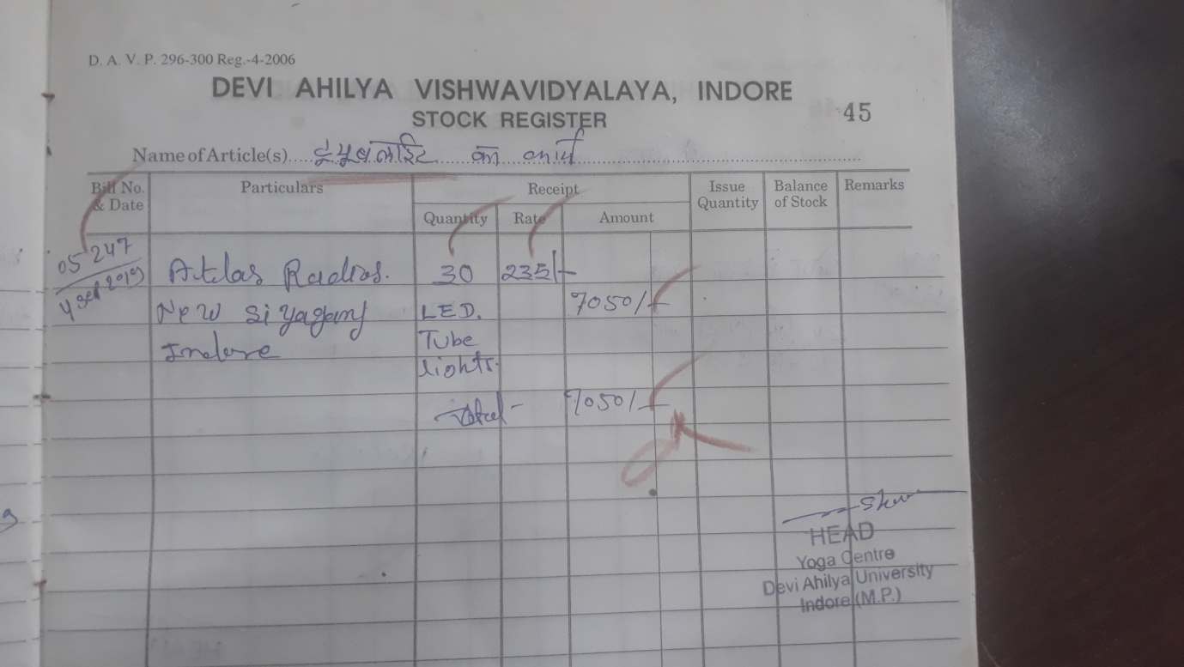
Figure 9: School of Yoga

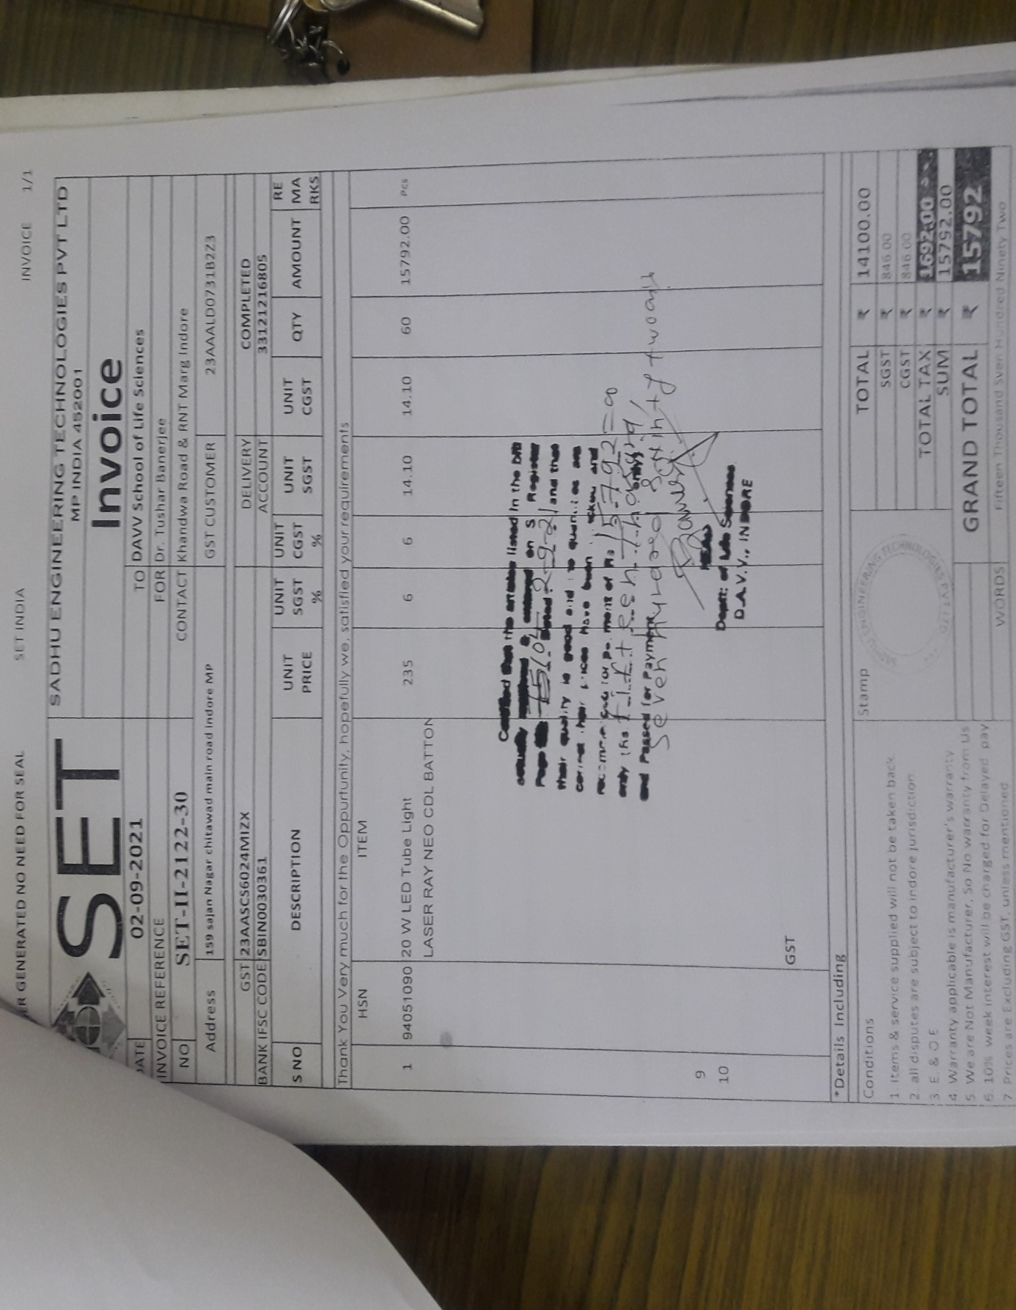
Figure 10: School of Life Sciences
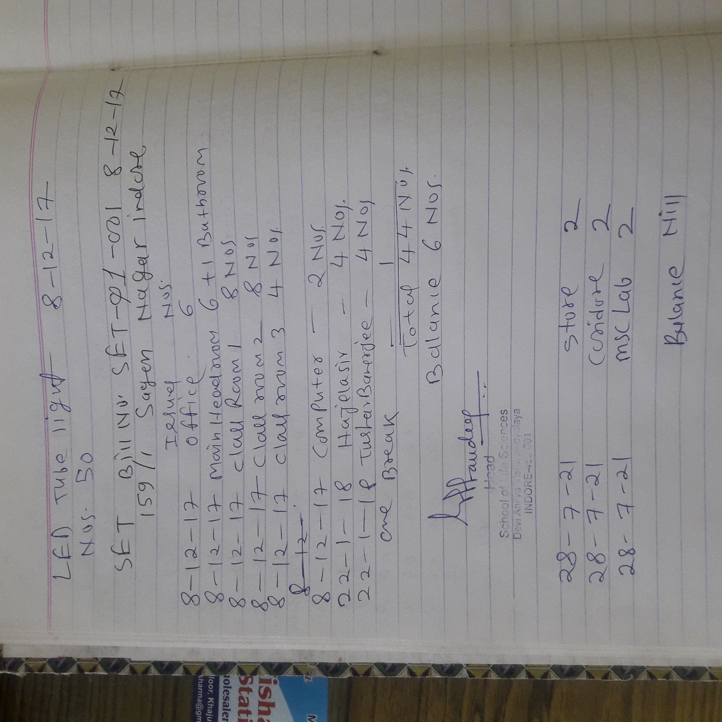
Figure 11: School of Life Sciences
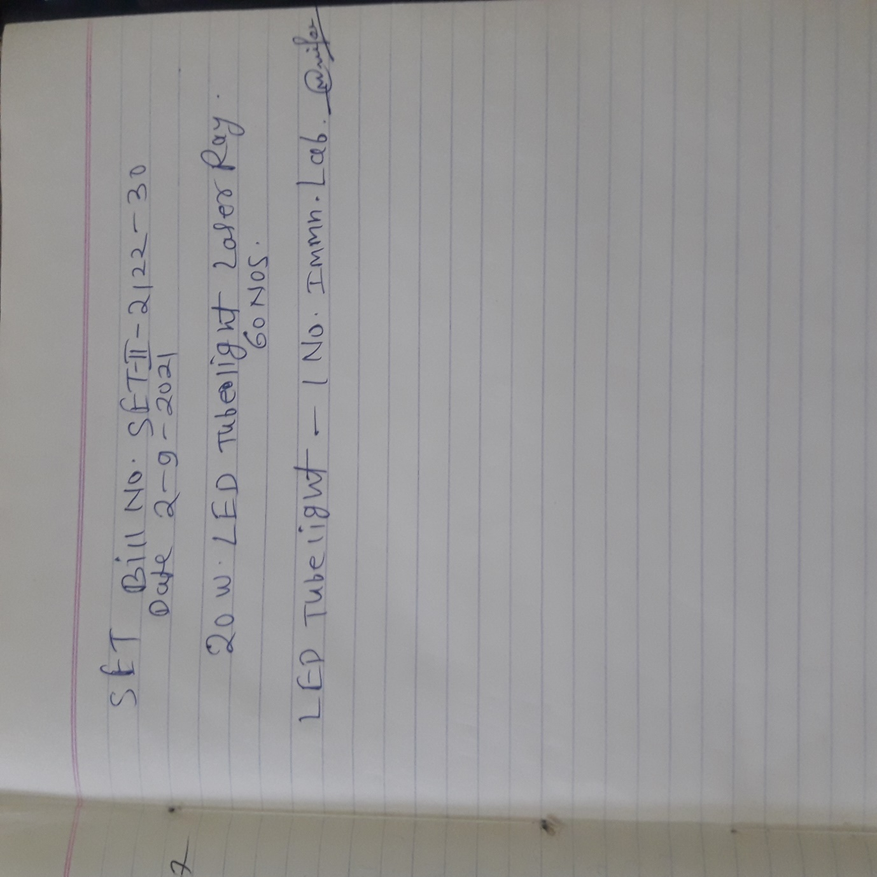
Figure 12: School of Life Sciences

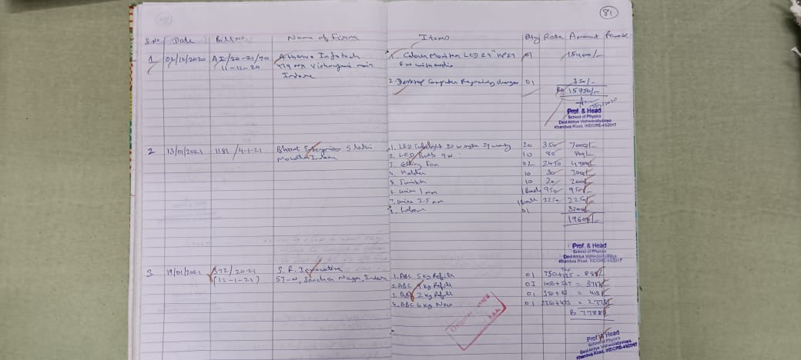
Figure 13: School of Physics
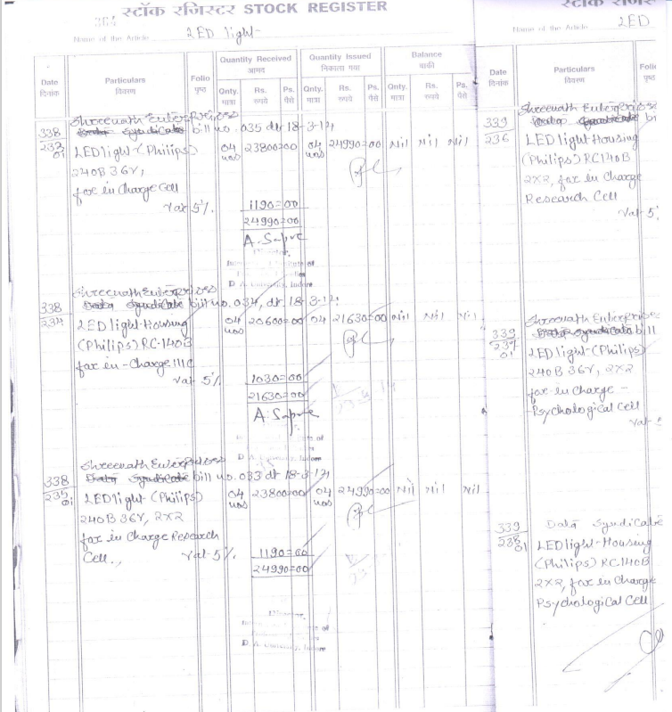
Figure 14: International Institute of Professional Studies
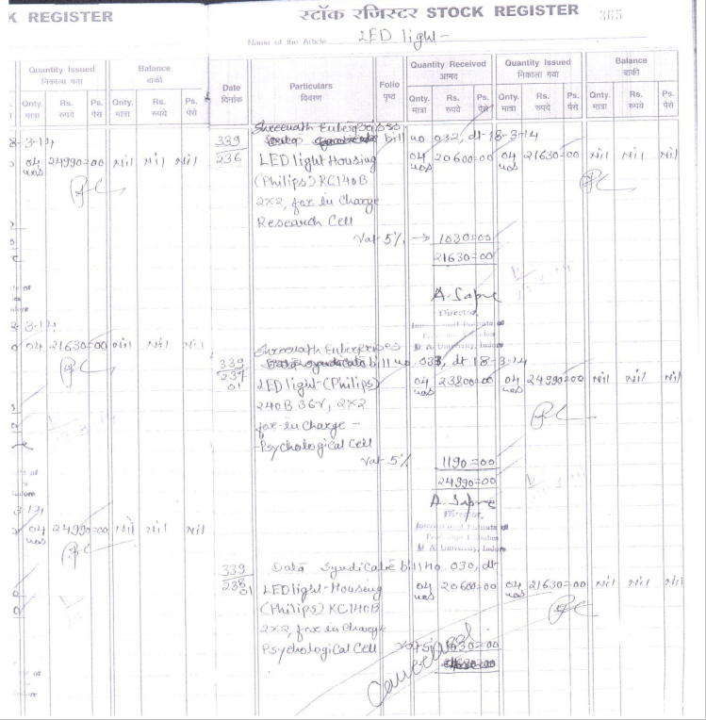

Figure 15: International Institute of Professional Studies
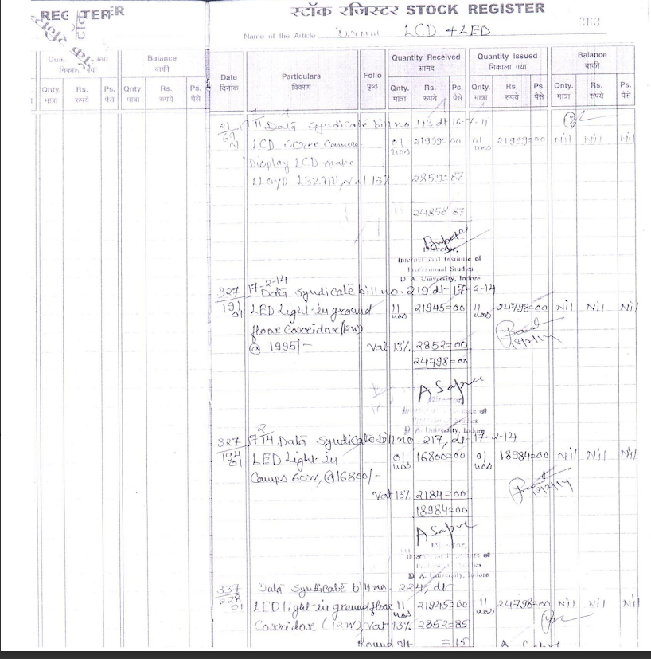
Figure 16: International Institute of Professional Studies

Figure 17: International Institute of Professional Studies

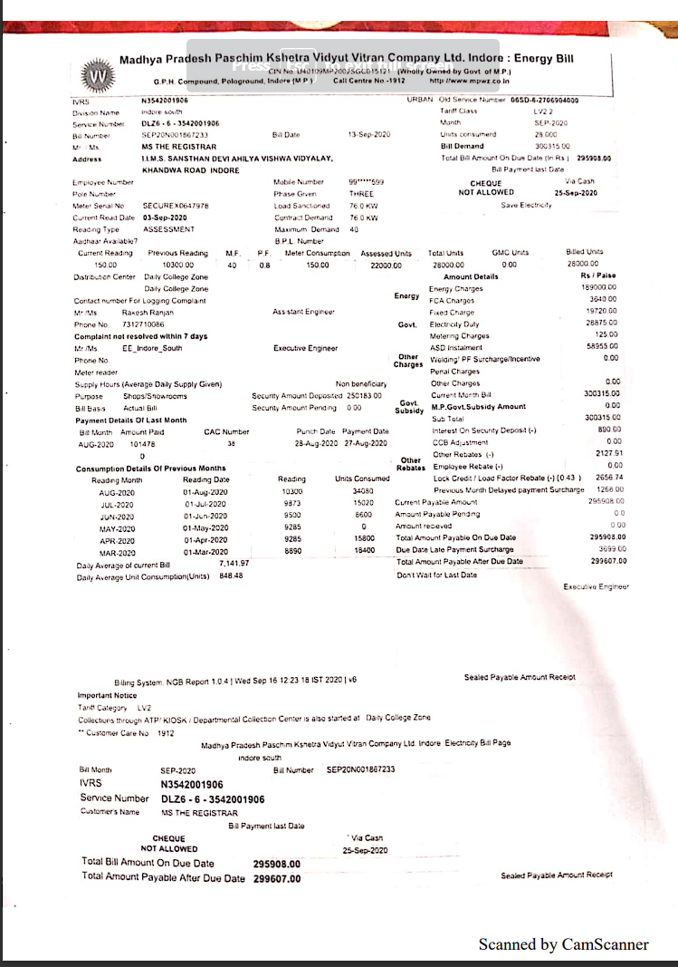
Figure 18: Institute of Management Studies

Statement of electricity bills payment Dec 2020- Jun 2021
Mundra Solar PV Ltd |  |  | MPPKVVCL (MPEB)
Date |  |  | Date
23 Dec 2020 to 5 Feb 21 | Units kWh | 17343 | 23 Dec 2020 to 23 Jan 2021 | Units kWh | 29149
 | Rate (INR) | 1.9894 |  | Rate (INR) | 13.97
 | Net Payable (INR) including 0.1% TCS | 34536.66636 |  | Net Payable (INR) | 407279
5 Feb 2021 to 26 Feb 2021 | Units kWh | 12683 | 23 Jan 2021 23 Feb 2021 | Units kWh | 26580
 | Rate (INR) | 1.9894 |  | Rate (INR) | 13.07
 | Net Payable (INR) including 0.1% TCS | 25256.79 |  | Net Payable (INR) | 347581.00
26 Feb 2021 to 27 Mar 2021 | Units kWh | 18443 | 23 Feb 2021 23 Mar 2021 | Units kWh | 22950
 | Rate (INR) | 1.9894 |  | Rate (INR) | 12.97
 | Net Payable (INR) including 0.1% TCS | 36727.19 |  | Net Payable (INR) | 297808.00
27 March 2021 to 7 Jun 2021 | Units kWh | 43957.95 | 23 Mar 2021 23 Apr 2021 | Units kWh | 24010
 | Rate (INR) | 1.9894 |  | Rate (INR) | 10.3
 | Net Payable (INR) including 0.1% TCS | 87537.40 |  | Net Payable (INR) | 247317.00
 |  |  | 23 Apr 2021 23 May 2021 | Units kWh | 16824
 |  |  |  | Rate (INR) | 11.77
 |  |  |  | Net Payable (INR) | 198146
 |  |  | 23 May 2021 23 Jun 2021 | Units kWh | 17306
 |  |  |  | Rate (INR) | 11.64
 |  |  |  | Net Payable (INR) | 201508
Total units generated by Solar PV/Units purchased from MPEB | Units Generated | 92426.95 |  | Units Purchased | 136819
Total net paid (INR) during the period under consideration |  | 184058.05 |  |  | 1699639.00
Rate /unit (kWh) |  | 1.99 |  |  | 12.42
Figure 19: Institute of Engineering and Technology
Institute of engineering and technology

