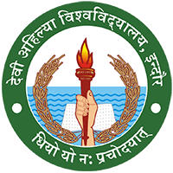

DEVI AHILYA VISHWAVIDYALAYA, INDORE

7.1.3
Biodegradable and Non-Biodegradable Waste

WASTE MANAGEMENT
in
International Institute of Professional Studies, DAVV, Indore
International Institute of Professional Studies is one of the biggest teaching departments of Devi Ahilya University by Physical Landscape and also based on no. of Teaching & Non-Teaching Staff and Students. The size of economic activity generate in the department also results in generation of large amount of solid (day to day garbage and educational waste like dumped examination material etc.) and E- waste (Old electronic items like computer & computer peripherals)

Solid Waste Management:-

  - The day-to-day bio- degradable garbage produced in the department is firstly, segregated in the department as Dry & Wet Waste, as per the norms of Indore Municipal Corporation. The garbage collection vehicle of IMC daily visits the department to collect its segregated day-to-day waste. (Photos of collection enclosed)
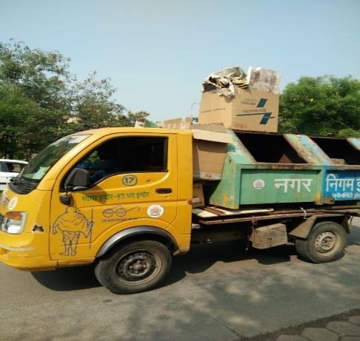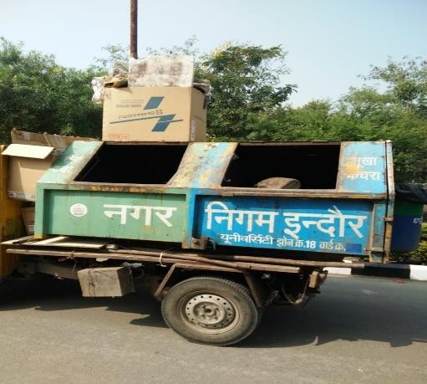
Figure 1: IIPS,DAVV

  - The Educational waste which automatically gets created as per norms of examination after six months of examination held, is disposed of for recycling by the department as per the disposable norms and tendering process as decided by Devi Ahilya University at central level for all its teaching departments.

E-waste Management: -

The E-waste that is accumulated in the department is disposed of in environmentally friendly manner by giving it to its manufacturers as buyback process at the time of buying new peripherals. The E-waste that is left over even after buybacks is disposed of at university levels as per the norms decided by Devi Ahilya University.

IMS, DAVV
NSS
Traffic Week
Place: Indore
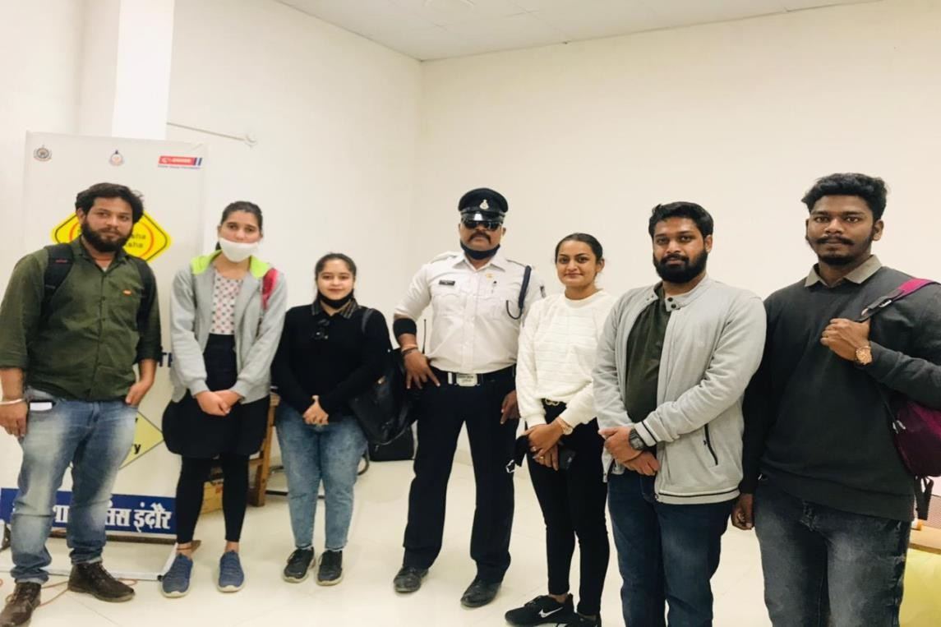
About: NSS Unit IMS participated in Traffic Week in January 2021.In the event participants contributed in awareness and educating to citizens about rules, regulation and importance of traffic discipline in collaboration of Traffic Police administration.NSS Officer Dr.Bhanu Pratap Singh coordinator of NSS Unit IMS.
Figure 2: IMS,DAVV

Event: “EK BHARAT SHRESHTH BHARAT”

Place: Indore city

About: NSS Unit IMS participated in “EK BHARAT SHRESHTH BHARAT” on 5th February, 2021.Participants contributed for Water conservation and Sanitation through poster making.20 volunteers participated in the event. NSS Officer Dr.Bhanu Pratap Singh coordinator of NSS Unit IMS.
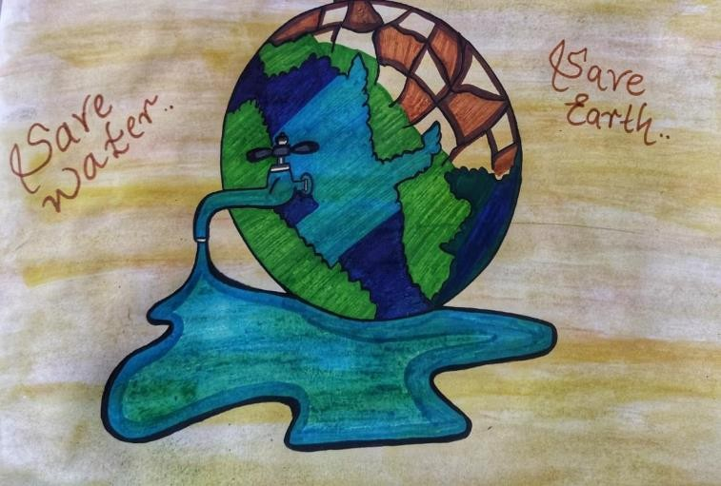
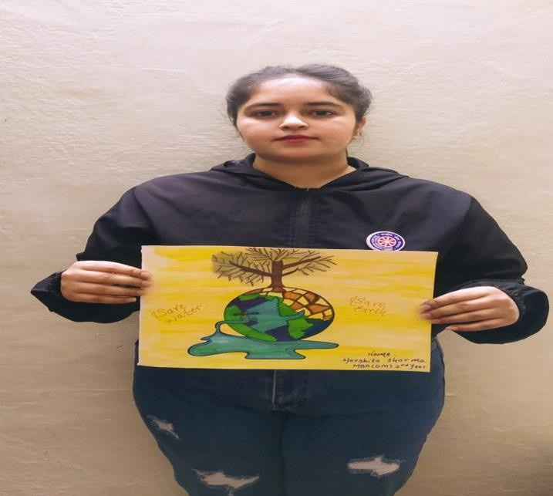
Figure 3: IMS,DAVV
Figure 4: IMS, DAV

Event: Webinar on Youth Day, 12thJanuary,2021
Place: Indore city
About: NSS Unit IMS participated in “Webinar on Youth Day” 12th January, 2021.Guest speaker Dr. Pawan Kumar Dubey, Group Director, Swami Vivekananda Group of Institute Indore enlightened the participants about teachings and contribution of Youth in nation Building in the excerpts of Swami Vivekananda.NSS Officer Dr.Bhanu Pratap Singh coordinator of NSS Unit IMS.The event was blessed by Director IMS Professor Sangeeta Jain.
60 volunteers participated in the event

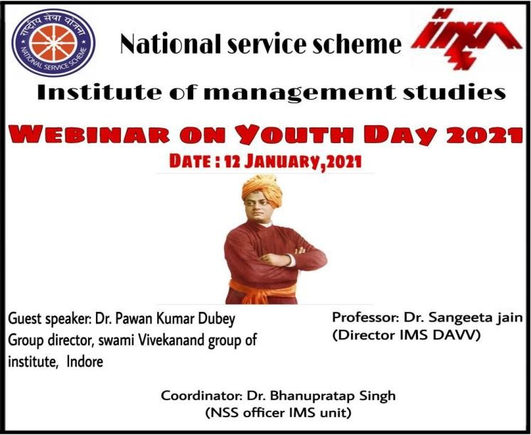
Figure 4:IMS,DAVV

Report

Event: Azaadi Amrit Mahotasava, 12th March 2021

Place: Indore city, School of Journalism and Mass Communication

About: On the occasion of Inauguration of Azaadi Amrit Mahotasava, live telecast of event was exhibited to the volunteers and faculties. Honorable Prime Minister Mr. Narendra Modi addressed the nation about Atmanirbahr Bharat and contribution of Mahatma Gandhi in self reliant step of India.The event was hosted under flagship of DAVV,Indore
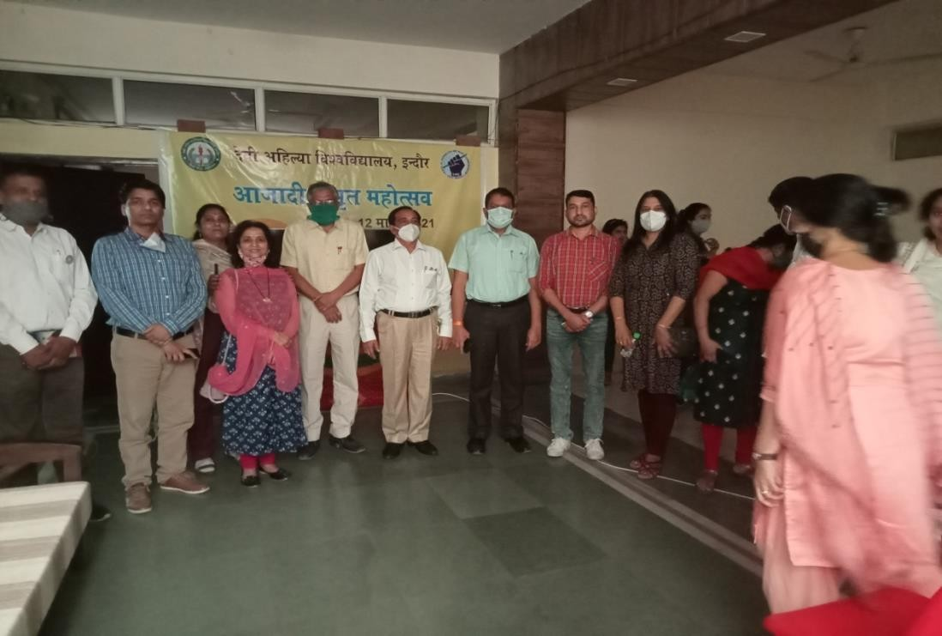
Figure 5: IMS,DAVV

Report “Cycle Rally”

Event: Azaadi Amrit Mahotasava, 16th March 2021
Place: IMS Takshshila Parisar to Kastoorba Gram,Indore

About: On the occasion of Azaadi Amrit Mahotasava, Cycle Rally was organized from IMS Takshshila Parisar to Kastoorba Gram,Indore.The Rally was aimed at developing awareness about contribution of Mahatma Gandhi contribution towards freedom movement and remembrance of Non-Cooperation Movement through Dandi Yaatra.The Rally was hosted by Dr. Anil Sharma,Registrar and dr. Ashok Sharma Rector,DAVV Indore.NSS Coordinator and NSS Officers of NSS Unit of different UTD participated along with 80 volunteers.
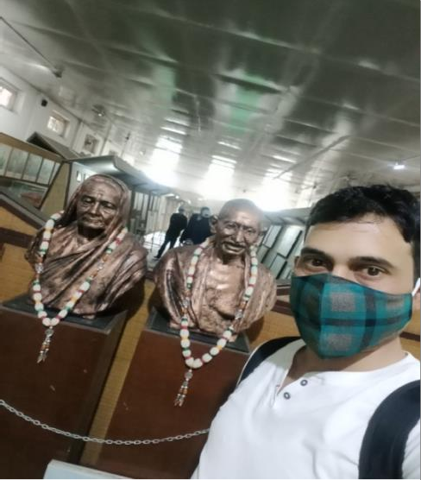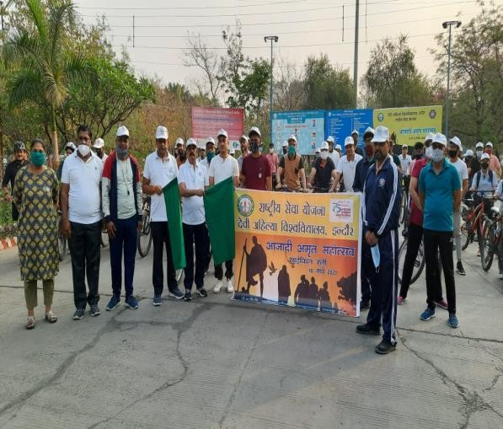
Figure 6: IMS,DAVV

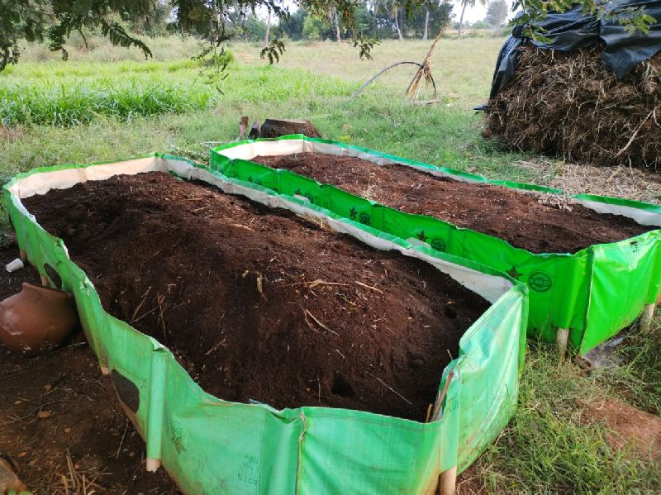
Figure 7: School of Economics
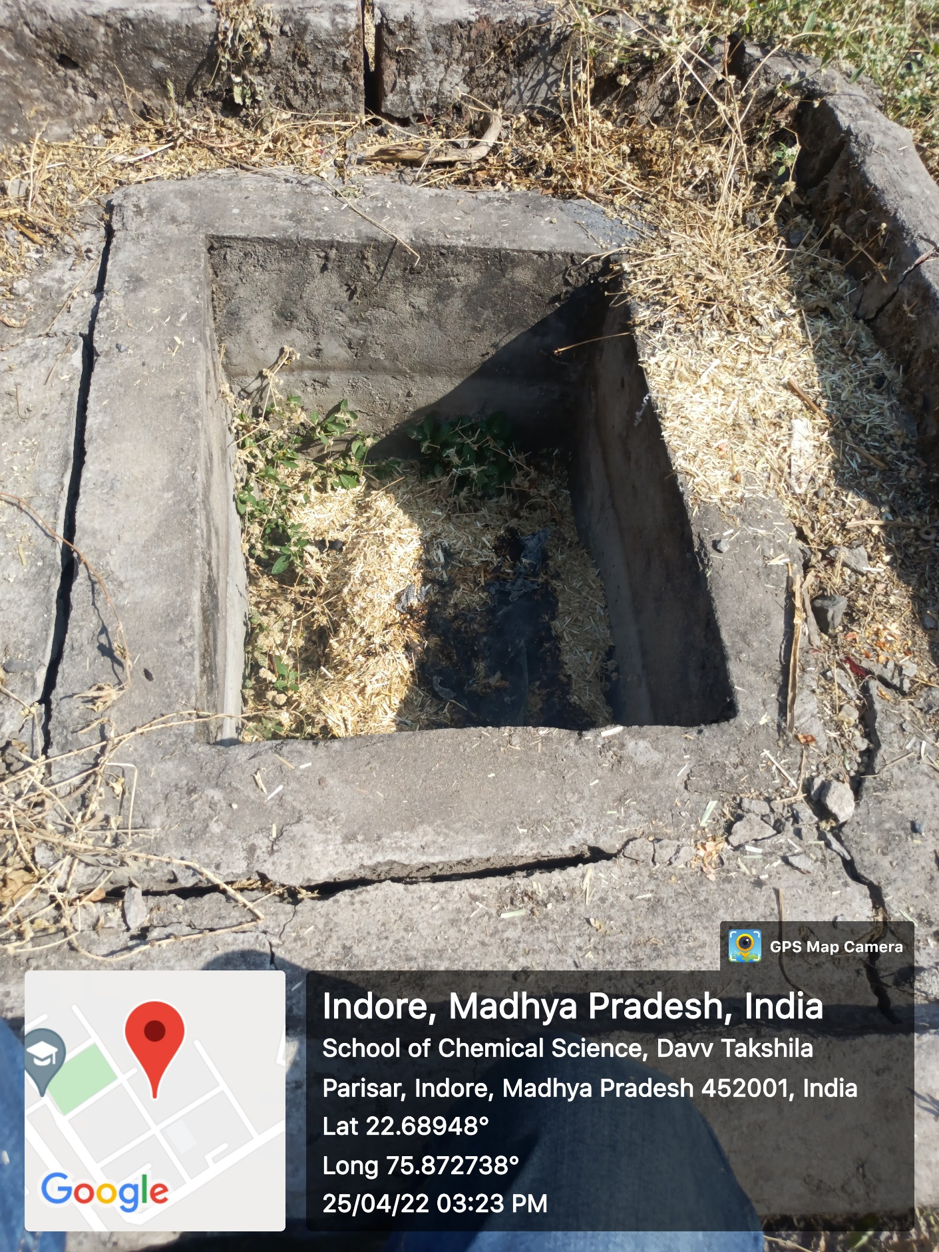
Figure 8: School of Life Sciences

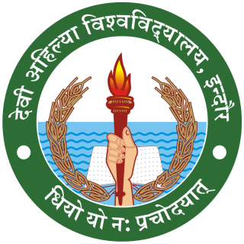
DEVI AHILYA VISHWAVIDYALAYA, INDORE
DEPARTMENT OF LIFE LONG LEARNING
Dr. Bharti Joshi
Head

7.1.3- WORKSHOP ON “FURNITURE CREATION through waste materials ”
The 7 days workshop was conducted by visiting faculty Ms. Anita Pal in academic session 2020-21 for the students B.Voc Interior design 6th sem. at the Department of Life Long Learning campus. They used dumped furniture & waste material like doors, windows, wood, tyre etc. They made double purpose centre table cum drawer, sofa with the dumped chairs, swing etc. The main aim of the workshop was how to use waste materials / goods to make furniture. They understood the use of area for better layout in less space. By using waste materials to make furniture, the students developed new ideas. This workshop also helped in keeping the environment neat and clean.
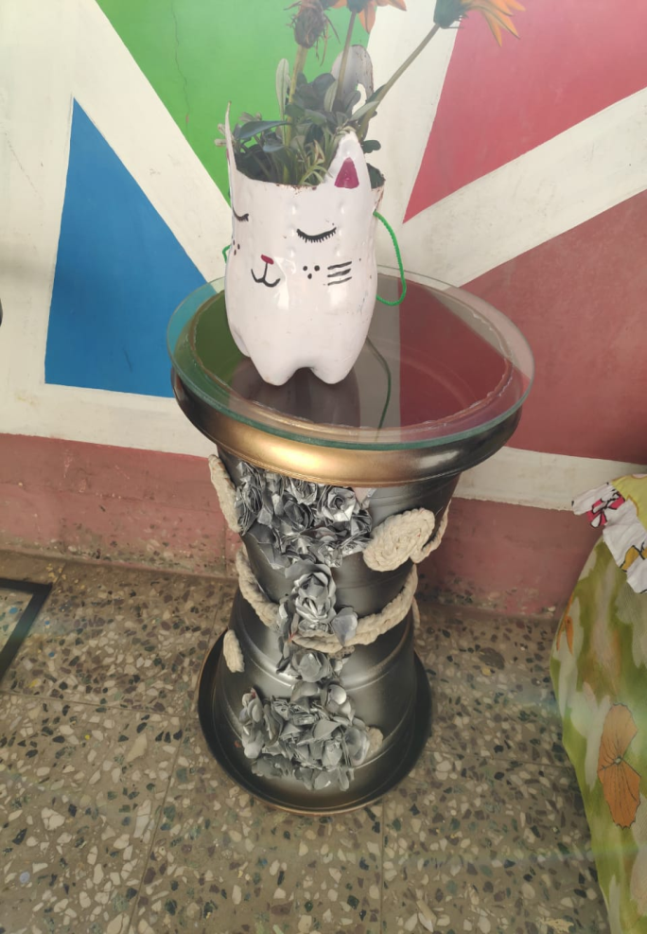
Figure 9: Department of Lifelong Learning
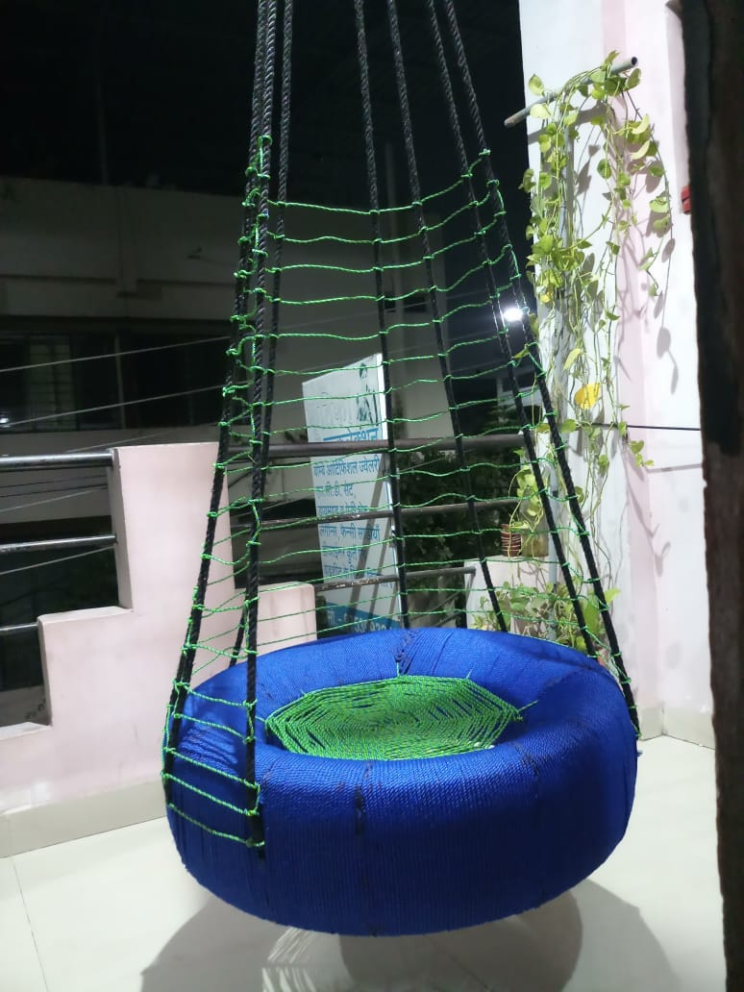
Figure 10: Department of Lifelong Learning
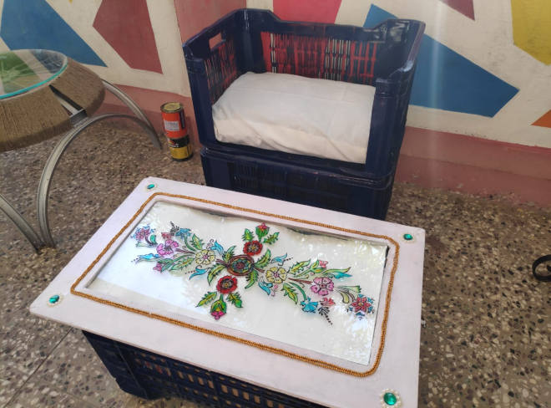
Figure 11: Department of Lifelong Learning
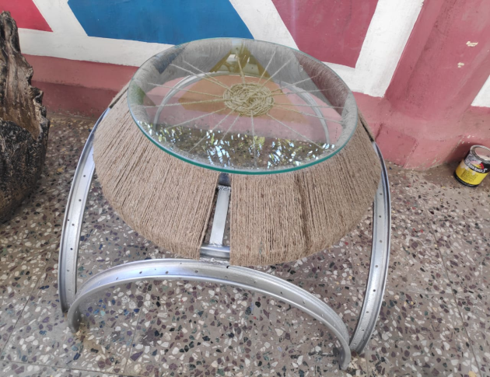
Figure 12: Department of Lifelong Learning
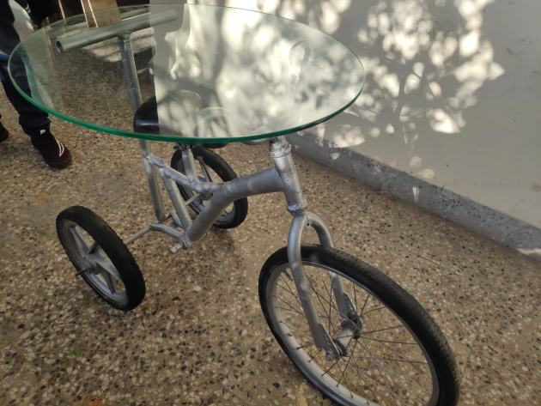
Figure 13:Department of Lifelong Learning
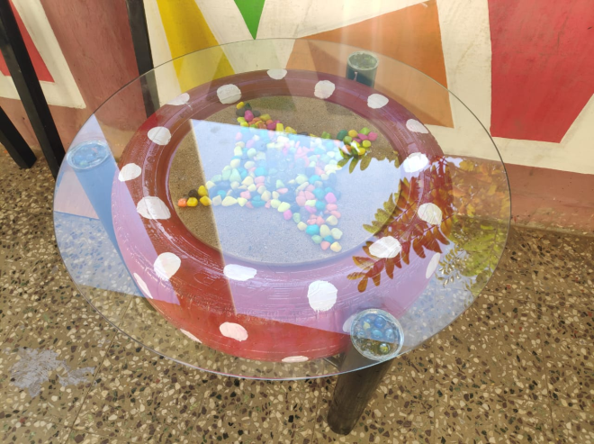
Figure 14:Department of Lifelong Learning

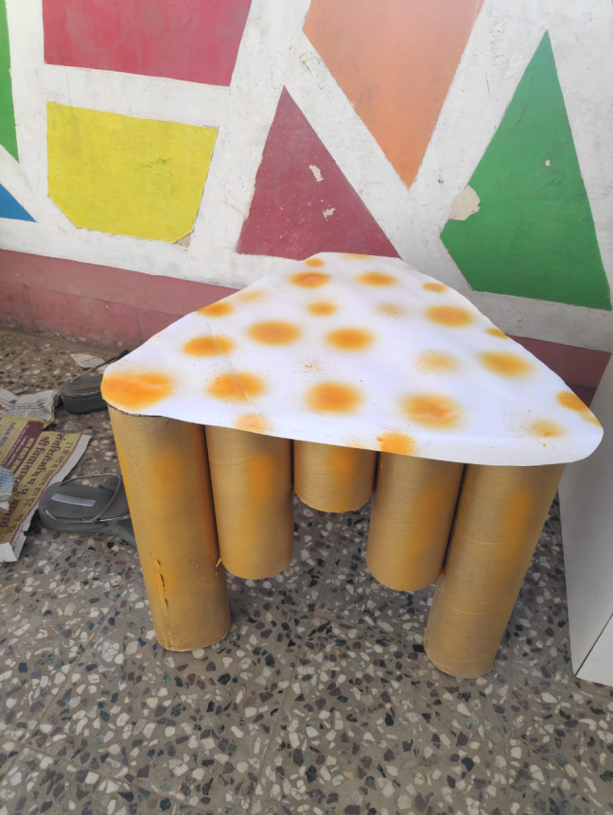
Figure 15: Department of Lifelong Learning
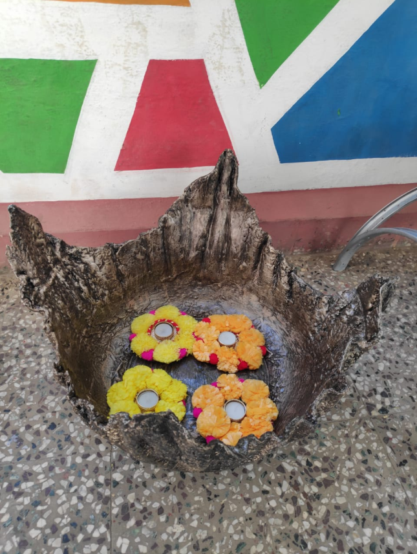
Figure 16:Department of Lifelong Learning
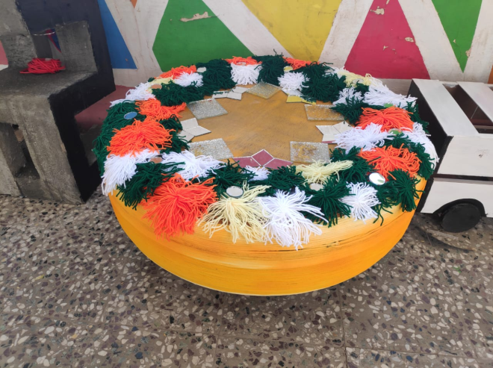
Figure 17: Department of Lifelong Learning
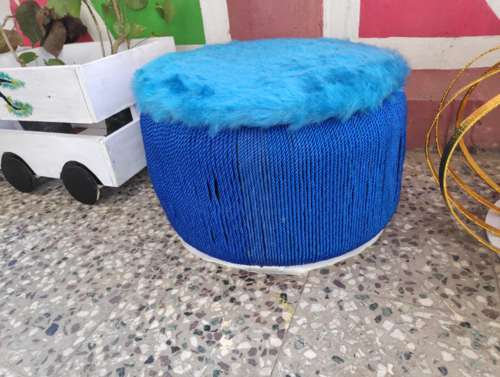
Figure 18:Department of Lifelong Learning
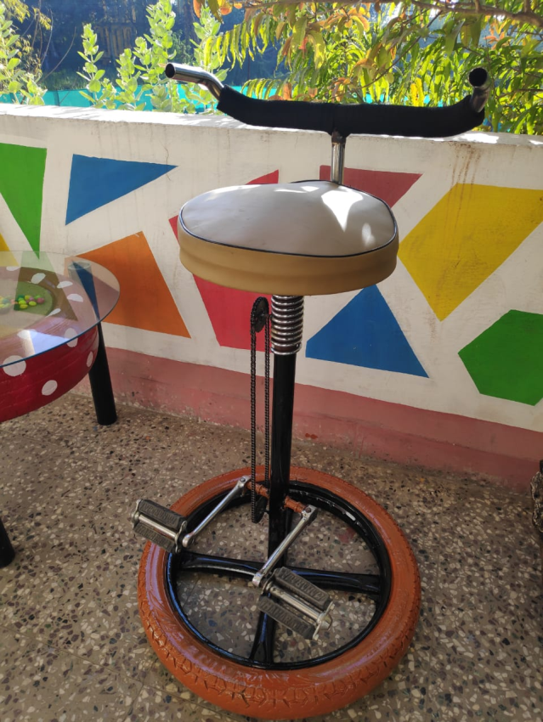
Figure 19: Department of Lifelong Learning
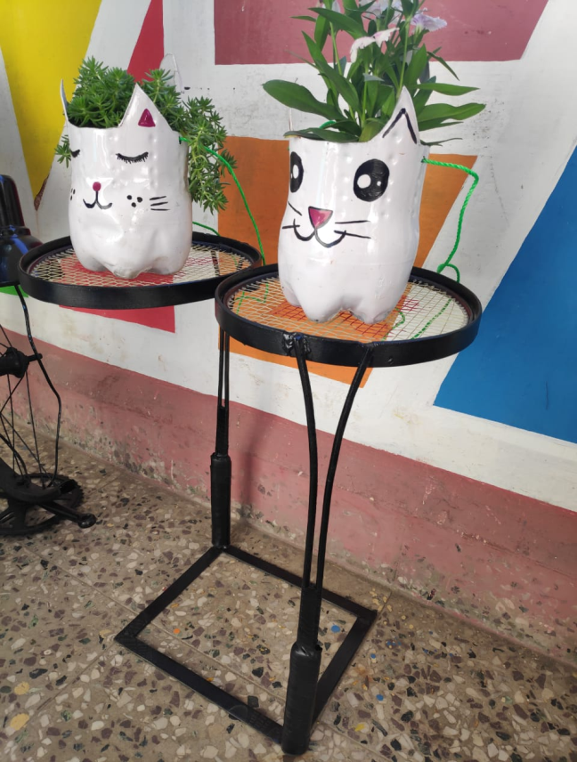
Figure 20: Department of Lifelong Learning
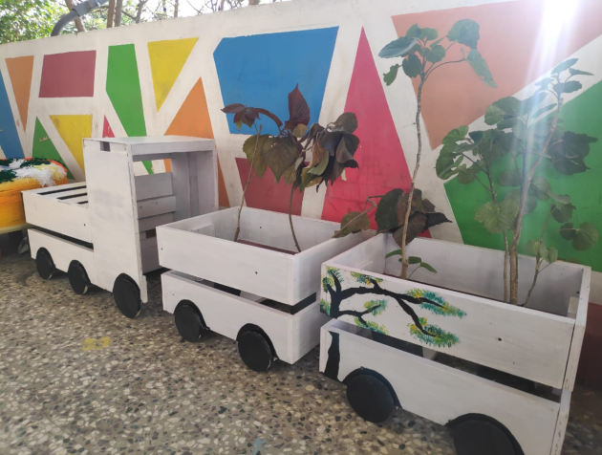
Figure 21: Department of Lifelong Learning
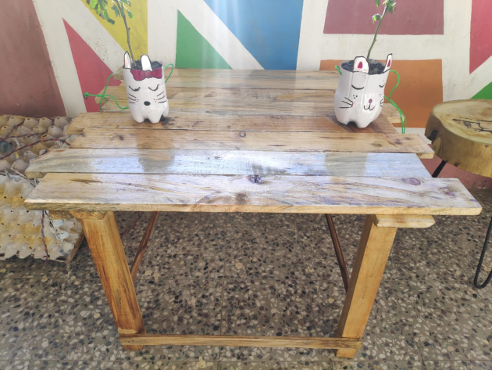
Figure 22: Department of Lifelong Learning
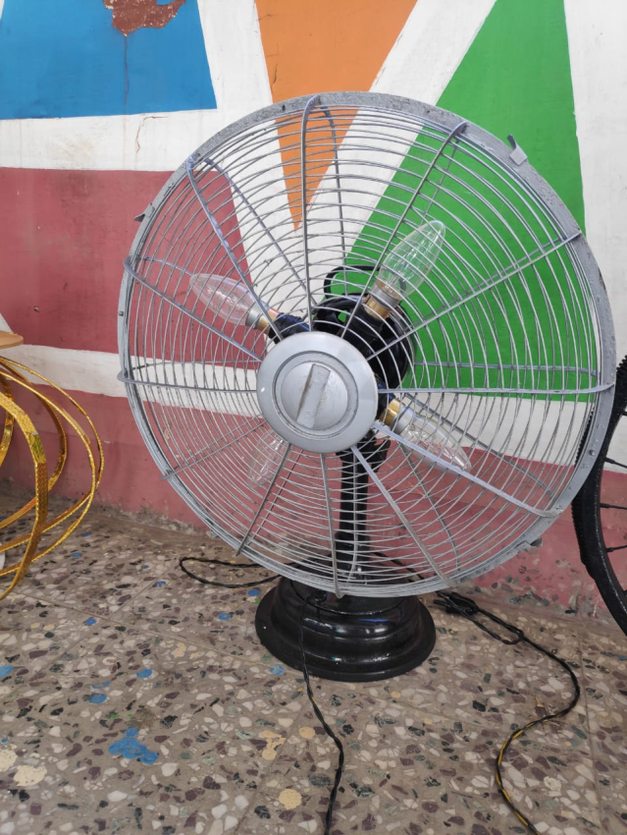
Figure 23:Department of Lifelong learning
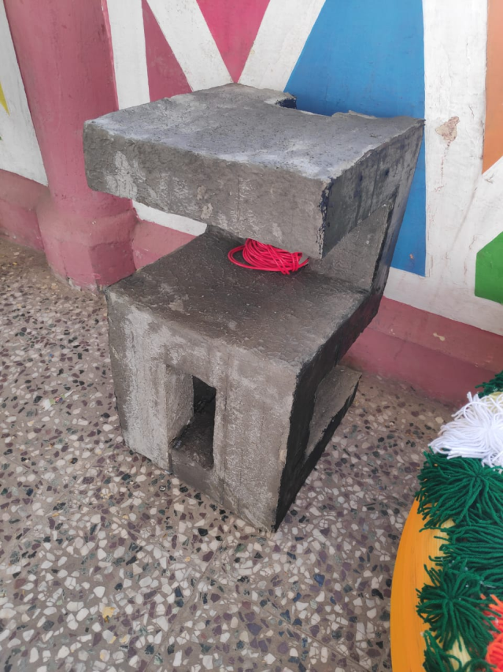
Figure 24: Department of Lifelong Learning
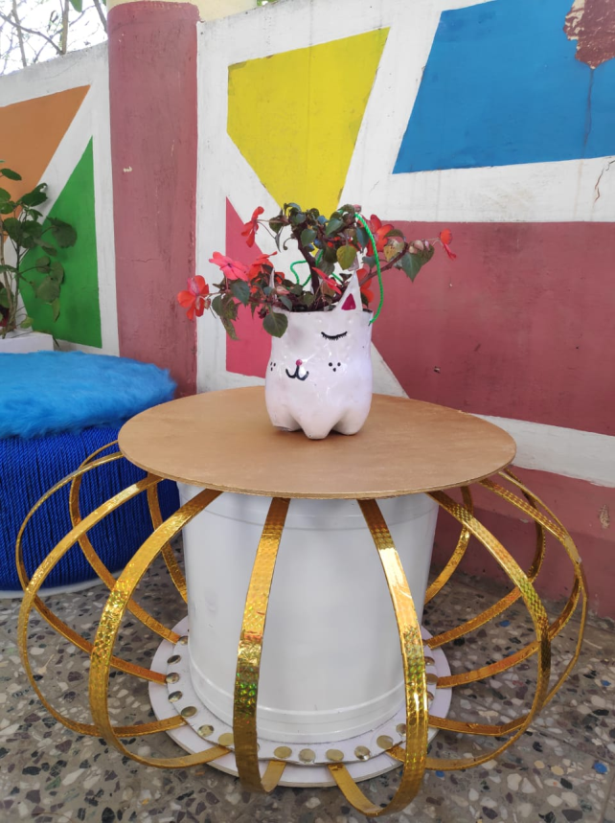
Figure 25: Department of Lifelong Learning
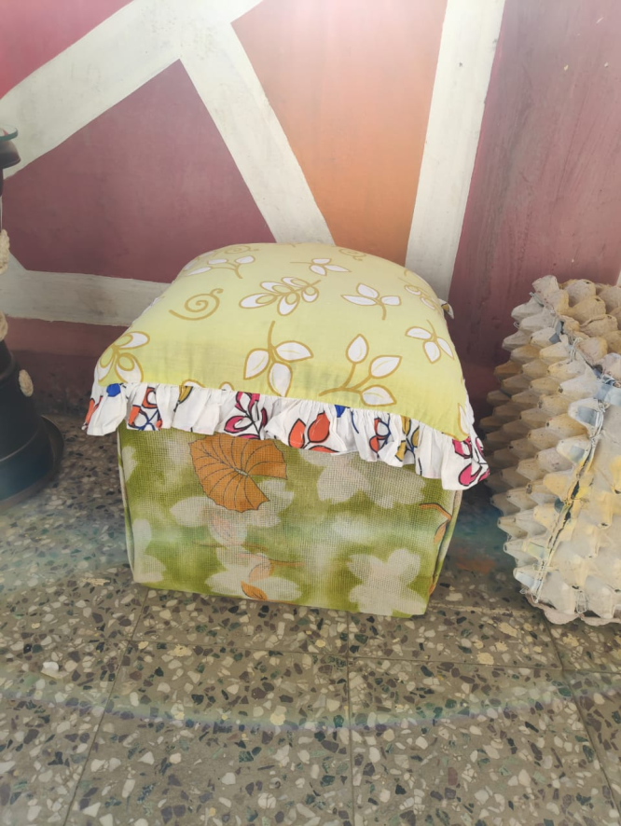
Figure 26: Department of Lifelong Learning
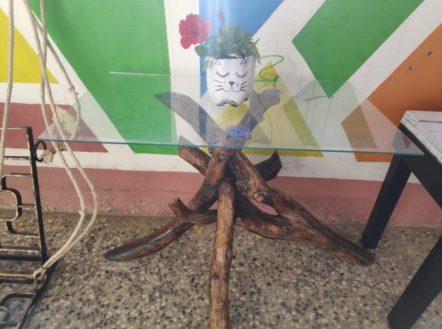
Figure 27: Department of Lifelong Learning
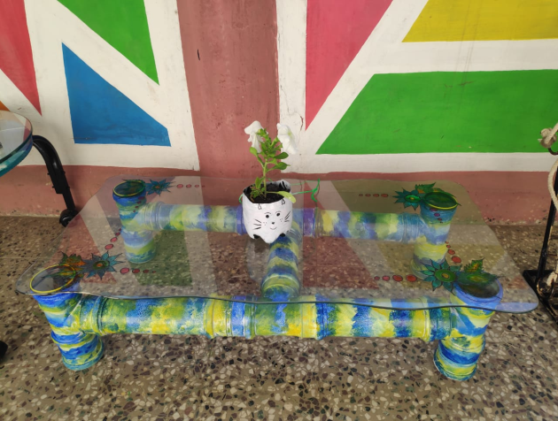
Figure 28: Department of Lifelong Learning
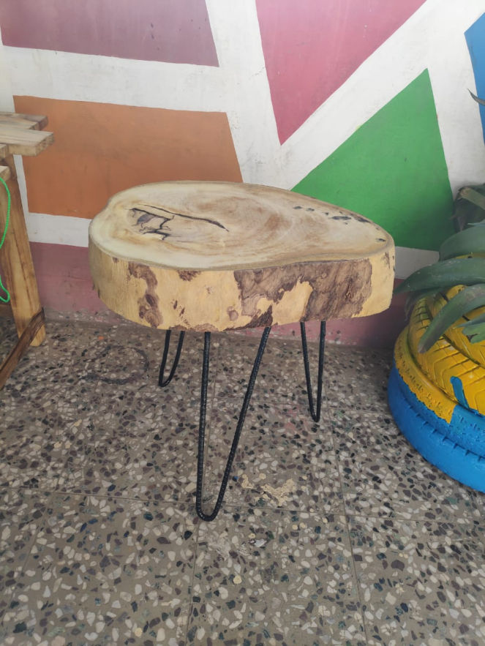
Figure 29: Department of Lifelong Learning
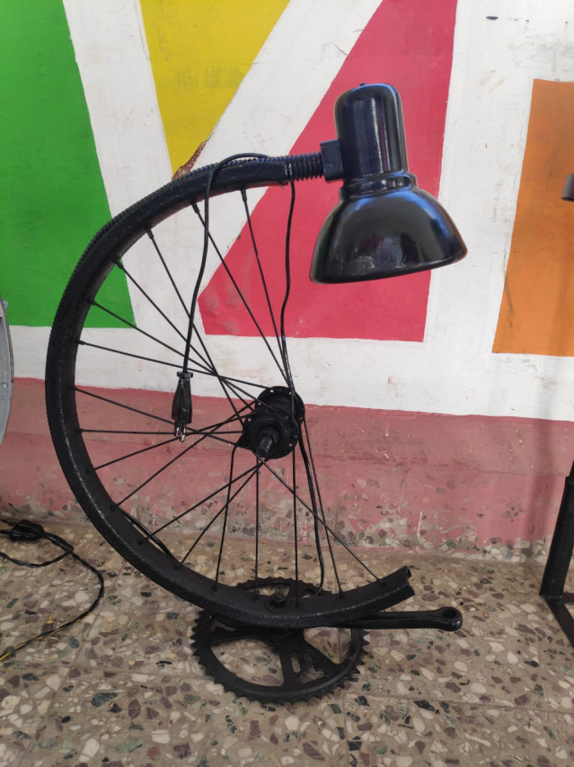
Figure 30:Department of Lifelong Learning

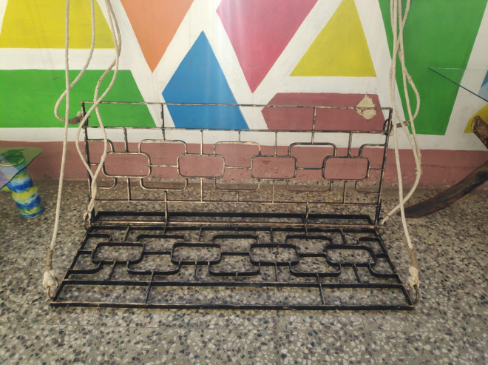
Figure 31: Department of Lifelong Learning
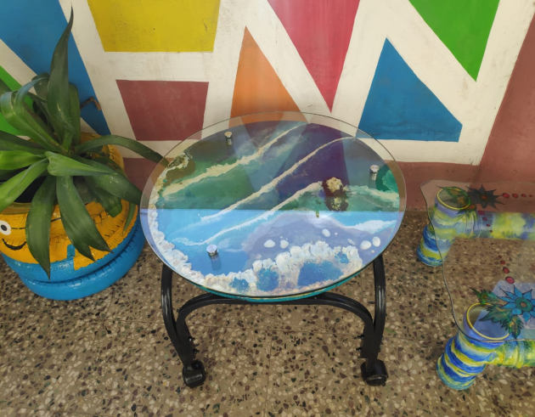
Figure 32: Department of Lifelong Learning
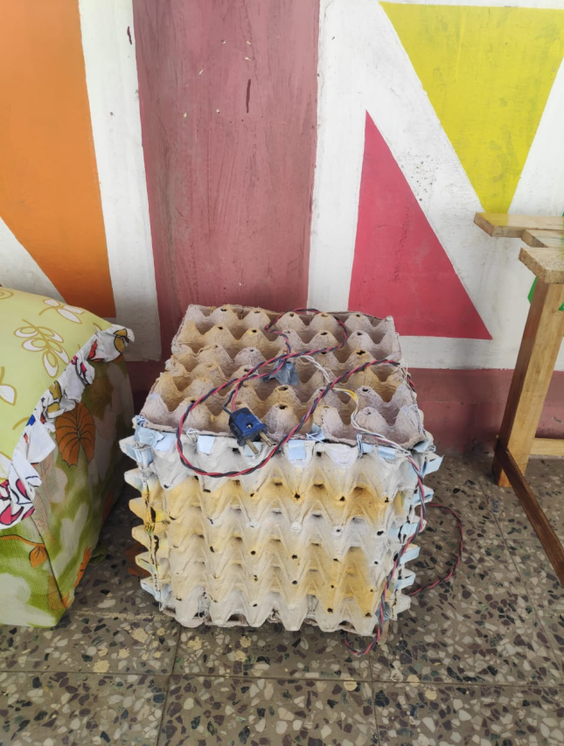
Figure 33: Department of Lifelong Learning
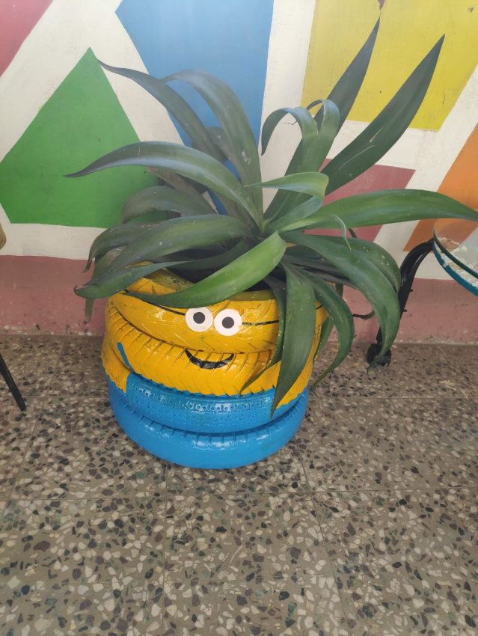
Figure 34: Department of Lifelong Learning
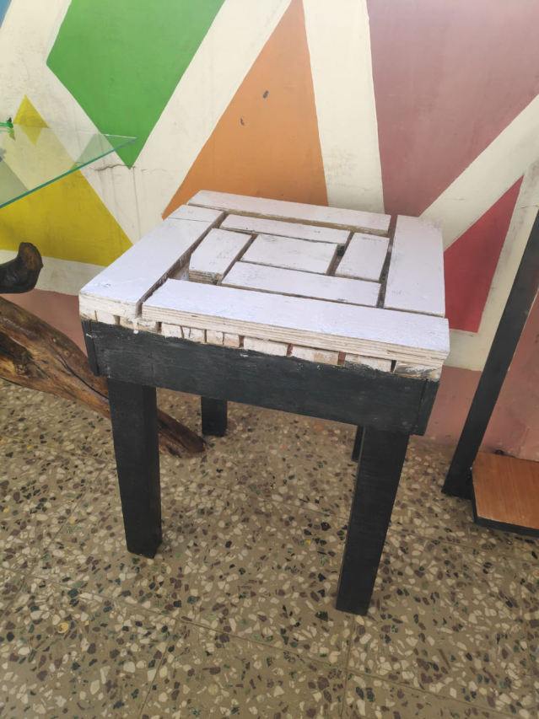
Figure 35: Department of Lifelong Learning
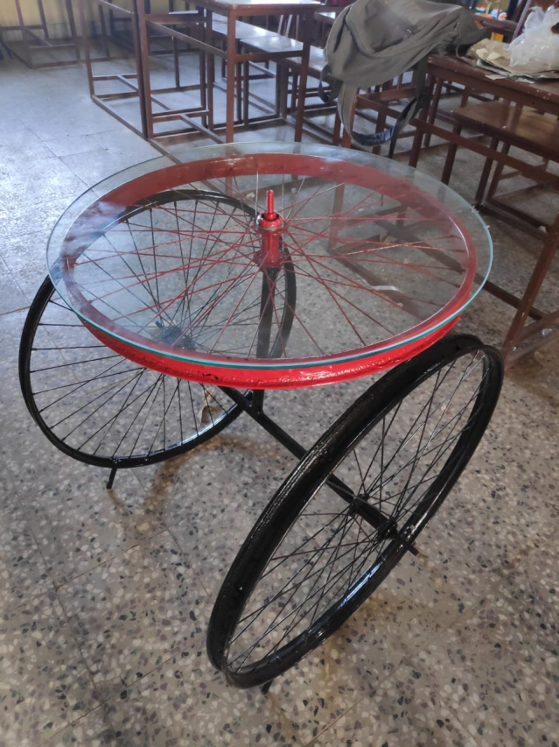
Figure 36: Department of Lifelong Learning
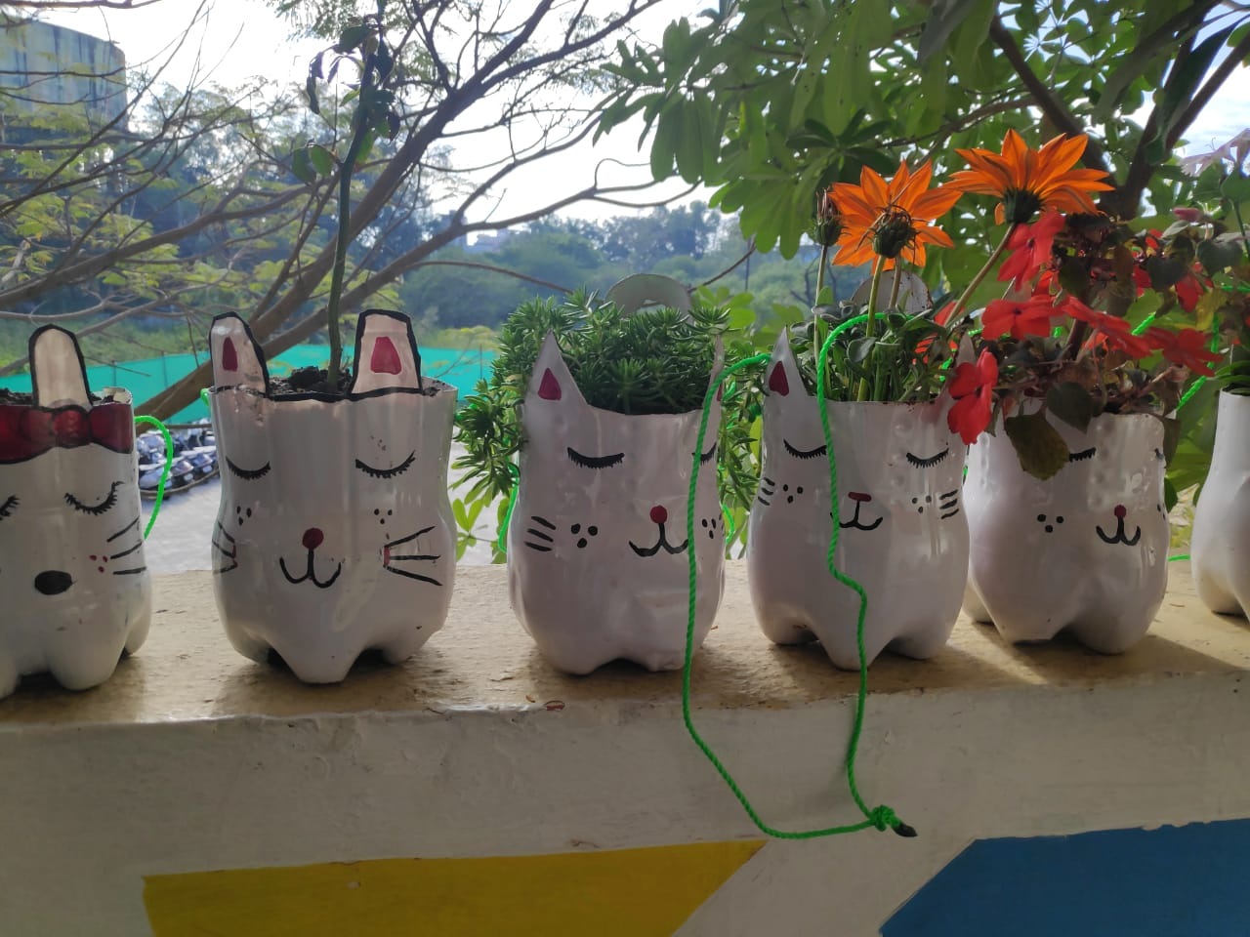
Figure 37: Department of Lifelong Learning

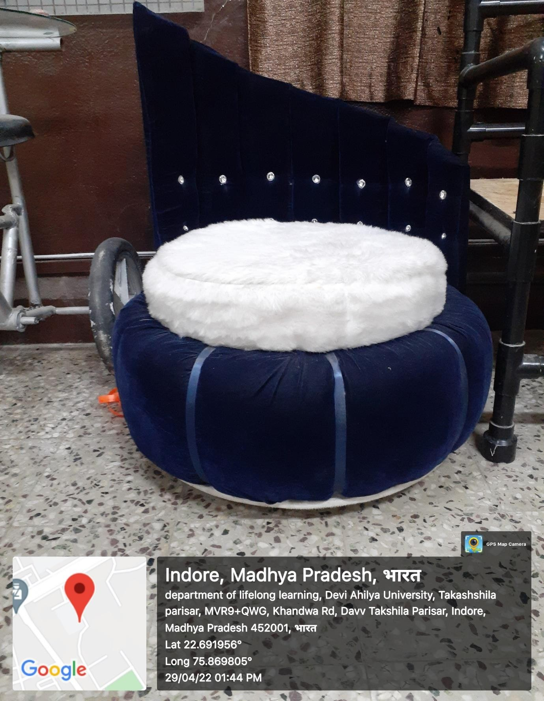
Figure 38: Department of Lifelong Learning

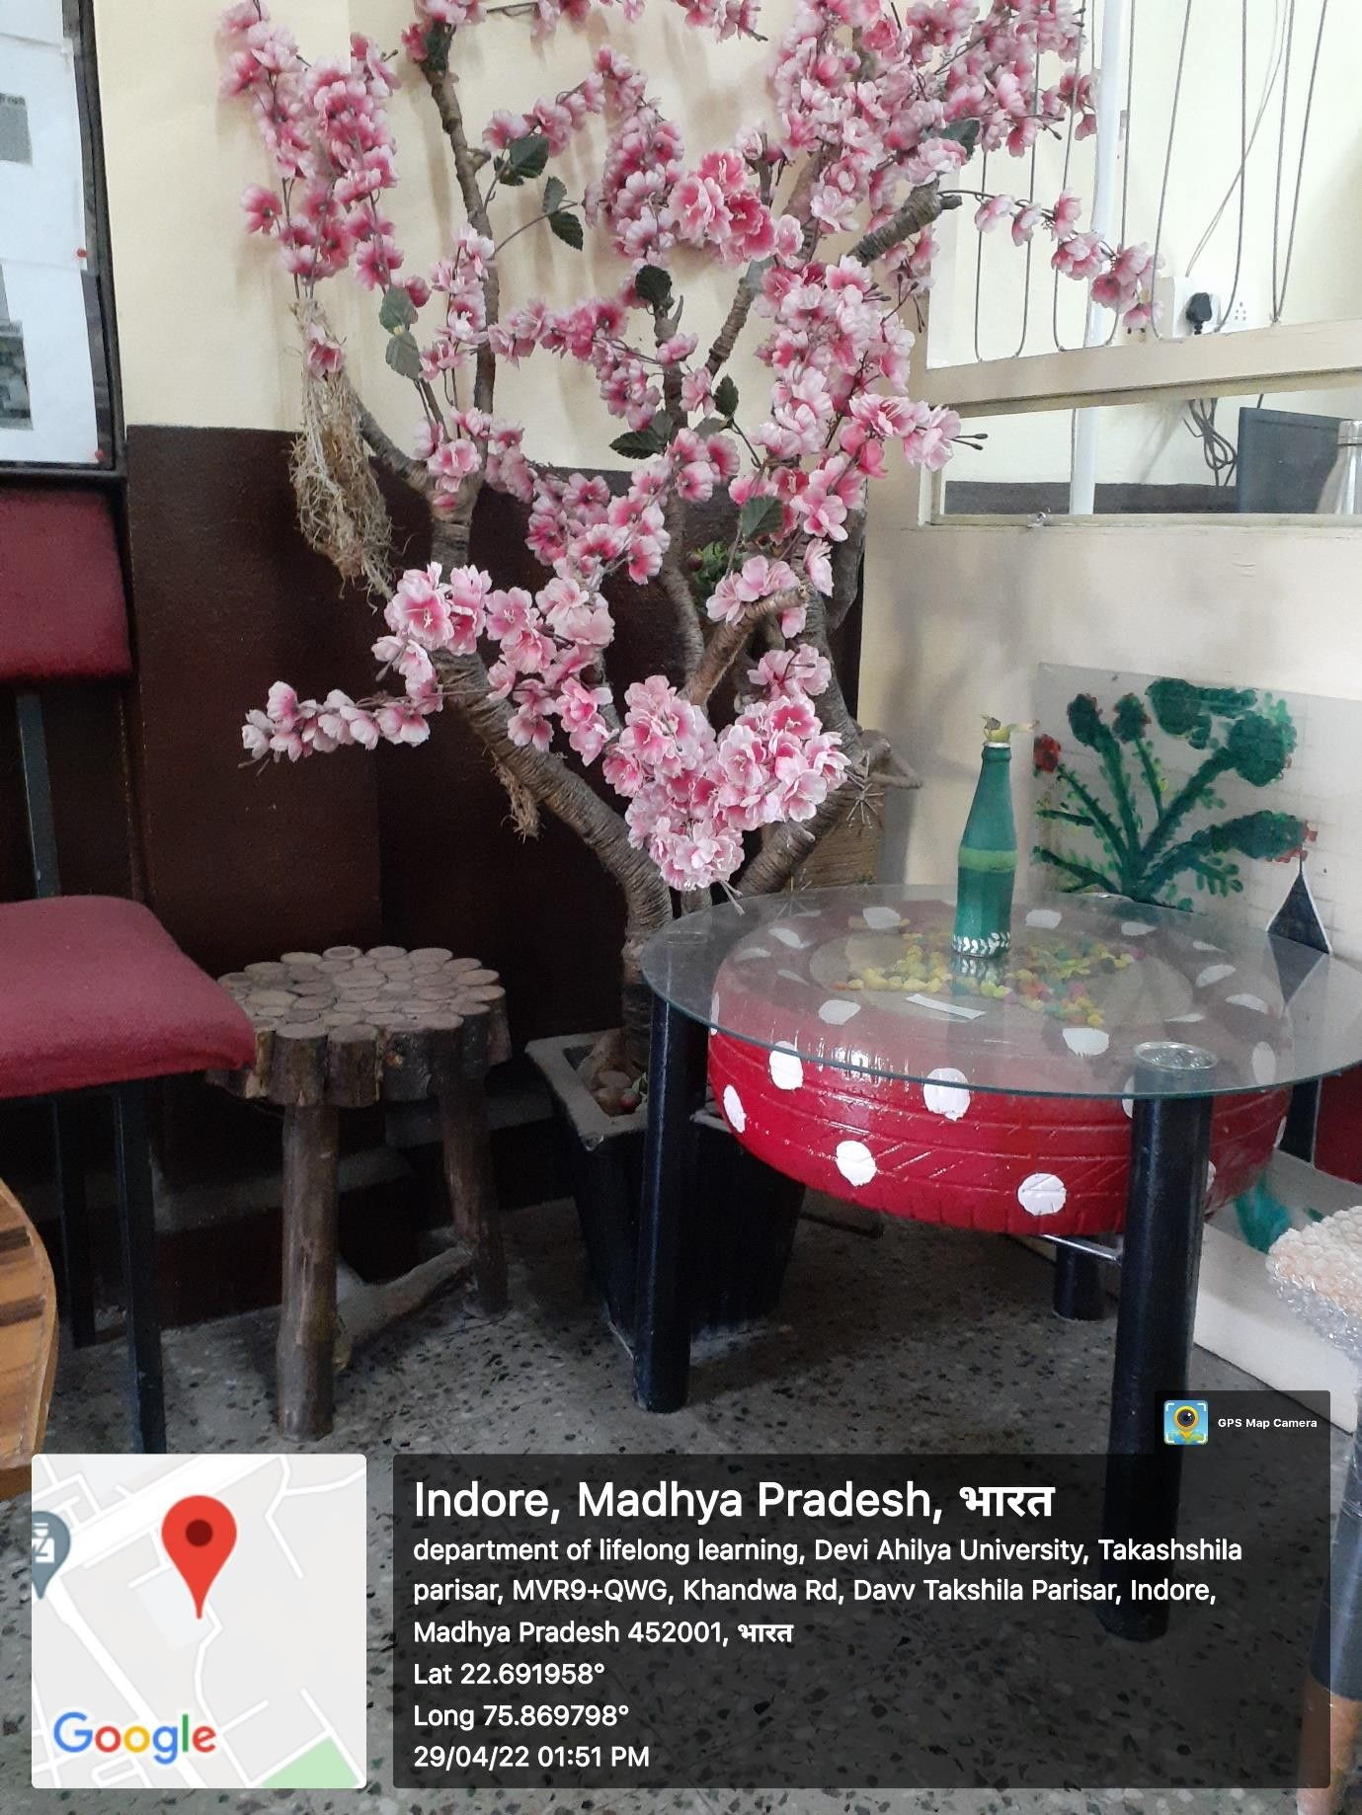
Figure 39:Department of Lifelong Learning

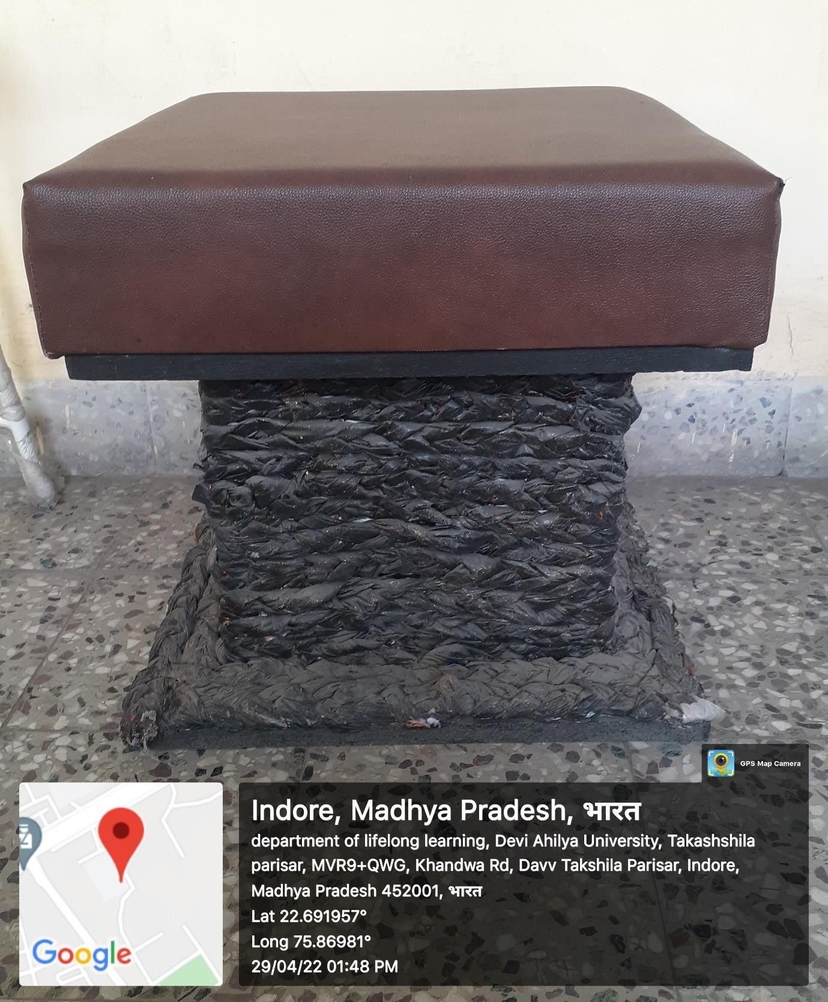
Figure 40: Department of Lifelong Learning

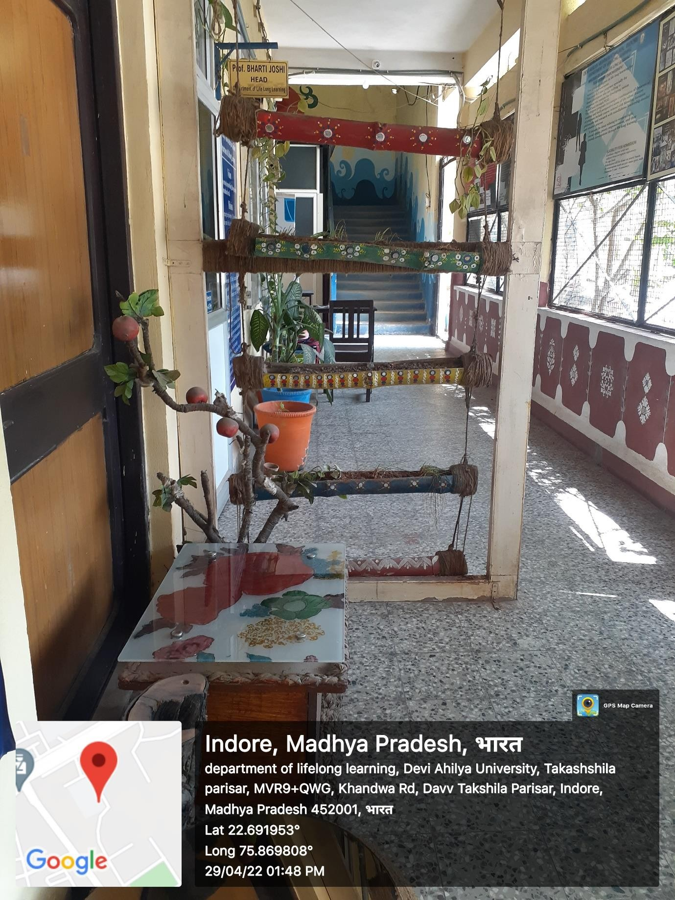
Figure 41: Department of Lifelong Learning

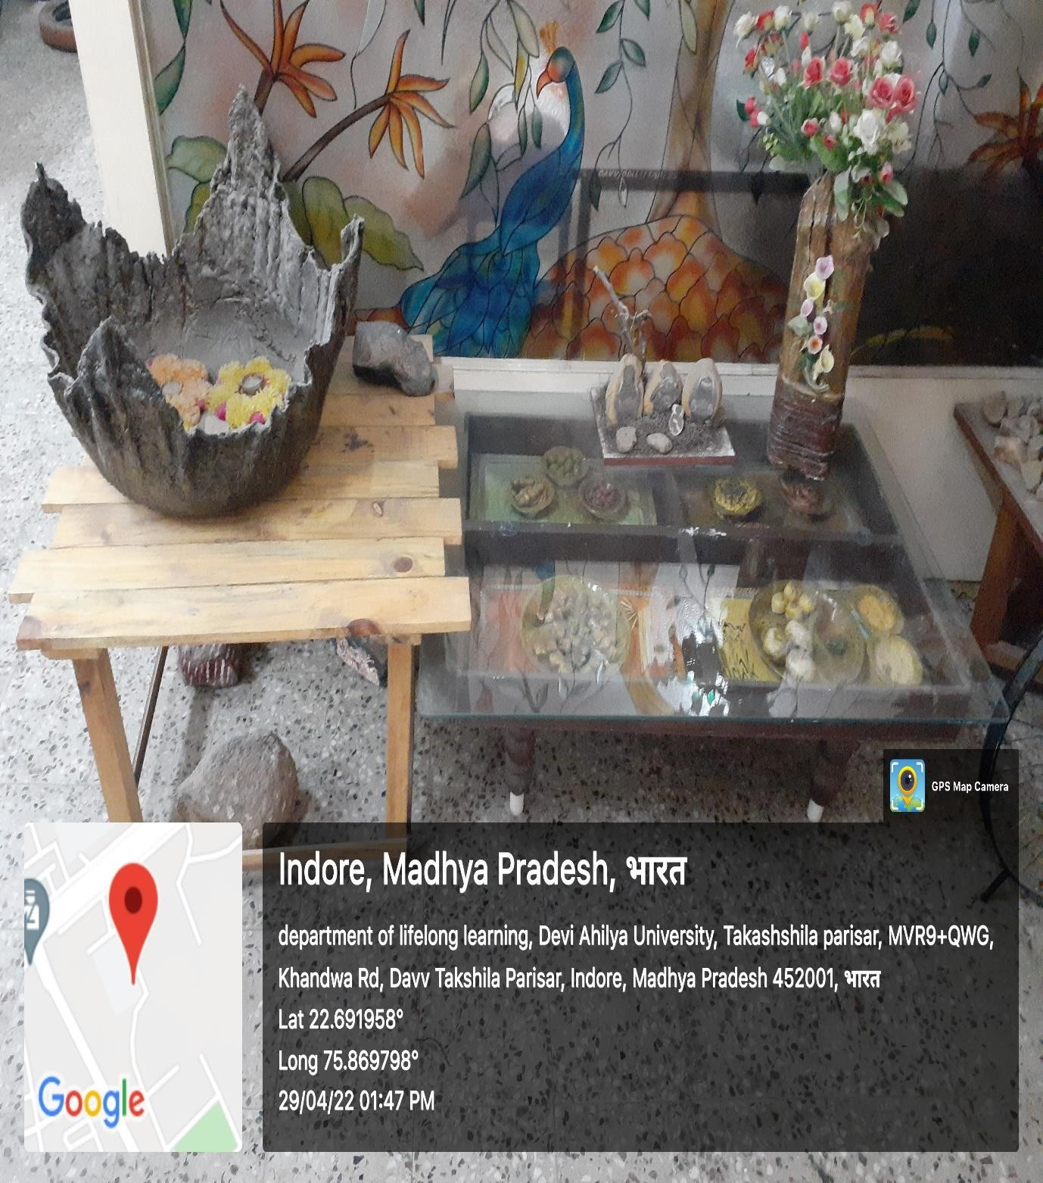
Figure 42:Department of Lifelong Learning

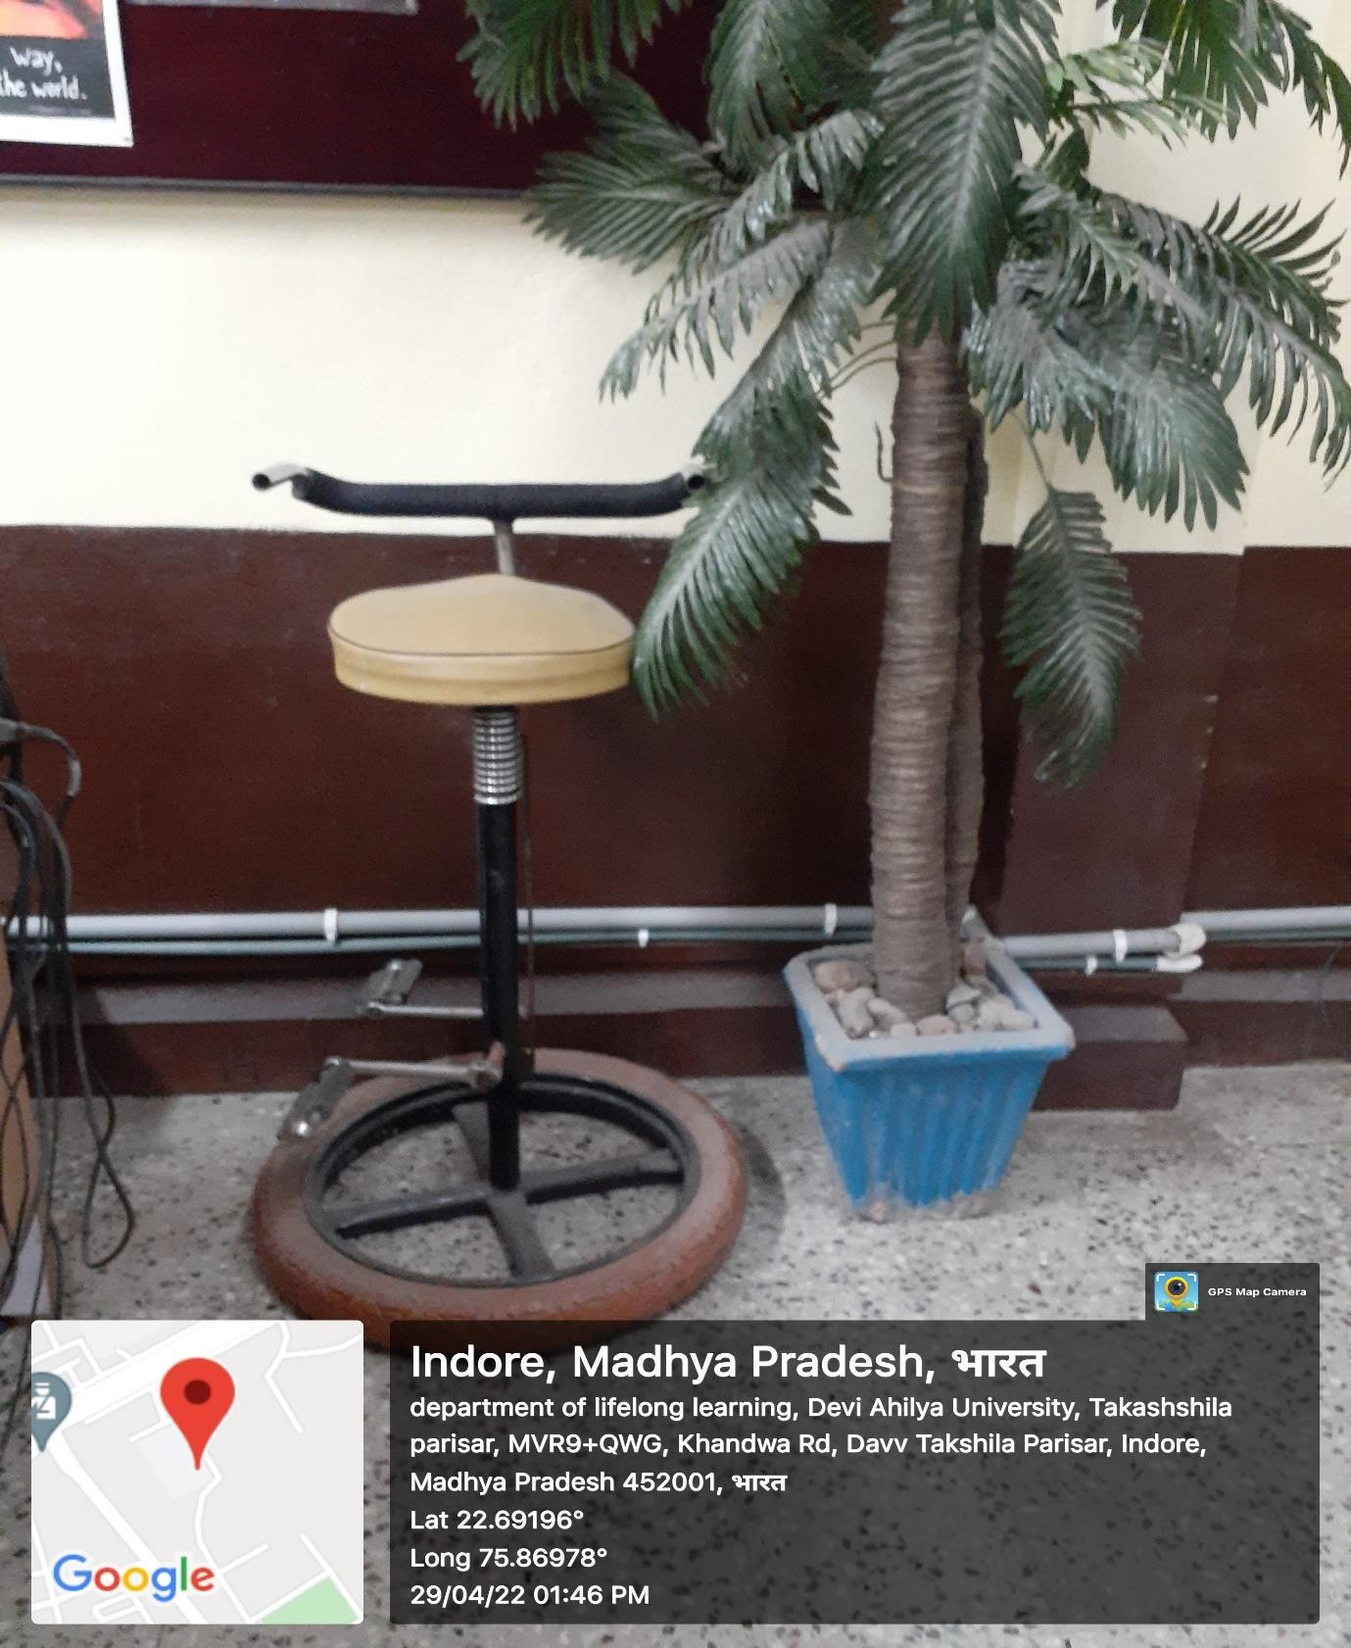
Figure 43: Department of Lifelong Learning

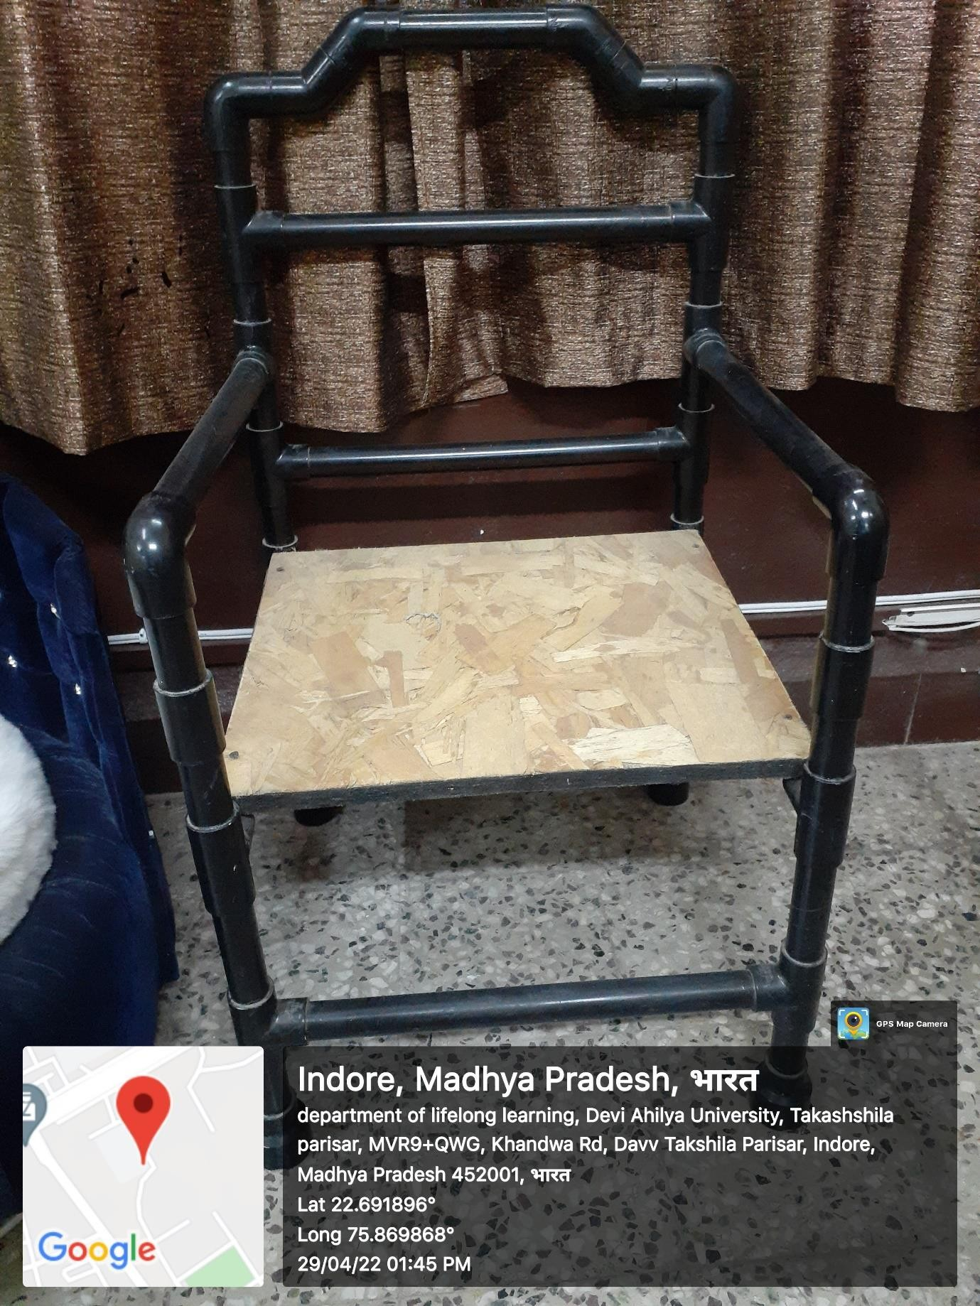
Figure 44: Department of Lifelong Learning

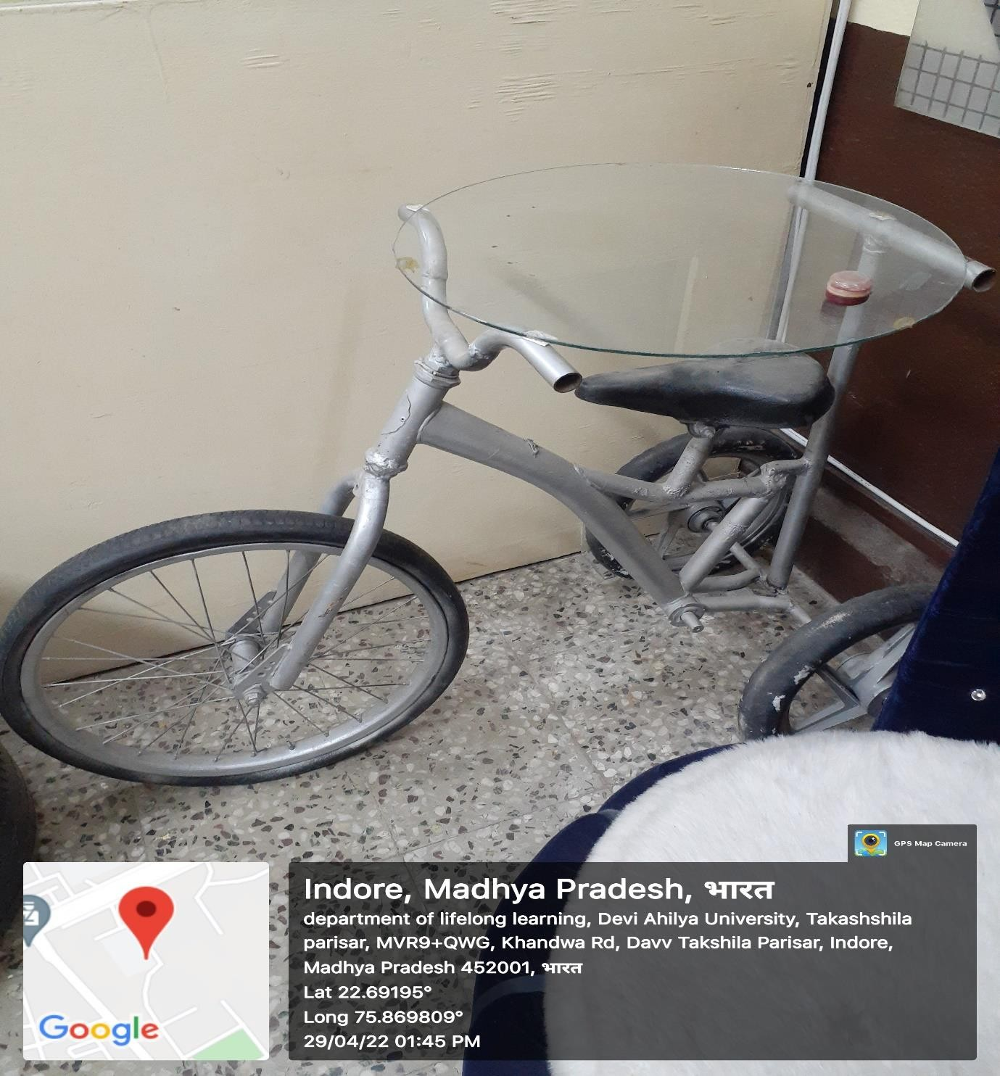
Figure 45:Department of Lifelong Learning

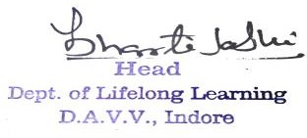
(Dr. Bharti Joshi)
HEAD

