

DEVI AHILYA VISHWAVIDYALAYA, INDORE

7.1.4
Water conservation facilities available in the Institution

Environmental Consciousness:
- Water Conservation

- Rain Water harvesting system based on rock fracturing technique was installed.
- Sprinklers are installed for gardens irrigation.
- Water wastages is minimized by checked regularly the leakages by maintenance.

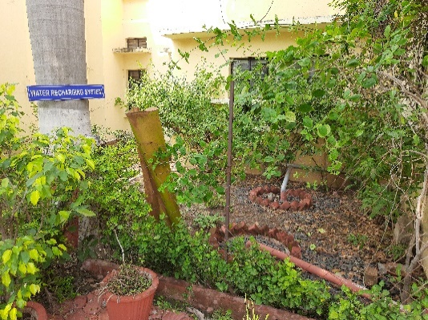
Figure 1:School of Energy and Environment

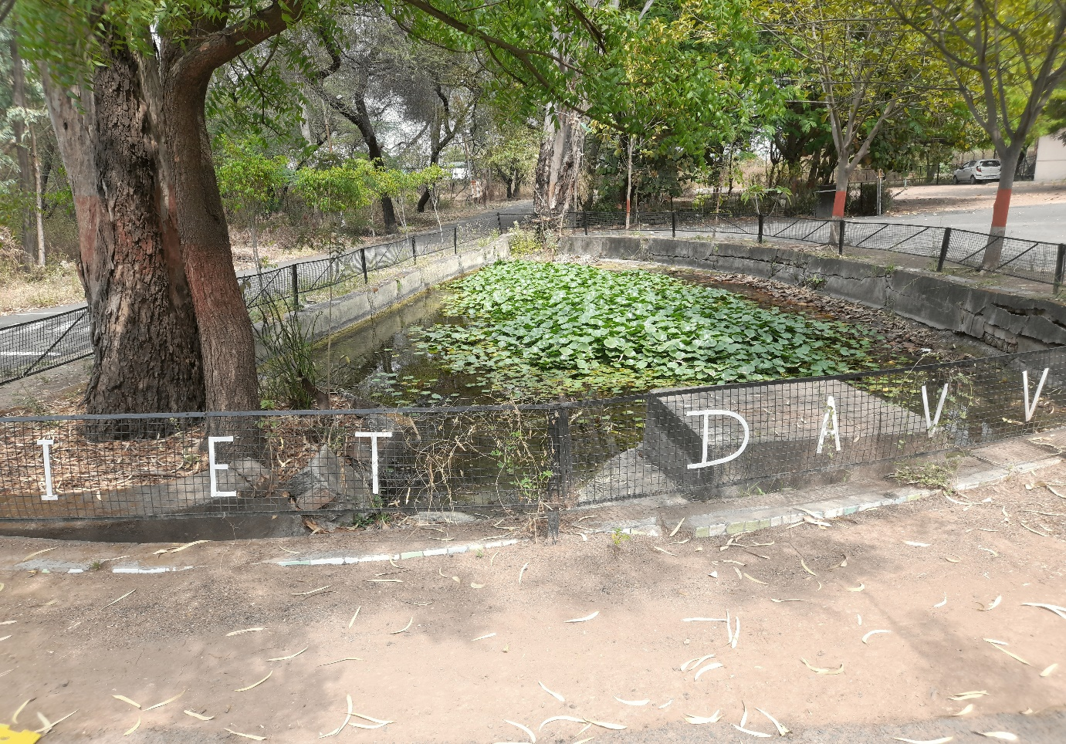Figure 2: IET- Bundtanks
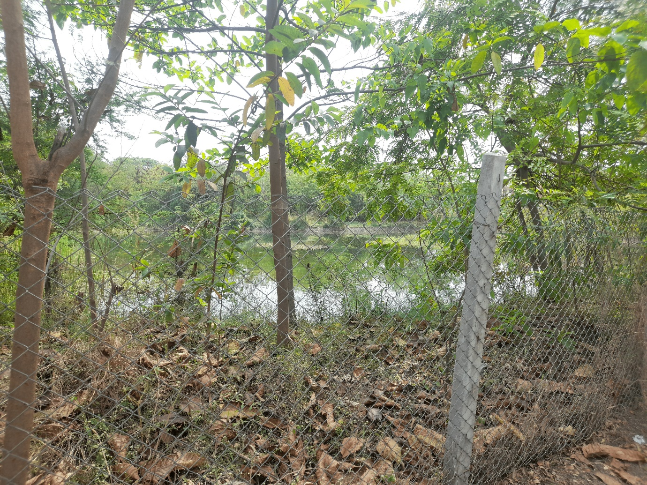
Figure 3: IET - Maintainence of Water Bodies
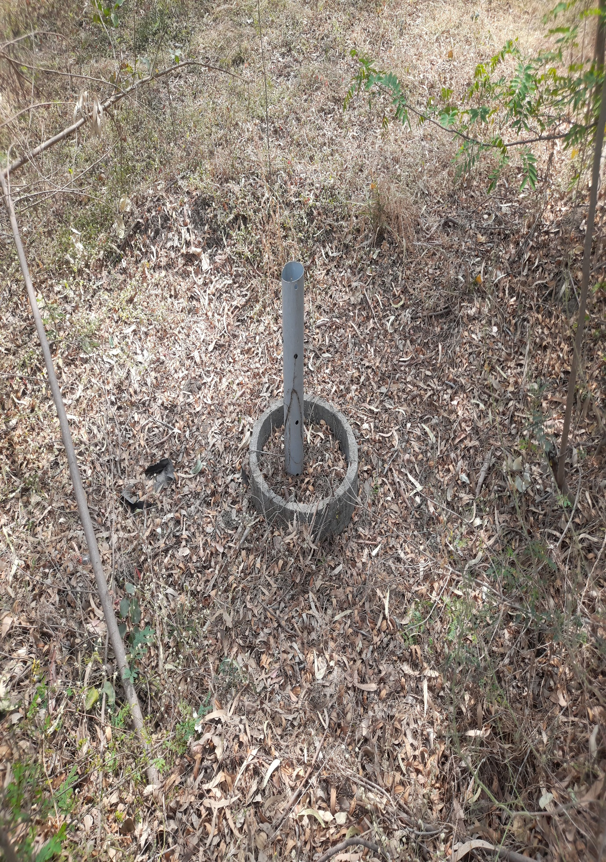
Figure 4:IET- Rainwater Harvesting
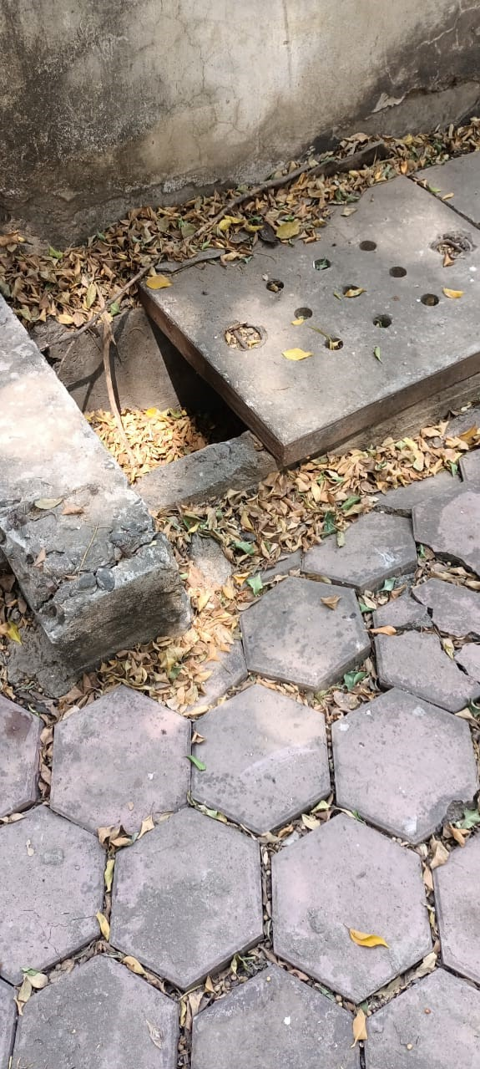
Figure 5: IIPS, Rainwater Harvesting
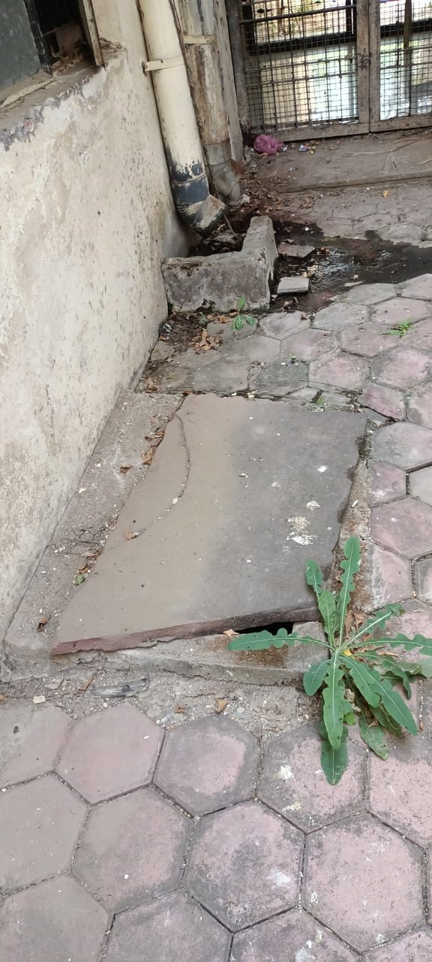
Figure 6: IIPS- Rainwater harvesting

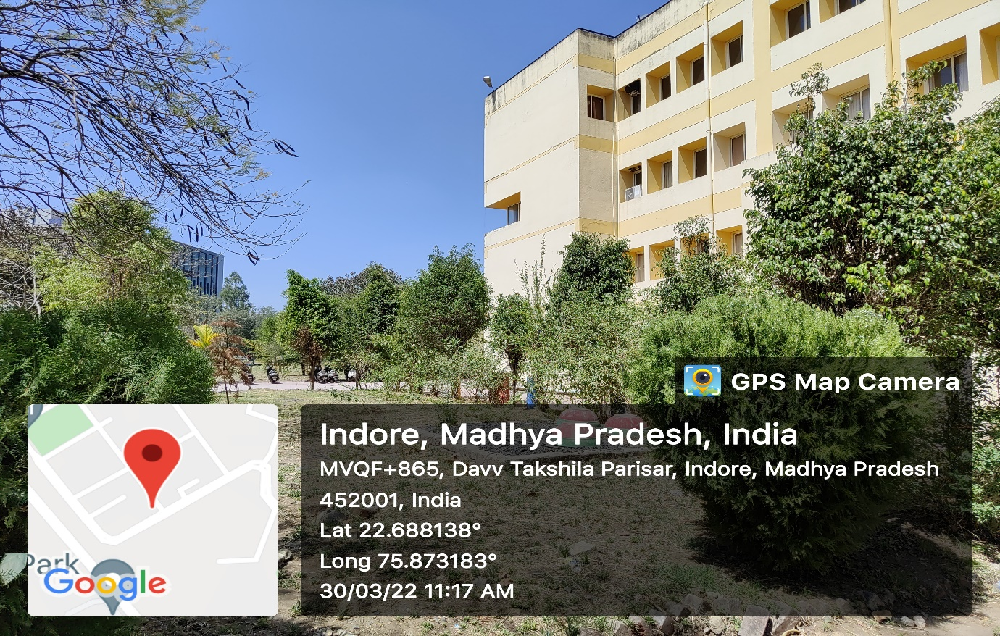
Figure 7: School of Journalism and Mass Communication
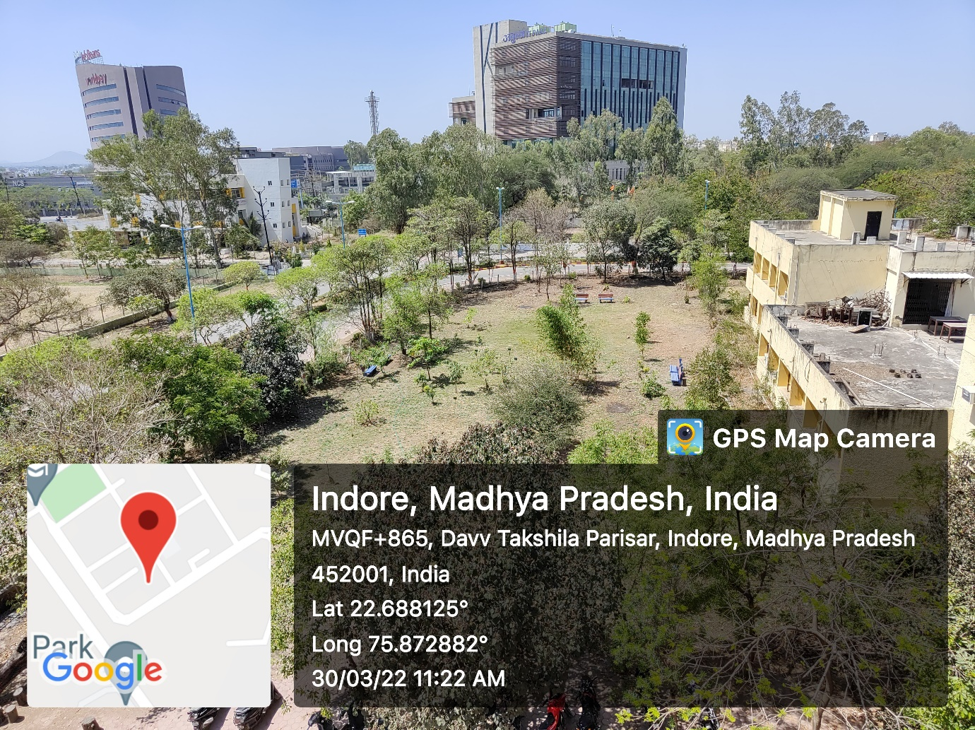
Figure 8:School of Journalism and Mass Communication

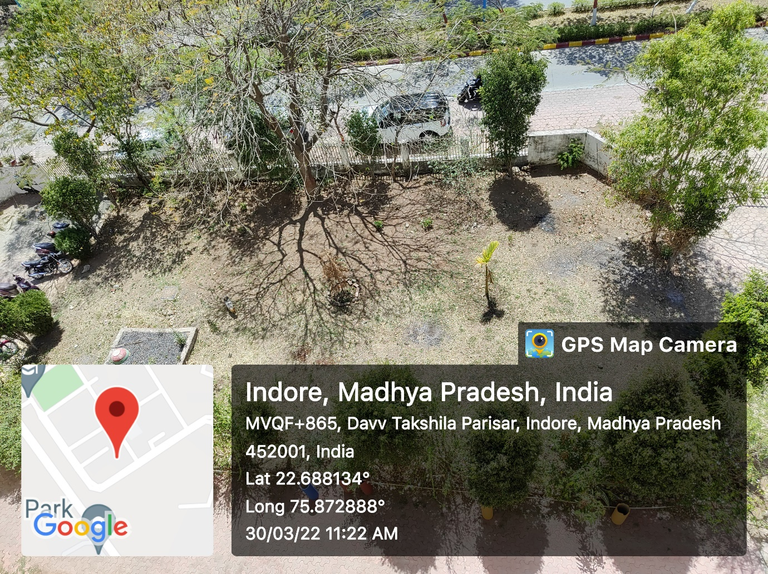
Figure 9:School of Journalism and Mass Communication
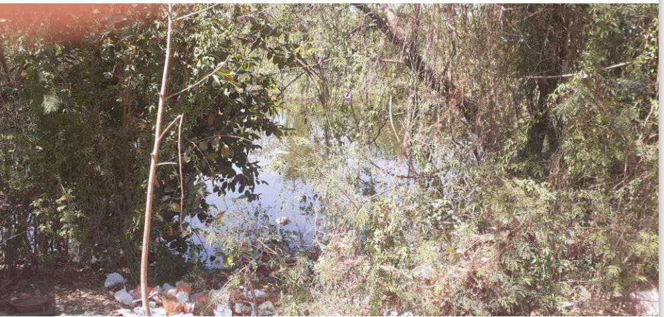
Figure 10:School of Law
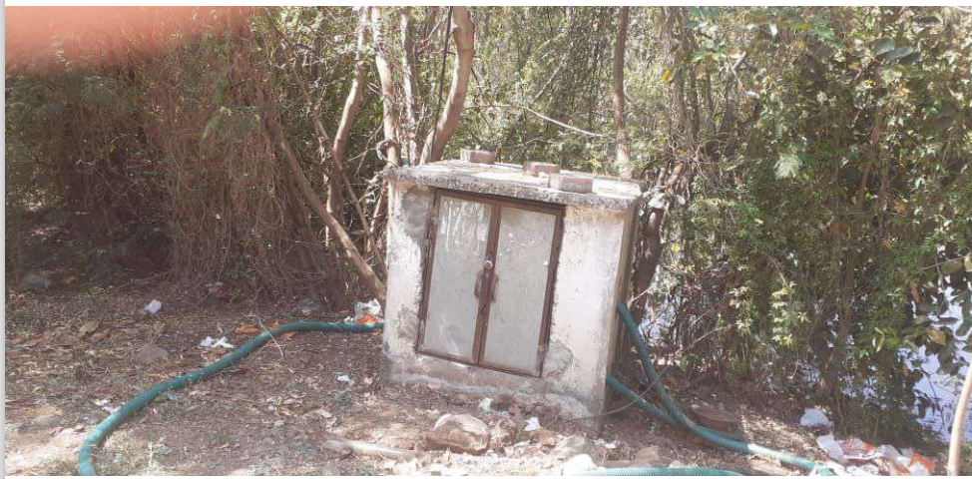
Figure 11: School of Pharmacy
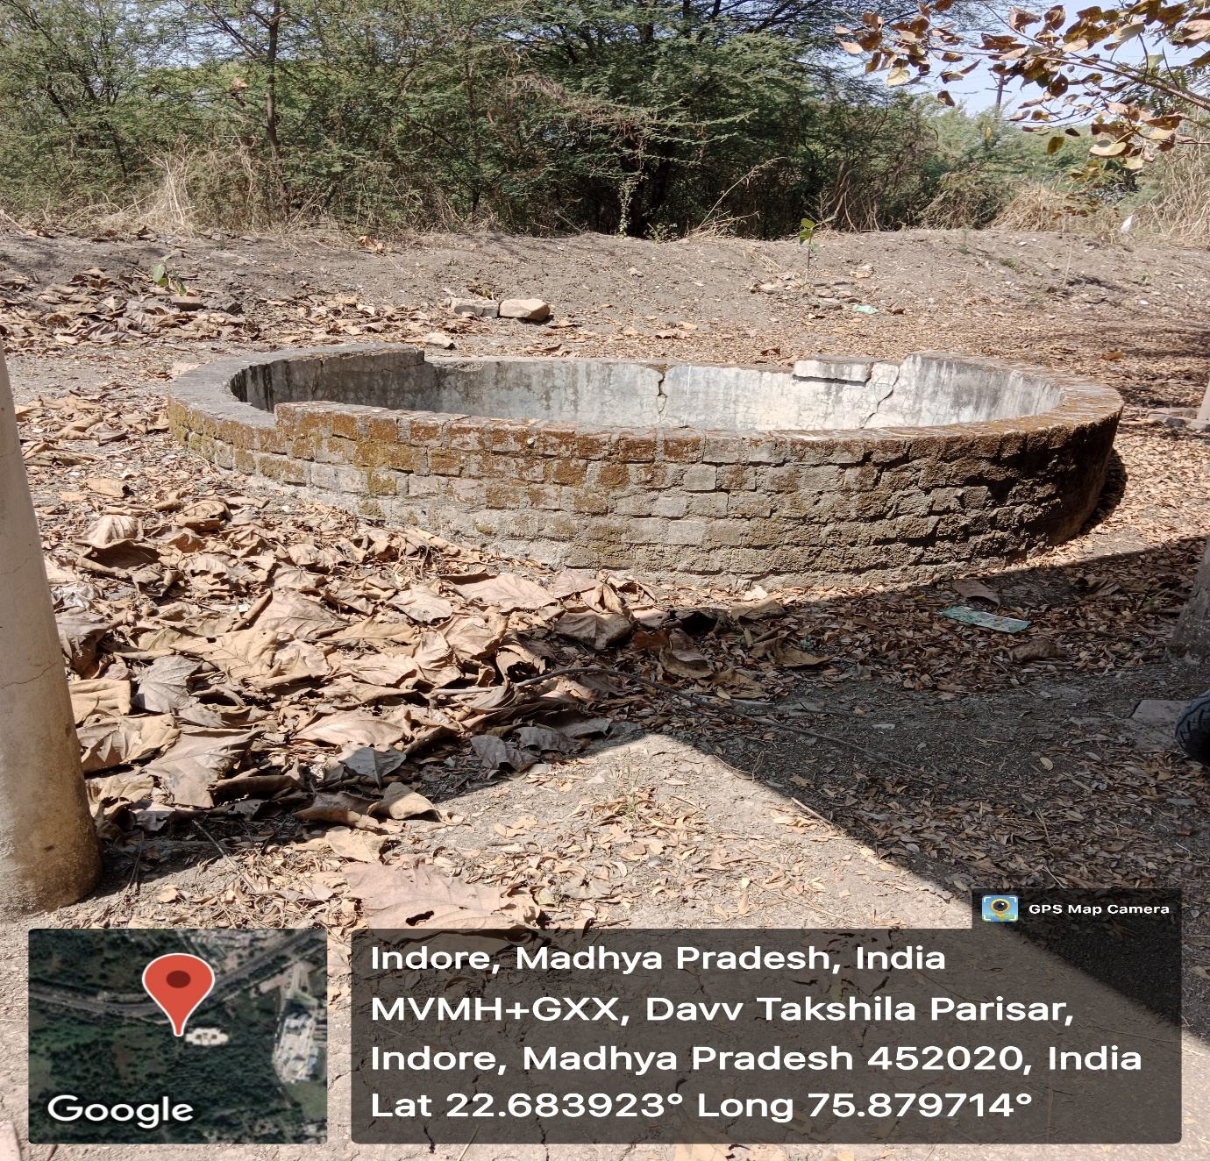
Figure 12: School of Pharmacy
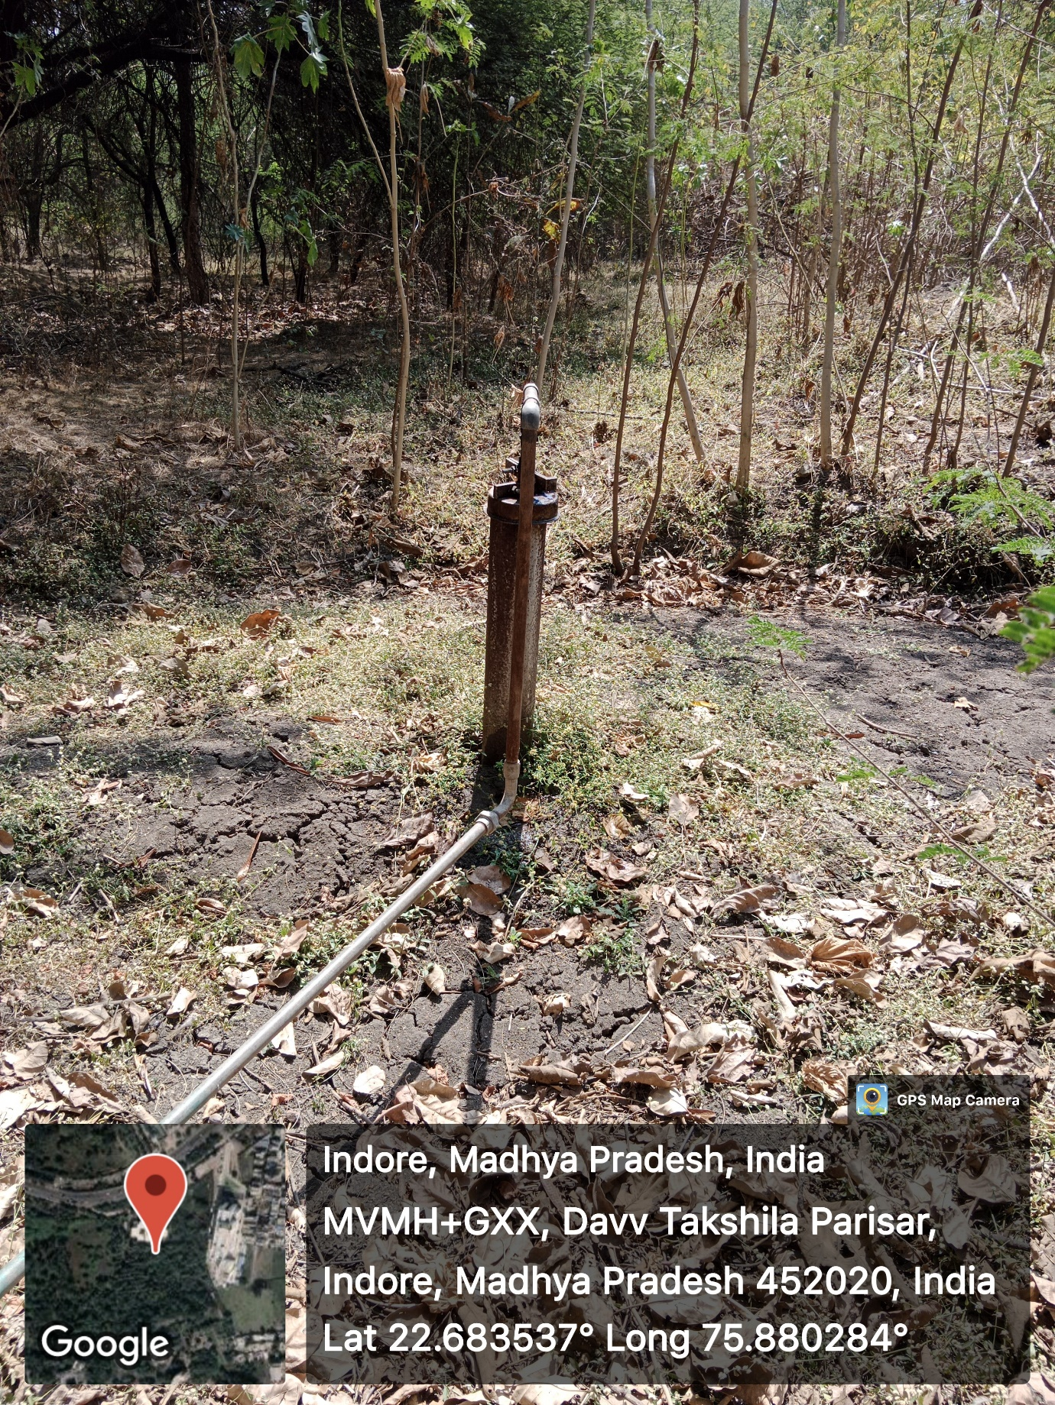
Figure 13:School of Pharmacy

