

DEVI AHILYA VISHWAVIDYALAYA, INDORE

7.1.5
Green campus initiatives

For Making Green Environment

Around 60 plants planted in campus to keep the environment clean, green, and healthy.
School of Physics
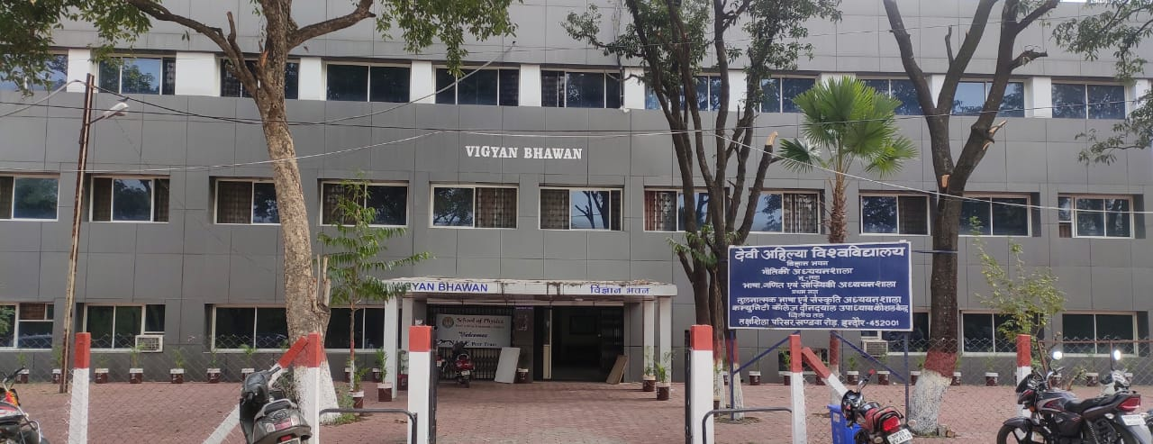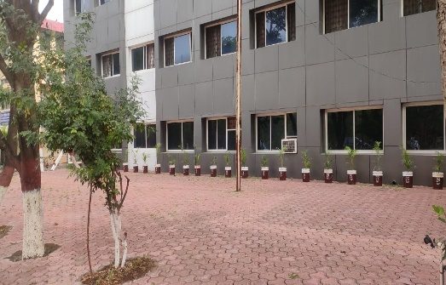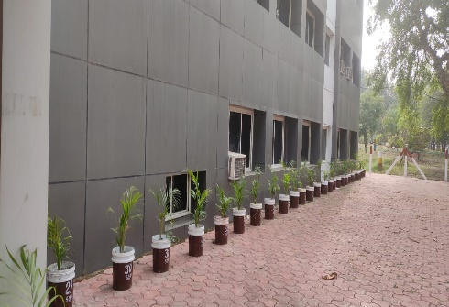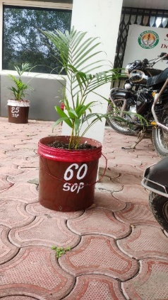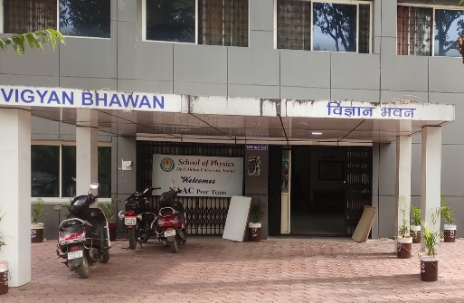

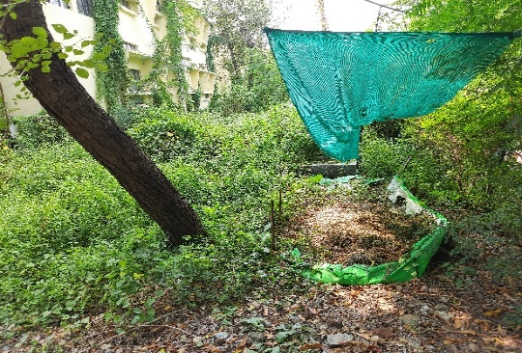
Vermi Composting

Plantation

Figure 1: School of Physics
Figure 2: School of Energy and Environment- Vermicomposting

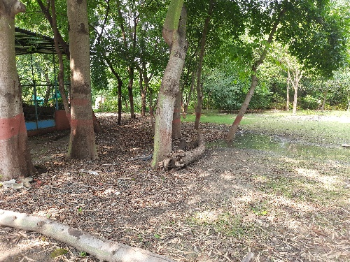
Figure 3: School of Energy and Environment- Plantation

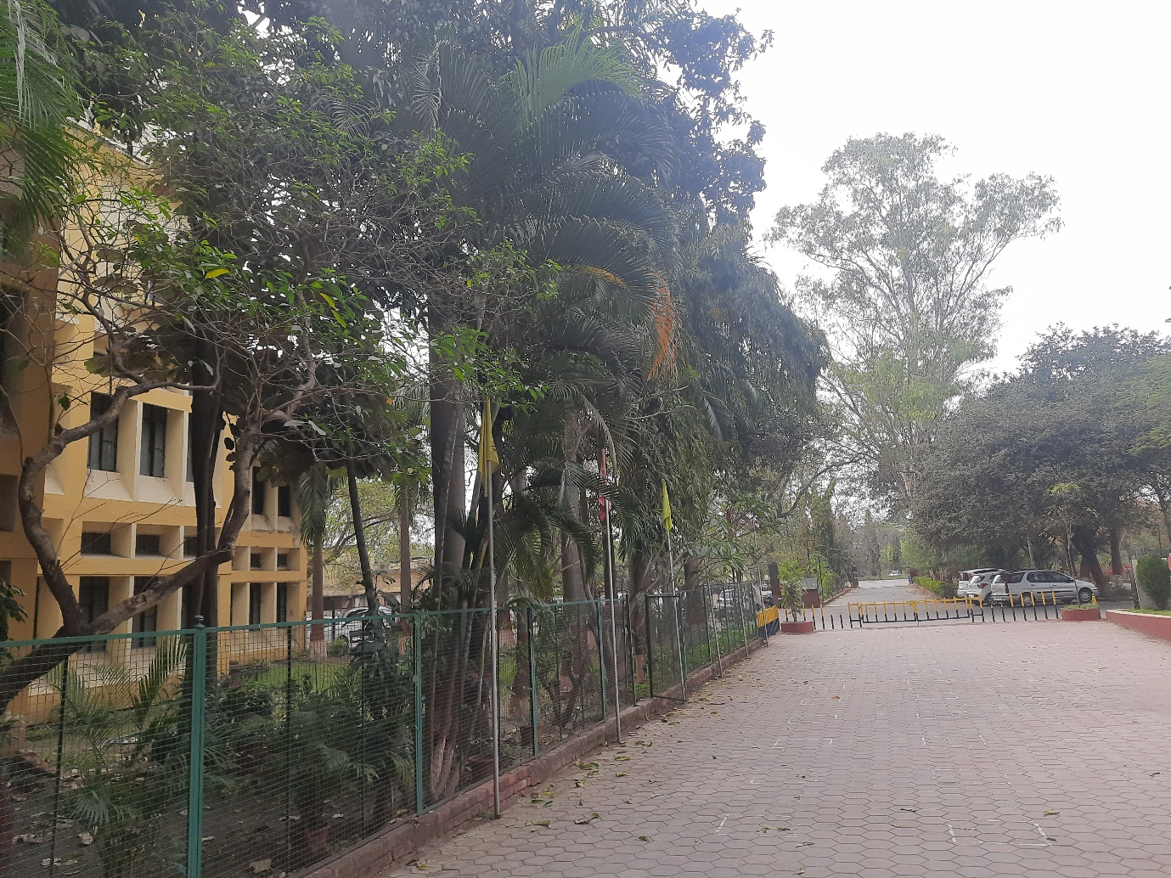
Figure 4: International Institute of Professional Studies
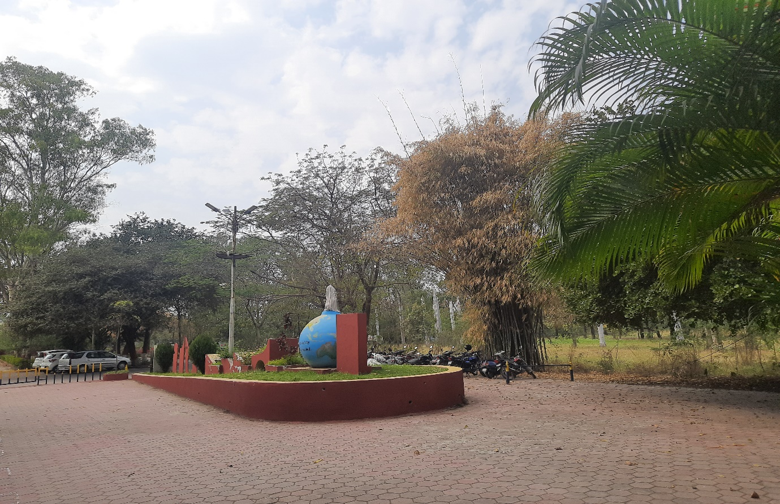
Figure 5: International Institute of Professional Studies

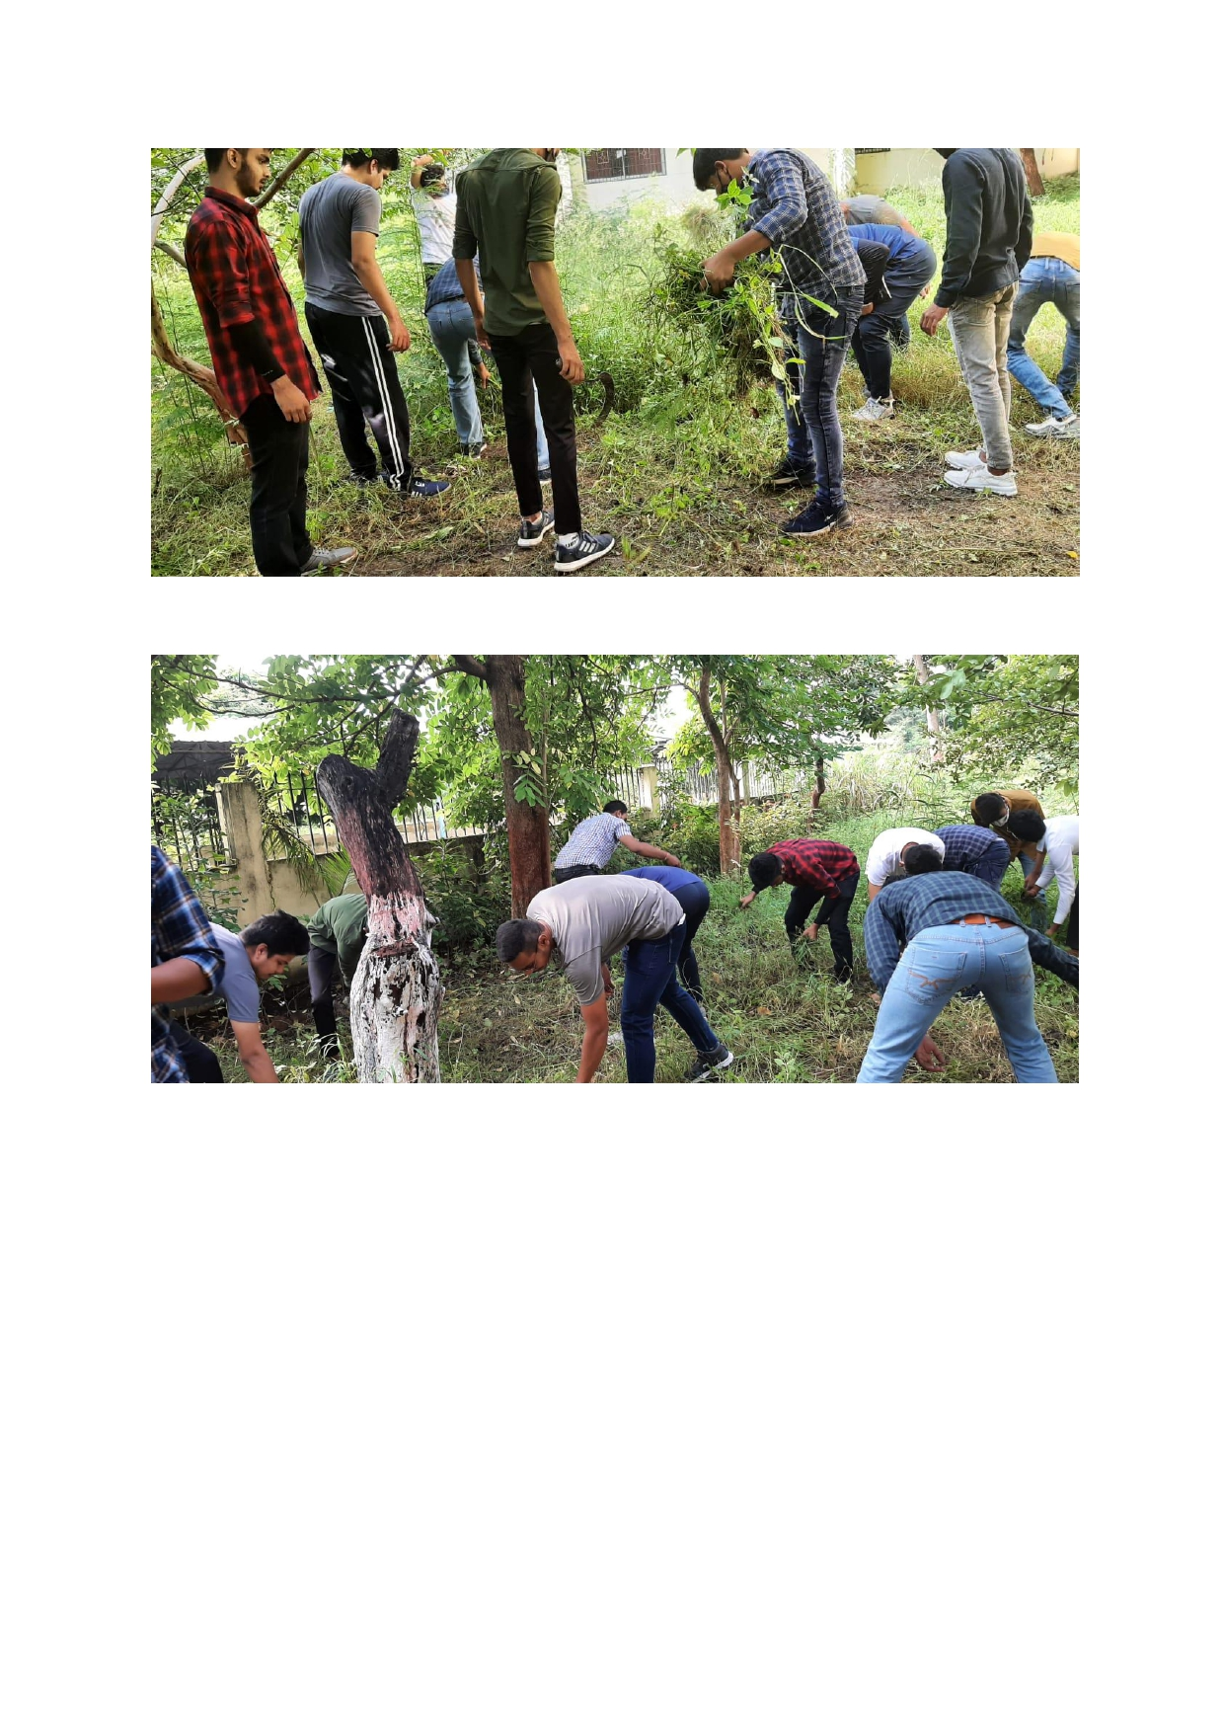
Figure 6: School of Computer Science and IT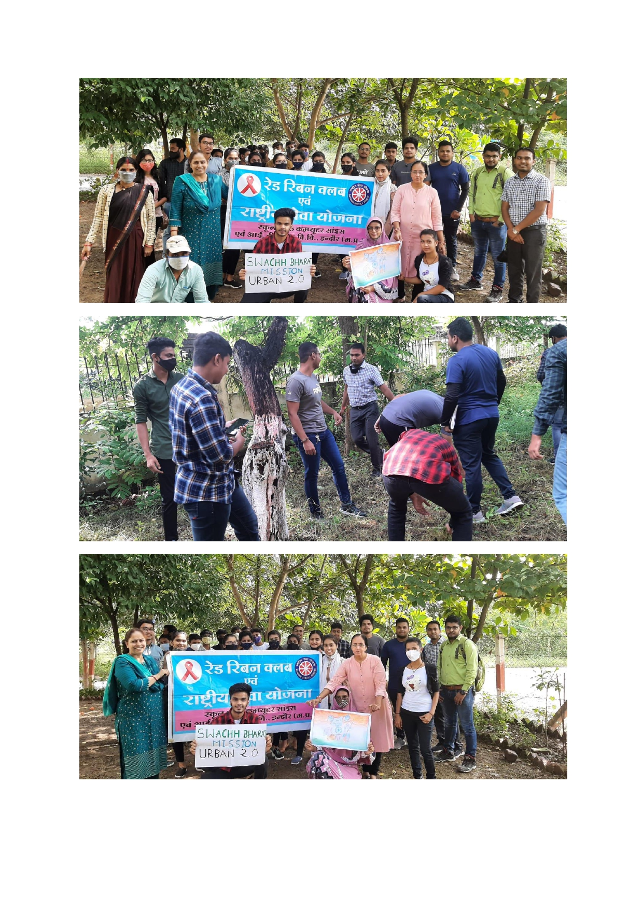
Figure 7: School of Computer Science and IT

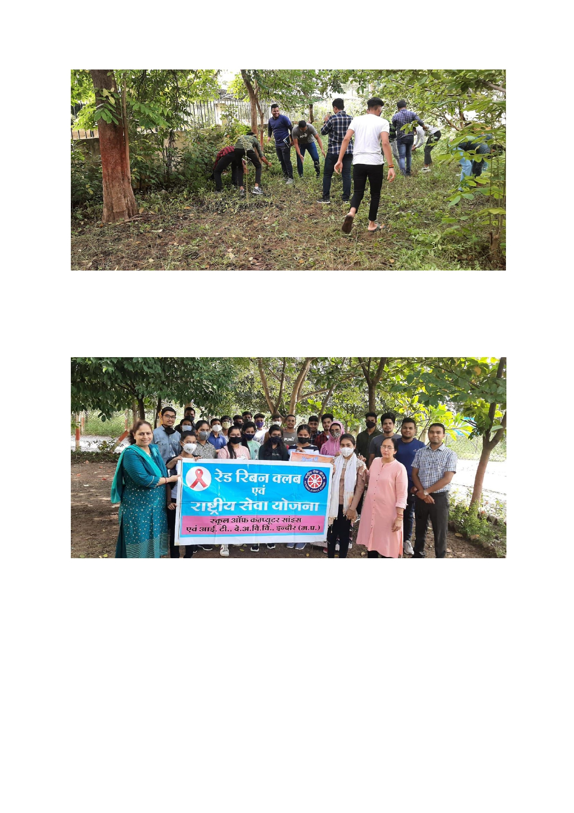
Figure 8: School of Computer Science and IT

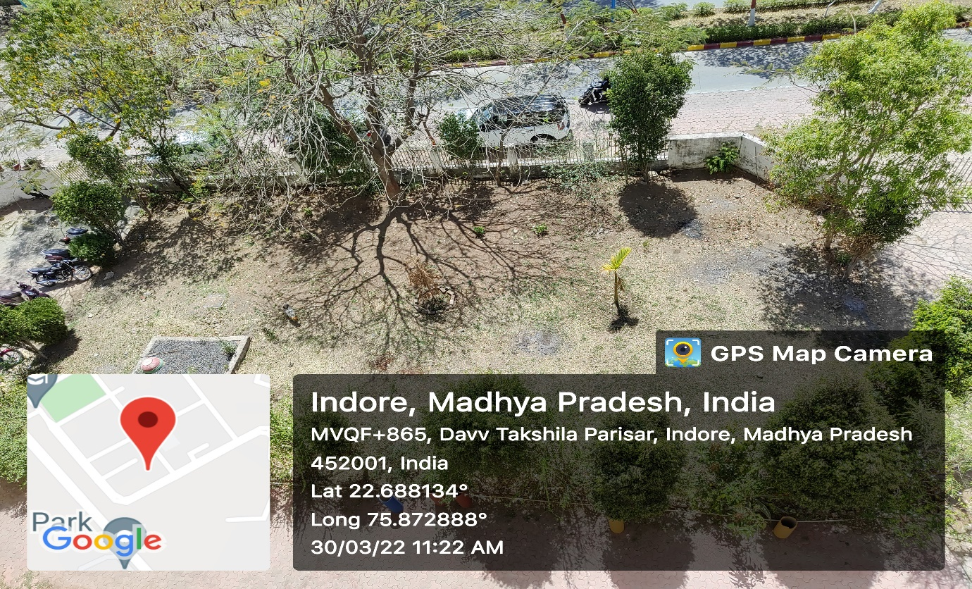
Figure 9: School of Journalism and Mass Communication

Figure 10: School of Journalism and Mass Communication

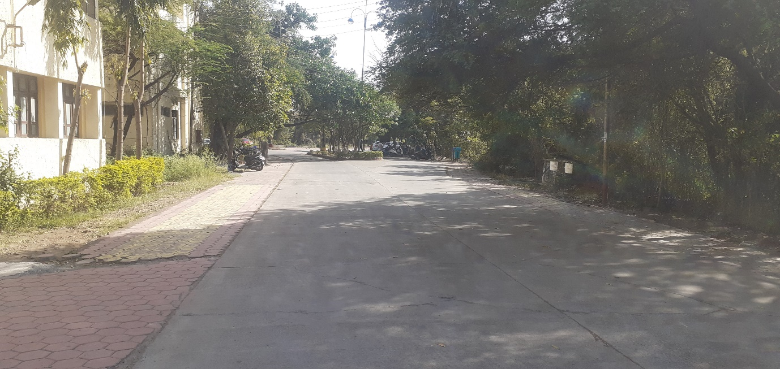
Figure 11: School of Law
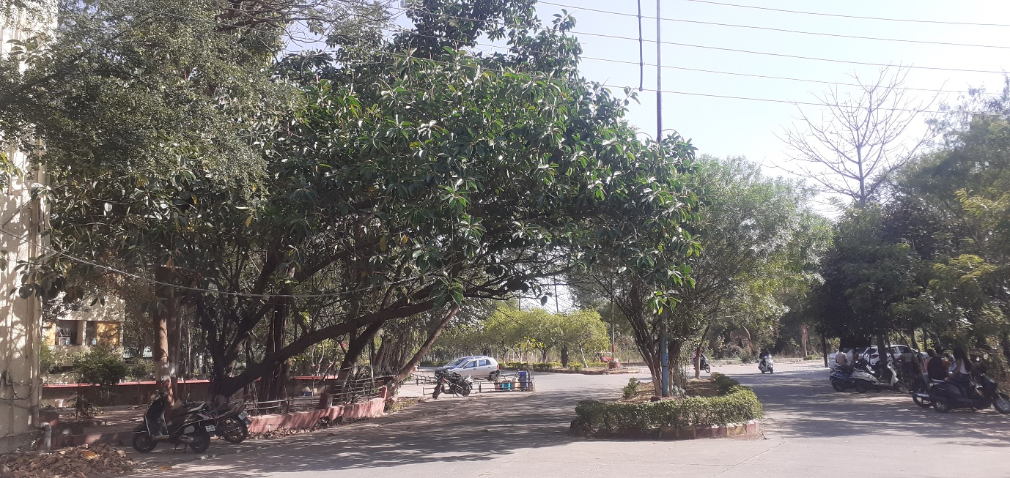
Figure 12: School of Law

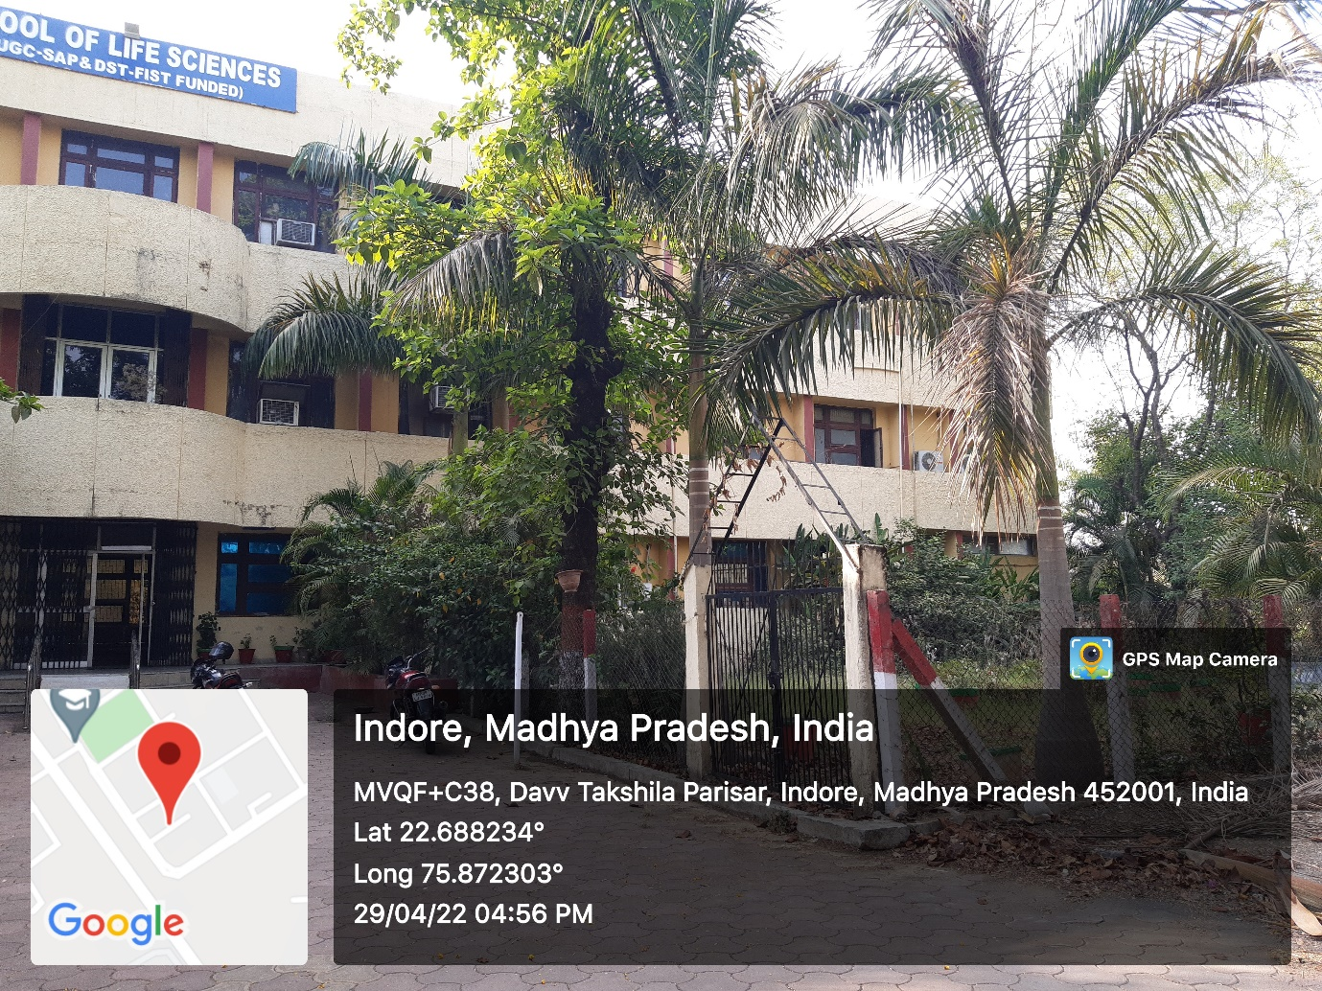
Figure 13: School of Life Sciences
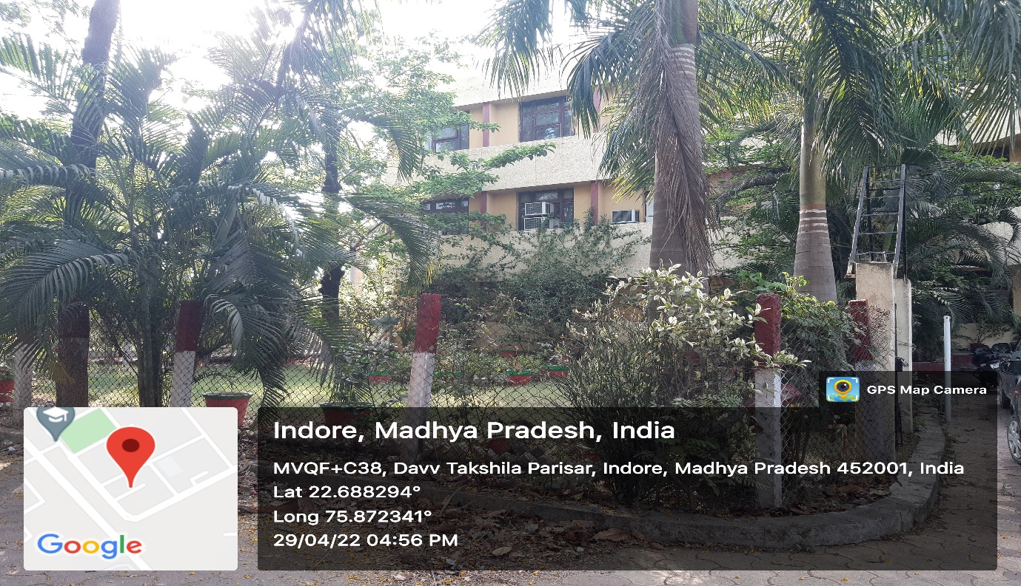
Figure 14: School of Life Sciences

Figure 15:School of Life Sciences
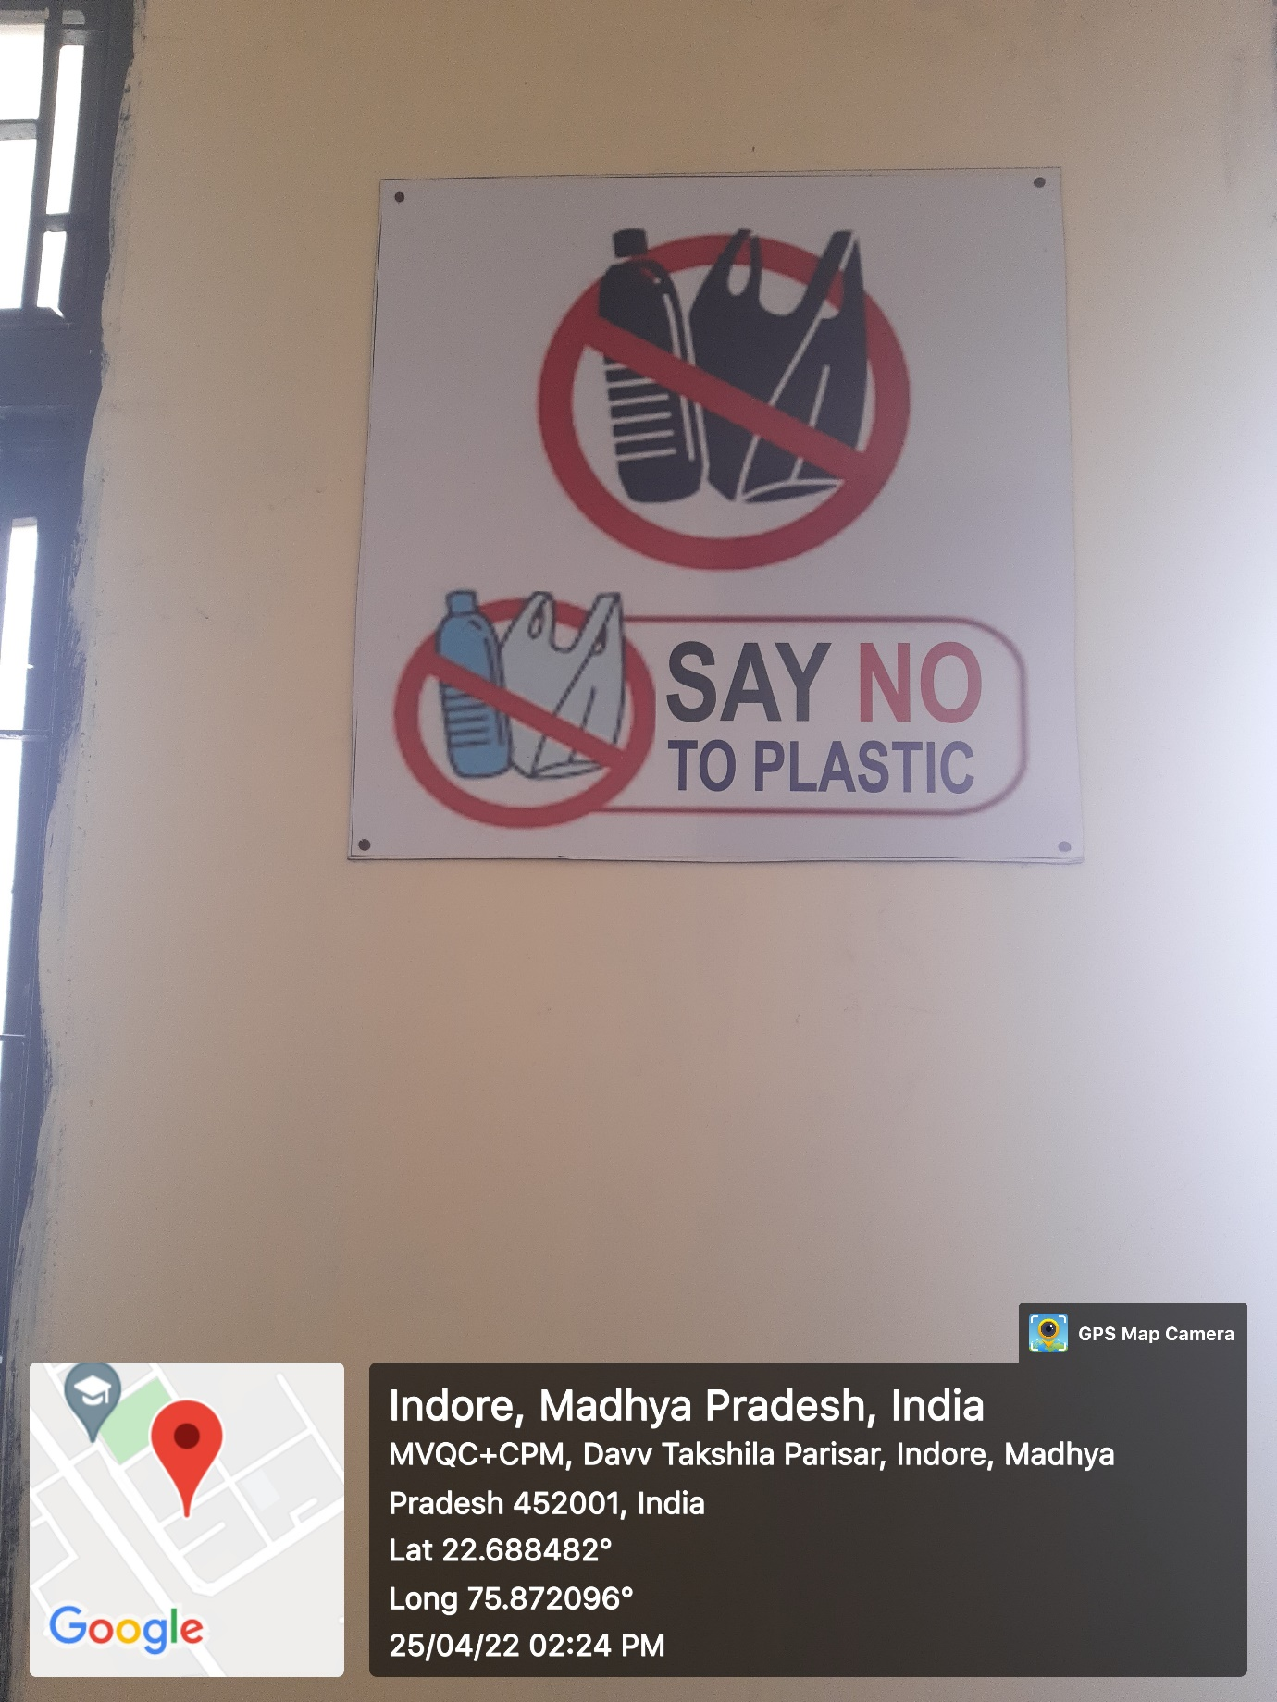
Figure 16: School of Life Sciences

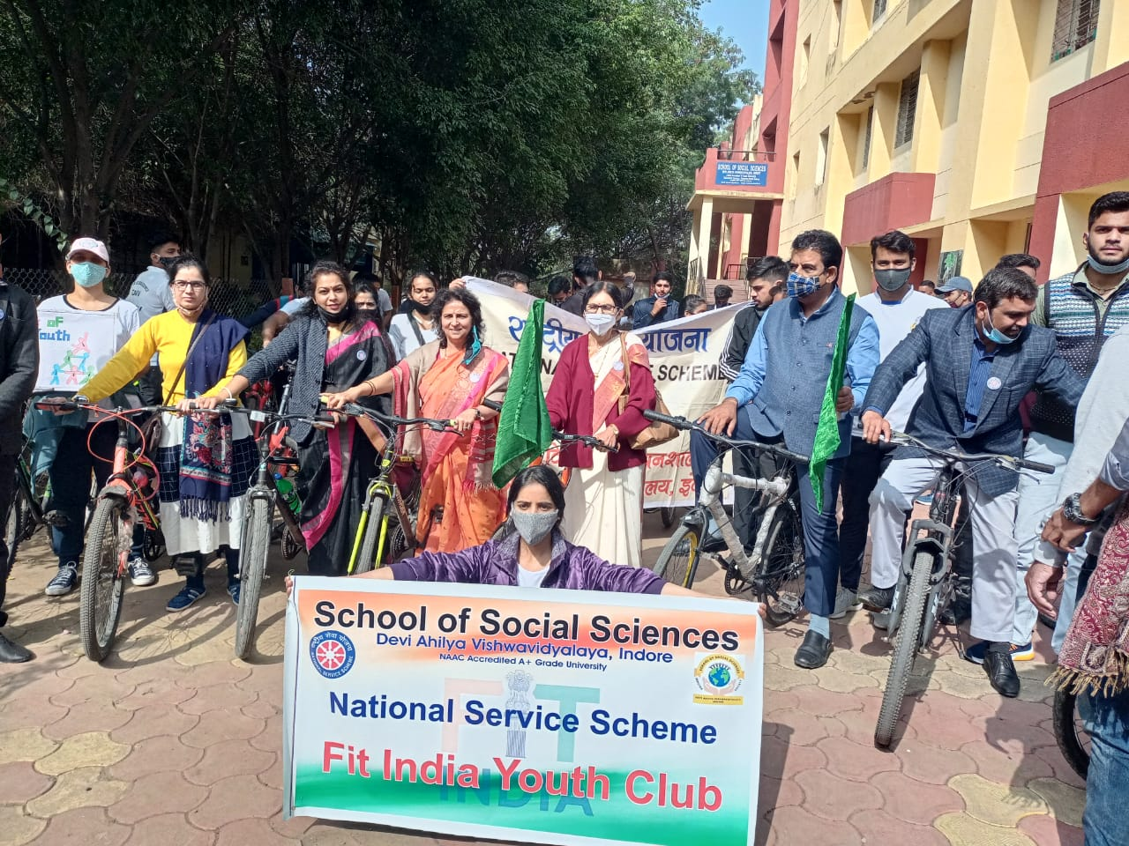
Figure 17: School of Social Sciences

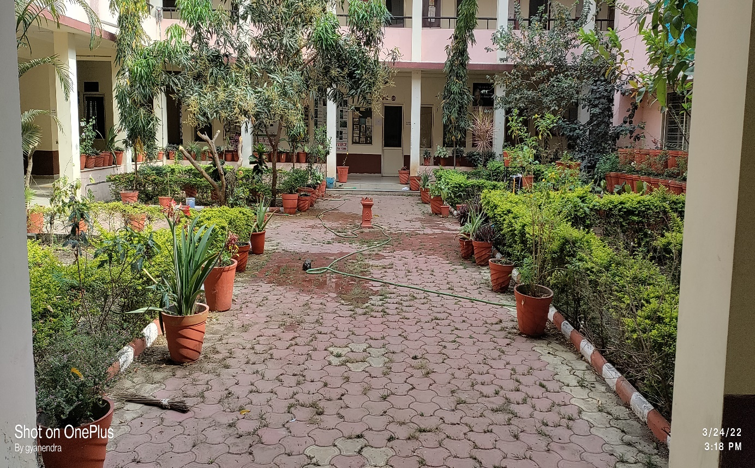
Figure 18: School of Social Sciences
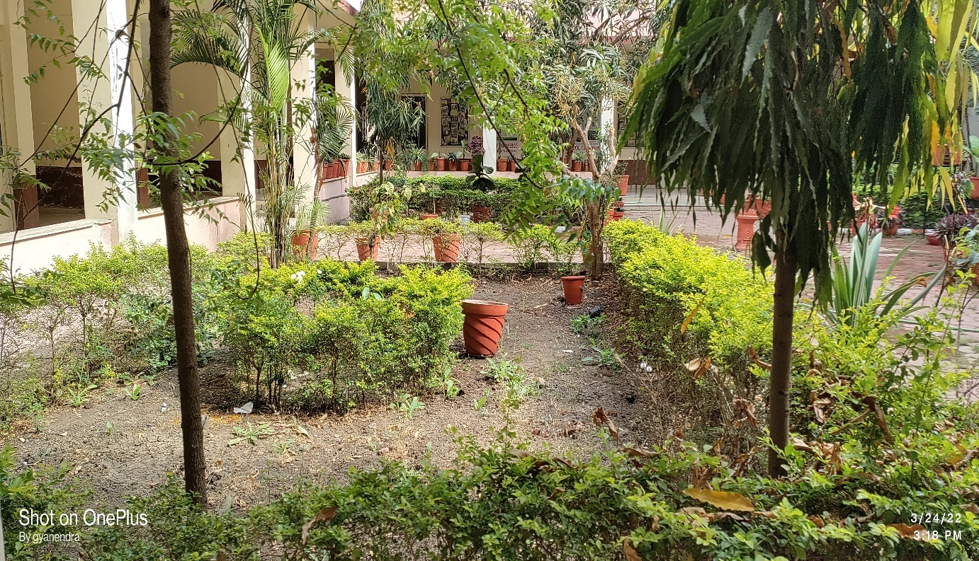
Figure 19: School of Social Sciences

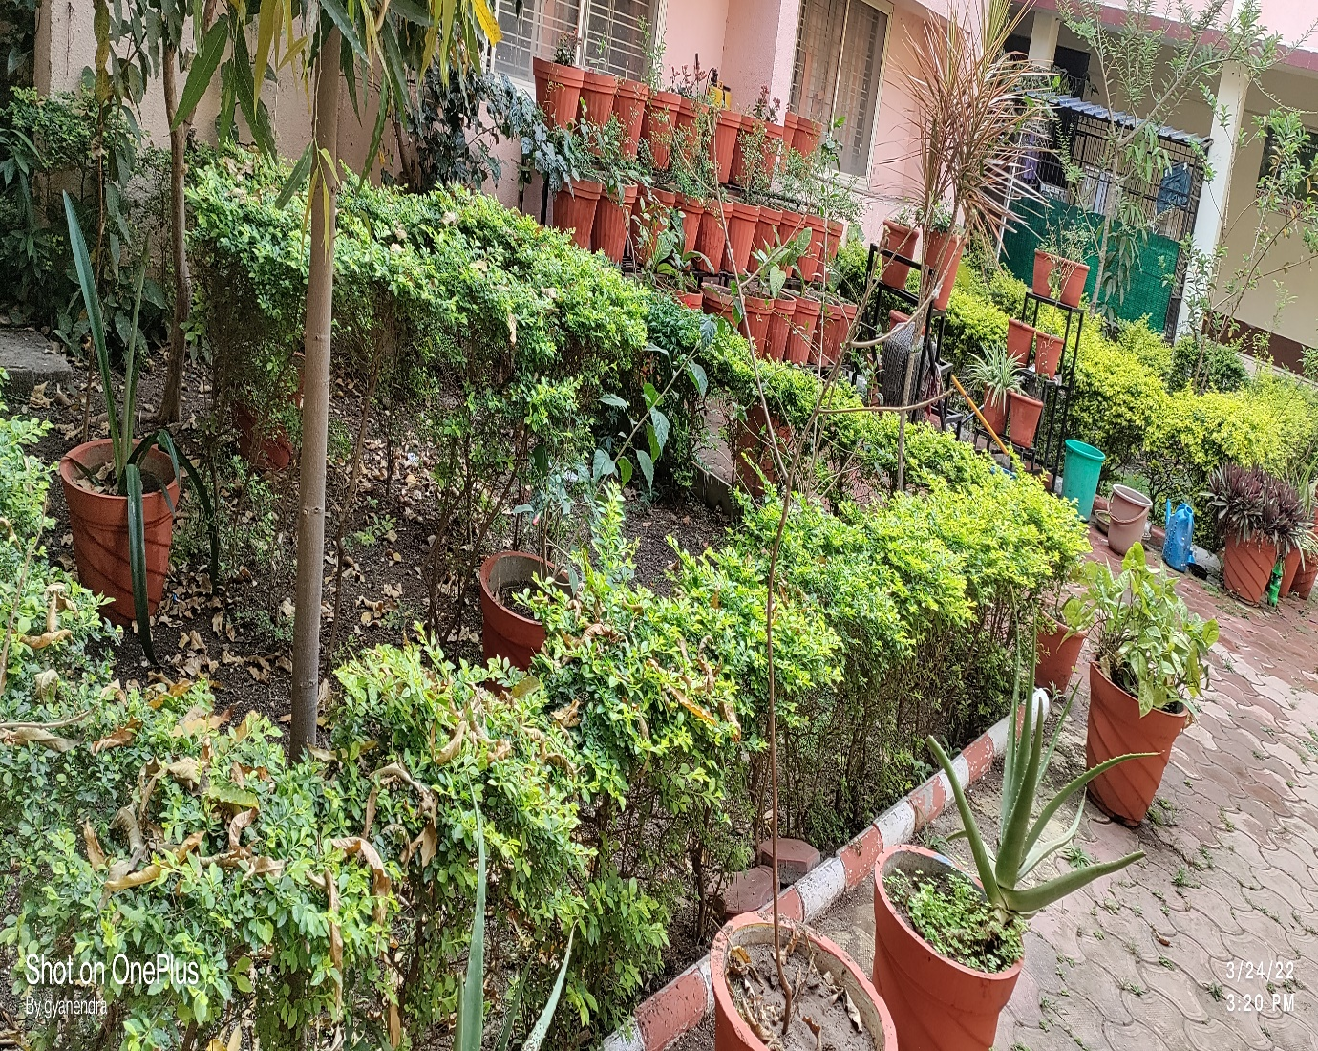
Figure 20: School of Social Sciences
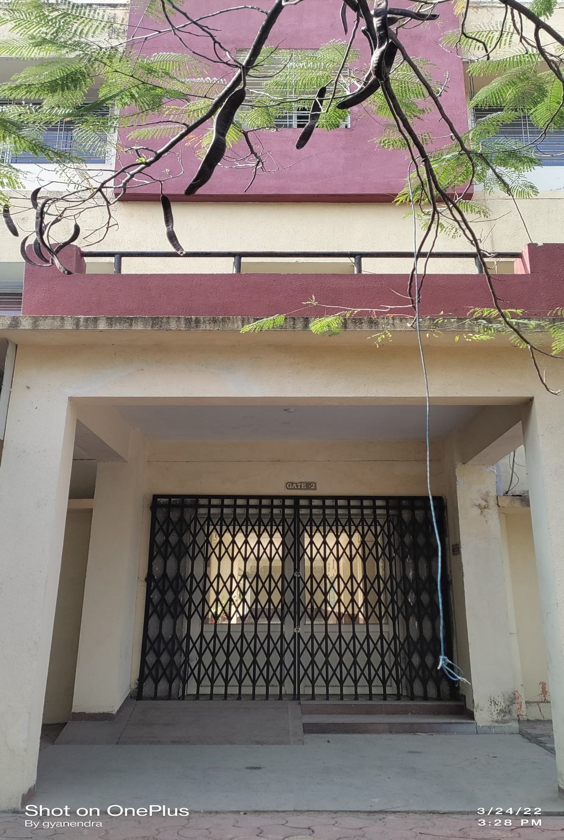
Figure 21: School of Social Sciences
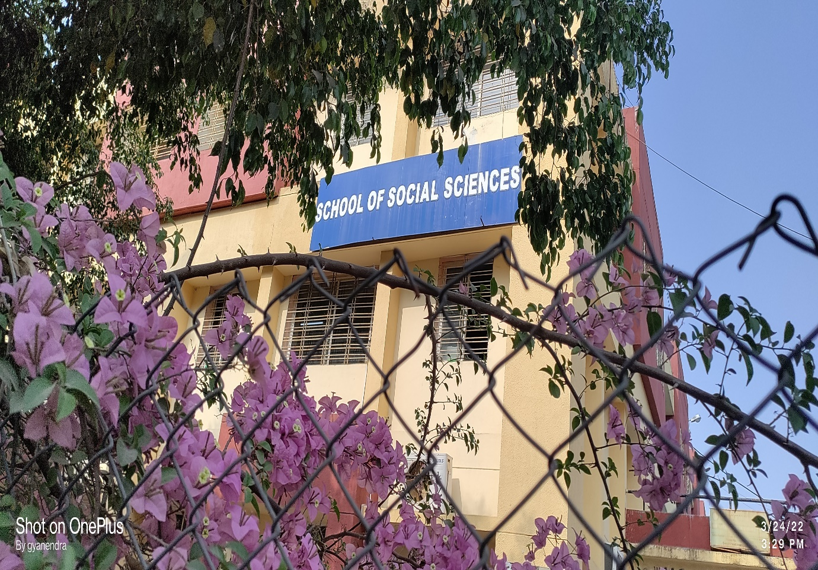
Figure 22: School of Social Sciences
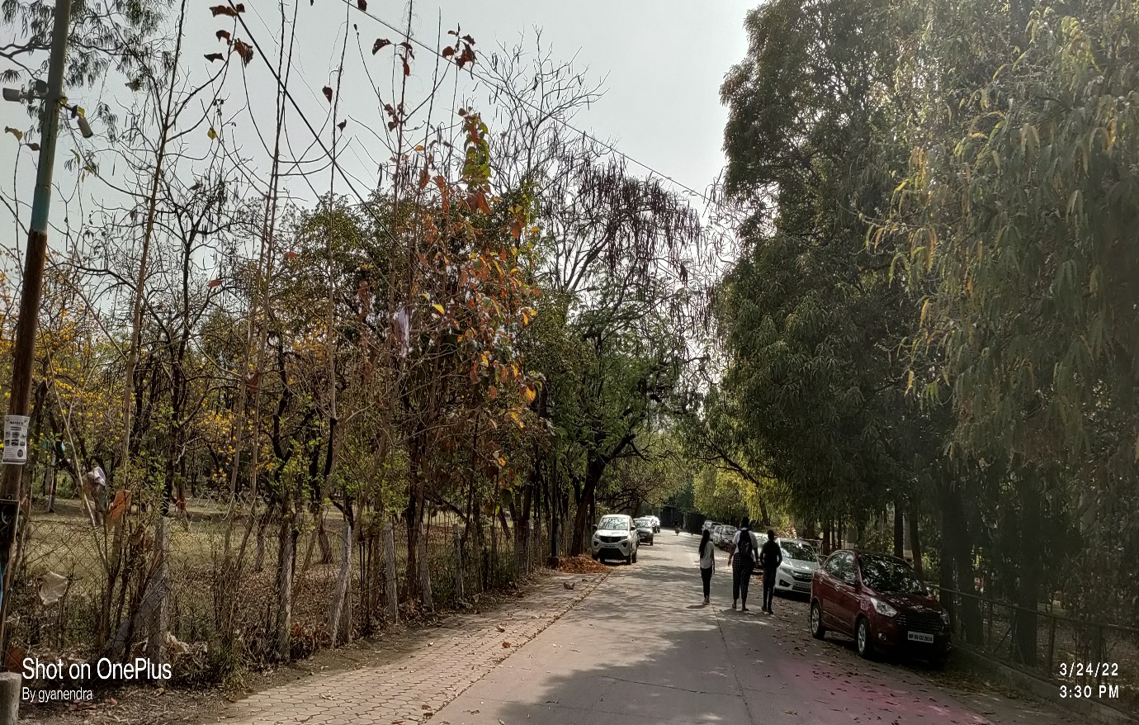
Figure 23: School of Social Sciences

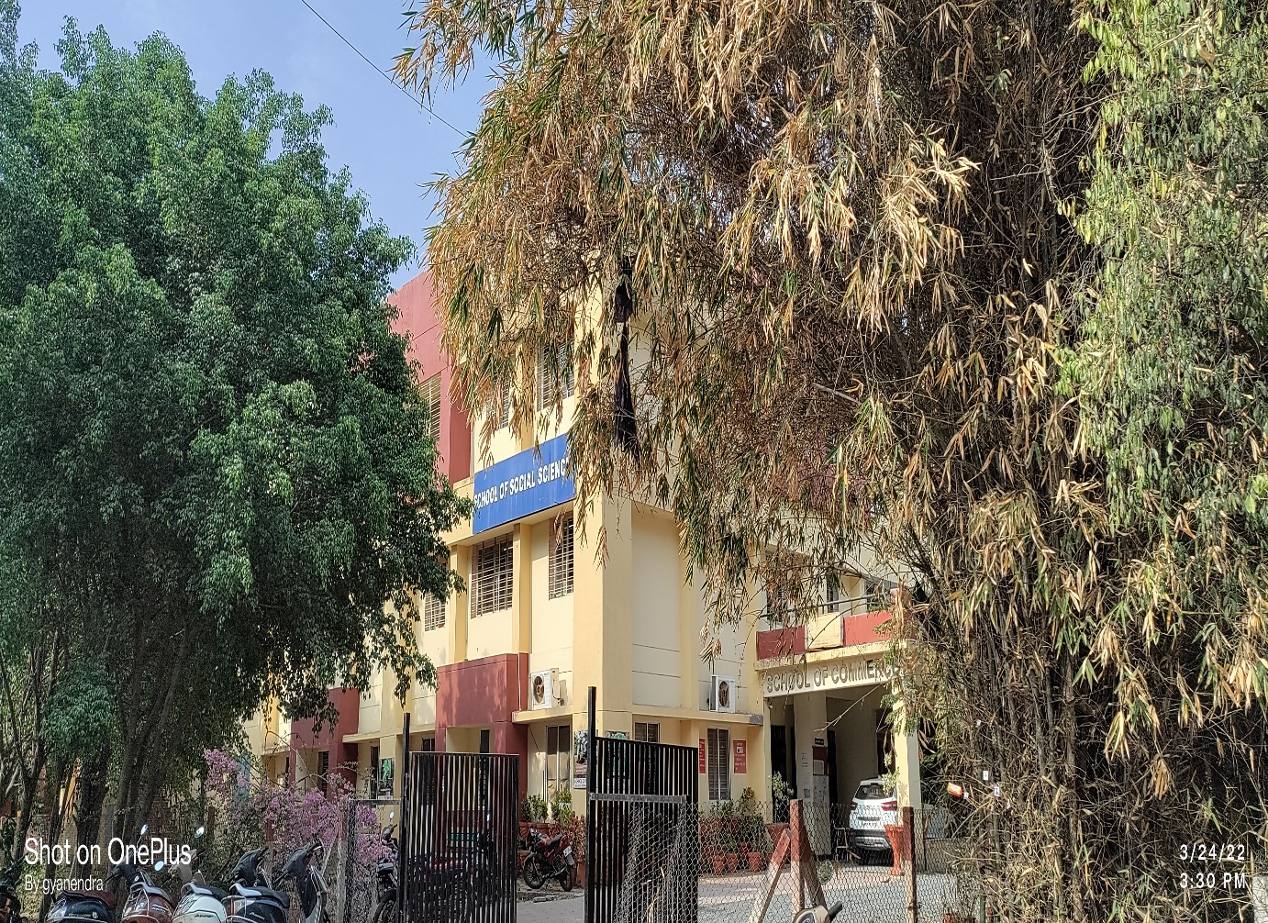
Figure 24: School of Social Sciences
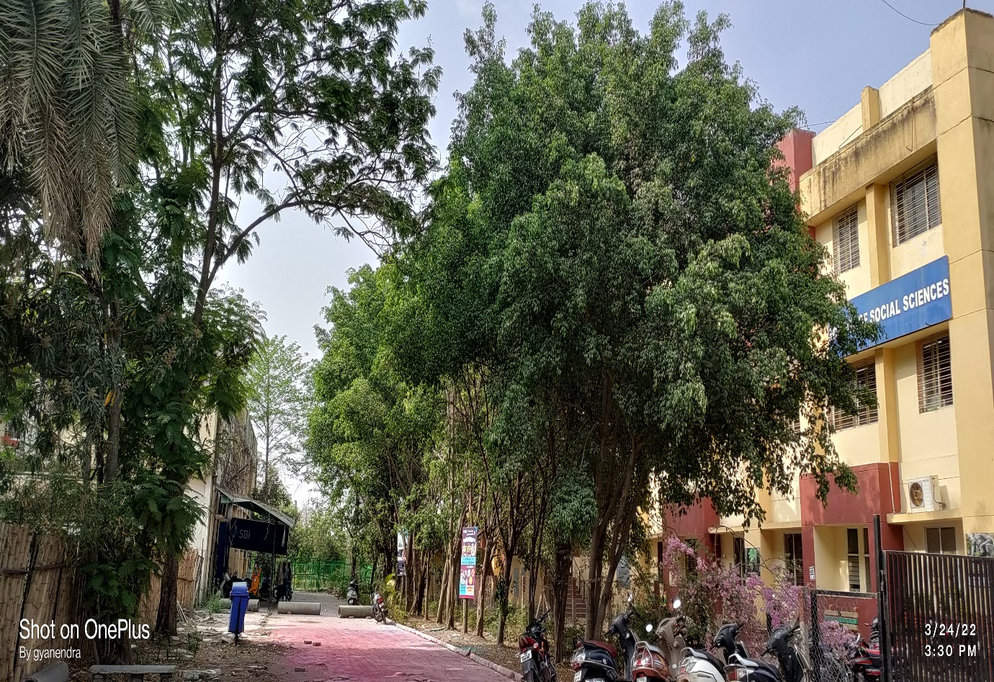
Figure 25: School of Social Sciences

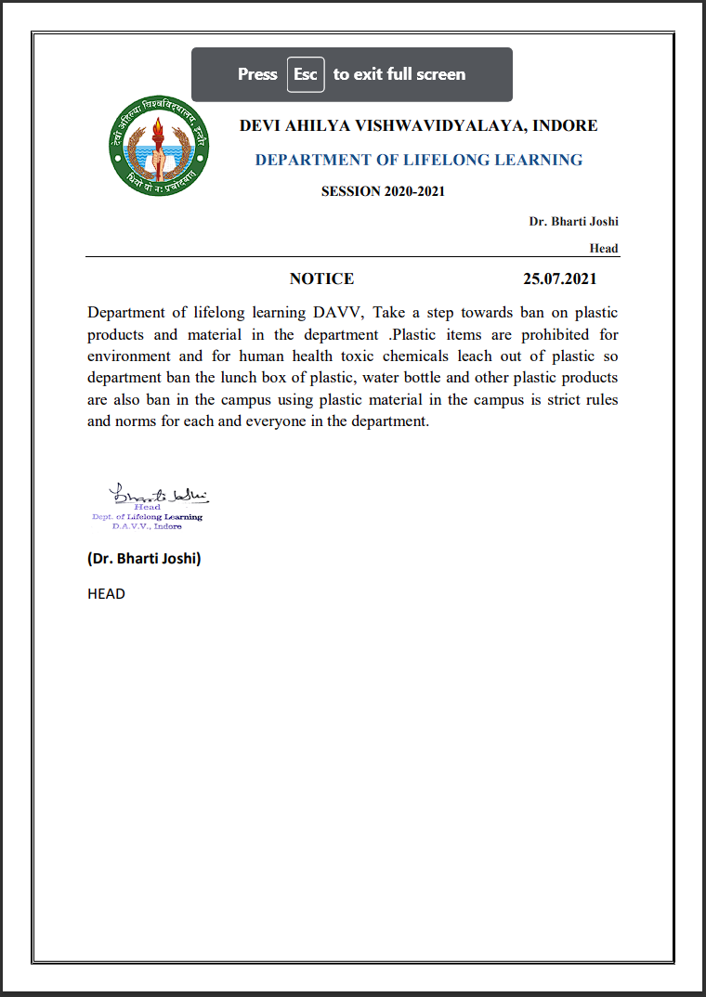
Figure 26: School of Lifelong Learning

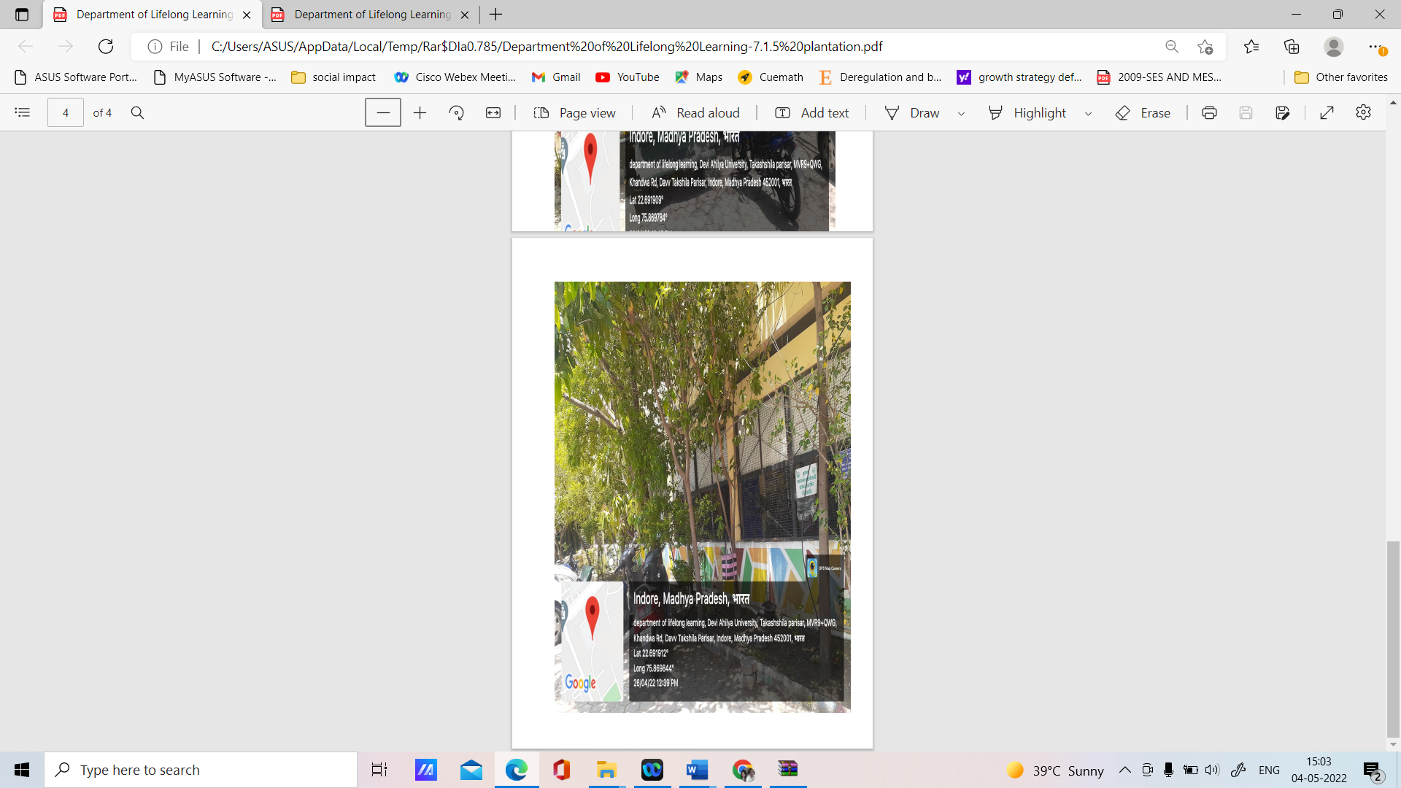
Figure 27: School of Lifelong Learning
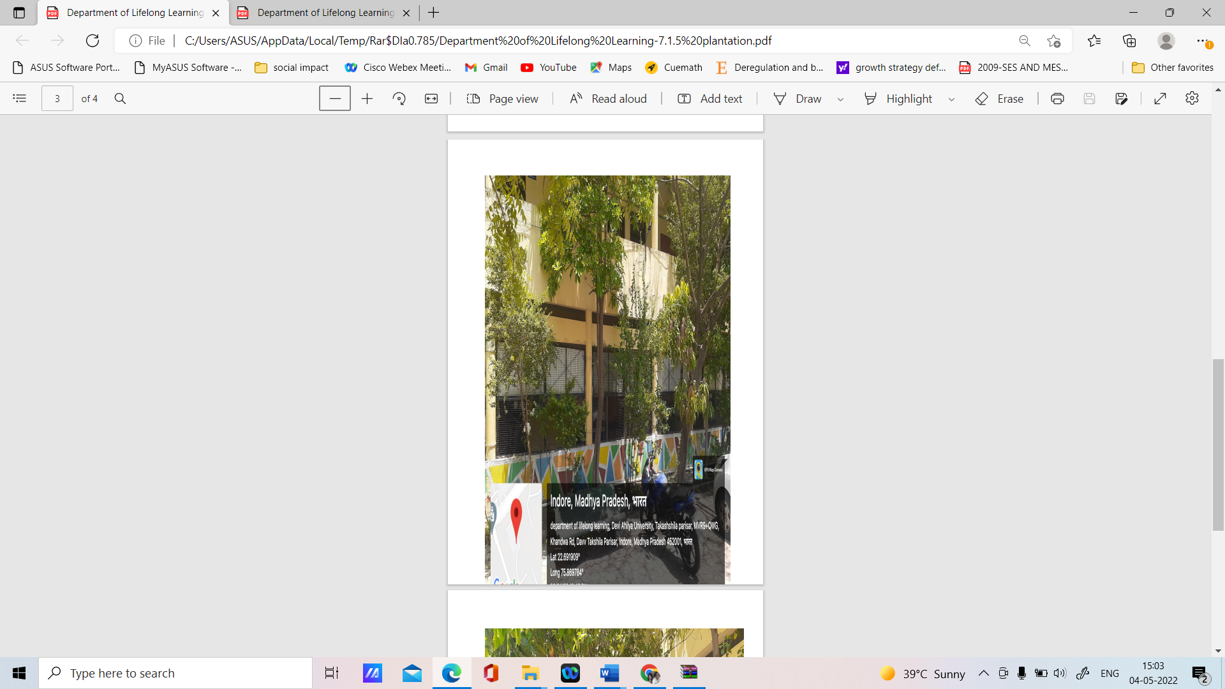
Figure 28: School of Lifelong Learning
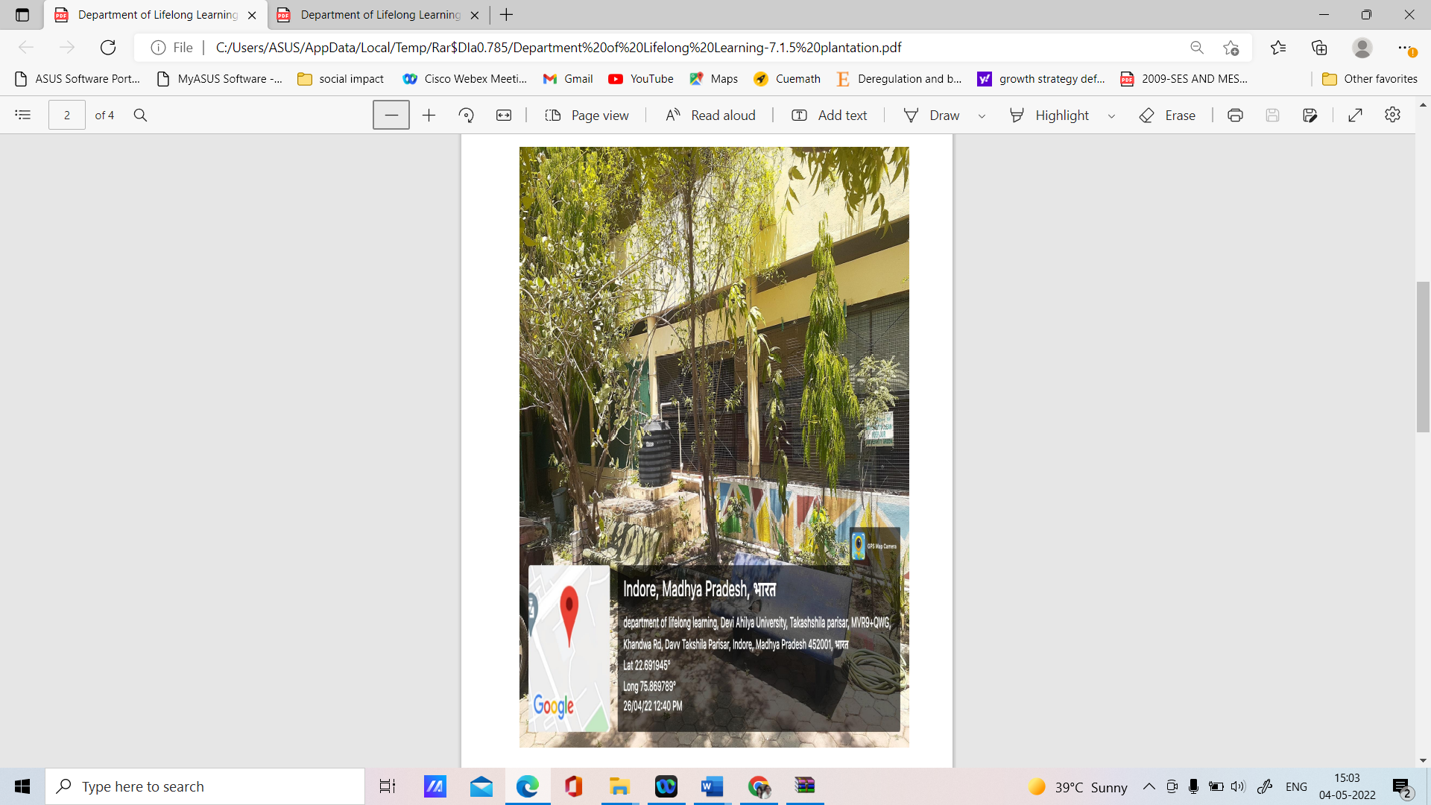
Figure 29: School of Lifelong Learning
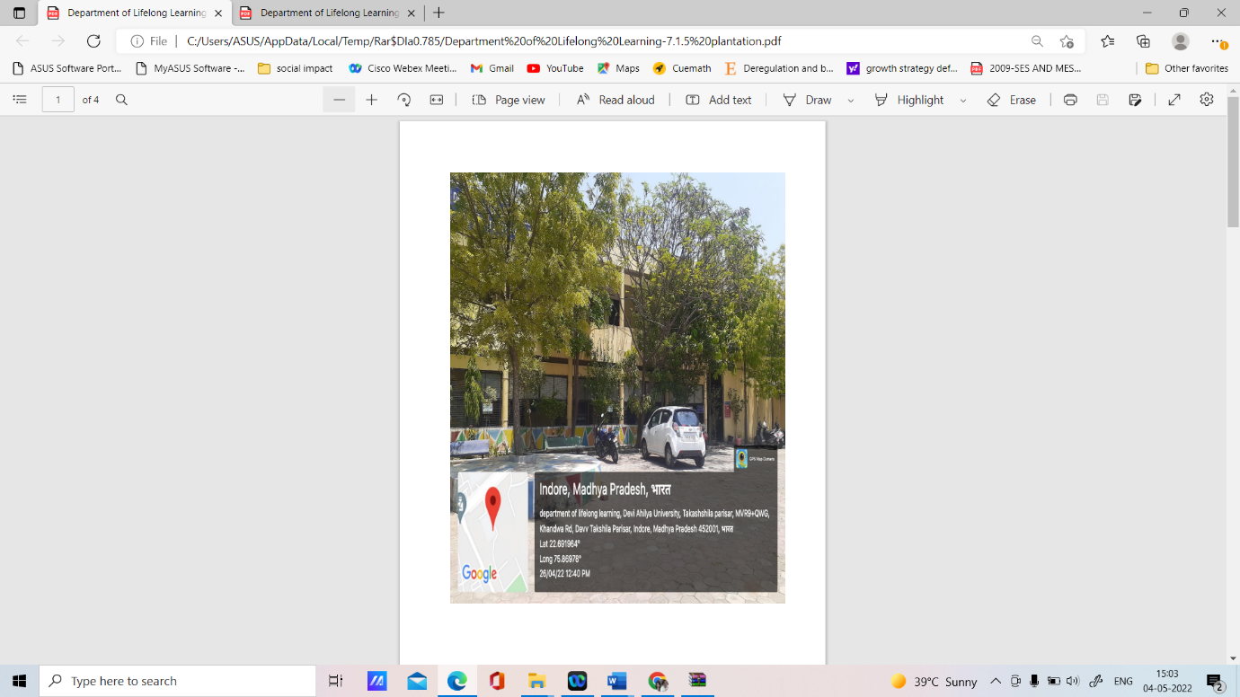
Figure 30: School of Lifelong Learning

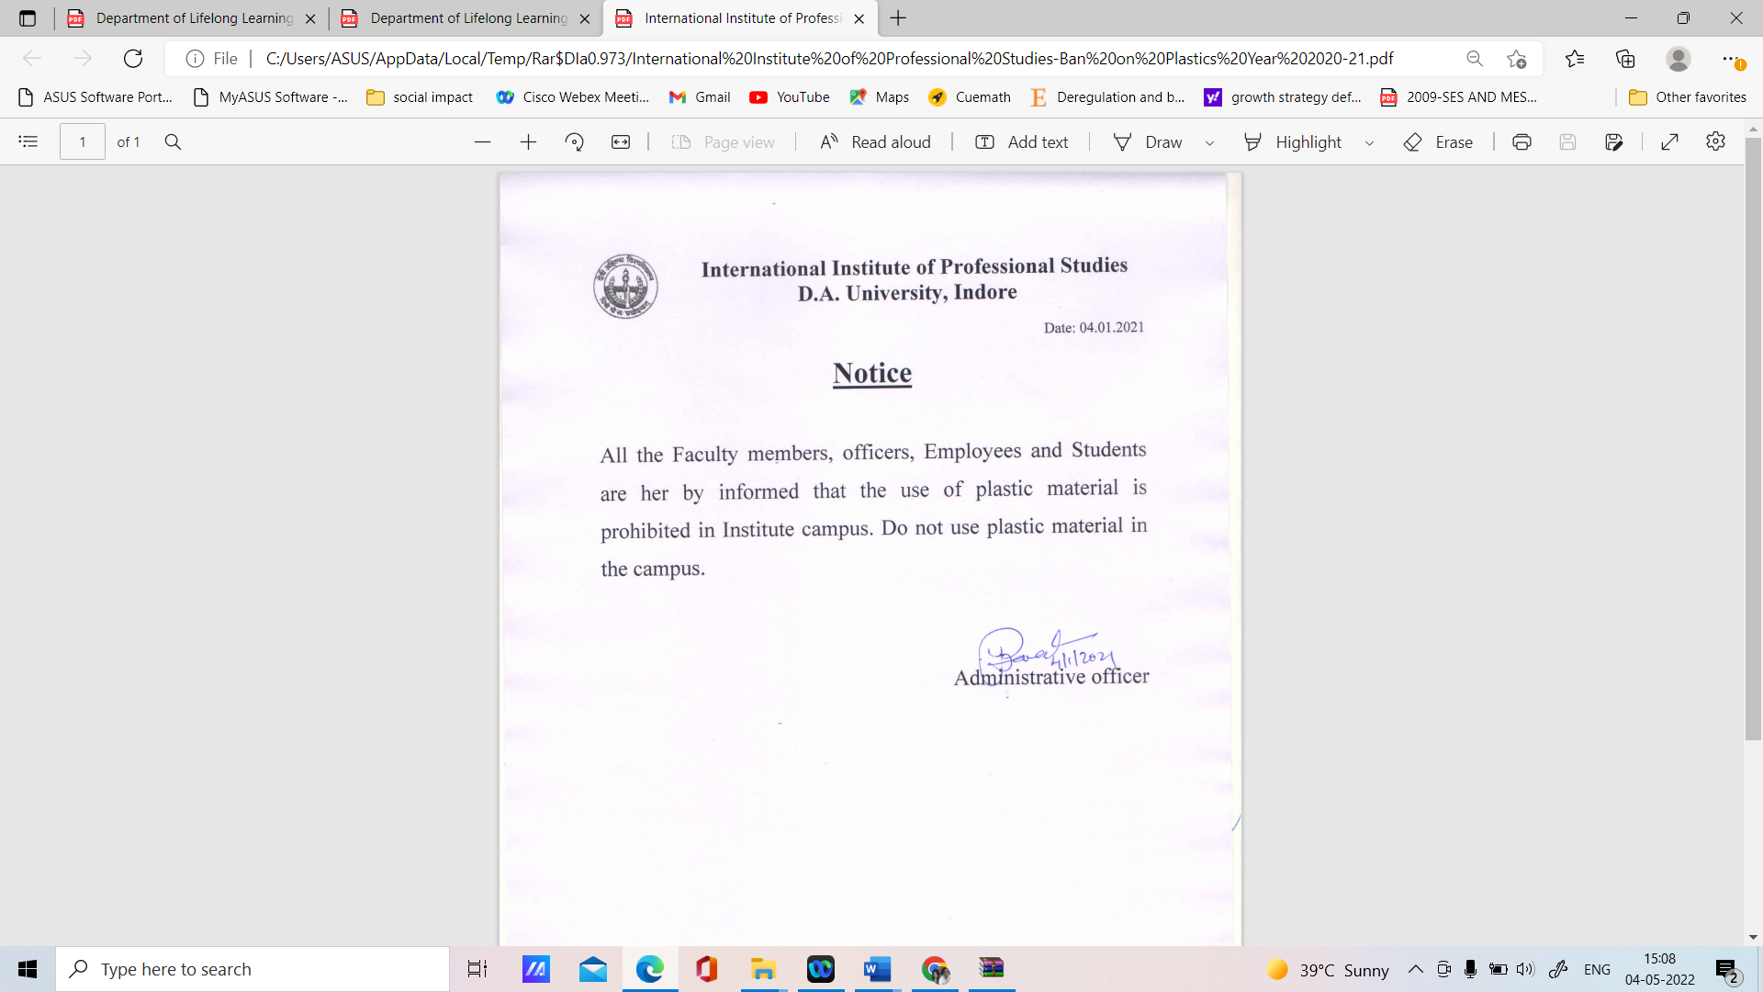
Figure 31: International Institute of Professional Studies

