



**DEVI AHILYA VISHWAVIDYALAYA, INDORE**

**7.1.6**

**Quality Audits on Environment**

Preliminary Energy Audit of

School of Law



Submitted by

Project Team :- Guided by: -

Samarth Barve Dr.S. P Singh

(HOD)

School of Energy and Environmental Studies Devi Ahilya Vishwavidyalaya, Indore Indore



# ACKNOWLEDGEMENT

First and foremost, we would like to give our sincere thanks to **Dr. Manish Sitlani (HOD)** of the School of Law, and the entire staff for their kind cooperation.

We take this opportunity to express our heartily thanks to all of them who directly or indirectly helped us in this project.

# Yours Sincerely

Samarth Barve



|  |  |  |
| --- | --- | --- |
| **Index** | | |
| **S. No.** | **Title** | **Page No.** |
| 01. | Executive Summary | 04 |
| 02. | Chapter 1- Introduction | 05 |
| 03. | Chapter 2 -Data Collection | 6-11 |
| 04. | General Recommendation | 12 |
| 05. | Energy Conservation Opportunities in Building | 14 |
| 06. | Annexure (i) | 15 |
|  | Annexure (ii) | 16 |
| 07. | Appendix | 17 |





**EXECUTIVE SUMMARY**

|  |  |  |  |  |  |  |  |
| --- | --- | --- | --- | --- | --- | --- | --- |
| **S.no** | **section** | **Energy conservation Measures** | **Energy Saving(kWh/yr)** | **Saving (Rs/yr)** | **Investment (Rs)** | **Payback period (Month)** | **Remark** |
| **1** | **Lightening load** | Replacement of Tube light to 18W LED  Tube lights | 6,352 | 44,467 | 23,100 | 6 | Feasible |
| **2** | **Cooling load** | Replacement of Fan into 53W Fan | 7,427 | 51,994 | 87,600 | 20 | Feasible |
| **3** | **Miscellaneous load** | Replacement of CRT into 18W LED  (18.5inch) | 2,783 | 19,481 | 49,500 | 30 | Feasible |
|  |  | **Total** | **16,563** | **1,15,942** | **1,60,200** | **17** |  |



**CHAPTER – 1 INTRODUCTION**

The School of Law was established in 1998. It is a premier institute in the field of Law with the sole aim of preparing students for a challenging and demanding career in the noble profession of Law. This institute strives to inculcate interdisciplinary approach and provide a backdrop of social sciences along with strong professional know-how.

The School of Law boasts of a core infrastructure, which includes extensive library with National and International Journals and Periodicals. In addition to classroom teaching, the students are taught through seminars, workshops, and moot court and case methods. Extensive interaction with Judges, Advocates, Law Officers and Legal Luminaries, is a part of the curriculum.



# Aims and Objectives

* To make law and legal processes efficient instruments of social development.
* To develop in students and research scholars a sense of responsibility to serve society in the field of law, legal services, legislation, law reforms and similar issues.
* To advance and disseminate learning and knowledge of law and legal processes and their role in national development.

# Course Offered

* + B.A., LL.B. (Hons) (5-year Full-time Programme)
  + LL.M. (2 Year Full-time Programme)
  + M. Phil (Law)
  + Ph. D. (Law)



**CHAPTER-2**

**DATA COLLECTION**

The Building is connected to a Common transformer of present contact demand is **350 KVA**. The Energy Audit conducted in month of October-2018, taken the relevant measurements on all gadgets and utilities used in the building. Also, the several important observations have been recorded to suggest the energy conservation measures. The objectives of the energy audit are as under:

* + To analysis of energy supply demand pattern of the School LAW, Indore.
  + To measure and analysis of power consumption at different gadgets utilities.
  + To analysis existing trend of energy consumption.
  + To propose suitable energy conservation measures with proper techno-economic analysis.

The energy consumption data for the year 2018 was collected. Data analysis and consumption pattern is given in the report. Energy conservation measures are given along with the detailed analysis in the Different sections. Audit report included the introduction, Executive summary, the detailed of energy consumption of School of LAW, Indore and general observations, Included the analysis of energy consumption in various floor of the School LAW, Indore.

# 2.1. Electrical Energy Consumption and Bills:

The power supply for the School of Law, Indore is from M.P.P.K.V.V.Co. Ltd. with the help of 33 KV non-industry urban feeders. The monthly electrical consumption for the department of the year 2018 is given in the following table:

**Monthly Energy Consumption in the year 2018:**

|  |  |  |  |  |
| --- | --- | --- | --- | --- |
| **Sr.no** | **Month** | **Energy Consumption(kWh/month)** | **Energy charge (Rs7/kWh)** | **Monthly bill (Rs)** |
| **1** | **Jan 18** | **1127** | **7** | **7889** |
| **2** | **Feb 18** | **1100** | **7** | **7700** |
| **3** | **Mar 18** | **1155** | **7** | **8085** |
| **4** | **Apr 18** | **1677** | **7** | **11739** |
| **5** | **May 18** | **1677** | **7** | **11739** |
| **6** | **Jun 18** | **1650** | **7** | **11550** |
| **7** | **July 18** | **1650** | **7** | **11550** |
| **8** | **Aug 18** | **1677** | **7** | **11739** |
| **9** | **Sep 18** | **1650** | **7** | **11550** |



**ENERGY CONSUMPTION kWh/Month**

1800

1600

1400

1200

1000

800

600

400

200

0

Jan-18 Feb-18 Marc 18 Apr-18 May-18 Jun-18

Jul-18 Aug-18 Sep-18

ENERGY CONSUMPTION

Column1

Column2

**Rs/Month**

14000

12000

10000

8000

6000

4000

2000

0

Jan-18 Feb-18 Mar-18 Apr-18 May-18 Jun-18 Jul-18 Aug-18 Sep-18

energy bill

Column1

Column2



# Connected Load of overall Department: -

|  |  |  |
| --- | --- | --- |
| **Sr.no** | **Load** | **kW** |
| 1 | **Lightening** | 4.89 |
| 2 | **Cooling** | 9.82 |
| 3 | **Miscellaneous** | 5.85 |
|  | **Total** | **20.56** |

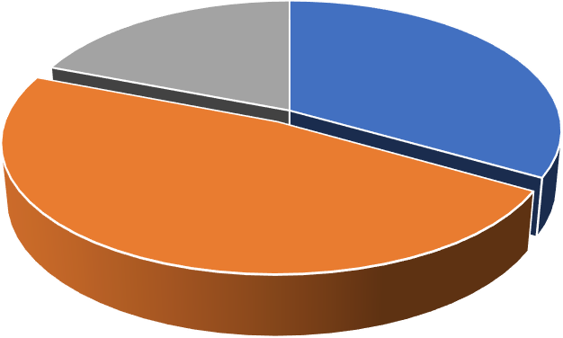

**Connected Load**

4.89

5.85

9.82

Lightening Cooling Miscellanous



* 1. **Connected Load of Department: -**

|  |  |  |  |  |  |
| --- | --- | --- | --- | --- | --- |
| **Sr. No.** | **Type of Load** | **Type** | **Rated Power (Watts)** | **Quantity** | **Total Wattage (kW)** |
| **1** | **Lighting** | **FTL** | 40 | 97 | 3.880 |
| 20 | 8 | 0.160 |
|  |  | **Lamps** | 150 | 3 | 0.450 |
|  |  |  | 200 | 2 | 0.400 |
|  |  |  | **Total kW** | | **4.89** |
| **2** | **Cooling** | **Fan** | 85 | 73 | 6.2 |
| **exhaust** | 60 | 2 | 0.12 |
|  |  | **AC** | 3517 | 1 | 3.517 |
|  |  |  | **Total kW** | | **9.82** |
| **3** | **Computer** | **CRT** | 110 | 11 | 1.21 |
| **LCD** | 35 | 5 | 0.175 |
| **Printer** | **SCX4300** | 350 | 4 | 1.4 |
| **Projector** |  | 300 | 1 | 0.3 |
| **Water Cooler** | **Aqua guard** | 300 | 1 | 0.576 |
|  |  | **Photocopy** | 650 | 1 | 0.650 |
|  |  |  | **Total kW** | | **5.85** |
|  |  |  | **Total kW** | | **20.57** |

Note: **Total connected load in building is around 20.57 kW**.



# Suggestions & Savings calculations:

**Replacement of 40W FTL to 18W LED Tube light**

|  |  |  |  |
| --- | --- | --- | --- |
| **Sr. No.** | **Parameter** | **Value** | **Units** |
| 1 | Type of load | **FTL** |  |
| 2 | Power in watt | **40** | **Watt** |
| 3 | Total no of fixtures | **105** | **units** |
| 4 | No of hrs/day | **10** | **hrs** |
| 5 | No of day/year | **275** | **days** |
| 6 | Suggested LED Tube light | **18** | **Watt** |
| 7 | Saving in kWh | **6352** | **kWh** |
| 8 | Load Factor | **0.9** |  |
| 9 | Energy Charges Rs. /kWh | **7.00** | **Rs/kWh** |
| 10 | Saving in Rs/Year | **44467/-** | **INR** |
| 11 | Cost/Piece (Rs) | **220/-** | **INR** |
| 12 | Total Investment (Rs) | **23,100/-** | **INR** |
| 13 | Pay Back Period (Month) | **7** | **Months** |
| 14 | Pay Back Period Year | **0.5** | **year** |

**Replacement of 90W ceiling fan to Energy efficient gorilla fan 40W fan**

|  |  |  |  |
| --- | --- | --- | --- |
| **Sr. No.** | **Parameter** | **Value** | **Units** |
| 1 | Type of load | **Fan** |  |
| 2 | Power in watt | **90** | **Watt** |
| 3 | Total no of fixtures | **73** | **units** |
| 4 | No of hrs/day | **10** | **hrs** |
| 5 | No of day/year | **275** | **days** |
| 6 | Suggested 40 W fan | **53** | **Watt** |
| 7 | Saving in kWh | **7427** | **kWh** |
| 8 | Load Factor | **0.9** |  |
| 9 | Energy Charges Rs. /kWh | **7.00** | **Rs/kWh** |
| 10 | Saving in Rs/Year | **51,994/-** | **INR** |
| 11 | Cost/Piece (Rs) | **1200/-** | **INR** |
| 12 | Total Investment (Rs) | **87,600/-** | **INR** |
| 13 | Pay Back Period (Month) | **20** | **Months** |
| 14 | Pay Back Period Year | **1.7** | **year** |



**Replacement of 110W CRT into 18W LED (18.5inch)**

|  |  |  |  |
| --- | --- | --- | --- |
| **Sr.no** | **parameters** | **value** | **Units** |
| 1 | Type of load | **CRT** |  |
| 2 | Power in watt | **110** | **Watt** |
| 3 | Total no of fixture | **11** | **units** |
| 4 | No of hrs/day | **10** | **hrs** |
| 5 | No of day/year | **275** | **days** |
| 6 | Suggested wattage | **18** | **Watt** |
| 7 | Saving kWh | **2783** | **kWh** |
| 8 | Load factor | **0.9** |  |
| 9 | Energy charge Rs/Kwh | **7** | **Rs/kWh** |
| 10 | Saving in rupee/year | **19481** | **INR** |
| 11 | Cost/piece Rs | **4500** | **INR** |
| 12 | Total investment | **49500** | **INR** |
| 13 | Payback period month | **30** | **Months** |
| 14 | Payback period year | **2.5** | **Year** |



# Recommendations: -

* + - Replace existing single fitting **40W** conventional tube light with **18W** LED tube light (As per Recommendation of BEE).
    - Replacement of **90 W** Ceiling Fan by Energy Efficient Gorilla Fan **53 W** fans.
    - Replacement of **70 W** Exhaust by low wattage **45 W** Exhaust fan.
    - Replacement of **110 W** Computer monitor **(CRT)** into **18W** LED (18.5inch).
    - Cminiature circuit breaker □f rating **50A** can be used for first Floor, for second and third floor **20A** MCB used, hence in case of excess load this MCB trip the Circuit.



# Energy Conservation Opportunities in Building

## Lighting strategies

* + - * Invest in high efficiency systems and equipment Specify energy efficient lighting fixtures to provide appropriate luminance levels for sufficiently bright internal spaces.

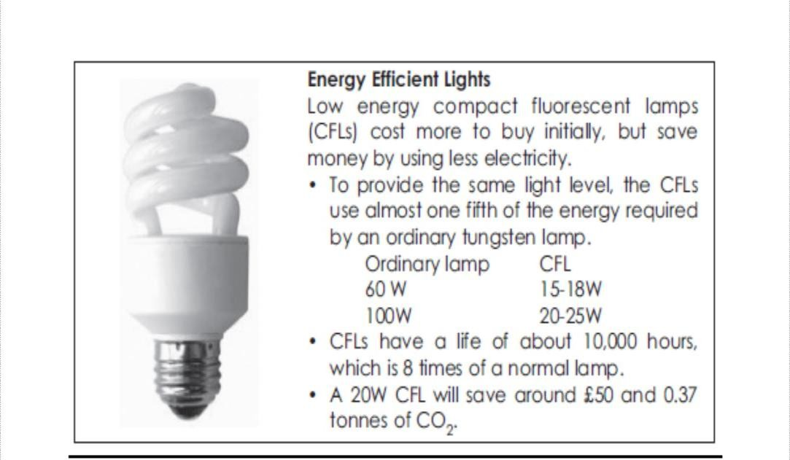

**Provide control to users**

* Provide desk lamps on work spaces in addition to room lights to meet the required light levels in offices and study areas in residential halls.
* Provide dimmers in rooms to control the amount of light in a room. This is especially beneficial in seminar rooms with data projection requirements.



# Buildings:

* Seal exterior cracks/openings/gaps with caulk, weather stripping, etc. 
* Consider new thermal doors, thermal windows, roofing insulation, etc.
* Install windbreaks near exterior doors.
* Replace single-pane glass with insulating glass.
* Consider covering some window and skylight areas with insulated wall panels inside the building.
* If visibility is not required but light is required, consider replacing exterior windows with insulated glass block.
* Consider tinted glass, reflective glass, coatings, awnings, overhangs, draperies, blinds, and shades for sunlit exterior windows.
* Use landscaping to advantage.
* Add vestibules or revolving doors to primary exterior personnel doors.
* Consider automatic doors, air curtains, strip doors, etc. at high-traffic passages between conditioned and non-conditioned spaces. Use self-closing doors if possible.
* Use intermediate doors in stairways and vertical passages to minimize building stack effect.
* Use dock seals at shipping and receiving doors.
* Bring cleaning personnel in during the working day or as soon after as possible to minimize lighting and HVAC costs.



## Annexure (i) Specifications required for Fan:

|  |  |  |
| --- | --- | --- |
| **S. No.** | **Parameter** | **Value** |
| 01. | Span (MM/INCH) | 1200/48 |
| 02. | Wattage | 53 |
| 03. | Air Delivery (CMM) | 230 |
| 04. | RPM | 300 |
| 05. | Warranty (Years) | 3-5 |
| 06. | Power Factor | >.98 |
| 07. | Number of Blades | 3 |

**Specifications required for LED Tube light (includes LED):**

|  |  |  |
| --- | --- | --- |
| **S. No.** | **Parameter** | **Value** |
| 01. | Size | Standard T5 |
| 02. | Color | Cool Day Light |
| 03. | Wattage | 18 watts |
| 04. | Warranty (Years) | 2-3 |
| 05. | Operating Life (Hrs.) | 35000-50000 |



## Annexure(ii)

|  |  |  |  |  |  |  |  |
| --- | --- | --- | --- | --- | --- | --- | --- |
| Parameter | **Type of Lamp** | | | | | | |
| Incandescent (Bulb) | CFL | Metal Halide | HPSV | LED | Fluorescent Tube light (T8) | LED  Tube light (T8) |
| **Power (watt)** | 25-150 | 18-95 | 50-400 | 50-  400 | 150 | 25-125 | 18-36 |
| **Output (lumens)** | 210-2700 | 1000-  7500 | 1900-  30000 | 3600-  46000 | 7200 | 2000 | 2000 |
| **Efficacy (lumens/ Watt)** | 8-18 | 55-79 | 38-75 | 72-  115 | 48 | 50-100 | 80-150 |
| **Life Span (Hrs)** | 750-2000 | 10000-  20000 | 10000-  20000 | 18000  - 24000 | 5000  0 | 7000-15000 | 35000-  50000 |
| **CRI** | Excellent (100) | Good | Good | Poor (20) | Very Good | Good | Very Good |



**Appendix**

## List of Vendors and Distributors of LED & 53 W Fan

|  |  |
| --- | --- |
| HELPLINE NUMBER: 18001803580/155275 | |
| 1 | AAZAD NAGAR MPEB, INDORE |
| 2 | AGRESEN NAGAR MPEB, INDORE |
| 3 | ANPURNA MPEB, INDORE |
| 4 | ARANYA NAGAR, MPEB, INDORE |
| 5 | ELECTRIC COMPLEX MPEB, INDORE |
| 6 | GANDHI NAGAR MPEB, INDORE |
| 7 | GUMASHTA NAGAR MPEB, INDORE |
| 8 | KHARJANA, MPEB, INDORE |
| 9 | MAHA LAXMI MPEB, INDORE |
| 10 | MALVA MILL MPEB, INDORE |
| 11 | MANORAMA GANJ, MPEB, INDORE |
| 12 | MECHANIC NAGAR, MPEB, INDORE |
| 13 | NARSING BAZAR MPEB, INDORE |
| 14 | NAVLAKHA MPEB, INDORE |
| 15 | POLO GROUND MPEB, INDORE |
| 16 | RAJ MOHALLA-KALANI NAGAR MPEB, INDORE |
| 17 | SANGAM NAGAR, MPEB, INDORE |
| 18 | SIYA GANJ MPEB, INDORE |
| 19 | SUBHAS CHOK MPEB, INDORE |
| 20 | TILAK NAGAR MPEB, INDORE |
| 21 | VIJAY NAGAR MPEB, INDORE |

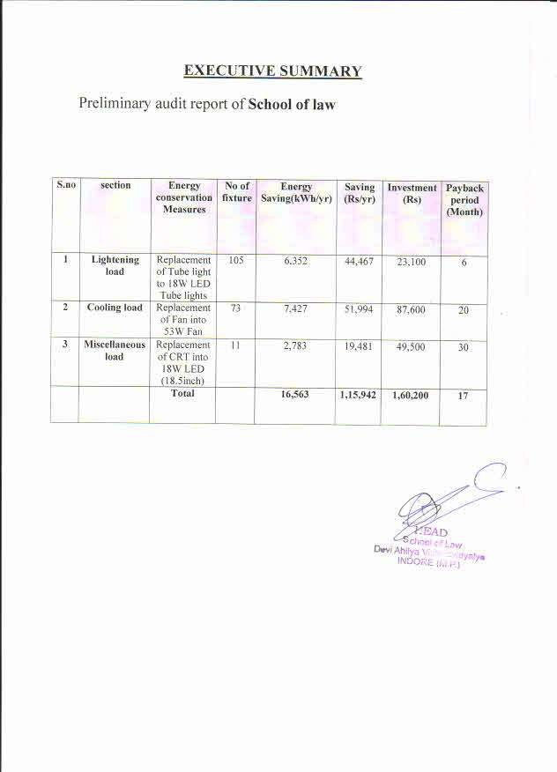

Preliminary Energy Audit of

**School of Energy & Environmental Studies (SEES)**

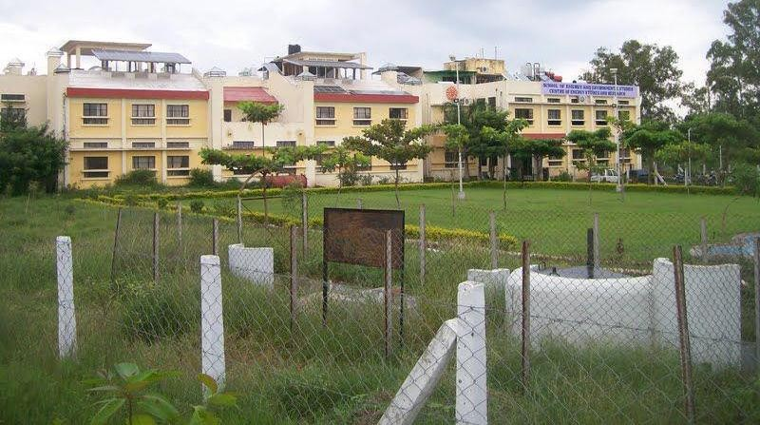

School of Energy and Environmental Studies Devi Ahilya Vishwavidyalaya, Indore (M.P.)

**EXECUTIVE SUMMARY**

|  |  |  |  |  |  |  |
| --- | --- | --- | --- | --- | --- | --- |
| **Sr. No** | **Section** | **Energy Conservation Measures** | **Energy Saving (kWh/yr)** | **Saving (Rs./year)** | **Investment (Rs.)** | **Simple payback Period**  **(Months)** |
| 1 | Lighting | Repl. of 54W Conv. TL with 28W T5 lights | 26,910 | 1,83,870/- | 1,72,500/- | 11 |
| Replacement of 100W Bulb with 28W CFL | 236 | 1650/- | 500/- | 4 |
| 2 | Cooling Load (Fan) | Replacement of 90W Fan with 52W ceiling fan | 166 | 1160 | 1800 | 35 |
| 3 | Ventilation Load(Ex.  Fan) | Replacement of 70W Ex.Fan with 35W  Ex.Fan | 840 | 5885/- | 1100/- | 24 |
| 4 | Computer | Replacement of 110 W CRT  with 25 W (LED) | 2005 | 14035/- | 50400/- | 43 |
| 5 | Regulator Fan | Replacement of 15W resiostive regulator with 25 W Electronic Regulator | 483 | 3375/- | 200/- | 17 |
|  |  | Total | **30,640** | **2,09,975/-** | **2,26,500/-** | **12** |

**THE SCHOOL**

**CHAPTER 1 INTRODUCTION**

School of Energy and Environmental Studies (SEES), a University Teaching Department under the Faculty of Engineering Sciences was established in 1990. It also has an autonomous sister unit Center of Energy Studies and Research (CESR). The school offers Ph.D., M. Tech., (Regular), M. Tech. (Distance Learning) and M. Phil. Degree Programmes. It is housed in the Takshashila Campus on Khandwa Road.

**OBJECTIVES**

Development, planning, implementation and evaluation of energy conservation, renewable energy and environment programmes in the country are to a great extent limited by the availability of trained personnel at research, design and engineering level. Hence there is need to train engineers/scientists in energy planning, conservation technologies, renewable energy systems, and their linkages with environment.

**ACADEMIC PROGRAMS**

1. Ph.D. in Energy and Environment in engineering.
2. M.Tech (Energy Management)
3. Regular mode, AICTE approved
4. Distance mode, DEC, IGNOU approved with special provision of 3 semesters PG Advanced Diploma in Energy Auditing*
5. M.Phill. in Energy and Environment. (UGC Sponsored)

**INFRASTRUCTURE**

The School is having 5 kW solar power plant to cater the needs of lighting and other needs of electricity of class rooms, seminar hall, labs etc. The infrastructure is excellent in school and also equipped with latest computers (Pentiums), internet connection to most of the computers. All the class rooms are equipped with multimedia projection system

**METHODOLOGY FOR ENERGY AUDIT**

The energy audit is carried out based on actual measurement on site, as well as placing special focus on identifying several sections that has the potential to implement energy savings measures. The following is a list of general procedure and information undertaken during the preliminary energy audit:

1. General information of the Building.
2. Baseline energy description
3. Estimated energy consumption on the basis of connected load
4. Detailed data collection of power consuming equipment’s
5. Power measurements of major electrical energy equipments
6. Analysis of collected data and measurements to develop specific energy saving proposals.
7. Energy analysis of different sections, including the CRSE, Distance Education Cell , NABL, etc

The primary goal of the preliminary energy audit was to identify sources and areas of potential energy savings and cost saving throughout the premises by measures of optimization, replacement, retrofitting, and on the other hand, to also provide recommendations on operational and maintenance practices improvements.

The objectives of the energy audit are as under:

* To analysis of energy supply demand pattern of the SEES.
* To measure and analysis of power consumption at different gadgets utilities.
* To analysis existing trend of energy consumption.
* To propose suitable energy conservation measurer with proper techno-economic analysis.

The energy consumption data for the year 2017 was collected. Data analysis and consumption pattern is given in the report. Energy conservation measures are given along with the detailed analysis in the Different sections. Audit report included the introduction, Executive summary, the details of energy consumption of SEES, DAVV, Indore and general observations, Included the analysis of energy consumption in various floor of the department.

**Connected Load Detail:**

**CHAPTER-2 DATA COLLECTION**

|  |  |  |  |  |  |  |
| --- | --- | --- | --- | --- | --- | --- |
| S.  No | Location | Type of Load | Type | Rated Power | Quantity | Total Power (W) |
| 1 | G1 | Lighting | T5 | 28 | 1 | 28 |
| CFL | 11 | 8 | 88 |
| LED | 18 | 2 | 36 |
| Cooling | FAN | 60 | 2 | 120 |
| Ex. FAN | 30 | 1 | 30 |
| 5* AC(1.5TR) | 1660 | 1 | 1660 |
| Computer | LCD | 360 | 1 | 360 |
|  | 170 | 1 | 170 |
| TV LCD | 24 | 1 | 24 |
| Printer | 720 | 2 | 1440 |
| UPS |  | 1500 | 1 | 1500 |
| 2 | G2 | Lighting | T12 | 20 | 1 | 20 |
| T5 | 28 | 1 | 28 |
| Cooling | FAN | 60 | 2 | 120 |
| AC | 2000 | 1 | 2000 |
| Computer | CRT | 240 | 1 | 240 |
| Printer | 600 | 0 | 0 |
| UPS |  | 600 | 0 | 0 |
| 3 | G3 | Lighting | T5 | 28 | 1 | 28 |
| CFL | 13 | 1 | 13 |
| Cooling | FAN | 60 | 2 | 120 |
| REGULATOR | 15 | 2 | 30 |
| Computer |  | 240 | 1 | 240 |
| 4 | G4 | Lighting | T5 | 28 | 1 | 28 |
| CFL | 13 | 2 | 26 |
| Cooling | FAN | 60 | 2 | 120 |
| Computer | LCD | 216 | 1 | 216 |
| CRT | 480 | 1 | 480 |
| LAPTOP | 60 | 1 | 60 |
| 5 | G5 | Lighting | T5 | 28 | 2 | 56 |
| T12 | 54 | 1 | 54 |
| Cooling | FAN | 60 | 2 | 120 |
| Computer | LAPTOP | 60 | 1 | 60 |

|  |  |  |  |  |  |  |
| --- | --- | --- | --- | --- | --- | --- |
| S.  No | Location | Type of  Load | Type | Rated  Power | Equ.  Quantity | Total Power  (W) |
| 6 | G6 | Lighting | T5 | 28 | 2 | 56 |
| Cooling | FAN | 60 | 1 | 60 |
| 7 | G7 | Lighting | T5 | 28 | 2 | 56 |
| BULB | 100 | 1 | 100 |
| Cooling | FAN | 60 | 2 | 120 |
| REGULATO  R | 15 | 2 | 30 |
| Ex.FAN | 70 | 1 | 70 |
| 8 | G8 | Lighting | T5 | 28 | 1 | 28 |
| T12 | 54 | 1 | 54 |
| Cooling | FAN | 60 | 1 | 60 |
| Computer | LCD | 260 | 1 | 260 |
| PRINTER | 600 | 1 | 600 |
| 9 | G9 | Lighting | T5 | 28 | 4 | 112 |
| CFL | 9 | 8 | 72 |
| FPL | 36 | 6 | 216 |
| Cooling | FAN | 60 | 4 | 240 |
| AC(1.5 TR) | 2000 | 1 | 2000 |
| 10 | G10 | Lighting | T5 | 28 | 1 | 28 |
| CFL | 8 | 1 | 8 |
| Cooling | FAN | 60 | 1 | 60 |
| REGULATO  R | 15 | 1 | 15 |
| AC | 1900 | 1 | 1900 |
| Computer | LCD | 240 | 1 | 240 |
| PRINTER | 600 | 1 | 600 |
| 11 | G11 | Lighting | T12 | 54 | 2 | 108 |
| Cooling | FAN | 60 | 1 | 60 |
| Fan | 90 | 2 | 180 |
| E. FAN | 70 | 2 | 140 |
| UPS  (1KVA) |  | 1000 | 1 | 1000 |
| 12 | G12 | Lighting | T5 | 28 | 1 | 28 |
| T8 | 46 | 1 | 46 |
| CFL | 18 | 1 | 18 |
| Cooling | FAN | 60 | 2 | 120 |
| REGULATO  R | 15 | 2 | 30 |
| Computer | LCD | 75 | 1 | 75 |
| CRT | 240 | 1 | 240 |

|  |  |  |  |  |  |  |
| --- | --- | --- | --- | --- | --- | --- |
|  |  |  | PRINTER | 480 | 1 | 480 |
| UPS |  | 500 | 1 | 500 |

|  |  |  |  |  |  |  |
| --- | --- | --- | --- | --- | --- | --- |
| S.  No | Location | Type of Load | Type | Rated  Power | Equ.  Quantity | Total Power  (W) |
| 12 | G12 | PHOTOCOPY |  | 1400 | 1 | 1400 |
| 13 | G13 | Lighting | T5 | 28 | 5 | 140 |
| Cooling | FAN | 60 | 6 | 360 |
| REGULATOR | 15 | 6 | 90 |
| Computer | LCD | 168 | 2 | 336 |
|  | 288 | 1 | 288 |
| PRINTER | 600 | 1 | 600 |
| UPS |  | 500 | 1 | 500 |
| 14 | F1 | Lighting | T5 | 28 | 4 | 112 |
| CFL | 36 | 8 | 288 |
| Cooling | FAN | 55 | 2 | 110 |
| AC(1.5 TR) | 2000 |  | 0 |
| 15 | F2 | Lighting | T5 | 28 | 1 | 28 |
| Cooling | FAN | 60 | 1 | 60 |
| AC | 1060 | 1 | 1060 |
| 16 | F3 | Lighting | T5 | 28 | 3 | 84 |
|  | Cooling | FAN | 55 | 4 | 220 |
|  | Computer | LAPTOP | 60 | 1 | 60 |
| 17 | F4 | Lighting | CFL | 36 | 12 | 432 |
| Cooling | FAN | 55 | 3 | 165 |
| 5* AC | 1650 | 1 | 1650 |
| NON *1.5 TR | 2000 | 1 | 2000 |
| Computer | LCD | 240 | 2 | 480 |
|  | 75 | 5 | 375 |
|  | 85 | 2 | 170 |
| UPS |  | 5000 | 1 | 5000 |
| 18 | F5 | Lighting | T5 | 28 | 2 | 56 |
| Cooling | FAN | 60 | 2 | 120 |
| REGULATOR | 15 | 2 | 30 |
| 5*AC | 1660 | 1 | 1660 |
| Computer | LCD | 70 | 1 | 70 |
|  | 240 | 1 | 360 |
| PRINTER | 600 | 2 | 1200 |
| UPS |  | 600 | 2 | 1200 |

|  |  |  |  |  |  |  |
| --- | --- | --- | --- | --- | --- | --- |
| S.  No | Location | Type of  Load | Type | Rated  Power | Equ.  Quantity | Total Power  (W) |
| 19 | F6 | Lighting | T5 | 28 | 4 | 112 |
| BULB | 60 | 1 | 60 |
| Cooling | FAN | 60 | 2 | 120 |
| REGULATOR | 15 | 2 | 30 |
| EX FAN | 70 | 2 | 140 |
| Computer | LCD | 288 | 1 | 288 |
| 20 | F7 | Lighting | T5 | 28 | 1 | 28 |
| Cooling | FAN | 60 | 2 | 120 |
| Computer | LCD | 288 | 2 | 576 |
| 21 | F8 | Lighting | T5 | 28 | 4 | 112 |
| CFL | 9 | 8 | 72 |
| FPL | 36 | 6 | 216 |
| Cooling | FAN | 60 | 4 | 240 |
| AC( 2TR) | 2550 | 1 | 2550 |
| Computer | LCD | 360 | 1 | 360 |
| SPEAKER | 32 | 2 | 64 |
| PROJECTOR | 190 | 1 | 190 |
| 2  2 | F10 | Lighting | T5 | 28 | 2 | 56 |
| CFL | 15 | 1 | 15 |
| Cooling | FAN | 60 | 3 | 180 |
| REGULATOR | 15 | 3 | 45 |
| EX.FAN | 70 | 2 | 140 |
| COOLER | 106 | 1 | 106 |
| Computer | CRT | 720 | 1 | 720 |
| 23 | F11 | Lighting | T5 | 28 | 2 | 56 |
| CFL | 15 | 1 | 15 |
| Cooling | FAN | 60 | 2 | 120 |
| Computer | LCD | 360 | 2 | 720 |
| PRINTER | 600 | 1 | 600 |
| Photocopy | 1080 | 1 | 1080 |
| Printer | 330 | 2 | 660 |

|  |  |  |  |  |  |  |
| --- | --- | --- | --- | --- | --- | --- |
| S.N  o | Location | Type of  Load | Type | Rated  Power | Equ.  Quantity | Total Power  (W) |
| 24 | SEMINAR HALL | Lighting | T5 | 42 | 12 | 504 |
| CFL | 36 | 12 | 432 |
| Cooling | FAN | 60 | 8 | 480 |
| 4*AC | 1785 | 4 | 7140 |
| Computer | LCD | 40 | 1 | 40 |
| PROJECTOR | 190 | 1 | 190 |
| SPEAKERS | 40 | 4 | 160 |
|  | 25 | 2 | 50 |
| SYNCHRONIZER | 2200 | 1 | 2200 |
|  | 15 | 1 | 15 |
| UPS |  | 2000 | 1 | 2000 |
| 25 | CORIDORE | Lighting | CFL | 20 | 6 | 120 |
| T5 | 28 | 3 | 84 |
| T8 | 46 | 1 | 46 |
| T12 | 54 | 2 | 108 |
| CFL | 18 | 3 | 54 |
| 13 | 3 | 39 |
| 15 | 1 | 15 |
| Cooling | FAN | 60 | 2 | 120 |
| 26 | TOILET | Lighting | T5 | 28 | 2 | 56 |
| CFL | 18 | 3 | 54 |
| BULB | 100 | 1 | 100 |
| Fresh Air | Ex.FAN | 70 | 4 | 280 |
| 28 | RTC | Lighting | CFL | 80 | 1 | 80 |
| Cooling | AC | 1800 | 1 | 1800 |
| Computer | LCD | 360 | 3 | 1080 |
| CRT | 720 | 1 | 720 |
| PRINTER | 600 | 3 | 1800 |
| UPS |  | 1000 | 1 | 1000 |
|  | 1500 | 1 | 1500 |
| 29 | BUILDING | Lighting | TUBELIGHT | 28 | 3 | 84 |
| CFL | 30 | 4 | 120 |
| 18 | 1 | 18 |
| INDUCTION  LAMP | 150 | 2 | 300 |
| SODIUM VAPOR  LAMP | 125 | 1 | 125 |
| **TOTAL CONNECTED LOAD =72.4 KW** | | | | | | |

**Table: Estimated Monthly Bill**

|  |  |  |  |  |
| --- | --- | --- | --- | --- |
| **S.NO** | **MONTHS** | **KWh** | **Rs/KWh** | **MONTHLY BILL** |
| 1 | JAN | 4320 | 6 | 25,920/- |
| 2 | FEB | 4320 | 6 | 25,920/- |
| 3 | MAR | 4100 | 6 | 24,600/- |
| 4 | APRIL | 4250 | 6 | 25,500/- |
| 5 | MAY | 4560 | 6 | 27,360/- |
| 6 | JUNE | 4560 | 6 | 27,360/- |
| 7 | JULY | 3270 | 6 | 19,620/- |
| 8 | AUG | 3270 | 6 | 19,620/- |
| 9 | SEPT | 3100 | 6 | 18,600/- |
| 10 | OCT | 3210 | 6 | 19,260/- |

**SAVINGS & CALCULATIONS:**

* **Calculation for replacement of 40W Tubelights with T5(28W):**

|  |  |
| --- | --- |
| **Parameter** | |
| Type of load | FTL |
| Power in watt | 54 |
| Total no of fixtures | 6 |
| No of hrs/day | 12 |
| No of day/year | 273 |
| Suggested watt | 28 |
| Saving in kWh/Year | 460 |
| Load Factor | 0.9 |
| Energy Charges Rs./kWh | 7 |
| Saving in Rs/Year | 3219 |
| Cost/Piece (Rs) | 500 |
| Total Investment (Rs) | 3000 |
| Pay Back Period (Month) | 11.2 |
| Pay Back Period (Year) | 0.9 |

**Replacement of 100 W Bulb with T5 (28 W)**

|  |  |
| --- | --- |
| **Parameter** | |
| Type of load | BULB |
| Power in watt | 100 |
| Total no of fixtures | 1 |
| No of hrs/day | 12 |
| No of day/year | 273 |
| Suggested watt T5 | 28 |
| Saving in kWh/Year | 235 |
| Load Factor | 1 |
| Energy Charges Rs./kWh | 7 |
| Saving in Rs/Year | 1651 |
| Cost/Piece (Rs) | 500 |
| Total Investment (Rs) | 500 |
| Pay Back Period (Month) | 3.6 |
| Pay Back Period (Year) | 0.3 |

**Replacement of 110 W CRT with 35 W LED**

|  |  |
| --- | --- |
| **Parameter** | |
| Type of load | CRT |
| Power in watt | 110 |
| Total no of fixtures | 8 |
| No of hrs/day | 12 |
| No of day/year | 273 |
| Suggested watt( LED) | 25 |
| Saving in kWh/Year | 2004.91 |
| Load Factor | 0.9 |
| Energy Charges Rs./kWh | 7 |
| Saving in Rs/Year | 14034.4 |
| Cost/Piece (Rs) | 6300 |
| Total Investment (Rs) | 50400 |
| Pay Back Period (Month) | 43 |
| Pay Back Period (Year) | 3.59 |

**Replacement of 90 W Fan with 52 W:**

|  |  |
| --- | --- |
| **Parameter** | |
| Type of load | Fan |
| Power in watt | 90 |
| Total no of fixtures | 2 |
| No of hrs/day | 8 |
| No of day/year | 273 |
| Suggested watt | 52 |
| Saving in kWh/Year | 165 |
| Load Factor | 1 |
| Energy Charges Rs./kWh | 7 |
| Saving in Rs/Year | 1161 |
| Cost/Piece (Rs) | 1800 |
| Total Investment (Rs) | 3600 |
| Pay Back Period (Month) | 37 |
| Pay Back Period (Year) | 3.09 |

**Replacement of 70 W exhaust fan with 35 W**

|  |  |
| --- | --- |
| **Parameter** | |
| Type of load | Ex .Fan |
| Power in watt | 70 |
| Total no of fixtures | 11 |
| No of hrs/day | 8 |
| No of day/year | 273 |
| Suggested watt | 35 |
| Saving in kWh/Year | 840.8 |
| Load Factor | 1 |
| Energy Charges Rs./kWh | 7 |
| Saving in Rs/Year | 5885.8 |
| Cost/Piece (Rs) | 1100 |
| Total Investment (Rs) | 12100 |
| Pay Back Period (Month) | 24 |
| Pay Back Period (Year) | 2.05 |

**General Recommendations**

* Replace existing single fitting **40 W** conventional tubes with convention chokes by **28 W**

energy efficient **(T5)** tubes.

* Replacement of **75 W and 73 W** Fan is needed with **52 W** fan.
* Sitting arrangement is not proper as per the day lighting hence it should be arranged as per maximum day lighting situation.
* At some places the condensing units are placed near the window or the door area, which is increasing the heat flux inside the conditioned room.
* Required lux level for reading is 500 so the place like library, it should be noticed and lux level should be increased wherever needed and use of daylight should be encouraged.

**Energy Conservation Opportunities in Building:-**

**Lighting:**

* Reduce excessive illumination levels to standard levels using switching, decamping, etc.
* (Know the electrical effects before doing decamping.)
* Aggressively control lighting with clock timers, delay timers, photocells, and/or occupancy sensors.
* Install efficient alternatives to incandescent lighting, mercury vapor lighting, etc. Efficiency (lumens/watt) of various technologies range from best to worst approximately as follows: low pressure sodium, high pressure sodium, metal halide, fluorescent, mercury vapor, incandescent.
* Select ballasts and lamps carefully with high power factor and long-term efficiency in mind.
* Upgrade obsolete fluorescent systems to Compact fluorescents and electronic ballasts
* Consider lowering the fixtures to enable using less of them.
* Consider day lighting, skylights, etc.
* Consider painting the walls a lighter color and using less lighting fixtures or lower wattages.
* Use task lighting and reduce background illumination.
* Re-evaluate exterior lighting strategy, type, and control. Control it aggressively.
* Change exit signs from incandescent to LED.

**Buildings:**

* Seal exterior cracks/openings/gaps with caulk, weather stripping, etc.
* Consider new thermal doors, thermal windows, roofing insulation, etc.
* Install windbreaks near exterior doors.
* Replace single-pane glass with insulating glass.
* Consider covering some window and skylight areas with insulated wall panels inside the building.
* If visibility is not required but light is required, consider replacing exterior windows with insulated glass block.
* Consider tinted glass, reflective glass, coatings, awnings, overhangs, draperies, blinds, and shades for sunlit exterior windows.
* Use landscaping to advantage.
* Add vestibules or revolving doors to primary exterior personnel doors.
* Consider automatic doors, air curtains, strip doors, etc. at high-traffic passages between conditioned and non-conditioned spaces. Use self-closing doors if possible.
* Use intermediate doors in stairways and vertical passages to minimize building stack effect.
* Use dock seals at shipping and receiving doors.
* Bring cleaning personnel in during the working day or as soon after as possible to minimize lighting and HVAC costs.

**COMPARISION B/W DIFFERENT TYPES OF LAMPS**

|  |  |  |  |  |  |  |
| --- | --- | --- | --- | --- | --- | --- |
| Factor | Incandescent (Bulb) | Fluorescent (CFL) | Metal Halide | HPSV | LED | Induction |
| Power (watt) | 25-150 | 18-95 | 50-400 | 50-400 | 150 | 80-150 |
| Output (lumens) | 210-2700 | 1000-7500 | 1900-30,000 | 3600-  46,000 | 7200 | 9600-12,000 |
| Efficacy (lumens/ Watt) | 8-18 | 55-79 | 38-75 | 72-115 | 48 | 75-80 |
| Lumen | 85 | 80 | 65 | 70 | 90 | 90 |
| Lamp life (Hr) | 750-2000 | 10,000-  20,000 | 10,000-  20,000 | 18,000-  24,000 | 50,000 | 1,00,000 |
| Life (operating hrs) | < 1 yr | 5.5 yr | 4 yr | 5.5 yr | < 14 yr | 27 yr |
| CRI | Excellent (100) | Good | Good | Poor (20) | Very Good | Very Good (80) |

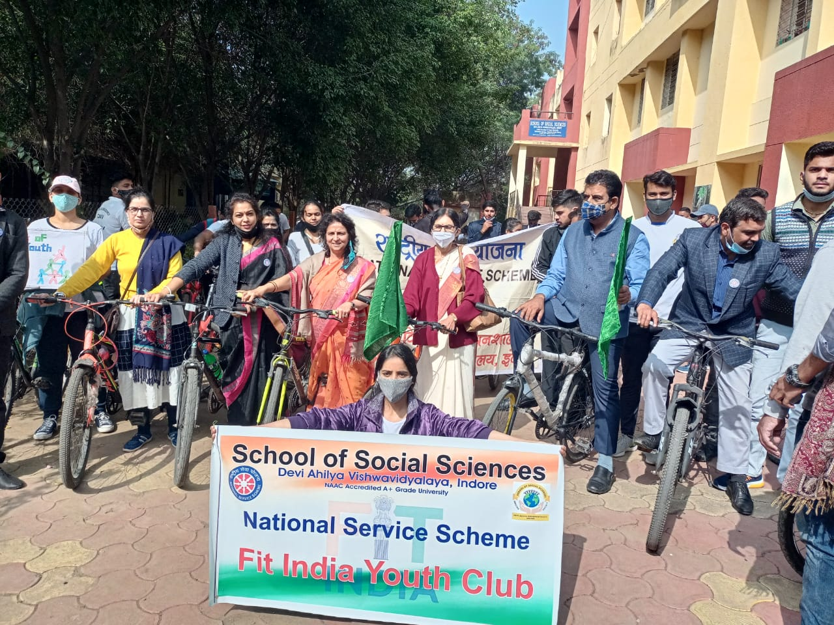

Figure 1: School of Social Sciences

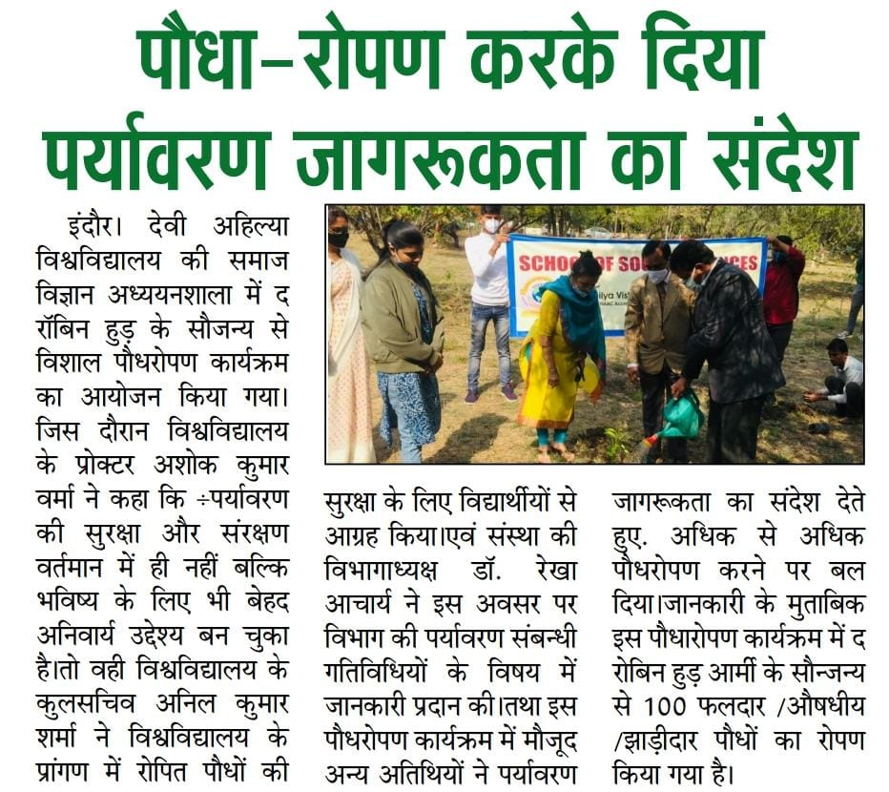

Figure : School of Social Sciences

