

DEVI AHILYA VISHWAVIDYALAYA, INDORE

7.1.7

Telephone Directory
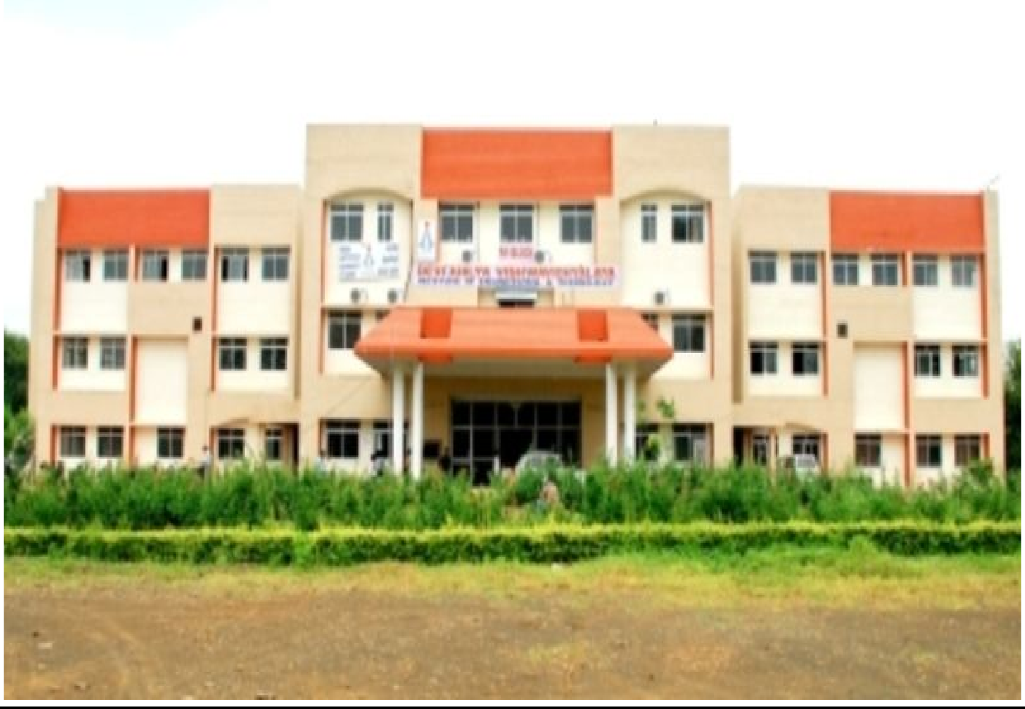

Institute of Engineering and Technology Devi Ahilya Vishawvidyalaya

Khandwa Road Indore-452017 (M.P.) (ph): 0731-2361116 / 2361117 / 2366800

Director & Head of Departments
Name | Designation | Contact Number | Email-Id
Dr. Sanjiv Tokekar | Director | 0731-2361117 Ext-401 | stokekar@ietdavv.edu.in
Dr. Vrinda Tokekar | Professor | 0731-2361117 Ext-701 | vtokekar@ietdavv.edu.in
Dr. G.L.Prajapati | Professor | 0731-2361117 Ext-204 | glprajapati@ietdavv.edu.in
Dr. Ashesh Tiwari | Professor | 0731-2361117 Ext-102 | atiwari@ietdavv.edu.in
Dr. Ajay Verma | Professor | 0731-2361117 Ext-502 | averma@ietdavv.edu.in
Dr. Shashi Prakash | Professor | 0731-2361117 Ext-303 | sprakash@ietdavv.edu.in
Dr. Pratosh Bansal | Professor | 0731-2361117 Ext-501 | pbansal@ietdavv.edu.in

Administration Section

Name | Extension No.
OSD - Dr. Paresh Atri | 404
Mr. Rajendra Jatav | 418
Mr. Gurudatt | 418
Mr. Hemant Sathe | 406
Mr. Mukesh Gupta | 419
Mr. Ranjeet Shinde | 400
Ms. Zahida Parveen | 416
Mrs. Devki Kashap | 421
Pawan kale | 409
Result Sec. Manoj | 402
State - Jitendra Bhatia | 428
Mr. Sohel Parveze | 125
Mrs. A.Samadhiya | 707

Library
236
Mr. Jitendra Chouhan

Important Phone Numbers
V.C. Office | 2521887
Registrar | 2527532
D R (Acad / Estt.) | 2524114
D R ( Dev ) | 2523530
D R (Exam) | 2525824
University Engineering Departments
Finance Officer | 2528967
Press Controller | 2528966
R S A | 2529474
S.G.S.I.T.S | 2538760 / 2434095
Medicaps | 4020492/ 2856294
S.V.I.T. Engg. Baroli | 0731-1224371,2,3,4
S.O.E. | 2463754
I C S E | 2470027
I M S | 2478800
MPEB - Navlakha | 2402119
MPEB - Deli College | 5022259
MPEB - University | 2360301

Computer Engineering Department

Name | Extension No. | Contact | Email id
Dr. Meena Sharma | 218 | 9826927378 | msharma@ietdavv.edu.in
Dr. Pragya Shukla | 702 | 9425082663 | pshukla@ietdavv.edu.in
Dr. G.L.Prajapati | 204 | 9826669205 | glprajapati@ietdavv.edu.in
Dr. Vaibhav Jain | 201 | 9425071648 | vjain@ietdavv.edu.in
Mr. Ashish Jain | 215 | 9329539402 | ajain@ietdavv.edu.in
Mrs. Mala Dutta | 217 | 9926082431 | mdutta@ietdavv.edu.in
Mr. Lalit Gehlot | 208 | 9893166970 | lgehlod@ietdavv.edu.in
Mr. Arpit Agrawal | 216 | 9424090249 | aagrawal@ietdavv.edu.in
Mr. Amit Mittal | 203 | 9993315549 | amittal@ietdavv.edu.in
Mr. Jitendra Soni | 216 | 7773803202 | jsoni@ietdavv.edu.in
Mrs. Nilima Karankar | 703 | 9300038204 | nkarankar@ietdavv.edu.in
Mrs. Jyoti Haweliya | 214 | 9907561756 | jhaweliya@ietdavv.edu.in
Mr. Aditya Makwe | 206 | 9425373163 | amakwe@ietdavv.edu.in
Ms. Harshita Sharma | 205 | 8109091485 | hsharma@ietdavv.edu.in
Mrs. Swati singh | 205 | 9617494489
Mr. Jay Singh | 221 | 9009760191 | jaysingh@ietdavv.edu.in
Mr. Narendra Solunki | 221 | 7024438677 | nsolanki@ietdavv.edu.in
Ms.Ankita Chourasia |  | 9424300653 | achourasia@ietdavv.edu.in
Ms. Vedpriya Dongre |  | 9753754889 | vdongre@ietdavv.edu.in
Mr. Ravindra Verma |  | 9713666360 | rverma@ietdavv.edu.in
Ms. Alka Aman |  | 9893221297 | aaman@ietdavv.edu.in

Information Technology Department
Name | Extension No. | Contact | Email id
Dr. Vrinda Tokekar | 701 | 9425317939 | vtokekar@ietdavv.edu.in
Dr. Pratosh Bansal | 501 | 9981643512 | pbansal@ietdavv.edu.in
Mr. Hemant Makwana | 711 | 9826046442 | hmakwana@ietdavv.edu.in
Dr. Vivek Kapoor | 209 | 9424566004 | vkapoor@ietdavv.edu.in
Mr. Pravin Karma | 711 | 9826313816 | pkarma@ietdavv.edu.in
Mrs. Bhawna Nigam | 214 | 9753181862 | bnigam@ietdavv.edu.in
Mr C. P. Patidar | 206 | 9826490631 | cpatidar@ietdavv.edu.in
Mr. Jagdish Raikwar | 221 | 9893942596 | jraikwal@ietdavv.edu.in
Mr. Shyam Maheshwari | 710 | 9074786441 | smaheshwari@ietdavv.edu.in
Mr. Vikas Vankhede | 710 | 9755255908 | vvankhede@ietdavv.edu.in
Mr. Ravindra Yadav |  | 9977872172 | ryadav@ietdavv.edu.in

Electronics & Instrumentation Engineering Department
Name | Extension No. | Contact | Email id
Dr. Ajay Verma | 310 | 9617801687 | averma@ietdavv.edu.in
Mr. Shahid Khilji | 305 | 9826091849 | skhilji@ietdavv.edu.in
Mrs. Pratibha Singh (lien) | 512 | 9826464732 | prsingh@ietdavv.edu.in
Mr. Amit Jha | 517 | 8889786191 | ajha@ietdavv.edu.in
Mr. Deepak Batham | 504 | 9755395903 | dbatham@ietdavv.edu.in
Mr. Shailendra Kumar Pathak | 505 | 9993576367 | spathak@ietdavv.edu.in
Mr.Tapesh Sarsodia | 517 | 9977036581 | tsarsodia@ietdavv.edu.in
Mr. Sunny Ganavadiya |  | 9977907330 | sganavdiya@ietdavv.edu.in
Mrs. Hemlata Pal | 512 | 9009490099 | hpal@ietdavv.edu.in
Ms. Priyanka Sharma |  | 9827640141 | psharma@ietdavv.edu.in

Electronics & Telecommunication Engineering Department

Name | Extension No. | Contact | Email id
Dr. Sanjiv Tokekar | 401/312 | 9425322306 | stokekar@ietdavv.edu.in
Dr. Raksha Upadhyay | 304 | 9993353996 | rupadhyay@ietdavv.edu.in
Dr. Ravi Sindal | 309 | 9425650360 | rsindal@ietdavv.edu.in
Dr. Dheeraj Nitnawre | 302 | 9893004791 | dnitnawwre@ietdavv.edu.in
Mrs. Madhvi Jangalwa | 314 | 9425060342 | mjangalwa@ietdavv.edu.in
Dr. Vaibhav Neema | 306 | 9174738874 | vneema@ietdavv.edu.in
Dr. Uma Bhatt | 304 | 9425333837 | umabhatt@ietdavv.edu.in
Mr. P. D. Ashok | 307 | 8517848488 | pdahat@ietdavv.edu.in
Mrs. Seema Dawar | 518 | 9827255224 | schouhan@ietdavv.edu.in
Mr. Praveen Singh | 306 | 9893526178 | psingh@ietdavv.edu.in
Mrs. Pushpa Raikwar | 512 | 7566961114 | praikwal@ietdavv.edu.in
Mr. Ashish Panchal |  | 9691243624 | apanchal@ietdavv.edu.in
Mr.Brahman Singh Bhalavi |  | 9685733028 | bbhalavi@ietdavv.edu.in
Ms. Sangita Solanki | 518 | 7898659341 | ssolanki@ietdavv.edu.in
Ms. Sneha Moghe | 308 | 9425359777 | smoghe@ietdavv.edu.in

Mechanical Engineering Department

Name | Extension No. | Contact | Email id
Dr. Ashesh Tiwari | 102 | 9826941506 | atiwari@ietdavv.edu.in
Dr. Nagendra Sohani | 121 | 9425311674 | nsohani@ietdavv.edu.in
Dr. Govind Maheshwari | 101 | 9826247653 | gmaheshwari@ietdavv.edu.in
Dr. Devendra S. Verma | 122 | 9826418567 | dverma@ietdavv.edu.in
Dr. Suvarna Torgal | 106 | 9893010615 | storgal@ietdavv.edu.in
Mr. Vijay Karma | 103 | 9424891320 | vkarma@ietdavv.edu.in
Dr. Sharad Chaudhary | 103 | 9303237602 | schaudhary@ietdavv.edu.in
Mr. Akhilesh Lodwal | 124 | 9425353249 | alodwal@ietdavv.edu.in
Mr. Ajeet Bergale | 106 | 7509874451 | abergaley@ietdavv.edu.in
Mr. Amit Gupta | 124 | 9406653327 | akgupta@ietdavv.edu.in
Mr. Ibrahim Hussain | 104 | 9827047074 | ihussain@ietdavv.edu.in
Mr. Santosh Kansal | 107 | 8827312195 | skansal@ietdavv.edu.in
Mrs. Jyoti Soni |  | 9575975223 | jyotisoni@ietdavv.edu.in
Mr. Omprakash Sondhya |  | 8359939246 | osondhiya@ietdavv.edu.in

Civil Engineering Department

Name | Extension No. | Contact | Email id
Dr. Pratosh Bansal | 501 | 9981643512 | pbansal@ietdavv.edu.in

Applied Science Department
Name | Extension No. | Contact | Email id
Dr. Shashi Prakash | 303 | 9977186156 | sprakash@ietdavv.edu.in
Dr. Dheeraj Mandloi | 110 | 9407894470 | dmandloi@ietdavv.edu.in
Dr. S. Khinchi | 307 | 8109487430 | skhinchi@ietdavv.edu.in
Mr. Jitendra Singh | 511 | 9893359141 | jsingh@ietdavv.edu.in
Mr. Rohit Pathak | 505 | 9926611479 | rpathak@ietdavv.edu.in
Ms. Sufia Aziz | 508 | 9893187718 | saziz@ietdavv.edu.in
Mr. Chandrashekhar Chouhan | 504 | 9826722978 | cchauhan@ietdavv.edu.in
Mrs. Aarti Sharan | 506 | 9425055884 | asharan@ietdavv.edu.in
Dr. Rachana Gupta | 508 | 9425059372 | rgupta@ietdavv.edu.in
Mrs. Ruchi Singh | 506 | 7898916163 | rsingh@ietdavv.edu.in

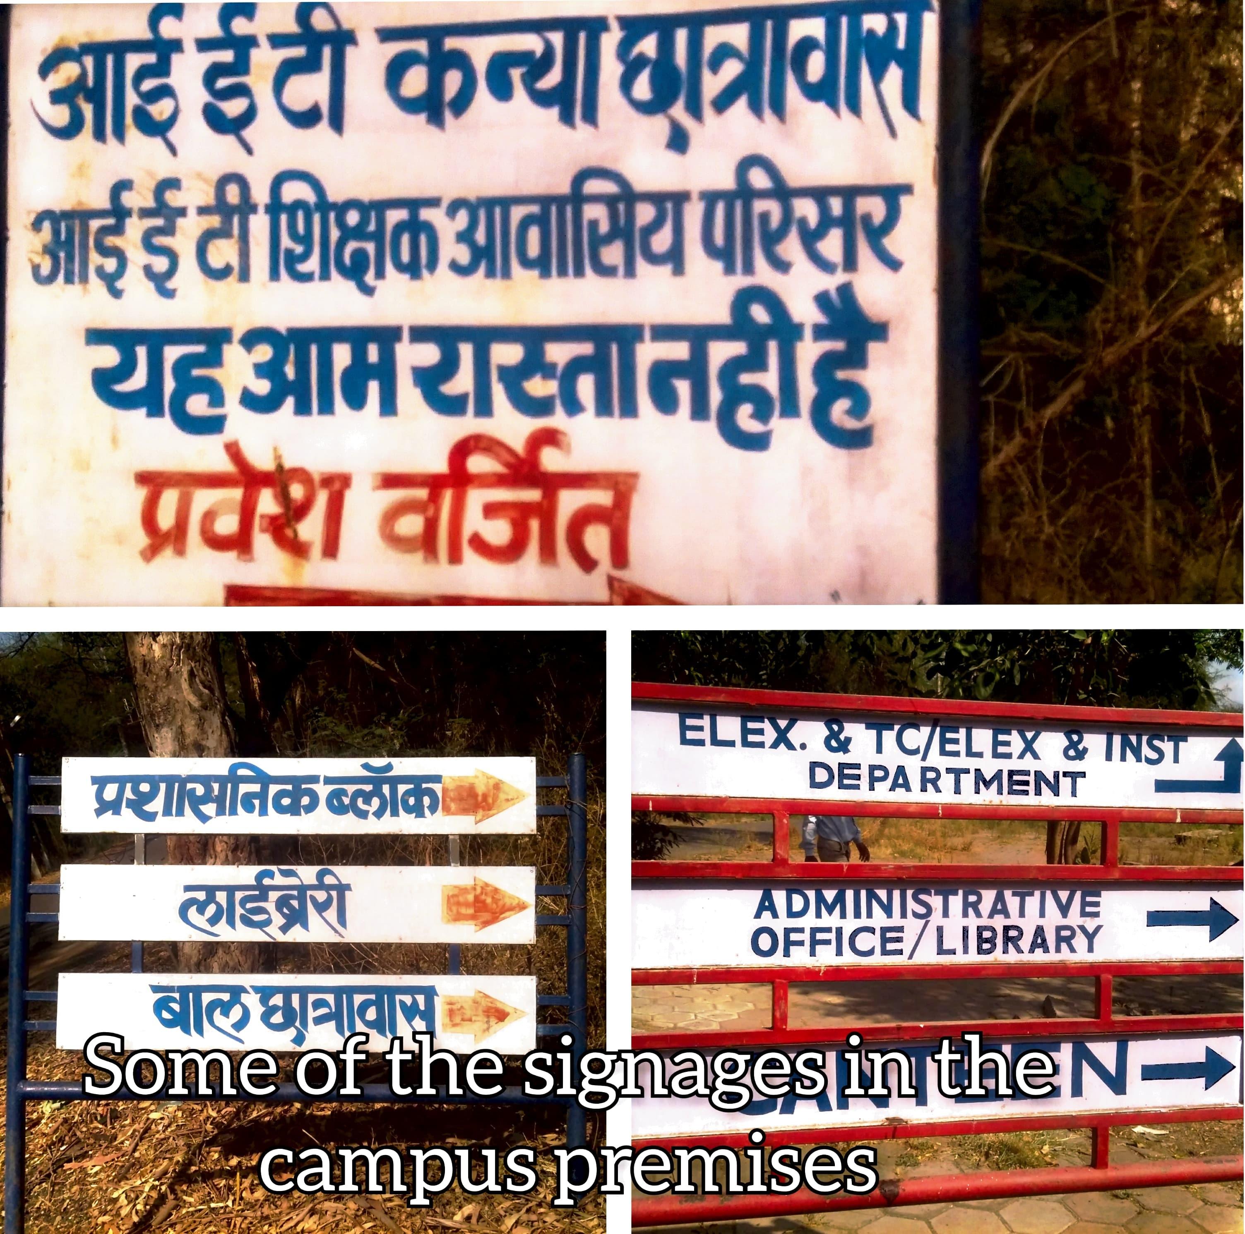
Figure 1: Institute of Engineering and Technology

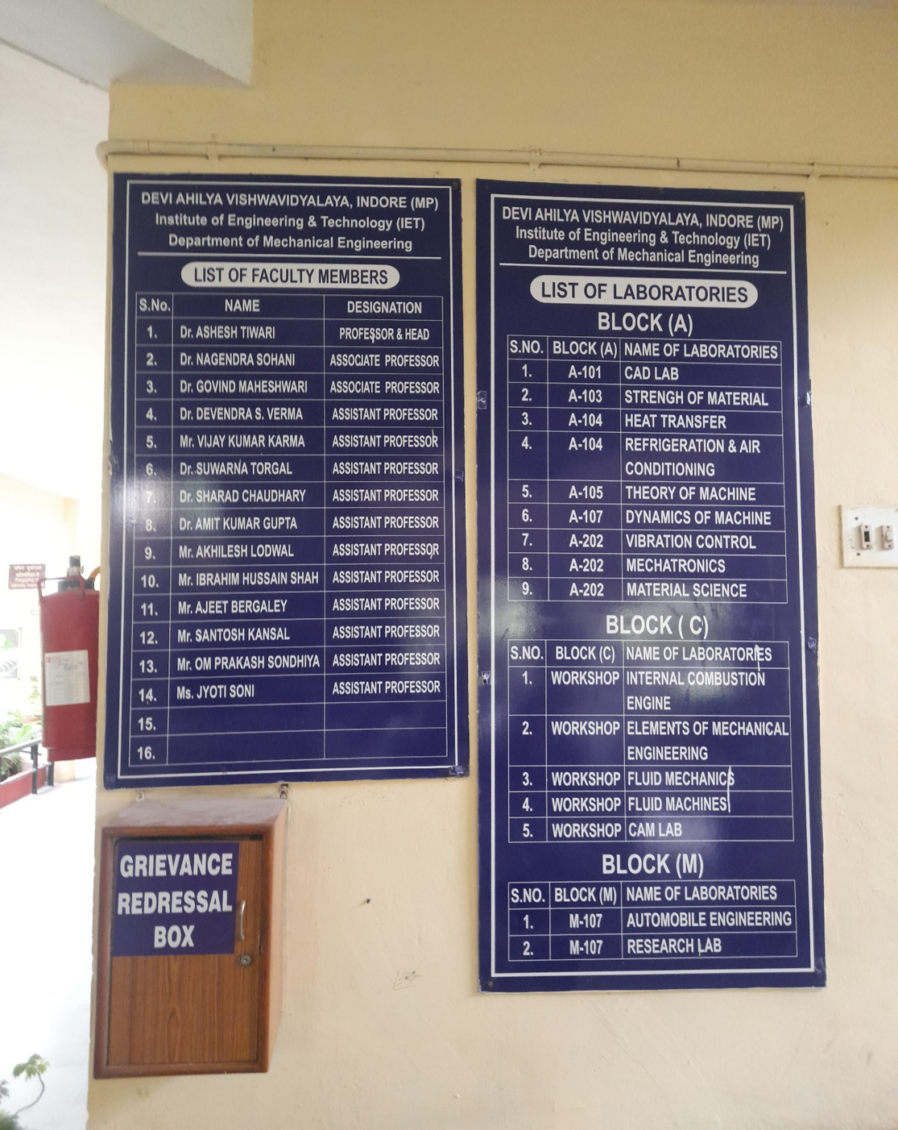
Figure 2: Institute of Engineering and Technology

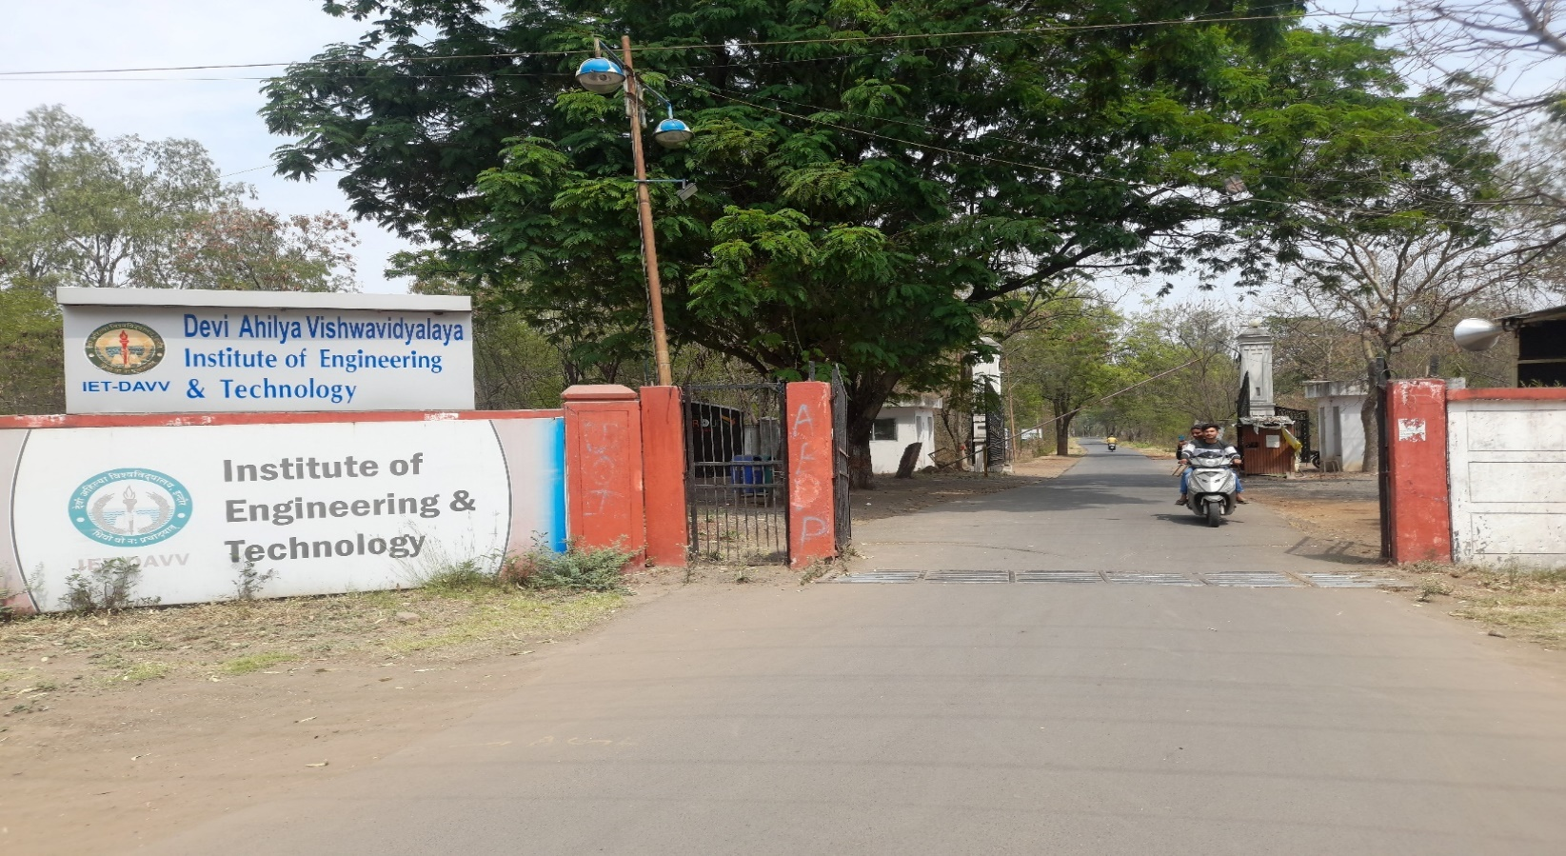
Figure 3: Institute of Engineering and Technology
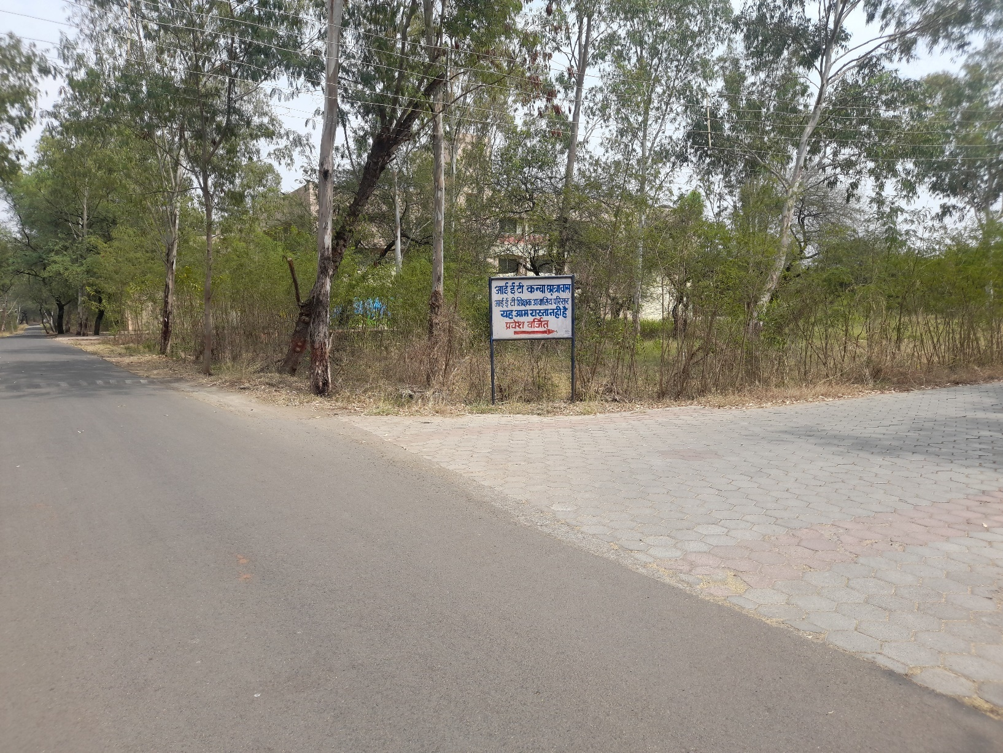
Figure 4: Institute of Engineering and Technology
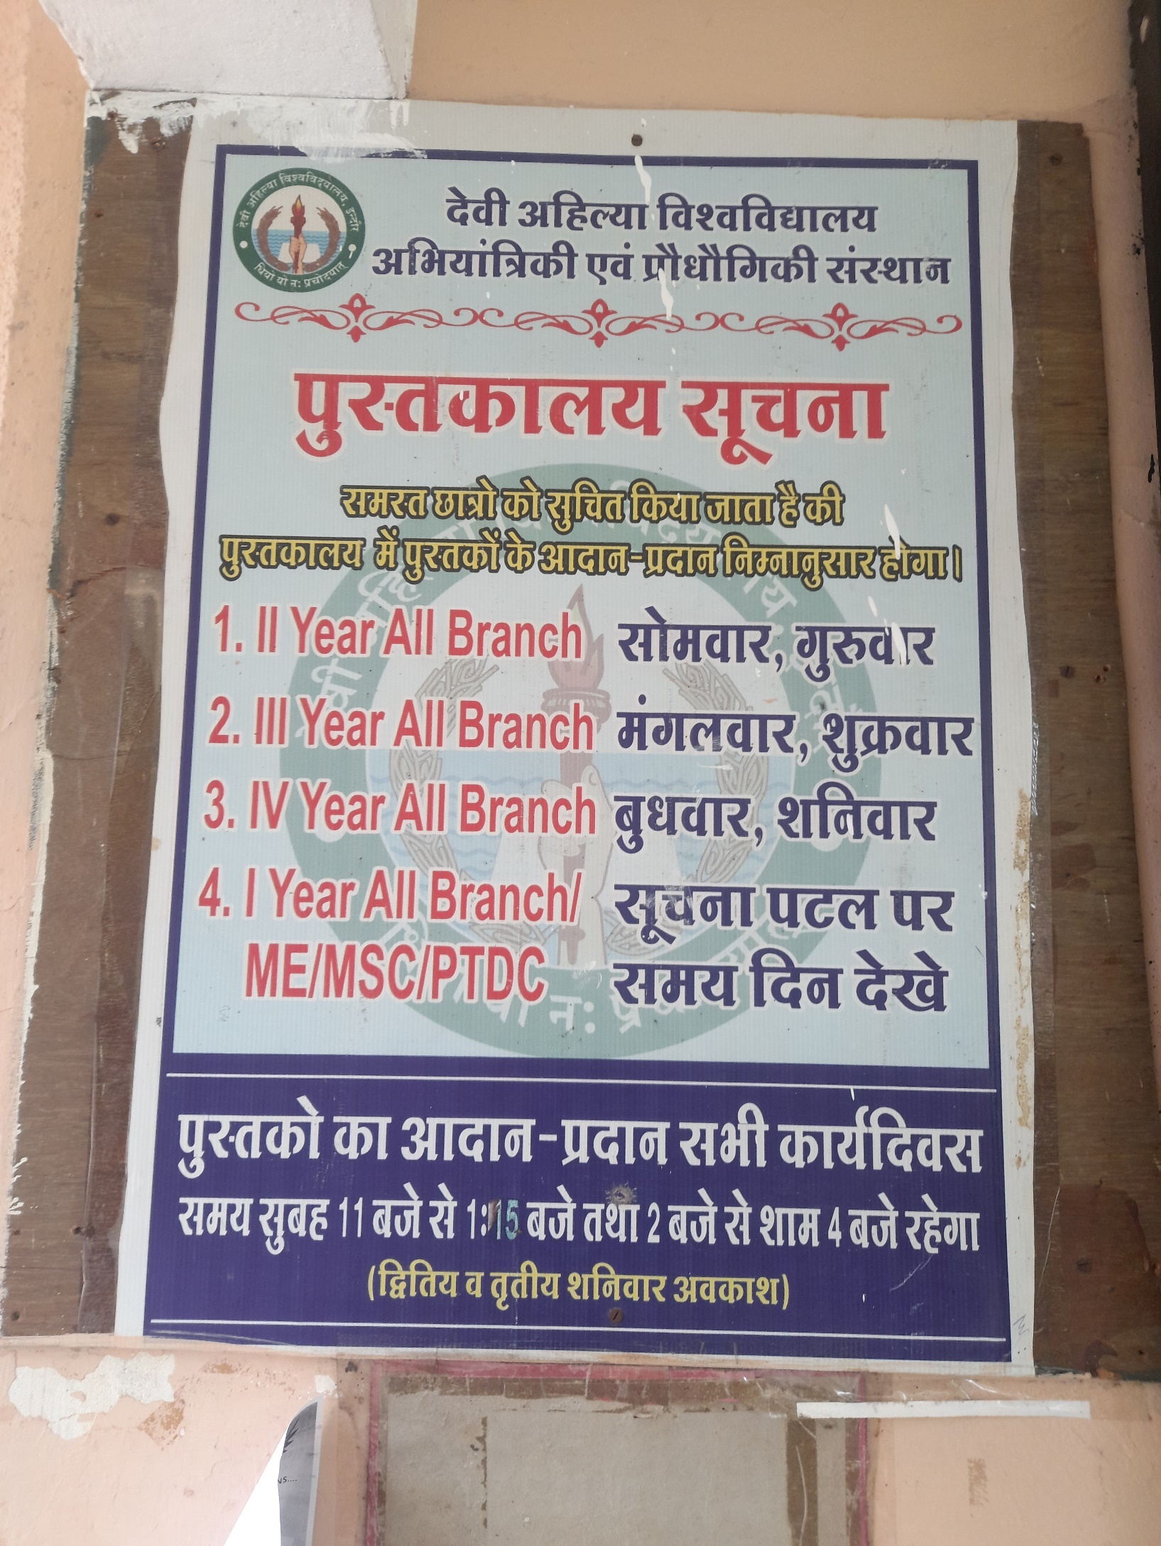
Figure 5: Institute of Engineering and Technology

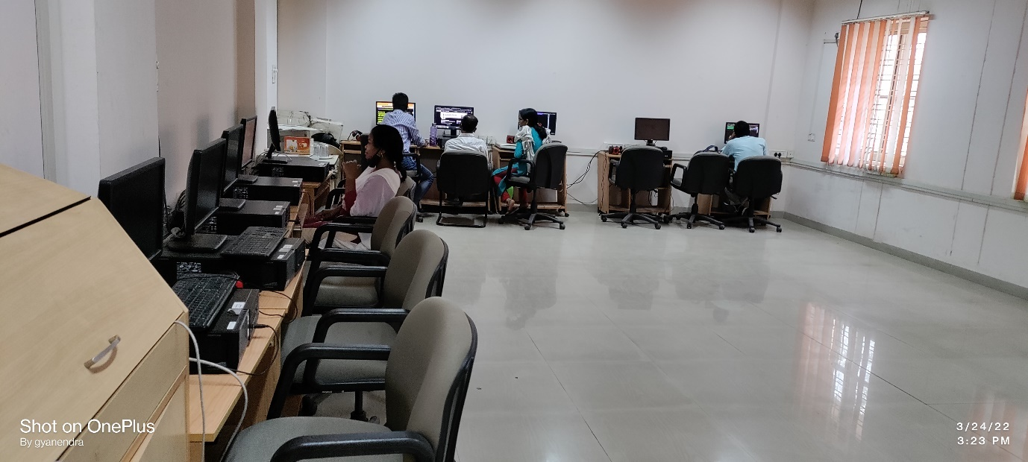
Figure 6: School of Social Sciences

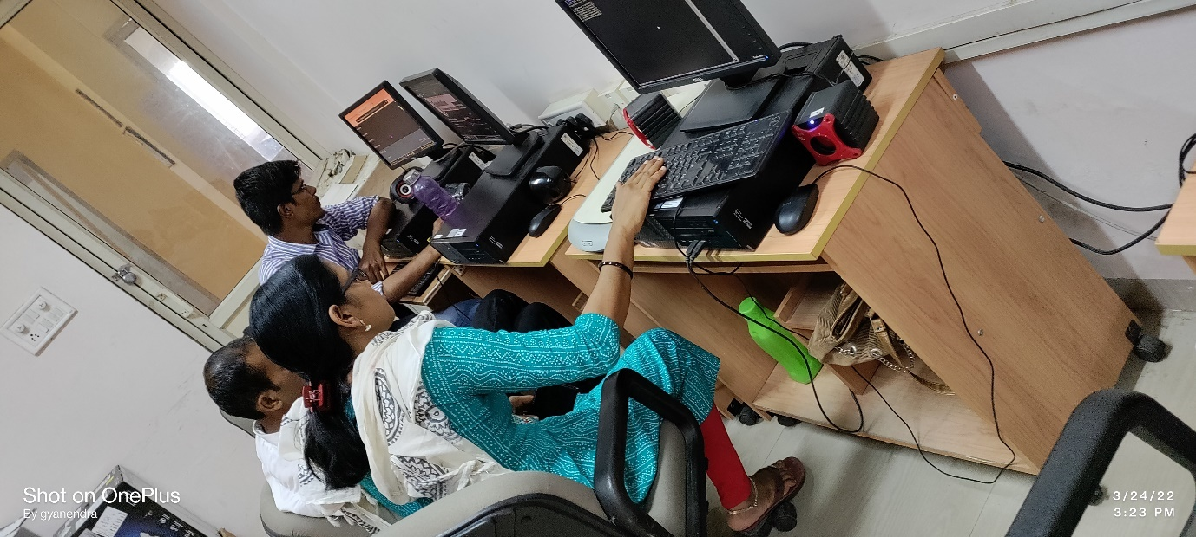
Figure 7: School of Social Sciences

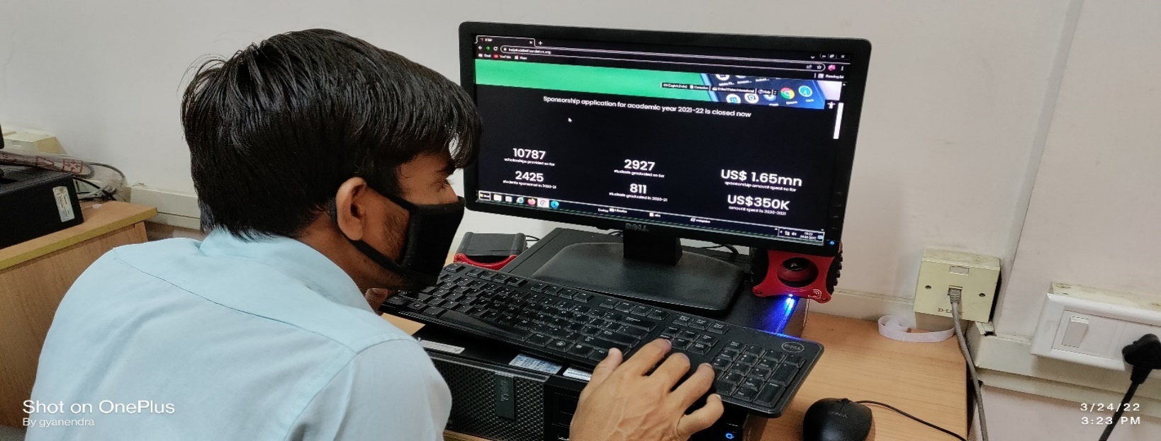
Figure 8: School of Social Sciences

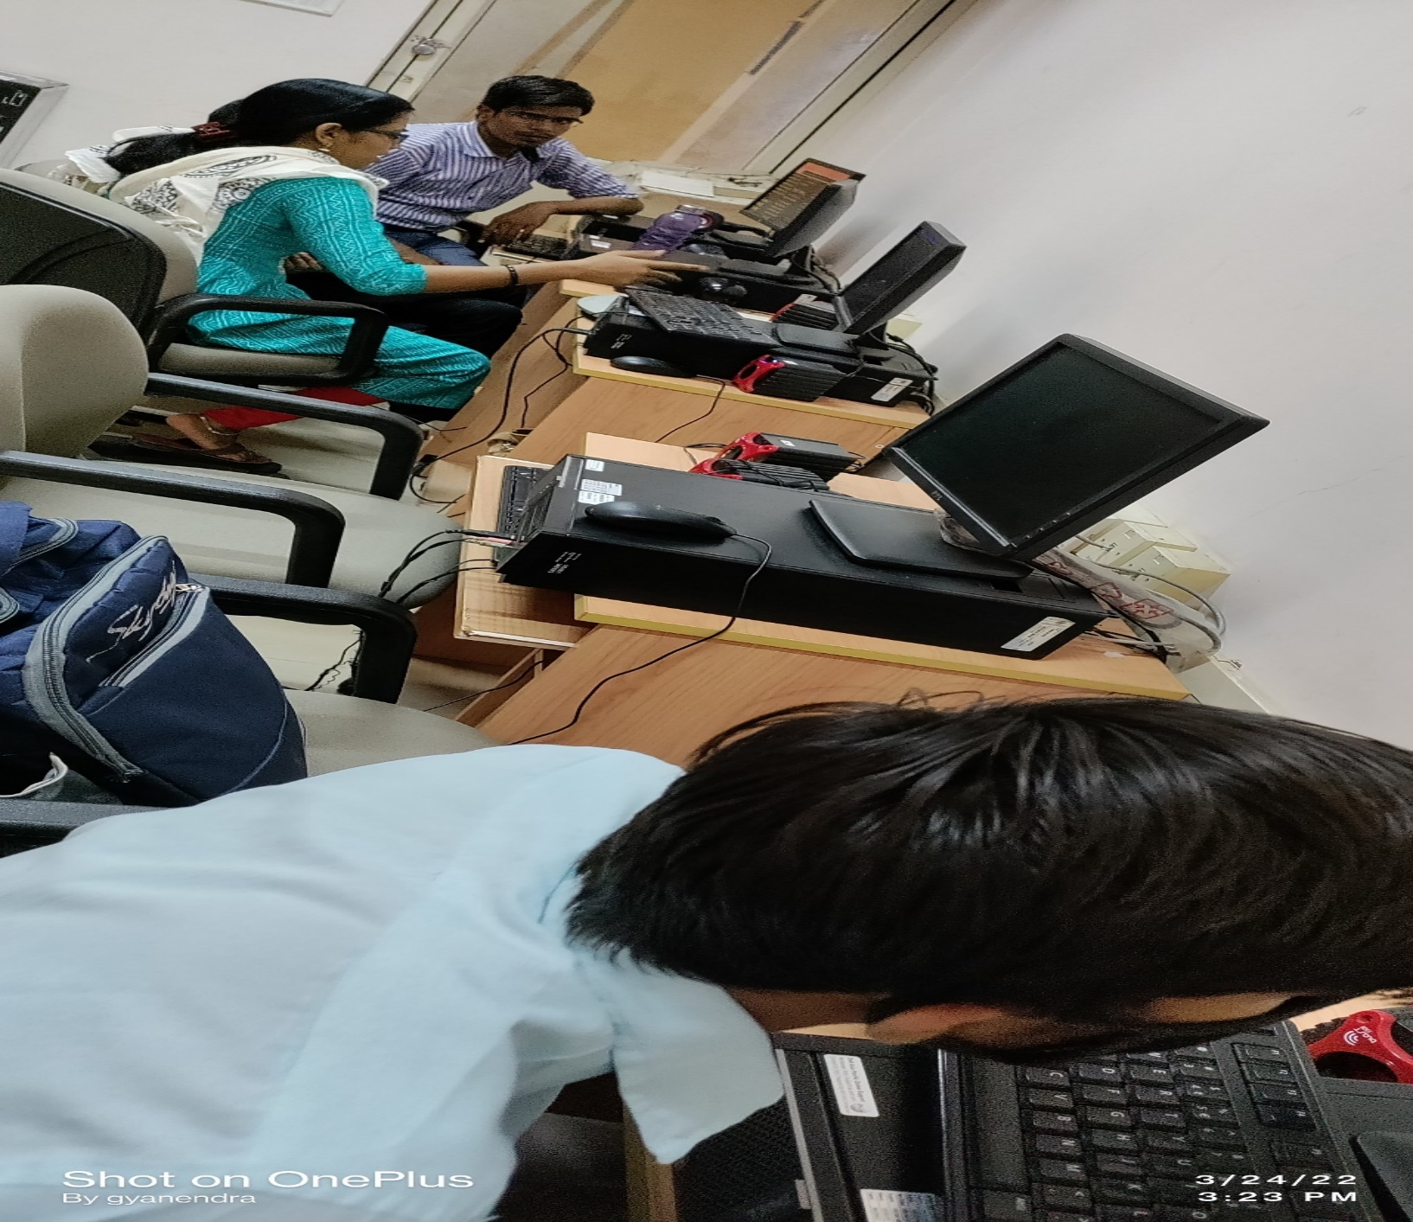
Figure 9: School of Social Sciences
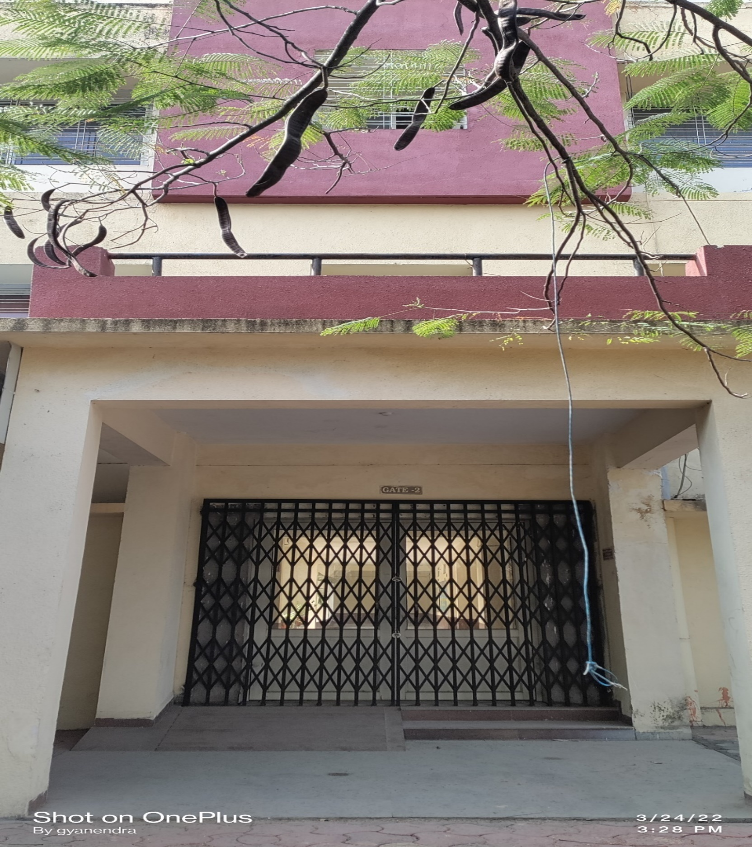
Figure 10: School of Social Sciences

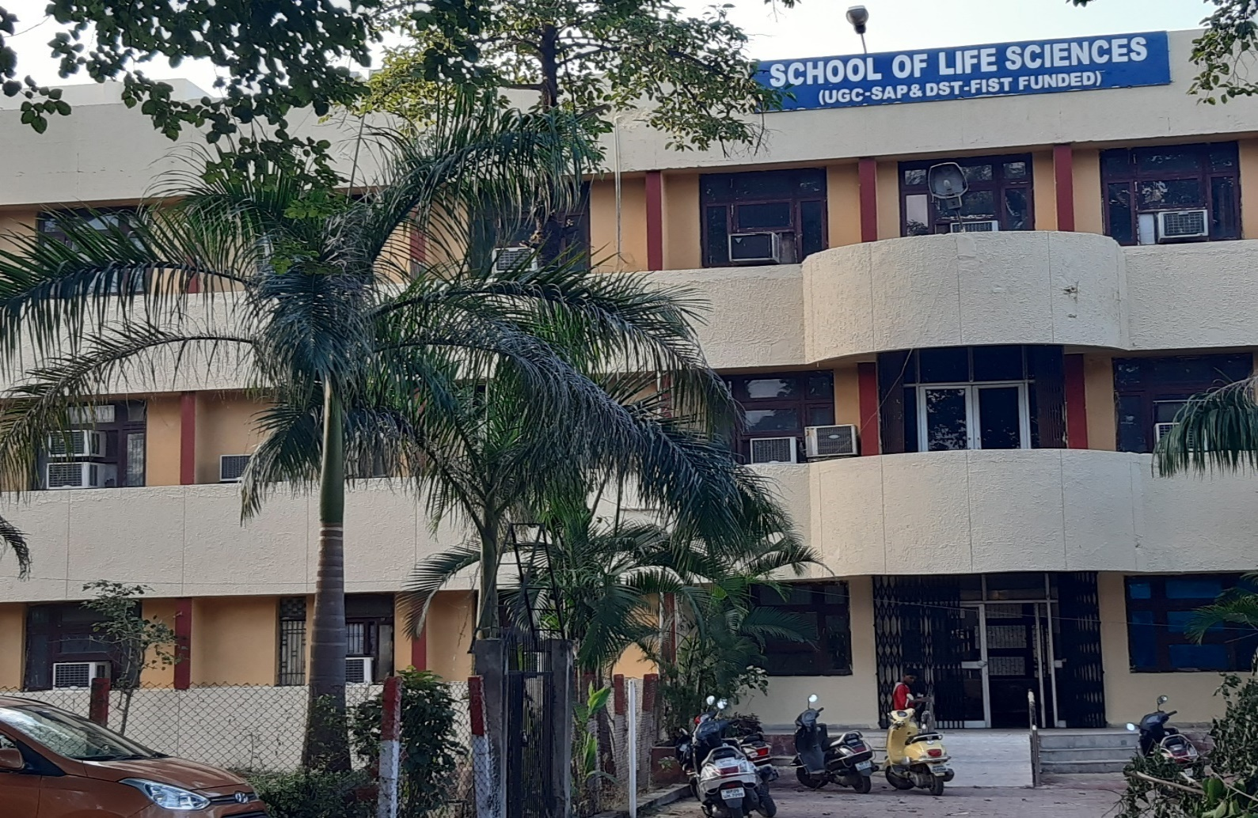
Figure 11: School of Life Sciences

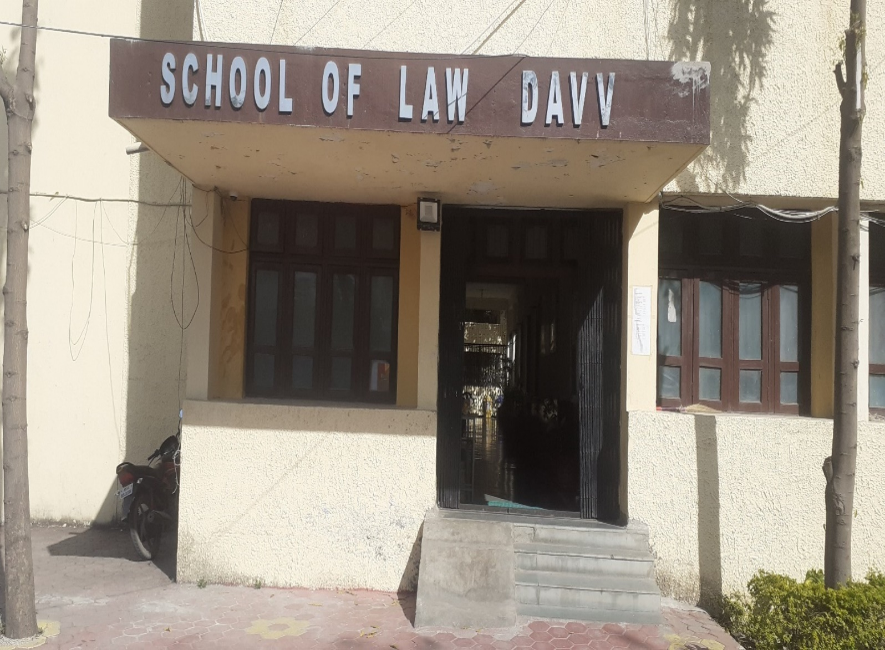
Figure 12: School of Law

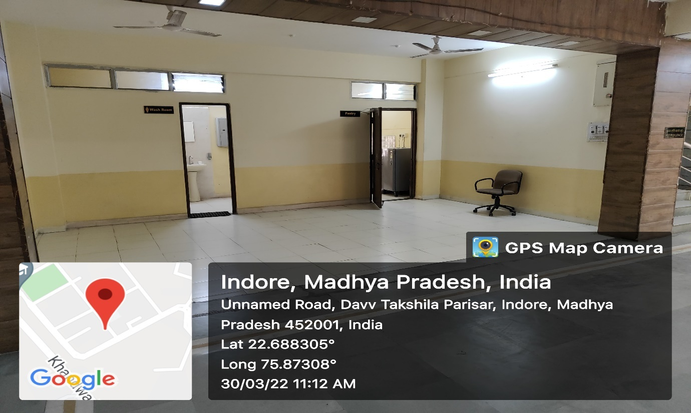
Figure 13: School of Journalism and Mass Communication

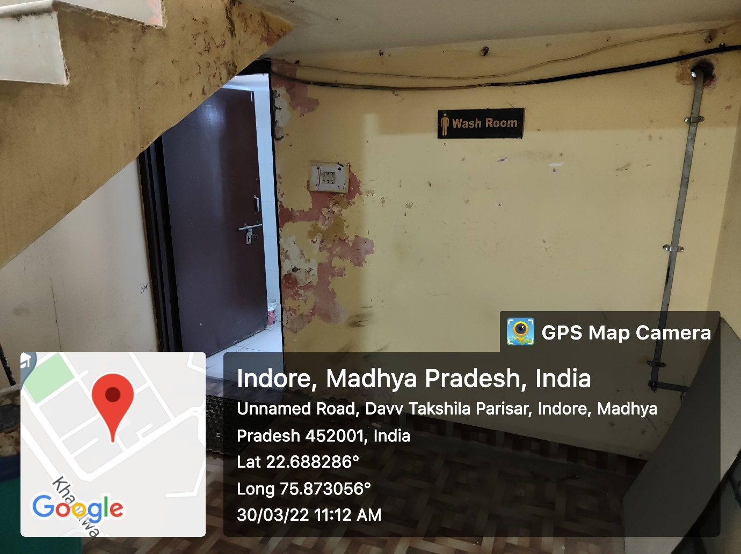
Figure 14: School of Journalism and Mass Communication

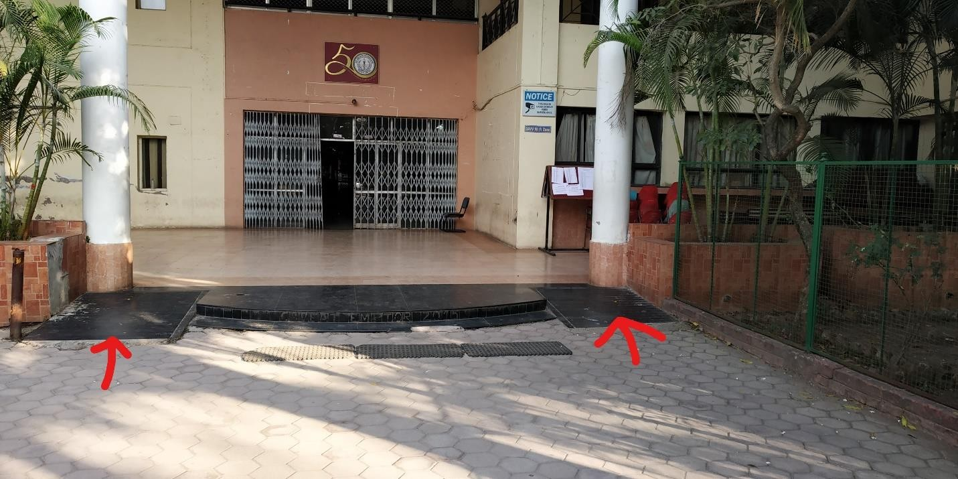
Figure 15: International Institute of Professional Studies

IIPS



DEVI AHILYA VISHWAVIDYALAYA, INDORE SCHOOL OF PHARMACY
Takshashila Campus, Khandwa Road (Ring Road) Indore-452001, India Phone 91-731 2100605, E-mail: sopdavv@gmail.com
Site: www.dauniv.ac.in, www.pharmacy.dauniv.ac.in

Resources available in the institution for differently abled students

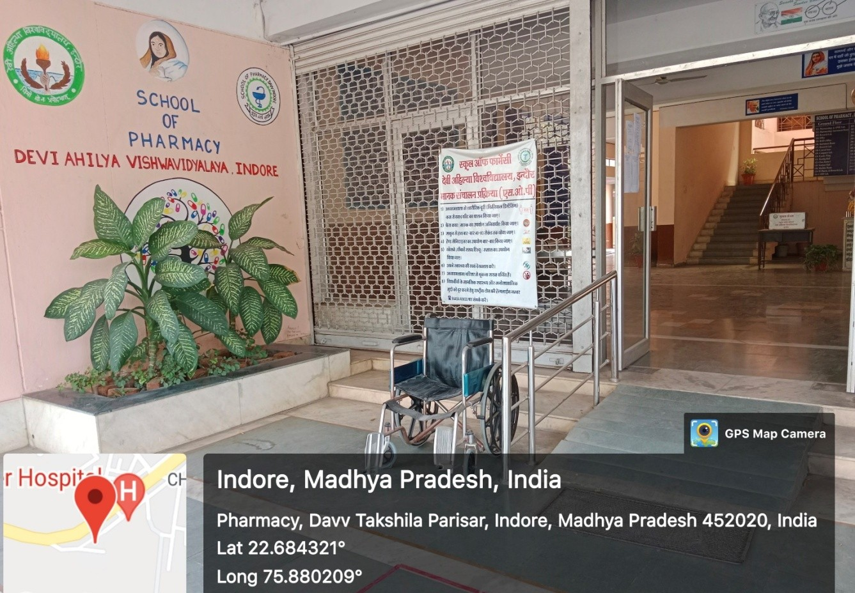
Ramp and Wheel Chair
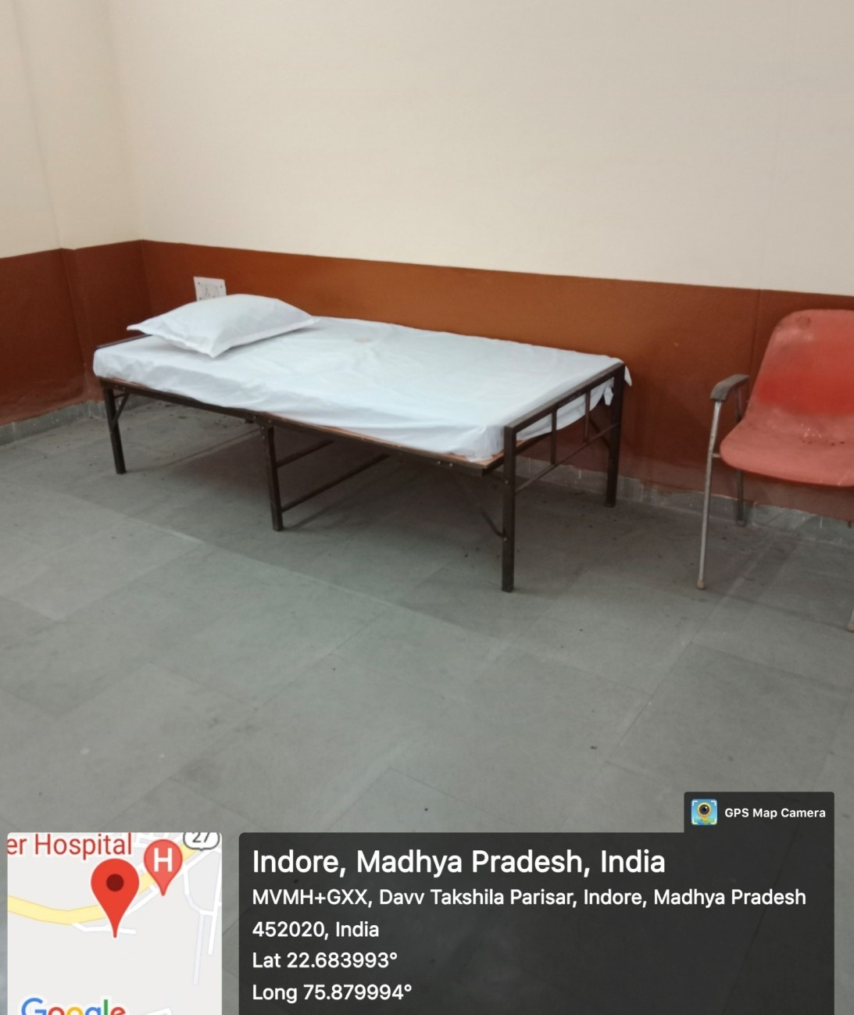
Rest room
Figure 16: School of Pharmacy

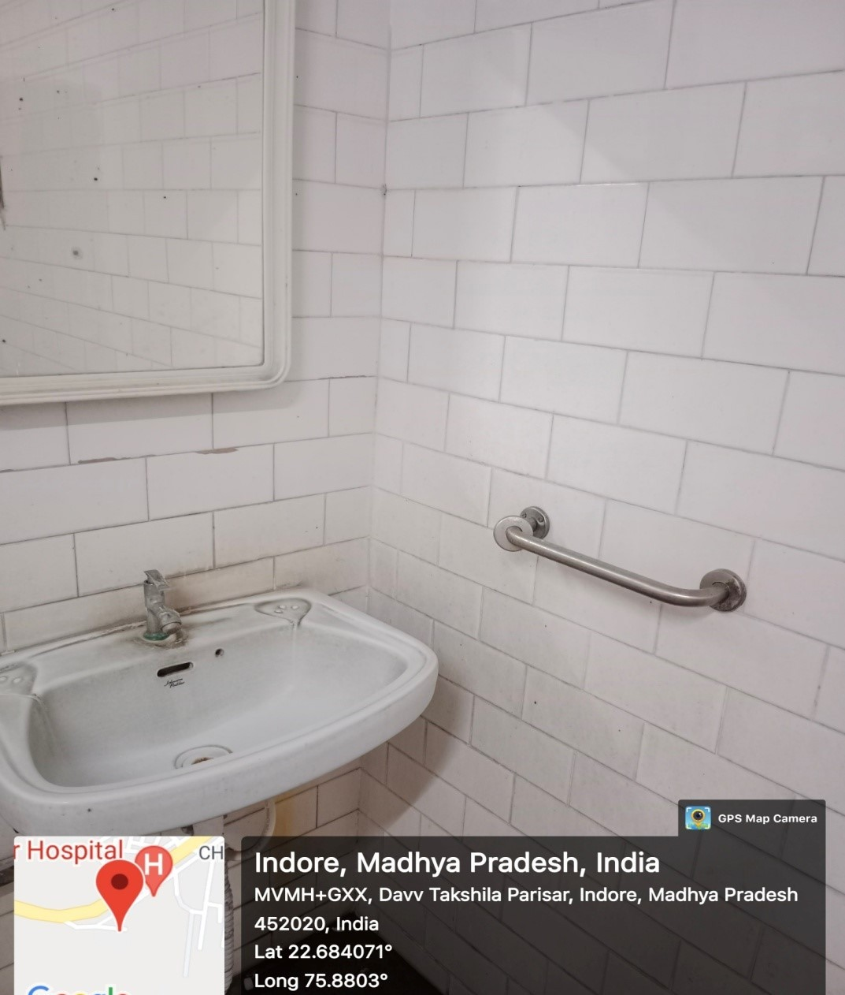
Figure 17: School of Pharmacy
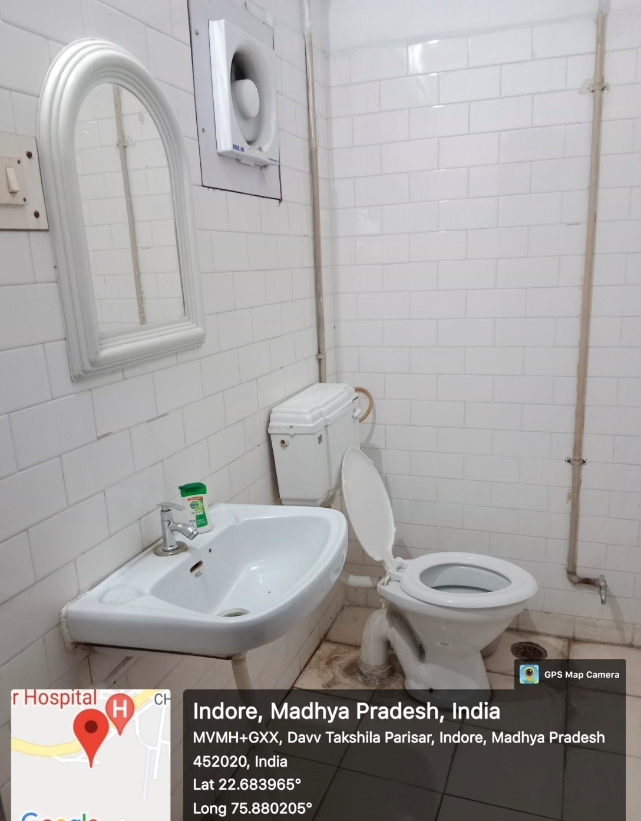
Figure 18: School of Pharmacy

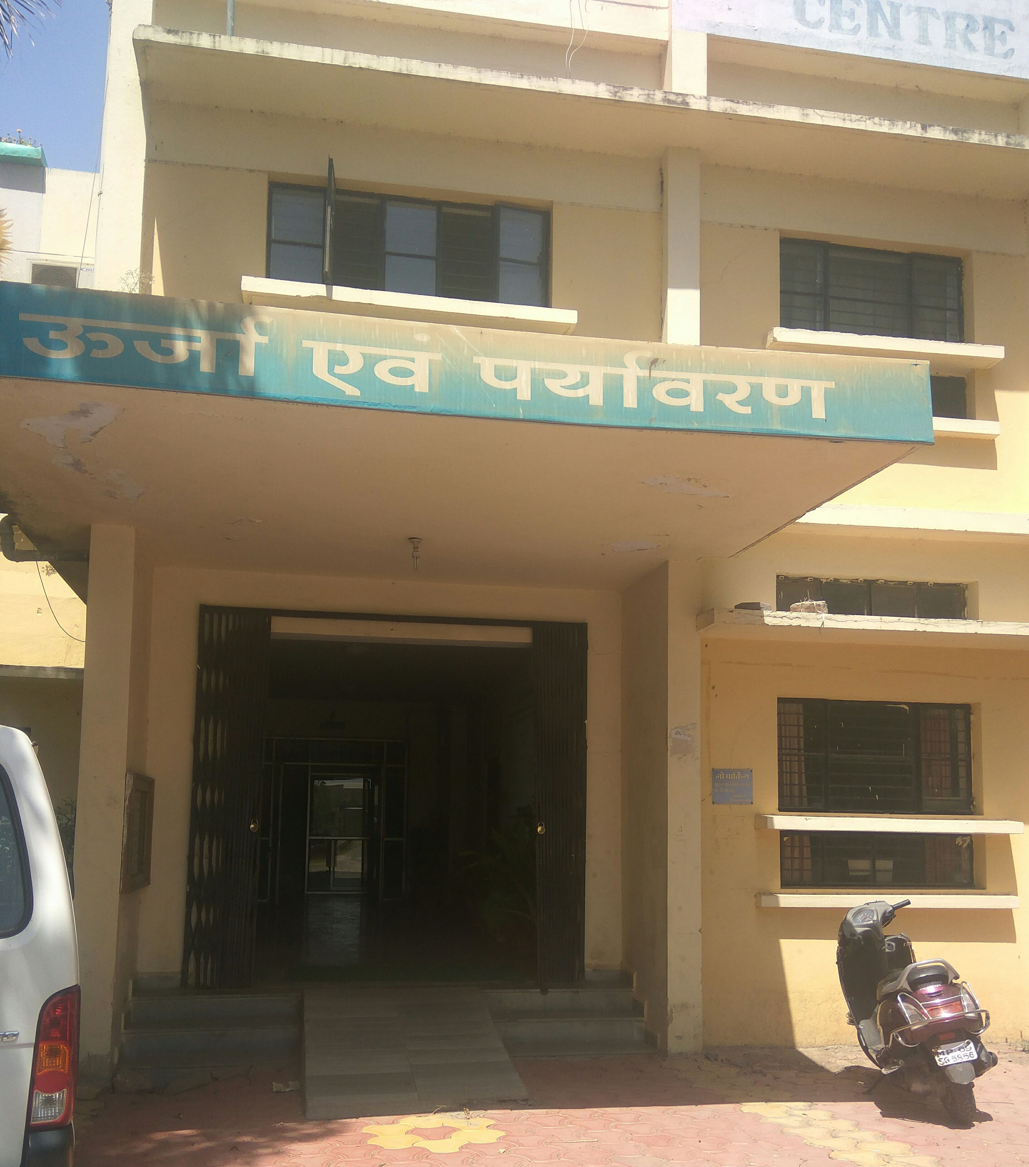
Figure 19: School of Energy and Environment

d

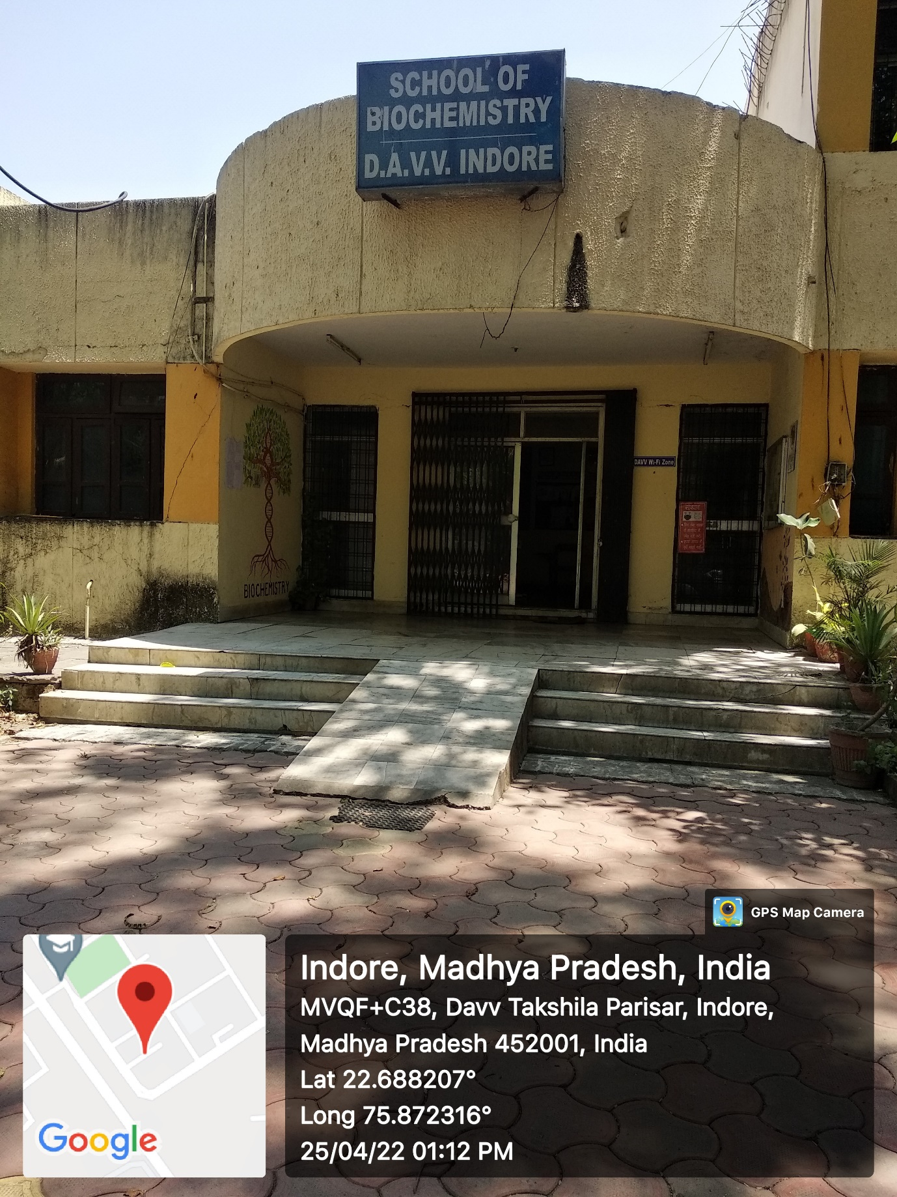
Figure 20: School of Biochemistry

