SCHOOL OF SOCIAL SCIENCES

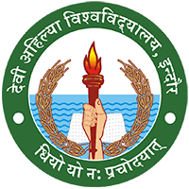

**DAVV INDORE (M.P.)**

**A REPORT ON FIELD VISIT TO**

**JAN SHIKSHAN SANSTHAN INDORE (M.P)**

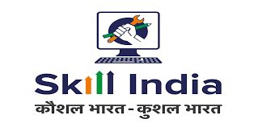

**Organised By- MBA 1ST SEM Teachers & Students**

**SESSION- 2021-22**

**SUBMITTED TO – DR.JYOTI CHAUHAN**

**SUBMITTED BY –AKASH SEN**

**ROLL NO – 2123402 ENROLLMENT NO. – DA1823881**

**ACKNOWLEDEGEMENT**

/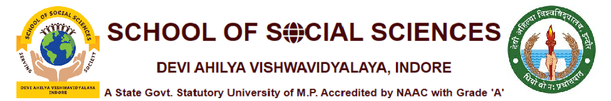

Acknowledgement is not a mere obligations but epitome of humility and ineptness to all those who have helped in the completion of this project. I am thankful to **Prof. Rekha Acharya (HOD)** **and Dr. Jyoti Chouhan** (project in charge) and ARVIND SIR (Head of Jan Shikshan Sansthan Indore) for their constant guidance and encouragement provided in this Endeavour. I also thank my parents for their continuous support, understanding and patience without whose support and understanding this Endeavour would have never been fruitful. I also thank all my friends for helping me out in completing this project and helping me in solving various problems encountered during the progress of this field report.

**A FIELD VISIT REPORT ON**

**“जन शिक्षण संस्थान”**

**INDORE (M.P)**

** **

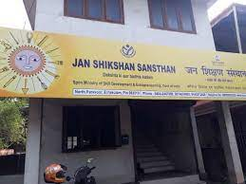

**INTRODUCTION**

Jan Shikshan Sansthan Indore was established on 16 May 1900 as a Workers' Institute (Labor Establishment) under the Social Education Scheme for urban industrial workers. This was an experimental scheme. In the year 1980, the Shram Pratishthan was converted into Shramik Vidyapeeth; it was the implementation center of multitasking regional plan which was established to meet the educational, entertainment and cultural needs of all the sections. On 15th May, 2000 it was converted as Jan Shikshan Sansthan. It was established as an autonomous institution under the Department of School Education and Literacy, Ministry of Human Resource Development, Government of India with the objective of offering informal and continuing education programs for the underprivileged in an institutionalized form.

National Development Mission was launched on 15 July 2015 on the occasion of World Skill Day. As a result of bringing uniformity in skill training activities, Jan Shikshan Sansthan Scheme was transferred to Ministry of Skill Development and Entrepreneurship, Government of India on 2nd July 2018. Jan Shikshan Sansthan Indore is currently working under the sponsorship of

“Directorate of Public Education, Ministry of Skill Development and Entrepreneurship.”

The institute is like an institutional framework that offers skill development programs for disadvantaged groups in a non-formal manner. The program of the Institute is based on a multidisciplinary approach. Provides vocational training to the target group of people. The work of the institute is in the entire district.

**OBJECTIVE:-**

• To enhance their efficiency, productive capacity and livelihood opportunities by improving vocational skills and technical knowledge of the target group.

• Identification and dissemination of traditional skills.

* Skill Development Sector Agencies Collaboration and coordination with and creating a pool of master trainers.

• To expand the range of knowledge and understanding of social, economic and political systems and to create awareness of the surrounding environment

* To promote national values ​​and to harmonize with national programmes.

• Promoting self-employment and providing credit and financial support to the target group.

**Work:-**

* Identification of target groups by preparing socio-economic profiles and finding out different educational and vocational needs.

• Exploration of need based options for target groups, innovation, working on alternatives, finding new methods, collaboration with academic-professional-sociocultural organizations.

• Networking and acting as a coordinator, facilitator and motivator in collaboration with partner institutions, departments and agencies.

• To provide training to the functionaries involved in various planning and implementation and consultancy services to like-minded agencies and enterprises.

• Organizing vocational training programs for upgradation of existing livelihood skills keeping in view the disadvantaged sections of the society, women, girls and unemployed youth.

• Promoting various organizational groups for socio-economic development. Providing follow-up services for the beneficiaries.

• Creating a livelihood cell for employment, self-employment and wage opportunities and linking it with National / State level portal.

• Identifying and developing local traditional skills.

**Target groups :-**

• Focus on socio-economically backward and educationally disadvantaged groups in rural and urban populations such as men, women and youth, self-employed, neo-literate, potential workers and their families as well as unemployed youth does.

* Main target- Illiterate persons with primary level of education up to 8th standard and people in the age group of 15 to 45 who drop out of school after 8th standard till 12th standard. The age limit may be higher for handicapped and deserving cases.

• Rural and Urban women, SC, ST, OBC. Preference to classes and minorities.

**Organization and Management:-**

The affairs of the Institute are looked after by a Board of Management which is constituted by the Government of India. An Executive Committee assists the Board of Management. The Institute employs the services of locally qualified, experienced trainers, resource persons, experts and skilled craftsmen at a remunerative rate for planning, coordinating and conducting the Institute's programmes. The Chairman of the Management Board is the Honorable Head and Director of the Institute, the Chief Executive Officer of the Jan Shikshan Sansthan and the Secretary of the Management Board.

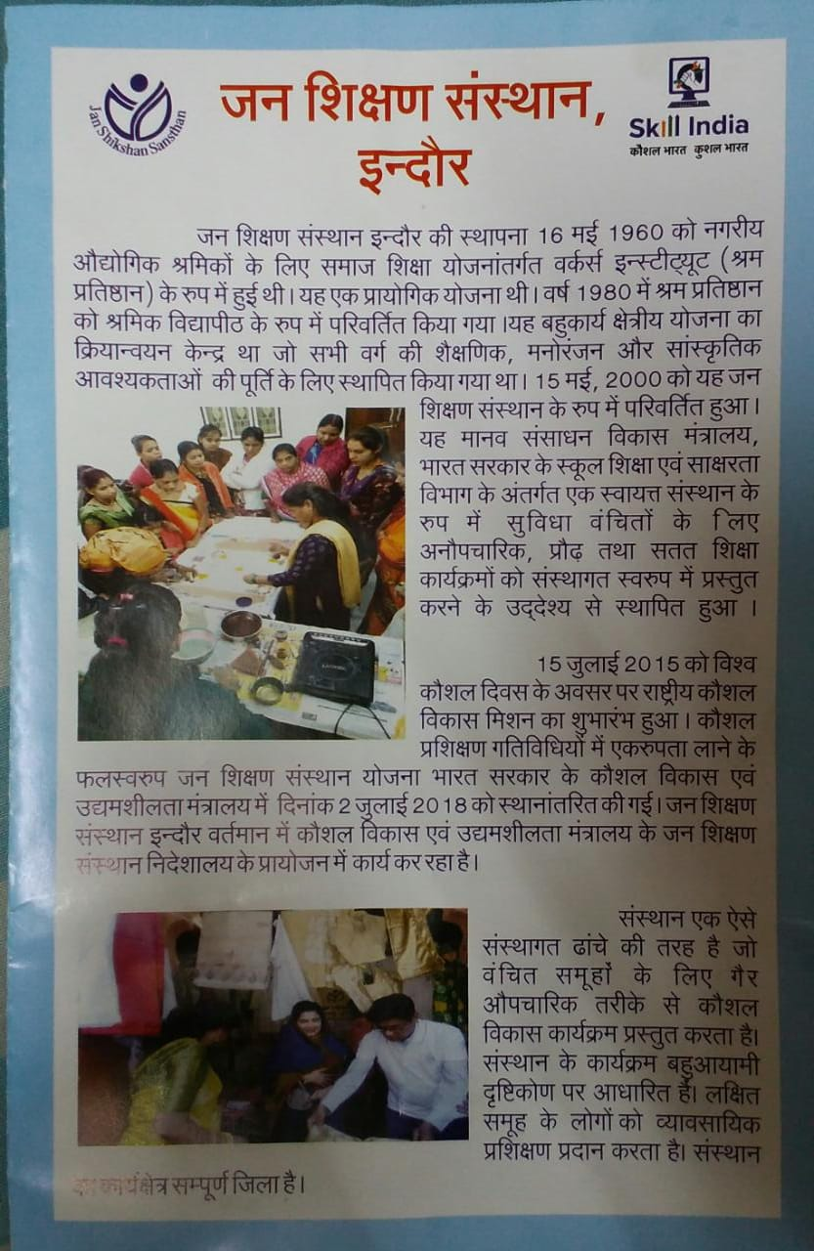

**Program planning and implementation:-**

The Institute organizes programs and activities in the district keeping in view the objectives and target groups. These are implemented in a phased and systematic manner. Online certificates are issued under Skill India to successful beneficiaries after assessing the beneficiaries of the courses conducted.

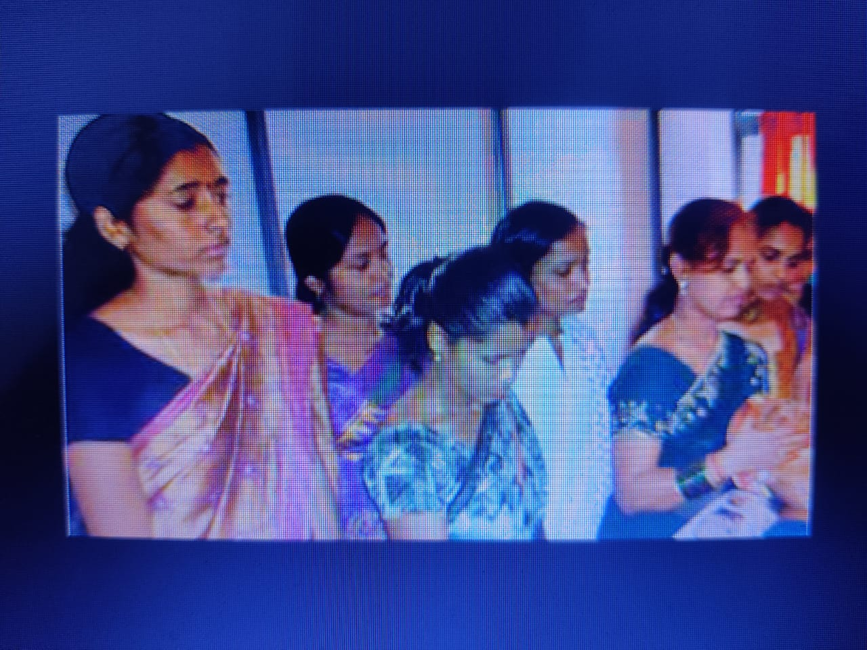

**PROFESSIONAL COURSES**:-

The institute provides quality business skills and technical knowledge at the least cost with its easy accessibility. Being close to the target population, working with the community and understanding the needs of the candidate are the key features of the institute. It is the district's elite skill center, which is a major center for empowerment and capacity building.

In line with local demand in the selection criteria for professional courses, for income generating clients relevant, accessibility of employment opportunities, Production service and IT-oriented include, by which this district skill to be developed as a development centre.

**MONITORING, EVALUATION AND FOLLOW-UP**:-

Monitoring of the Institute is done continuously by the Government of India through online, review meetings, portal and twice a year. Evaluation of the institution by an external agency - based on objective-oriented work review, feedback and the impact of the program on the beneficiaries.

/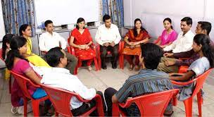

**PHOTO GALLERY**

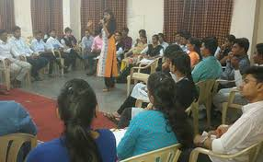 SKILL TRAINNING

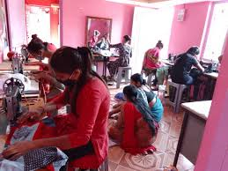 WOMENS TRAINNING

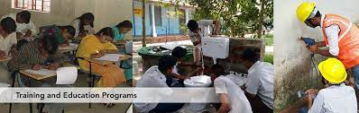 PLUMMING TRANNING

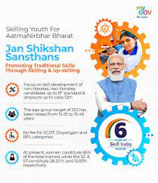

Prime Minister Narendra Modi also twitted on his twitter handle on skilling youth with help of Jan shikshan Sansthans.

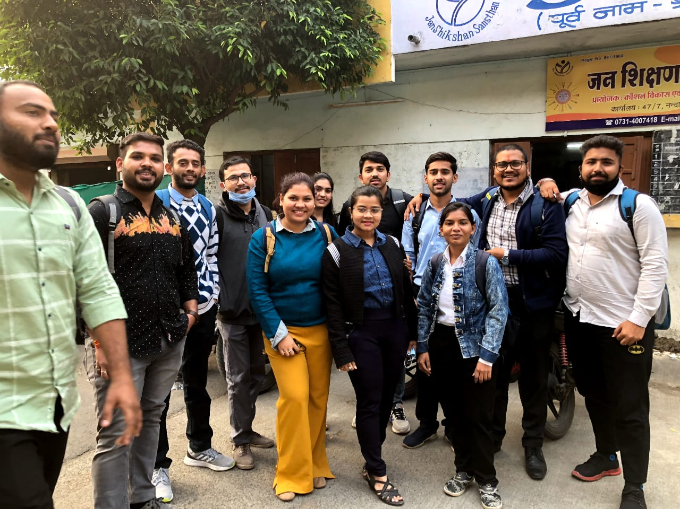 Our Group Photo at Field Visit

**Conclusion**

The field trip to Jan Shiksan Sansthan taught us the true problems that are faced by backward classes and what are the actual reasons and resources that are required to uplift and motivate these people to do welfare for the society and for themselves. The orgainization enchances the required capabilities and skill to its demoralized human resources so that it can contribute towards upliftment of society

**THANK YOU!!!!!!**