**SCHOOL OF SOCIAL SCIENCES**

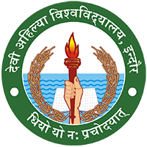

**DAVV INDORE (M.P.)**

**A REPORT ON FIELD VISIT TO**

**JAN SHIKSHAN SANSTHAN KENDRA & NAGRATH CHARITABLE TRUST, INDORE (M.P)**

_________

**SUBMITTED TO – DR.JYOTI CHAUHAN**

**SUBMITTED BY –DURGESH PARMAR**

**ROLL NO. – 2123406**

**ENROLLMENT NO. – DS1819029**

**ACKNOWLEDGEMENT**



I would like to express my deepest gratitude to my Teacher (**DR.JYOTI CHOUHAN**) for contributing their valuable time and efforts in helping me out with this project. Their suggestions and feedback have helped me a lot in improving the quality of the project.

I would also like to thank my friends and family for their constant encouragement and support throughout the project.

Lastly, I like to thank all my supporters who have motivated me to fulfill their project before the timeline.

**DURGESH PARMAR**

# **Jan Shikshan Sansthan Kendra (JSS)**

### **Background**

The Scheme of Jan Shikshan Sansthan (JSS), formerly known as Shramik Vidyapeeth is implemented through a network of NGOs in the country since March 1967. The first Shramik Vidyapeeth was established in Mumbai [Worli] and was commissioned by Bombay City Social Council Education Committee, a voluntary organisation engaged in the field of Adult Education. After the success of the project, the Govt. of India developed a scheme for setting up a network of such institutions in the country in a phased manner.

**Introduction:**

With the transformation in the economic and social setup over the years, the role and scope of these polyvalent educational institutions have widened manifold. In the changed scenario, the focus of Shramik Vidyapeeth (SVP) was shifted from industrial workers in urban areas to the non-literates, neo-literates, unskilled and unemployed youth particularly from SC/ST/OBC/Minority/Divyang/Women throughout the country especially to underprivileged people in the rural areas. The SVPs were accordingly renamed as Jan Shikshan Sansthan (JSS) w.e.f. year 2000.

The scheme of Jan Shikshan Sansthan was consequently transferred from Ministry of Human Resources Development (MHRD) to Ministry of Skill Development and Entrepreneurship (MSDE) in July 2018.

**Objectives**

* To improve the occupational skills and technical knowledge of the non/neo literates and persons having rudimentary level of education upto 8th standard and other school dropouts beyond 8th standard i.e. upto class 12th to raise their efficiency, increase productive ability and enhance their livelihood opportunities
* To identify and promote traditional skills in the districts through skilling/upskilling
* To create a pool of master trainers working across the department/agencies of skill development through training/orientation programme
* To collaborate and coordinate with other departments/agencies working in the filed of skill development
* To widen the range of knowledge and understanding of social, economic and political systems and create awareness about the environment
* To Promote national values and to align with national programmes
* To promote self-employment and facilitate to get financial support including loans/ for the target groups through linkage with credit and consortium membership.

### **Status**

At present 248 Jan Shikshan Sansthans in 27 States and 2 UTs are active out of which 17 JSSs are not functional. A decision of setting up of 83 new Jan Shikshan Sansthans.

**Major Tasks**:

Major tasks and accomplishments (as reported by the NGO): Piolet project of Workers Education since 1960. converted into polyvalent Adult Education Centre called Shramik Vidyapeeth 1980 and then now worked as Jan Shikshan Sansthan 2000. Working in AIDS awareness education, Population education, environment education, Vocational education, material development for Literacy and Adult Education, PMJDY, PMMY.

**Scheme Outline**

JSS refers to an institute that conducts skill upgradation programme in a non-formal mode in rural and urban regions of a district. It provides both academic and technical resource support to target groups from these areas and serves as an institutional framework that offers non-formal mode skill development programmes to disadvantaged groups. Its initiatives include vocational and skill development programmes for non-neo-literates and individuals having basic level education in both industrial/urban and rural areas and other school dropouts. All programmes offered under the scheme are based on the polyvalent or multi-dimensional approach.

**Functions**

The functions of JSS is to

* Identify precise target areas and groups by developing socio-economic profiles.
* Identity and ascertain educational and vocational needs of different categories to clientele groups.
* Explore, innovate and try new approaches to meet the requirements of different groups through programmes based on national educational training.
* Cooperate with educational, cultural and social or organisations that are involved in organising programmes and activities to meet educational, social, vocational, cultural and welfare needs of target groups.
* Act as a facilitator, coordinator and catalytic agent by developing a networking system by collaborating with other vocational and technical institutions, development departments, welfare agencies, employers and workers’ organisations, voluntary agencies, economic enterprises etc.
* Manage the training and orientation of resource individuals/instructors involved in the planning and implementation of various agreements.
* Render consultancy services to agencies and enterprises that are planning to organise programmes for training and vocational education of similar target groups.
* Organise vocational training programmes with special concern for women/girls, deprived sections, and unemployed youth to provide new skills, enhance and upgrade the existing livelihood skills for employment, self-employment and income generation.
* Promote organisation like co-operative societies, manuals and associations of women, youth and workers to undertake collective activities for socio-economic development.
* Provide follow-up services to the beneficiaries of JSS.
* Create a Livelihood Cell for employment/self and wage employment opportunities. Livelihood Cell would be linked with the concerned national/state level portal for the promotion of livelihood opportunities.
* Identify and develop curriculum on local traditional skills

**Target Group**

* Jan Shikshan Santhan focuses on the socio-economic backward and educationally disadvantaged groups of urban/rural population such as men, women, youth, employed, self-employed, neo literates, prospective workers and their family members, along with unemployed youth.
* The scheme also targets to impart vocational skills to the non-literates and individuals having a rudimentary level of education of up to 8th standard and other school dropouts.
* Preference is given to women, SC, ST, OBS and minorities in the rural and urban areas.

However, the age limit can be adjusted unless the candidate belongs to Divyang category and other deserving cases.

**Observations and learnings**

* The unskilled people were trained and made aware of the wide arena of opportunities.
* Women’s training was done so as to make sure they become independent by themselves.
* Hands on training was provided for the practical approach.
* vocational training programmes were organized with special concern for women/girls, deprived sections, and unemployed youth to provide new skills, enhance and upgrade the existing livelihood skills for employment, self-employment and income generation.

**Conclusion:**

The institution provides non-formal and vocational education to less fortunate adolescents. The Sansthan runs a project of Ministry of Human Resource Development, Department of School Education and Literacy, Government of India. By linking literacy with vocational training, centres of JSS seek to improve the quality of life of the underprivileged mass.

Shramik Vidyapeeth, as it was formerly known, the organisation got renamed as Jan Shikshan Sansthan in the year 2000. In the beginning, JSS organised vocational training and skill upgradation programmes. Now with the National Literacy Mission, the Sansthan is covering almost the entire country and several JSS centres are being set up in different districts to consolidate the literacy campaign and enhancing the life of underprivileged mass through various vocational training courses.

The activities of Jan Shikshan Sansthans have been expanded to provide academic and technical support to Zila Saksharata Samitis (District Literacy Committees) in taking up vocational and skill development programmes in both urban and rural areas.

JSS has also been successful in transforming the lives of young girls rescued from trafficking and bar girls by providing them vocational education like tailoring and beautician courses. Jan Shikshan Sansthan’s main objective is to improve occupational skills and technical knowledge of underprivileged adolescents so as to raise their efficiency and increase their productive ability.

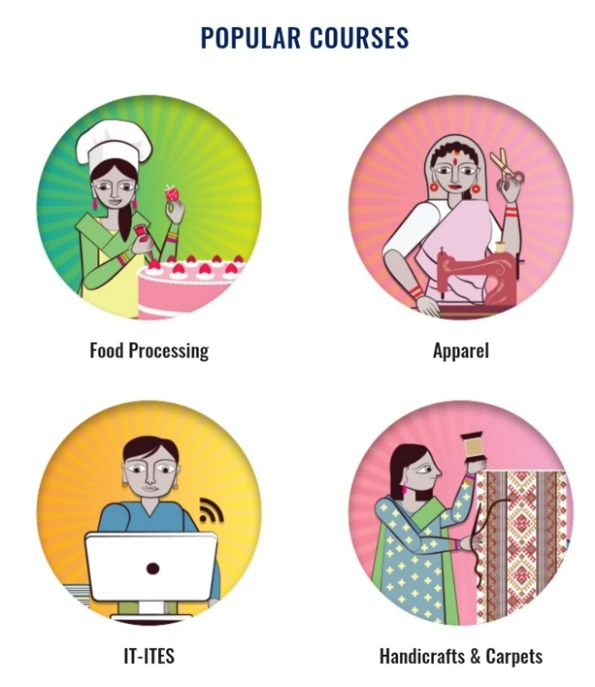**Appendix:**

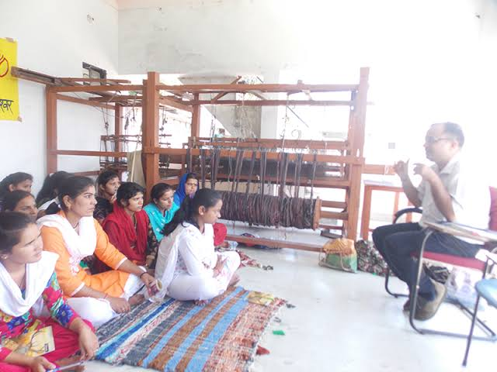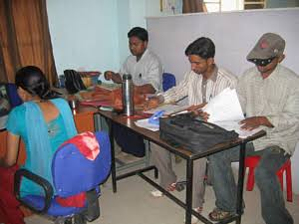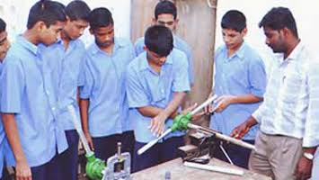

**IT training**

**Handloom Training**

**Plumbing Training**

**Nagrath Charitable Trust**

**A National Independent Charity Organization**

Nagrath Charitable Trust is a secular, non-political and non-profit making Trust registered under MP Public Trust Act with registration number 10 dated 1st April 1969. Late Dr. Chamanlal Nagrath, F.R.C.S., F.I.A.C.S. & Late Dr. Mrs. Pushpa Nagrath, F.R.C.S., F.R.F.P.S. laid the Foundation of the Trust in the year 1969. The Founders of the Trust had a transcendent vision, of providing first rate preventive and curative community health services to needy poor persons and villagers living in remote areas. They wanted to promote social justice & equality among the scheduled tribes, scheduled castes and women, and also raise the standard of living of the poor villagers through Watershed Management Techniques & now the successors and present Board of Trustees and the Managing Trustee Dr. Ramesh Nagrath, uphold the principles of the Founders.

**Introduction:**

Nagrath Charitable Trust is an NGO that aims to promote and ensure a good mean based lifestyle for all those people who are unknown to them and/or they don’t have to required basic knowledge about the same.

The vision is providing qualitative, preventive & curative medical care exclusive without prejudice to caste, creed and religion, through Pushpkunj Hospital and extension of medical and social relief to poor and needy villagers living in remote areas.﻿ The mission is Promoting indigenous technology to develop and manage water resources and enhance agricultural output in the rural areas and to provide gainful employment throughout the year.﻿

* Providing preventive & curative medical care.﻿
* Promoting gender equality & human rights ensuring social justice at all levels.﻿
* Supporting community based programs for attaining self reliance and sustainability.﻿
* Liaisoning with the government and other agencies for achieving the vision of the trust.﻿ ﻿ ﻿ ﻿ ﻿ ﻿ ﻿ ﻿ ﻿

Board of trustees:

| **S.No** | **Name** | **Designation** |
| --- | --- | --- |
| 1. | Shri. Vinay F.Kothari | Chairman |
| 2. | Dr. Ramesh Nagrath | Managing Trustee |
| 3. | Shri. Anil Nagrath | Trustee |
| 4. | Shri. S.K. Bais | Trustee |
| 5. | Dr. Ashok Tyagi | Trustee |
| 6. | Smt. Aparajita Nagrath | Trustee |
| 7. | Dr. Mrs. Kamalsingh | Trustee |

**Works by Nagrart Charitable Trust:**

**Pushpkunj Hospital:**

It was established in the year 1971 with the objective of providing much needed first rate community health services, preventive as well curative, to all especially the poor and the deprived ones living in remote villages. It is a 30 bedded well equipped hospital and over the course of its existence the Hospital has been able to create a good reputation of providing first rate Healthcare facilities to nearby remote villages.

**Watershed Management**

Integrated Watershed Management Program (Govt of India) had allotted 3 Projects to the Trust which was previously supported by Rajiv Gandhi Jalgrahan Prabandhan Mission but later on it was merged with the PMKSY scheme (Pradhan Mantri Krishi Sinchai Yojana).

1. Choral River Revival under Integrated Watershed Management Program (IWMP-3):- this project was approved in year 2009-10 for kalakund area in Mhow Block of Indore District. The total area under treatment was 4548 hectares. Under this project we had to work in 17 villages of 5 micro watershed committees. In watershed development work head we constructed 13 stop dams, 37 check dams, 4 percolation tanks, 3 earthen dams and 2 farm ponds under water conservation through which 134.62 hectares area was increasingly irrigated, as a result of which farmers are able to plant 2-3 crops in a year and the river flows throughout the year. Under soil and water conservation we constructed 43320 RMT of farm bunding, 54460 RMT of contour trenching work and 3965 Cum. Of boulder structures. In productivity head we distributed various foundation and breeder seeds of wheat, soyabean, onion, flowers and various vegetables to enhance the quality as well as quantity of produce and provided latest technological equipment to improve agricultural land with the help of Soyabean Research Center and Central Institute of Agricultural Engineering. In livelihood head we created 30 SHGs involving 231 family members and also attached 41 individuals to create women’s empowerment and improve standard of living of the villagers.
2. Sukhadi River Revival under Integrated Watershed Management Program (IWMP-4):- This project was approved in year 2011-12 for Choral area in Mhow Block of Indore District and at present this project is at work phase level. The total area under treatment was 5051 hectares. Under this project we had to work in 11 villages of 6 micro watershed committees. In watershed development work head we constructed 7 stop dams, 31 check dams, 6 dugout ponds, 1 earthen dam and 3 farm ponds under water conservation through which 137.69 hectares area was irrigated. Under soil and water conservation we constructed 22345 RMT of farm bunding, 52537 RMT of contour trenching work and 6142 Cum. Of boulder structures and a 73 cum Gabian structure. In productivity head we distributed various foundation and breeder seeds of wheat, soybean, onion, flowers and various vegetables to enhance the quality as well as quantity of produce and provide latest technological equipments to improve agricultural land with the help of Soyabean Research Center and Central Institute of Agricultural Engineering. In livelihood head we created 46 SHGs involving 469 family members and also attached 54 individuals to create women’s empowerment and improve standard of living of the villagers.
3. Integrated watershed Management Program (IWMP-10):- This project was approved in year 2013-14 for Bhagora area in Mhow Block of Indore District and at present this project is at preparatory phase level. The total area under treatment was 5428 hectares. Under this project we had to work in 10 villages of 6 micro watershed committees. In watershed development work head we constructed 5 stop dams, 34 check dams,4 farm ponds under water conservation through which 180.20 hectares area was irrigated. In productivity head we distributed foundation seeds of wheat from IARI (Indian Agricultural Research Institute). In livelihood head we created 26 SHGs involving 296 family members to create women’s empowerment and improve standard of living of the villagers.

**Women’s Empowerment**

1. KALAKUND KA KALAKAND: - Kalakund is a place which is 10 kms from Choral and is famous for kalakand (a type of sweet). It was being sold at Kalakund railway station since the past many years. Traditionally it was prepared by 3 generations of 6-7 families on chulhas (a small wood fired stove), after collaboration with the Integrated Watershed Management Program 10 women from the same family were merged to create a Self Help Group SHG (Sachchhi lagan swa sahayata samuh).

These women not only tried to improve the quality of kalakand but also to connect other women with them. Initially they sold kalakand at the railway station only. Passengers passing between the hills of Kalakund were buying kalakand since the past several decades. Rural women now discovered the magic of the highway. Today kalakand has reached other places too (like choral, baigram and even Indore). Women also adopted modern technologies for making kalakand like boiler chulha and also proper packaging to make the kalakand reach a longer distance.

1. READYMADE GARMENTS UNIT: - This is the story of a woman who came from a backward society, where girl’s education was not important at all. No freedom was given to the women in the community to work together added to financial constraints. Today she is fighting and not only standing on her own feet, but is also encouraging other women to be self-dependent. She has lit a spark of light for a new beginning which gradually reached the villages around and the effect is visible.

Gawalu Village lies about 40 kms from Indore, at khandwa road. The population of this village is around 1200 and Sheela is one of them. Sheela was very good in studies but lacked proper facilities and her family also did not allow her to go out of the village to study. She has just read till the eighth class. At the age of 19, Sheela was married to Mukesh Rathore who lived in Indore city. After the expansion of their family their expenses also increased. To manage the expenses at first she learned sewing work. And then began working in a nearby ready-made garment factory. When she got some earnings, she bought a sewing machine and started taking orders from the market. And started earning good money as she was skilled in her work. To expand her work she moved to her own village Gawalu, and started involving other women and made a SHG (Jyoti jalgrahan swa sahayata samuh) with the help of integrated watershed management program (IWMP-04). Firstly a training session was conducted by the program for these women, and after getting proper training, the project gave revolving fund to the SHG women so that they were able to purchase sewing machines. They started to work in August 2015, and initially worked 2-3 hrs a day and earned Rs 1500/- to Rs 2500/- monthly.

1. LED Lights (Jhalar) Making:- In Choral Village which is nearly about 25 kms. From Indore we conducted a training session of 10-15 days to learn how to make LED lights (Jhalar) through which 10-15 women were trained and formed a group to start making Jhalars. After seeing their efforts Eicher Motors tied-up with them for their three day diwali fair during which the women managed to sell 1500 LED lights (jhalars).

**Technologies In Agriculture**

1. **Advanced Technologies in Agriculture: -** Generations continued doing traditional farming. The traditional way of farming was neither good nor was its economic output sufficient.

Farmers planted seeds distributed by us after consultation with scientists of Indian Agriculture Research Institute and Agriculture Research Institute which were greatly improved in quality and as a result, positive changes were seen as compared to traditional methods.

**Modern farming** – Farmers were encouraged to cultivate improved varieties of seeds using modern methods. Their production rose higher from the start. And to strengthen their economic position. Wheat seed (1544, 8663, 2004 amar) and soyabean seeds (JS 9560, Hd 4662) were distributed. The use of good quality seeds produced more opportunities to strengthen the economic situation of farmers and made them happy and content.

**Encourage producing Marigold** – Farmers were encouraged to do floriculture work. And they were told what type of flowers can enhance their earnings.

1. **Seed Bank**: - The Trust powered by Integrated Watershed Management Programme component of prime agricultural irrigation scheme established a Seed Bank under the Production system and micro enterprises head. Through which we gave 30 kg of improved seeds to some farmers and in return they gave us 60 kg of the produce from those improved seeds. The seeds were placed in the seed bank and were given to other farmers as well. .

They planted other varieties of seeds (Purna, Poshan and Sharbati) in place of traditional seeds. Thereby increasing their earnings. As initially they were available only to a few farmers, after the establishment of seed bank they were available to approx 80% to 90% of farmers. Through the establishment of Seed Bank the farmers have been able to sow good quality of seeds resulting in higher quality of produce for which they received a much better price.

# **Health And Nutrition**

Available data indicates pervasive under nutrition among women and children in India. According to the National Family Health Survey-3 data, nearly half the children in the country were undernourished. Full immunization coverage in rural areas is still alarmingly low, at 40%. The proportion of anemic children under-3 has gone up from 74% to 79%. We also have the highest percentage (87%) of pregnant anemic women in the world (World Bank, 2007).

The area where Nagrath Charitable Trust is working is one of the poorest, remote and drought-prone tribal pockets in Madhya Pradesh, characterized by a high incidence of poverty and malnutrition, low levels of literacy, poor availability of health, education facilities etc. There is an urgent need for carrying out reforms in the remote hinterland of this country, especially these tribal areas that face a terrible crisis of governance. The Trust has made plenty of efforts and has made significant headway in reducing these abysmal figures.

# **Self Help Groups**

Agriculture for small and marginal farmers requires timely and affordable credit to cover the variety of input and other costs. Rural moneylenders that dominate the informal credit market readily offer loans to the farmers with little paperwork at a rate of interest as high as 60% per annum.

The inability to repay such a loan leads to the beginning of a vicious cycle where the borrowers can even become bonded labourers of the moneylender. In this scenario, a formal and timely source of credit with better terms of repayment has enabled many members to break from the shackles of intergenerational debt bondage. A savings programme enables the poor to extricate themselves from the clutches of usurious moneylenders. The Trust in almost every area in which it has interventions has tried to introduce the concept of SHG’s and has resulted in vast improvement to the standard of living of the populace.

**Rain Water Harvesting**

With the assistance of our team of highly skilled and qualified professionals, they provide a wide array of Rain Water Harvesting installation and consultancy services to our clients. Their offered services include complete maintenance and repair of water harvesting system in an efficient manner. Their services are carried out by highly skilled professionals and greatly appreciated among the clients for their timely manner, flexibility and prompt delivery. These services are offered as per the International standards in an efficient manner to ensure better functionality of instruments.

**Observations and Learning:**

* The people who need help are being approached and educated
* The emphasis on the self- dependency of girls/women are made sure.
* The basic help such as providing BPL card help, ration help is provided.
* Latest technologies are being used to help villagers and the people of remote areas.
* The health and nutrition is paid special importance and hence they are being supportive towards that.

**Conclusion:**

Nagrath Charitable Trust is an NGO that aims to promote and ensure a good mean based lifestyle for all those people who are unknown to them and/or they don’t have to required basic knowledge about the same.

The vision is providing qualitative, preventive & curative medical care exclusive without prejudice to caste, creed and religion, through Pushpkunj Hospital and extension of medical and social relief to poor and needy villagers living in remote areas.

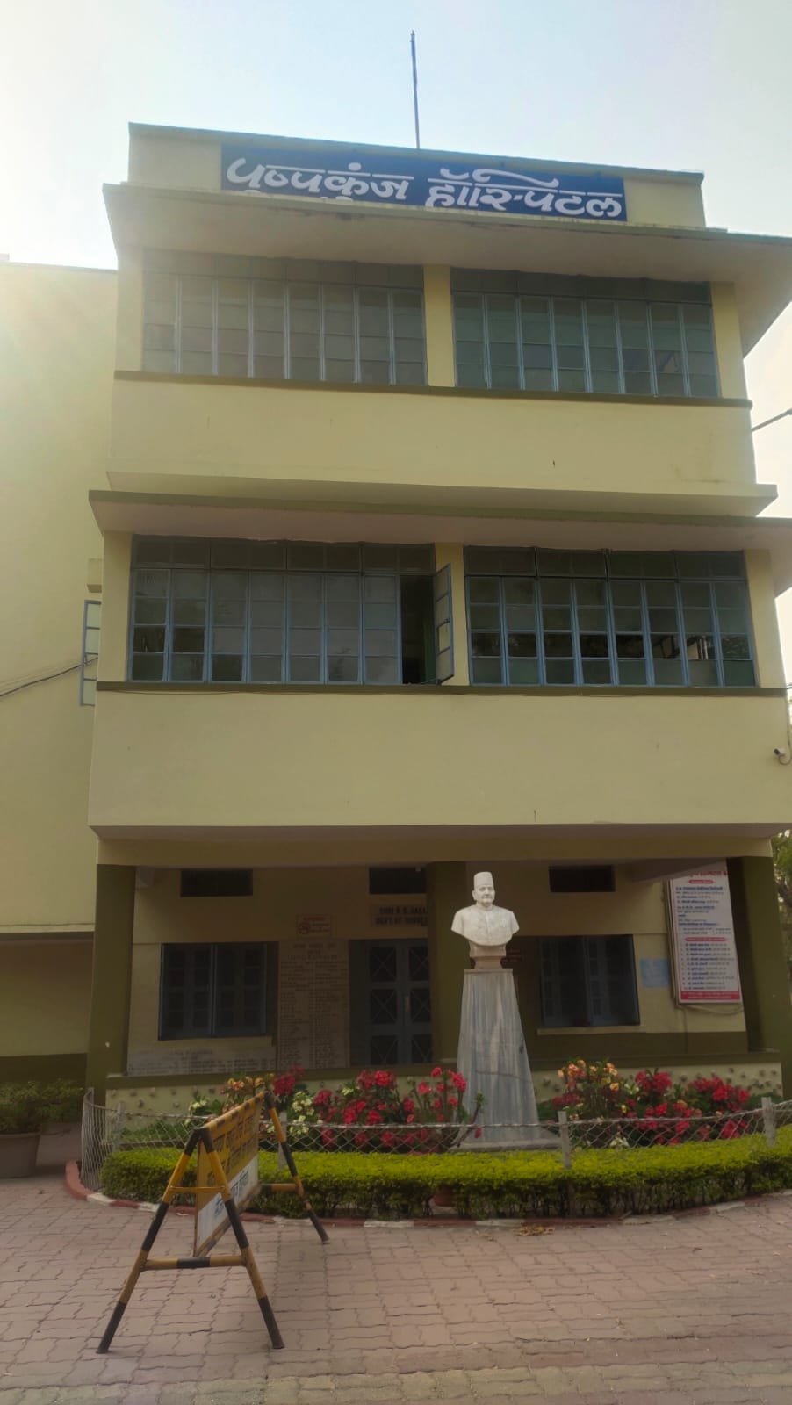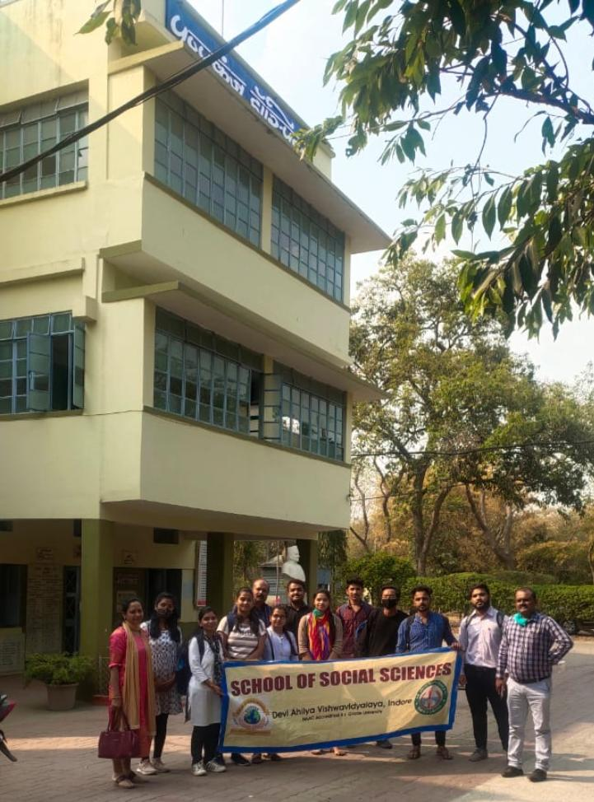**Appendix:**

**Field Visit at Pushpkunj Hospital**

**- Pushpkunj Hospital**

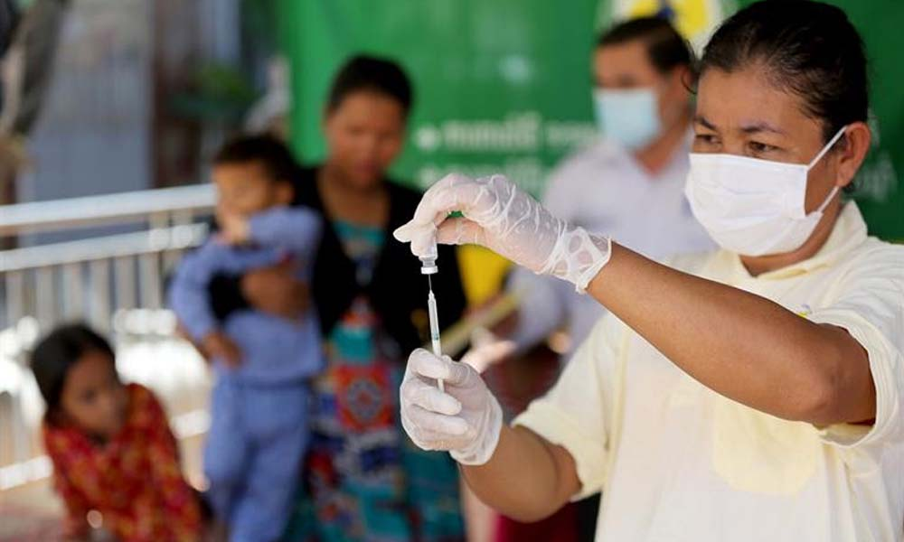

**Health and Nutrition**

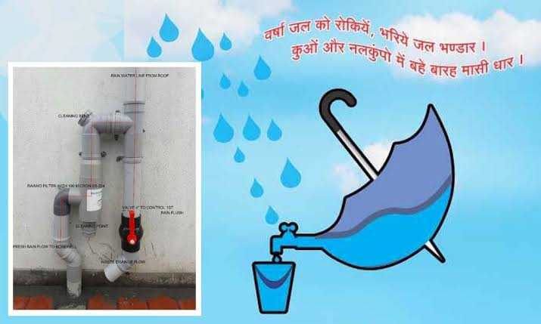

**Water Management**

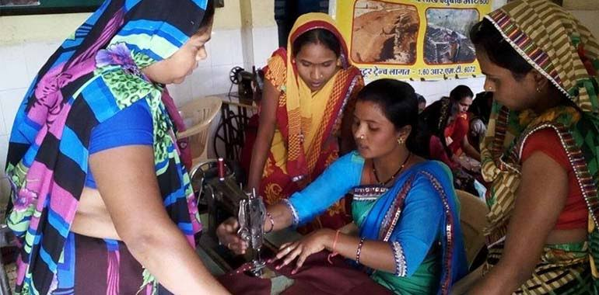

**Women empowerment**