DEVI Ahilya Vishwavidyalaya, Indore

Session 2021-2022

Name: - ***Riya Sharma.***

Department: - ***School of Social Science.***

class: - ***MBA Public Administration and Policy***. (1st Sem)

Topic: - ***Report on Field Visit at a Government Organization.***

Name of organization: -“***Jan Shikshan Sansthan”.***

Submitted to***: - Dr. Jyoti Chouhan Ma’am***

Date of submission: - **09/03/2022**

**Acknowledgement**

I would like to express my special thanks of gratitude to my coordinator **Dr. Jyoti Chouhan** Ma’am and **Mrs. Rachna Jain** Ma’am for her guidance and support in successfully completing the project. I would also like to thank our Head of department (HOD) **Rekha Acharya** ma’am for providing the opportunity to visit the NGO Jan Shikshan Sansthan and for all the required facilities.

I would also like to thank my **friends and family** for their constant encouragement and support throughout the project. Lastly, I like to **thank all my supporters** who have motivated me to fulfill my Project before the timeline.

**RIYA SHARMA**

**MBA PUBLIC ADMINISTRATION**

**AND POLICY (I SEM)**

**Content**

1. Introduction.
2. Purpose of Visit.
3. Structure of the organization
4. Objective of JSS
5. Establishment and funding of JSS.
6. Function of JSS.

1. Role of different divisions of JSS.
2. Popular courses offered by the organization.
3. Our learning from the organization
4. conclusion

**INTRODUCTION**

The Scheme of Jan Shikshan Sansthan (JSS) formerly known as **Shramik Vidyapeeth** was a unique creation of Government of India is being implemented through NGOs in the country since **1967**. The scheme was **renamed as Jan Shikshan Sansthan in 2000**. JSS scheme was transferred from **Ministry of Education** (erstwhile Ministry of Human Resource Development) **to Ministry of Skill Development & Entrepreneurship in July, 2018.**

At present, 304 JSSs in 27 States and 7 Union Territories are functional. The annual coverage of the beneficiaries is around **4 lakhs**, out of which **85% are women.**

Jan Shikshan Sansthan (JSS) scheme is implemented through NGOs with **100% grants from the Government of India**. Jan Shikshan Sansthans are registered under the **Societies Registration Act, 1860**. The affairs of Jan Shikshan Sansthan are managed by respective Board of Management approved by the Government of India.

The mandate of the scheme is to provide vocational skills in non-formal mode to non-literate, neo-literates, persons with rudimentary level of education upto *8th and school drop-outs up to 12th standard* in the age group of **15-45 years.** The priority groups are women, SC, ST, minorities and other backward sections of the society. JSSs are reaching to the unreached areas to cater the needs of the poorest of the poor. They work at the door step of the beneficiaries with a minimum infrastructure and resources.



**Purpose of Visit**

The objective of the visit was to acquire knowledge about the functioning of an institute which is related to government and to learn about the administration of such an organization which helps so many poor people specially the women and minority people.

We visited Jan Shikshan Sansthan on 4th Jan 2022 at 1:20 PM. There we met the coordinator of the organization who explained us the working and objective of the organization. we came to know that this organization is helping so many women of all the classes those who don’t have a source of earning, who used to work on streets by picking up garbage or who are unable to live a lifestyle which they deserve.

The organization provide vocational training to the youth. They train people so that they can learn a skill and then become self-dependent. The process of finding such people starts with surveying about where they will get such people who are unable to get a source of living. Then they target those people are willing to that work and are keen to learn new things. At last, they train them through different programs launched by the organization. In other word, they follow a cycle of survey, target and train. Out of which they select people on 50-50 ratio, i.e. 50% people from rural area and 50% from urban area.

**Survey**

**Target**

**Training**

**Structure of Organization**

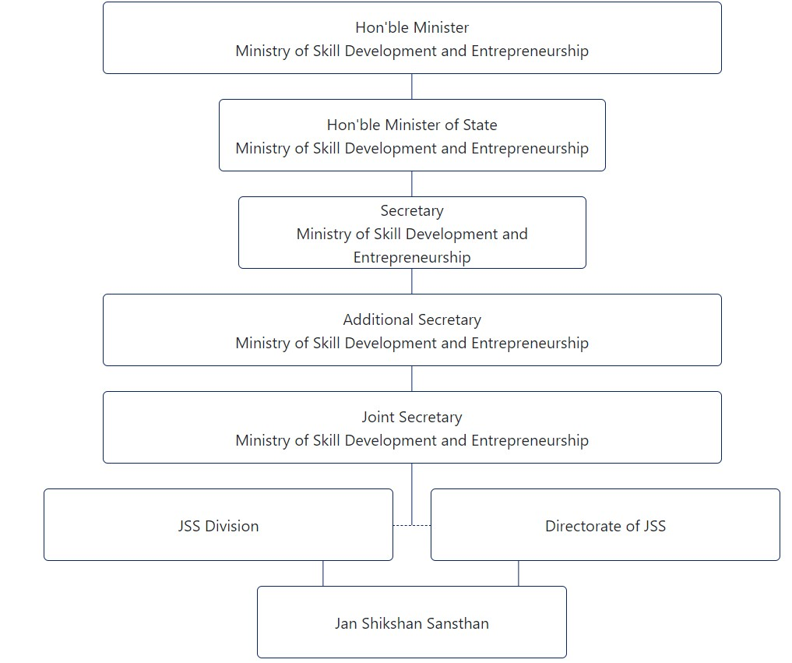

Within Jan Shikshan Sansthan

1. **one director**
2. **one program officer**
3. **one assistant Program officer**
4. **Field Assistant**
5. **Computer operator**
6. **One accounts Manager**
7. **Pion**

**Objective of JAN Sikshan Sansthan**

1. To enhance occupational skills and technical knowledge of the neo-literates and individuals having basic school education.
2. To raise efficiency, increase productive ability and enhance their livelihood opportunities.
3. To identify and assist traditional skills in the district through skilling/upskilling.
4. To create master trainers who are eligible to work in a department/agency of[**skill development**](https://www.indiafilings.com/learn/national-skill-development-mission/) through training and orientation programmes.
5. To collaborate and coordinate with other departments/agencies who are working in the field of skill development.
6. To widen the range of knowledge and understand the social, economic and political systems and creating environmental awareness.
7. To promote national values and align with national programmes.
8. To promote [**self-employment**](https://www.indiafilings.com/learn/self-employment-scheme/) and facilitate financial support, including loans for the target group through linkage with credit and consortium membership.



**Steps to Establish JSS**

**Step 1:**Proposals to set up new Jan Shikshan Sansthans are invited through open advertisements.

**Step 2:**Request for Proposal (RFP) would be called to establish new JSS.

**Step 3:**The entire process of scrutiny/assessment, field visit, evaluation and ranking of the applicants may be handled by a third-party expert agency.

**Step 4:**Selected top-ranking applicants would be required to assemble before the selection committee of MSDE to make their presentations.

**Step 5:**The selection committee shortlists the applicants and makes recommendations for consideration/approval of the competent authority.

**Step 6:**All applicants who have been approved by the competent authority would be sanctioned to establish new Jan Shikshan Sansthan.

**Funding of Jan Shikshan Sansthan**

The Development Fund of the JSS would be generated on account of the following.

* The fee collected from the trainees
* Donations
* Consultancy fee for the programmes conducted by JSS on behalf of the other departments/agencies
* Any income received other than grant-in-aid that is received from the Government of India.

A separate account would be maintained for the income that is received under the Development Fund from different sources that are specifically mentioned. The fee for different courses/activities would be decided by the respective Board of Management. Nevertheless, the fee for SC/ST would be given concession or exemption.

**Function of JSS**

1. Identify precise target areas and groups by developing socio-economic profiles.
2. Identity and ascertain educational and vocational needs of different categories to clientele groups.
3. Explore, innovate and try new approaches to meet the requirements of different groups through programmes based on national educational training.
4. Cooperate with educational, cultural and social or organisations that are involved in organising programmes and activities to meet educational, social, vocational, cultural and welfare needs of target groups.
5. Act as a facilitator, coordinator and catalytic agent by developing a networking system by collaborating with other vocational and technical institutions, development departments, welfare agencies, employers and workers’ organisations, voluntary agencies, economic enterprises etc.
6. Manage the training and orientation of resource individuals/instructors involved in the planning and implementation of various agreements.
7. Render consultancy services to agencies and enterprises that are planning to organise programmes for training and vocational education of similar target groups.
8. Organise vocational training programmes with special concern for women/girls, deprived sections, and unemployed youth to provide new skills, enhance and upgrade the existing livelihood skills for employment, self-employment and income generation.
9. Promote organisation like co-operative societies, manuals and associations of women, youth and workers to undertake collective activities for socio-economic development.
10. Provide follow-up services to the beneficiaries of JSS.
11. Create a Livelihood Cell for employment/self and wage employment opportunities. Livelihood Cell would be linked with the concerned national/state level portal for the promotion of livelihood opportunities.
12. Identify and develop curriculum on local traditional skills.

**Role of different divisions**

| Ministry of Skill Development and Entrepreneurship | |
| --- | --- |
|  | 1. Release of grants (Re-evaluation of grants heads as per state SC/ST population Matrix) and issuance of UCS |
|  | 1. Grievances handling of functional and non-functional JSS |
|  | 1. Handling Parliamentary issues, RTI and PG Portal |
|  | 1. Holding Annual Review Meeting of JSS Chairperson |
|  | 1. Monitoring of Scheme implementation of the states |
|  | 1. Technical support for effective implementation of the scheme |
|  | 1. Policy changes / upgradation whenever required |
|  | 1. Develop required guidelines and norms for effective implementation |
|  | 1. Impact Assessment and Evaluation of JSS |
|  | 1. Coordinate CAG-Thematic Audit |
|  | 1. Coordination with NSTI, NSDC, NSDA and other stakeholders |
|  | 1. Court cases in respect of JSS Scheme |
|  | 1. Budgetary matters of JSS Scheme |
|  | 1. Approval/Sanction of new JSS |
|  | 1. Any other work as assigned to the Division for the promotion/implementation of JSS Scheme or the matter related to it. |

| **Directorate of Jan Shikshan Sansthan** | |
| --- | --- |
|  | 1. Approval of Annual Action Plan of JSSs |
|  | 1. Recommendation of release of Grants of JSSs |
|  | 1. Facilitating and coordinating technical support services to JSSs |
|  | 1. Facilitating evaluation of JSSs |
|  | 1. Provide technical resource support to Scheme of JSS |
|  | 1. Supervision and Monitoring of JSSs progress through periodical visits |
|  | 1. Training and orientation to the programme / administrative staff of JSS |
|  | 1. Creation of pool of master trainers |
|  | 1. Clearing house services |
|  | 1. Providing guidance to the members to the Board of Management / Executive committee and Programme / Administrative staff |
|  | 1. Conduct Half Yearly / Annual Review meetings |
|  | 1. Development of course curriculum |
|  | 1. Monitoring of Livelihood Cells of JSS |
|  | 1. Collaborate and coordinate with other stakeholders in the field of skill development |
|  | 1. Operationalisation of new JSSs |
|  | 1. Matters related to JSS Portal, viz. its periodical updation, maintenance, etc |
|  | 1. Publicity and media |
|  | 1. Organization of national level meetings / workshops / seminars |
|  | 1. Activities needed for promotion of the objectives of the scheme |
|  | 1. Scrutiny of Proposal of Board of Management of JSSs |
|  | 1. Grievances on Public Grievances Portal |
|  | 1. RTI matters in respect of JSS on functional issues |
|  | 1. Providing input on court cases on functional issues of JSS |
|  | 1. Any other work as assigned to the Directorate for the promotion/implementation of JSS Scheme or the matter related to it |

| **Jan Shikshan Sansthan** | |
| --- | --- |
|  | 1. Identify appropriate target areas and groups by developing socio-economic profiles |
|  | 1. Identify and ascertain educational and vocational needs of different categories of clientele groups |
|  | 1. Explore, innovate, work out alternatives and try new methodologies to meet the need of different groups through programmes of vocational education and trainings |
|  | 1. Cooperate with educational, cultural and social organizations involved in organizing programmes and activities to meet educational, vocational, social, cultural and welfare needs of target groups |
|  | 1. Act as a co-ordinator, facilitator and catalytic agent by developing a system of net-working in collaboration with other vocational and technical institutions, development departments, welfare agencies, employers and workers’ organisations, voluntary agencies, economic enterprises etc |
|  | 1. Undertake training and orientation of resource persons/instructors involved in planning and implementation of various programmes |
|  | 1. Provide consultancy services to agencies and enterprises planning to organise programmes for training and vocational education of similar target groups |
|  | 1. Organise vocational training programmes with special concern for deprived sections, women/girls and unemployed youth to provide new skills, refine/sharpen/upgrade the existing livelihood skills for employment, self-employment and income generation |
|  | 1. Promote organisation of forums such as co-operative societies, mandals and associations of women, youth and workers with a view to undertake collective activity for socio-economic development |
|  | 1. Provide follow-up services to beneficiaries of the JSS |
|  | 1. Create Livelihood Cell for employment/ self and wage employment opportunities. Livelihood Cell will be linked with appropriate national / state level portal for promotion of livelihood opportunities |
|  | 1. Identify and develop curriculum on local traditional skills |

**Popular courses offered by JSS**

JSSs offer the courses in 22 sectors. Some of the popular sectors are apparel made-Ups and Home furnishing, Beauty and wellness, handicrafts and carpets, Food Processing, Agriculture, Domestic workers, electronics and hardware, plumbing etc.

1. Agriculture.
2. Apparel. Made-Ups & Home Furnishing
3. Automotive
4. Beauty and wellness
5. Construction
6. Domestic workers
7. Electronics and hardware
8. Food processing
9. Handicraft and carpets
10. Furniture and fitting
11. Healthcare
12. IT
13. Iron and steel
14. Leather
15. Management, Entrepreneurship and professional
16. Mining
17. Paints and coating
18. Plumbing
19. Retail
20. Rubber
21. Textile and handloom
22. Tourism and hospitality



**Conclusion and learnings**

Jan Shikshan Sansthan is an organization which focuses on skill development and vocational training to urban and rural people. It aims at human resources development so that people can earn through skills and knowledge. It is a great initiative by Jan Shikshan Sansthan to provide such skills so that people can get income and wages and the ratio of street baggers will decrease. It will reduce unemployment ratio, people can earn enough so that they can get a good meal to eat and to feed their families, and people can fulfill their basic needs without any outer financial assistance.

My suggestion to the organization would be that they should spread such lessons at a larger level, also promote their training sessions well as not so many people are aware about this organization. promotions can be done through the previous trainees as vocal promotion, which will not create any additional expense.

