SCHOOL OF CHEMICAL SCIENCES
FEEDBACK ON CURRICULUM - BY STUDENTS (ACADEMIC SESSION 2021-2022)
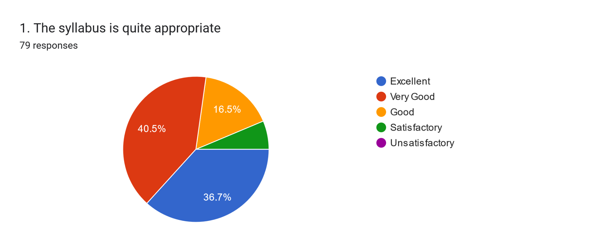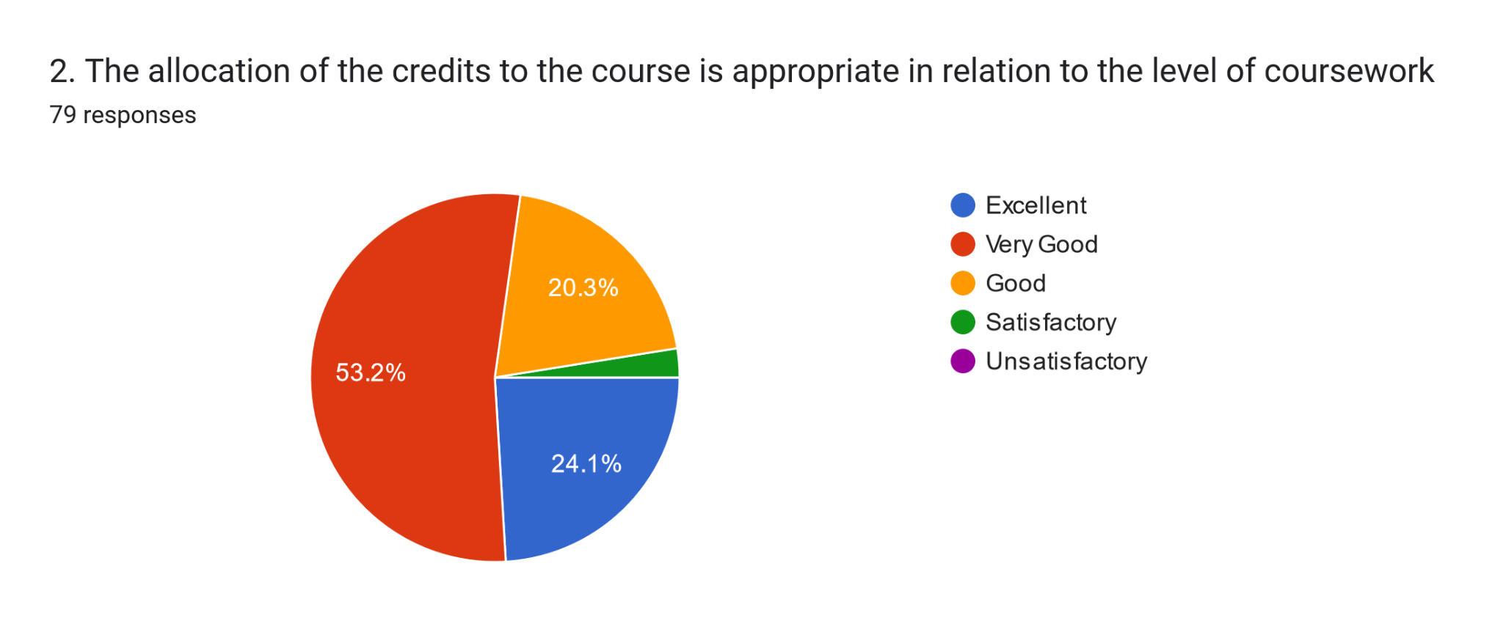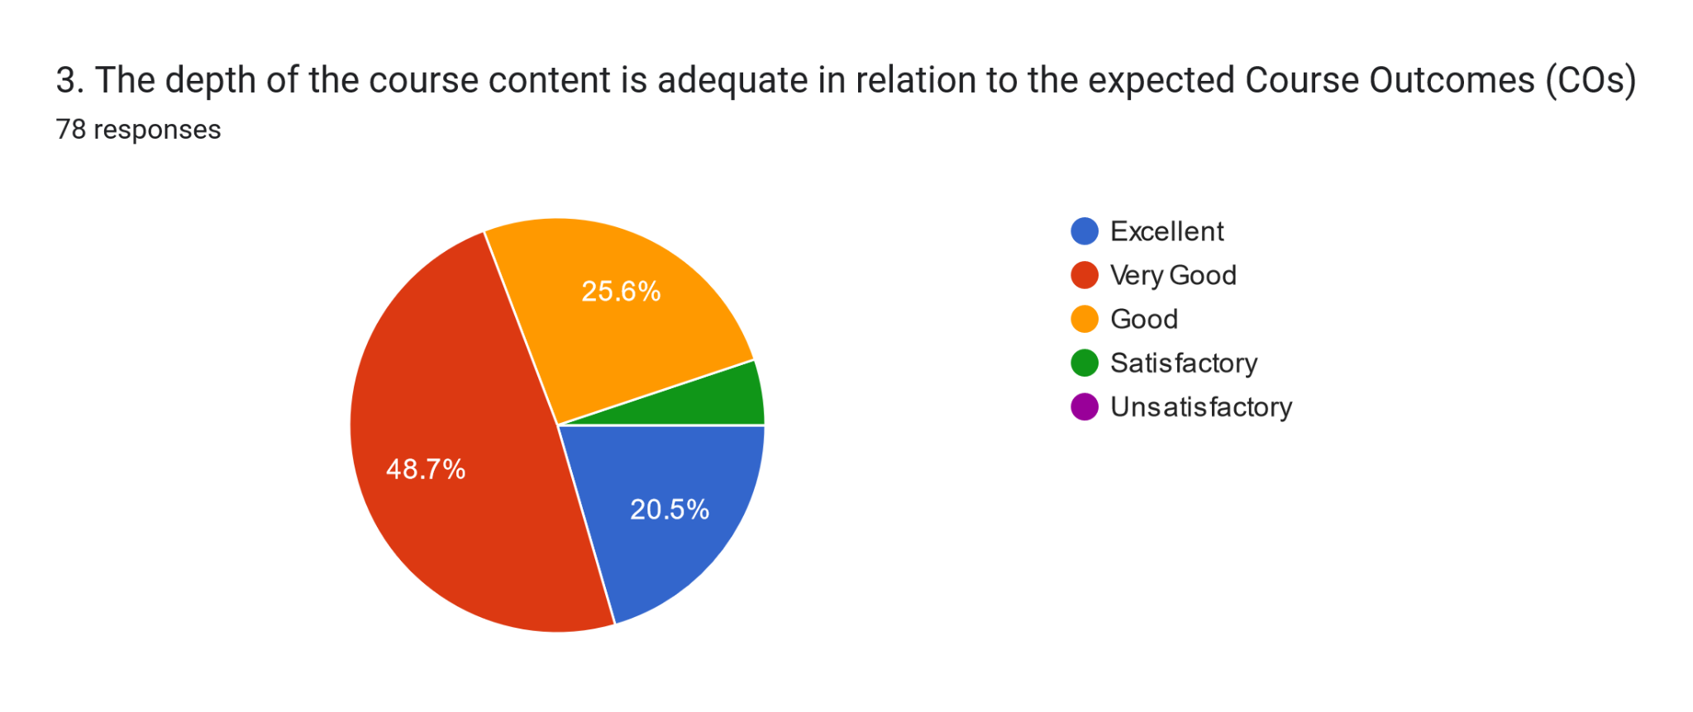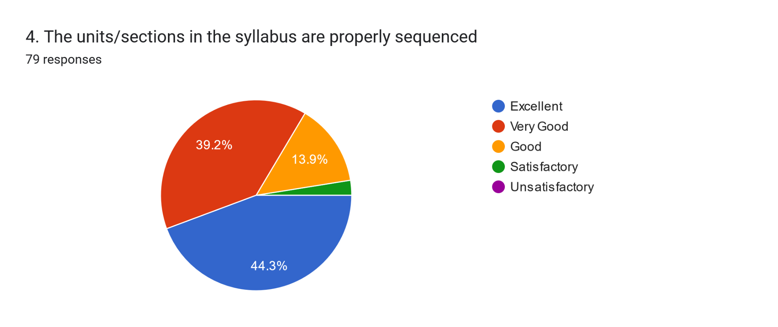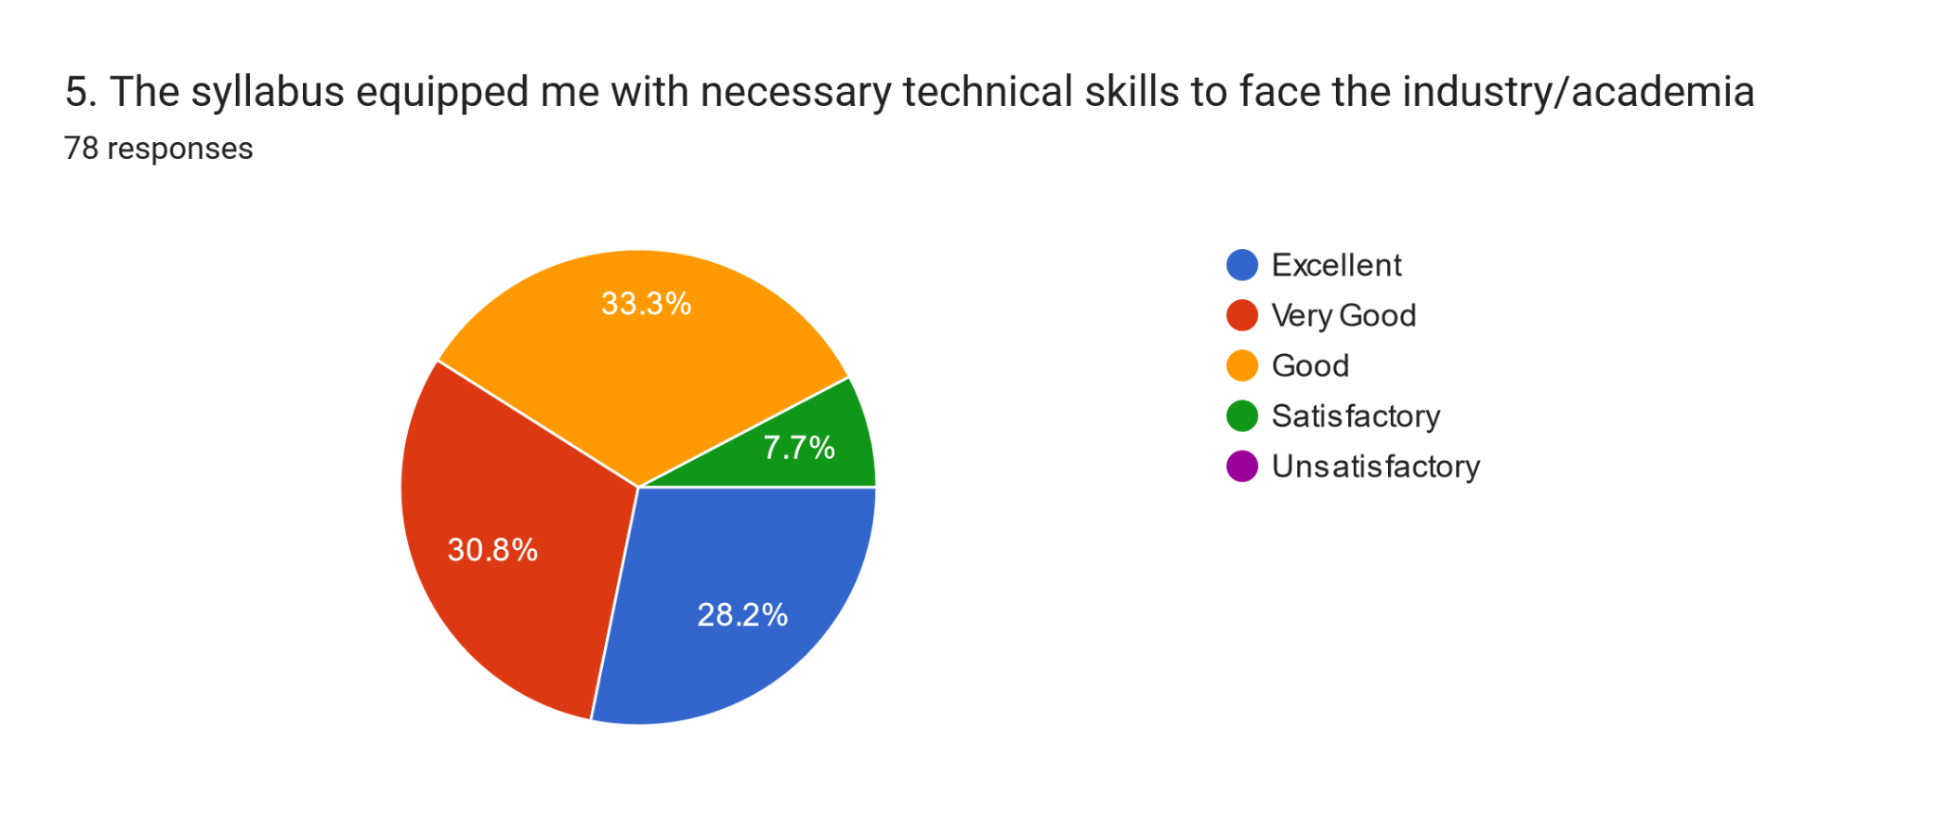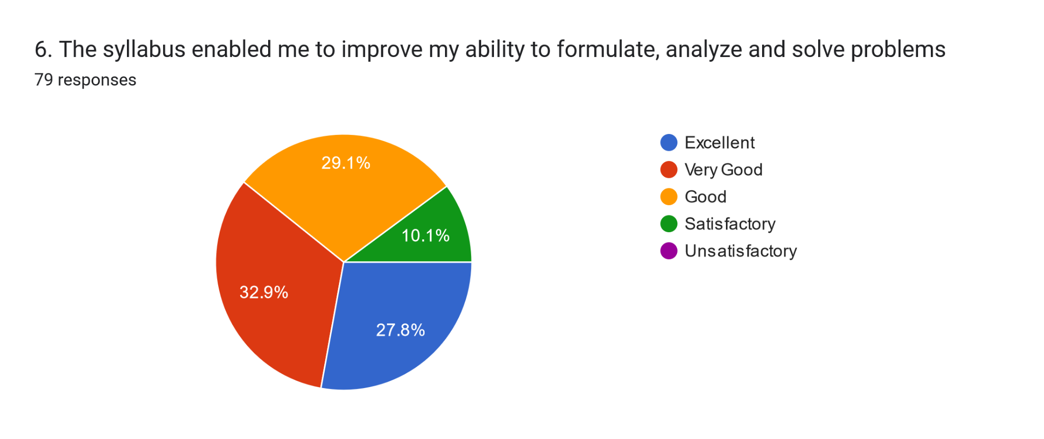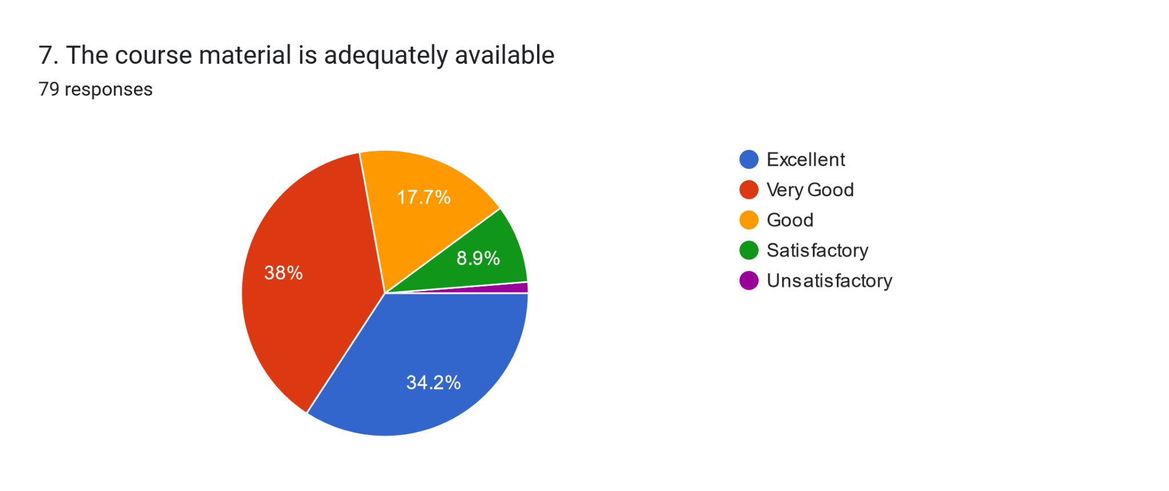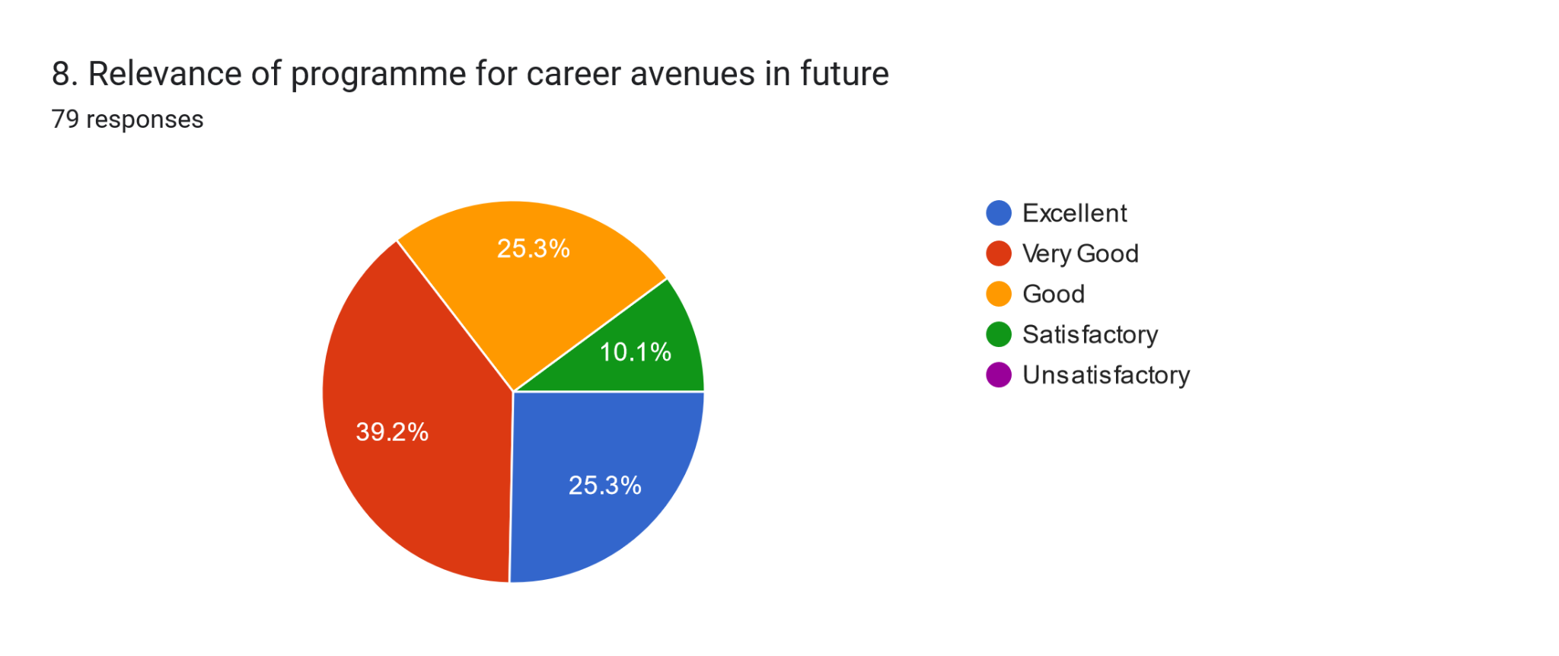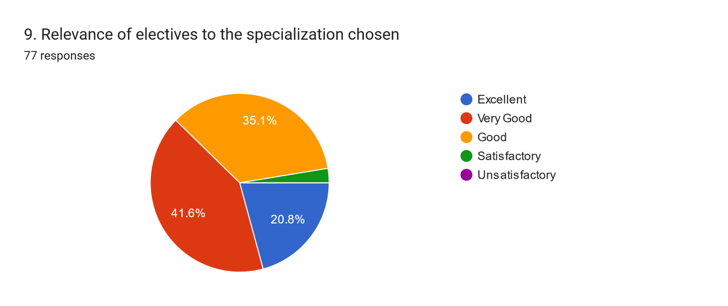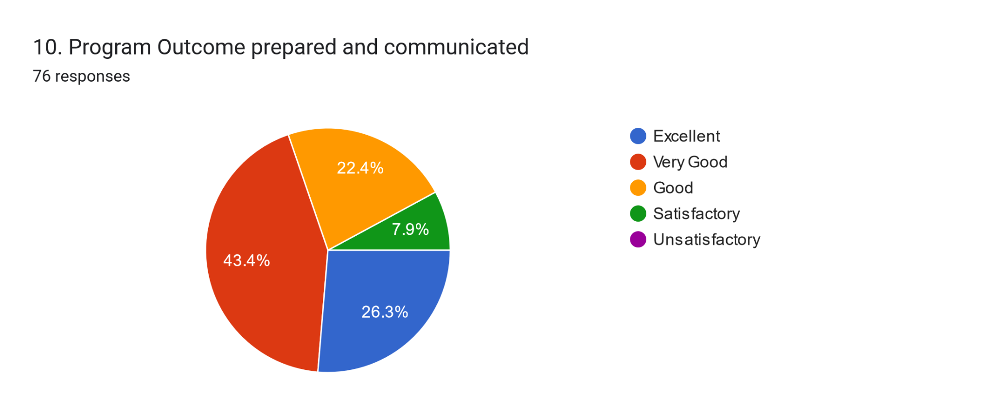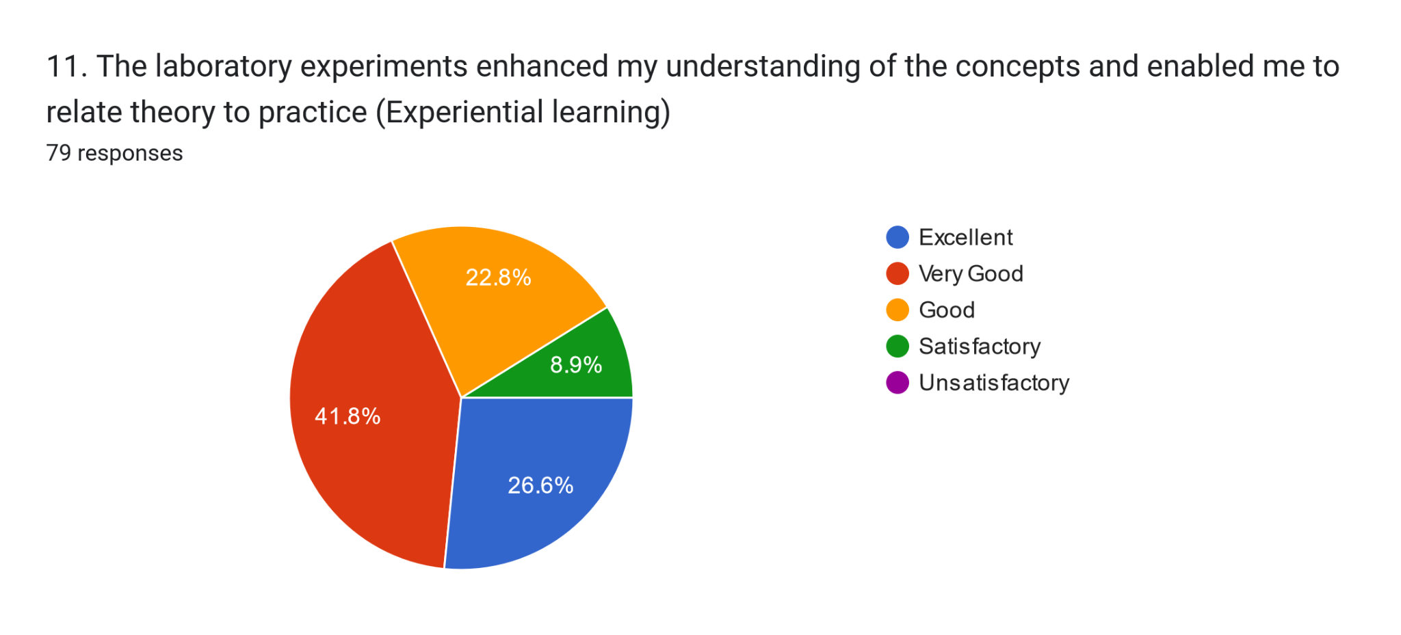
12. Suggestions/Comments, (If Any)
- No
- Faculty and department is very good.
- Good
- Couldn't learn much because of corona but in future we will try to do something more and are doing
- Excellent
- It's a pleasure to study in the SOC, thankyou for all teachers.
- It provide impressive facilities to inculcate an atmosphere conducive for high quality research and teaching pedalogy.
- Davv department very helpful for me
- The professor and faculty are very good . The teacher lesson is speak to more experienced colleagues to discuss good practice and a new teaching techniques.
- Introducing a digital library system will be useful for students to expand their innovative thoughts.
- N/A
- We Aim to become a leader of the premier institutes that provide world class research
- Department has helped us to reach a pinnacle in their carrers.

S.no | Action Points | Action Taken

