 | Spectro-Analytical Instrumentation Laboratory
location | School of Chemical Sciences, Devi Ahilya University, Takshashila Campus, Indore (M.P.)
Faculty member(s) | Dr. Ashok Kumar,Dr. A.V. Bajaj, Dr. H.P.S. Chauhan,Dr.Sheela Joshi,  Dr.Pratibha Sharma, Dr. Savita Khare
contact | - Dr.Ashok Kumar, Mobile No. 9425962688;  e-mail: drashoksharma2001@yahoo.com  - Dr.A.V. Bajaj, Mobile No.9425363818  email: dravbajaj@gmail.com  - Dr. H.P.S. Chauhan, Mobile No. 9826219748  email:hpsc@redffmail.com  - Dr. Sheela Joshi, Mobile No. 9826085169  email: spjoshi@radiffmail.com  - Dr. Pratibha Sharma, Mobile No. 9425187226  e-mail: drpratibhasharma@yahoo.com  - Dr. Savita Khare, Mobile No.9407164882  kharesavita@rediffmail.com
Keywords  (Available Instruments) | FT- IR Spectrometer, UV- Visible Spectrophotometer, Gas Chromatograph (GC),  High Performance Liquid Chromatograph (HPLC), Electrochemical System (Potentiostat), Water Distillation Assembly.
Facilities & Expertise | Our department has the facilities to synthesize, characterize and interpret the structure of compounds by various spectroanalytical techniques. FT-IR and UV-Vis. Instruments; purification, isolation and reaction monitoring through HPLC and GC; study of electrochemical redox behaviour/modified electrodes using computerised Potentiostat.
Instruments  LH Pnt | 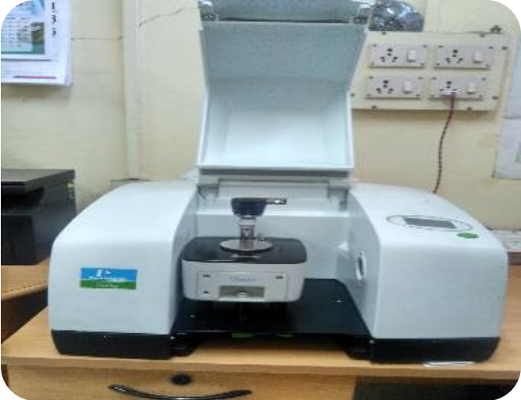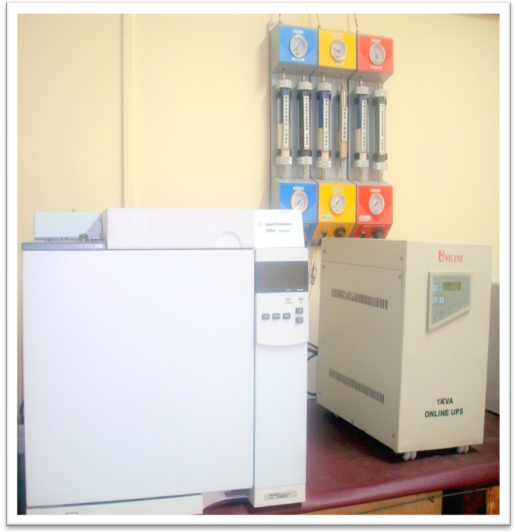
LN2 Plant
Gas Chromatograh
FT-IR Spectrometer
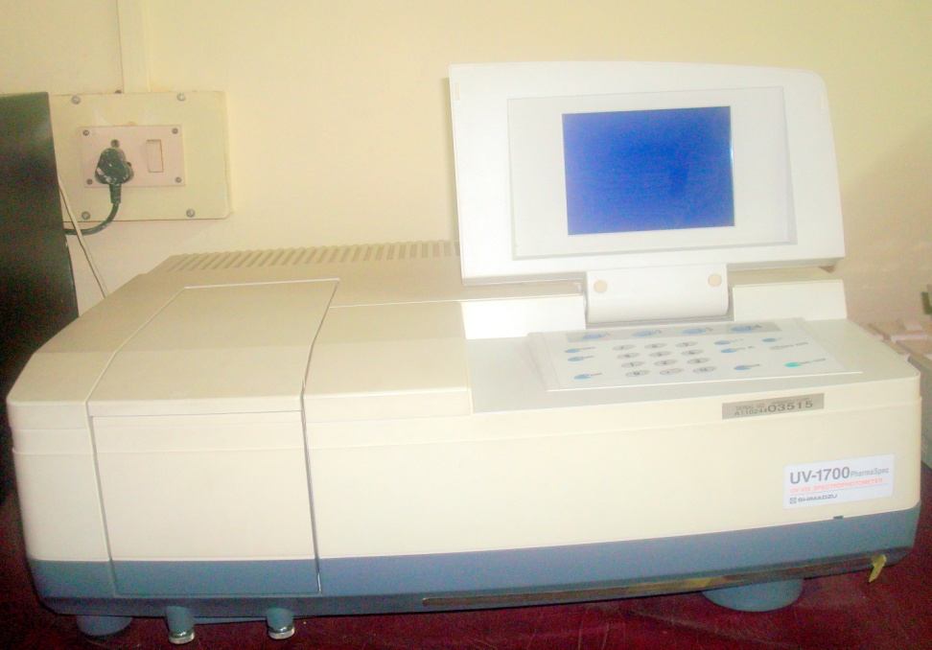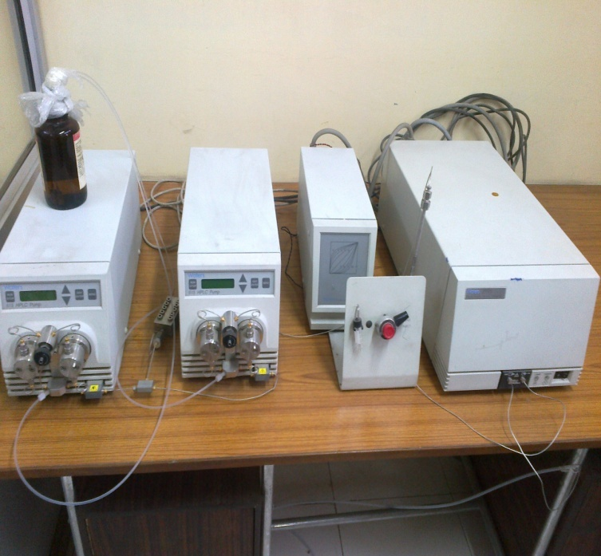
HPLC
UV-Vis Spectrophotometer

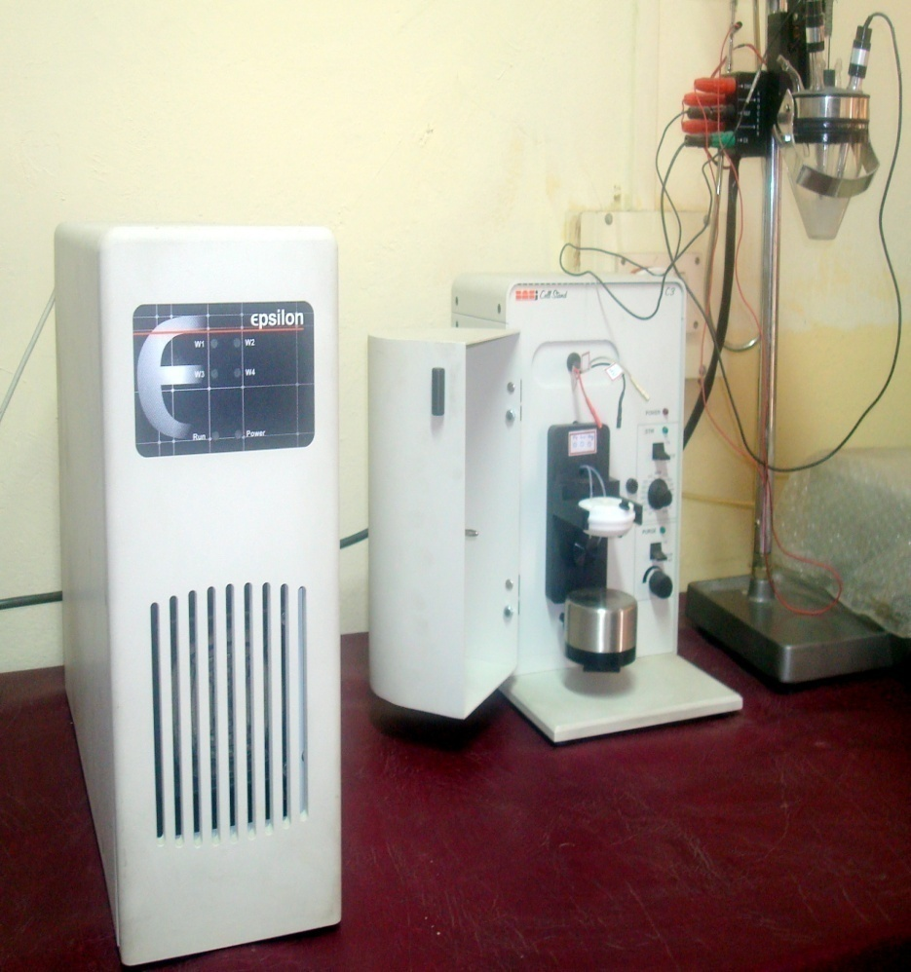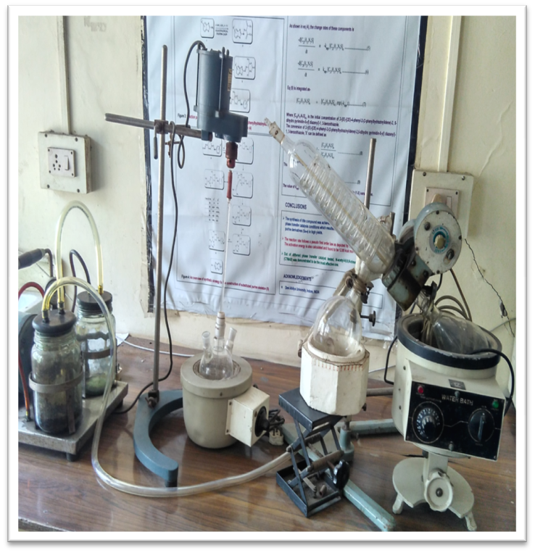
Electrochemical System
Rotatory Evaporator

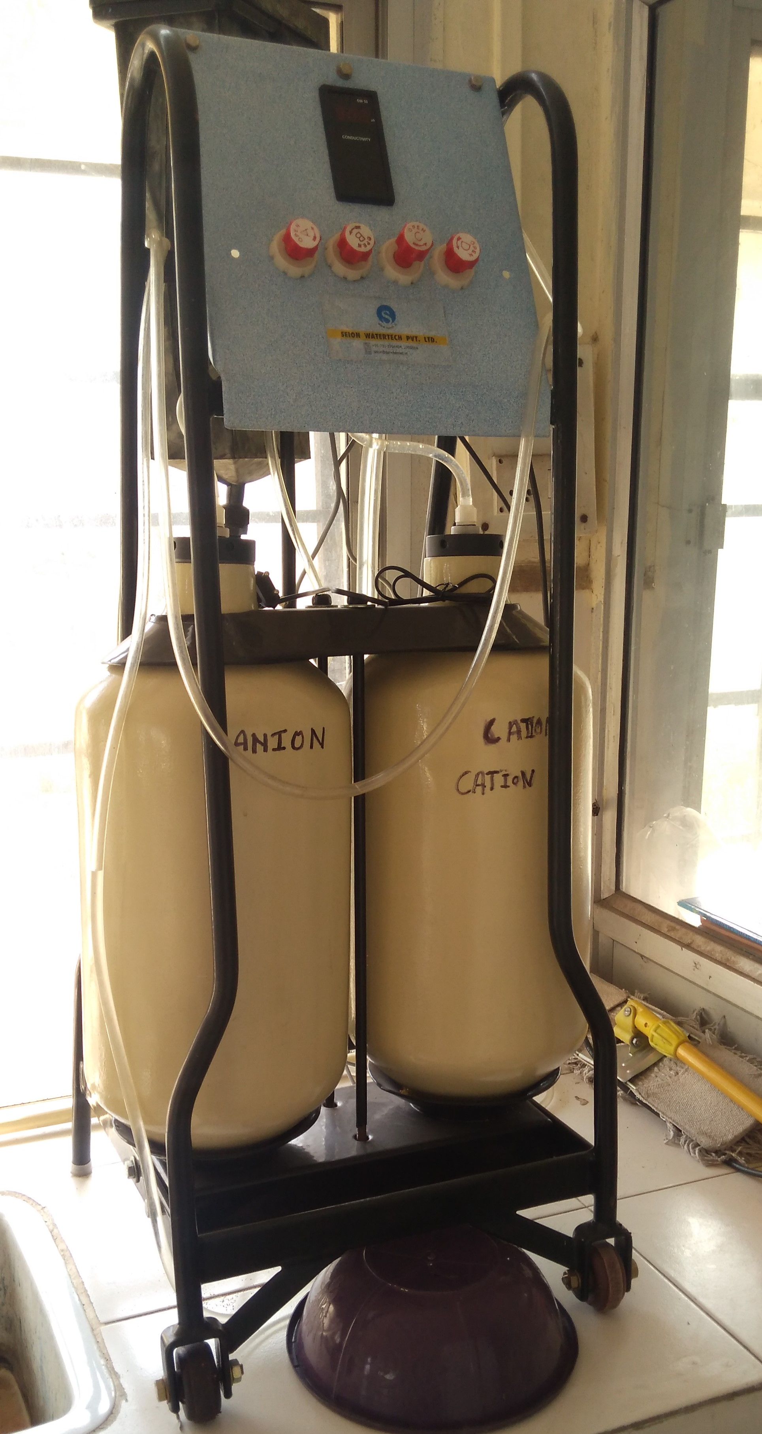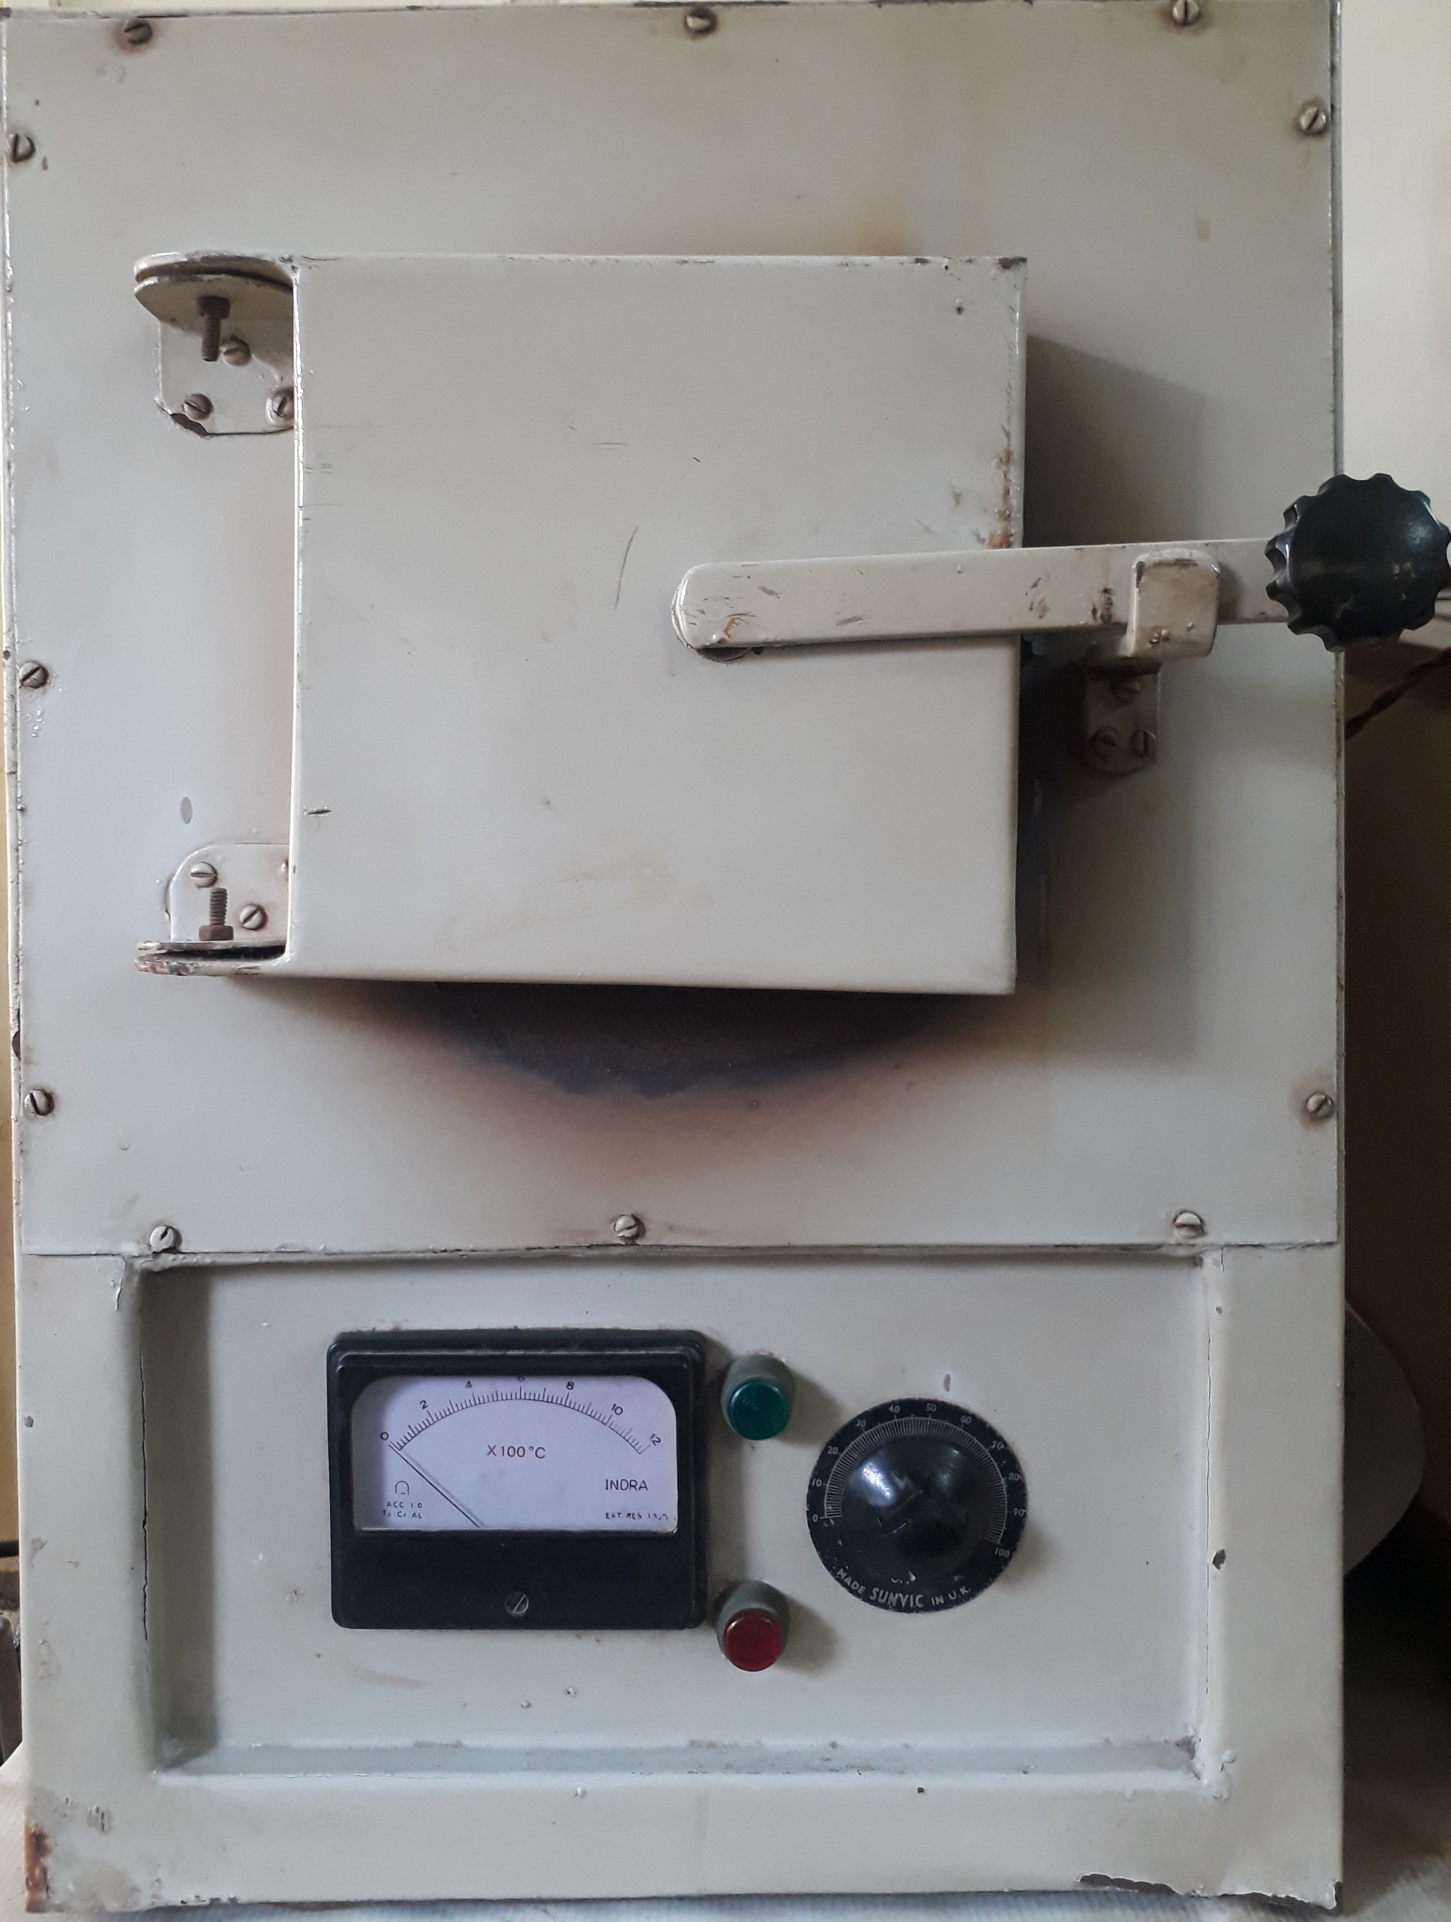
Muffle Furnace
Water Distillation Unit

