**Extension and outreach programmes conducted by the institution (**[**http://www.biotech.dauniv.ac.in/event.php**](http://www.biotech.dauniv.ac.in/event.php) **)**

1. [**Swachta Abhiyan, 02 October 2022**](http://www.biotech.dauniv.ac.in/image/Swachta_Abhiyan_02_10_22/report_2nd_Oct_2022.pdf)

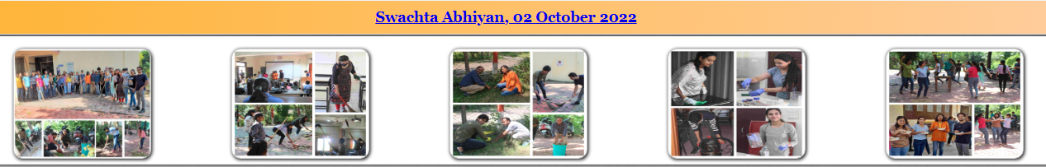

1. [**Seminar by Dr. Anjana Jajoo under the lecture series "Sashakt Naari-Sarthak Samvaad" 22 February 2021**](http://www.biotech.dauniv.ac.in/image/Sashakt%20naari%2022%20Feb%202021/report%2022-2-2021.pdf)

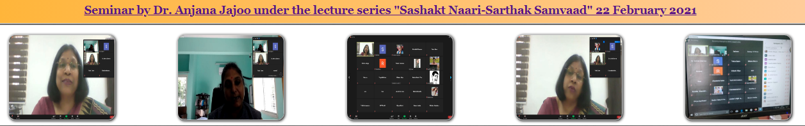

1. **"Covid Testing" 03 February 2021**

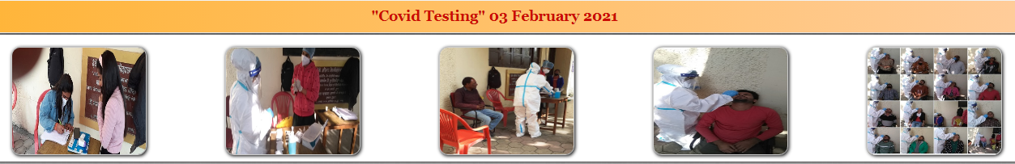

1. [**Webinar on "Awareness on Cyber Crime against Women" 25 January 2021**](http://www.biotech.dauniv.ac.in/image/awareness%20on%20cyber%20crime/report%2025-1-2021.pdf)

