SCHOOL OF SOCIAL SCIENCES
ACTIVITIES
July 2021- December 2022

Deekshaarambh
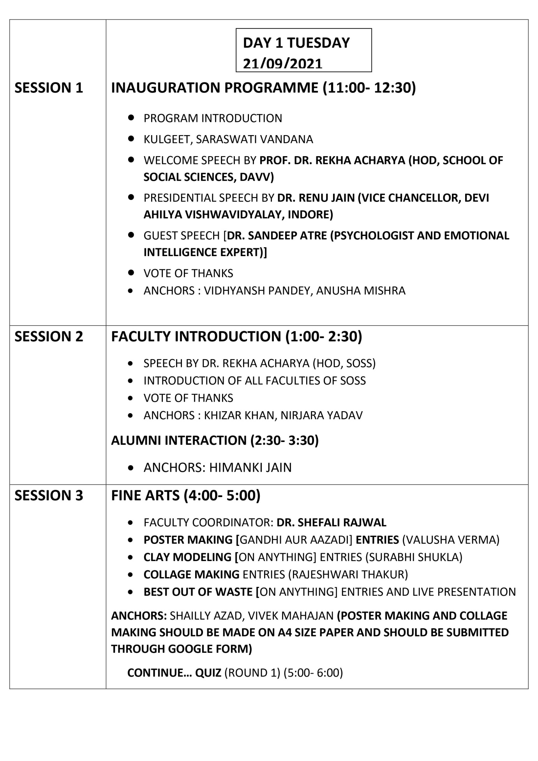

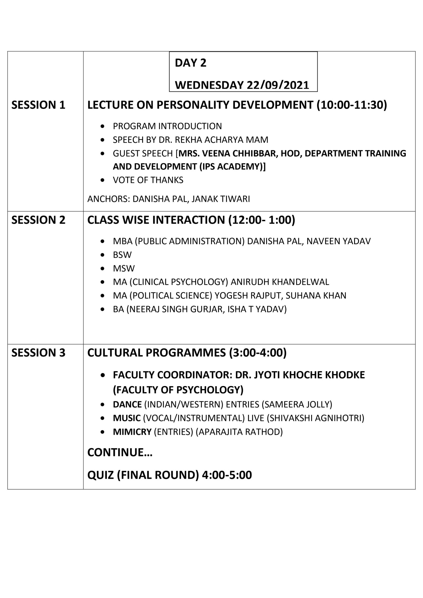

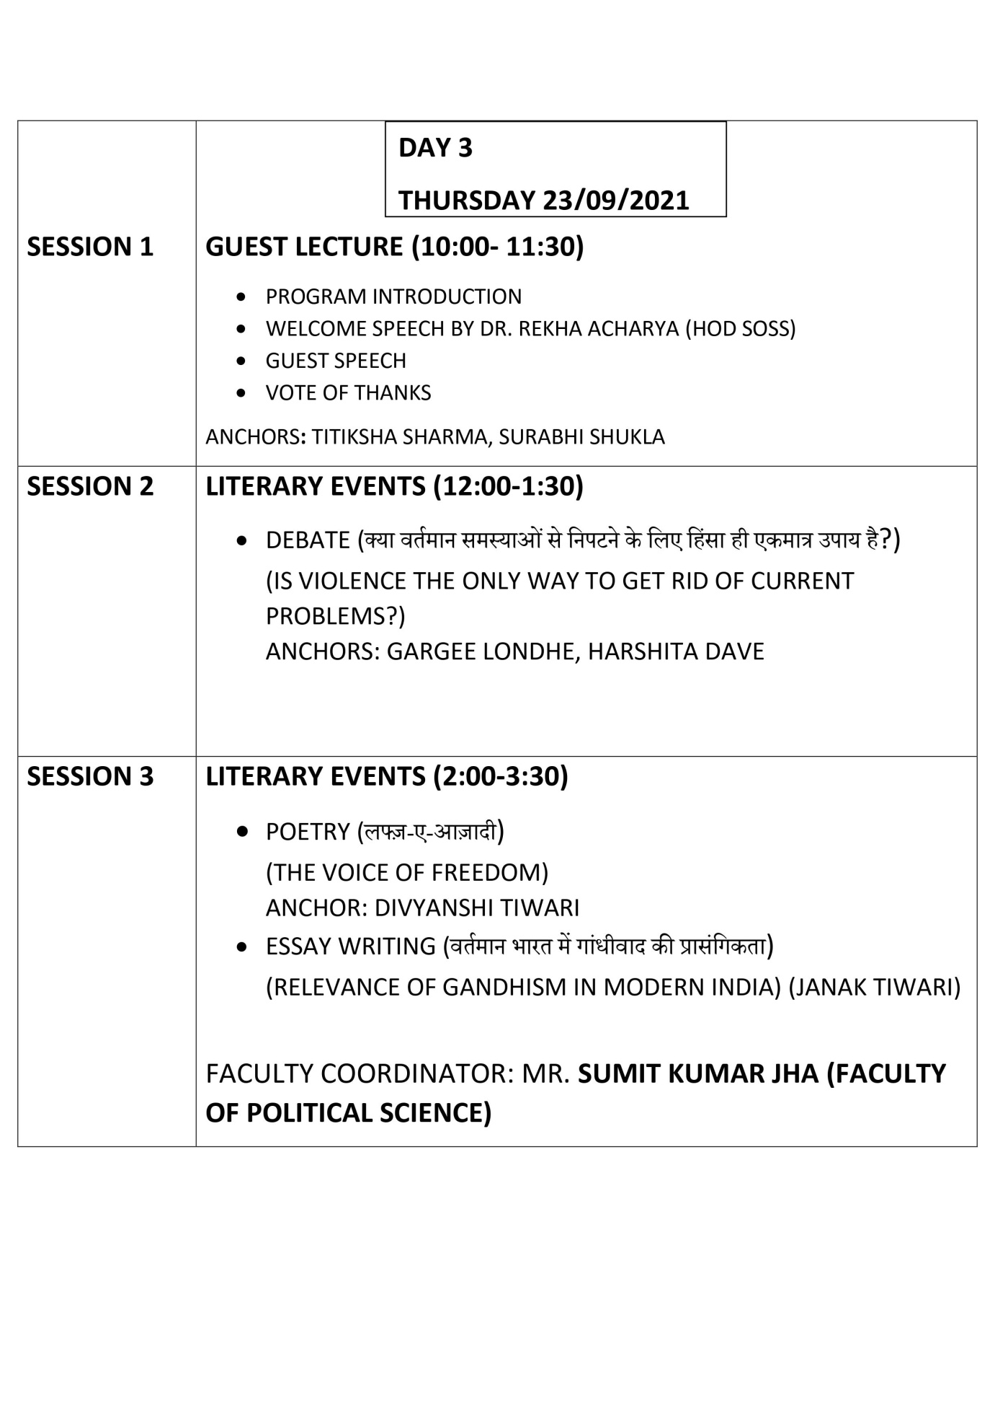

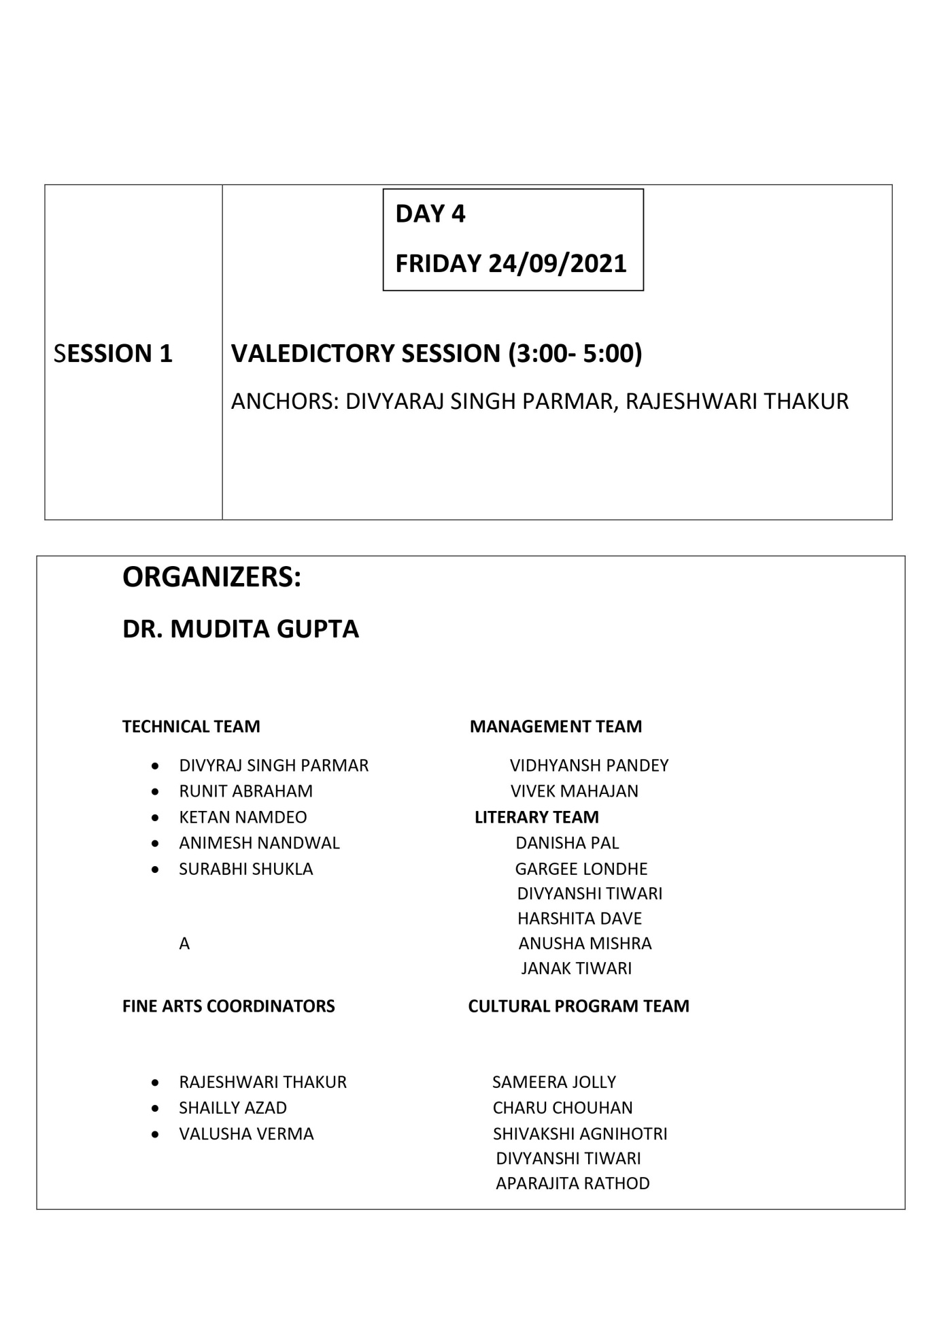

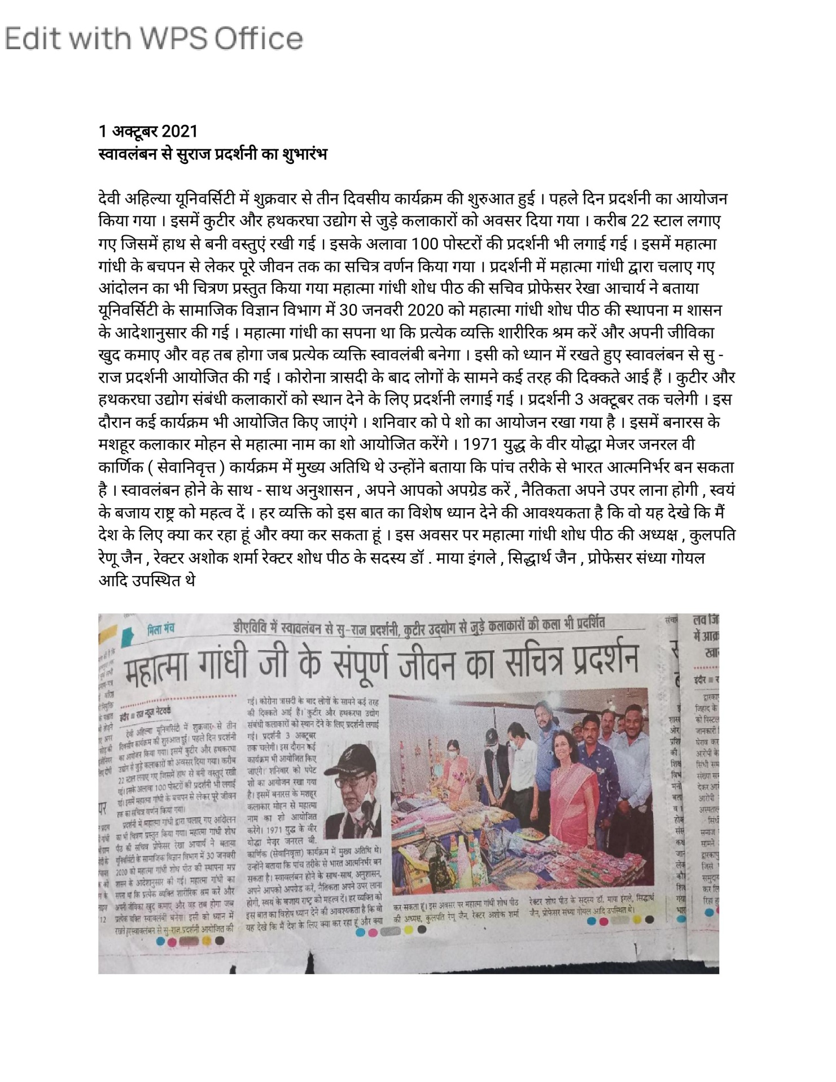

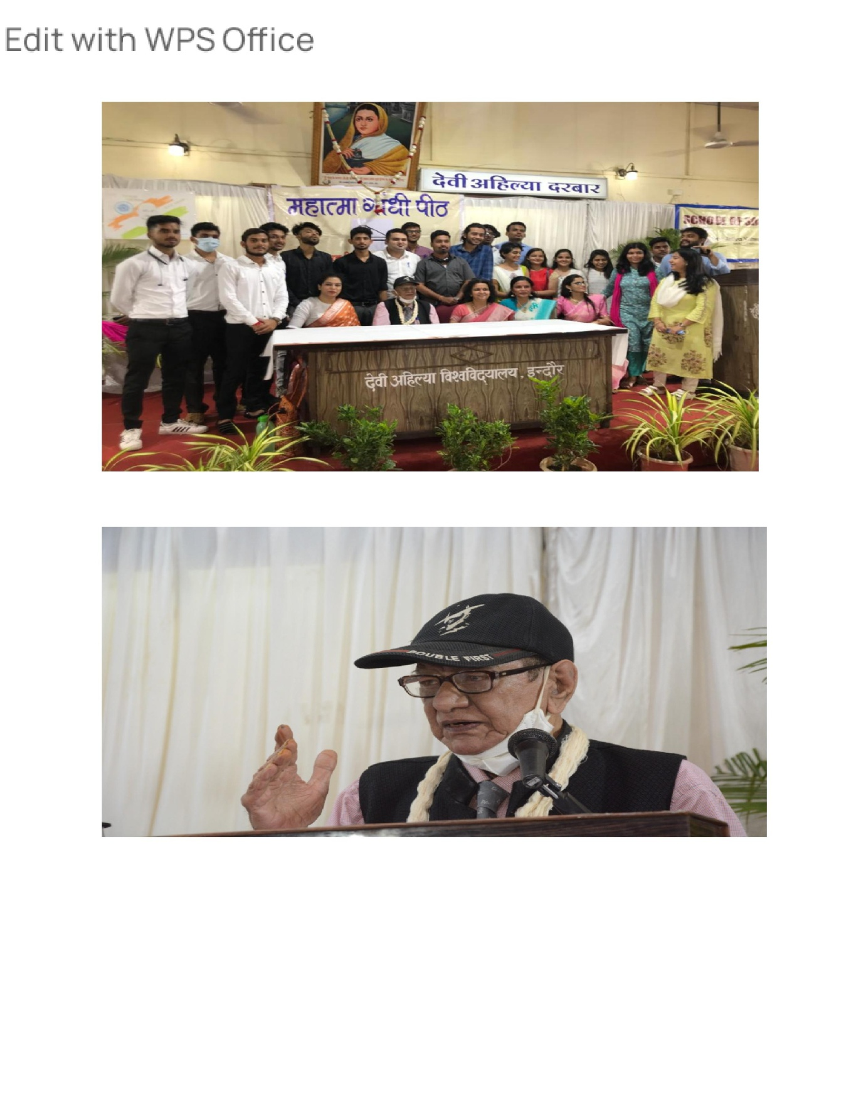
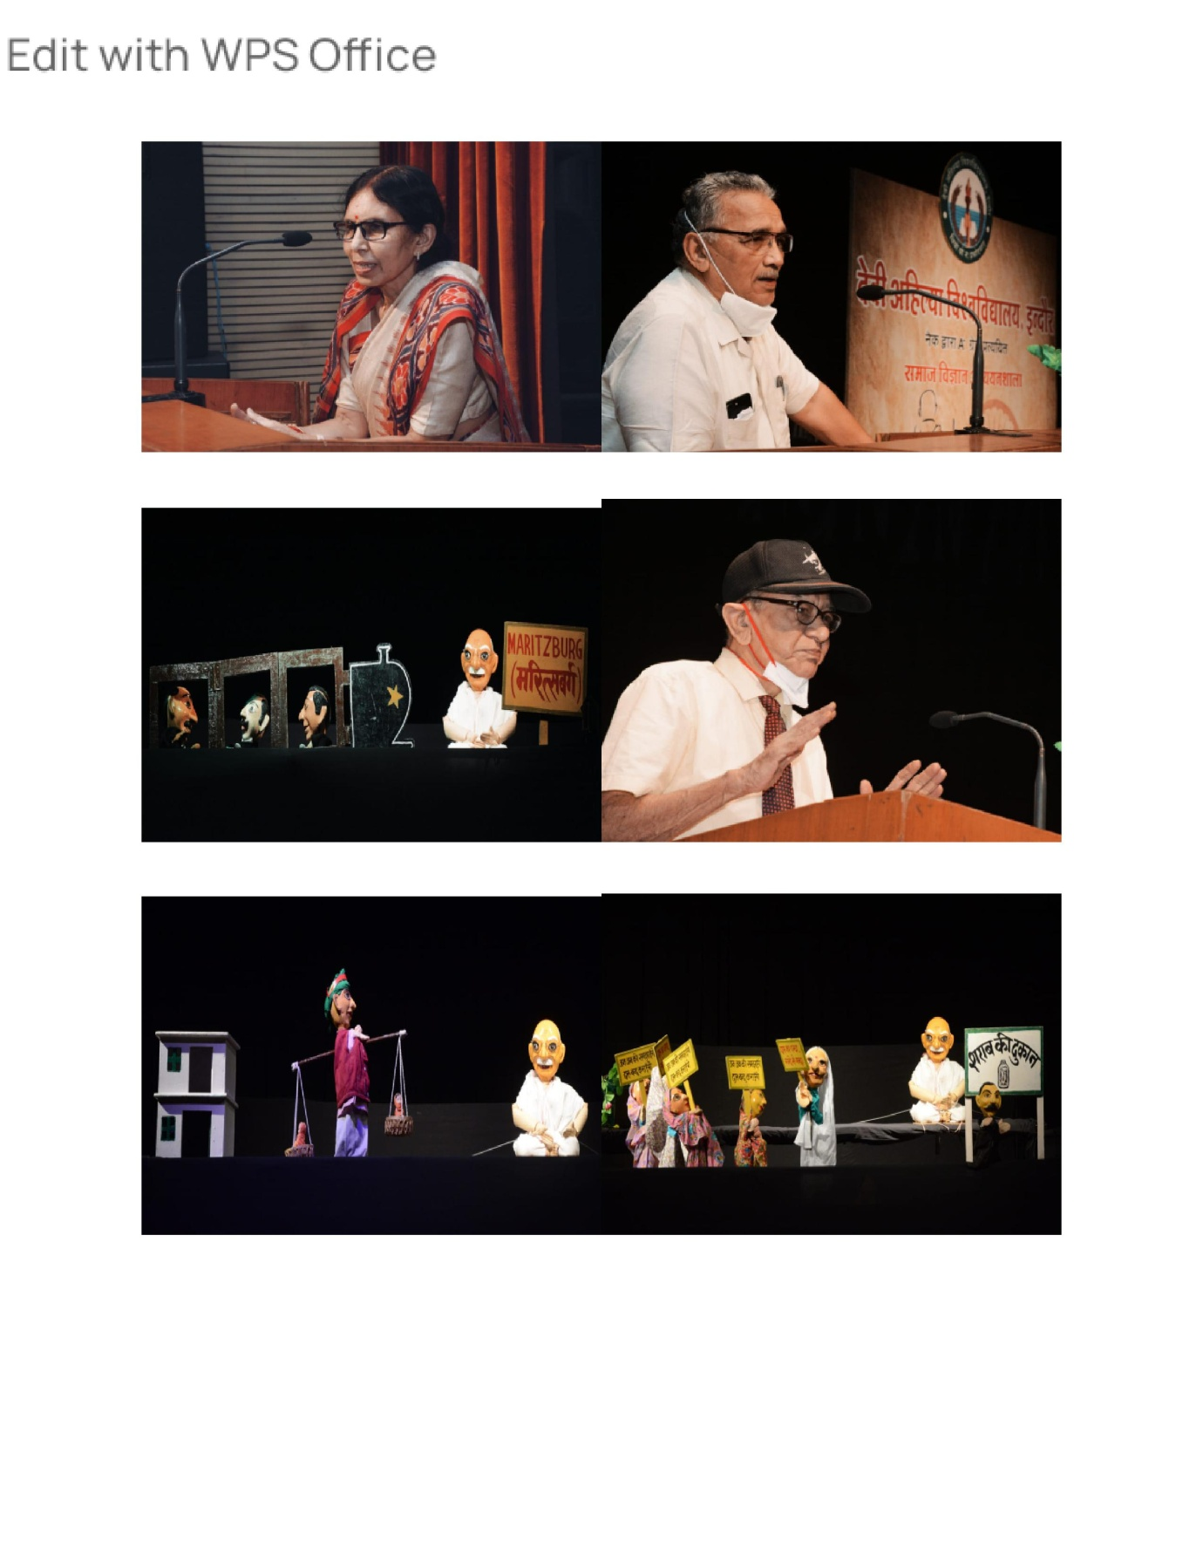
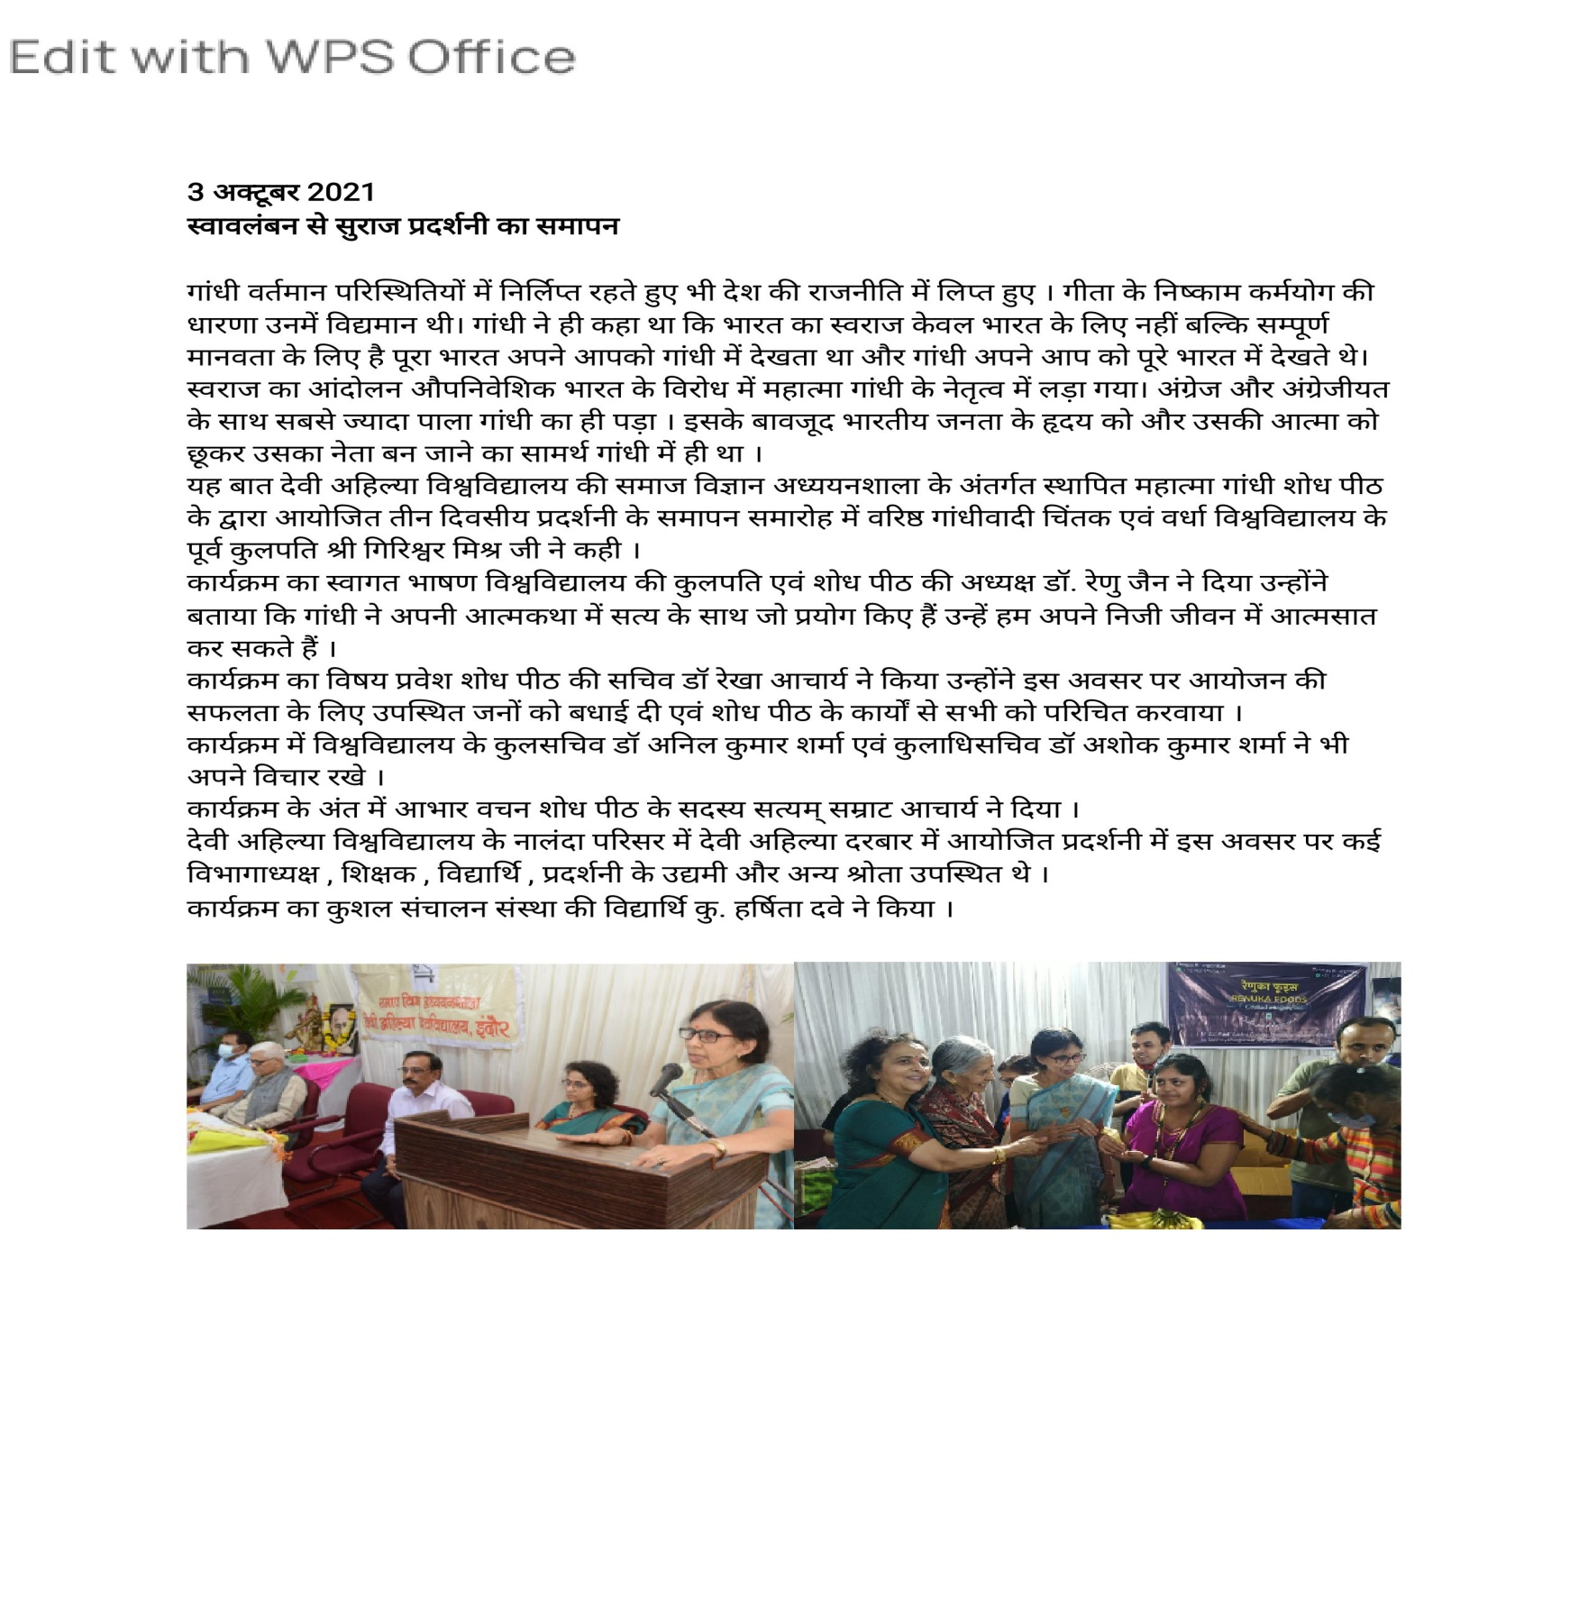

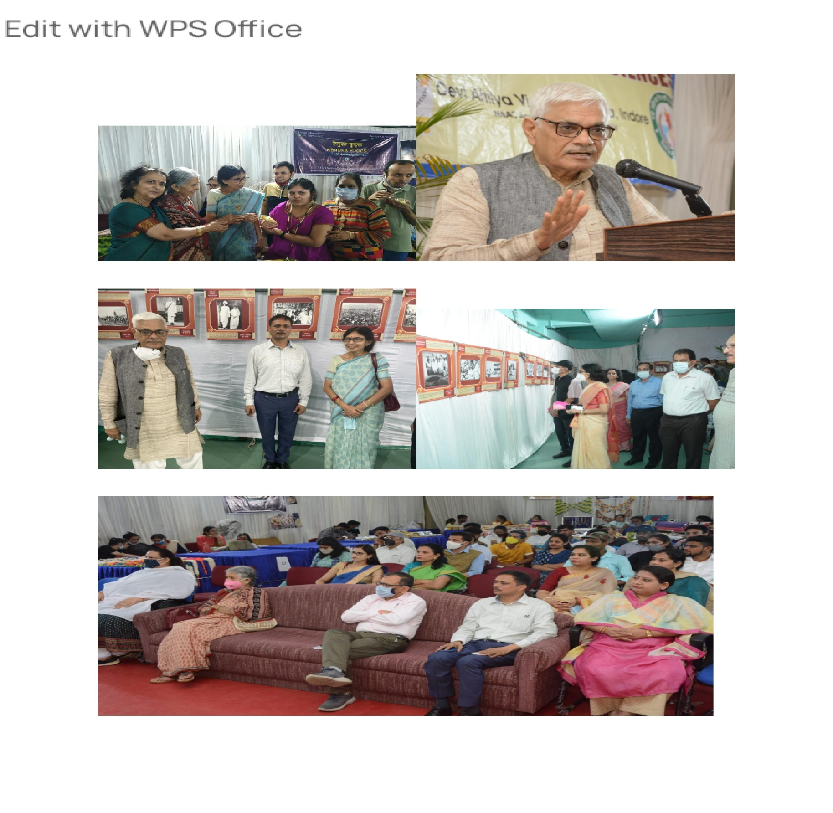
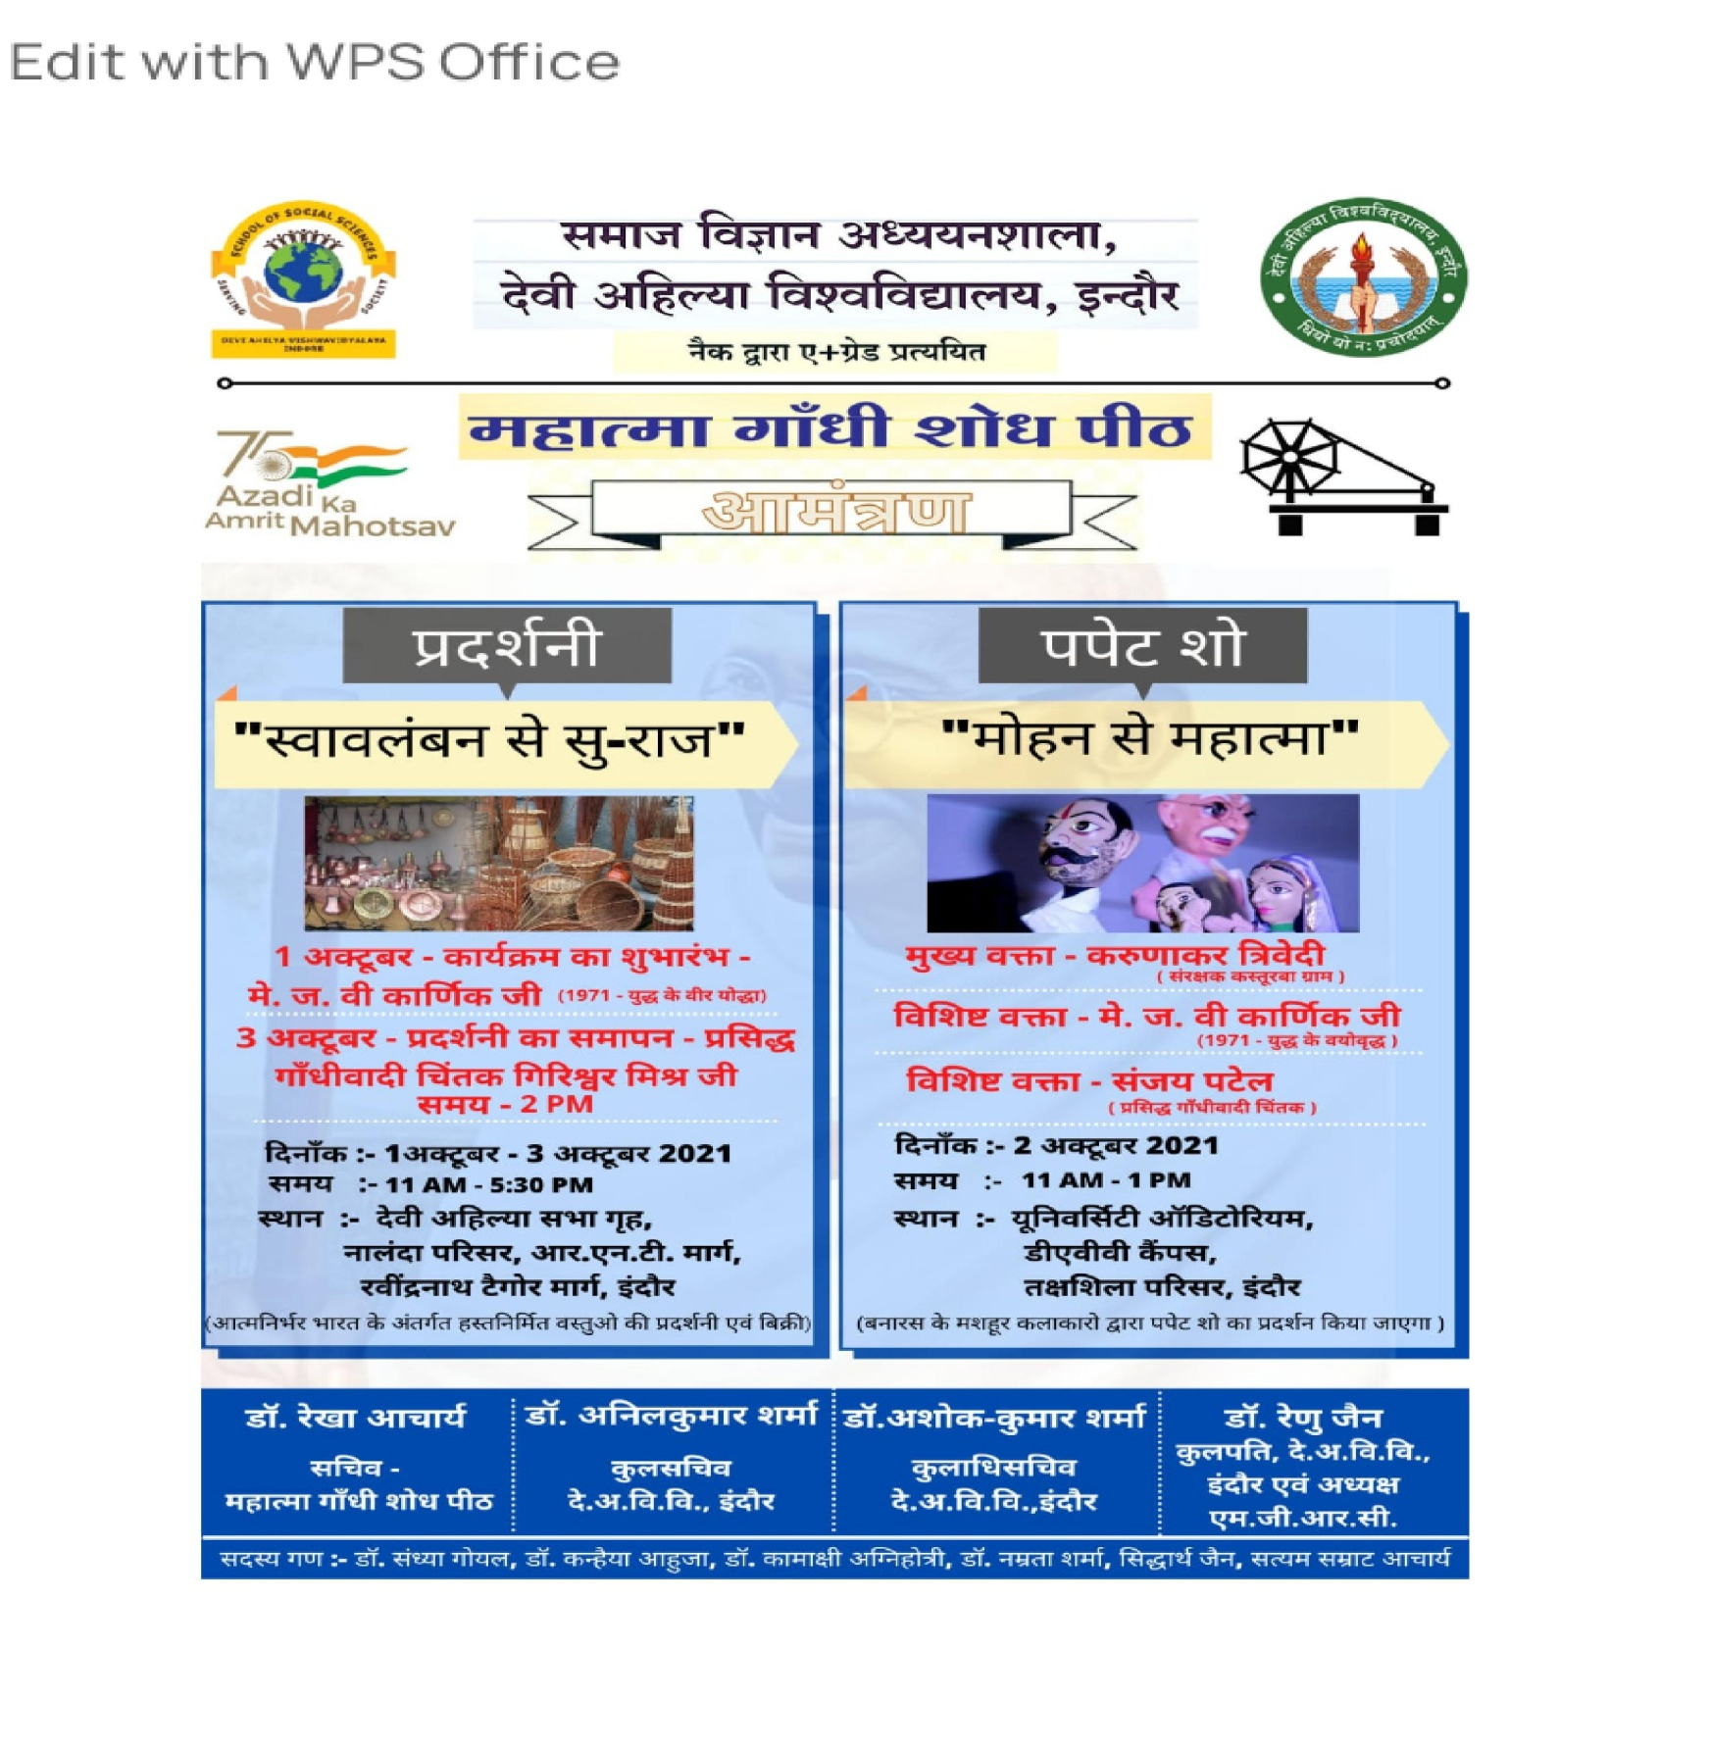
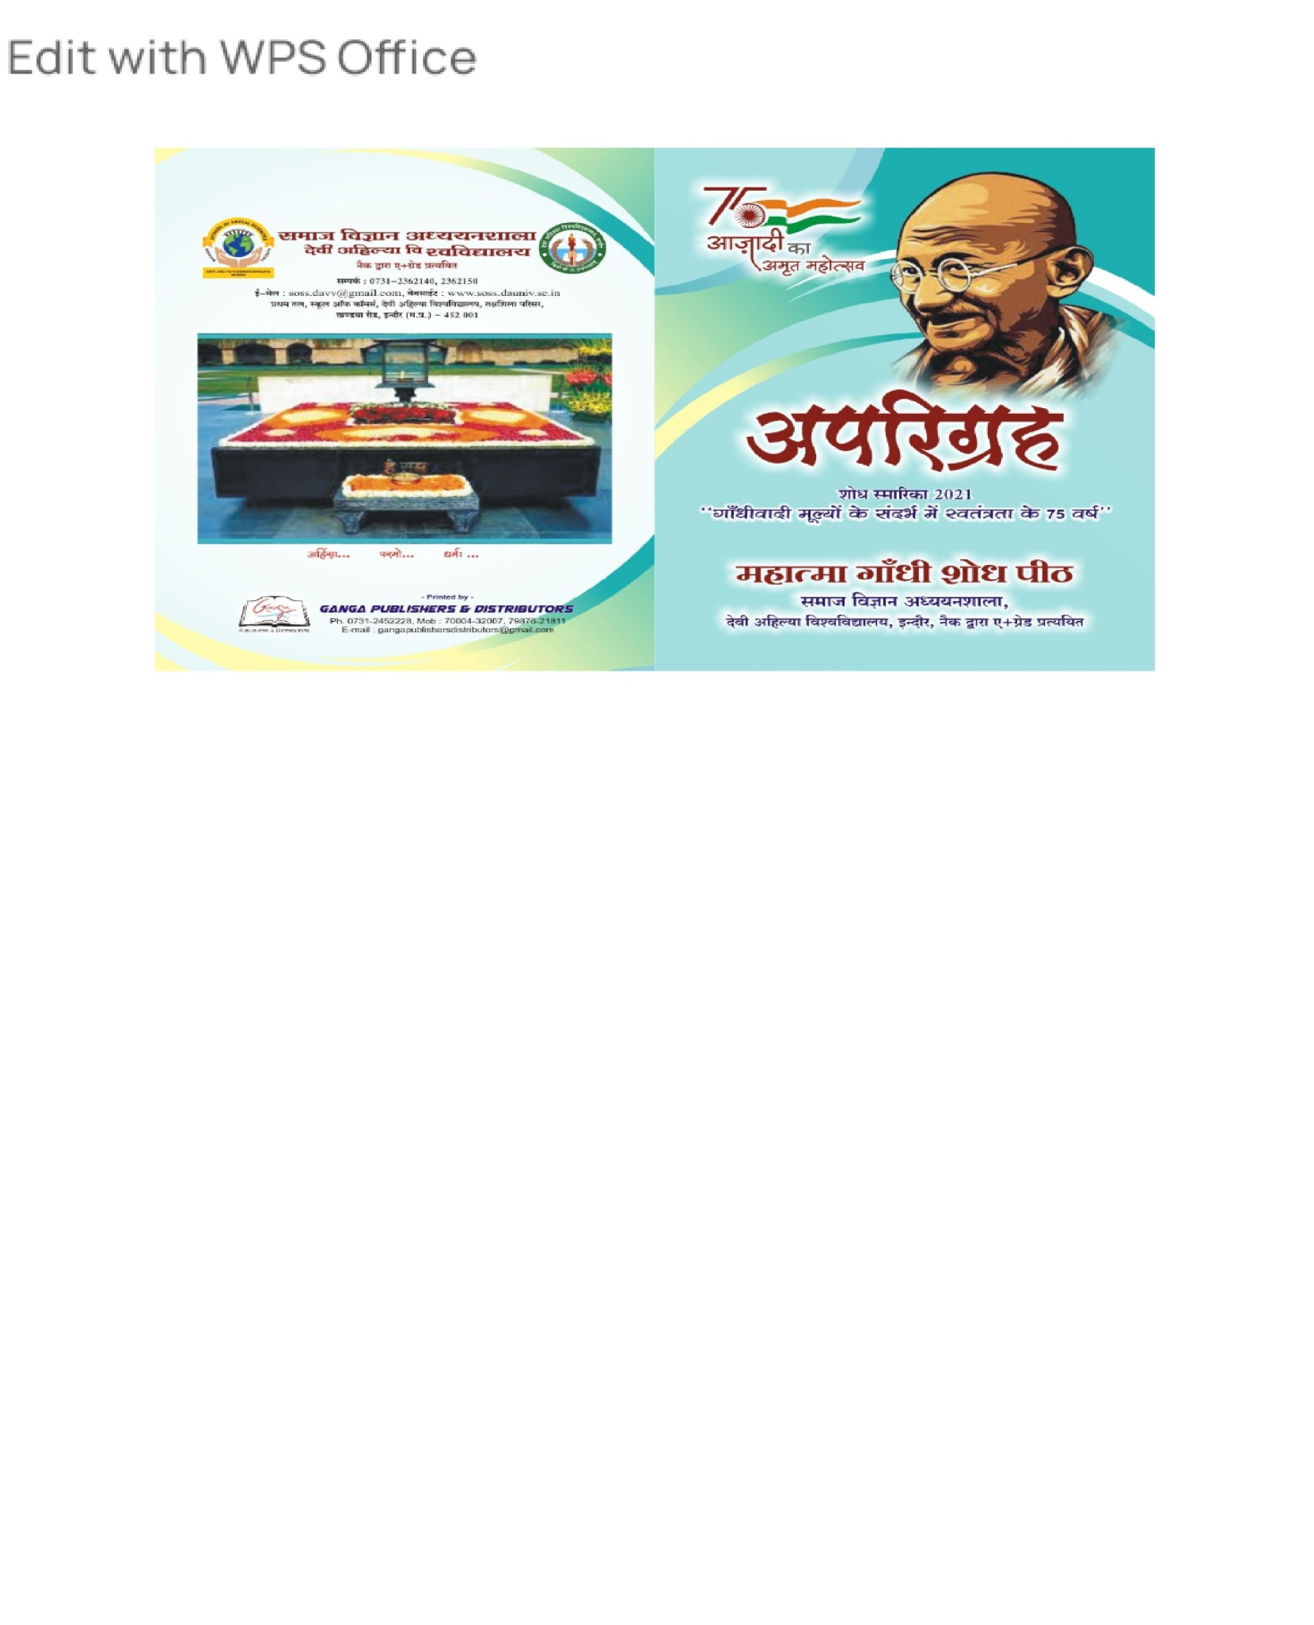
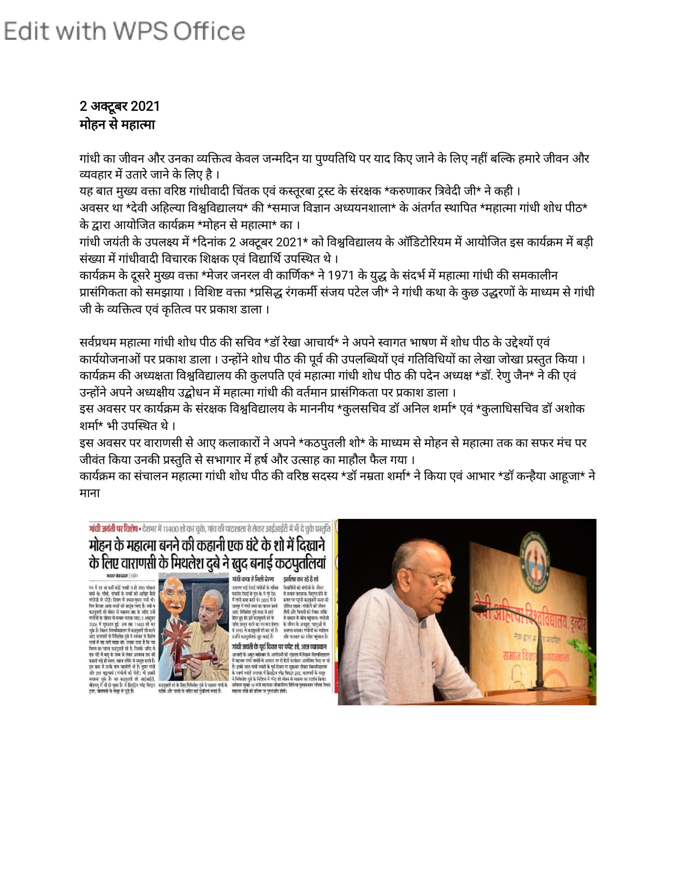
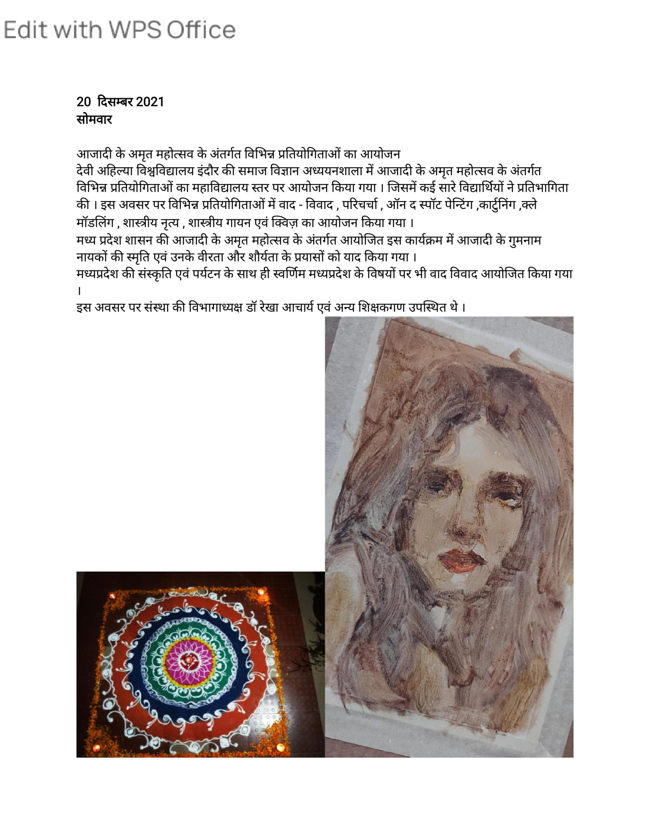
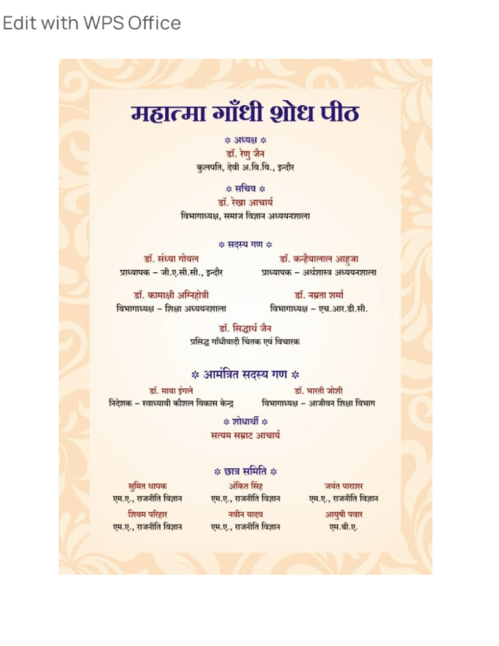

Students of SOSS performed Nukkad Natak at Navlakha bus stand under Safe City Program.
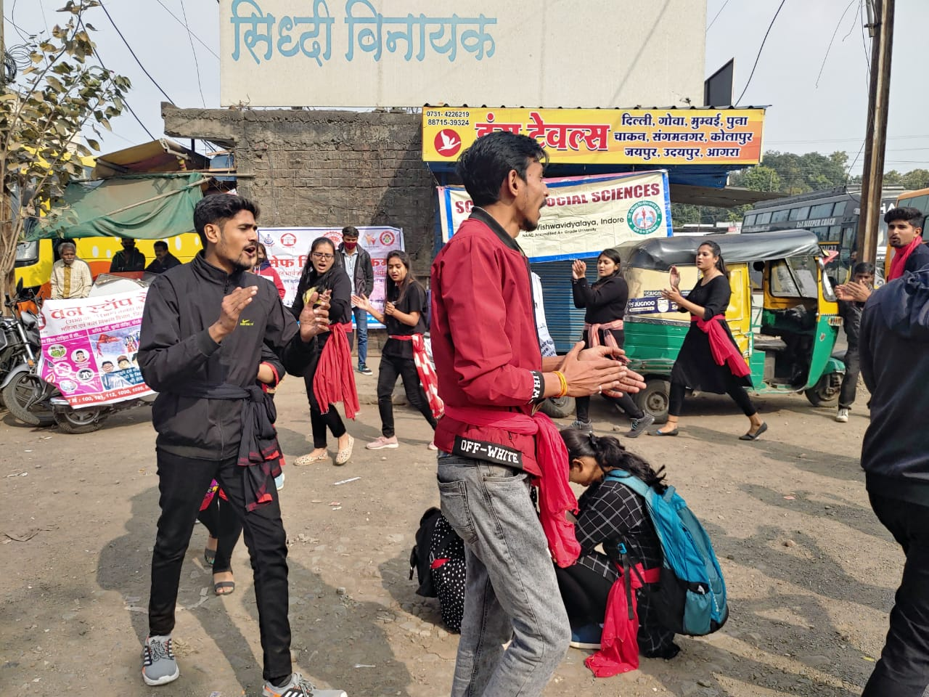

Organisational group Visit at Jan Shikshan Santhan, Indore
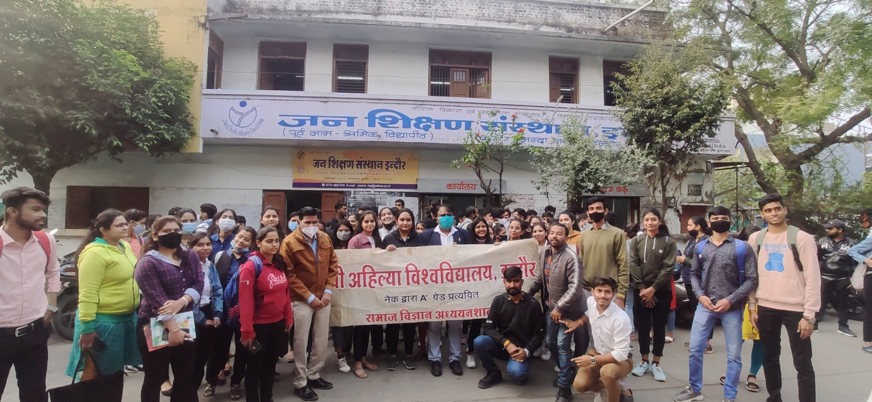

स्वर्णिम क्षण, स्वर्णिम दिवस, स्वर्णिम विजय वर्ष*

अत्यंत हर्ष के साथ सूचित किया जा रहा है कि भारत-पाक युध्द 1971 मे विजय प्राप्ति के उपलक्ष मे सम्पूर्ण देश *स्वर्णिम विजय दिवस* मना रहा है। इस अवसर पर देश की चारों दिशाओं में *विजय मशाल* का विभिन्न शहरों-गावों में भारत के तत्कालीन वीर योध्दाओ तथा वीरगति प्राप्त शहीदो को श्रद्धांजलि अर्पित करने हेतु आगमन हो रहा है।

हम सभी देवी अहिल्या विश्वविद्यालय, इंदौर के साथी अत्यंत सौभाग्यशाली है कि *दिनांक 28 सितम्बर 2021 को प्रात: 11 बजे* यह *विजय मशाल* वि. वि. के खंडवा रोड स्थित तक्षशिला परिसर मे पदार्पण करने जा रही है। मुख्य कार्यक्रम विश्व विद्यालय सभागार में आयोजित होने जा रहा है।

इस अवसर पर आप सभी से अनुरोध करते है कि *विजय मशाल* को सम्मान देने हेतु कृपया दिनांक 28 सितंबर को सुबह 10.30 बजे अपनी उपस्थिति सुनिश्चित करें।

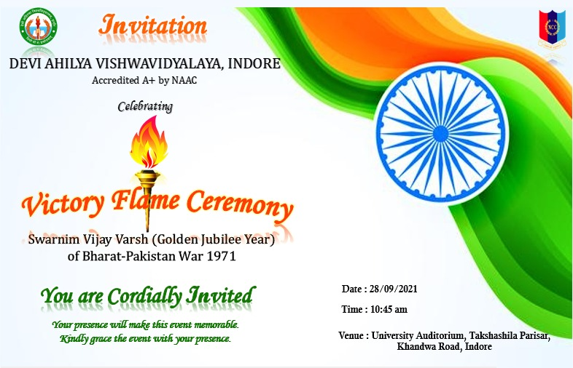

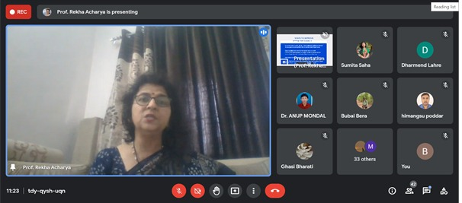
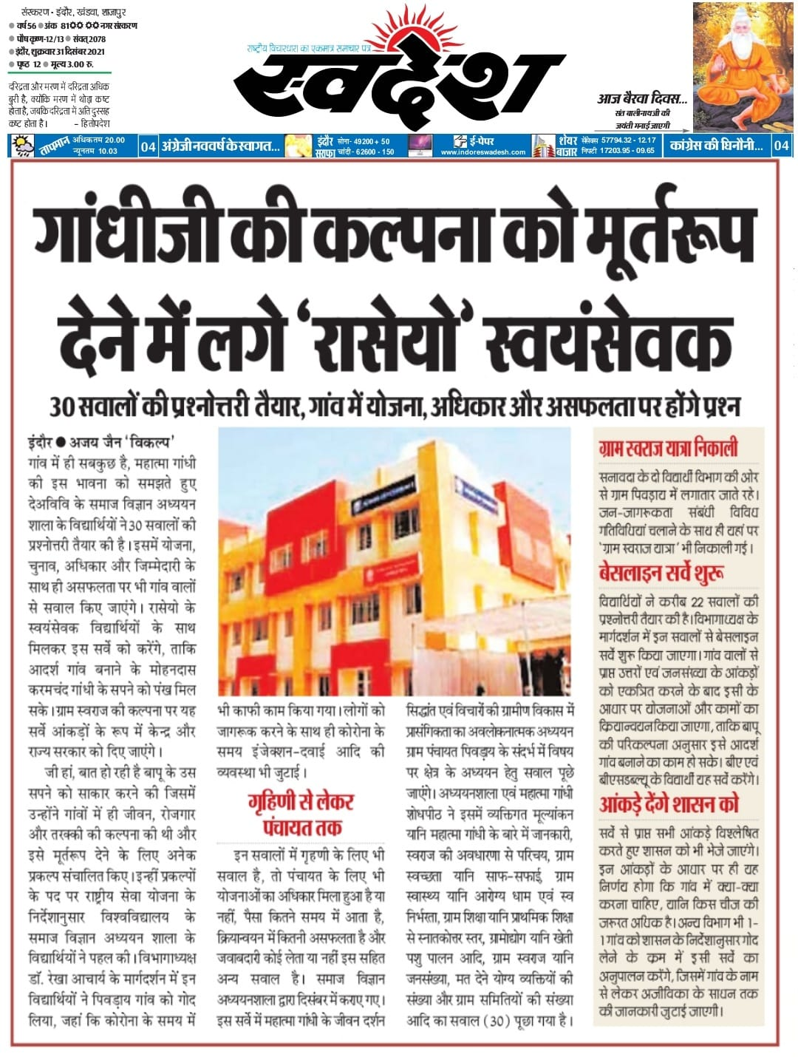
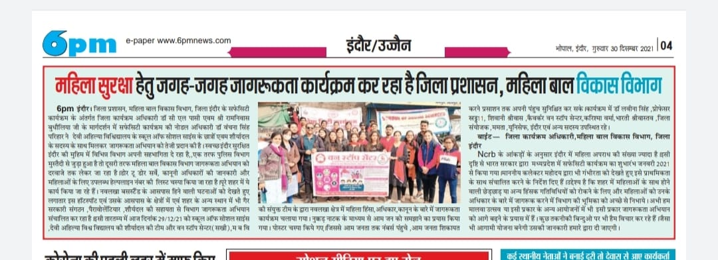

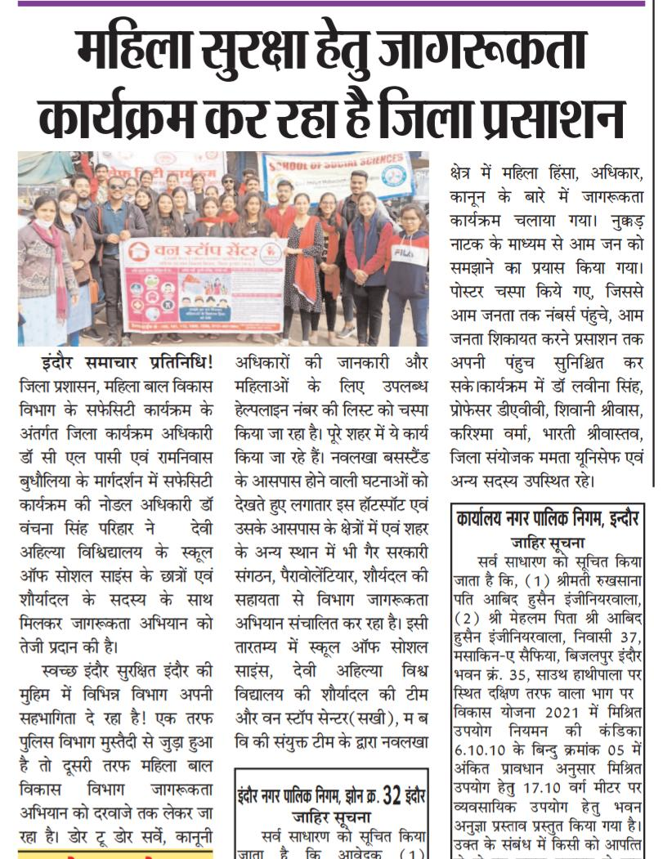

Organisational Group visit to Yug Purush Dham.
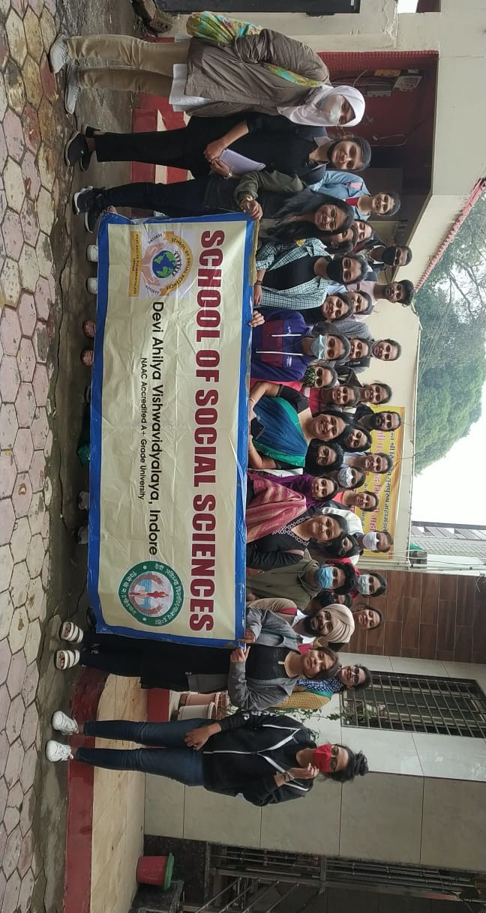
Emotional Intelligence For Life Management Skills

Emotional intelligence for life management skill workshop held on 10 Dec 2021 by Dr. Nidhi
Deouskar madam. In which she explained about Emotional Intelligence.
She explained emotional Intelligence as one&#39;s ability to recognize and understand emotion in yourself and others and your ability to use this awareness to manage your behavior and relationship. Than she also explained self-awareness as if you&#39;re self-aware, you can see your own patterns of behaviour and motives. You know how your emotions and actions impact those around you, for better or for worse. How to develop self-awareness? Turning into your sense. Getting in touch with you feeling and know your goal. She also gave example of &#39;Karoly Takocs&#39; Hungarian athlete who twice won Olympic gold medals in rapid-fire pistol shooting despite having his shooting hand aimed by a hand grenade. Later she explained empathy and she also did Emotional Intelligent test to check audience self-awareness, self-management, social awareness and Relationship
Management. With this Emotional Intelligent test she ended this workshop with gratitude.
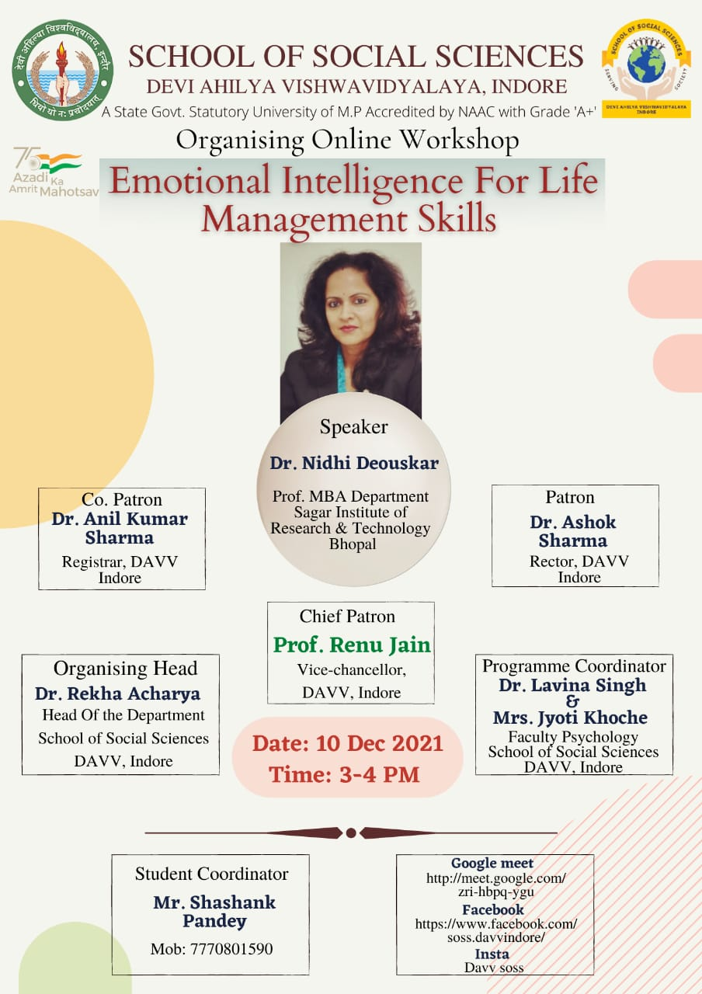
S.No. | Visits | Date | Student Present
1 | YogPurush Dham
2 | Happy Home | 10 Dec 2021 | 15
3 | Govt. Girls Higher Secondary School, Rajendra Nagar | 20 Dec 2021 | 4
4 | Govt. Higher Secondary School, Kila Maidan | 21 Dec 2021 | 5
5 | Govt. Higher Secondary School, Bajrang Nagar | 23 Dec 2021 | 4
6 | Shahkiya Subhash Higher Secondary School, Bada Ganpati | 24 Dec 2021 | 6
7 | Shri YogPurush Dham Baudhik Vikas School | 28 Dec 2021
8 | Govt. Higher Secondary School, Ahilyashram | 10 Dec 2021 | 5

