|  |
| --- |
| IET SPORTS CLUB 2022  2022 |
|  |
| DATE :- 7 & 8 April |

ISC is one of the most awaited sports event of iet davv organised by Iet Sports CLub . Isc is interbranch sportsmeet. this year it was held on 7th and 8th of april 2022. sports iNcluded for this session were cricket , volleyball , basketball , table-tennis , carrom and chess. STUDENTS OF ALL BRANCHES MAKE TEAMS AMONG THEM WHICH INCLUDES STUDENTS OF 1ST TO 4TH YEAR INCLUDING A GIRL. BRANCH WITH MAXIMUM WIN IN DIFFERENT SPORTS IS CONSIDERED AS OVERALL WINNER. FOR THIS YEAR 2022 , CS-A IS OVERALL WINNER.

Objectives of ISC include development of:

* Physical fitness and skills
* Mental alertness
* Ethical qualities
* Constructive social abilities
* Emotional maturity

All objectives and principles in extra-curricular activities must be primarily concerned with the welfare and educational development of the student participant. The principles, which are to be achieved from the Interscholastic Program, are to provide students with the opportunity to:

* Develop physical talents to their maximum potential.
* Engage in competitive activities, while promoting sound health, safety, and physical fitness.
* Exemplify good conduct as a means for learning good citizenship.
* Learn to appropriately experience both success and failure in an educational environment.
* Learn from experience that consequences follow the violation of a rule.

INDOOR SPORTS :-

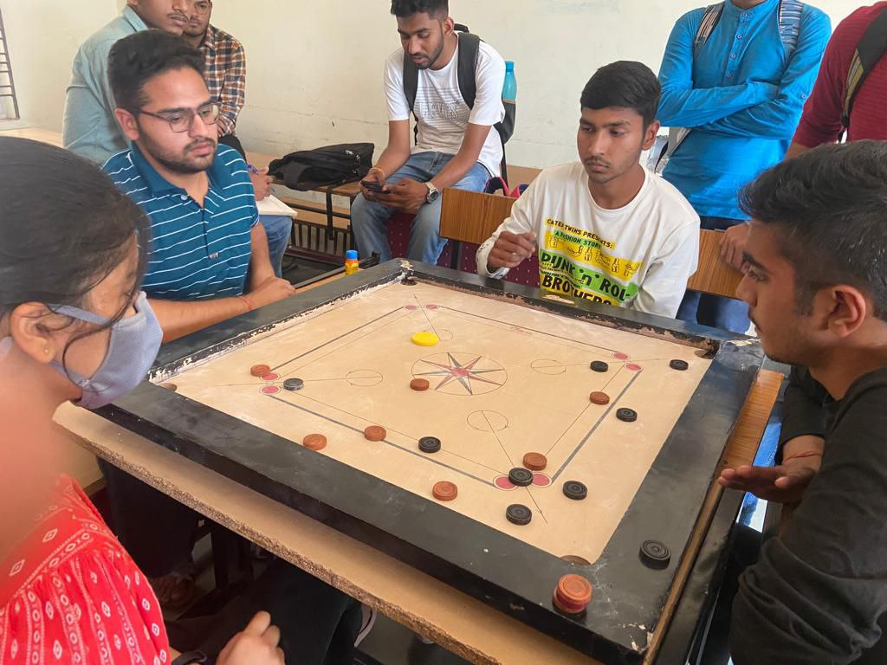

OUTDOOR SPORTS :-

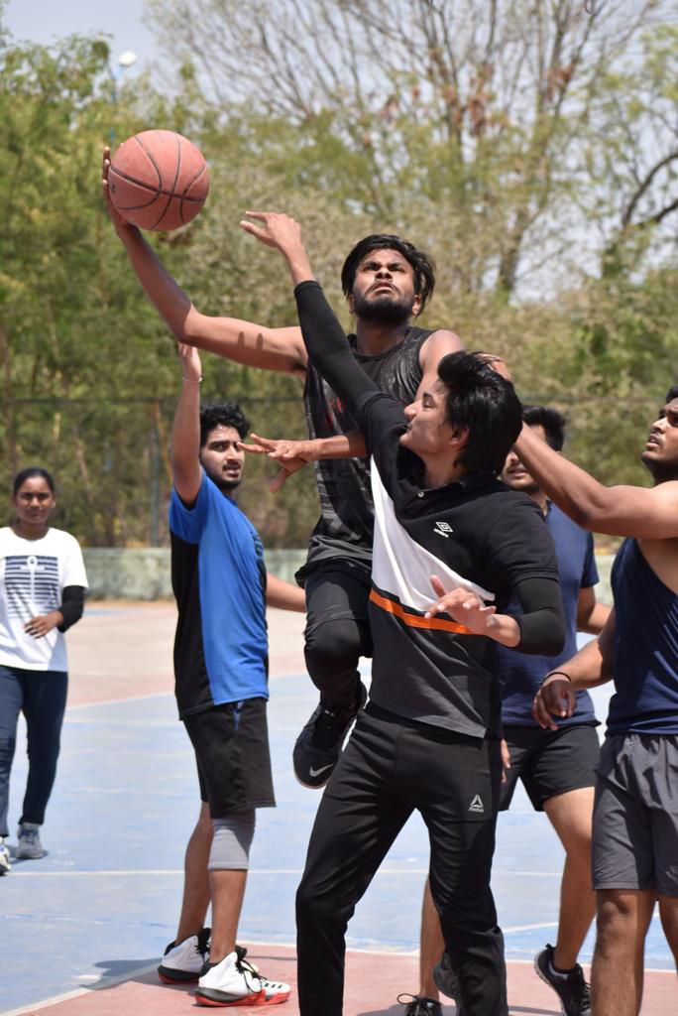

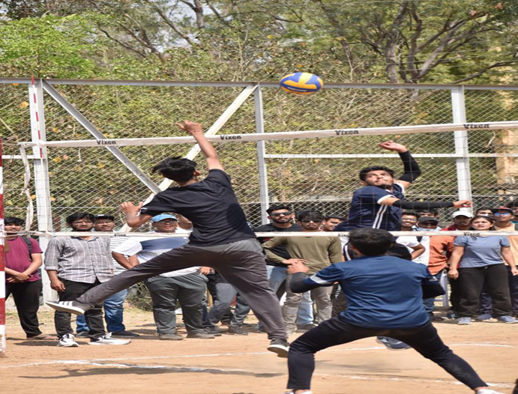

RESULTS :-

* CHESS

1st - CS-A

2nd - CIVIL

* VOLLEYBALL

1st - CS-A

2nd - CS-B

* CARROM

1st - CIVIL

2nd -TC-A

* TABLE TENNIS

1st - CS-B

2nd – IT-A

* CRICKET

1st - Mechanical

2nd - CS-A

* BASKETBALL

1st - CS-A

2nd - IT-B

* Overall winner :-

CS-A

(3-1st ,1-2nd)