cultural events (<http://www.biotech.dauniv.ac.in/event.php> )

1. [**Induction Program 2022**](http://www.biotech.dauniv.ac.in/image/induction_2022/report_induction_prog_2022.pdf)

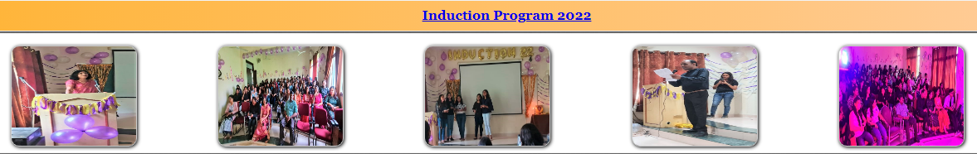

1. [**Spring Celebration "Vasant Utsav" 26 February 2022**](http://www.biotech.dauniv.ac.in/image/vasant_utsav/vasant_utsav_report.pdf)

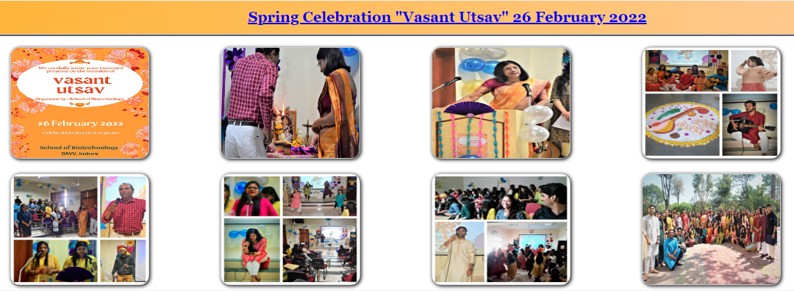

1. [**Welcome Session (Offline Classes) 04 October 2021**](http://www.biotech.dauniv.ac.in/image/induction%202021/report%20Induction%20programme%202021.pdf)

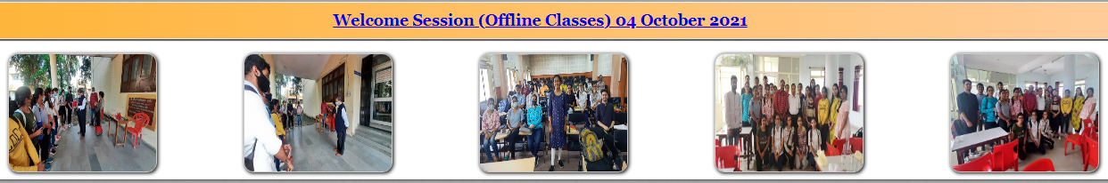

1. [**Online Induction Program 06 September 2021**](http://www.biotech.dauniv.ac.in/image/induction%202021/report%20Induction%20programme%202021.pdf)

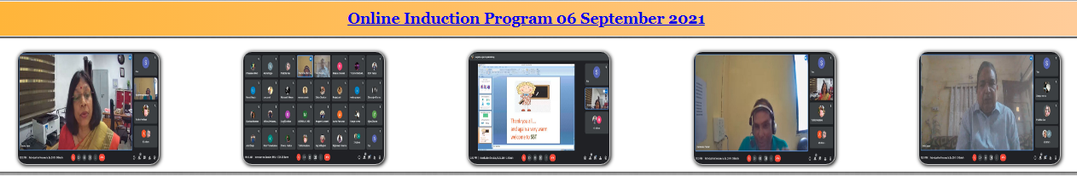

1. [**Online Teachers Day Celebration 05 September 2021**](http://www.biotech.dauniv.ac.in/image/Teachers%20Day%202021/Teacher's%20day%20report.pdf)

