5.4.1

The Alumni Association/Chapters (registered and functional) contributes significantly to the development of the institution through financial and other support services during the year
Describe contribution of alumni association to the institution within a maximum of 500 words
The alumnus forms the major strength of the institution. The Alumni Association was formed in the year 2007 under the name . Alumni shares their views and give suggestions for the betterment of their junior students. Alumni regularly provides updates globally and national scenario related to energy and environment. Such activities are reflected in social media group. More then 500 students are inter-connected with each other. The alumni meet is hosted by the alumni association. Such meetings are mutually beneficial for the Institution and the alumni. This provides an opportunity for the alumni to meet their friends and act as a bridge for the faculty to share their experience, knowledge and insights. Successful entrepreneurs from the alumnus are invited to talk on their success stories at various occasions of the Institute. The alumni also help the final year students of the various streams of engineering and business administration to get their project placements and summer internship in their companies or to assist them get it through their reference. They also assist the students for placement in public and private sectors and alumni is one of the way for the student carrier. The School has also maintains regular contact with the alumni and have a national and globally networking with their alumina through various networking sources
and former faculty through various email groups and social
networking sites such as Facebook, whats-app, link-din , Instagram
S.no. | Social media name | Desktop profile | link
1 | Whatsapp | 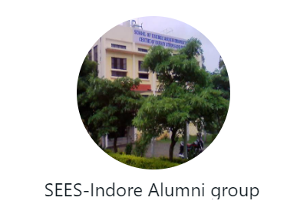 | https://chat.whatsapp.com/FjBx4sQBV2cCFs1aEjCyt4
2 | Insta-gram | 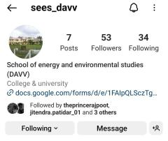 | https://instagram.com/sees_davv?igshid=NDk5N2NlZjQ=
3 | Link-din | 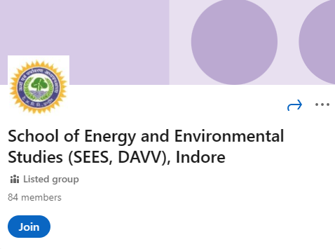 | https://www.linkedin.com/groups/10397145/
4 | Facebook | 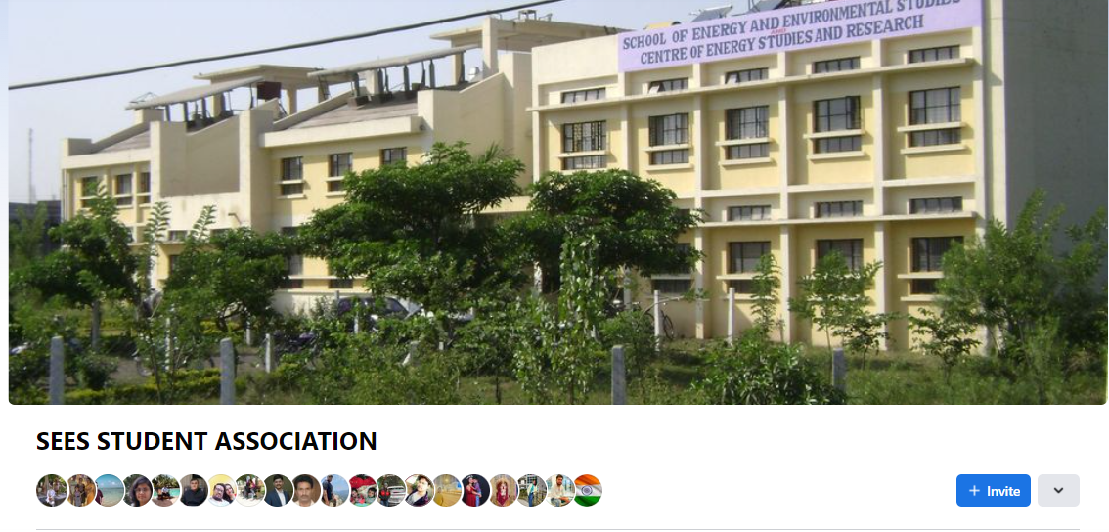 | https://www.facebook.com/groups/374066962621552

