NATIONAL SERVICE SCHEME UNIT

INSTITUTE OF MANAGEMENT STUDIES,

DAVV

ACTIVITY REPORT

FOR THE SESSION 1JULY 2021- 30 JUNE 2022

NSS Unit

Institute of Management Studies, DAVV

**Report**

Event: “EK BHARAT SHRESHTH BHARAT”

Place: Indore city

About: NSS Unit IMS participated in“EK BHARAT SHRESHTH BHARAT” on 8 AUGUST, 2021.Participants contributed for Water conservation and Sanitation through poster making.20 volunteers participated in the event. NSS Officer Dr.Bhanu Pratap Singh coordinator of NSS Unit IMS.

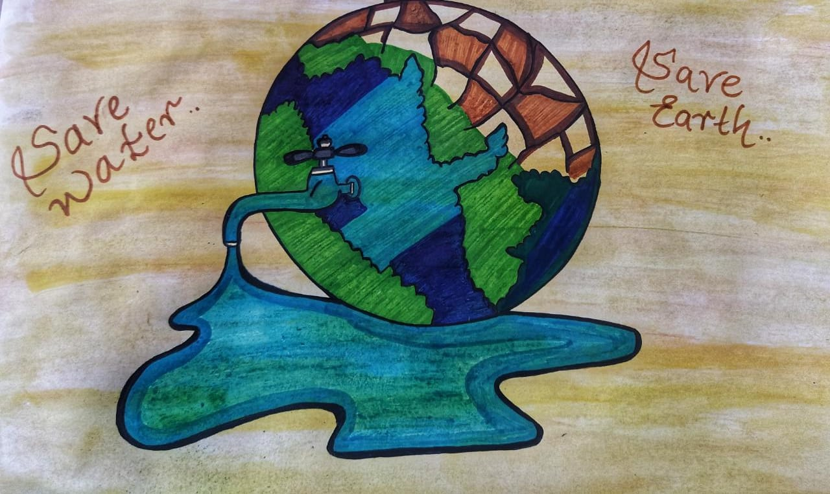

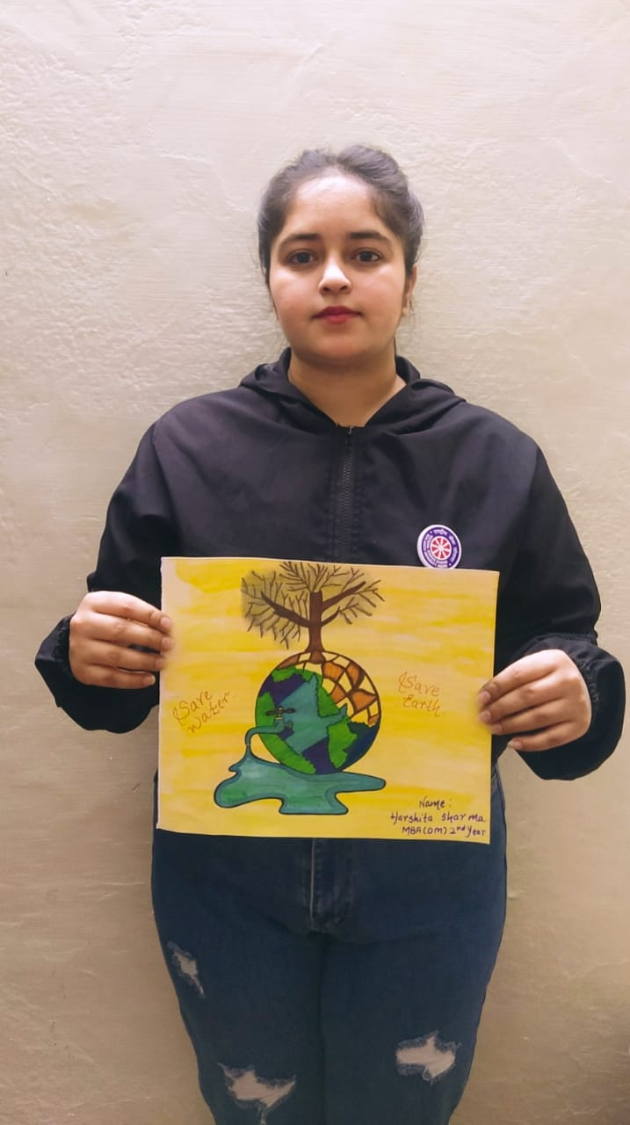

NSS Unit

Institute of Management Studies, DAVV

**Report**

**Event**: Plantation under ANKUR Program Dated 21.08.2021

**Place**: Institute of Management Studies, Takshshila Parisar

**No. of Participants**: 40

**About**: NSS Unit IMS in reference of office letter Indore Collectorate Sr.No./4099/21 Indore Dated 18.08.2021 organized Plantation under ANKUR Program on 21.08.2021.

Instituion Director Professor Sangeeta Jain initiated the Program and NSS Officer IMS Unit Dr.Bhanu Pratap Singh coordinated the event.

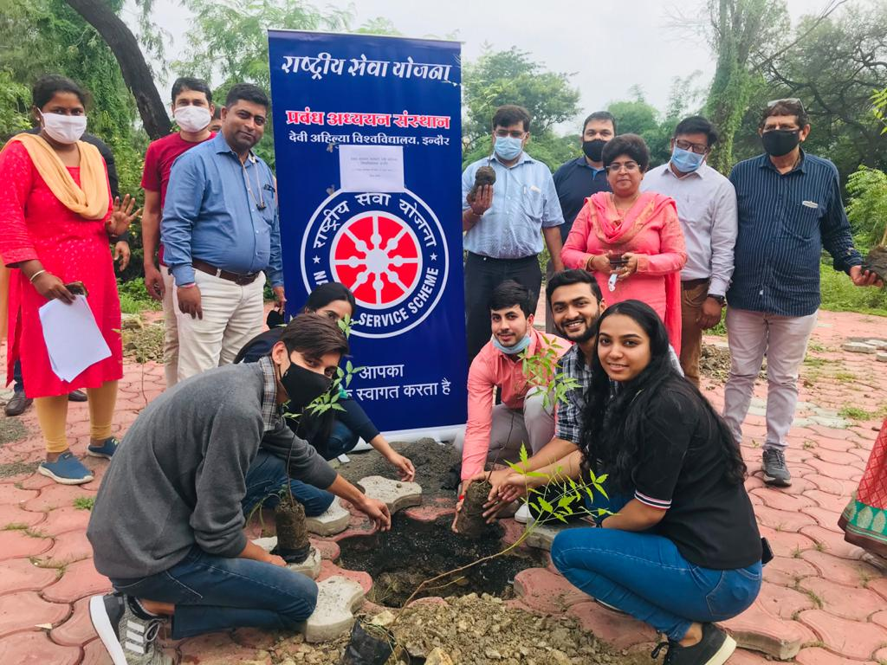

NSS Unit

Institute of Management Studies, DAVV

**Report**

**Event**: Sadbhavana Day Pledge dated 19.08.2021

**Place**: Institute of Management Studies, Takshshila Parisar

**No. of Participants**: 45

**About**: NSS Unit IMS organized Sadbhavna Day pledge on 19.08.2021 for the spread of emotional oneness and harmony of all the people of India and resolve of all differences among through dialogue and constitutional means.

Institution Director Professor Sangeeta Jain initiated Programme and NSS Officer IMS Unit Dr.Bhanu Pratap Singh coordinated the event.

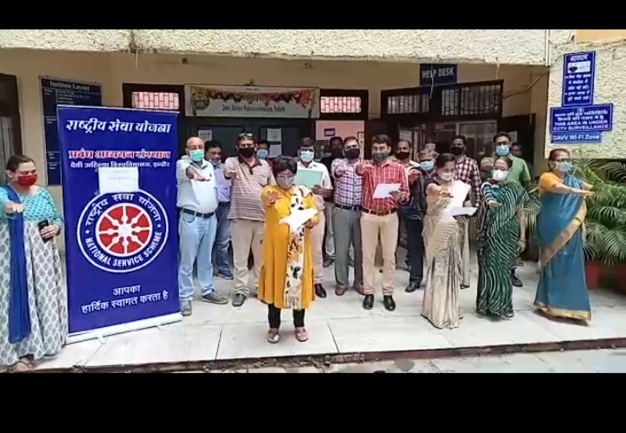

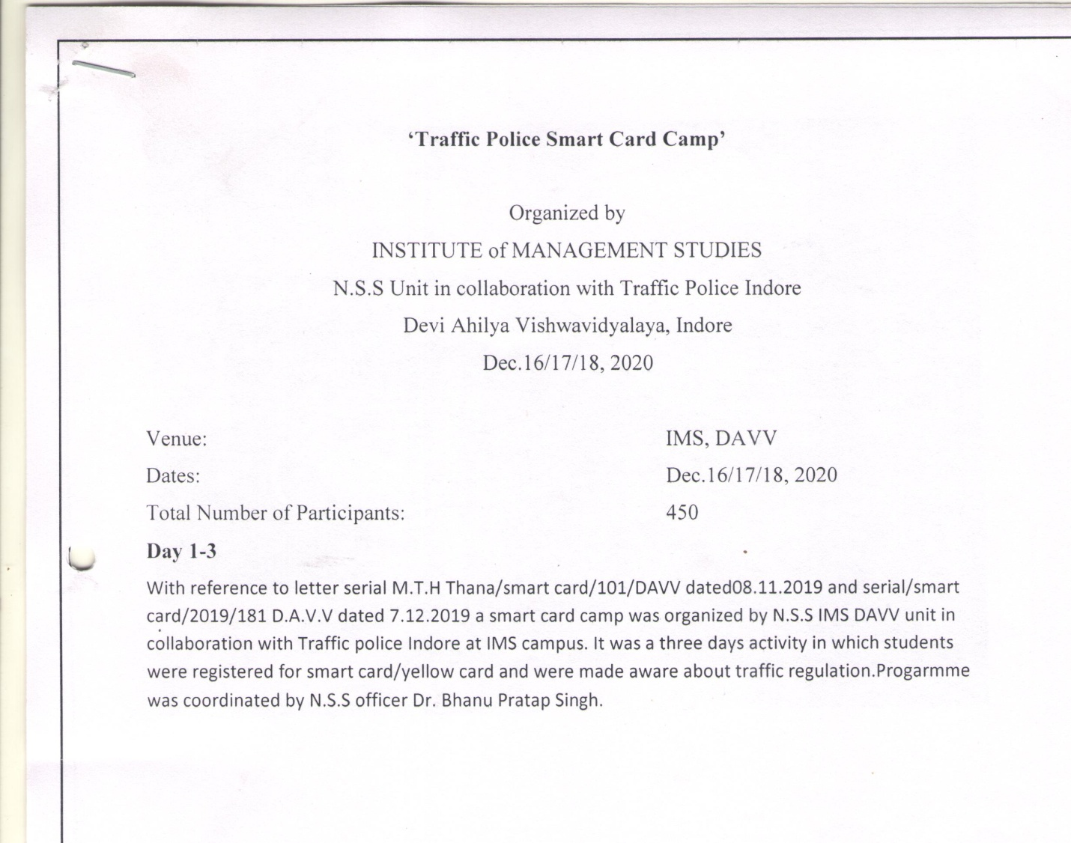

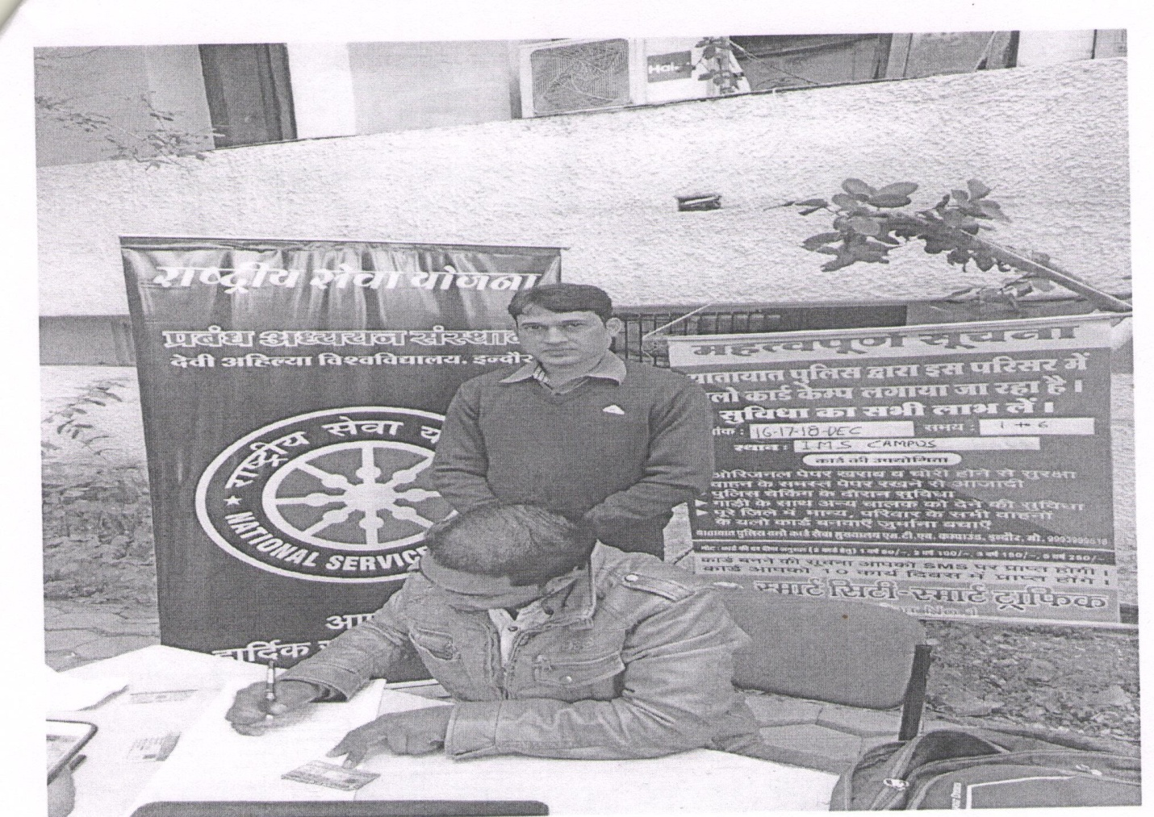

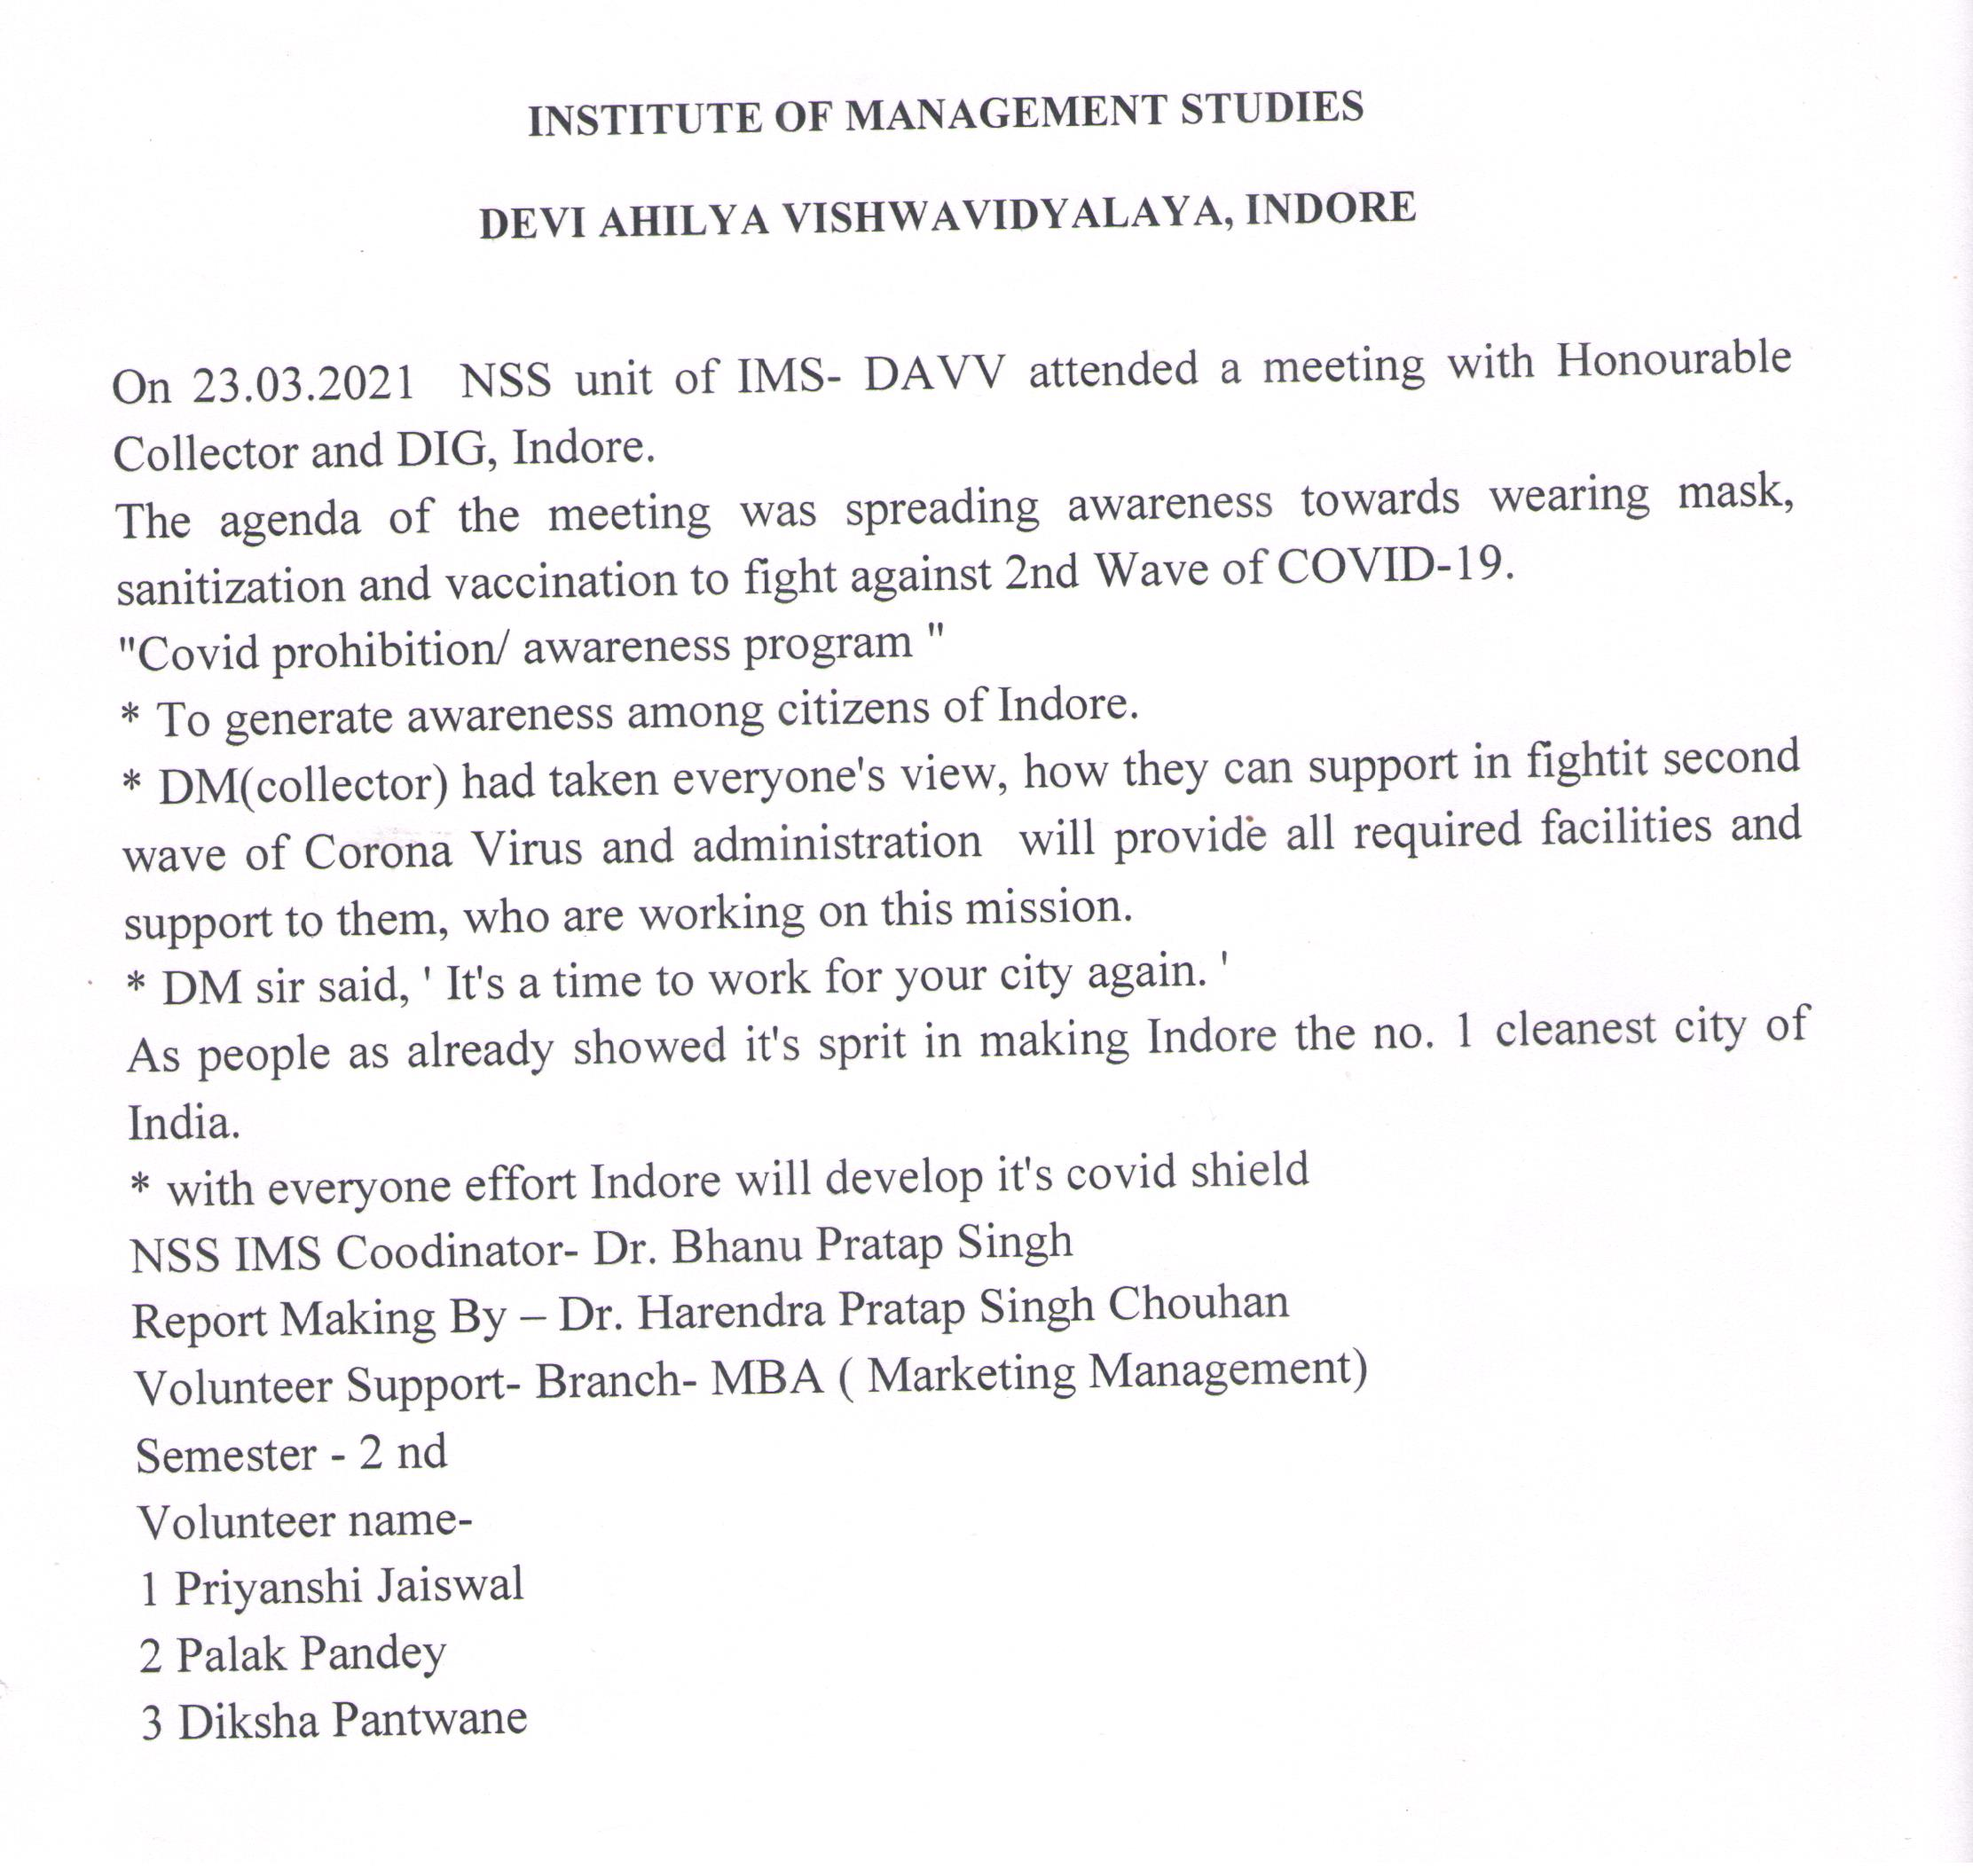

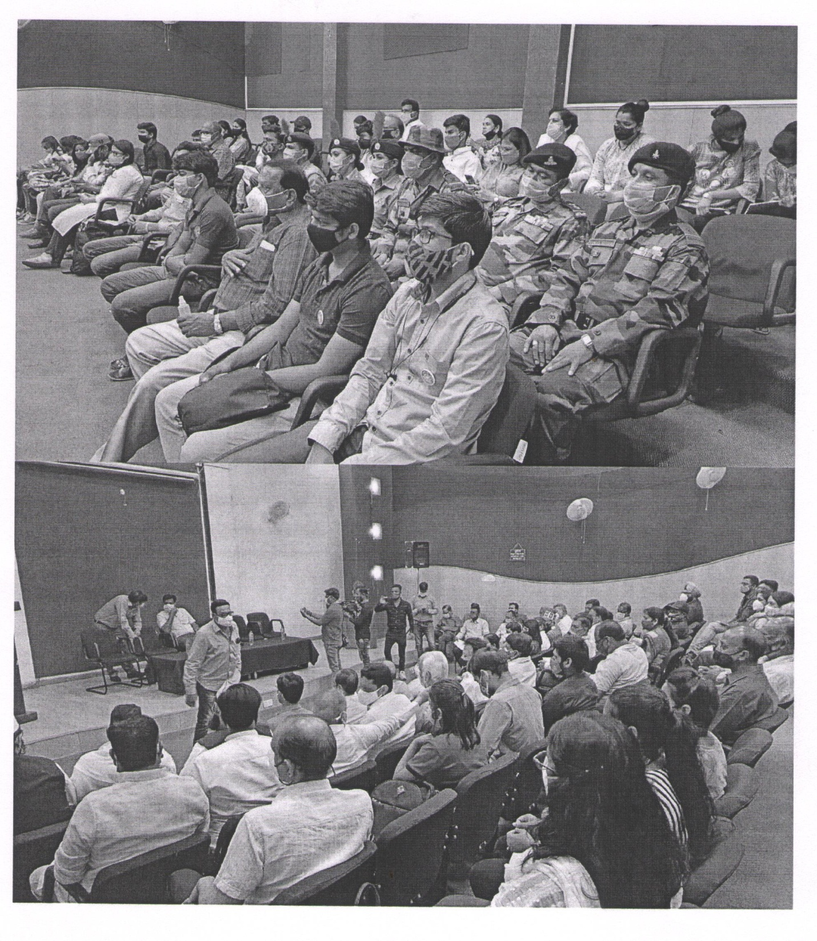

NSS Unit

Institute of Management Studies, DAVV

**Report**

22 April 2021 NSS Unit IMS celebrated earth day.Poster making activity was carried out

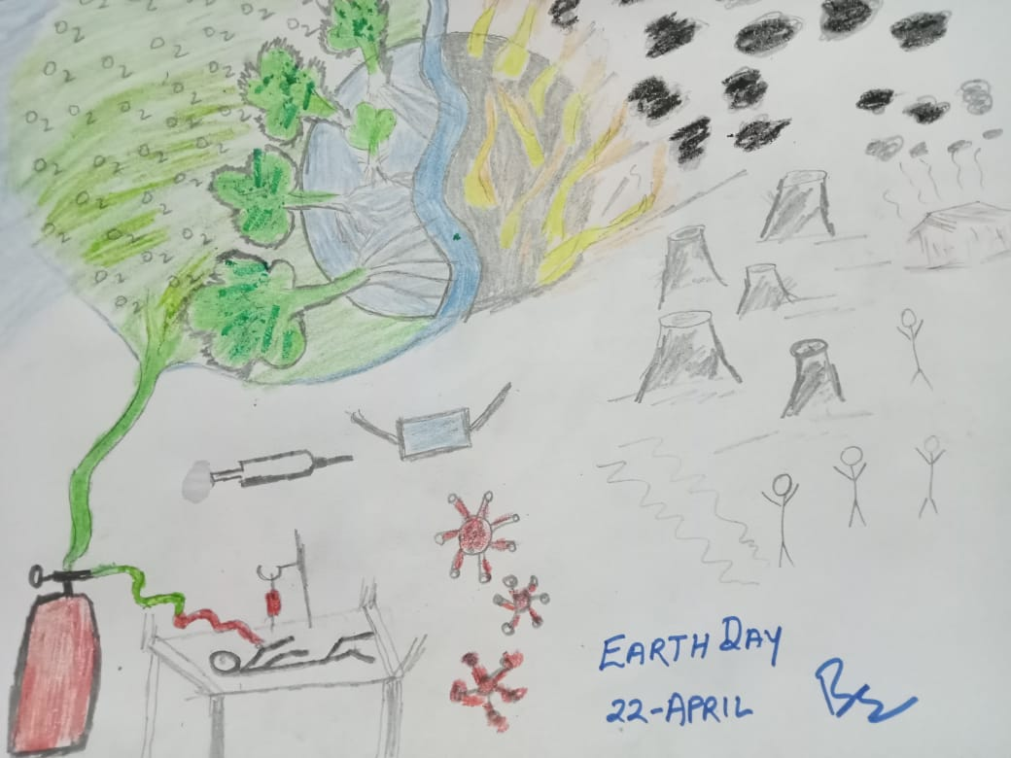

NSS Unit

Institute of Management Studies, DAVV

**Report**

Event: “Martyr’s Day Rememberance

Place: Indore city

About event: NSS Unit IMS offered tribute to freedom fighter on the occasion of Martyr’s Day on 30-January-2021. Around 25 Teachers and student participated and remembered the sacrifices made by Martyr’s.NSS Officer Dr.Bhanu Pratap Singh coordinator of NSS Unit IMS.

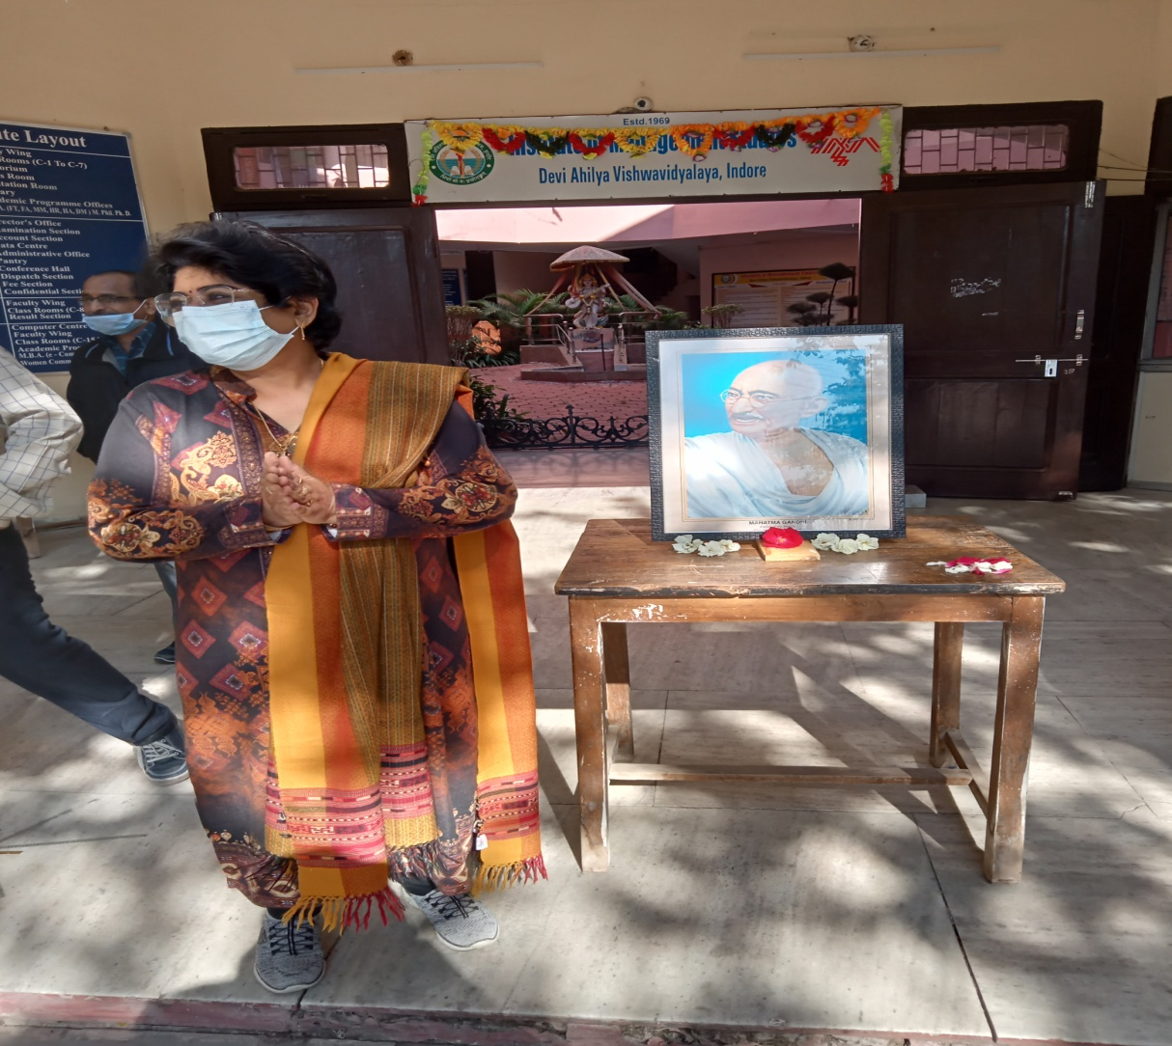

NSS Unit

Institute of Management Studies, DAVV

**Report**

Event: 125th anniversary of S.C.Bose

Place: Indore city

About event: NSS Unit IMS organizes a talk on 125th Anniversary of great freedom fighter Netaji Subhash Chandra Bose on 23rd January 2021.The event focuses on various dimension of contribution of Bose towards freedom movement.NSS Officer Dr.Bhanu Pratap Singh coordinator of NSS Unit IMS.26 Faulties and students participated in the event.

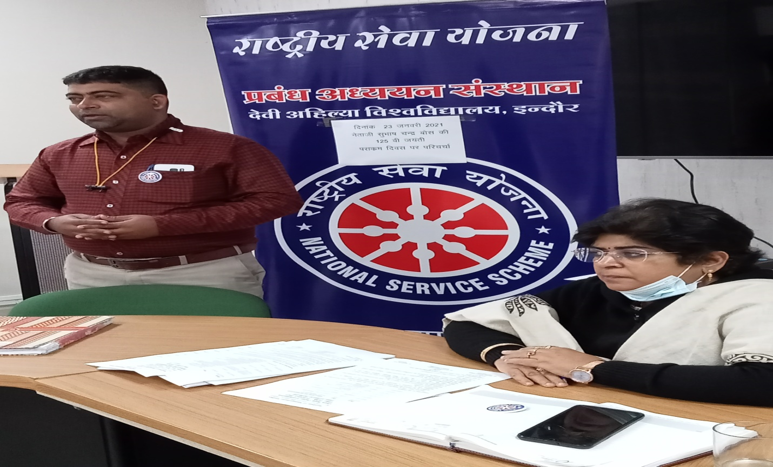

NSS Unit

Institute of Management Studies, DAVV

**Report**

Event: Clean campuss Green campus

Place: IMS DAVV,Indore city

About event: NSS Unit IMS organizes Clean campuss Green campuss drive at Institute of Management Studies premise on 10 february 2021.The purpose of activity was to create awareness for cleanliness and maintenance of campuss.30 Volunteers participated in the activity..NSS Officer Dr.Bhanu Pratap Singh coordinator of NSS Unit IMS.26 Faculties and students participated in the event.

