7.1.4  Q_{n}M | Water conservation facilities available in the Institution:  - Rainwater harvesting  - Bore well /Open well recharge  - Construction of tanks and bunds  - Waste water recycling  - Maintenance of water bodies and distribution system in the campus  Options:  A. Any 4 or All of the above  B. Any 3 of the above  C. Any 2 of the above  D. Any 1of the above  E. None of the above  Upload relevant supporting document  (Data template is not applicable to this metric)

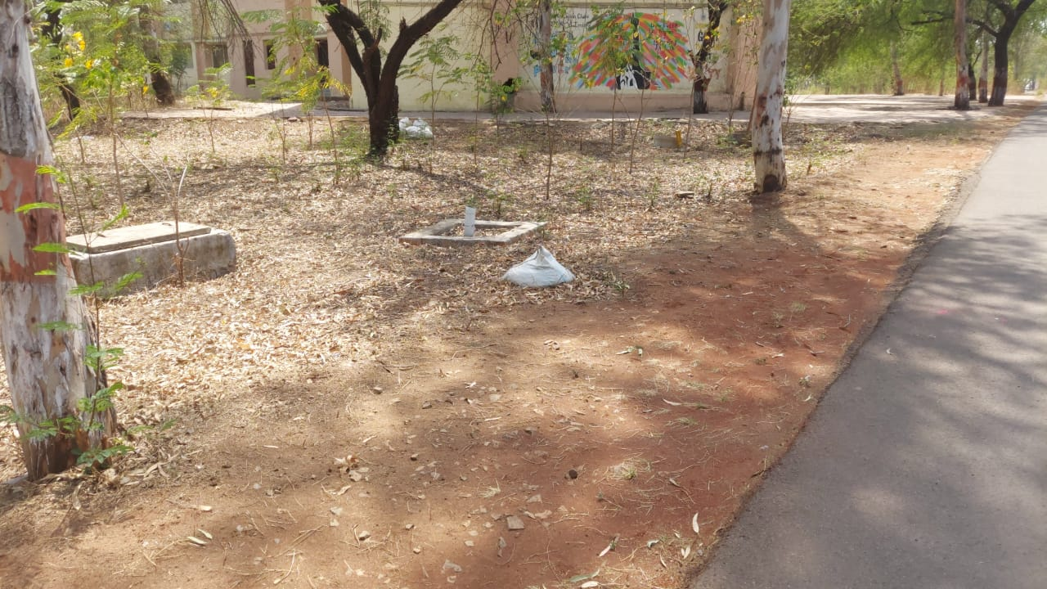
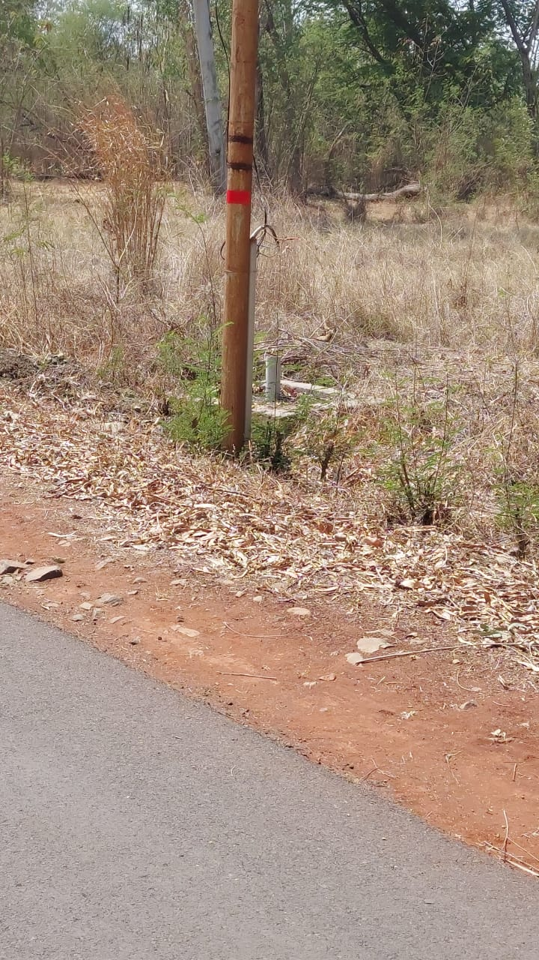
Rain water Harvesting
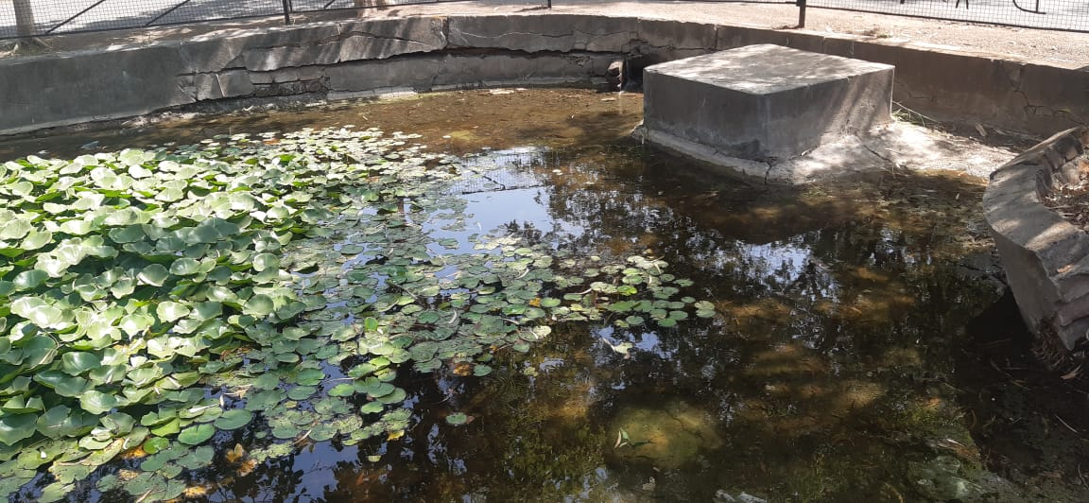
Construction of tanks and bunds
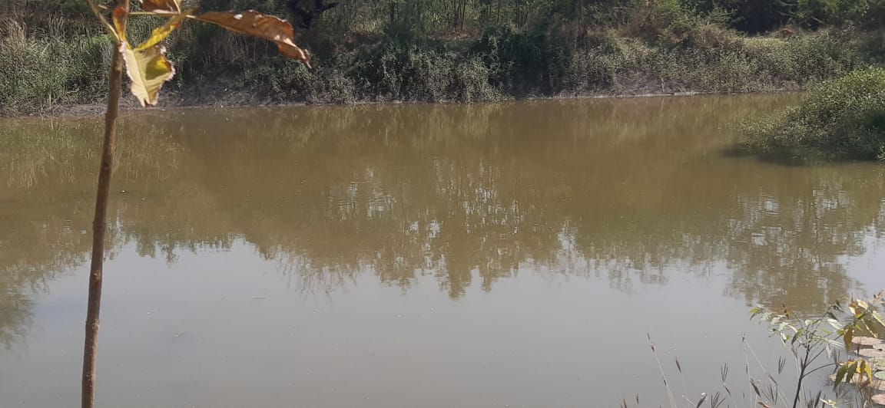
Construction of Tanks and water bodies

