NATIONAL SERVICE SCHEME UNIT

INSTITUTE OF MANAGEMENT STUDIES,

DAVV

ACTIVITY REPORT

FOR THE SESSION 1JULY 2021- 30 JUNE 2022

**Report**

**Event**: Plantation under ANKUR Program Dated 21.08.2021

**Place**: Institute of Management Studies, Takshshila Parisar

**No. of Participants**: 40

**About**: NSS Unit IMS in reference of office letter Indore Collectorate Sr.No./4099/21 Indore Dated 18.08.2021 organized Plantation under ANKUR Program on 21.08.2021.

Instituion Director Professor Sangeeta Jain initiated the Program and NSS Officer IMS Unit Dr.Bhanu Pratap Singh coordinated the event.

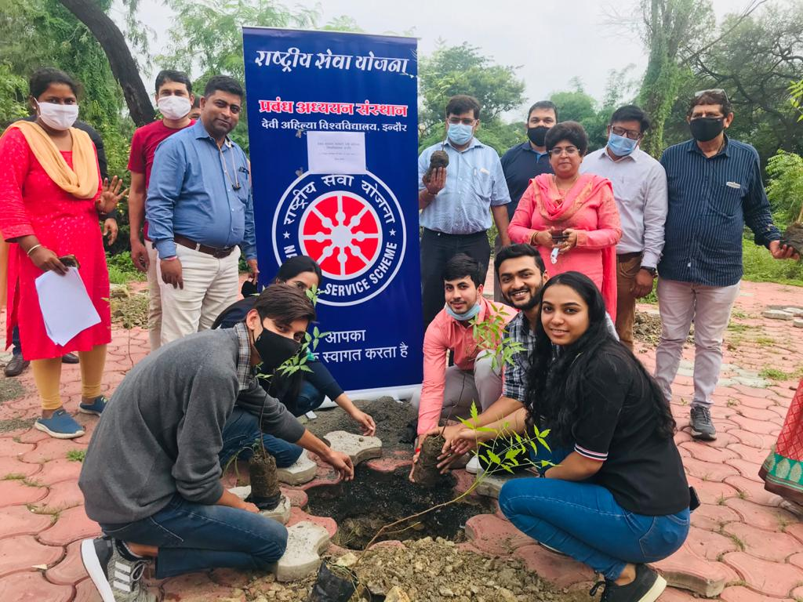

NSS Unit

Institute of Management Studies, DAVV

**Report**

22 April 2021 NSS Unit IMS celebrated earth day.Poster making activity was carried out

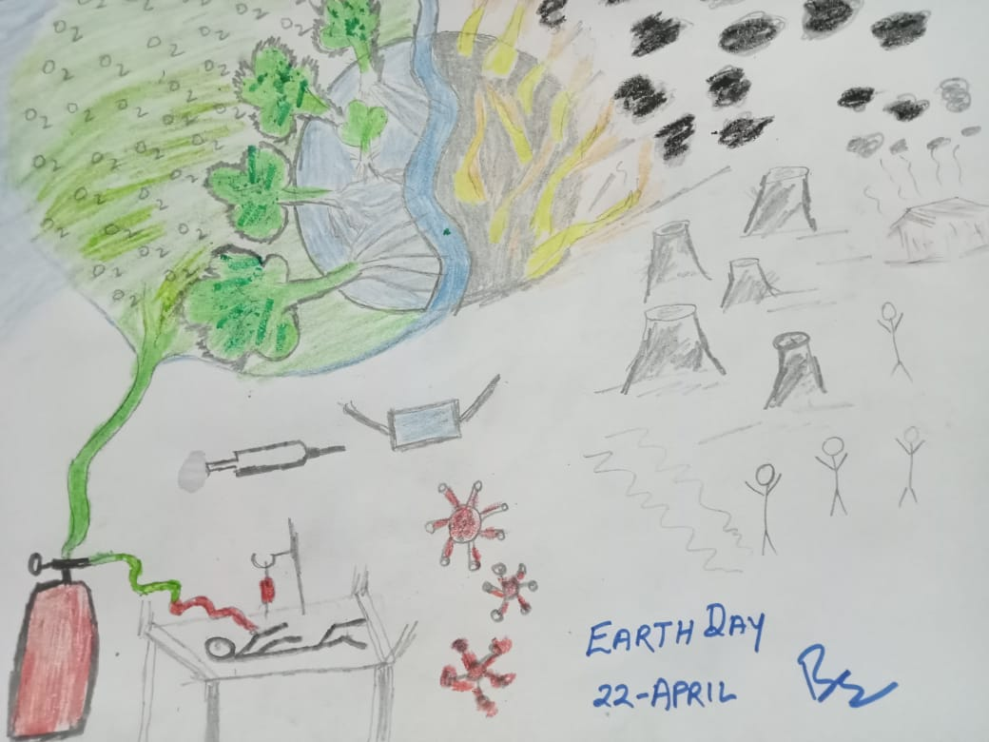

NSS Unit

Institute of Management Studies, DAVV

**Report**

Event: Clean campuss Green campus

Place: IMS DAVV,Indore city

About event: NSS Unit IMS organizes Clean campuss Green campuss drive at Institute of Management Studies premise on 10 february 2021.The purpose of activity was to create awareness for cleanliness and maintenance of campuss.30 Volunteers participated in the activity..NSS Officer Dr.Bhanu Pratap Singh coordinator of NSS Unit IMS.26 Faculties and students participated in the event.

