5
7.1.7  Q_{n}M | The Institution has a disabled-friendly and barrier-free environment  Signage including tactile path lights, display boards and signposts

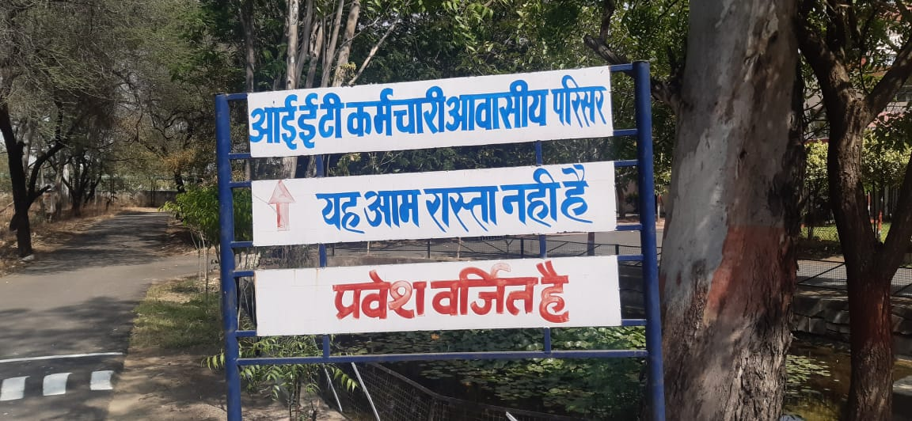 | 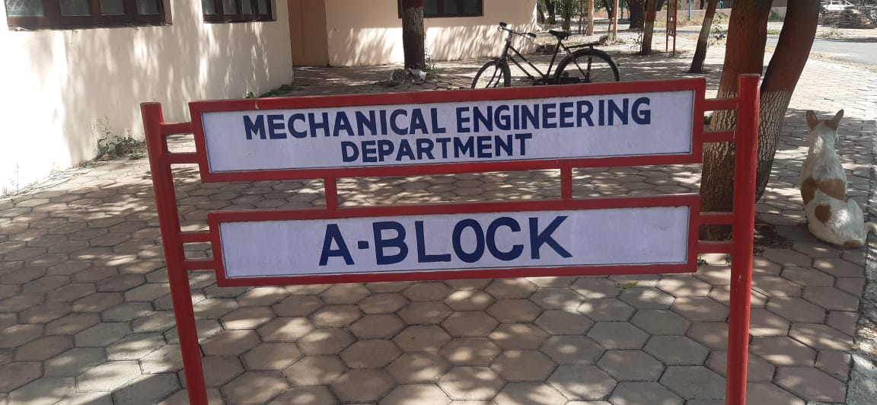
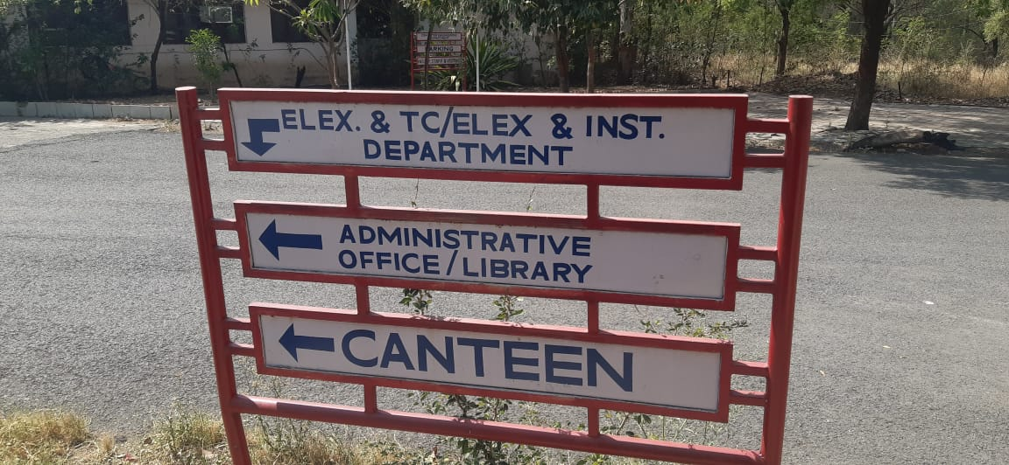 | 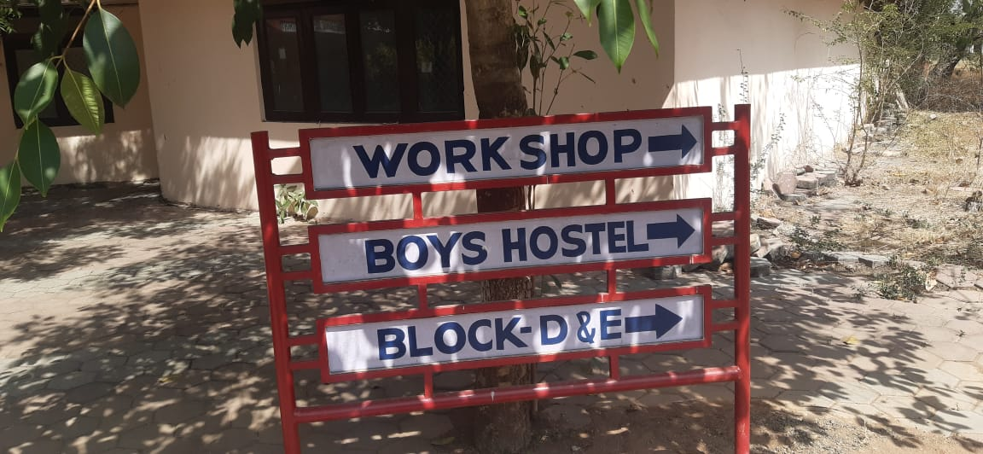
Signage including tactile path lights, display boards and signposts

