Hands on Training

1. [**Value Added 7 Days Hands-on Training Program on "Enzymes, Gene Manipulation and Functional Genomics" 20-26 February 2023**](http://www.biotech.dauniv.ac.in/image/7dyas_hands-on_feb2023/report_7daysHands-on.pdf)

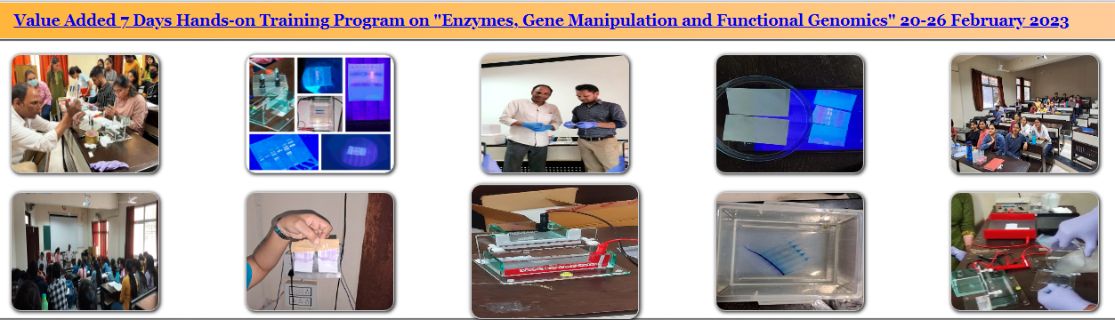

1. [**Value Added Course On "Mammalian Cell Culture Techniques and Related Assays" 09-13 November 2022**](http://www.biotech.dauniv.ac.in/image/Value_added_course/5days_hands-on_report.pdf)

