**3.3.2 Number of workshops/seminars conducted on Research methodology, Intellectual Property Rights (IPR), entrepreneurship, skill development**

1. [**Lecture by Dr. Sanjit Kumar on "Biochemical Characterization and Structural Studies of Adenosine Deaminase from Mycobacterium Tuberculosis (MtbADA)" 17 May 2023**](http://localhost/Biotech/image/LectureByDrSanjit/report.pdf)

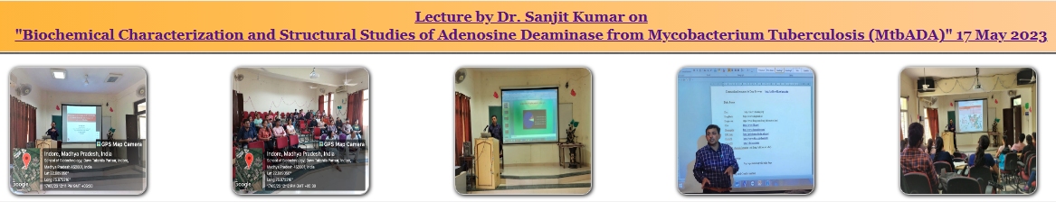

1. [**Value Added 7 Days Hands-on Training Program on "Enzymes, Gene Manipulation and Functional Genomics" 20-26 February 2023**](http://localhost/Biotech/image/7dyas_hands-on_feb2023/report_7daysHands-on.pdf)

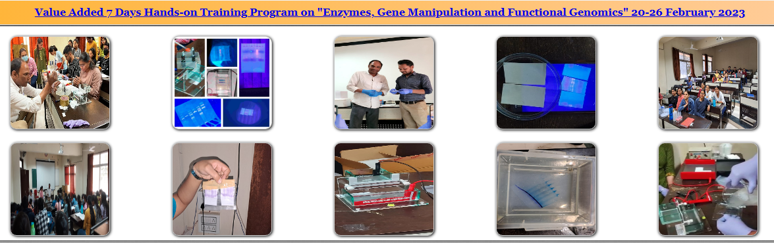

1. [**Book Launch of "Indian Woman, Feminism and Women's Liberation" 9 February 2023**](http://localhost/Biotech/image/book_launch_event/book_launch_report.pdf)

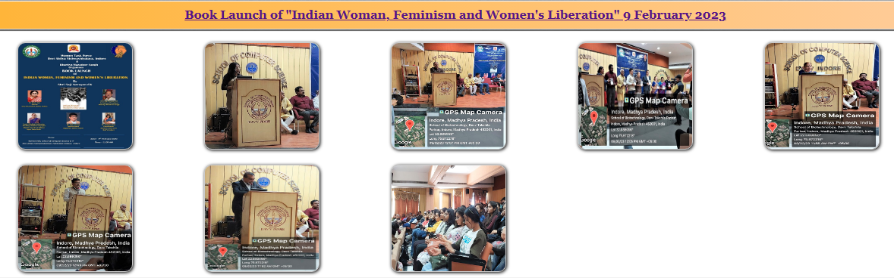

1. [**Value Added Course On "Mammalian Cell Culture Techniques and Related Assays" 09-13 November 2022**](http://localhost/Biotech/image/Value_added_course/5days_hands-on_report.pdf)

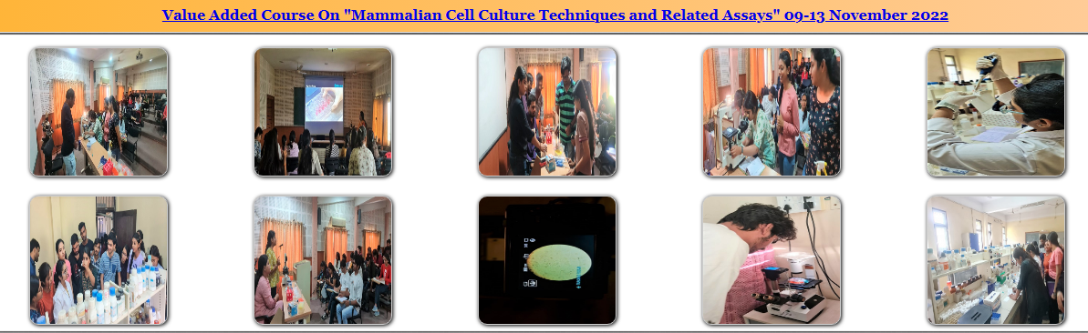

1. [**Importance of Interview techniques for the freshers and resume writing, 19 September 2022**](http://localhost/Biotech/image/Webinar_19_sep22/webinar_report_19_Sep_2022.pdf)

