Institution celebrates / organizes national and international commemorative days, events and festivals
Describe the efforts of the Institution in celebrating /organizing national and international commemorative days, events and festivals during the year within 200 words

1. Guru Purnima Celebration 2022

Date | Name  of Inst. | Place | No. of Participants |  | Summary  of the event
 |  |  | students | teachers
13/07/22 | IET- DAVV | Campus | 09 | 18 | “Better than thousand hours of reading books is 1 hour with a great teacher.” In Indian culture the importance of Gurus is evidently magnanimous, from seeking blessings to extending thankfulness for delivering us the best of wisdom and knowledge. It’s Guru whose importance is even above God and that’s why to commemorate this auspicious day, The IETians showcased respect to the dignified faculty and administration members.  Students arranged sweet dishes and tilak to welcome the respected faculty members at all the departments and revered Director Sir with administrative members and touched their feet to receive blessings with some happy conversations about marking this special day.  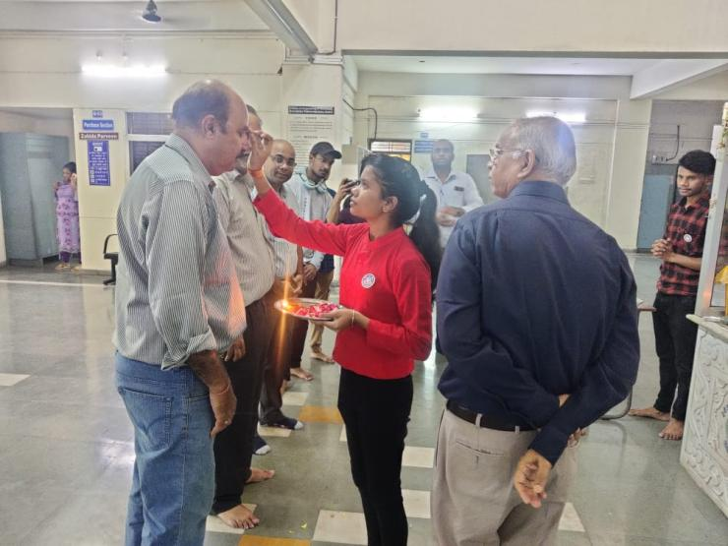

2. Sadhbhavna Diwas
Date | Name of Inst. | Place | No. of Participants |  | Summary of the event
 |  |  | students | teachers
20/08/22 | IET- DAVV | Online | 15 | 01 | On 20th august, the birth anniversary of former prime minister Rajiv Gandhi is celebrated as Sadhbhavana Diwas every year. Sadhbhavana means having good feelings for others, So it is also known as harmony day.  Having good feelings for others was the only the mission of the government of Rajiv Gandhi. This day is observed to encourage the national integration, peace, affection and communal harmony among the Indian people of all religions.  On this day, To commemorate the birth of former prime minister Rajiv Gandhi, NSS team gathered in which teachers and volunteers both are included to take the plegde for resolving differences and to keep peace  against each and every differences.  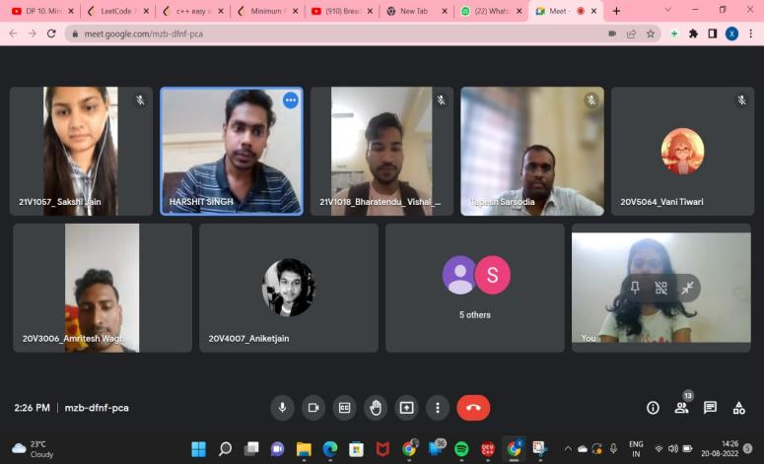

3. Teacher’s Day Celebration
Date | Name  of Inst. | Place | No. of Participants |  | Summary  of the event
 |  |  | students | teachers
05/09/22 | IET- DAVV | M-Block  Auditorium | 130+ | 27 | “The influence of teachers extends beyond the classroom, well into the future.” To commemorate the presence of our guiding lights and mentors for life, the volunteers organized celebration of teacher’s day in the auditorium of M-Block.  The students were joyously engaged in preparations and decorations for the august celebration, program started at 12 O’clock with warm welcome of all teachers with roses and tilak and making the day memorable with wonderful performances of students ranging from stand-ups to music, speeches and poems dedicated to ones who give us the gift of knowledge and skills along with positive influence in our lives.  The program was further made delightful by the team pratyaksh’s nukkad natak performance, which added feathers to the cap of the day. Teachers too appreciated efforts of students and blessed everyone with wishes and message of love and wisdom for the future.  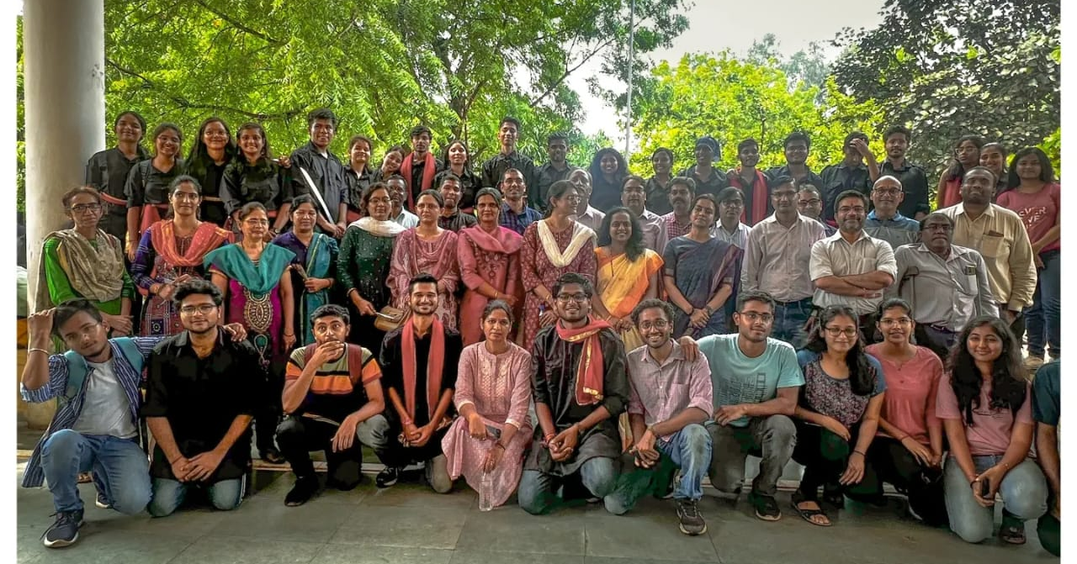

4. NSS Day Celebration + Village Visit
Date | Name of Inst. | Place | No. of Participants |  | Summary of the event
24/09/22 | IET-DAVV | Barlai Jagir Village | 27 | 03 | The greatest way to find yourself is to lose yourself in the service to mankind. With the noble motive of ‘Not me but you’ in mind, the volunteers planned to set out an awareness centered village visit to the adopted village of the institute to celebrate the occasion of NSS Day.  Performing students along with program coordinators arrived at the village panchayat house by afternoon via traveler buses arranged by institute, the topic of awareness was organic farming, sanitization, cleanliness and hygiene, voting rights and importance, girls’ education. Along with performing on the topics of influence at places around the village like school and field, students also interacted with village men and talked about various issues of day to day lives and sustainable solutions to them, they were provided refreshments too by the end of the day. Under the guidance of mentors and travailing efforts of students the event turned out to the successful and most meaningful celebration of the NSS day with lots of learnings and memories that follow along the service.  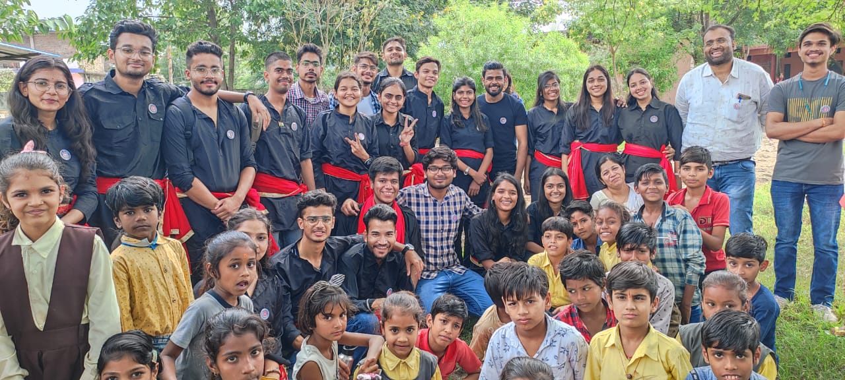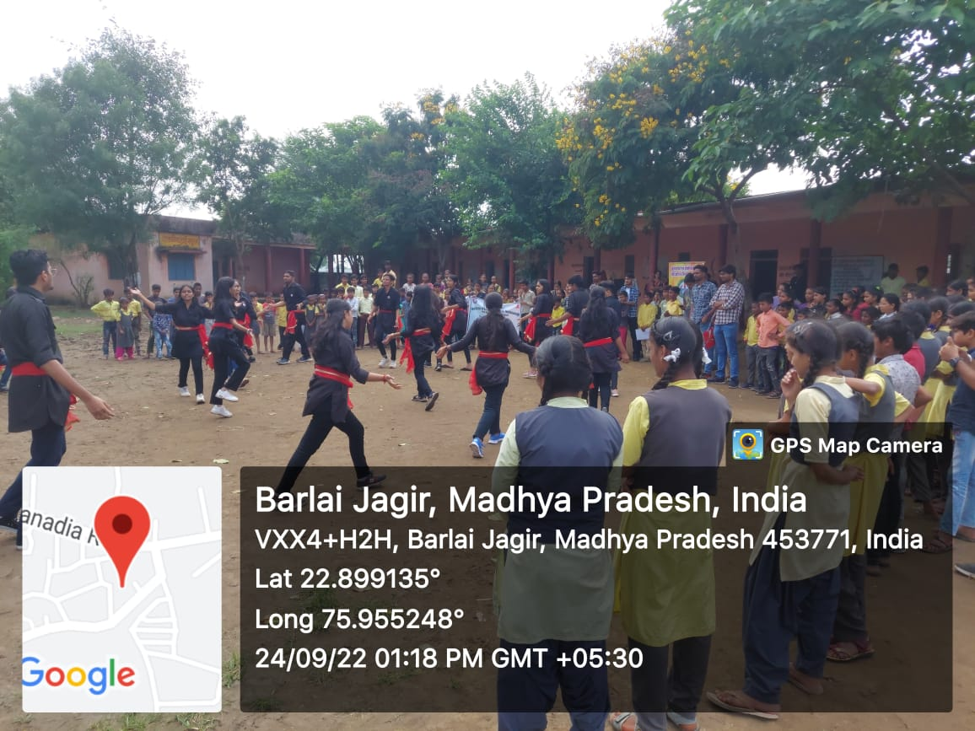

5. GANDHI JAYANTI

Date | Name  of  Inst. | Place | No. Of participants | Summary of the Event
05/10/22 | IET-DAVV | Offline  Mode | 30 | To commemorate Mahatma Gandhi’s (Bapu) 153rd birthday in a special way, the NSS unit of IET DAVV, INDORE, initiated cleanliness drive in and outside the college campus  with the motto of ‘Swaccha Bharat Abhiyan’ .  As a part of regular NSS activities our NSS  unit Organized cleanliness drive in the college Campus aswell as in other cities.  During this activity volunteers cleaned the campus and many students cleaned their  neighbourhood in different cities as well.  They picked up the all plastic garbage from  both sides of road.  The drive was concluded at main gate of our college.  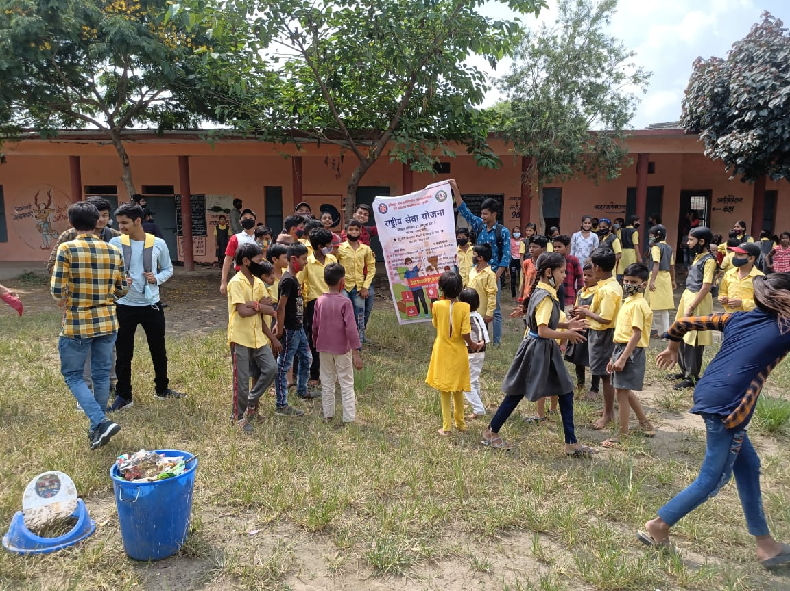

6. Run For Unity and Oath Ceremony

Date | Name  of  Inst. | Place | No. of  Participants |  | Summary of the event
 |  |  | Students | Teachers
31/10/22 | IET-DAVV | Offline | 70 | 25 | As an endeavor to solidify the bond of oneness and unification , the country celebrates the Birth Anniversary of Sardar Vallabh Bhai Patel on 31st October as National Unity day.  So on this auspicious day NSS-DAVV organized an event for whole DAVV family. The event was “Run For Unity and Oath ceremony”.  The run started from the Takshila Main Gate. Honourable VC Dr. Renu Jain mam, Registrar Dr. Anil Sharma sir and Faculty members, Students, NSS volunteers and Staff took the active participation in it. All the people took ’Rashtriya Ekta Diwas Pledge’. The run ended at University Auditorium where regional director Dr.Prakash Garhwal sir spoke few words and sang a song which fueled up everybody present over there .  With the warm support of the faculty and enthusiastic nature of the students , the event was a huge success.  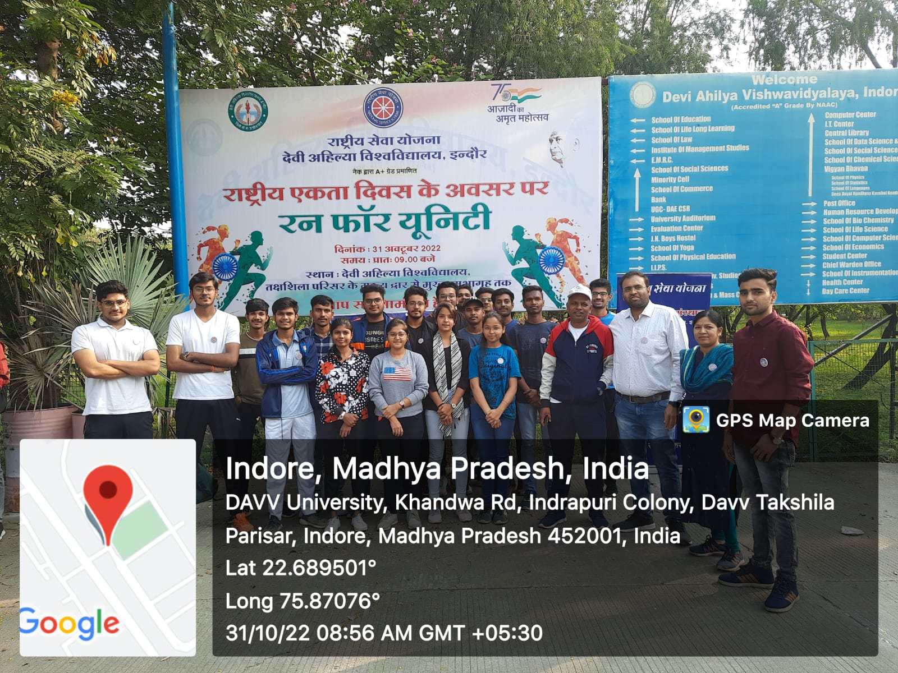

8 National Voter’s Day

Date | Name of  Institution | Venue | No. of  Participants |  | Summary of the Event
Date | Name of  Institution | Venue | Students | Teachers | Summary of the Event
25-01-2023 | IET DAVV | M-Block |  |  | The National Voter’s Day is celebrated on 25th January to mark the foundation day of Election Commission of India. The theme allotted for this year was ‘Nothing like Voting, I vote for Sure’.  Team NSS IET DAVV conducted a series of events to spread awareness about the election system. The freshmen students were actively involved in the events as they will be casting their first vote this year. A poll was conducted to check the number of students having Voter ID card.  Lastly, the students were informed about their electoral rights and the importance of voting in a democratic system. The program was concluded by taking the National Voter’s Day Pledge.

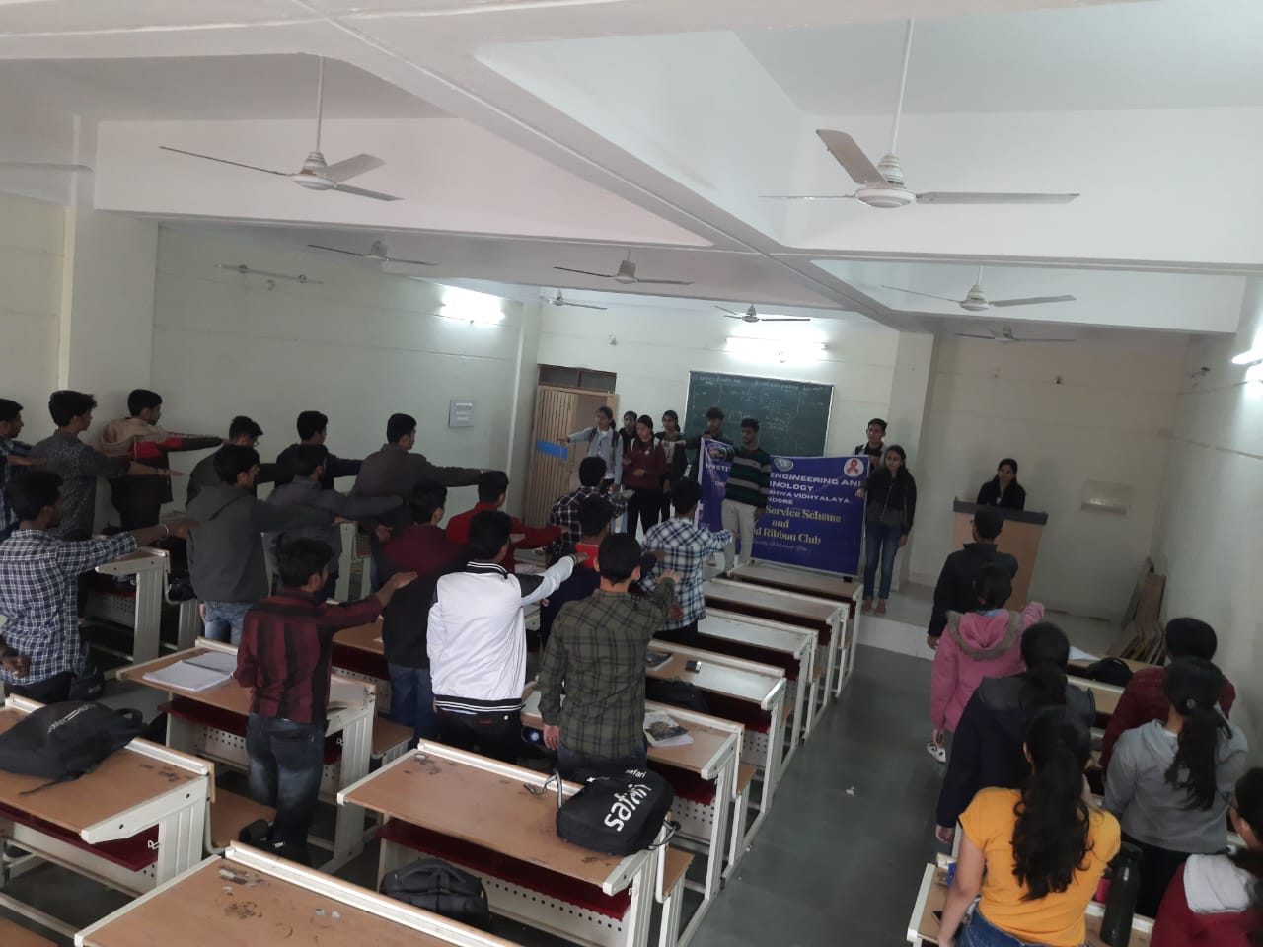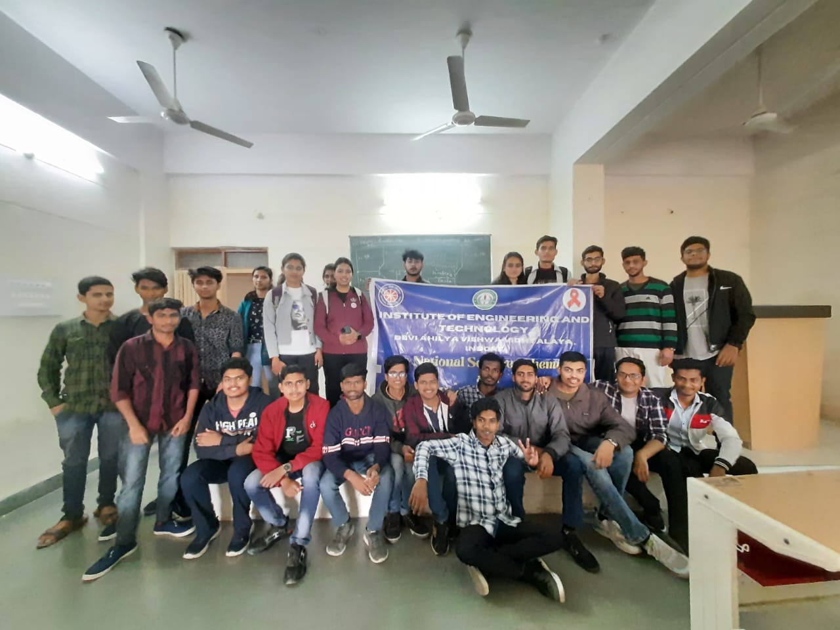

9 International Yoga Day Celebration

Date | Name  of  Inst. | Place | No. of  Participants |  | Summary of the event
 |  |  | Students | Teachers
21/06/23 | IET-DAVV | M-Block Auditorium | 30 | 3 | "YOGA SE HI HOGA".  This is a famous quote translating to "It can be done only by Yoga."  To spread the message of physical fitness, NSS -IET DAVV took the initiative to conduct a yoga session on International Yoga Day. The event took place at 8 am in the morning under the guidance of Yoga faculties Rashmi Mam and Juhi Mam from Nature Pace Classes of Yoga. It was attended by the head of NSS- INDORE DIVISION, Dr. Prakash Gadhwal Sir as Chief guest and Mrs Seema Chouhan Mam.  According to students very helpful, energized and calm yoga session. The faculties addressed on the importance of yoga in the student’s life and highlighted the immense benefits of practicing yoga. It serves as a reminder of the importance of embracing this ancient discipline to enhance physical, mental, and spiritual well. Lastly refreshment of banana , sprouts and fruits were distributed among the students .
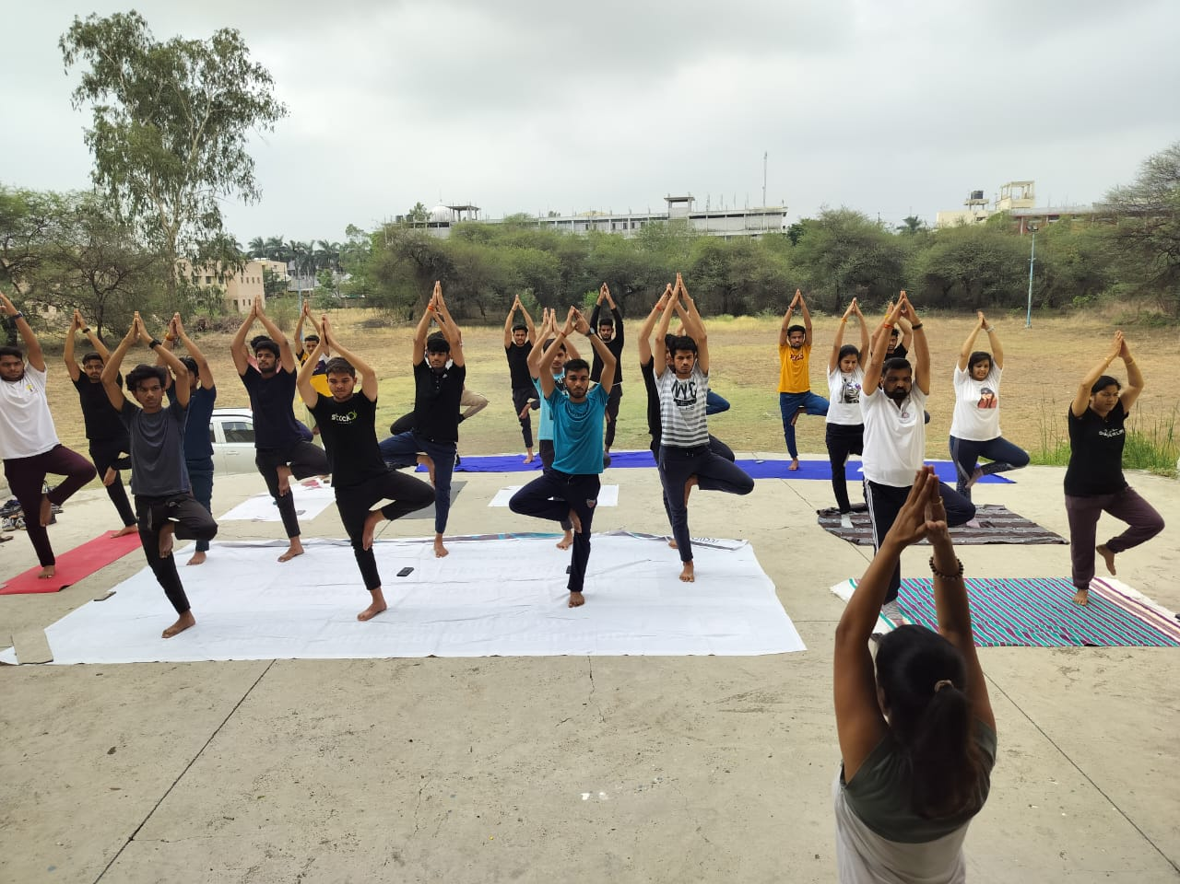

10. Enviroment Day

Date | Name  of  Inst. | Place | No. of  Participants |  | Summary of the event
 |  |  | Students | Teachers
05/06/23 | IET-DAVV | Online | 50 | 4 | "  NSS-IET DAVV organised an online event on the occasion of World Environment Day.  The main objective of the occasion was to raise awareness of the environment and the necessity of its protection. To assist the environment become cleaner and greener, students were advised to plant saplings at home and care for them. They participated fervently and enthusiastically and shared pictures with the saplings making the event a success  