Describe the Institutional efforts/initiatives in providing an inclusive environment i.e., tolerance and harmony towards cultural, regional, linguistic, communal socioeconomic and other diversities (within 200 words).

1. Guru Purnima Celebration 2022

Date | Name  of Inst. | Place | No. of Participants |  | Summary  of the event
 |  |  | students | teachers
13/07/22 | IET- DAVV | Campus | 09 | 18 | “Better than thousand hours of reading books is 1 hour with a great teacher.” In Indian culture the importance of Gurus is evidently magnanimous, from seeking blessings to extending thankfulness for delivering us the best of wisdom and knowledge. It’s Guru whose importance is even above God and that’s why to commemorate this auspicious day, The IETians showcased respect to the dignified faculty and administration members.  Students arranged sweet dishes and tilak to welcome the respected faculty members at all the departments and revered Director Sir with administrative members and touched their feet to receive blessings with some happy conversations about marking this special day.  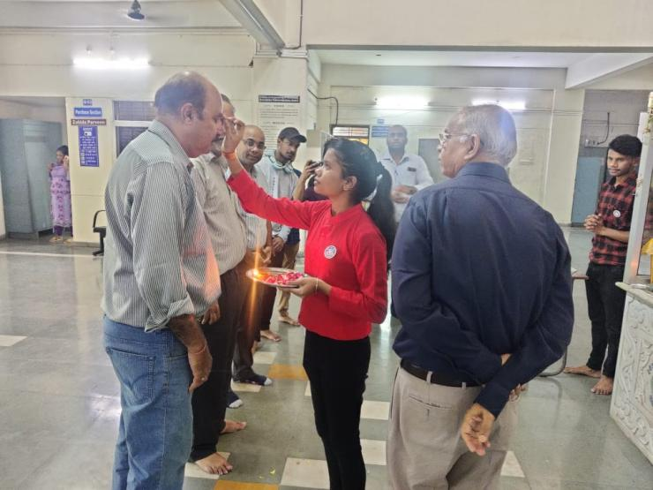

2. Teacher’s Day Celebration
Date | Name  of Inst. | Place | No. of Participants |  | Summary  of the event
 |  |  | students | teachers
05/09/22 | IET- DAVV | M-Block  Auditorium | 130+ | 27 | “The influence of teachers extends beyond the classroom, well into the future.” To commemorate the presence of our guiding lights and mentors for life, the volunteers organized celebration of teacher’s day in the auditorium of M-Block.  The students were joyously engaged in preparations and decorations for the august celebration, program started at 12 O’clock with warm welcome of all teachers with roses and tilak and making the day memorable with wonderful performances of students ranging from stand-ups to music, speeches and poems dedicated to ones who give us the gift of knowledge and skills along with positive influence in our lives.  The program was further made delightful by the team pratyaksh’s nukkad natak performance, which added feathers to the cap of the day. Teachers too appreciated efforts of students and blessed everyone with wishes and message of love and wisdom for the future.  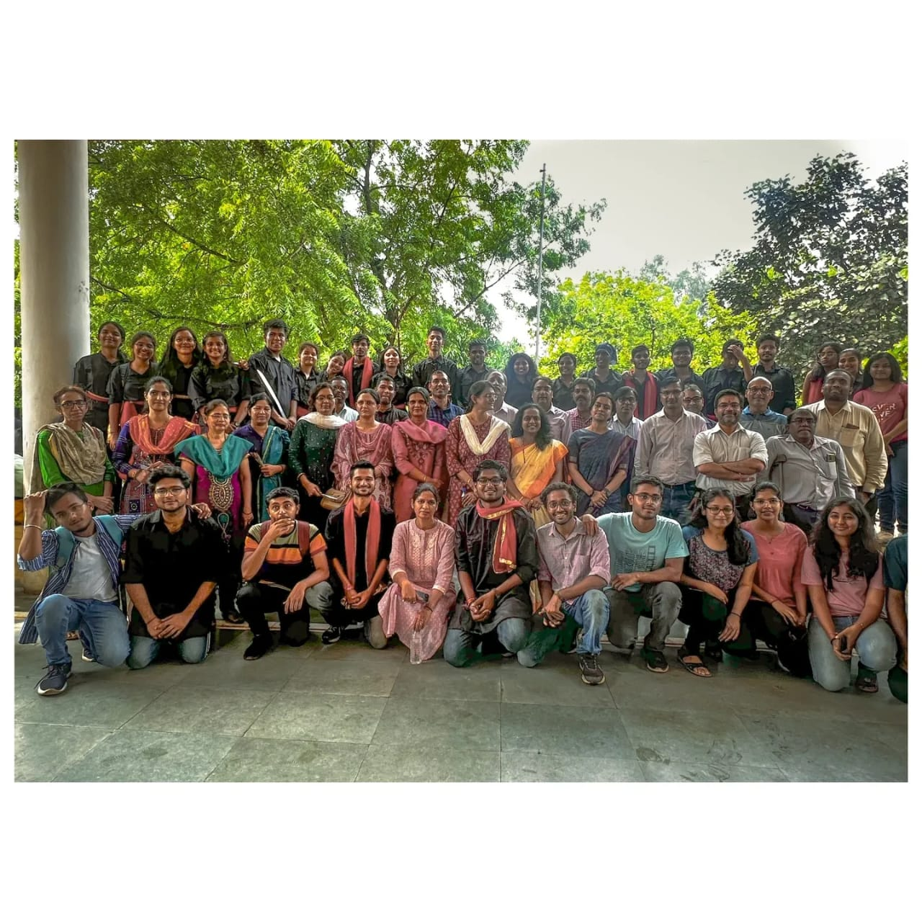

3. NSS Day Celebration + Village Visit
Date | Name of Inst. | Place | No. of Participants |  | Summary of the event
 |  |  | students | teachers
24/09/22 | IET-DAVV | Barlai Jagir Village | 27 | 03 | The greatest way to find yourself is to lose yourself in the service to mankind. With the noble motive of ‘Not me but you’ in mind, the volunteers planned to set out an awareness centered village visit to the adopted village of the institute to celebrate the occasion of NSS Day.  Performing students along with program coordinators arrived at the village panchayat house by afternoon via traveler buses arranged by institute, the topic of awareness was organic farming, sanitization, cleanliness and hygiene, voting rights and importance, girls’ education. Along with performing on the topics of influence at places around the village like school and field, students also interacted with village men and talked about various issues of day to day lives and sustainable solutions to them, they were provided refreshments too by the end of the day. Under the guidance of mentors and travailing efforts of students the event turned out to the successful and most meaningful celebration of the NSS day with lots of learnings and memories that follow along the service.  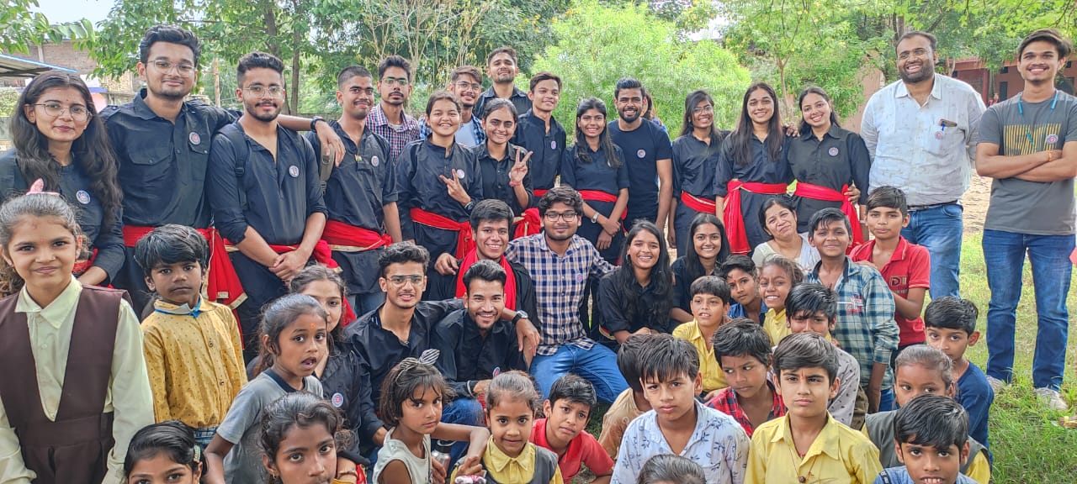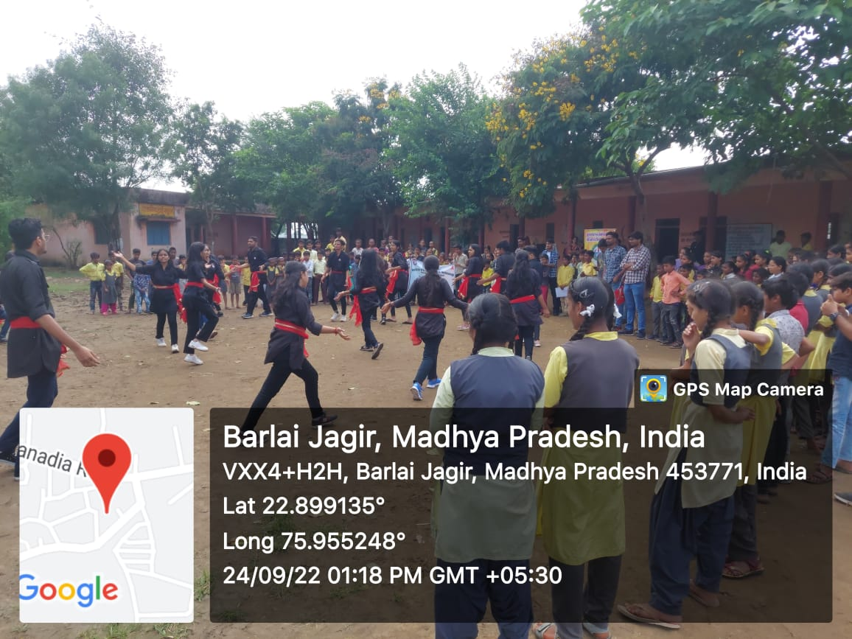  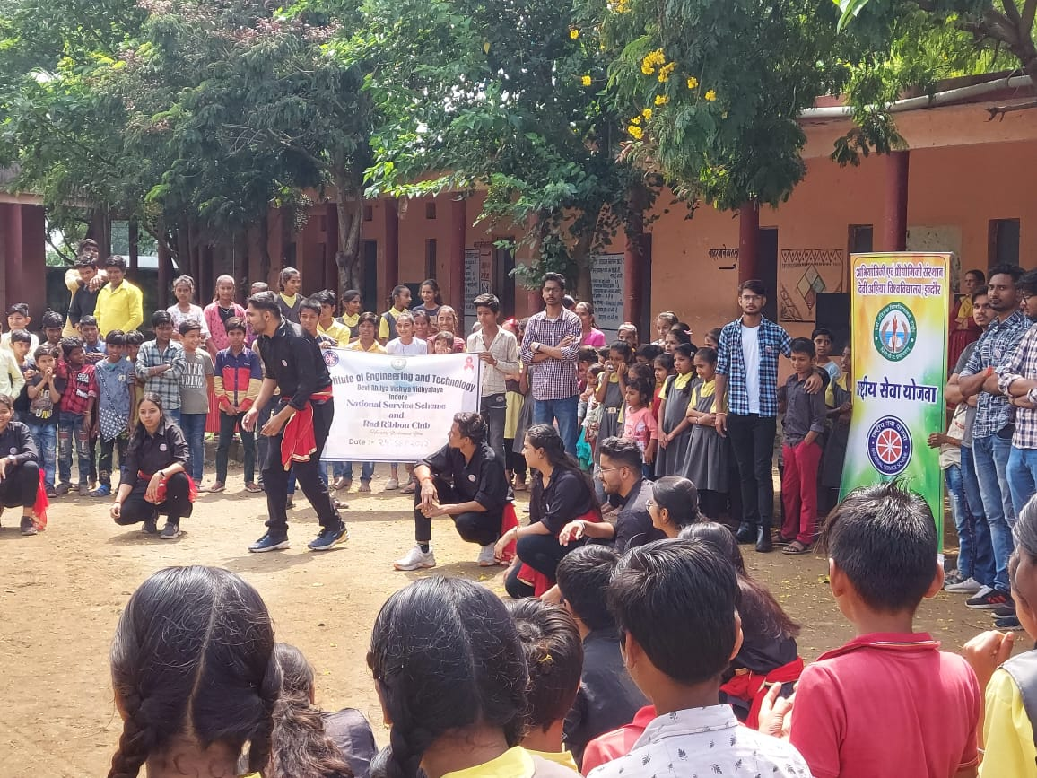

4. GANDHI JAYANTI

Date | Name  of  Inst. | Place | No. Of participants | Summary of the Event
05/10/22 | IET-DAVV | Offline  Mode | 30 | To commemorate Mahatma Gandhi’s (Bapu) 153rd birthday in a special way, the NSS unit of IET DAVV, INDORE, initiated cleanliness drive in and outside the college campus  with the motto of ‘Swaccha Bharat Abhiyan’ .  As a part of regular NSS activities our NSS  unit Organized cleanliness drive in the college Campus aswell as in other cities.  During this activity volunteers cleaned the campus and many students cleaned their  neighbourhood in different cities as well.  They picked up the all plastic garbage from  both sides of road.  The drive was concluded at main gate of our college.  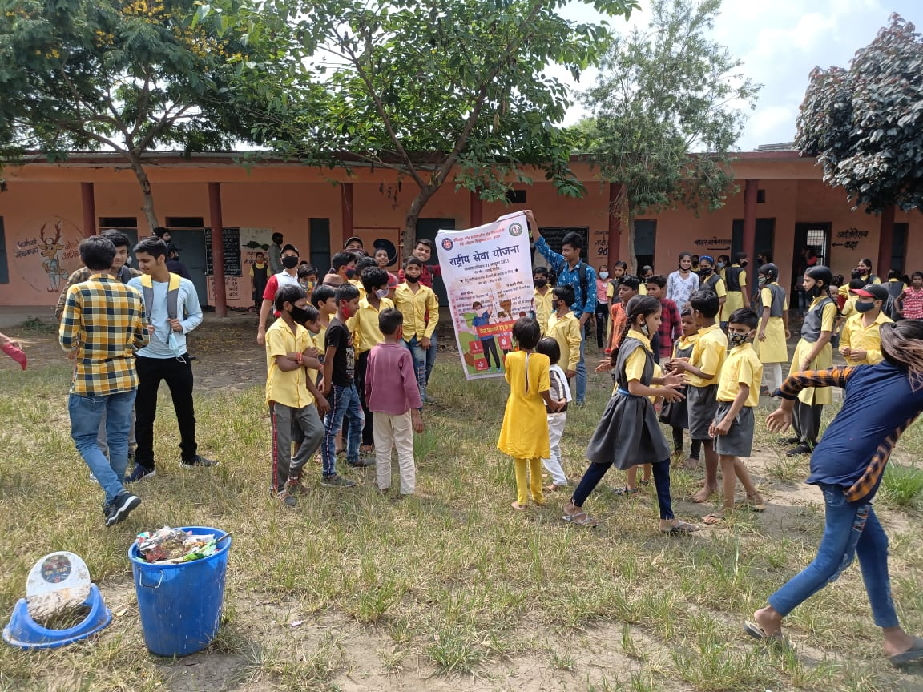

5. Run For Unity and Oath Ceremony

Date | Name  of  Inst. | Place | No. of  Participants |  | Summary of the event
 |  |  | Students | Teachers
31/10/22 | IET-DAVV | Offline | 70 | 25 | As an endeavor to solidify the bond of oneness and unification , the country celebrates the Birth Anniversary of Sardar Vallabh Bhai Patel on 31st October as National Unity day.  So on this auspicious day NSS-DAVV organized an event for whole DAVV family. The event was “Run For Unity and Oath ceremony”.  The run started from the Takshila Main Gate. Honourable VC Dr. Renu Jain mam, Registrar Dr. Anil Sharma sir and Faculty members, Students, NSS volunteers and Staff took the active participation in it. All the people took ’Rashtriya Ekta Diwas Pledge’. The run ended at University Auditorium where regional director Dr.Prakash Garhwal sir spoke few words and sang a song which fueled up everybody present over there .  With the warm support of the faculty and enthusiastic nature of the students , the event was a huge success.  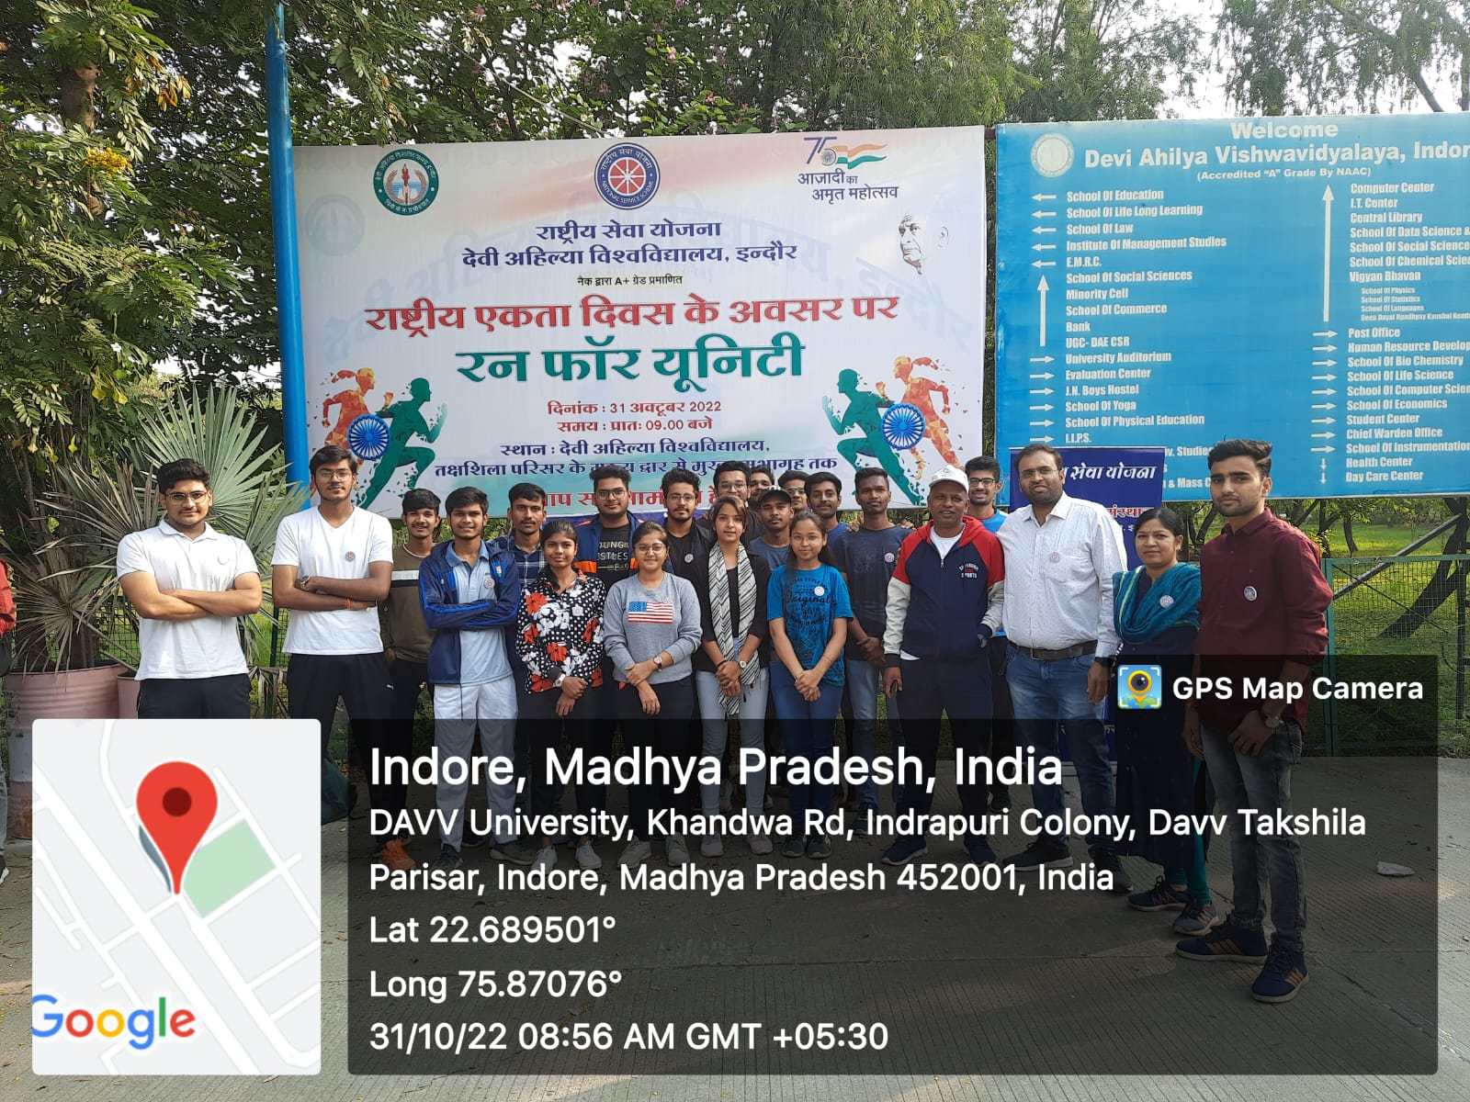

6. Nukkad Natak on Nasha Mukti 2022
Date | Name  of  Inst. | Place | No. of  Participants |  | Summary of the event
16/12/22 | IET-DAVV | Campus+ Bhavarkuan Square | 20 | 02 | 16 दिसंबर को दोपहर 12:00 बजे टंट्या भील चौराहे पर नशा मुक्ति अभियान के अंतर्गत IET-DAVV के छात्र - छात्राओं द्वारा एवं 'नेशनल सर्विस स्कीम (NSS)' और 'प्रत्यक्ष-ड्रामा ग्रुप' के निर्देशन में एक शानदार नुक्कड़ नाटक की प्रस्तुति दी गई। इस दौरान महाविद्यालय की कुलपति श्रीमती रेणु जैन, कुलसचिव महोदय डाॅ.अनिल कुमार शर्मा,कार्यक्रम समन्वयक डाॅ. प्रकाश गढ़वाल,संस्थान के निर्देशक डाॅ. संजीव टोकेकर,कार्यक्रम के अधिकारी राष्ट्रीय सेवा योजना से प्रोफेसर तपेश सरसोदिया एवं प्रोफेसर सीमा चौहान जी सहित करीब 500 दर्शक उपस्थित थे। प्रतिभागी छात्र-छात्राओं ने बड़े उत्साह और सुंदरता के साथ,नशे के दुष्परिणामों एवं उन्हें जड़ से खत्म करने के उपायों की तरफ प्रकाश डाला। नाटक में घरेलू हिंसा, तंबाकू, शराब एवं नशीली पदार्थों के सेवन के दुष्परिणाम बताए गए। इस प्रस्तुति में उपस्थित सभी लोगों को नशा छोड़ने के लिए प्रेरित किया गया एवं सभी लोगों ने स्वयं सेवकों के साथ मिलकर आजीवन नशे से दूर रहने की शपथ ली।  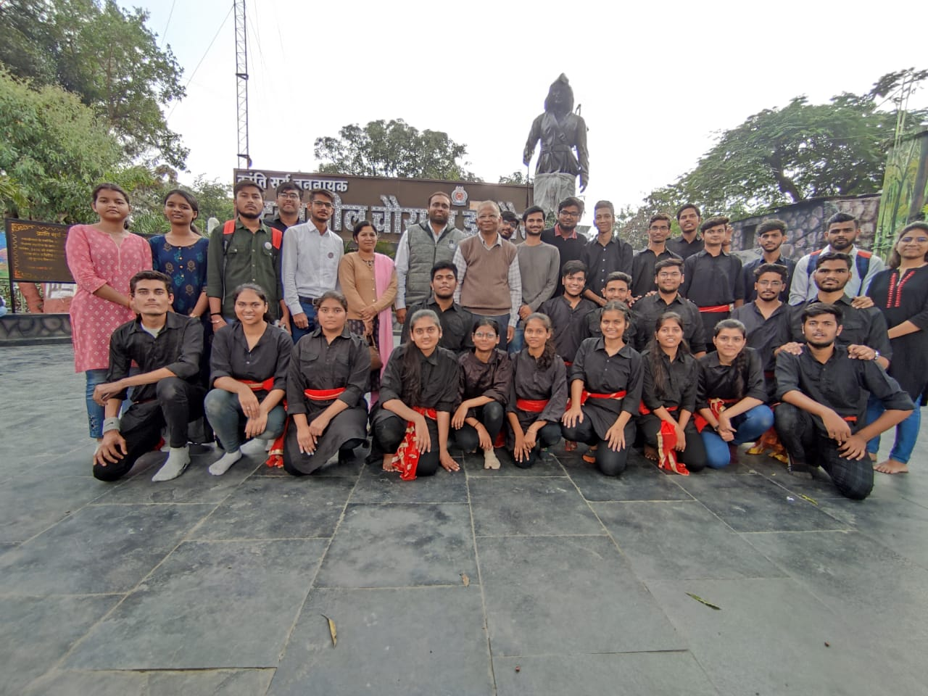

7 Lecture on India’s Scientific Contribution to Freedom Struggle

Date | Name of Inst. | Place | No. of Participants |  | Summary of the event
 |  |  | students | Teachers
17/08/2022 | IET- DAVV | M-Block Auditorium |  |  | On 75th year of India’s Independence, “Azadi ka Amrit Mahotsav”,to commemorate this special day Dr. Rajiv Dixit was invited. He spoke about several unsung scientists and science commutators who were involved in the struggle and challenges during freedom movement of India.  Referring to Plassey Battle in 1757,he pointed out how the Britishers carried out a survey of India scientifically in1767. He also told about Jagdish Chandra Bose,who protested against Britishers by not taking the reduced salary. Like these he told about many more scientists who contributed in India’s freedom struggle.  At the end he concluded that “We should not only limit our celebrations to freedom fighters who sacrificed their life for Independence,but need to remember the vision of those great scientists who stood for their scientific thinking even during the adverse situations.”  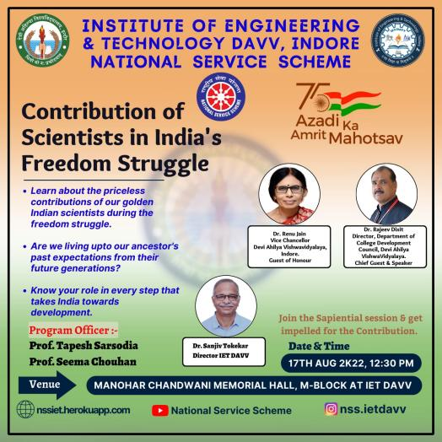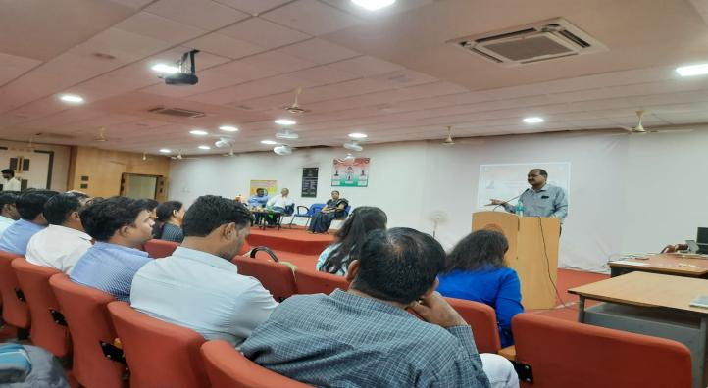

8. Rangoli Making Competition

Date | Name  of Inst. | Place | No. of Participants |  | Summary  of the event
 |  |  | students | teachers
12/09/22 | IET-DAVV | M-Block | 15 | 04 | The best way to express the creativity is through hands and heart filled with art. A rangoli making competition was organized in the M-Block for the NSS Volunteers of not just Institute of Engineering & Technology but all the other departments of DAVV.  The competition started from 12 in the afternoon, students gathered with their colors and equipment to paint the floors with beautiful patterns and sceneries through rangoli art with a given theme of “Ek Bharat Shrestha Bharat”.  They were guided and invigilated by teachers and staff members as well. The criteria of winning were creativity, clarity, cleanliness, time constraint and depth of thought in the creation.  Results were enclosed to be announced later after proper analysis and informed thereafter on community group.  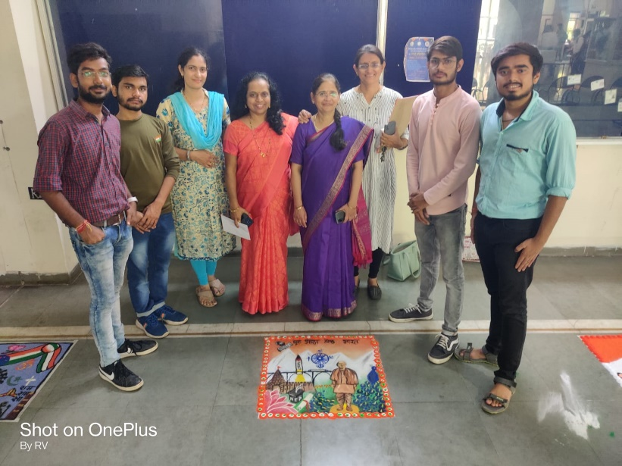

9. Sadbhawna Diwas

Date | Name of Inst. | Place | No. of Participants |  | Summary of the event
 |  |  | students | teachers
20/08/22 | IET- DAVV | Online | 15 | 01 | On 20th august, the birth anniversary of former prime minister Rajiv Gandhi is celebrated as Sadhbhavana Diwas every year. Sadhbhavana means having good feelings for others, So it is also known as harmony day.  Having good feelings for others was the only the mission of the government of Rajiv Gandhi. This day is observed to encourage the national integration, peace, affection and communal harmony among the Indian people of all religions.  On this day, To commemorate the birth of former prime minister Rajiv Gandhi, NSS team gathered in which teachers and volunteers both are included to take the plegde for resolving differences and to keep peace  against each and every differences.  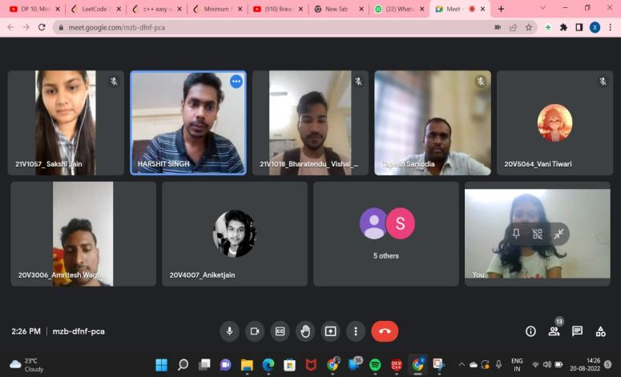

10. Rangoli Making Competition
Date | Name  of Inst. | Place | No. of Participants |  | Summary  of the event
 |  |  | students | teachers
12/09/22 | IET-DAVV | M-Block | 15 | 04 | The best way to express the creativity is through hands and heart filled with art. A rangoli making competition was organized in the M-Block for the NSS Volunteers of not just Institute of Engineering & Technology but all the other departments of DAVV.  The competition started from 12 in the afternoon, students gathered with their colors and equipment to paint the floors with beautiful patterns and sceneries through rangoli art with a given theme of “Ek Bharat Shrestha Bharat”.  They were guided and invigilated by teachers and staff members as well. The criteria of winning were creativity, clarity, cleanliness, time constraint and depth of thought in the creation.  Results were enclosed to be announced later after proper analysis and informed thereafter on community group.

11. AIDS Day Human Chain Event 2022

Date | Name of Inst. | Place | No. of  Participants |  | Summary of the event
 |  |  | students | teachers
01/12/22 | IET-DAVV | Campus Main Gate | 150 | 02 | “The greatest power in the universe is the man with purpose.”  Showcasing this noble perspective in mind, NSS Volunteers organized a human chain event in the campus of IET DAVV.  On the occasion of AIDS Day, the students decided to make awareness of this life-threatening disease affecting millions of people worldwide, with the grace of teachers and massive participation, formation of human chain began at the main gate of campus.  Around 150 students along with teachers under guidance of Sir Tapesh Sarsodia stood with holding hands in consistent formation and through banners, posters and mediums of speech made people aware of the need to counter this disease.  Through the massive participation and enthusiasm of students for an awareness drive, the program turned out to be successful accomplishment in the endeavors of NSS IET DAVV.
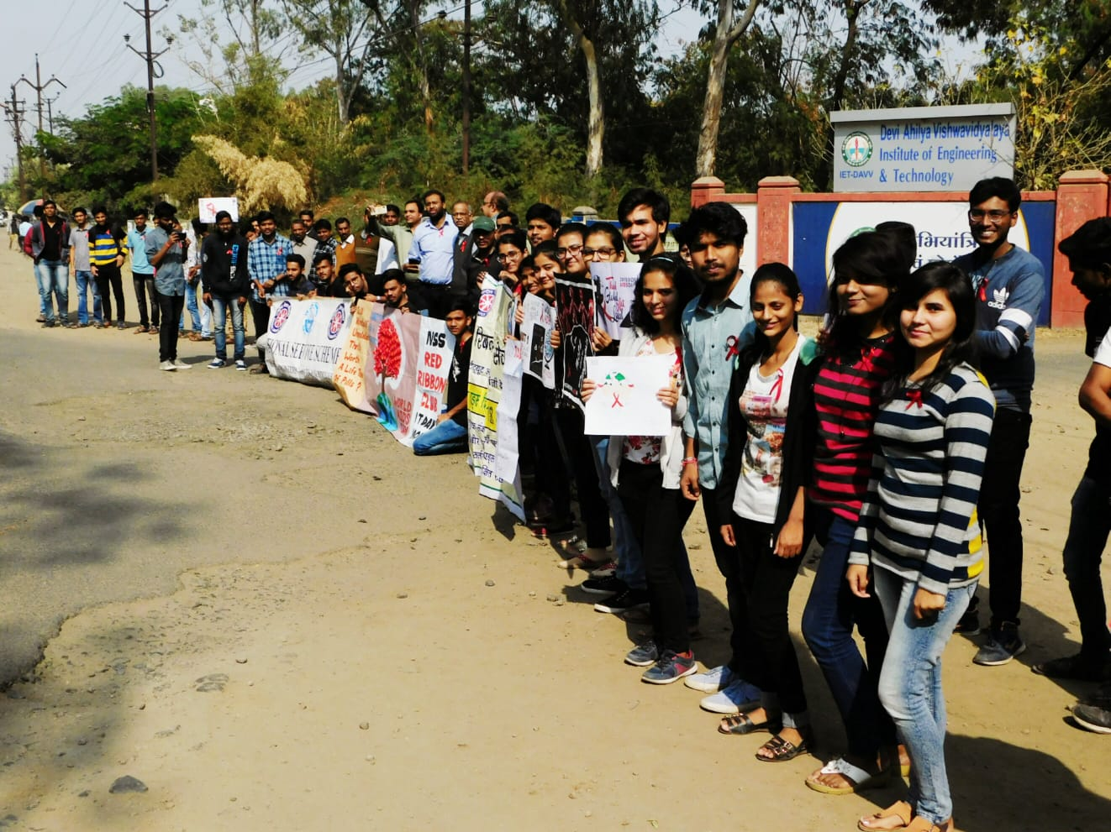 | 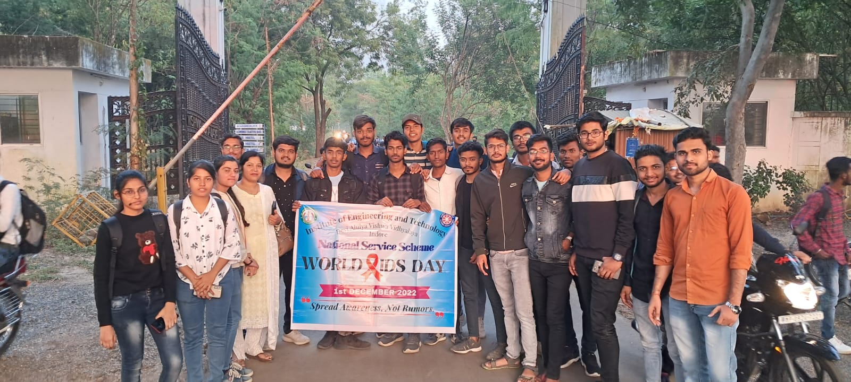

Date | Name  of  Inst. | Place | No. of  Participants |  | Summary of the event
 |  |  | Students | Teachers
17/02/23 | IET-DAVV | M-Block  AUDITORIUM | 50 | 4 | The NSS IET-DAVV team organized a special enlightening session on "Facing Life Problems" with the well-known Youth Mentor and Motivational Speaker His Grace Krishnapada Das Ji to help the students resolve their issues and find serenity in light of the rising mental pressure in today's society.  As is customary, the session began with the Kulgeet of the Vidyalaya and was followed by the lamp-lighting ceremony in front of Maa Saraswati. The session continued as Guruji shared his knowledge and inspired the students as they worked to build their confidence. He advised them to maintain their composure and adhere to their goals if to succeed in life.  By comparing the human mind and intellect to a charioteer and the soul to the rider on a chariot (human body) driven by the horses (Senses), he further clarified the significance of one's ability to control their senses when they are exposed to materialistic pleasures.  Guruji spoke to students about his organization, which provides food and educational opportunities for those who are less fortunate. He also guided the students in building a connection with their inner consciousness.  Everyone joined Guruji in chanting the holy name of Krishna and he responded to their questions as the session came to a close leaving the students enlightened and happy.

12 Blood Donation and Awareness Campaign

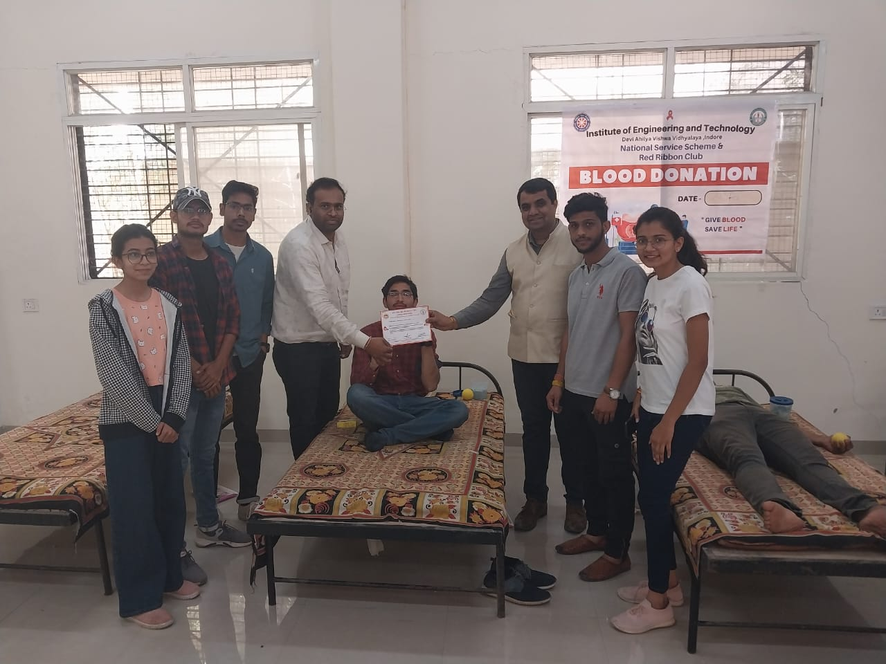 | 