**1.1.1 Curricula developed /adopted have relevance to the local/ national / regional/global developmental needs with learning objectives including Programme outcomes, Programme specific outcomes and course outcomes of the entire Programme offered by the University.**

**Answer:**

In view of the diversified platforms and unique evolutionary history of Devi Ahilya University, Indore, matched with integration of innovative practices, all the stakeholders work in rhythm to treat knowledge as a prominent vehicle of empowerment. University believes strongly in following healthy practices so that students often float their queries at appropriate platforms and upgrade their proficiency through a blend of short term and long term goals. With a galaxy of wide range of faculties - Management and Commerce, Engineering and Technology, Physical Sciences, Life Sciences, Arts, Social Science, Physical Education - a spirit of out-of-the-box thinking is encouraged to explore the hitherto less explored avenues, with holistic vision and greater respect for classification over compartmentalization. The University projects itself as an active centre of learning with provision of cross-breeding of ideas. The philosophy of university lies in the:

**“Transformation of an Empty Mind into Open Mind”**

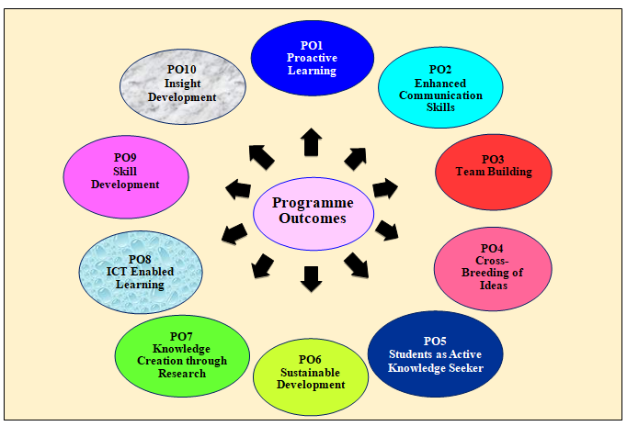

**PO1:** To inculcate the spirit of proactive learning among students so that they are empowered to explore the true potential of knowledge.

**PO2:** Students develop capabilities to think independently in English as well as in Hindi so as to connect with respective scenarios in an obvious mode.

**PO3:** To provide opportunities for students to evolve suitable attitudes and attributes for effective working in a team so that conversion of energy into synergy is ensured.

**PO4:** To get involved in thought provoking discussions so as to explore different facets of knowledge on the basis of contextual relevance and need based arrangements.

**PO5:** To inculcate the work culture oriented towards rigorous academic environment conducive to motivate the students to become active knowledge seekers.

**PO6:** To envision sustainable development with high priority so that meaningful utilization of resources is worked out and environmental issues are also properly addressed.

**PO7:** To recognize the importance of knowledge creation through research which provides the needed forward momentum to the overall academic scenario.

**PO8:** To promote wide spread and deep rooted use of ICT devices to be in active touch with the contemporary knowledge practices and to orient the students for emerging avenues of knowledge.

**PO9:** To promote the importance of skill development and to apply it in forthcoming situations of life with highest focus on smooth compliance.

**PO10:** To develop a critical insight for effectiveness as well as efficiency and to apply them meaningfully for enjoyable journey towards natural ecosystem

**\*\*\*\*\*\*\*\*\*\*\*\*\***