fnukad% 11.05.2019

This is to certify that university is presently (2018-19) offering 195 number of programs in its 29 teaching departments. Name of the Departments and programs offered are listed below:
Details | 2018-19 | 2017-18 | 2016-17 | 2015-16 | 2014-15 | 2013-14
Number of Programs | 195 | 175 | 170 | 170 | 168 | 166
Number of Department offering Academic programs | 29 | 29 | 29 | 29 | 28 | 28
* DDU Kaushal Kendra (earlier Community College) was started in the academic session 2015-16.
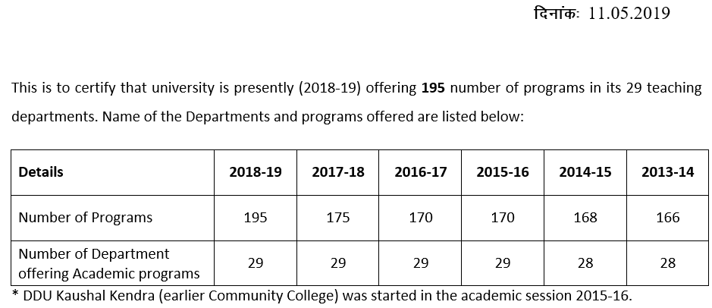


dqylfpo


