

**DEVI AHILYA VISHWAVIDYALAYA, INDORE**



**P`aat:smarNaIya puNyaSlaaok laaokmaata dovaI Aihlyaabaa[- haolakr**

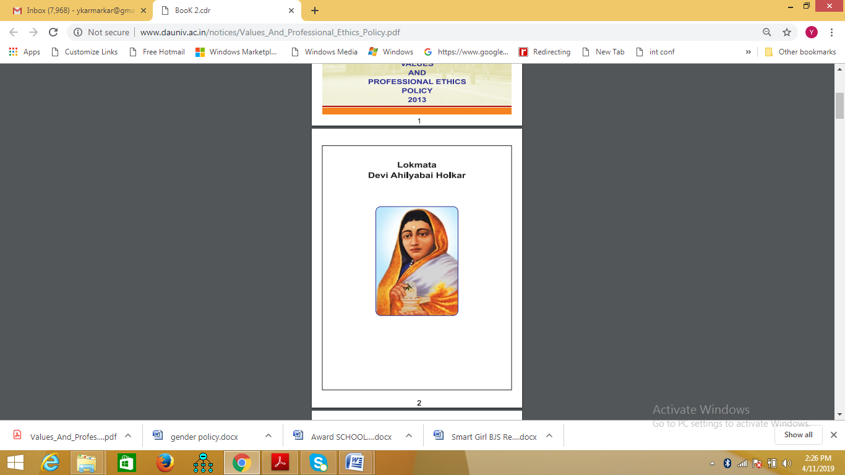

**“sa%ta ko bala pr maOM jaao kaya- k$MgaI ]saka javaaba mauJao [-Svar kao donaa haogaa.”**

**DEVI AHILYA VISHWAVIDYALAYA, INDORE**



**PREAMBLE-**

Devi Ahilya Vishwavidyalaya is a State University recognized under 12 (B) and 2(F) of University Grants Commission. The University is imparting education to approximately 10,500 students in regular courses through 37 schools and centre’s of study. University is having 1150 faculty members and 850 supporting staff to manage the activities of the university. As per the guidelines of University Grants Commission it is essential to develop a safe and secure and cohesive learning environment in the University campus. Keeping in line with it, the University has framed a generalized policy for understanding the concept of gender equality and its related issues.

**MAY ALL WOMEN IN THIS UNIVERSITY BE INSPIRED BY LOKMATA AHILYA BAI HOLKAR**

**DEVI AHILYA VISHWAVIDYALAYA, INDORE**



**INTRODUCTION**

At DAVV Gender equality especially pertains to gender sensitization towards all stakeholders. These stakeholders include students (boys/girls), faculty members (Male/female), employees (Male/Female) and administrators (male/female). DAVV believes in imparting equal ease of access to the existing resources opportunities, economic participation and decision making irrespective of gender. The main aim of development and execution of the policy is to develop highly cohesive environment in University by enhancing the personal ability and thinking of stakeholders without rigid gender discrimination.

**DEVI AHILYA VISHWAVIDYALAYA, INDORE**

**OBJECTIVES**

To fulfill this aim following objectives have been laid down:

1. To create awareness amongst the stakeholders about their social, cultural, economic, political and institutional rights.
2. To promote a culture of respect and equality for gender especially towards women.
3. To promote women for undertaking high quality research and academic activities.
4. To organize various seminars, workshops and other activities from time to time.
5. To inculcate strong leadership quality and capacity building amongst stakeholders so as to participate in decision making effectively.
6. To eliminate the harassment on the basis of gender.

**DEVI AHILYA VISHWAVIDYALAYA, INDORE**

**SUGGESTED ACTIVITIES**

To achieve aforementioned objectives, the University aims to conduct related activities regularly:

* Workshops on PNDT act, prevention of Sexual Harassment at work place.
* Seminars on harmonious environment in academic institutional campus.
* Debates and elocution on discrimination of gender issues such as women empowerment, reservation policy, character building and ethics.
* Poster competition on gender equality.
* Training related to Gender Sensitization for teachers and students.
* Expert lectures on fundamental rights, legal remedies etc.
* Other suitable activities in collaboration with related institutions.

These activities may be included in the umbrella of “*Devi Ahilya ‘Women First’ program”.*

**EXPECTED OUTCOME**

The stakeholders will have the awareness about their rights thereby building up their confidence for effective decision making. The implementation of related activities will enhance perspectives and conceptual clarity on gender issues thereby developing a conducive environment in the campus.

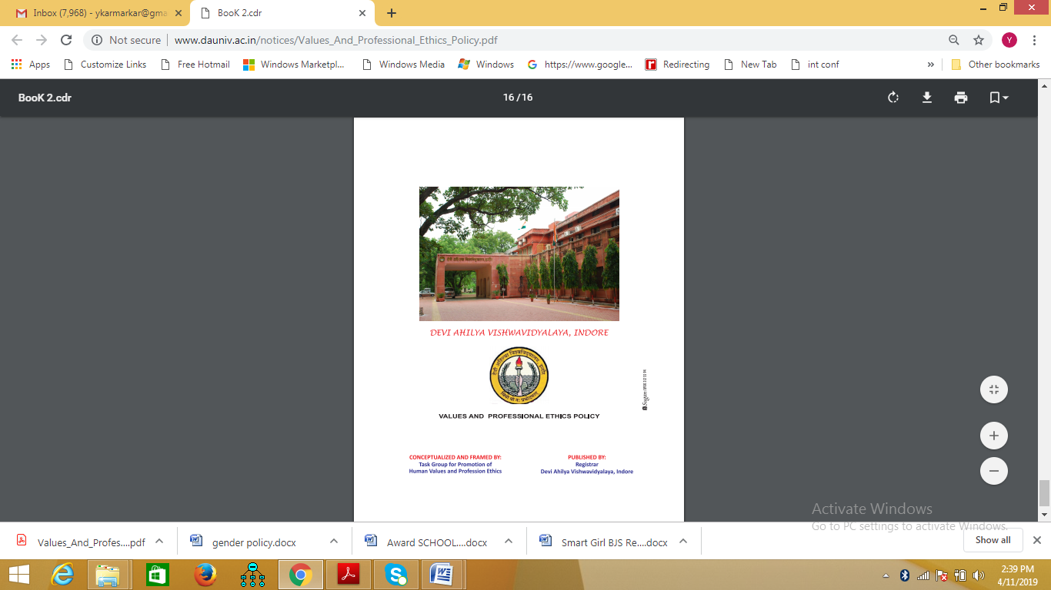



**GENDER EQUALITY POLICY**