fnukad% 08.03.2019

The list of value added courses is given below. The students of Devi Ahilya Vishwavidyalaya, Indore may opt for more than one of the Value added courses.
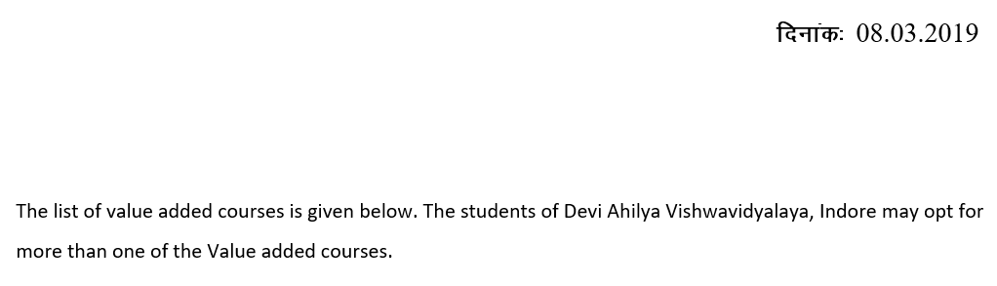
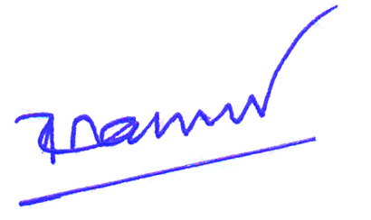

dqylfpo


