This is to certify that following number of teachers of the University were provided with financial support to attend conferences/workshops and towards membership fee of professional bodies during last five years:
Year | 2013-14 | 2014-15 | 2015-16 | 2016-17 | 2017-18
Number of Teachers | 27 | 35 | 49 | 36 | 29

dqylfpo

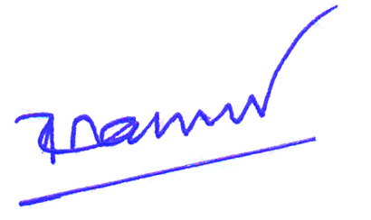
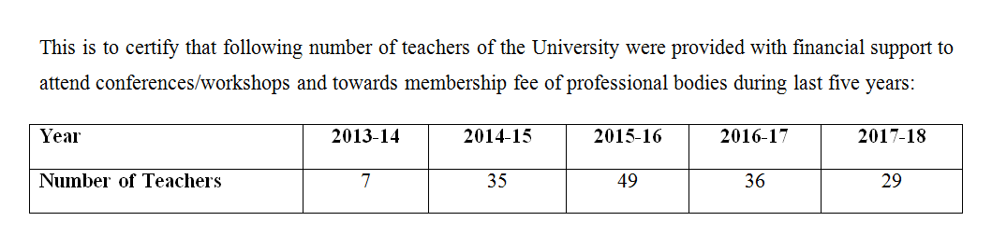
dqylfpo
