**DEEN DAYAL UPADHYAY KAUSHAL KENDRA**

**D.A.V.V., INDORE**

**Basic Computer Hardware Maintenance**

10 May 2018 to 23 May 2018

|  |  |  |
| --- | --- | --- |
| **S No.** | **Name** | **Designation** |
|  | Abhishek Dhande | Student |
|  | Aditya Girothia | Student |
|  | Apurv Bargale | Student |
|  | **Arpit Agrawal** | **Faculty, IET** |
|  | Atharv Pandit | Student |
|  | **Atul Kaushal** | **Non teaching, IMS** |
|  | **Avdesh Verma** | **Non teaching, IMS** |
|  | Chandni Porwal | Student |
|  | Harshit Porwal | Student |
|  | **Himanshu Vyas** | **SCSIT, Faculty** |
|  | **Javed Munir Khan** | **Non-teaching, SCSIT** |
|  | Mohd Fateen Farooqui | Student |
|  | **Nandkishore Wagh** | **Non-teaching, SOEx** |
|  | Nivedita Bobade | Student |
|  | **Pankaj Jagtap** | **SCSIT, Faculty** |
|  | Prakhar Vyas | Student |
|  | Rajesh Saway | Student |
|  | **Rajesh Zope** | **Non-Teaching, IET** |
|  | Ravi Kumar Verma | Student |
|  | **Shantilal Dawar** | **SCSIT, Faculty** |
|  | Shreedhar Soni | Student |

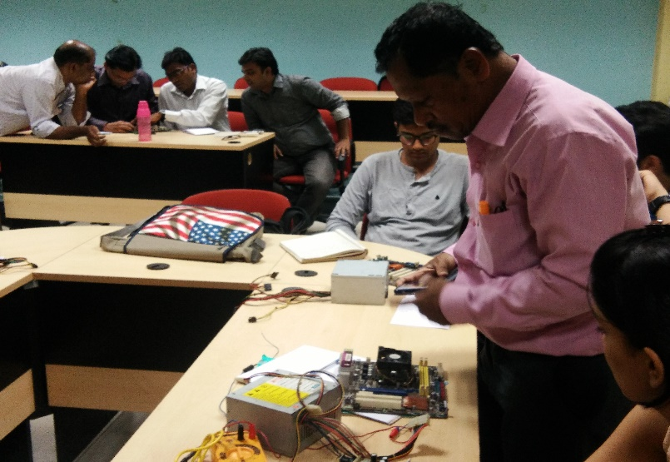 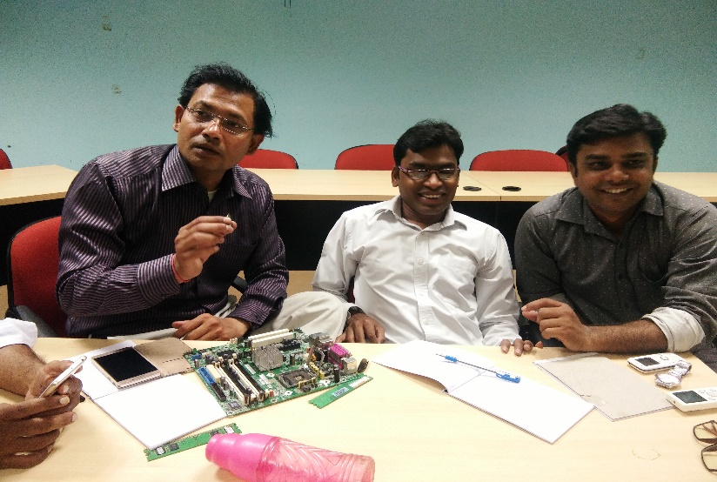

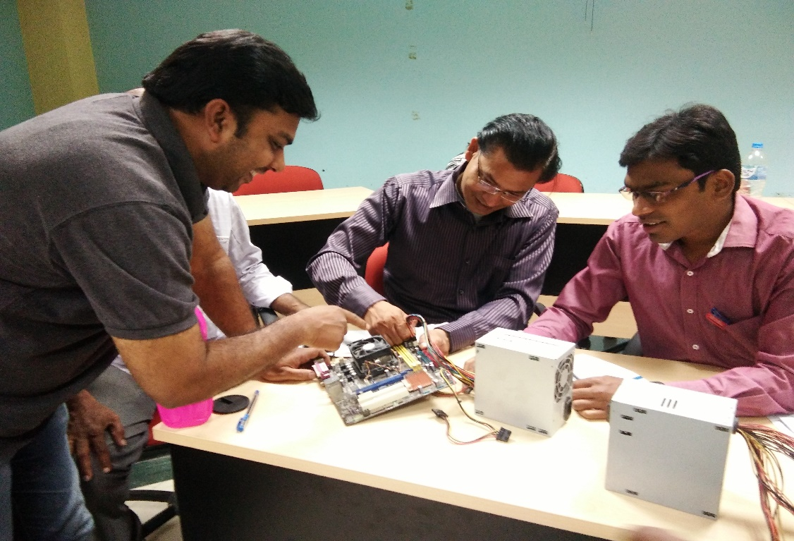

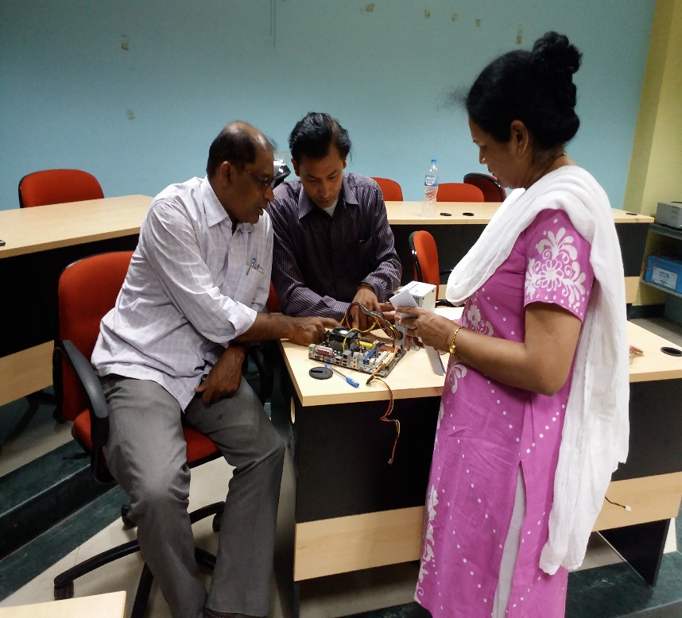 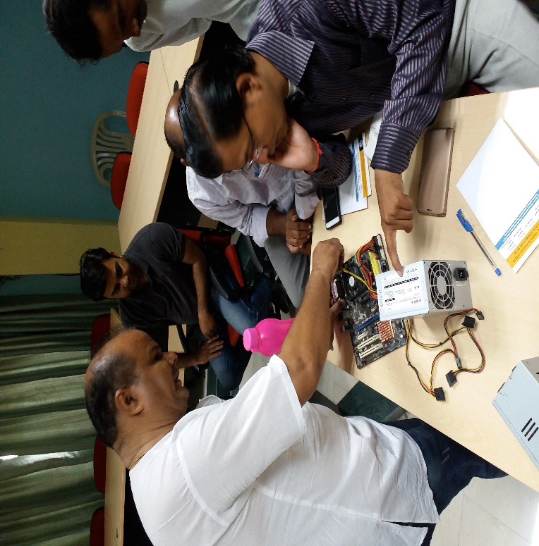

**DEEN DAYAL UPADHYAY KAUSHAL KENDRA**

**D.A.V.V., INDORE**

**Awareness on Healthy Snacks & Beverages**

02-Jun-18

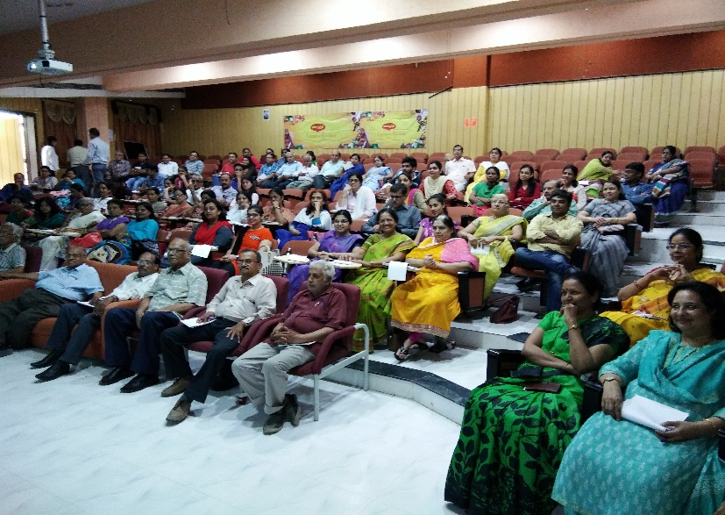 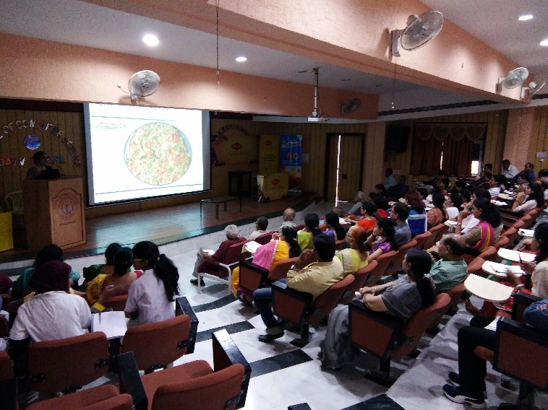

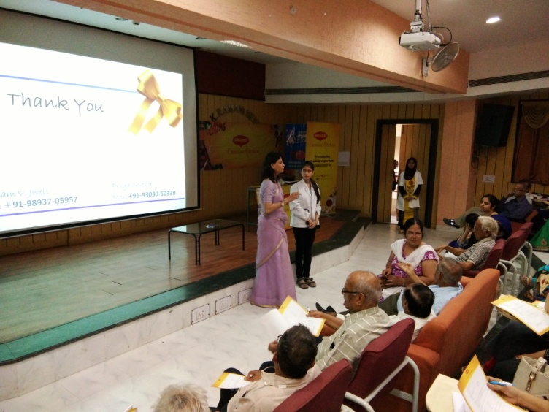

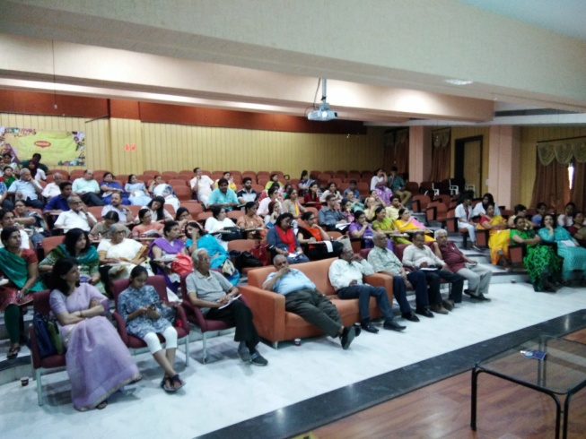 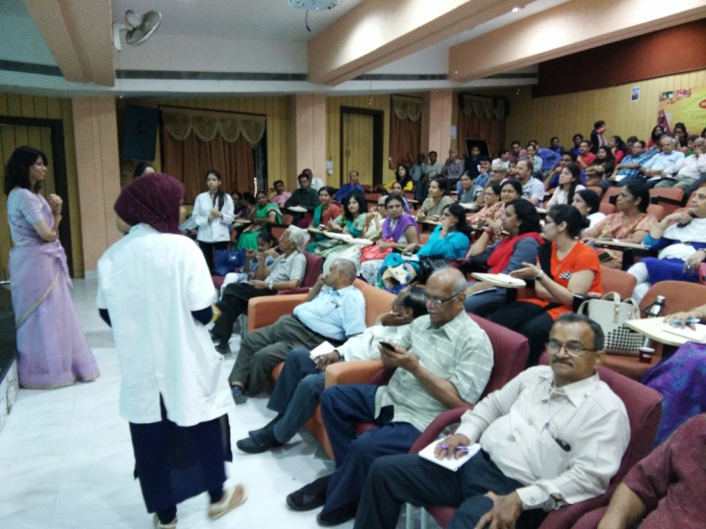

**DEEN DAYAL UPADHYAY KAUSHAL KENDRA**

**D.A.V.V., INDORE**

**Two Weeks Workshop on**

**Network Routing & Switching**

02 July 2018 to 14 July 2018

|  |  |  |
| --- | --- | --- |
| **S.No** | **Name** | **Designation** |
|  | Aditya Bagdare | Student |
|  | Atharv Pandit | Student |
|  | Chandni Porwal | Student |
|  | **Dr. Jagdish Raikwal** | **Faculty** |
|  | **Dr. Nitin Nagar** | **Faculty** |
|  | **Dr.Vivek Shrivastava** | **Faculty** |
|  | **Javed Munim Khan** | **Non teaching** |
|  | **Jumana Balwaniwala** | **Faculty** |
|  | **Kaushlesh Singh Shakya** | **Non teaching** |
|  | Manish Rathod | Student |
|  | Meenal Vijayvargiya | Student |
|  | **Naresh Dembla** | **Faculty** |
|  | Nikita Khare | Student |
|  | **Pankaj Jagtap** | **Faculty** |
|  | **Pooja Gulganwa** | **Faculty** |
|  | **Poonam Mangwani** | **Faculty** |
|  | **Prachi Pandey** | **Faculty** |
|  | **Pradeep K Jatav** | **Faculty** |
|  | Prati Dubey | Student |
|  | Pratiksha Nigam | Student |
|  | Ravi Kumar Verma | Student |
|  | **Rupesh Sendre** | **Faculty** |
|  | Sakshi Yadav | Student |
|  | Shahrukh Khan | Student |
|  | **Shantilal Dawar** | **Faculty** |
|  | Shivali Bajaj | Student |
|  | Simpi Kumari | Student |
|  | **Sunita Gaur** | **Faculty** |
|  | Varsha Garg | Student |
|  | **Yogendra Singh Bawal** | **Non teaching** |

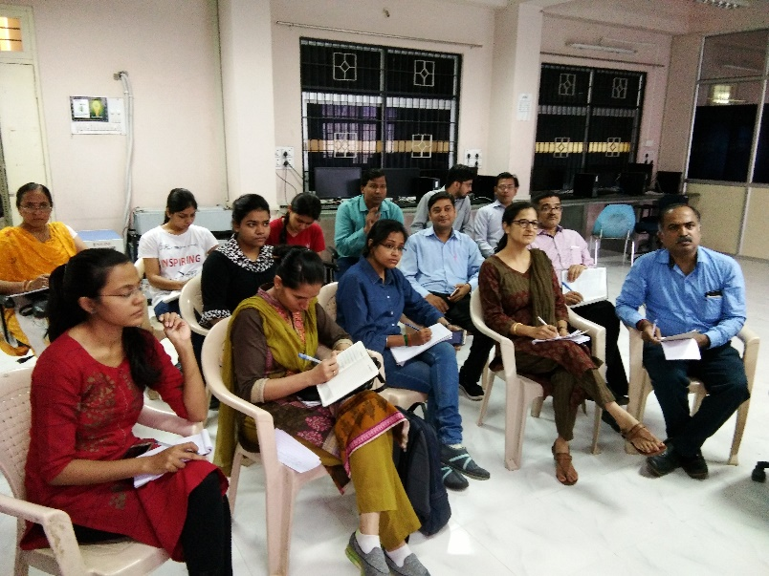 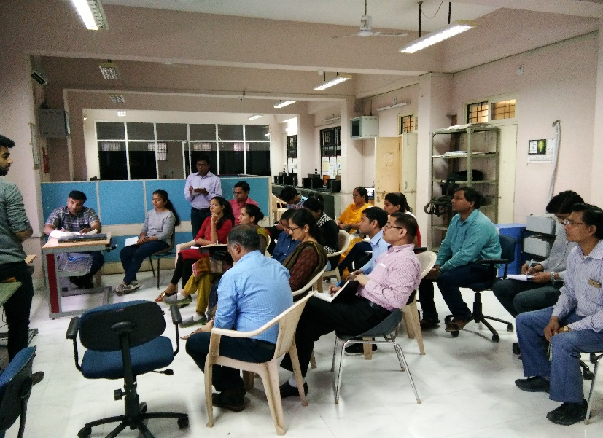

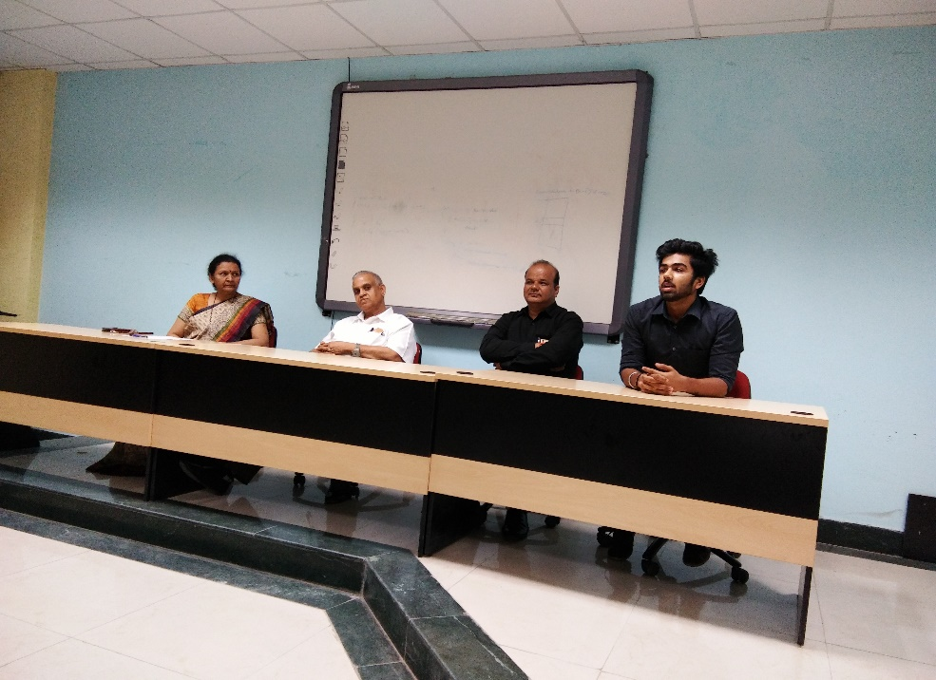

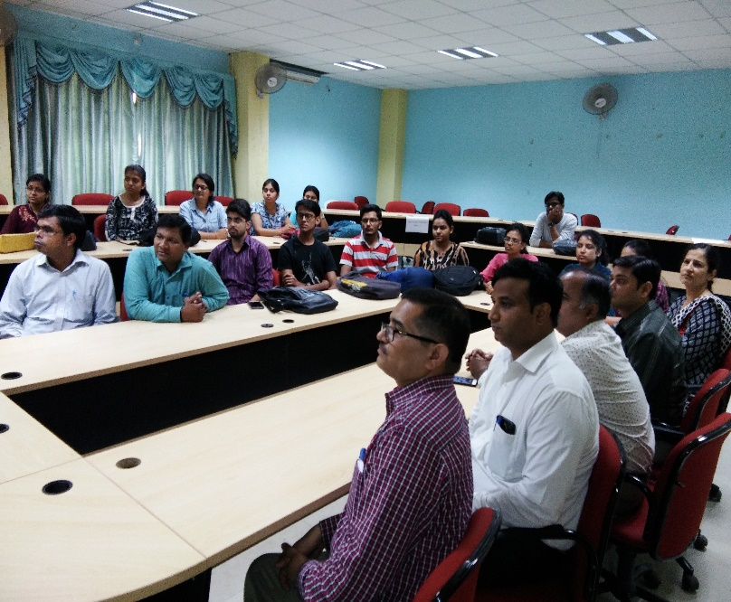 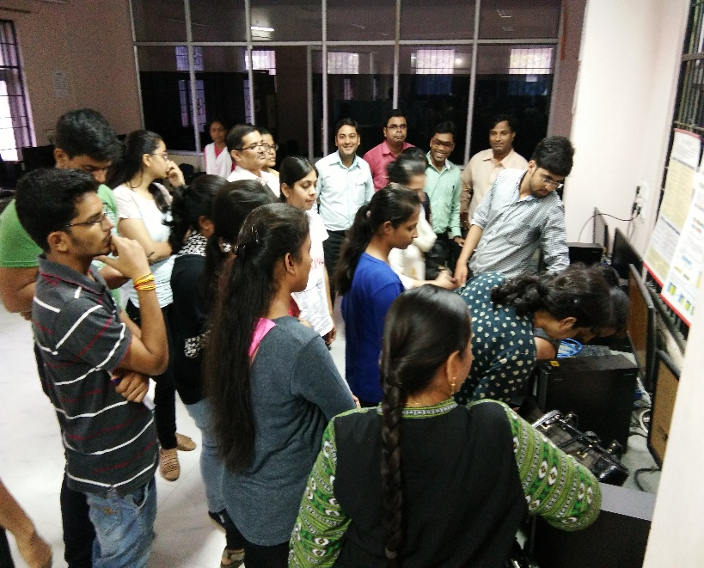

**DEEN DAYAL UPADHYAY KAUSHAL KENDRA**

**D.A.V.V., INDORE**

**Website Design & Development**

6-27 August 2018

|  |  |  |
| --- | --- | --- |
| **S.No** | **Name** | **Designation** |
|  | Aditya Dixit | Student |
|  | Akshata Acharya | Student |
|  | Akshita Jain | Student |
|  | Amrata Pathak | Student |
|  | Astha Sharma | Student |
|  | Chandra Prakash Mewari | Student |
|  | Deepak Kestwal | Student |
|  | Deepika Agnihotri | Student |
|  | Dilip Jadam | Student |
|  | **Dr. Madhulika Verma** | **Faculty** |
|  | **Dr. Shraddha Mashi** | **Faculty** |
|  | Jay Chak | Student |
|  | Kamini Patel | Student |
|  | Lucky Gupta | Student |
|  | Manish Kumar Patidar | Student |
|  | Meenal Verma | Student |
|  | Namrata Jain | Student |
|  | Nandini Joshi | Student |
|  | Nidhi Mandloi | Student |
|  | Nikita Khare | Student |
|  | Nikita Pare | Student |
|  | Nilesh Sharma | Student |
|  | Nisha Singh | Student |
|  | Palak Joshi | Student |
|  | Poonam Tanwar | Student |
|  | Prachi Soni | Student |
|  | Pragati Nayak | Student |
|  | Priyal Jain | Student |
|  | Priyanka Jaiswal | Student |
|  | **Priyesh Hardia** | **No teaching** |
|  | Purnima Thakur | Student |
|  | Pushpendra Billore | Student |
|  | Raveena Patidar | Student |
|  | Rohit Solanki | Student |
|  | Sagar Srivastava | Student |
|  | Sakshi Wadurkar | Student |
|  | Shivani Jaiswal | Student |
|  | Shivani Verma | Student |
|  | Shrashti Ajmera | Student |
|  | Shubham Shrivastava | Student |
|  | Shubhangi Vaishnv | Student |
|  | Shubhangi Wadekar | Student |
|  | Shweta Shukla | Student |
|  | Sneha Rani Chaurasia | Student |
|  | Snigdha Ganguly | Student |
|  | Sonika Patel | Student |
|  | Srishti Bagga | Student |
|  | Sunaina Ranglani | Student |
|  | Swati Patidar | Student |
|  | Tarun Carpenter | Student |
|  | Vaishali Sarathe | Student |
|  | Vikas Toppo | Student |
|  | Vinay Rajput | Student |
|  | Yasha Raghuwanshi | Student |
|  | Yashwardhan Singh Rathore | Student |

**DEEN DAYAL UPADHYAY KAUSHAL KENDRA**

**D.A.V.V., INDORE**

**Zangle/ Doodle Art**

23-25 Oct 2018

|  |  |  |
| --- | --- | --- |
| **S.NO** | **Name** | **Designation** |
|  | Aayush Jangid | Student |
|  | Ankita Tripathi | Student |
|  | Anuj Pramal | Student |
|  | **AR. Ruchira Jain** | **Faculty** |
|  | Bhavana Salkade | Student |
|  | Chandni Asnani | Student |
|  | Charvee Khamgaonkar | Student |
|  | Dr. Ruma Shukla | Student |
|  | Eshika Raghuvanshi | Student |
|  | Fatima Qureshi | Student |
|  | Gaurav Chopra | Student |
|  | Gunita Risbud | Student |
|  | Hardiki Sharma | Student |
|  | Kajal Gupta | Student |
|  | Kartik Pawar | Student |
|  | Krishna Chawre | Student |
|  | Kumail Ali | Student |
|  | Kush Sharma | Student |
|  | Megha Jadiya | Student |
|  | Milind Deshpande | Student |
|  | Mohit Gattani | Student |
|  | **Mrs. Poonam jwell** | **Faculty** |
|  | Mrs. Preeti Shridhar Kasbekar | Student |
|  | Mrs. Rohini Kalele | Student |
|  | Mrs. Seema Verma | Student |
|  | Nafisa Kapadia | Student |
|  | Naima Khan | Student |
|  | Namrata Dheman | Student |
|  | Nandini Verma | Student |
|  | Nitin Dabi | Student |
|  | Pragya Barue | Student |
|  | Pranav Sharma | Student |
|  | Priyanshi Chouhan | Student |
|  | Rakhi Gupta | Student |
|  | Rinshu Agrawal | Student |
|  | Riya Gupta | Student |
|  | Ruchira Rakhe | Student |
|  | Rupali Govind Joshi | Student |
|  | Sailee Deo | Student |
|  | Saloni Tiwari | Student |
|  | Sandhya Shah | Student |
|  | Sanskriti Pandey | Student |
|  | Shivani Pawar | Student |
|  | Shruti Verma | Student |
|  | Shruti Saptaputre | Student |
|  | Sneha Kasera | Student |
|  | Sumeet kalsekar | Student |
|  | Surbhi Behere | Student |
|  | Tarun Kumawat | Student |
|  | Tushina Trivedi | Student |
|  | Twinkle Yadav | Student |
|  | Vapika Sethi | Student |
|  | Veethika Acharya | Student |
|  | Vishal Nagre | Student |

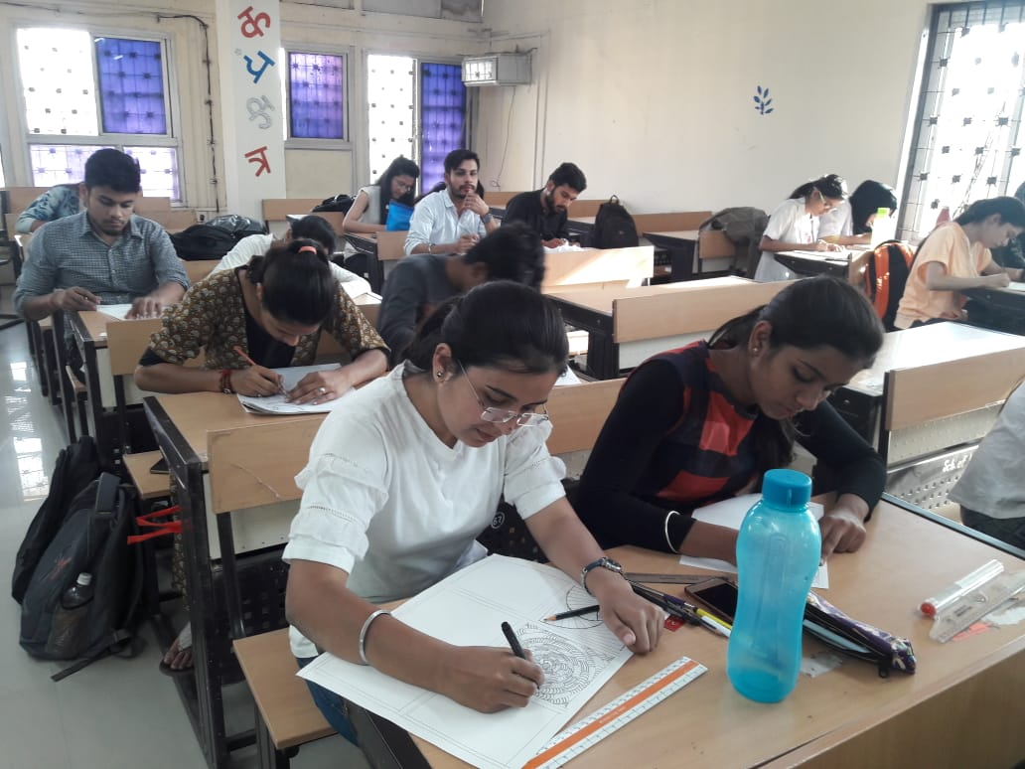 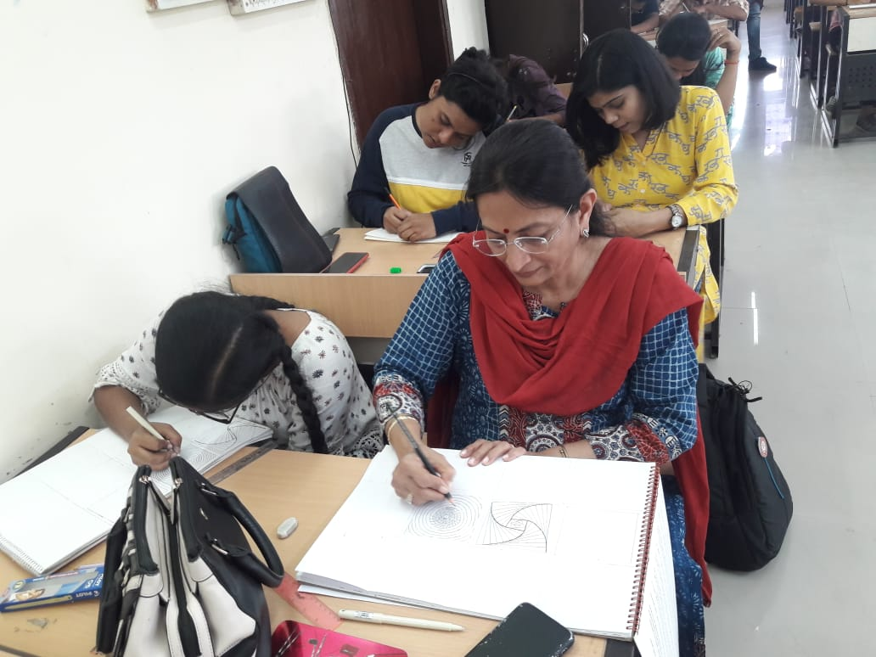

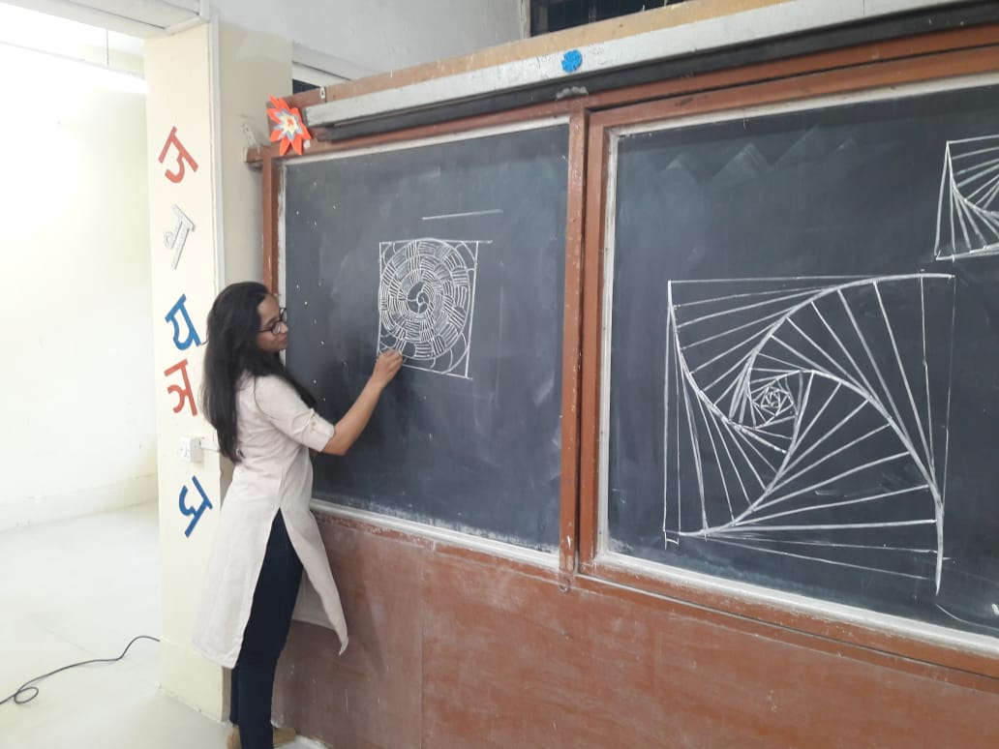

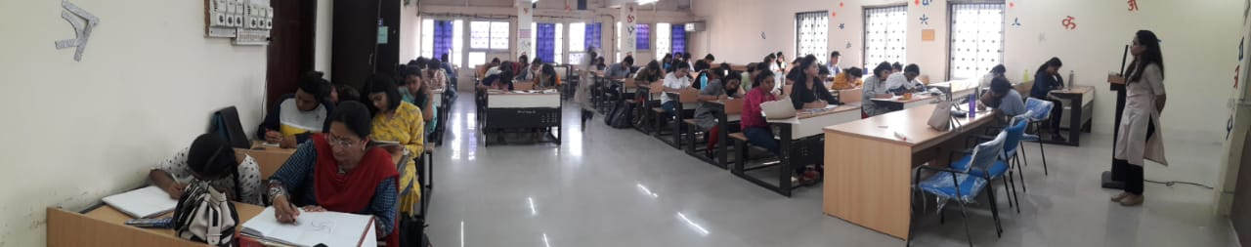

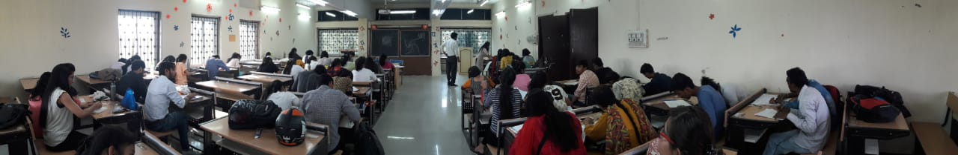

**DEEN DAYAL UPADHYAY KAUSHAL KENDRA**

**D.A.V.V., INDORE**

**Entrepreneurship Development Program**

15-30 Nov 2018

