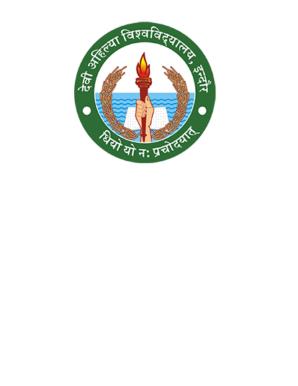

**Devi Ahilya Vishwavidyalaya, Indore**

**7.1.1**

**A Report on**

**Gender Equity Promotion Programs**