**WORKSHOP ON KALAMKARI PAINTING**

Department of Lifelong Learning conducted one day Kalamkari Painting workshop for the students, home maker & senior citizens at Department of Lifelong Learning campus.

Kalamkari is a traditional method of hand painting or hand block printing using natural vegetable dyes. This art originated in Machilipatnam, Andhra Pradesh and has become popular all over India.  Kalamkari art as religious painting, depicting Indian Gods and Goddesses to the process of gaining recognition till today, this art has come a long way. Kalamkari is one of the finest and oldest arts of India.

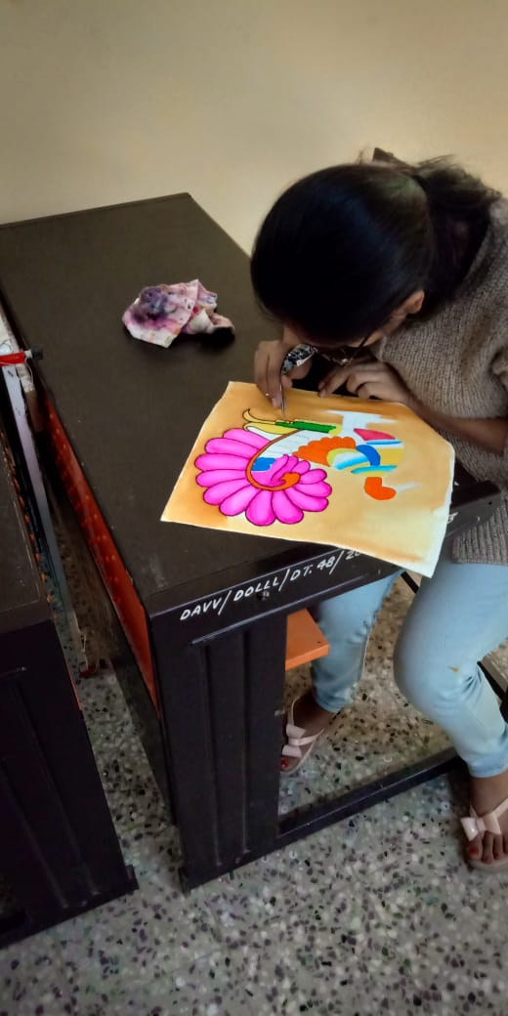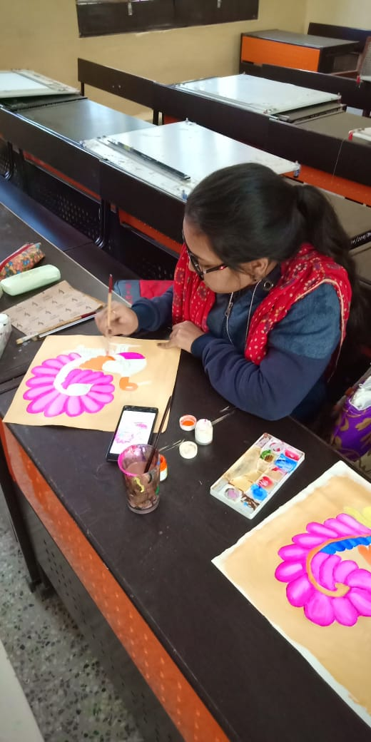In this workshop candidates learnt how to do Kalamkari Painting in an effortless manner, even for those without prior knowledge of painting or arts. They made beautiful traditional motifs on stoles and kurtis, wall painting etc.

