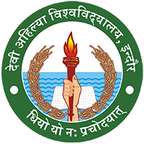**DEVI AHILYA VISHWAVIDYALAYA, INDORE**

**DEPARTMENT OF LIFE LONG LEARNING**

***Dr. Bharti Joshi***

***Head***

Rakhi making workshop was organized for students of B.Voc. Fashion Technology and B.Voc. Interior Design at Department of Life Long Learning. The instructor was Mrs. Swarna Modi (PMB Gujarati college). The workshop was held for two days from 28/07/17 to 29/07/17.

* To develop new skills in the students.
* The students were very new to the art and culture. This kind of workshop created awareness towards the various forms of art.
* They learned a new skill apart from their syllabus.
* Student learned to make Traditional & eco- friendly Rakhi.
* They learnt to expand their imagination and improve their creativity.
* Rakhis were purchased by students & faculties to help them in their Startup.

