***Workshop on Rakhi Making***

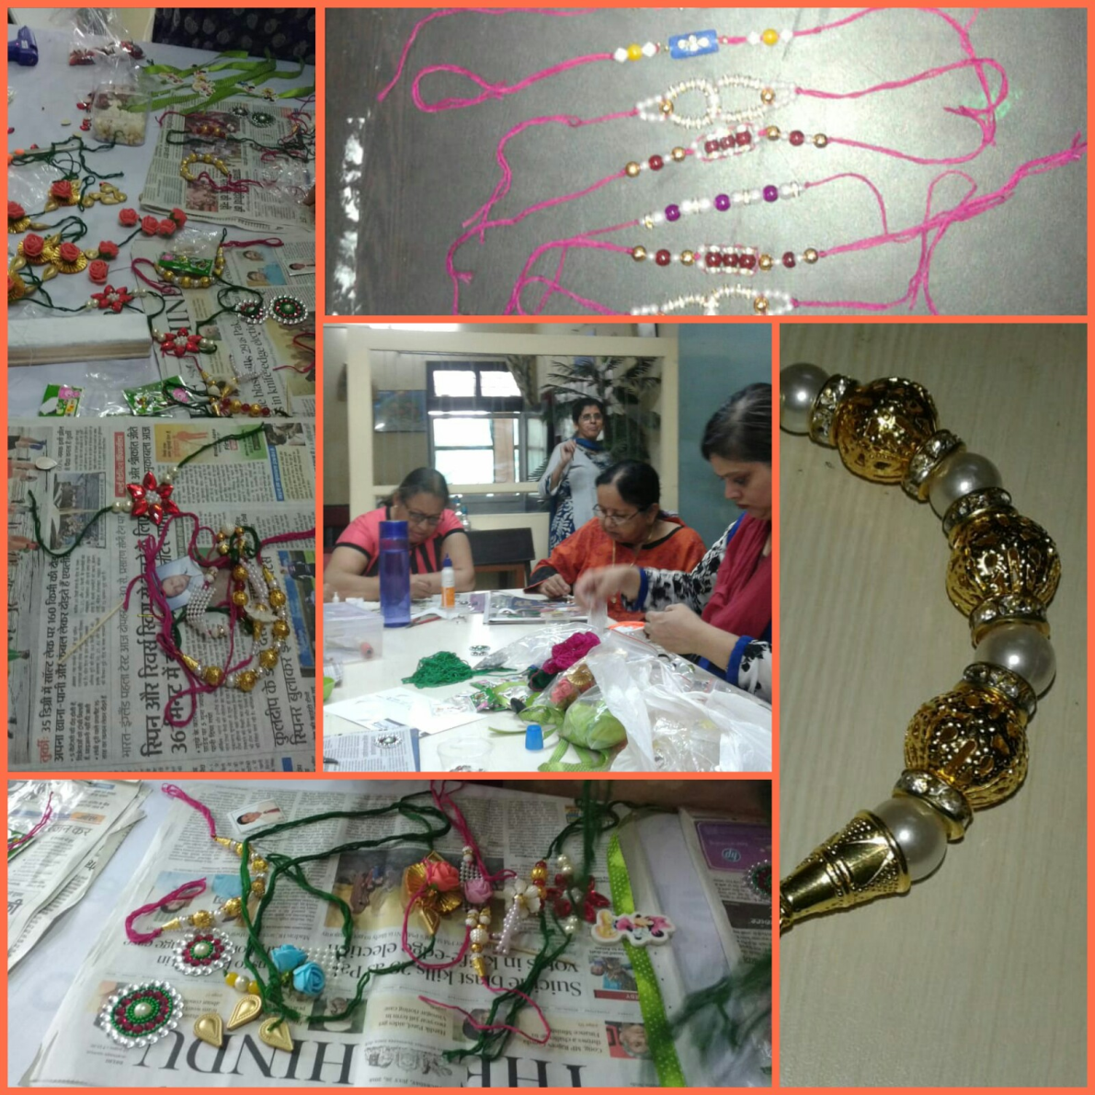Rakhi making workshop was organized for Senior citizens and Home maker at Department of Life Long Learning. In workshop, participants made various types of Rakhis such as Kids Rakhi, Bracelet Rakhi, Lumba Rakhi, Spiritual Rakhi, Pearl Rakhi. Some participants used their brother’s photo to make rakhi where as some used moldit (shilpkar) and gave various shapes and applied colours, they were eco-friendly rahkis.

