WORKSHOP ON NAMEPLATE MAKING
We organized one day workshop on “Nameplate creation’ at Department of Lifelong Learning, DAVV campus. Participants were students, homemakers & senior citizens.
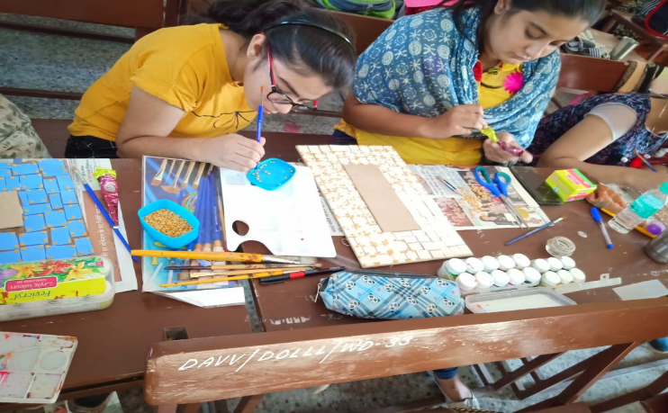
A nameplate identifies and displays a person or product's name. Nameplates are usually shaped as rectangles but are also seen in other shapes, sometimes taking on the shape of someone’s name. Candidates Learned the Art of making their own Nameplate and decorate house entrance with handmade artistic piece. It was a nameplate that can accommodate two names of a couple. All materials provided in the workshop. Lamasa art, Varly art etc. were used for making nameplates. We had found it very useful to produce simple name plates for workshop participants.

