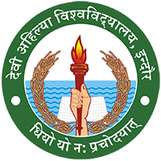

**DEVI AHILYA VISHWAVIDYALAYA, INDORE**

**Summary of Workshops and Activities**

