**Feed Back Survey**

**Summary of the Physical verification Work, Year 2017-18**

|  |  |  |  |  |  |  |  |
| --- | --- | --- | --- | --- | --- | --- | --- |
| **District** | **No of Village Surveyed** | **Plants Inspected** |  | **Working satisfactory / Partially** | **Functionality % age** | **Non Commi- ssioned \*** | **Non Functional Due to Dung/ Water\*** |
| Balodabajar | **49** | **218** |  | **201** | **92.20 %** | **3** | **13** |
| Aurangabad | **30** | **148** |  | **139** | **93.91 %** | **01** | **08** |
| Nashik | **31** | **109** |  | **84** | **77.06 %** | **22** | **03** |
| Chandrapur | **12** | **150** |  | **117** | **78.00 %** | **4** | **29** |
| Dhar | **76** | **310** |  | **299** | **96.45 %** | **07** | **04** |
| Damoh | **28** | **75** |  | **73** | **97.33 %** | **2** | **0** |
|  | **226** | **1010** |  | **913** | **90.39 %** | **39** | **57** |

**Summary Sheet: Physical verification, 2016-17**

|  |  |  |  |  |  |  |  |  |  |
| --- | --- | --- | --- | --- | --- | --- | --- | --- | --- |
| **SNo** | **Particulars State** | **MP** | **CG** | **MH** | | | | | **Remark** |
| **Districts** | **UJJAIN** | **RAIGAD** | **AHMAD**  **NAGAR** | **PUNE** | | **SATARA** | |
| 1 | No of Block covered | 4 | 6 | 6 | 2 | | 2 | |  |
| 2 | No of Village covered | 26 | 23 | 27 | 18 | | 11 | | Plants constructed in given district in three year except Raigad |
| 3 | No. of Plants constructed | 302 | 812 | 1388 | 665 | | 472 | |
| 4 | Year of Construction | 2013-16 | 2012-16 | 2013-16 | 2013-16 | | 2013-16 | |
| 5 | No. of Plants inspected | 114 | 286 | 383 | 180 | | 113 | |  |
| 6 | Working satisfactory | **90** | **200** | **301** | **176** | | **102** | |  |
| 7 | Working Partially | **03** | **23** | **55** | **00** | | **07** | |  |
| 8 | Non commissioned | 04 | 18 | 07 | 03 | | 00 | |  |
| 9 | Incomplete | 00 | 00 | 03 | 00 | | 00 | |  |
| 10 | Structural problem | 02 | 09 | 00 | 00 | | 00 | |  |
| 11 | Operation Problem | 14 | 22 | 16 | 01 | | 04 | |  |
| 12 | Disinterest of Users | 00 | 13* | 01 | 00 | 00 | |  | |
| 13 | Found Missing | **01** | **01** | **01** | 00 | | 00 | |  |
| 14 | Remark on O&M |  | Lack of Trained Technicians in the Agencies | | | | | | |
| **15** | **Overall Functionality %** | **81.60 %** | **78.00 %** | **92.95 %** | **97.80 %** | | **96.50 %** | | **=(6th +7th) *100/5th** |

*Fully Subsidised by Jindal Power plant.

**Table 17**

**Photo Graphs 2016-17: Feed Back Survey check karana hai**

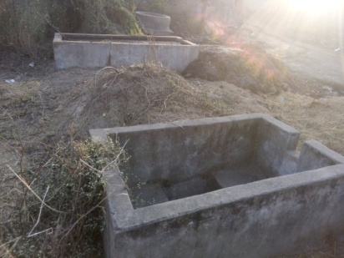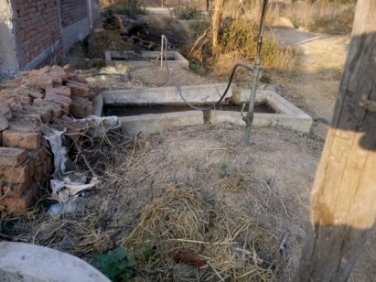

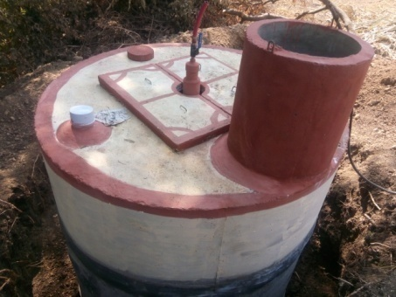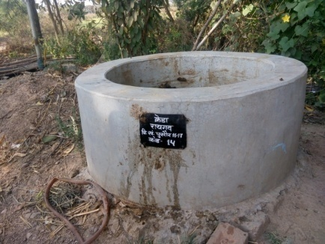

**Summary Sheet: Physical verification, 2015-16.**

|  |  |  |  |  |  |  |
| --- | --- | --- | --- | --- | --- | --- |
| **SNo** | **Particulars State** | **MP** | **CG** | **MH** | **MH** | **Remark** |
| **Districts** | **BETUL** | **KONDAGOAN** | **WARDHA** | **AMARAWATI** |
| 1 | No of Block covered | 4 | 3 | 4 | 7 |  |
| 2 | No of Village covered | 39 | 07(23) | 30 | 17 | In given block |
| 3 | No. of Plants constructed | 331 | 637 | 796 | 258 |
| 4 | Year of Construction | 11-12-13-14 | 12-13-14-15 | 12-13-14-15 | 12-13-14-15 |
| 5 | No. of Plants inspected | 204 | 260 | 409 | 128 |  |
| 6 | Working satisfactory | **182** | **110** | **145** | **0** |  |
| 7 | Working Partially | **11** | **22** | **63** | **32** |  |
| 8 | Un commissioned | 2 | 2 | 48 | 6 |  |
| 9 | Incomplete | 1 | 0 | 5 | 9 |  |
| 10 | Structural problem | 0 | 2 | 41 | 0 |  |
| 11 | Operation Problem | 8 | 104 | 105 | 79 |  |
| 12 | Disinterest of Users | Not Identified | | | | |
| 13 | Found Missing | 0 | 20 | 2 | 2 |  |
| 14 | Remark on O&M | Lack of Trained Technicians in the region | | | | |
| **15** | **Functionality %= (6th +7th) *100/5th** | **94.60** | **50.80** | **50.90** | **25.00** |  |

**Summary Sheet: Physical verification, 2014-15**

|  |  |  |  |  |  |  |
| --- | --- | --- | --- | --- | --- | --- |
| **SNo** | **Particulars State** | **MP** | **MP** | **CG** | **MH** | **Total** |
| **01** | **Districts\*\*** | **Ratlam** | **Vidisha** | **Mahasamund** | **Kolhapur** |
| 02 | No of Block covered | 03 | 02 | 02 | 02 | 09 |
|  | No of Village covered | 58 | 08 | 28 | 66 | 160 |
|  | No. of Plants constructed | 508 | 235 | 701 | 1804 | 3248 |
| 03 | Year of Construction | 2011-14 | 2011-14 | 2011-14 | 2012-14 |  |
| 04 | No. of Plants inspected | 255 | 47 | 224 | 525 | 1051 |
| 05 | Working satisfactory | 236 | 33 | 172 | 495 |  |
| 06 | Working Partially | 10 | 05 | 23 | 27 |  |
| 07 | Un commissioned | 05 | 04 | 04 | 02 |  |
| 08 | Incomplete | 00 | 00 | 00 | 00 |  |
| 09 | Structural problem | 02 | 00 | 04 | 00 |  |
| 10 | Operation Problem | 01 | 01 | 01 | 01 |  |
| 11 | Disinterest of Users | 01 | 01 | 20 | 00 |  |
| 12 | Found Missing | 00 | 00 | 00 | 00 |  |
| 13 | Remark on O&M | 00 | 03 | NA | 00 |  |
| **14** | **Functionality %** | **92.55%** | **80.85%** | **87%** | **94.30%** |  |