**2015-16**

**[A]** **Construction cum Maintenance Training:**

**Purpose**: To prepare trained and skilled mason for using effective technology in the field.

**Duration:** Ten Days

**Material:** Arranged by Beneficiaries.

**Trainees:** Ten numbers each.

Enlisted trainings have been conducted during the year 2015-16

|  |  |  |  |  |  |  |
| --- | --- | --- | --- | --- | --- | --- |
| **SN** | **Agency / State** | **District** | **Block** | **village** | **Duration** | **No of Trainees** |
| 1 | MPAGRO, MP | Harada | Khirkiya | Pahanpaat | 29.10.15 T0 07.11.15 | 10 |
| 2 |  | Mandla | Bichchiya | Kurwahi | 01.12.15 To 10.12.15 | 10 |
| 3 |  | Sagar | J singh nagar | Somala | 13.12.15 To 22.12.15 | 10 |
| 4 |  | Khandwa | Pandhana | Heerapur | 09.01.16 To 18.01.16 | 10 |
| 5 |  | Gwalior | Murar | Rasidpur | 23.01.16 To 01.02.16 | 10 |
|  | | | | | | |
| 6 | CREDA, CG | Balarampur | Shankargarh | Changro | 29.10.15 To 07.11.15 | 10 |
| 7 |  | Kondagoan | Farasgoan | Jaitpuri | 22.11.15 To 01.12.15 | 10 |
| 8 |  | Mungeli | Lormi | Bandha | 12.03.16 To 21.03.16 | 10 |
|  | | | | | | |
| 9 | ZP, MH | Wardha | Aarvi | Sukli | 09.02.16 To 18.02.16 | 10 |
| 10 |  | Amarawati | Achalpur | Pardi | 22.02.16 To 05.03.16 | 10 |
|  | | | | | | |

**Photo Graphs 2015-16: CCM Trainings**

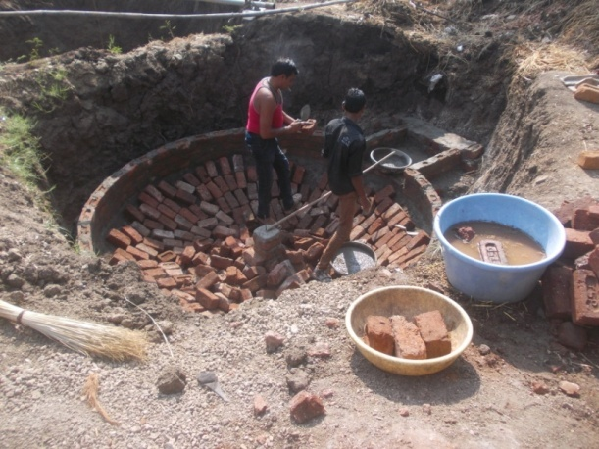 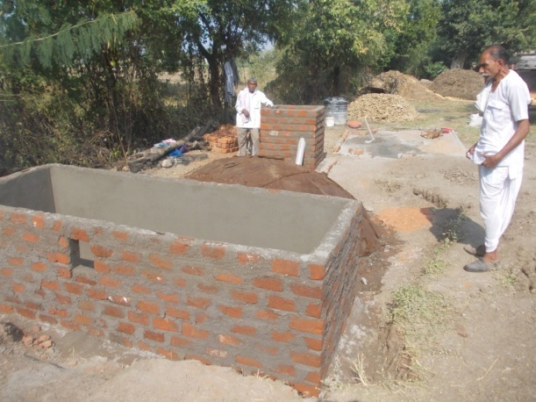

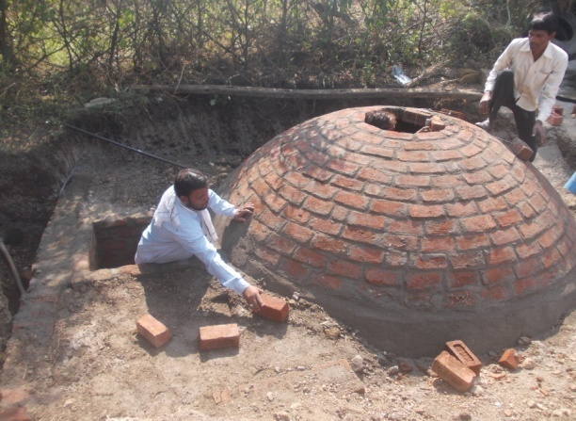 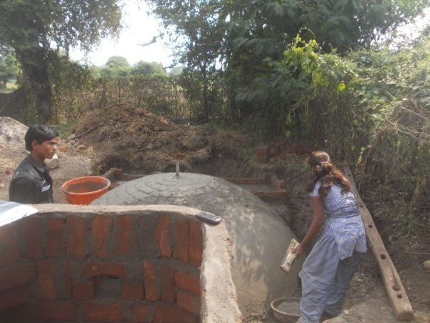

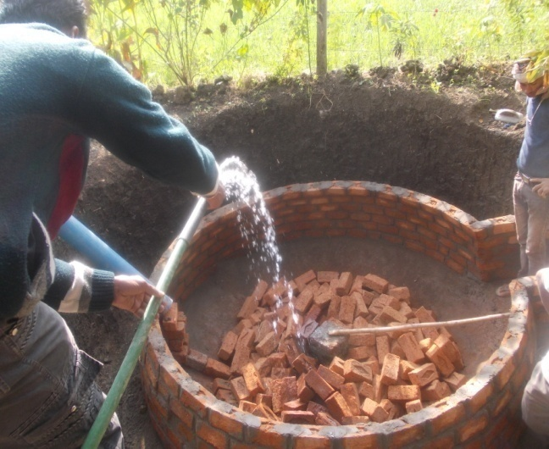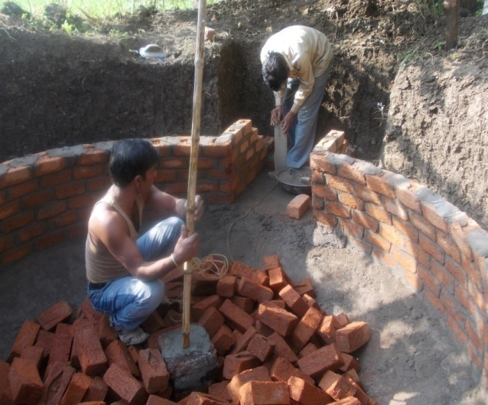

**Different Stage of Plants Construction (MP, CG)**

**Photo Graphs 2015-16: CCM Trainings**

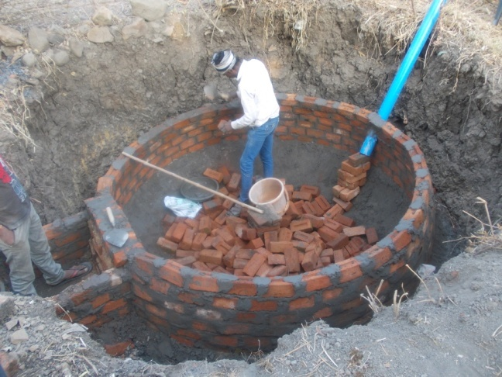 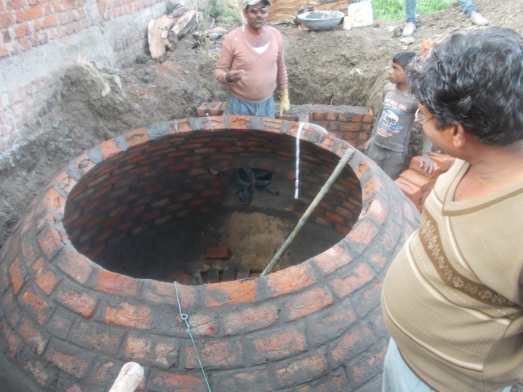

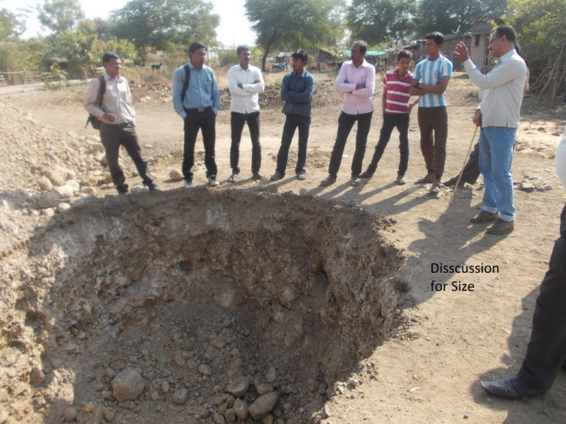 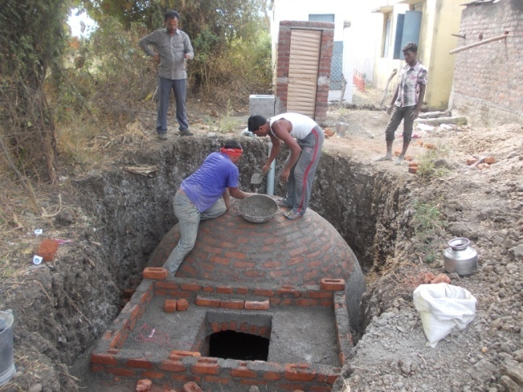

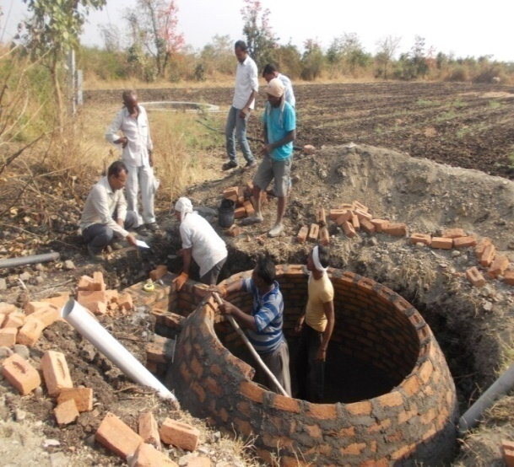 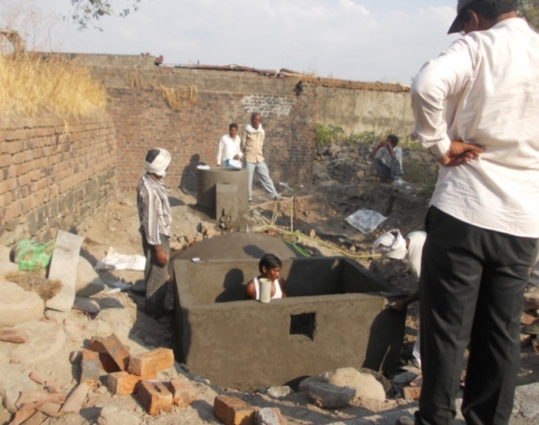

**Different Stage of Plants Construction (Maharashtra)**

**[B] Turnkey Workers Training 2015-16:**

**Purpose:** To prepare trained and skilled Self Employed Workers or Rural Energy Technicians for using effective technology in this field.

**Duration:** Fifteen Days

**Trainees:** State agencies, CREDA (CG), MPAGRO (MP), ZP (MH) and KJBF, Wardha.

Allocated target was 03 for the current year to the BDTC, Indore. MPAgro, and CREDA Chhattisgarh sent their candidate in the program in the course. Two programs are conducted simultaneously at Centre of BDTC, Indore.

While the third training program conducted at Wardha, Maharashtra for the candidates from Maharashtra.

Enlisted trainings have been conducted during the year 2015-16.

|  |  |  |  |  |  |
| --- | --- | --- | --- | --- | --- |
| **Sr. No.** | **Duration of Training** | **Venue** | **Agency** | **From Districts** | **No. of Trainees** |
| 1 | 09.12.14 To 23.12.14 | BDTC,  Indore | MP AGRO | Shivpuri,Khandwa,Tikamgarh  Katni,Gwalior,Dhar, Indore | 11 |
| 2 | CREDA | Raigarh, Dhamtari, BAloda,Gariyaband,Sukama,  Bilaspur,Dhamtari,Kawardha | 10 |
| 3 | 16.02.16 To 01.03.16 | Hotel Parth, Wardha | Zilla Parisad | Wardha, Kolhapur | 10 |

**Photo Graphs 2015-16: TKW Trainings**

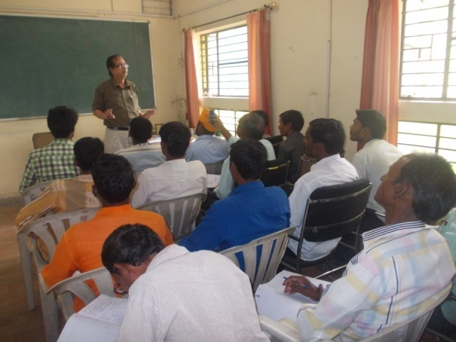 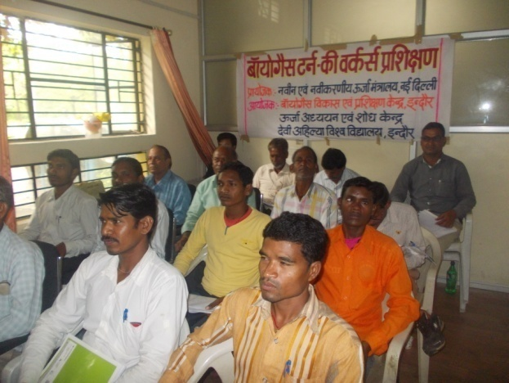

**Lecture delivered by Dr. S P Singh, Coordinator (BDTC)**

**Candidate from MP and CG**

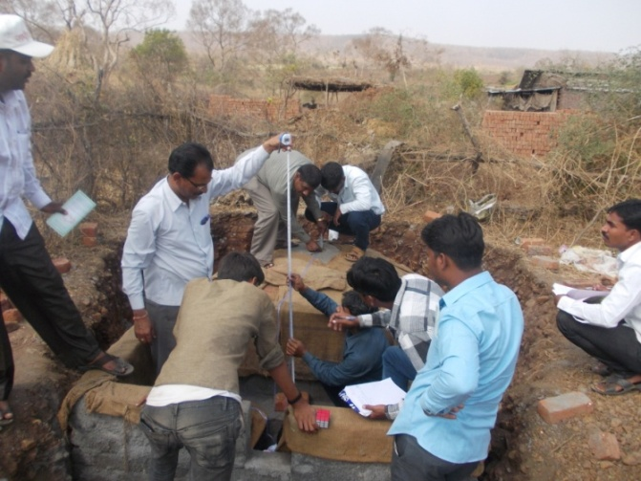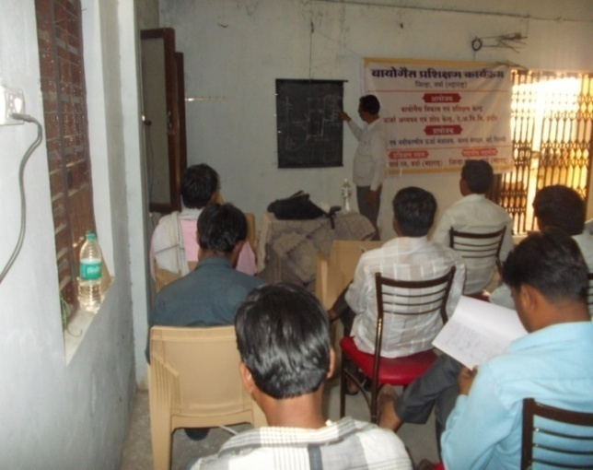

**Lecture delivered by R S Pawar, STA (BDTC) - Maharashtra**

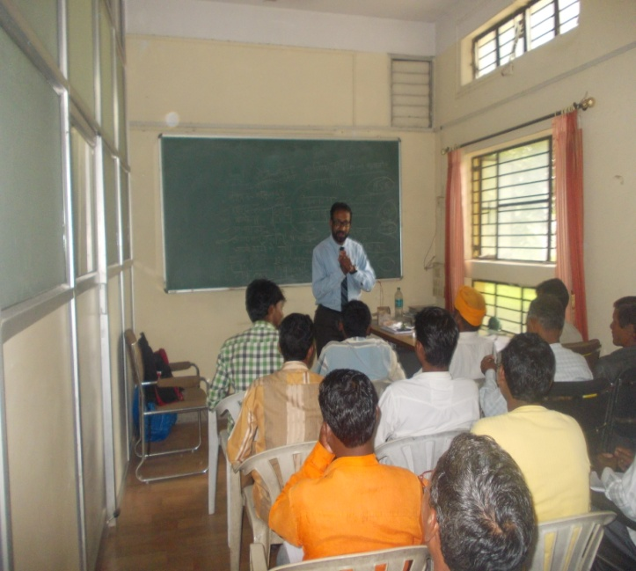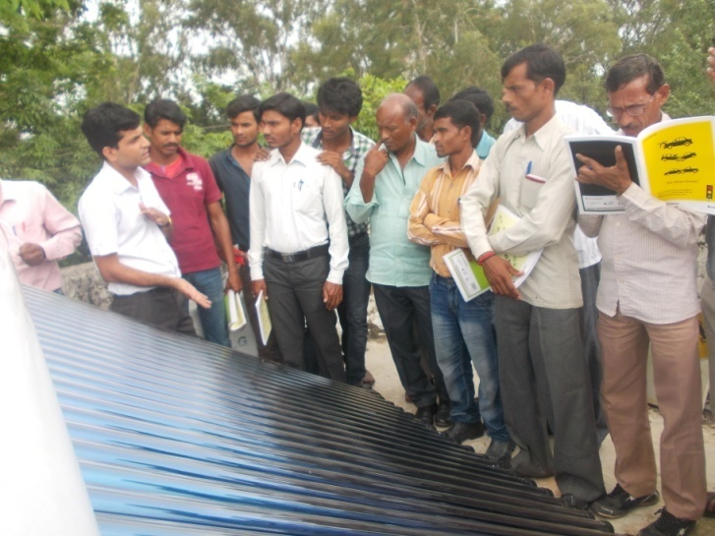

**Guest Speaker Lecture on Time Lecture delivered on Solar Water Heating and work Management System at RTC, Indore**

**………………………………………………………………………………………**

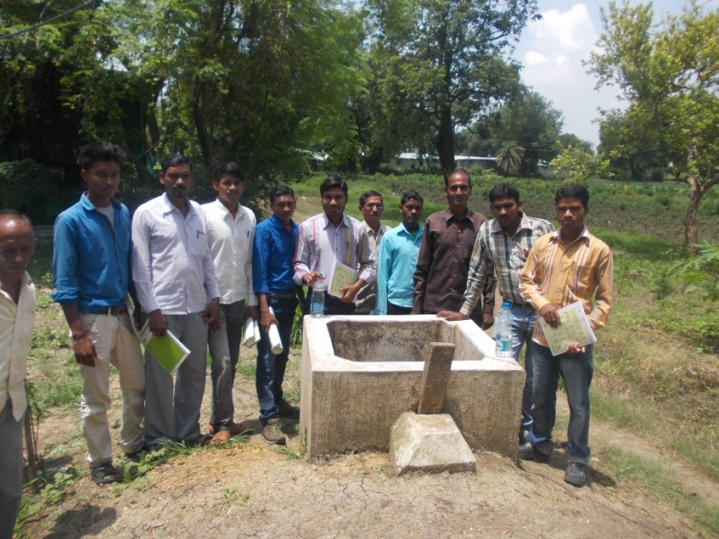

**Field visit- at biogas plant made by TKW trainees**

**[C] Government Functionaries Training 2015-16:**

**Purpose**: To minimize the field problems by choosing the right beneficiary, construction and operational problems.

**Duration:** Four Days.

**Trainees:** Members from CREDA (CG), RDD, ZP (MH) and Extension Centre, Kamalnayan Jamunalal Bajaj Foundation, Wardha.

Enlisted trainings have been conducted during the year 2015-16.

Allocated target was three for the current year to the BDTC, Indore. One of three training organised for staff of CREDA, Chhattisgarh where two are conducted simultaneously for Zilla parishad Wardha and Amarawati, Maharashtra.

|  |  |  |  |  |
| --- | --- | --- | --- | --- |
| **Sr No** | **State** | **Name of Agency/Venue** | **Duration** | **No. of Trainees**  **From all Blocks** |
|  | Chhattisgarh | CREDA, Kondagoan | 02.12.15 To 03.12.15 | 19 |
|  | Maharashtra | ZP, Wardha | 23.02. 15 To 24.02.16 | 45 |
|  | Maharashtra | ZP, Amarawati | 02.03.16 To 03.03.16 | 38 |

**The trainings were mainly concluded are as under.**

1. Lack of technical field workers and No TKWs in district wardha and Amarawati.
2. Construction technology and material management.
3. Costing of two cubic meter deenbandhu brick made biogas plant.
4. Lack of trained mason in district wardha and Amarawati.
5. To increase the quality of construction and rate of functionality.
6. Need of awareness about identification of fault and rectification for the same.

**Photo Graphs 2015-16: Gove Functionaries – Chhattisgarh**

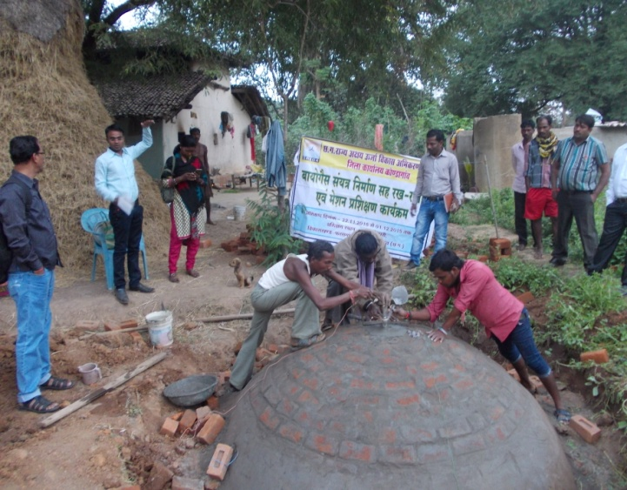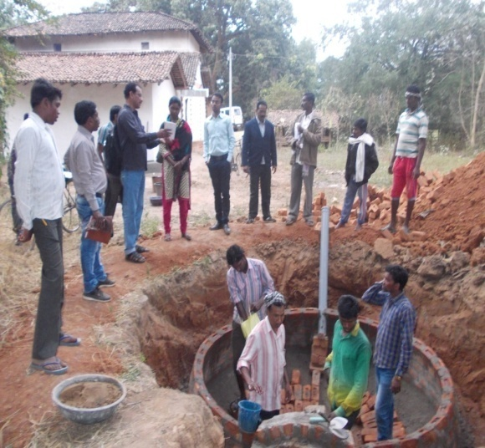

**Field visit of CREDA Staff at Village- Jaitpuri, Kondagoan**

**Photo Graphs 2015-16: Gove Functionaries - Maharashtra**

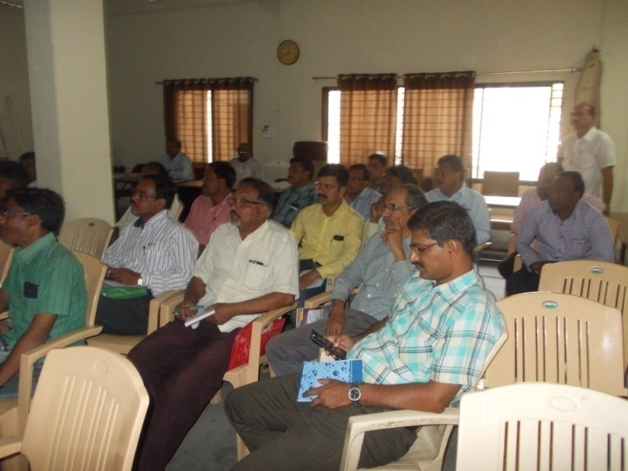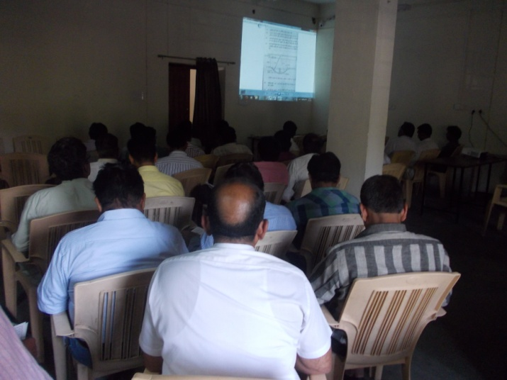

**Power Point Presentation – Wardha, Maharashtra**

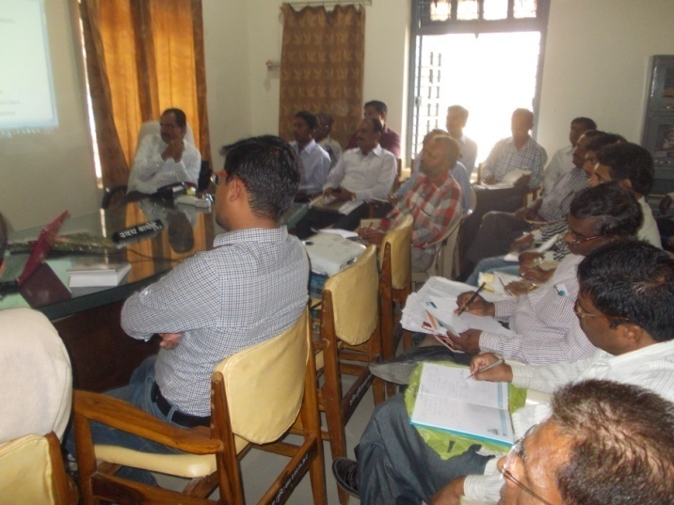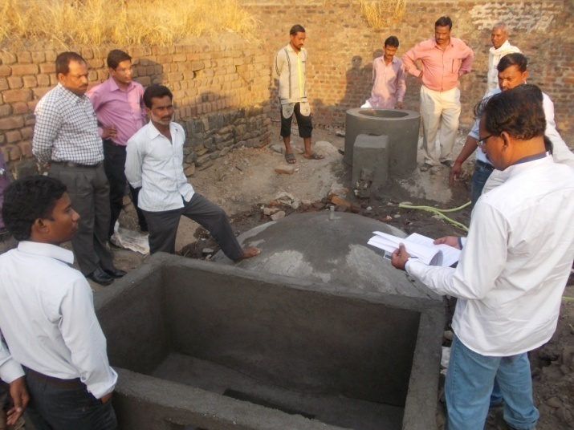

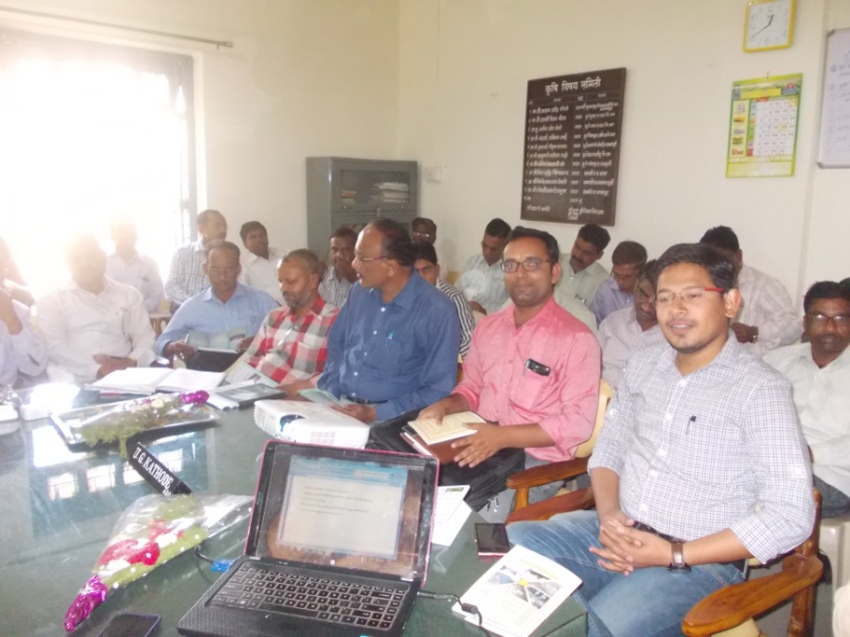

**Power Point Presentation – ZP, Amarawati**

**Field Visit of ZP Staff at Village – Pardi, Amarawati**

**[D] Users Training 2015-16:**

**Purpose**: To provide awareness about size of BG plant, during construction, Operational solution and maintenance Tips.

**Duration:** One Day.

**Trainees:** Beneficiaries and School student.

Allocated target was100 for the current year 2015-16 to the BDTC, Indore. 75 trainings were conducted in the state of MP , CG, And Maharashtra.

Enlisted trainings have been conducted during the year 2015-16.

|  |  |  |  |  |  |
| --- | --- | --- | --- | --- | --- |
|  |  | DURING CCM TRAINING | | | |
| SR NO | VILLAGE / VENUE | BLOCK | District | DATE | STATE |
|  |  |  |  |  |  |
| 1 | Changro | Shankargarh | Balrampur | 17.10.15 | **CG** |
| 2 | Pahanpaat | Khirkiya | Harada | 07.11.15 | MP |
| 3 | H S Girls School | Khirkiya | Harada | 06.11.15 | MP |
| 4 | H S Girls School, Chipawad | Khirkiya | Harada | 06.11.15 | MP |
| 5 | Excellence H S School, Harada | Harda | Harda | 07.11.15 | MP |
| 6 | Jaitpuri | Farasgoan | Kondagoan | 01.12.15 | CG |
| 7 | H S School, Lanjoda | Farasgoan | Kondgoan | 01.12.15 | CG |
| 8 | Kurvahi | Bichchiya | Mandla | 10.12.15 | MP |
| 9 | Somala | J Singnagar | Sagar | 22.12.15 | MP |
| 10 | Heerapur | Pandhan | Khandwa | 18.01.16 | MP |
| 11 | Rashidpur | Murar | Gwalior | 01.02.16 | MP |
| 12 | Sukli | Aarvi | Wardha | 18.02.16 | MH |
| 13 | Piplod | Pandhana | Khandwa | 18.02.16 | MP |
| 14 | Pardi | Achalpur | Amarawati | 05.03.16 | MH |
| 15 | Bandha | Lormi | Mungeli | 21.03.16 | CG |
| 16 | Ghorpura | Mungeli | Mungeli | 20.03.16 | CG |
| 17 | Gidhdha | Mungeli | Mungeli | 21.03.16 | CG |

**Photo Graphs 2015-16: Users Training - Maharashtra**

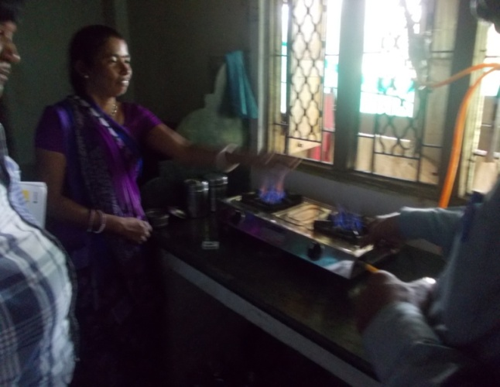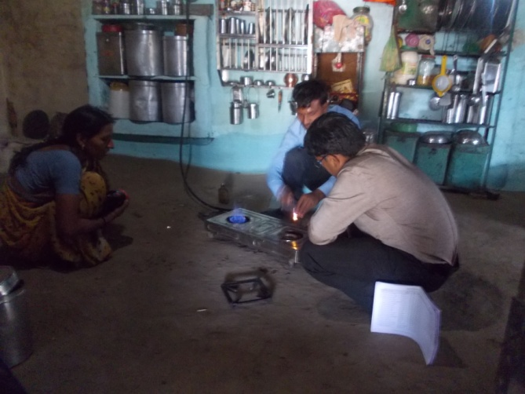

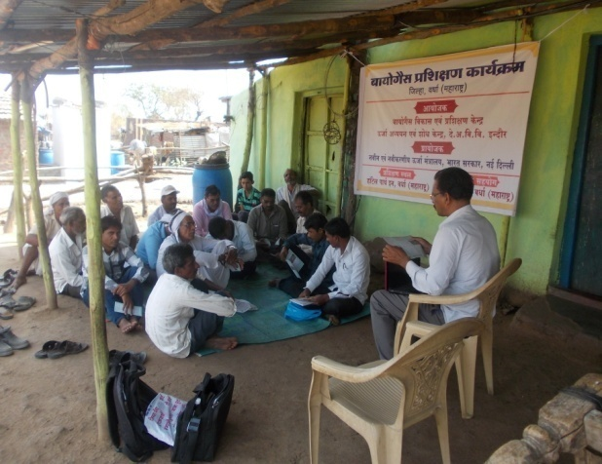 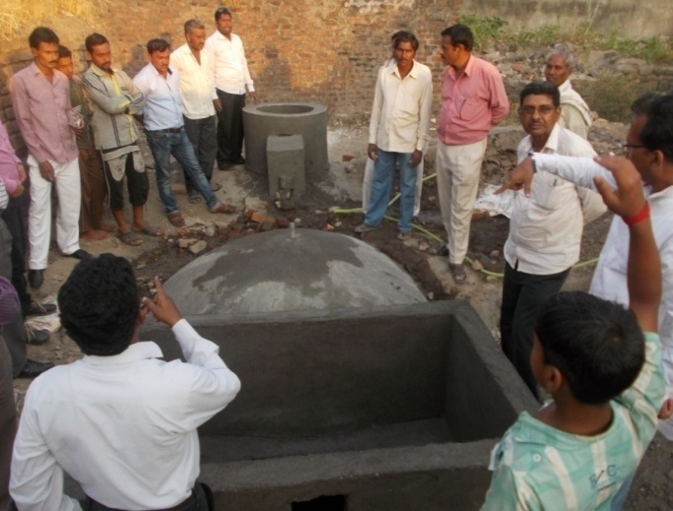

|  |  |  |  |  |
| --- | --- | --- | --- | --- |
|  | STATE | CHHATTISGARH | | |
| SR NO | VILLAGE / VENUE | BLOCK | DATE | DISTRICT |
|  |  |  |  |  |
| 18 | **Khutpadar** | **Keshakal** | **28.11.15** | KONDAGOAN |
| 19 | Patelpara | Kondagaon | 28.11.15 | KONDAGOAN |
| 20 | Jaithari | Kondagaon | 28.11.15 | KONDAGOAN |
| 21 | Linjoda | Kondagaon | 29.11.15 | KONDAGOAN |
| 22 | Sonpur | Vishrampuri | 29.11.15 | KONDAGOAN |
| 23 | Pendravan | Vishrampuri | 29.11.15 | KONDAGOAN |
| 24 | Baderajpur | Baderajpur | 30.11.15 | KONDAGOAN |
| 25 | Cherbeda | Keshkal | 30.11.15 | KONDAGOAN |
| 26 | Chichodi | Pharasgaon | 01.12.15 | KONDAGOAN |
| 27 | Badgaon | Pharasgaon | 02.12.15 | KONDAGOAN |

**Student (Youth) Training – A unique object & an easy target a useful instrument:** We, under the age of Biogas Development and Training Centre, Indore followed the following novel innovative and the most practical strategy to bring awareness amongst villagers about the use of biogas. Whenever Users training programs were held, it was notice that very few users actually attended them with interest. Only those people came who had some complaint or a problem related to their biogas plant. Some just came attracted by the snacks offered during the training programs. Besides of these we thought of attracting the youth, youngsters, fresh and enthusiastic ones, would gain some knowledge and if they would be aware of the importance of this technology, they would automatically motivate the elders at home and thus the use of biogas would expand to achieve this target., we went to the students specially girls of rural school and talked to the students of classes IX to XII. This method worked successfully. Aware and educated youngsters started trying to motivate their family members and all the villagers. We observed a positive change which benefited our biogas training program. This technique provides a full of joy as well as a learning information in the field of new and renewable energy sources.

|  |  |  |  |  |
| --- | --- | --- | --- | --- |
|  | STATE | MAHARASHTRA | | |
| SR NO | VILLAGE / VENUE | BLOCK | DATE | DISTRICT |
|  |  |  |  |  |
| 28 | Dhamangoan | Wardha | 09.02.16 | WARDHA |
| 29 | Sawali | Wardha | 09.02.16 | WARDHA |
| 30 | **Kharagana** | **Wardha** | **10.02.16** | WARDHA |
| 31 | Bothali Heti | Aarvi | 10.02.16 | WARDHA |
| 32 | Panchala | Aasthi | 11.02.16 | WARDHA |
| 33 | jamgoan | Aasthi | 11.02.16 | WARDHA |
| 34 | Aanji | Deoli | 12.02.16 | WARDHA |
| 35 | Bidhali Kinhala | Aarvi | 12.02.16 | WARDHA |
| 36 | Chithli | Aarvi | 12.02.16 | WARDHA |
| 37 | Lahan aarvi | Aasthi | 13.02.16 | WARDHA |
| 38 | Peepari Pu | Aarvi | 13.02.16 | WARDHA |
| 39 | Talegoan | Aarvi | 13.02.16 | WARDHA |
| 40 | Pimpal Khunta | Aarvi | 13.02.16 | WARDHA |
| 41 | Gumgoan | Aarvi | 14.02.16 | WARDHA |
| 42 | Bodhad Pol | Aarvi | 14.02.16 | WARDHA |
| 43 | Diwapur | Karanja | 14.02.16 | WARDHA |
| 44 | Jhadh goan | Wardha | 15.02.16 | WARDHA |
| 45 | Borgoan | Wardha | 15.02.16 | WARDHA |
| 46 | Rohana | Aarvi | 16.02.16 | WARDHA |
| 47 | Mandawa | Wardha | 23.02.16 | WARDHA |
| 48 | Pawnoor | Wardha | 23.02.16 | WARDHA |
| 49 | Pipri meghe | Wardha | 25.02.16 | WARDHA |
| 50 | Sundi heeti | Sellu | 24.02.16 | WARDHA |

**Photo Graphs 2015-16: Users Training –Madhya Pradesh**

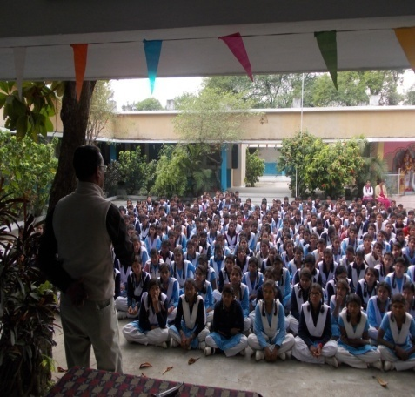 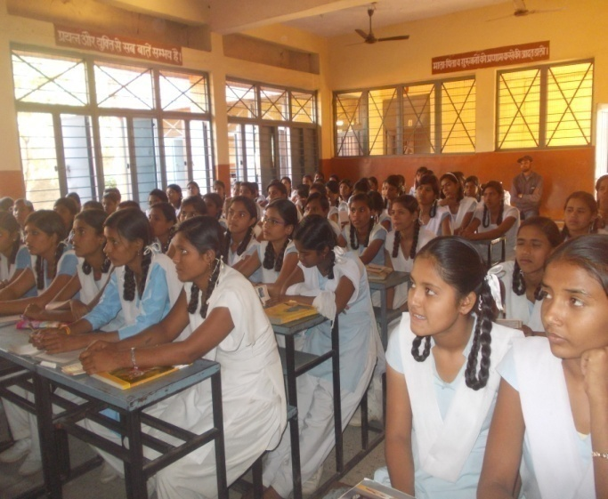

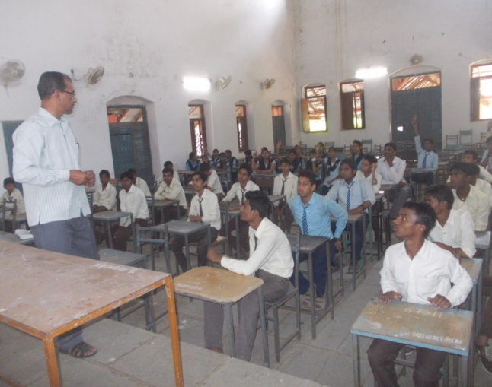 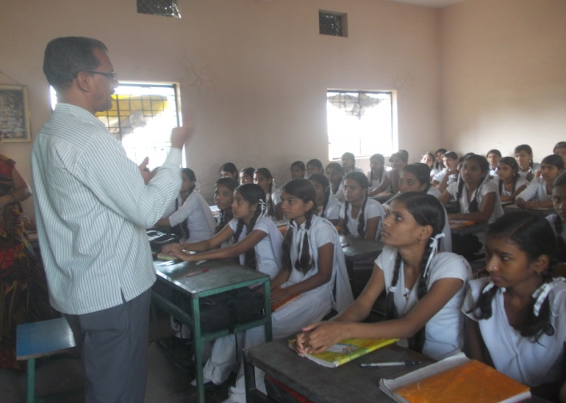

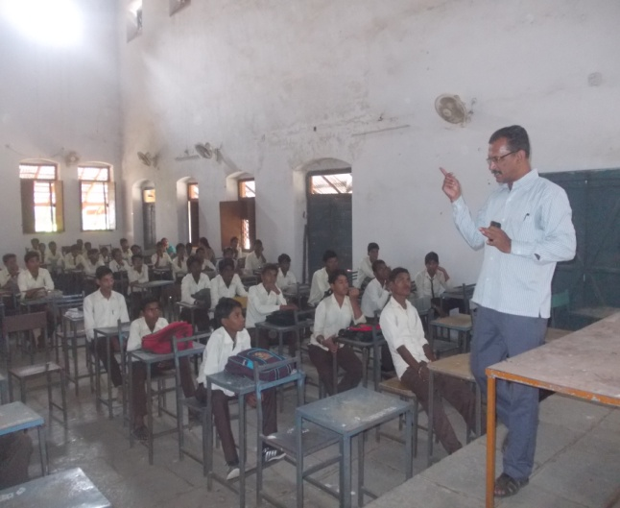 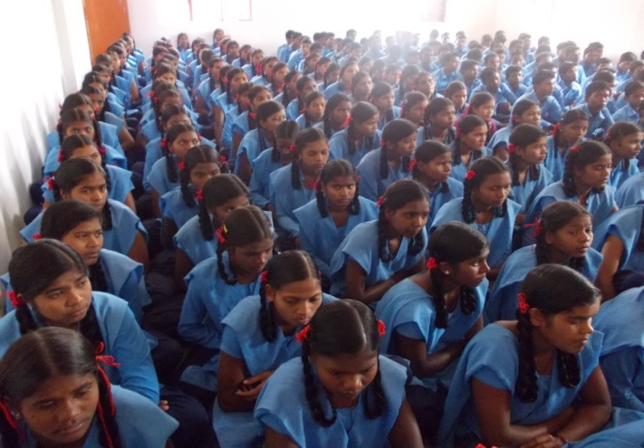

**Lectures to the School Student on Awareness of Energy and use of Biogas**

|  |  |  |  |  |
| --- | --- | --- | --- | --- |
|  | STATE | MAHARASHTRA | | |
| SR NO | VILLAGE / VENUE | BLOCK | DATE | DISTRICT |
| 51 | Ambada | Achalpur | 19.02.16 | AMARAWATI |
| 52 | Narsalla | Achalpur | 19.02.16 | AMARAWATI |
| 53 | Wadgoan | Achalpur | 19.02.16 | AMARAWATI |
| 54 | Bhankheda BK | Amarawati | 20.02.16 | AMARAWATI |
| 55 | Dhanora | Amarawati | 20.02.16 | AMARAWATI |
| 56 | Ghadasgoan | Anjan goan | 21.02.16 | AMARAWATI |
| 57 | Pandhari | Anjangoan | 21.02.16 | AMARAWATI |
| 58 | Ganoja devi | Bhatkuli | 21.02.16 | AMARAWATI |
| 59 | Neemkhed | Chandur BZ | 03.03.16 | AMARAWATI |
| 60 | Titwa | Chandur BZ | 03.03.16 | AMARAWATI |
| 61 | Jhargoan | Dhamangoan R | 04.03.16 | AMARAWATI |
| 62 | Bellora | Nandgoan | 01.03.16 | AMARAWATI |
| 63 | Jamgoan | Nandgoan | 01.03.16 | AMARAWATI |
| 64 | Gokhad | Nandgoan | 01.03.16 | AMARAWATI |

|  |  |  |  |  |  |  |  |  |  |
| --- | --- | --- | --- | --- | --- | --- | --- | --- | --- |
|  | | |  | | |  | |  | |
|  | STATE | | MADHYAPRADESH | | | | |
| SR NO | VILLAGE / VENUE | | BLOCK | DATE | | DISTRICT | |
|  |  | |  |  | |  | |
| 65 | **Mandaibujurge** | | **Betul** | **24.12.15** | | BETUL | |
| 66 | Jogli | | Chicholi | 25.12.15 | | BETUL | |
| 67 | Gunkhed | | Athner | 26.12.15 | | BETUL | |
| 68 | Ambada | | Athner | 27.12.15 | | BETUL | |
| 69 | Kumhariya | | Betul | 28.12.15 | | BETUL | |
| 70 | Raverkhedi | | Badwah | 24.01.16 | | KHARGONE | |
| 71 | Dudgaon | | Badwah | 24.01.16 | | KHARGONE | |
| 72 | Selda | | Badwah | 25.01.16 | | KHARGONE | |
| 73 | Temla | | Bhikangaon | 27.01.16 | | KHARGONE | |
| 74 | Saikheda | | Khargone | 28.01.16 | | KHARGONE | |
| 75 | Raibidpura | | Khargone | 29.01.16 | | KHARGONE | |

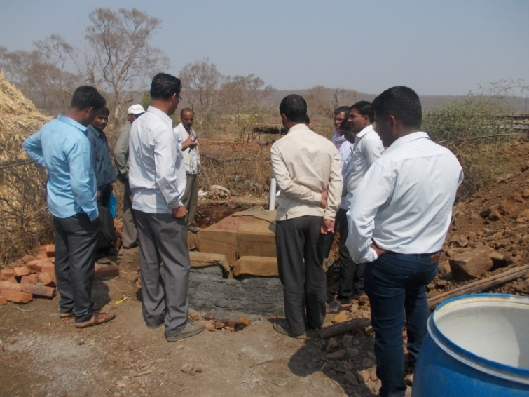

**Interact to the Users for Feeding of New Biogas Plant- Maharashtra**