**2016-17**

**[A] Construction cum Maintenance Training:**

**Purpose**: To prepare trained and skilled mason for using effective technology in the field.

**Duration:**Ten Days

**Material:** Arranged by Beneficiaries.

**Trainees:**Ten numbers each.

Enlisted trainings have been conducted during the year 2016-17

|  |  |  |  |  |  |  |  |
| --- | --- | --- | --- | --- | --- | --- | --- |
| **SN** | **Agency / State** | | **District** | **Block** | **village** | **Duration** | **No of Trainees** |
| 1 | MPAGRO, | | Sagar | J singhnagar | Jhunda | 19.12.16 to28.12.16 | 10 |
| 2 |  | | Rajgarh | Narsinghgarh | Mulyawala | 29.01.17 to07.02.17 | 10 |
| 3 |  | | Shajapur | Shajapur | Taajpur | 16.01.17 to25.01.17 | 10 |
| 4 |  | | Khargone | Badwah | Linepura | 29.12.16 to08.01.17 | 10 |
| 5 | CREDA, | | Raigarh | Dharamjgah | Manpur | 14.02.17 to23.02.17 | 10 |
| 6 |  | | Dhamtari | Nagri | Dhurawar | 20.03.17 to29.03.17 | 10 |
| 7 | | RDD, MH | Pune | Baramati | Malegoan | 21.11.16 to30.11.16 | 10 |
| 8 | |  | Satara | Karad | Sawarghar | 21.01.17 to30.01.17 | 10 |
| 9 | |  | Amarawati | Dharni | Chutiya, | 03.01.17to 12.01.17 | 10 |
| 10 | |  | A Nagar | Rahuri | Dhamanda | 05.11.16to 14.11.16 | 10 |

**Table-9**

**Photo Graphs 2016-17:CCM Trainings:**

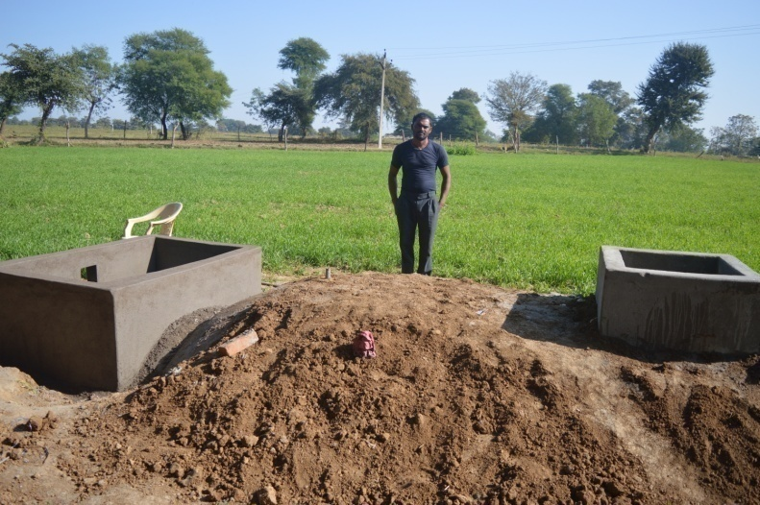

**Construction- at Vill. Tajpur, Dist. Shajapur, MP**

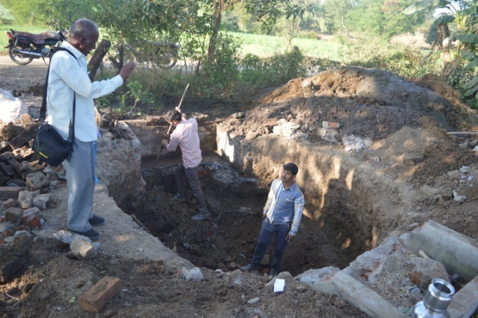

**Old & Non- functional plant dismantling for new construction by beneficiary**

**at Village- Jhunda, Dist. Sagar, MP**

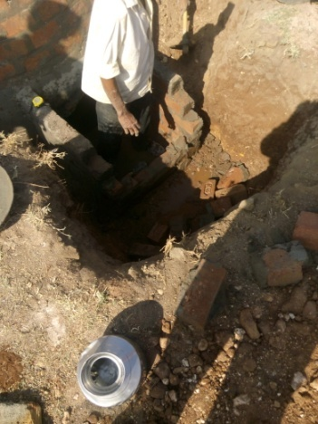

**Dismantling of Wrong work by Trainees at Village- Linpura, Dist. Khandwa, MP**

**[B]Turnkey Workers Training 2016-17:**

**Purpose:** To prepare trained and skilled Self Employed Workers or Rural Energy Technicians for using effective technology in this field.

**Duration:** Fifteen Days

**Trainees:** State agencies, CREDA (CG), MPAGRO (MP) and ZP (MH)

Allocated target was 03 for the current year to the BDTC, Indore.

MPAgro, CREDA and ZPs sent their candidate in the program in the course. All threeprograms were conducted simultaneously at “Mahatma Phule agriculture University, Rahuri, Ahmednagar (MH) .

Enlisted trainings have been conducted during the year 2016-17.

|  |  |  |  |  |  |
| --- | --- | --- | --- | --- | --- |
| **Sr. No.** | **Duration of Training** | **Venue** | **Agency** | **From Districts** | **No. of Trainees** |
| 1 | 05.11.16 To 19.11.16 | Mahatma Phule Vidhyapith,  Ahamad Nagar,MH | MP AGRO | Nimach,Mandsour,Khandwa,  Katni,Aagar,Shajapur,Dewas | 10 |
| 2 | CREDA | Kondagaon, Dhamtari,Ambikapur | 06 |
| 3 | 05.11.16 To 19.11.16 | RDD | Ahamad nagar, Pune | 14 |

**Table 10**

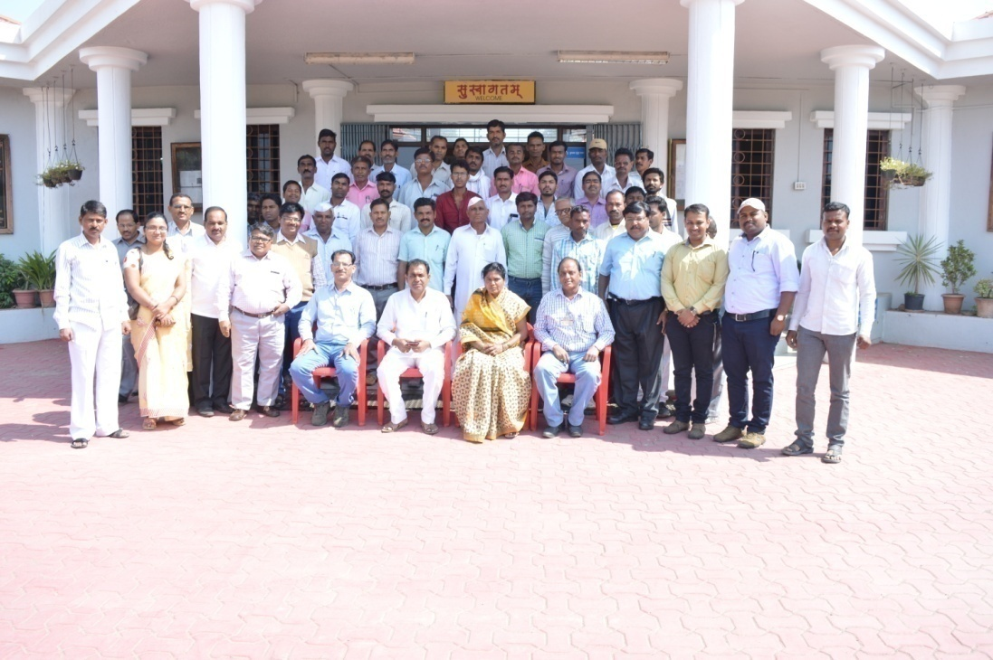

**Mahatma Phule Vidhyapith, Ahamad Nagar, MH**

**Photo Graphs 2016-17: TKW Trainings**

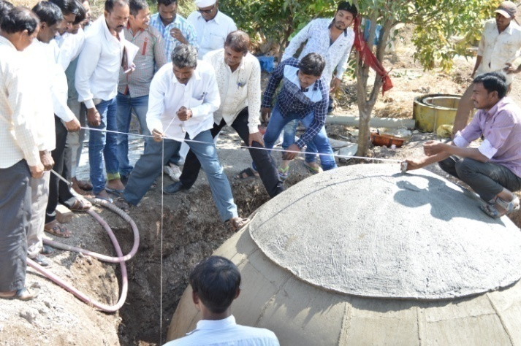

**Candidate from MP, MH and CG are measuring the newly constructed plant**

**At Village Dhamanda, Dist. Ahamadnagar,MH**

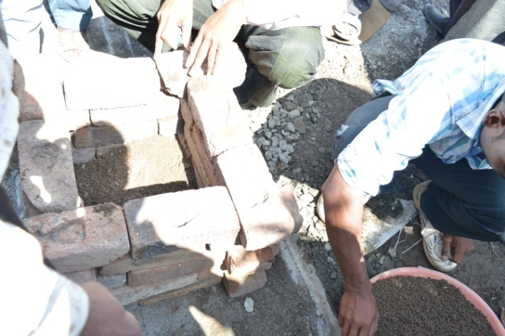

**Method for material measurement at site**

**At Village Dhamanda, Dist. Ahamadnagar,MH**

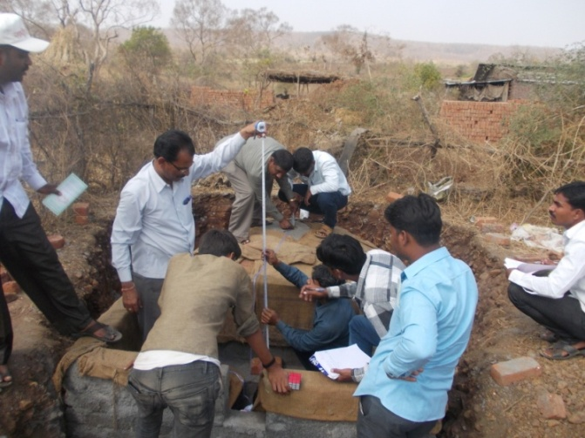

**Method for measurement of Existing plant**

**At Village Dhamanda, Dist. Ahamadnagar,MH**

**[C] Government Functionaries Training 2016-17:**

**Purpose**: To minimize the field problems by choosing the right beneficiary, construction and operational problems.

**Duration:** Four Days.

**Trainees:** Members from Agriculture department, Zilla Parisad, MH.

Enlisted trainings have been conducted during the year 2016-17.

Allocated target was three for the current year to the BDTC, Indore. All three training organised for staff of Zilla Parisad (ZP), Maharashtra.

|  |  |  |  |  |
| --- | --- | --- | --- | --- |
| **Sr No** | **State** | **Name of Agency/Venue** | **Duration** | **No. of Trainees**  **From all Blocks** |
|  | Maharashtra | ZP, Ahamadnagar | 19.11.16 to 20.11.16 | 42 |
|  | Maharashtra | ZP, Pune | 28.11.16 to 29.11.16 | 34 |
|  | Maharashtra | ZP, Satara | 31.01.17 to 01.02.17 | 32 |

**Table 11**

**The trainings were mainly concluded are as under.**

1. Lack of technical field workers and sufficient Number of TKWs in district.
2. Construction technology and material management.
3. Costing of two/ Three cubic meter deenbandhu brick/ RCC made biogas plant.
4. Lack of trained mason in district.
5. To increase the construction quality as well as functionality rate.
6. Need of awareness about identification of fault and rectification for the same.
7. **Photo Graphs 2016-17: Gove Functionaries -Maharashtra**

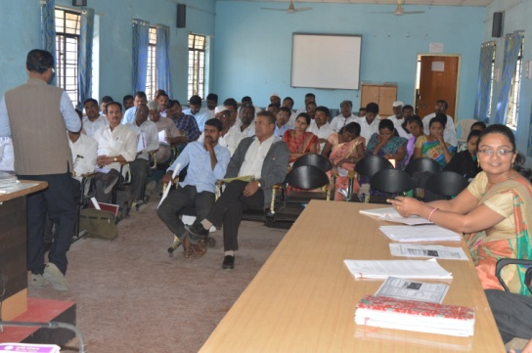

**At Block Rahata, Dist. Ahamadnagar, MH**

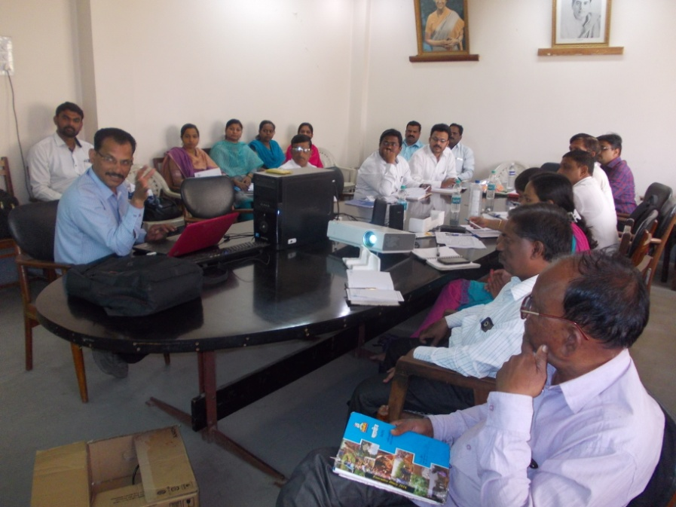

**At Block Satara, Dist. Satara, MH**

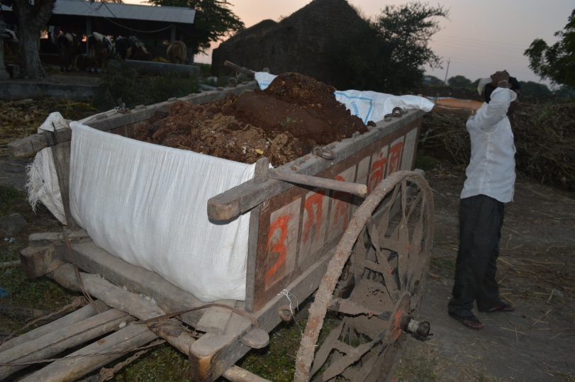

**Quantity calculation of Dung for First Feeding**

**Photo Graphs 2016-17: Gove Functionaries –Maharashtra**

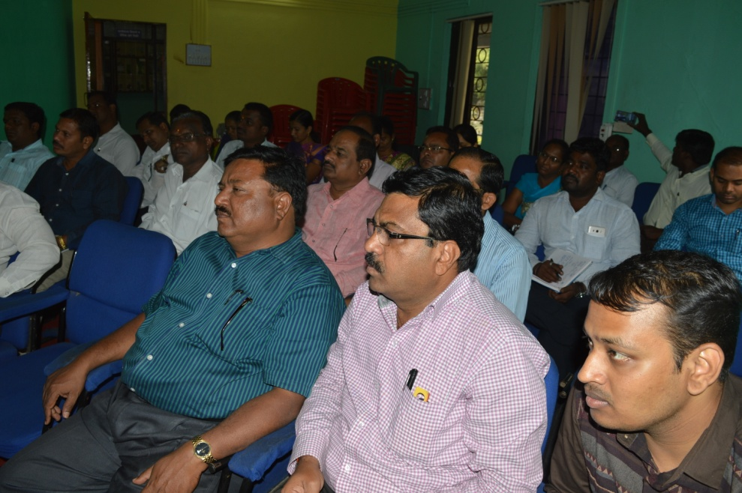

**At Mahatma Phule University,Rahri, Dist. Ahamadnagar, MH**

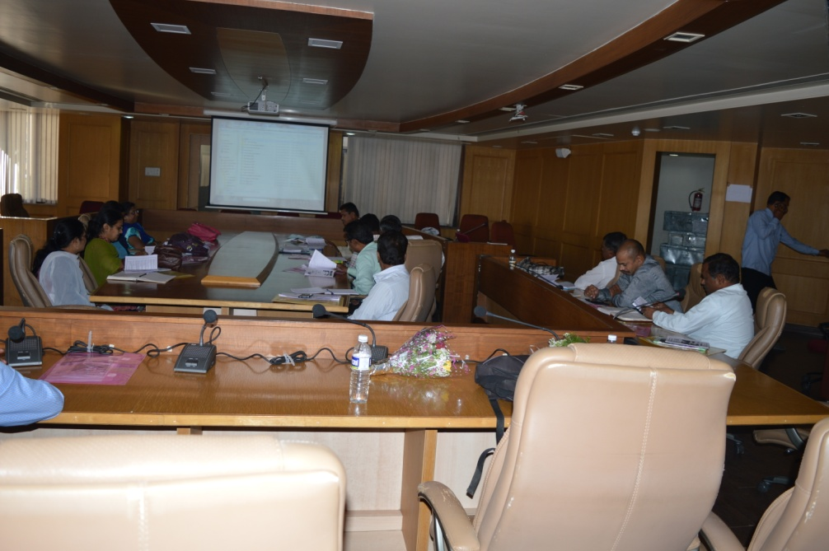

**At Zilla Parisad, Dist. Pune, MH**

**[E] Users Training 2016-17:**

**Purpose**: To provide awareness about size of BG plant, during construction, Operational solution and maintenance Tips.

**Duration:** One Day.

**Trainees:** Beneficiaries and School student.

Allocated target was100 for the current year 2016-17 to the BDTC, Indore. 88% trainings were conducted in the state of MadhyaPradesh, Chhattisgarh and Maharashtra.

|  |  |  |
| --- | --- | --- |
| SR NO | STATE | Numbers of Training Conducted |
| 1 | MADHYAPRADESH | 9 |
| 2 | CHHATTISHGARHH | 19 |
| 3 | MAHARASHTRA | 40 |

**Table 12**

Enlisted trainings have been conducted during the year 2016-17.

|  |  |  |  |  |  |
| --- | --- | --- | --- | --- | --- |
| SR NO | VILLAGE / VENUE | BLOCK | District | DATE | STATE |
| 1 | Sirali | Khirkiya | Harada | 06.10.16 | **MP** |
| 2 | Pahatkala | Khirkiya | Harada | 07.10.16 | MP |
| 3 | Sirkhamba | Harada | Harada | 08.10.16 | MP |
| 4 | Kuhigwadi | Timarani | Harada | 09.10.16 | MP |
| 5 | Shyampur | Murena | Murena | 15.10.16 | MP |
| 6 | Birampura | Murena | Murena | 15.10.16 | MP |
| 7 | Roonipur | Amba | Murena | 16.10.16 | MP |
| 8 | Devrai | Amba | Murena | 16.10.16 | MP |
| 9 | Rahuri (Pimpalwadi) | Rahuri | Ahmadnagar | 20.10.16 | MH |
| 10 | Nandgoan | Rahuri | Ahmadnagar | 07.11.16 | MH |
| 11 | Shingwe | Ahmadnagar | Ahmadnagar | 13.11.16 | MH |
| 12 | Dehre | Ahmadnagar | Ahmadnagar | 13.11.16 | MH |
| 13 | Dhamoli | Rahuri | Ahmadnagar | 14.11.16 | MH |
| 14 | Umbe | Rahuri | Ahmadnagar | 14.11.16 | MH |
| 15 | Malegoan | Baramati | Pune | 30.11.16 | MH |
| 16 | Shikaarpura | Mohkhed | Chhindwada | 21.12.16 | MP |
| 17 | Arjunwadi | Mohkhed | Chhindwada | 22.12.16 | MP |

|  |  |  |  |  |  |  |  |  |  |
| --- | --- | --- | --- | --- | --- | --- | --- | --- | --- |
| SR NO | | VILLAGE / VENUE | | BLOCK | District | | DATE | STATE | |
| 18 | | Khutpipariya | | Chorai | Chhindwada | | 23.12.16 | MP | |
| 19 | | Kapoorda | | Chorai | Chhindwada | | 24.12.16 | MP | |
| 20 | | Kharaiti | | Amarwada | Chhindwada | | 25.12.16 | MP | |
| 21 | | Dhasanwada | | Amarwada | Chhindwada | | 25.12.16 | MP | |
| 22 | | Sanjara | | Garhakota | sagar | | 28.12.16 | MP | |
| 23 | | Bamnoda | | Garhakota | sagar | | 29.12.16 | Mp | |
| 24 | | Bhatoli | | Garhakota | sagar | | 29.12.16 | MP | |
| 25 | | Bichchiya | | Garhakota | sagar | | 30.12.16 | MP | |
| 26 | | Chaurai | | Garhakota | sagar | | 30.12.16 | MP | |
| 27 | Linepura | | Barwah | | | Khargone | 04.01.17 | MP |
| 28 | Katkut | | Barwah | | | Khargone | 04.01.17 | MP |
| 29 | Bramani | | Rahuri | | | Ahmadnagar | 05.01.17 | MH |
| 30 | Deshwandi | | Rahuri | | | Ahmadnagar | 05.01.17 | MH |
| 31 | Jagtap | | Rahuri | | | Ahmadnagar | 05.01.17 | MH |
| 32 | Guhi | | Rahuri | | | Ahmadnagar | 05.01.17 | MH |
| 33 | Chandra pur | | Rahta | | | Ahmadnagar | 06.01.17 | MH |
| 34 | Loni BK | | Rahta | | | Ahmadnagar | 06.01.17 | MH |
| 35 | Nandur | | Rahta | | | Ahmadnagar | 06.01.17 | MH |
| 36 | Ramwadi | | Rahta | | | Ahmadnagar | 06.01.17 | MH |
| 37 | Akadgoan | | Kopargoan | | | Ahmadnagar | 07.01.17 | MH |
| 38 | Daunch | | Kopargoan | | | Ahmadnagar | 07.01.17 | MH |
| 39 | Kumbhari | | Kopargoan | | | Ahmadnagar | 08.01.17 | MH |
| 40 | Mahgoan | | Kopargoan | | | Ahmadnagar | 08.01.17 | MH |

|  |  |  |  |  |  |
| --- | --- | --- | --- | --- | --- |
| SR NO | VILLAGE / VENUE | BLOCK | District | DATE | STATE |
| 41 | Karegoan | Pathardi | Ahmadnagar | 09.01.17 | MH |
| 42 | Vaijuba | Pathardi | Ahmadnagar | 09.01.17 | MH |
| 43 | Khampipri | Sevgoan | Ahmadnagar | 10.01.17 | MH |
| 44 | Varu | Sevgoan | Ahmadnagar | 10.01.17 | MH |
| 45 | Kalkup | Parner | Ahmadnagar | 11.01.17 | MH |
| 46 | Malewadi | Parner | Ahmadnagar | 11.01.17 | MH |
| 47 | Chutiya | Dharni | Amarawati | 12.01.17 | MH |
| 48 | Nandgoan | Dharni | Amarawati | 12.01.17 | MH |
| 49 | Takli hati | Shirur | Pune | 21.01.17 | MH |
| 50 | Jaategoan | Shirur | Pune | 21.01.17 | MH |
| 51 | Lakhangoan | Ambegoan | Pune | 23.01.17 | MH |
| 52 | Manchar | Ambegoan | Pune | 23.01.17 | MH |
| 53 | Taajpur | Shajapur | Shajapur | 25.01.17 | MP |
| 54 | Mandawar | Shajapur | Shajapur | 25.01.17 | MP |
| 55 | Launi | Ambegoan | Pune | 25.01.17 | MH |
| 56 | Piparkhed | Ambegoan | Pune | 25.01.17 | MH |
| 57 | Ganeshwadi | Karad | Satara | 30.01.17 | MH |
| 58 | Kapil | Karad | Satara | 30.01.17 | MH |
| 59 | Charegoan | Karad | Satara | 30.01.17 | MH |
| 60 | Sawarghar | Karad | Satara | 30.01.17 | MH |
| 61 | Rethere khurd | Karad | Satara | 31.01.17 | MH |
| 62 | Bharatgoan | Satara | Satara | 01.02.17 | MH |
| 63 | Marde | satara | Satara | 01.02.17 | MH |
| 64 | Sonwadi | satara | Satara | 02.02.17 | MH |
| 65 | Gajwadi | satara | Satara | 02.02.17 | MH |
| 66 | Mulyawala | Narsinghgad | Rajgad | 08.02.17 | MP |
| 67 | Bamitha | Narsinghgad | Rajgad | 08.02.17 | MP |
| 68 | Barpali | Baramkela | Raigarh | 21.02.17 | CG |
| 69 | Jaampali | Baramkela | Raigarh | 21.02.17 | CG |
| 70 | Shahpur | Dharamjaygar | Raigarh | 21.02.17 | CG |

|  |  |  |  |  |  |
| --- | --- | --- | --- | --- | --- |
| SR NO | VILLAGE / VENUE | BLOCK | DISTRICT | DATE |  |
| 71 | Baharamar | Dharamjaygar | Raigarh | 21.02.17 | CG |
| 72 | Khokhra | Pushore | Raigarh | 22.02.17 | CG |
| 73 | Telpaali | Pushore | Raigarh | 22.02.17 | CG |
| 74 | Dhanagar | Raigarh | Raigarh | 22.02.17 | CG |
| 75 | Junwani | Raigarh | Raigarh | 22.02.17 | CG |
| 76 | Maanpur | Dharamjaygar | Raigarh | 23.02.17 | CG |
| 77 | Kharwani | Saranggarh | Raigarh | 23.02.17 | CG |
| 78 | Gadarachua | Saranggarh | Raigarh | 23.02.17 | CG |
| 79 | Madhopali | Saranggarh | Raigarh | 23.02.17 | CG |
| 80 | Nawadeeh | Saranggarh | Raigarh | 24.02.17 | CG |
| 81 | Rohinapaali | Saranggarh | Raigarh | 24.02.17 | CG |
| 82 | BAndhapali | Tamnaar | Raigarh | 24.02.17 | CG |
| 83 | Kachchkoba | Tamnaar | Raigarh | 24.02.17 | CG |
| 84 | Kashdol | Tamnaar | Raigarh | 25.02.17 | CG |
| 85 | Mahloi | Tamnaar | Raigarh | 25.02.17 | CG |
| 86 | Dhurawar | Nagri | Dhamtari | 29.03.17 | CG |
| 87 | Tutiyakhedi | Khachrod | Ujjain | 29.03.17 | MP |
| 88 | Atalwada | Khachrod | Ujjain | 30.03.17 | MP |

**Table 13**

**Photo Graphs 2016-17: USERS TRAININGS:**

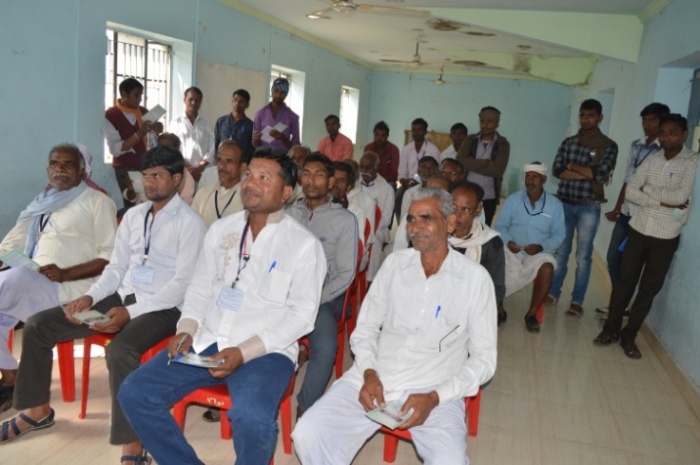

**At Village –Sirali, Block –Khirkiya, Dist –Harada, MP**

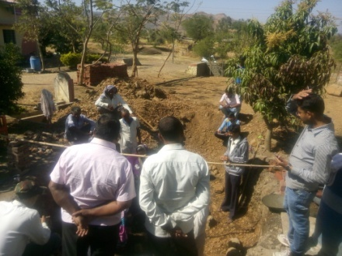

**At Village –Sawarghaar, Block –Karad, Dist –Satara, MH**

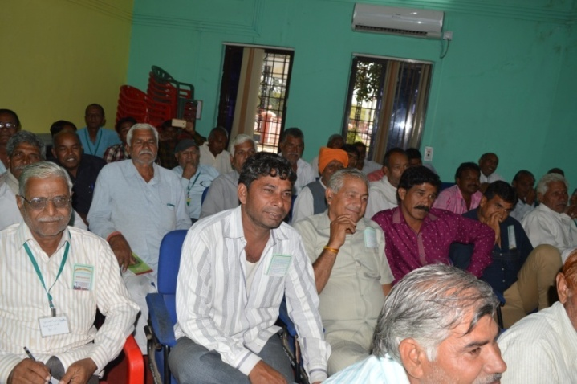

**At Village –Junwani, Block –Raigad, Dist –Raigad, CG**

**Photo Graphs 2016-17: USERS TRAININGS:**

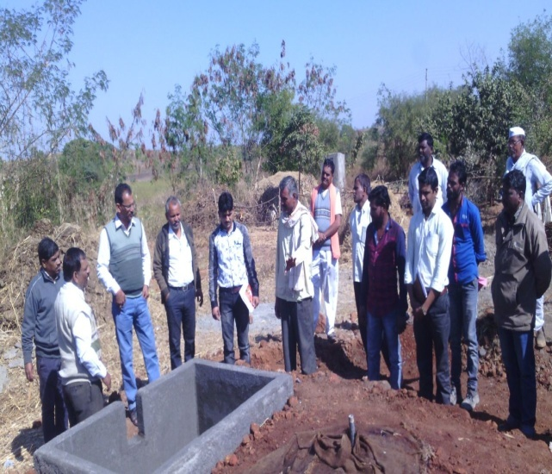

User- During CMC, Training at Village Nandgon Dist- Amarawati, MH

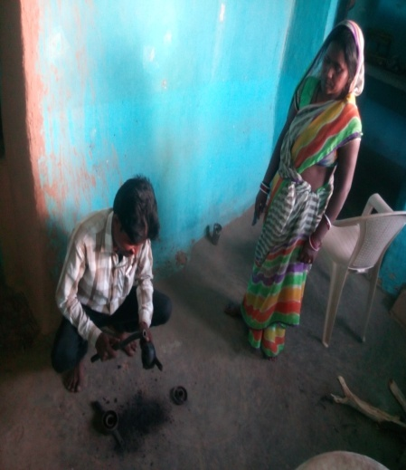

User Training at Village Shahpur, Dist- Raigad, CG

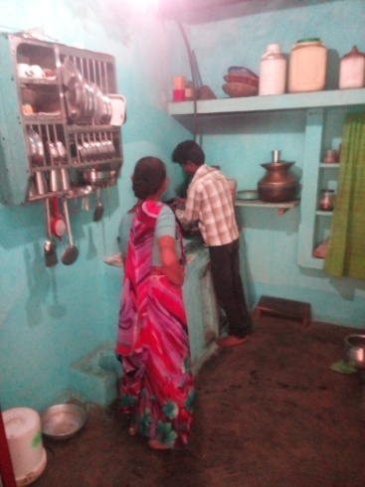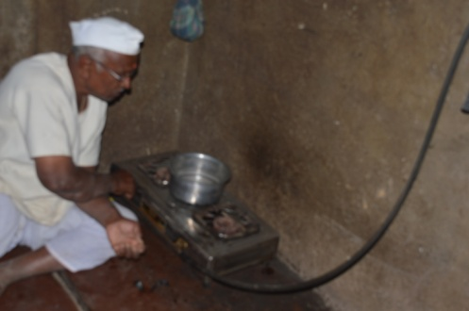Village- Nandgoan, B- Rahuri, Dist. Pune, MH. Village- , B- Rahuri, Dist. Pune, MH