**2017-18**

**[A] Construction cum Maintenance Training, 2017-18:**

**Purpose**: To prepare trained and skilled mason for using effective technology in the field.

**Duration:** Ten Days

**Material:** Arranged by Beneficiaries.

**Trainees:** Ten numbers each.

Enlisted trainings have been conducted during the year 2017-18

|  |  |  |  |  |  |  |
| --- | --- | --- | --- | --- | --- | --- |
| **Sr No** | **Agency** | **District** | **Block** | **village** | **Duration** | **No of Trainees** |
| 1 | MPAGRO | Rajgarh | Byawara | Laxman pura | 07.09.17 To 17.09.17 | 10 |
| 2 |  | Khargone | Barwah | Bargana | 09.11.17 To 19.11.17 | 10 |
|  | | | | | | |
| 3 | CREDA | Ambikapur | Ambikapur | Sakalo | 19.09.18 To 28.09.18 | 10 |
| 4 |  | Jashpur | Duldula | Barpani | 05.10.17 To 14.10.17 | 10 |
|  | | | | | | |
| 5 | ZP, MH | Chandrapur | Sindhewahi | Siddhekala | 21.11.17 To 30.11.17 | 10 |
| 6 |  | Kolhapur | Sahuwadi | Retre warna | 01.12.17 To 10.12.17 | 10 |
| 7 |  | Sangli | Sirala | Pan Umri | 15.12.17 To 24.12.17 | 10 |
| 8 |  | Sindhudurg | Kankawali | Kankewadi | 13.12.17 To 22.12.17 | 10 |
|  | | | | | | |

**Table 6**

**PHOTOGRAPHS OF CCM TRAINING PROGRAMS CONDUCTED AT VARIOUS SITES**

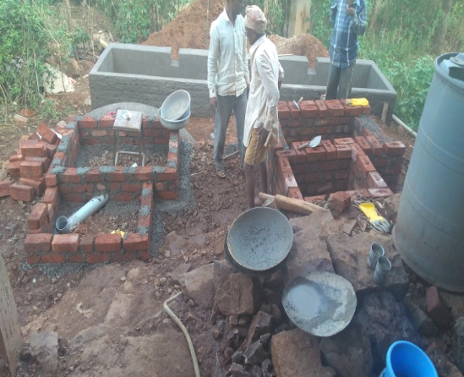

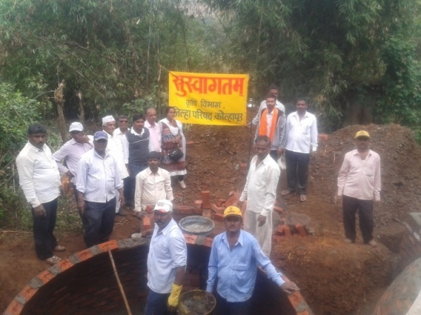

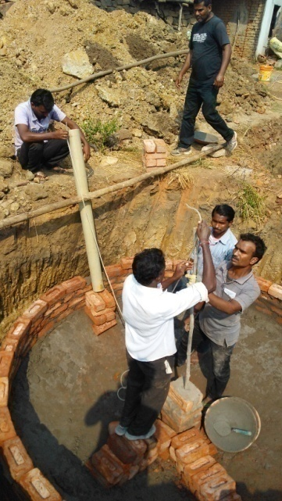

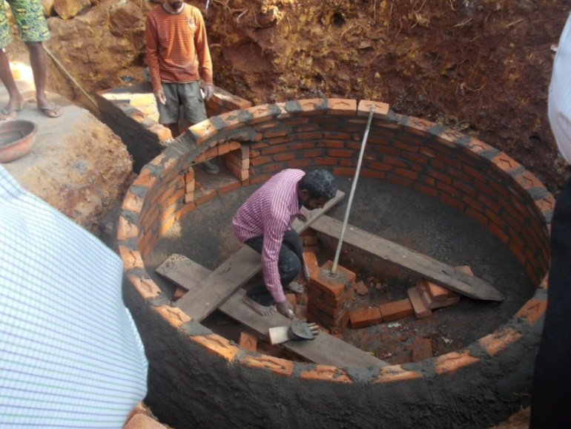

**PHOTOGRAPHS OF CCM TRAINING PROGRAMS CONDUCTED AT VARIOUS SITES**

**[B] Turnkey Workers Training, 2017-18:**

**Purpose:** To prepare trained and skilled Self Employed Workers or Rural Energy Technicians for using effective technology in this field.

**Duration:** Fifteen Days

**Trainees:** State agencie, ZP (MH). Trainees from Kolhapur and Sangli.

Allocated target was 03 for the current year to the BDTC, Indore. ZP, Kolhapur, and ZP, Sangli sent their candidate in the program. Two programs have been conducted simultaneously at Kolhapur, MH.

**Enlisted trainings have been conducted during the year 2017-18.**

|  |  |  |  |  |  |
| --- | --- | --- | --- | --- | --- |
| **Sr. No.** | **Duration of Training** | **Venue** | **Agency** | **From Districts** | **No. of Trainees** |
| 1 | 10.12.17 to 24.12.17 | Zilla Parisad Kolhapur | Zilla Parisad | Kolhapur, | 05 |
| 2 | Zilla Parisad | Sangli | 10 |

**Table 7**

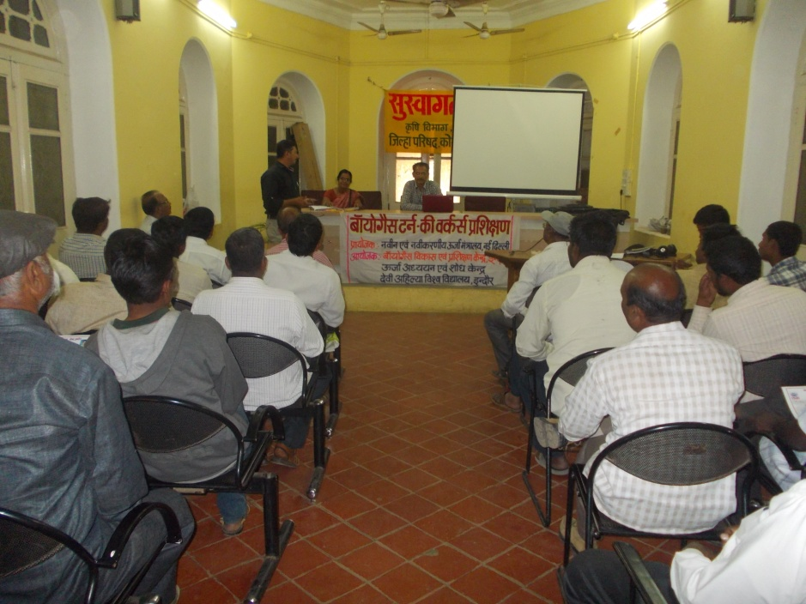

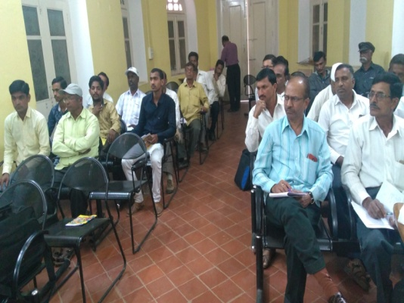

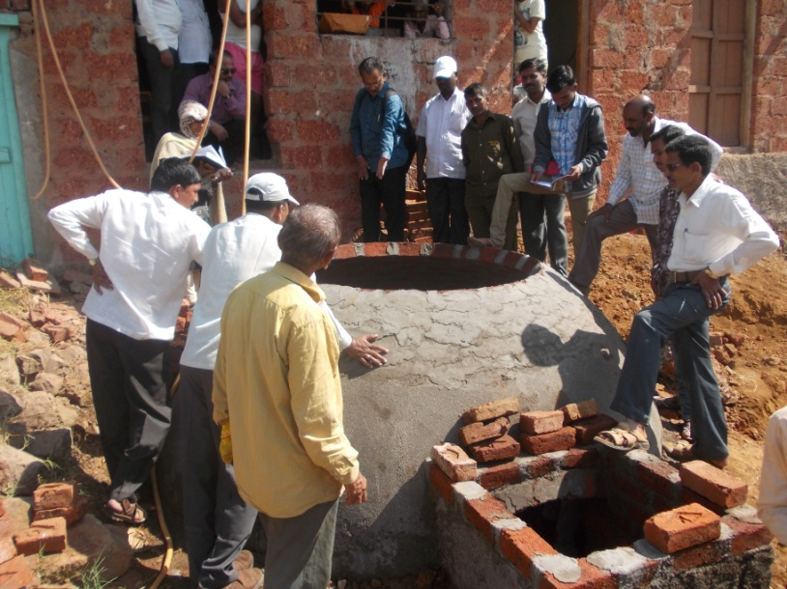

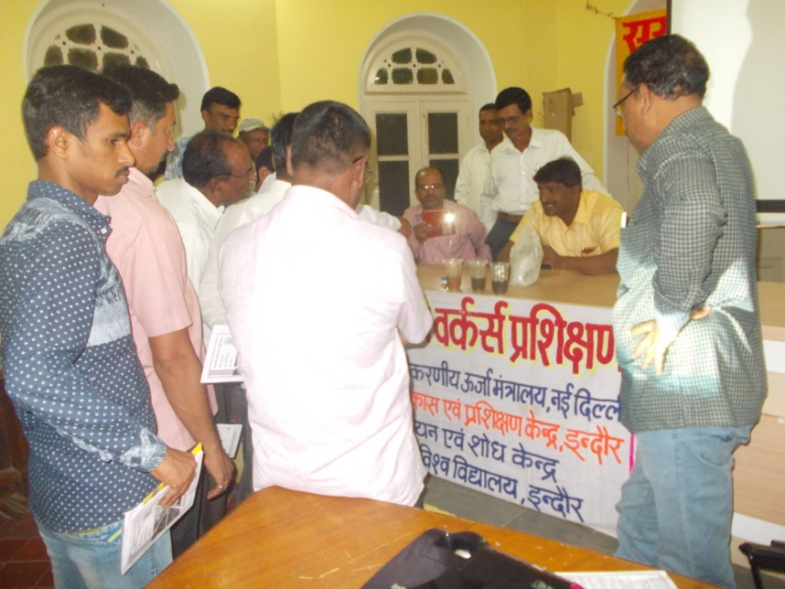

PHOTOGRAPHS OF TKW TRAINING PROGRAM

**[C]Government Functionaries Training, 2017-18:**

**Purpose**: To minimize the field problems by choosing the right beneficiary, construction and operational problems.

**Duration:** Two to Four Days.

**Trainees:** Members from Zilla Parisad, Chandrapur, Sangli and Sindhudurg, MH.

Allocated target was three for the current year to the BDTC, Indore. All the three trainings have been conducted simultaneously for Zilla parishad Chandrapur, Sindhudurg and sangli.

Enlisted trainings have been conducted during the year 2017-18.

|  |  |  |  |  |
| --- | --- | --- | --- | --- |
| **Sr No** | **State** | **Name of Agency/Venue** | **Duration** | **No. of Trainees** |
|  | Maharashtra | ZP, Chandrapur | 29.11.17 To 30.11.17 | 40 |
|  | Maharashtra | ZP, Sindhudurg | 21.12.17 To 22.12.17 | 12 |
|  | Maharashtra | ZP, Sangli | 26.12.17 To 28.12.17 | 14 |

**Table 8**

Zilla Parisad officer are acknowledged that such type of training programs never organized for Mason, Users, Biogas worker and field Staff also, by any authorized agency of Central Government like BDTC or state Government. All the participants agreed and committed to do better work with new conception and hope to conduct these training programs time to time for other worker at Taluka and village level.

**PHOTOGRAPHS OF STAFF TRAINING PROGRAM CONDUCTED AT VARIOUS SITES**

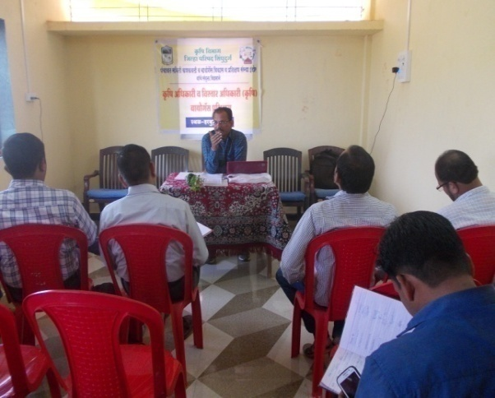

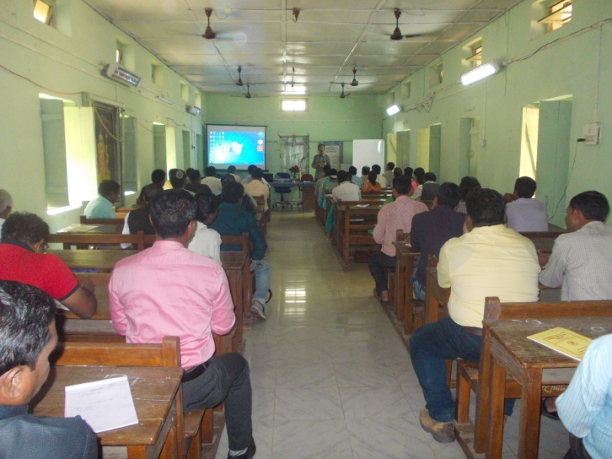

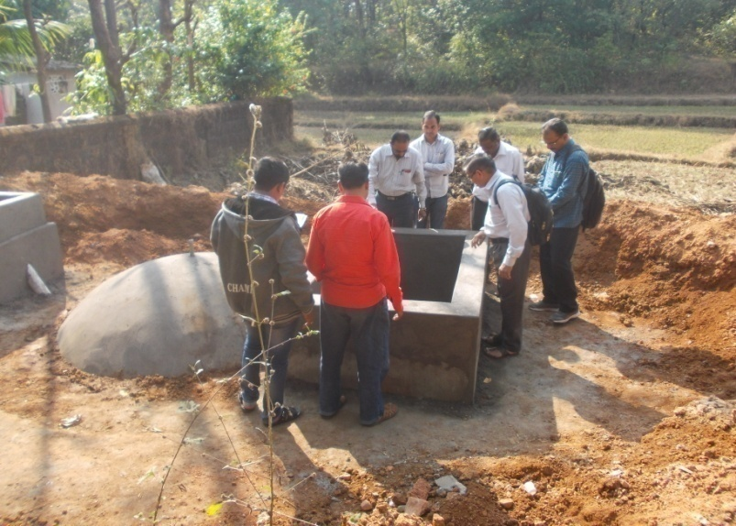

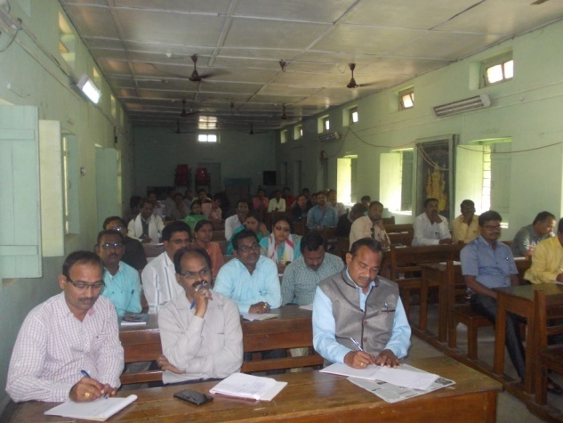

**PHOTOGRAPHS OF STAFF TRAINING PROGRAM CONDUCTED AT VARI**

**[D] Users Training, 2017-18:**

**Purpose**: To provide awareness about size of BG plant, during construction, Operational solution and maintenance Tips.

**Duration:** One Day.

**Trainees:** Beneficiaries and School student.

Allocated target was100 for the current year 2017-18 to the BDTC, Indore. 37 trainings were conducted in the state of MP, CG, and Maharashtra up to 15th of January.

Enlisted trainings have been conducted during the year 2017-18.

|  |  |  |  |  |  |
| --- | --- | --- | --- | --- | --- |
| **Sr.No.** | **Village** | **Block** | **District** | **State** | **Date** |
| **During CCM Training 1 To 9** | | | | |  |
| 1 | Laxmanpura | Byawara | Rjgarh MP | MP | 17.09.17 |
| 2 | Barapani | Duldula | Jashpur | CG | 14.10.17 |
| 3 | Sakalo | Ambikapur | Ambikapur | CG | 27.09.17 |
| 4 | Bargala | Badwah | Khargone | MP | 19.11.17 |
| 5 | Sindhekala | Sindhewahi | Chandrapur | MH | 26.11.17 |
| 6 | Kankewadi | Kankawali | Sindhudurg | MH | 22.12.17 |
| 7 | Pan Umari | Shirala | Sangli | MH | 27.12.17 |
| 8 | Retrewarna | Shahuwadi | Kolhapur | MH | 10.12.17 |
|  | | | | |  |
| 9 | Chaugoan | Baglan | Nasik | MH | 01.09.17 |
| 10 | Joran | Baglan | Nasik | MH | 01.09.17 |
| 11 | Jategoan | Nasik | Nasik | MH | 31.08.17 |
| 12 | Khed | Igatpuri | Nasik | MH | 02.09.17 |
| 13 | Pimplas | Sinnar | Nasik | MH | 02.09.17 |

**Table 9 a**

|  |  |  |  |  |  |
| --- | --- | --- | --- | --- | --- |
| **Sr.No.** | **Village** | **Block** | **District** | **State** | **Date** |
| 14 | Lonarwadi | Sinnar | Nasik | MH | 03.09.17 |
| 15 | Kanherwadi | Kalwan | Nasik | MH | 03.09.17 |
| 16 | Niwane | Kalwan | Nasik | MH | 04.09.17 |
| 17 | Mohra | Kannad | Aurangabad | MH | 12.09.17 |
| 18 | Peesore | Kannad | Aurangabad | MH | 13.09.17 |
| 19 | Khamgoan | Phulambari | Aurangabad | MH | 12.09.17 |
| 20 | Dharakwadi | Aurangabad | Aurangabad | MH | 13.09.17 |
| 21 | Jangda | Simga | Baloda Bajar | CG | 23.09.17 |
| 22 | Rikokala | Kasdol | Baloda Bajar | CG | 24.09.17 |
| 23 | Lakua Pali | Kasdol | Baloda Bajar | CG | 24.09.17 |
| 24 | Mohada | Kasdol | Baloda Bajar | CG | 25.09.17 |
| 25 | Amgoan | Kasdol | Baloda Bajar | CG | 25.09.17 |
| 26 | Kachloan | Simga | Baloda Bajar | CG | 23.09.17 |
| 27 | Kudase | Dodamal | Sindhudurg | MH | 12.12.17 |
| 28 | Adeli | Kudal | Sindhudurg | MH | 13.12.17 |
| 29 | Ambegoan | Vengurla | Sindhudurg | MH | 13.12.17 |
| 30 | Adeli | Sawantwadi | Sindhudurg | MH | 14.12.17 |
| 31 | Vaibhavwadi | Khaskilwada | Sindhudurg | MH | 14.12.17 |
| 32 | Utimal | Sindewahi | Chandrapur | MH | 22.11-17 |
| 33 | Umarwahi | Sindewahi | Chandrapur | MH | 22.11-17 |
| 34 | Vasera | Sindewahi | Chandrapur | MH | 23.11-17 |
| 35 | Tekritu | Sindewahi | Chandrapur | MH | 23.11-17 |
| 36 | Avalgoan | Sindewahi | Chandrapur | MH | 24.11-17 |
| 37 | Gangalwadi | Bramhapuri | Chandrapur | MH | 24.11-17 |

**Table 9 b**

**PHOTOGRAPHS OF USERS TRAINING PROGRAM CONDUCTED AT VARIOUS SITES**

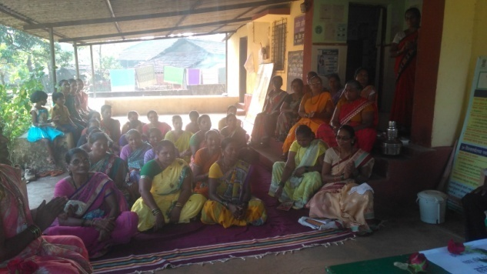

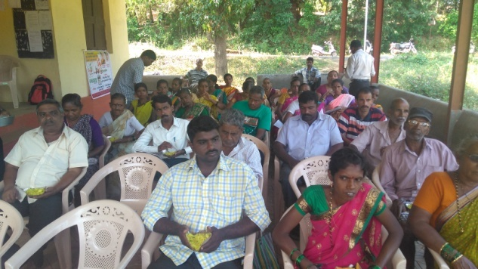

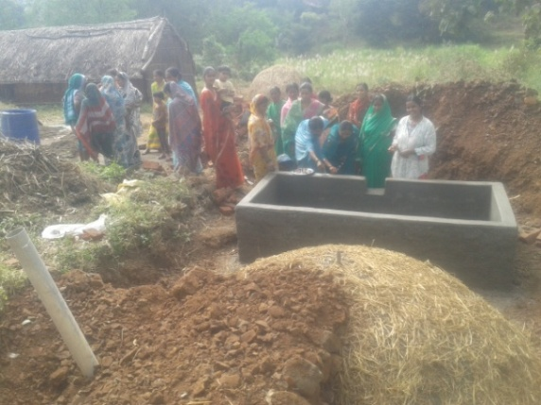

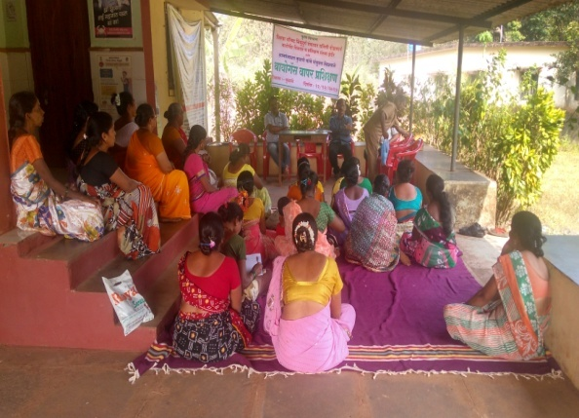

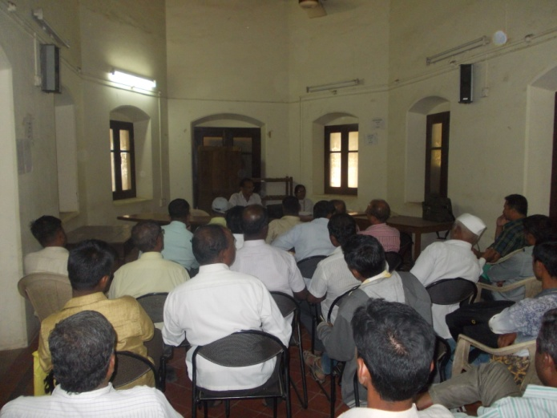

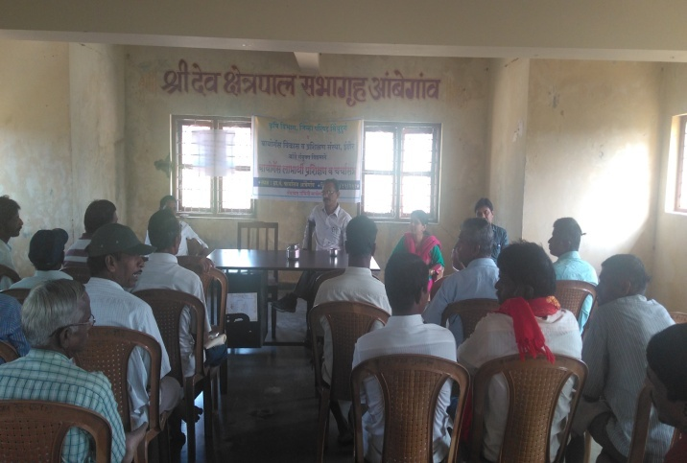

**PHOTOGRAPHS OF USERS TRAINING PROGRAM CONDUCTED AT VARIOUS SITES**