Biogas Development for Rural & Urban Communities
India's overall energy production is considerably less than its overall energy consumption. The government views biogas technology as a vehicle to reduce rural poverty, and as a tool in part of a wider drive for rural development as well as urban areas.
SEES, DAVV is organized BDTC program in M.P., CG & Maharastra.The Main purpose of training is develop an awareness of this technology. The beneficiaries of villagers and people of semi urban areas. Biogas certainly has a significant impact on rural women’s lives. Biogas technology is a particularly useful system in the Indian rural economy, and can fulfill several end uses. A regular supply of energy piped to the home reduces, if not removes, the daily task of fuel wood gathering, which can, in areas of scarcity, be the single most time consuming task of a woman's day - taking more than three hours in some areas.
The several types of training were organized in different villages and urban areas of M.P., CG & Maharashtra are as follows.
2014-15

[A] Construction cum Maintenance Training:
The main objective of CCM training is how to construct biogas plant and their maintenance. Seven trainings out of eight have been successfully conducted in this year 2014-15 and due to unhealthy weather conditions (Hud Hud) one more was cancelled.
Venue of the CCM Trainings is as under:
S N | Agency | District | Block | Village | Period | No of Trainees | Plants constructed
1 | MP AGRO | Sagar | Garhakota | Madia AG | 03.02.15 To12.02.15 | 10 | 05
2. | CREDA | Surajpur | Pratapgarh | Chandrel | 11.01.15 To 20.01.15 | 10 | 08
3. | MP AGRO | Bhind | Gohad | Rai ki pali | 27.12.14 To 05.01.15 | 12 | 06
4. | CREDA | Dhamtari | Nagri | Purniya | 23.11.14 To 02.12.14 | 14 | 08
5. | MP AGRO | Tikamgarh | Mohangarh | Gaur | 18.03.15 To 27.03.15 | 10 | 10
6. | MP AGRO | Rajgarh | Biora | Khuri | 10.02.15 To 20.02.15 | 10 | 09
7 | Zilla Panchayat | Kolhapur | Karveer | Nigave KHA | 23.02.15 To 04.03.15 | 10 | 04
8

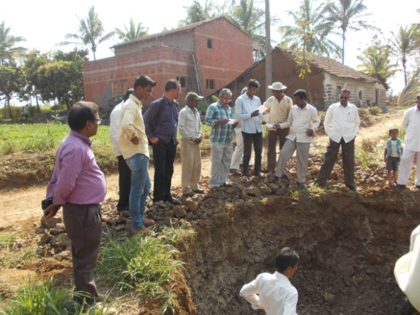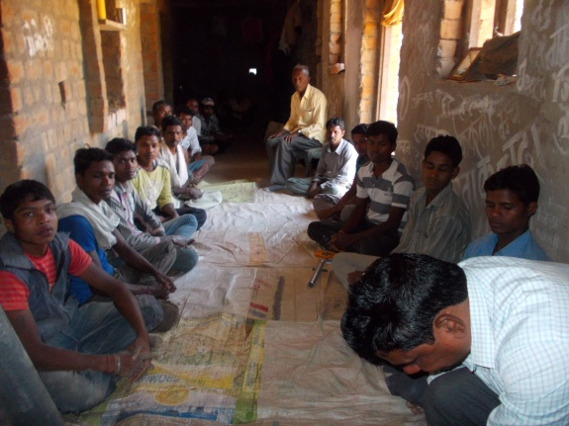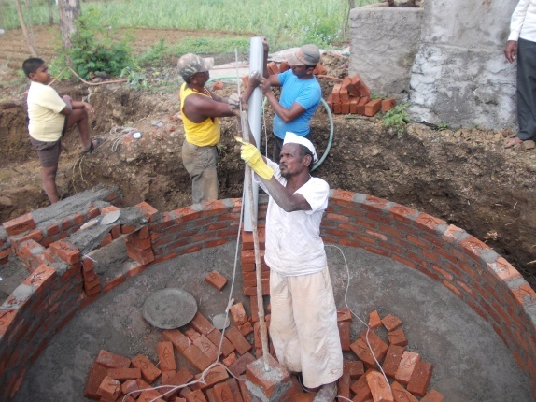
[B] Turnkey Workers Training:
Allocated target was 02 for the current year to the BDTC, Indore. MPAgro, and CREDA Chhattisgarh sent their candidate in the program as usual. Both the programs are conducted simultaneously.
Sr. No. | Duration of Training | Venue | Agency | Requested Numbers | No. of trainees
1 | 09.12.14 To 23.12.14 | BDTC,  Indore | MP Agro | 10 | 10
2 |  |  | CREDA | 10 | 09
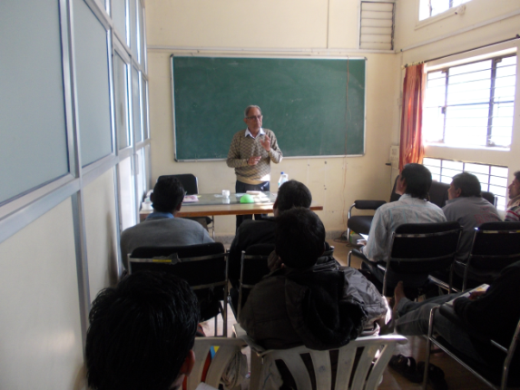
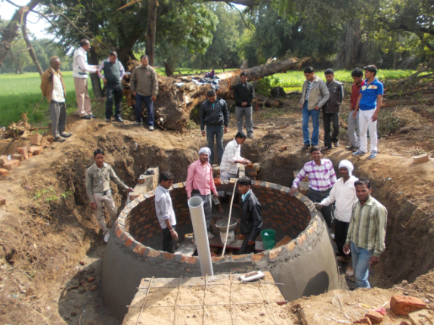
Classroom Lecture Construction of Biogas Plant by trainees

[C] Government functionaries Training:
Kolhapur 02.03.15 to 03.03.15 Summary contained, 01 courses allocated to the BDTC by Ministry of New and Renewable Energy, Govt. of India, conducted for Department of Agriculture, Zillas Parishad, and Kolhapur Maharashtra.
S No | Agency | District | Period | No of Trainees
1 | Department of Agriculture, Zillas Parishad, | Kolhapur MH | 02.03.15 To 03.03.15 | 35

The trainings were mainly concluded are as under.

- Clause under fixation and distribution of subsidy.
- Lack of trained and confidential biogas mason.
- Toilet Linked plant and expenditure.
- The presence of water vapor in the biogas causes problems created in biogas stove.
- Reasoning of partially functional plants.
- Need of awareness about identification of fault and rectification for the same.
- Number of Staff trainings should be organized at block level.
- Construction technology and material management.

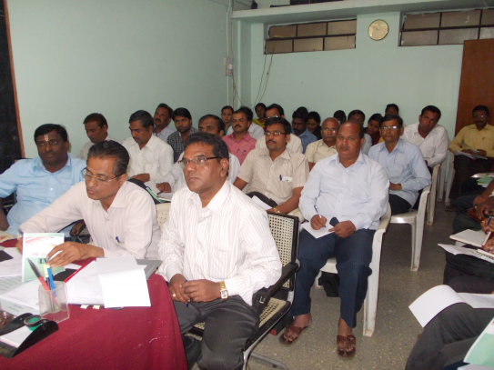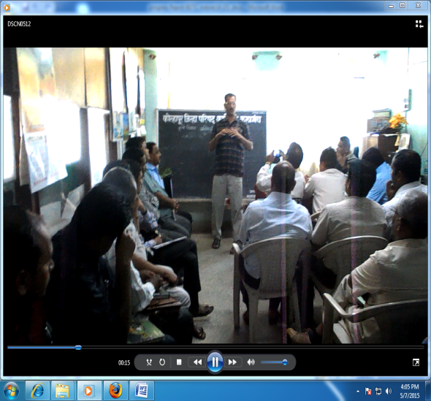

Zilla Parishad Kolhapur

[D] Users Training:
The main objective of this training is motivate to school children and villagers for developing a biogas plant in their areas. Allocated target was 80 for the current year 2014-15 to the BDTC, Indore. Maximum course are compelled with physical verification work of biogas plants in all three state while others are conducted along with CCM Trainings. Few of the courses conducted for higher Secondary school children in the state MP, CG and Maharashtra also.
SrNo | Name of State | Name of District covered | Numbers of Course for Family Members | Numbers of Course during CCM Training | Numbers of Course for School Children | Total Training Conduct
1. | MadhyaPradesh | Vidisha, Ratlam | 10 | 04 | 02 | 16
2. | Chhattisgarh | Mahasamund | 08 | 02 | 07 | 17
3. | Maharashtra | Kolhapur | 17 | 02 | 01 | 20
Total 35 08 10 |  |  |  |  |  | 53

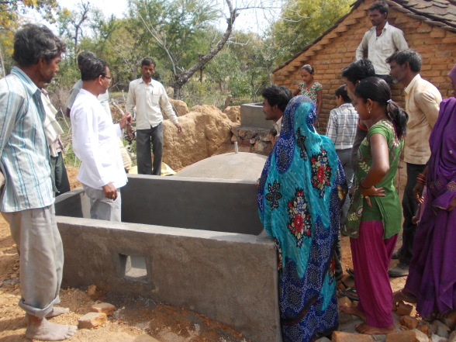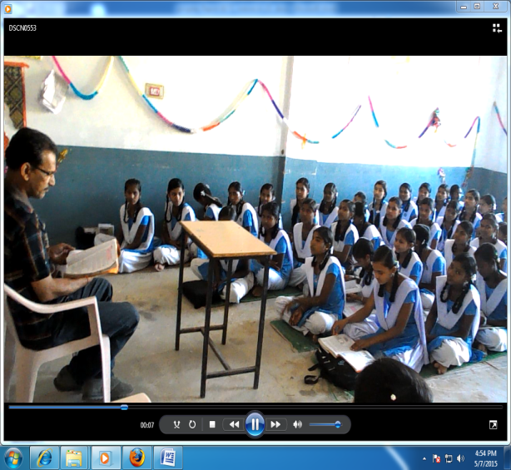
Users during CCM Training Motivation program, School- CG
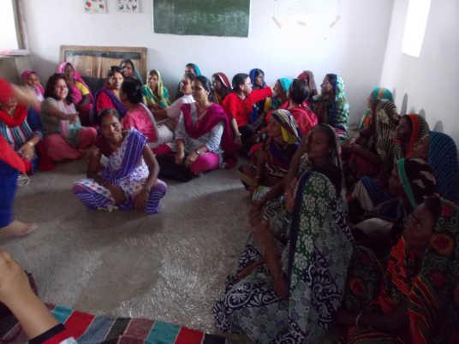
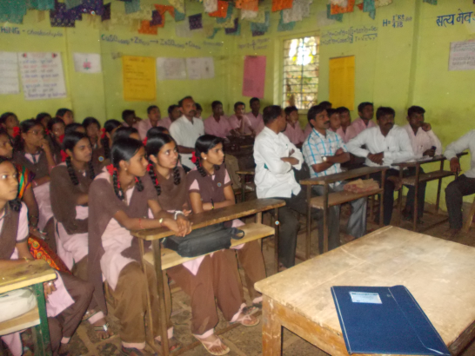 Motivation program, Village – MP Motivation program, School- MH

Feed Back survey:
A target of physical verification cum feedback survey of 1000 Biogas Plants are fixed for the BDTC by the MNRE under NBMMP in the successive year. The survey work carried out in the following respective districts i.e. Ratlam, Vidisha in MP, Mahasamund in Chhattisgarh and Kolhapur from Chhatishgarh.

Inspection summary Report of family type Biogas Plants, Installed under the NBMMP*.

SN | Particulars | MP |  | CG | MH
1 | Implementing agency | MP AGRO | MP AGRO | CREDA | ZILLA PARISHAD
2 | District | Ratlam | Vidisha | Mahasamund | Kolhapur
3 | Date of Inspection | 25.03.To 30.03.15 | 21.03.15 To 25.03.15 | 02.02.15 To 10.02.15 | 23.02.15 To 03.03.15
4 | Name & Model of BG plant | Deen  Bandhu | Deen  Bandhu | Deen  Bandhu | Deen Bandhu Toilet Attached
5 | Members of Inspection Team | BDTC- 02  Agency - 01 | BDTC- 02  Agency - 01 | BDTC- 02  Agency - 01 | BDTC- 02  Agency - 01
6 | Method of Selection | Randomly Selection | Randomly Selection | Randomly Selection | Randomly Selection
7 | Model of BG plant inspected | Deen  Bandhu | Deen  Bandhu | Deen  Bandhu | Deen  Bandhu
*Format given by MNR
S No | Name of District / Block ** | Year 11-12 | Year 12-13 | Year 13-14 | Sob Total | Total
1 | Ratlam ,MP Ratlam | 132 | 127 | 108 | 367
 | Piploda | 37 | 28 | 13 | 78
 | Jaora | 28 | 19 | 16 | 63 | 508
2 | Vidisha, MP Vidisha | 73 | 36 | 71 | 180
 | Gyaraspura | 21 | 22 | 12 | 55 | 235
3 | Mahasamund CG Pithora | 180 | 159 | 183 | 522
 | Bagbahara | 63 | 36 | 80 | 179 | 701
4 | Kolhapur ,MH Karvir | - | 545 | 525 | 1079
 | Budhargarh | - | 375 | 350 | 725 | 1804

SNo | Particulars State | MP | MP | CG | MH | Total
01 | Districts** | Ratlam | Vidisha | Mahasamund | Kolhapur
02 | No of Block covered | 03 | 02 | 02 | 02 | 09
 | No of Village covered | 58 | 08 | 28 | 66 | 160
 | No. of Plants constructed | 508 | 235 | 701 | 1804 | 3248
03 | Year of Construction | 2011-14 | 2011-14 | 2011-14 | 2012-14
04 | No. of Plants inspected | 255 | 47 | 224 | 525 | 1051
05 | Working satisfactory | 236 | 33 | 172 | 495
06 | Working Partially | 10 | 05 | 23 | 27
07 | Un commissioned | 05 | 04 | 04 | 02
08 | Incomplete | 00 | 00 | 00 | 00
09 | Structural problem | 02 | 00 | 04 | 00
10 | Operation Problem | 01 | 01 | 01 | 01
11 | Disinterest of Users | 01 | 01 | 20 | 00
12 | Found Missing | 00 | 00 | 00 | 00
13 | Remark on O&M | 00 | 03 | NA | 00
14 | Functionality % | 92.55% | 80.85% | 87% | 94.30%

- Additional work assigned by MNRE and agencies:

  - Biogas (Off-grid) Power Plants: Following plants are constructed by the MPUVN and commissioned under the Technical support and monitoring of BDTC, Indore.

S. No. | Name of the Institutes | Capacity CUM | Capacity (kW)
1 | Adrash Goshala, MC, Gwalior | 85 | 10
2 | Pashu Prajanan Parikshetra, Bhaadbhada | 85 | 10
3 | Pashu Prajanan Parikshetra, Minora, Tikamgarh* | 85 | 10
4 | Central Semen Station, Bhadhada, Bhopal | 85 | 10
5 | Bull mother Form, Bhadbada, Bhopal | 45 | 05
 | * Plants are under construction

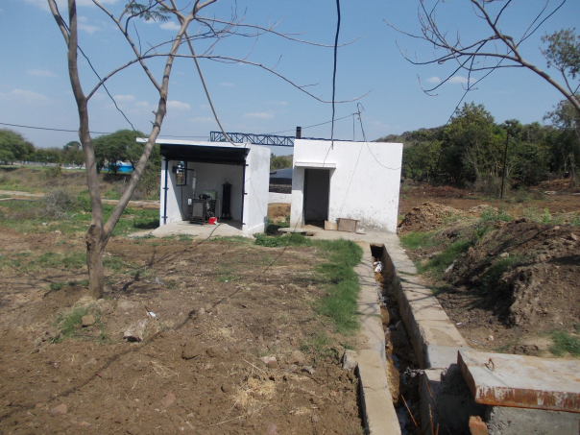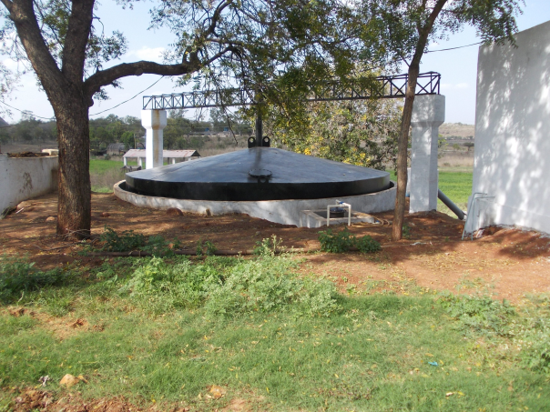
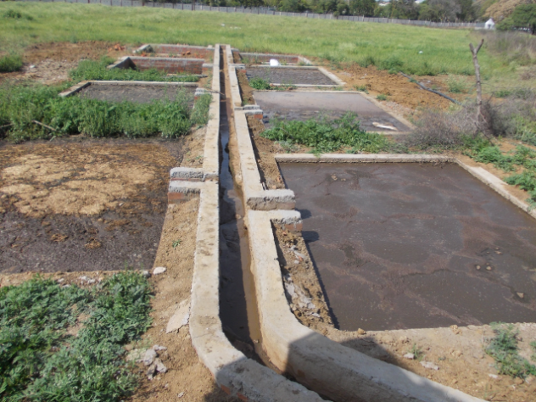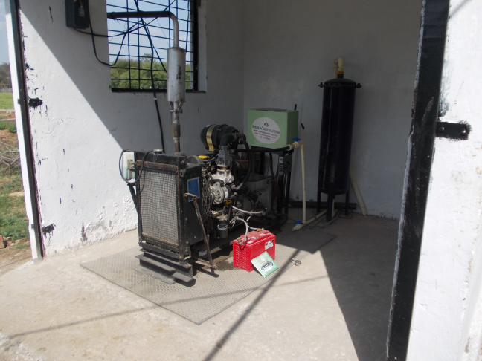
Photographs of Running plant under BGFP Program, at Bhopal, MP
  - Staff Training CREDA:
Two staff Trainings was conducted by BDTC at Indore from 30.07.14 to 06.08.14 for first batch and from 07.08.14 to 14.08.14 for 10 and 11candidates respectively. All candidates were from different responsibilities in CREDA and those are recently joined for the post against Assistant Engineers in different stream.
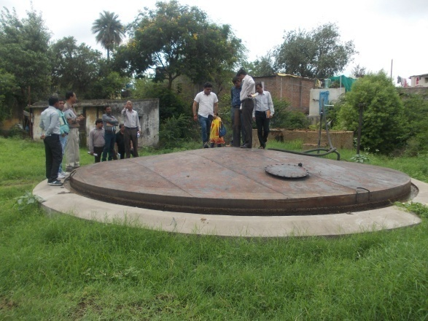
Field visit at Power Generation site
  - Inspection of Seven “Biogas based Power Generation System” based on ( File No 25-16(b) /2010- BE, Dated 10-02-2011, and File No 25-16(b) /2010- BE, Dated 17-04-2014) sanctioned in the state of Maharastra and the report had been sent to the MNRE.
SN | Name of the Beneficiaries / Contact Number | Address of Beneficiaries /  Venue of Set up
i | Shri Kiran Uttareshwar Paigan 09421027510 | Village- Mandegoan, Tal.- Barsi,  Distt. – Solapur
ii | Shri Pranav P Lunawat 09423124357 | Lunawat Nagar, Dhamangoan Railway,  Distt. Amarawati
iii | Shri Ram Baburao Jogdand, 09822872039 | Village Amkheda, Taluka- Malegoan,  Distt. – Malegoan
iv | Shri M B Jadhav 09850533800 | Village- Kusgoan (Pama), Taluka- Mawal,  Distt. – Pune
v | Shri Ramkrishna Shamaroo Jamdade 09890220713 | Village – Kamtha, Taluka – Tuljapur,  Distt.- Osmanabad
vi | Shri Saybanna S Hiramukhe 09422465403 | Village –Bhusani, Taluka- Umerga,  Distt. Osmanabad
vii | Shri Ganesh Krishnaji Jagdale 07721084383 | Village-Mahajanwadi, Taluka- Beed,  Distt. Beed

Venue of the Users Training:

SN | Village | Block | District | Duration
29 | Bhati Barodiya | Ratlam | Ratlam | 28-03-15
30 | Badnara | Ratlam | Ratlam | 29-03-15
31 | Savaniya Jagir | Ratlam | Ratlam | 30-03-15
32 | Upli | Jaora | Ratlam | 30-03-15
33 | Hariyakheda | Piploda | Ratlam MP | 31-03-15
34 | Nigvekhalsa | Karvir | Kolhapur MH | 23-02-15
35 | Vadak shivale | Karvir | Kolhapur | 23-02-15
36 | Spurli | Karvir | Kolhapur | 23-02-15
37 | Admapur | Gargoti | Kolhapur | 24-02-15
38 | Anturli | Gargoti | Kolhapur | 24-02-15
39 | Siroldu | Karvir | Kolhapur | 25-02-15
40 | Bachni | Karvir | Kolhapur | 25-02-15
41 | Chuye | Karvir | Kolhapur | 02-03-15
42 | Gur | Gargoti | Kolhapur | 26-02-15
43 | Kalnakwadi | Gargoti | Kolhapur | 26-02-15
44 | Darwad | Gargoti | Kolhapur | 27-02-15
45 | Vaghapur | Gargoti | Kolhapur | 27-02-15
46 | Gangapur | Gargoti | Kolhapur | 28-02-15
47 | Girgaon | Gargoti | Kolhapur | 28-02-15
48 | Nagdevwadi | Gargoti | Kolhapur | 24-02-15
49 | Mhalunge | Karvir | Kolhapur | 01-03-15
50 | Ambavane | Karvir | Kolhapur | 01-03-15
51 | Kanchawadi | Karrvir | Kolhapur | 25-02-15
52 | Dindnerli | Karvir | kolhapur | 25-02-15
53 | Bele | Karvir | Kolhapur MH | 24-02-15

